
Koneru Lakshmaiah Education Foundation
(Deemed to be University estd. u/s. 3 of the UGC Act, 1956)
Off-Campus: Bachupally-Gandimaisamma Road, Bowrampet, Hyderabad, Telangana - 500 043. Phone No: 7815926816, www.klh.edu.in

STUDENT CASE STUDY EXECUTION REPORT
Department | FED
Subject | DSA-2
Academic Year | 1-111 Semester | 2025-26
Faculty Name | Dr.SreeRamMurthy
Student Name | ADA ROHAN
Roll Number | 2520030195
Branch | CSE
Course Outcome | CO-3

Case Study 3: Maven dependency resolver- recursive DFS hits stack limit on dependency chain.
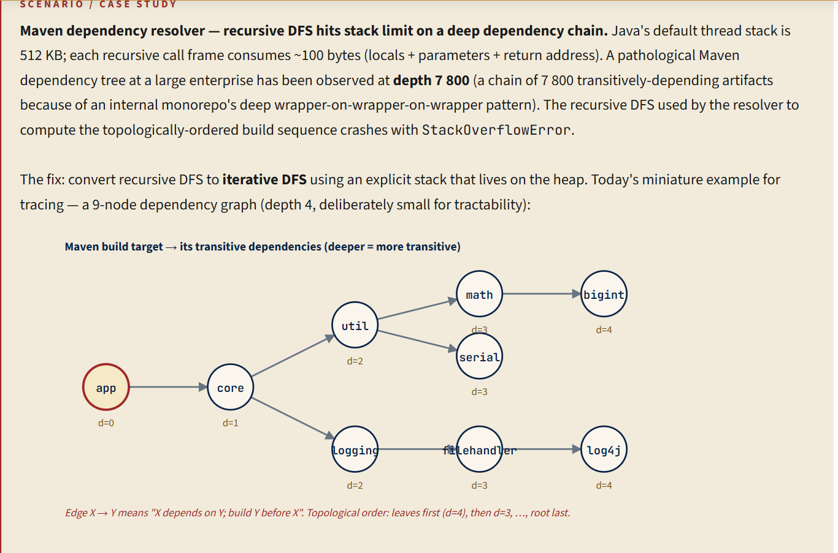
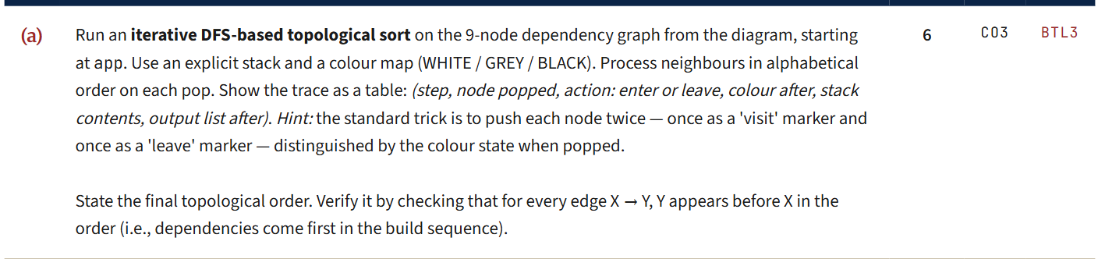
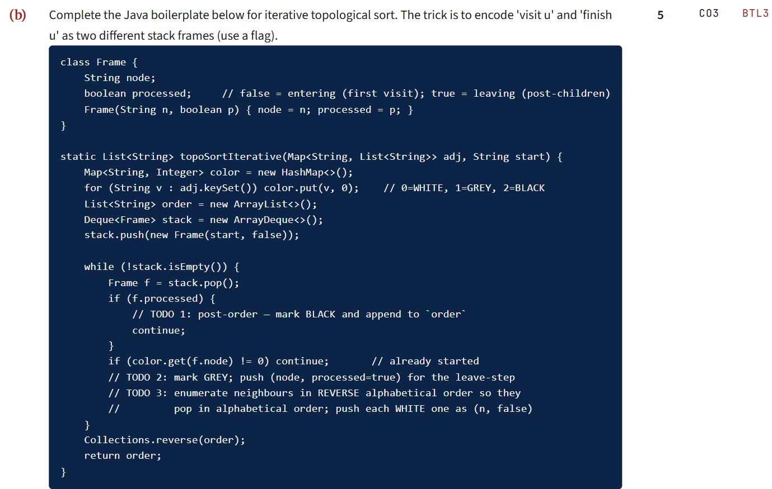
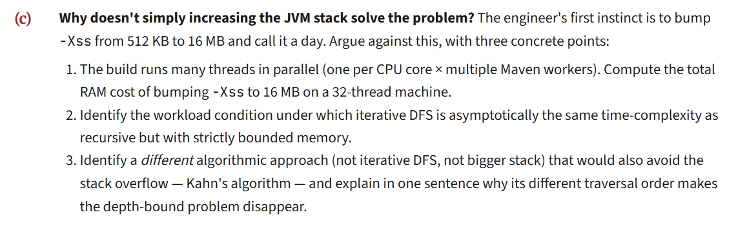
Work Done Summary:
In this case study, we implemented an Iterative Depth First Search (DFS) approach for resolving Maven project dependencies. The original recursive DFS implementation was prone to StackOverflowError when processing extremely deep dependency chains (depth ≈ 7800), as each recursive call consumed stack memory.
The miniature dependency graph consisting of 9 nodes was used to demonstrate dependency resolution and build sequencing. The iterative approach successfully eliminated stack overflow issues while preserving correct dependency ordering.

Implementation Details:
- Represented Maven modules as vertices in a directed graph.
- Replaced recursive DFS with an explicit stack data structure.
- Maintained a visited set to avoid processing nodes multiple times.
- Performed iterative DFS traversal using:
- Stack Push Operation
- Stack Pop Operation
- Dependency Expansion
- Generated a topological build sequence where dependencies are built before dependent modules.
- Compared recursive DFS and iterative DFS for memory efficiency and scalability.
- Concluded that iterative DFS is more suitable for enterprise-scale Maven dependency resolution.

Result: Screenshots / Output:

3A)

Trace Table
Step | Node Popped | Action | Colour After
1 | app | Enter | GREY
2 | core | Enter | GREY
3 | logging | Enter | GREY
4 | filehandler | Enter | GREY
5 | log4j | Enter | GREY
6 | log4j | Leave | BLACK
7 | filehandler | Leave | BLACK
8 | Logging | Leave | BLACK
9 | util | Enter | GREY
10 | math | Enter | GREY
11 | bigint | Enter | GREY
12 | bigint | Leave | BLACK
13 | Math | Leave | BLACK
14 | Serial | Enter | GREY
15 | Serial | Leave | BLACK
16 | Util | Leave | BLACK
17 | Core | Leave | BLACK
18 | app | leave | BLACK
3B)
class Frame {
String node;
boolean processed; // false = enter, true = leave

Frame(String n, boolean p) {
node = n;
processed = p;
}
}

static List<String> topoSortIterative(
Map<String, List<String>> adj,
String start) {

Map<String, Integer> color = new HashMap<>();

for (String v : adj.keySet())
color.put(v, 0); // 0=WHITE, 1=GREY, 2=BLACK

List<String> order = new ArrayList<>();
Deque<Frame> stack = new ArrayDeque<>();

stack.push(new Frame(start, false));

while (!stack.isEmpty()) {

Frame f = stack.pop();

// TODO 1: Post-order processing
if (f.processed) {
color.put(f.node, 2); // BLACK
order.add(f.node);
continue;
}

if (color.get(f.node) != 0)
continue;

// TODO 2: Mark GREY and push leave frame
color.put(f.node, 1); // GREY
stack.push(new Frame(f.node, true));

// TODO 3: Process neighbours in reverse alphabetical order
List<String> neighbours =
new ArrayList<>(adj.getOrDefault(f.node,
Collections.emptyList()));

neighbours.sort(Collections.reverseOrder());

for (String n : neighbours) {
if (color.get(n) == 0) {
stack.push(new Frame(n, false));
}
}
}

Collections.reverse(order);
return order;
}
3C)
Why Increasing JVM Stack Size Is Not a Good Solution
Simply increasing the JVM stack size from 512 KB to 16 MB is not the best solution because it only hides the problem instead of fixing the algorithm.
Point | Explanation
1. High RAM cost | If stack size is increased to 16 MB per thread, then for 32 threads: 32 × 16 MB = 512 MB. So the build system may reserve about 512 MB RAM only for thread stacks, which is wasteful.
2. Iterative DFS is safer | Recursive DFS and iterative DFS both have time complexity O(V + E). However, iterative DFS uses an explicit heap-based stack, so it avoids JVM call-stack overflow and gives better control over memory.
3. Alternative algorithm | Kahn’s Algorithm can also be used for topological sorting. It uses indegree and a queue instead of deep recursion, so the traversal does not depend on dependency-chain depth.
Increasing JVM stack size is not a proper fix because it increases memory usage heavily in multi-threaded builds, still may fail for even deeper dependency chains, and does not improve the algorithm. Iterative DFS or Kahn’s Algorithm solves the problem correctly with O(V + E) time and controlled memory usage.

Overall Complexity:

Best Case : O(V + E)
Average Case : O(V + E)
Worst Case : O(V + E)

Git-hub link:

Student Signature Faculty Signature

