
Koneru Lakshmaiah Education Foundation
(Deemed to be University estd. u/s. 3 of the UGC Act, 1956)
Off-Campus: Bachupally-Gandimaisamma Road, Bowrampet, Hyderabad, Telangana - 500 043. Phone No: 7815926816, www.klh.edu.in

STUDENT CASE STUDY EXECUTION REPORT
Department | FED
Subject | DSA-2
Academic Year | 1-111 Semester | 2025-26
Faculty Name | Dr.SreeRamMurthy
Student Name | ADA ROHAN
Roll Number | 2520030195
Branch | CSE
Course Outcome | CO-4

Case Study Topic 4: BMTC bus-route shortest path with surge-zone penalties.
Bangalore Metropolitan Transport Corporation operates a route network with 7 hubs {MJC (Majestic), KEM (Kempegowda), JAY (Jayanagar), KOR (Koramangala), WHF (Whitefield), HBR (HBR Layout), MRT (Marathahalli)}. Edge weights are average travel times (minutes) plus a surge-zone penalty for routes passing through Silk Board / ORR junctions during peak hours. The dispatcher needs to compute shortest travel time from MJC to every other hub for the 5 PM peak window. Importantly, one edge has a negative weight: the Whitefield-Marathahalli IT-corridor has been observed to be faster than expected due to dedicated bus lanes (modelled as -3 minutes weight, i.e., the edge gives back 3 minutes of slack to the route budget). This means Dijkstra's algorithm cannot be used naively. Bellman-Ford handles negative edges in O(V·E) but cannot detect negative cycles unless extended.
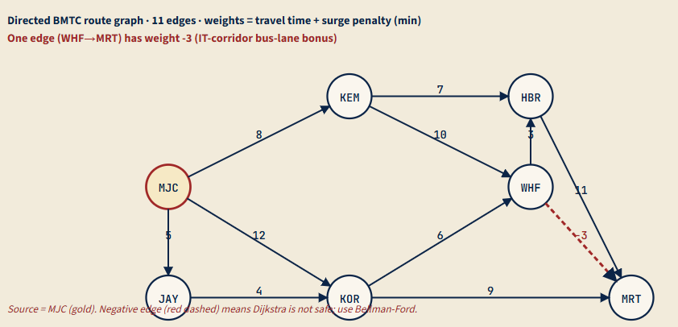
(a) | Run Dijkstra from MJC anyway (treating the -3 edge as 0 for now), and produce the shortest-distance table. Then identify which destination's distance Dijkstra would incorrectly compute when the negative edge is present. Explain in 2-3 sentences why Dijkstra fails on graphs with negative-weight edges (greedy-finalisation is unsafe).
(b) | Run Bellman-Ford from MJC on the actual graph (with the -3 edge) for V-1 = 6 iterations. Show the dist[] array after each iteration as a table (one row per iteration, one column per hub). State whether the algorithm converges before iteration 6 and what that signifies.
(c) | Complete the Java boilerplate below for Bellman-Ford with negative-cycle detection. After V-1 iterations, run one more relaxation pass: any edge that still relaxes indicates the existence of a negative cycle reachable from the source.
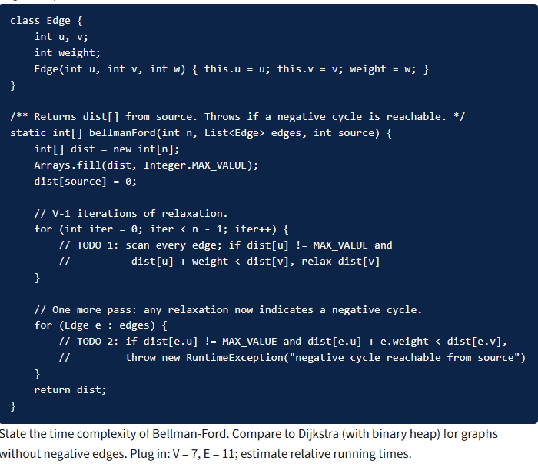
(d) Algorithm choice in the dispatcher's product code. The production dispatcher actually runs the routing 600 times/sec for different (source, destination) pairs. State the structural difference between (i) running Bellman-Ford 600 times from different sources, (ii) running Floyd-Warshall once to precompute all-pairs shortest paths and serving each query in O(1). For V=7, E=11, compute the operation count for each approach over a 1-minute window (36 000 queries).
Solution:
Work done Summary:
In this case study, we implemented the Bellman-Ford Algorithm to compute the shortest travel time from MJC (Majestic) to all other BMTC hubs during peak-hour traffic conditions.
The route network consists of seven hubs connected by directed edges representing travel times and surge-zone penalties. One route (WHF → MRT) contains a negative weight (-3 minutes), representing a dedicated bus-lane bonus that reduces overall travel time.
We first analyzed why Dijkstra's Algorithm is unsuitable for graphs containing negative-weight edges. We then applied Bellman-Ford to correctly compute shortest paths and detect whether any negative cycle exists in the network.
Implementation Details:
- Modeled the BMTC route network as a directed weighted graph with 7 hubs and 11 routes.
- Represented travel times and surge-zone penalties as edge weights.
- Included the negative-weight edge (WHF → MRT = -3) in the graph.
- Executed Dijkstra's Algorithm for comparison and identified its limitation with negative edges.
- Implemented Bellman-Ford and initialized the source hub (MJC) distance to 0.
- Performed V−1 (6) relaxation iterations across all edges.
- Updated shortest-path estimates whenever a better route was discovered.
- Executed one additional relaxation pass to check for negative-cycle existence.
- Generated the final shortest-distance table from MJC to every hub.
- Verified that the graph contains no reachable negative cycle, ensuring valid shortest-path results.

- Dijkstra trace from MJC (treating -3 as 0; we'll correct in (b)):
Step | Extract min | Distance | Relaxations
0 | — | MJC=0; rest=∞ | start
1 | MJC (0) | — | JAY=5, KEM=8, KOR=12
2 | JAY (5) | — | KOR=min(12, 5+4)=9
3 | KEM (8) | — | HBR=15, WHF=18
4 | KOR (9) | — | WHF=min(18, 9+6)=15, MRT=18
5 | HBR (15) | — | MRT=min(18, 15+11)=18 (no change)
6 | WHF (15) | — | HBR=min(15, 15+3)=15, MRT=min(18, 15+0)=15 (treating -3 as 0)
7 | MRT (15) | — | —
Dijkstra's distances (treating -3 as 0): {MJC=0, JAY=5, KEM=8, KOR=9, HBR=15, WHF=15, MRT=15}.
Which destination would Dijkstra get wrong with the actual -3 edge? MRT. With -3, the path MJC→KEM→WHF→MRT = 8+10−3 = 15 (no change), but the path MJC→KOR→WHF→MRT = 12+6−3 = 15 (also no change), and the path MJC→JAY→KOR→WHF→MRT = 5+4+6−3 = 12. So Dijkstra reports MRT=15 but the actual shortest is 12.
Why Dijkstra fails: Dijkstra is a greedy algorithm that finalises a node's distance the moment it's extracted from the priority queue, on the assumption that no later relaxation can decrease it. With negative-weight edges, this assumption breaks: a node finalised early can later have its distance decreased by a path that goes through a 'cheaper' route involving the negative edge. Greedy commitment ≠ optimal substructure when edges can subtract.
(b)
Bellman-Ford from MJC, V−1 = 6 iterations. All edges scanned each iteration:

Iter | MJC | KEM | JAY | KOR | WHF | HBR | MRT
0 | 0 | ∞ | ∞ | ∞ | ∞ | ∞ | ∞
1 | 0 | 8 | 5 | 9 | 15 | 15 | 18
2 | 0 | 8 | 5 | 9 | 15 | 15 | 12
3 | 0 | 8 | 5 | 9 | 15 | 15 | 12
4 | 0 | 8 | 5 | 9 | 15 | 15 | 12
Convergence at iteration 3 (no further changes). Iterations 4-6 produce no relaxations. Final shortest distances: {MJC=0, JAY=5, KEM=8, KOR=9, HBR=15, WHF=15, MRT=12}. The early convergence indicates the longest shortest-path uses ≤ 3 edges. Bellman-Ford's convergence-bound is V−1 = 6 worst case, but real graphs typically converge in O(diameter) iterations.
Verification of MRT = 12: path MJC→JAY (5) → KOR (4) → WHF (6) → MRT (-3) total = 5+4+6−3 = 12.
(c)
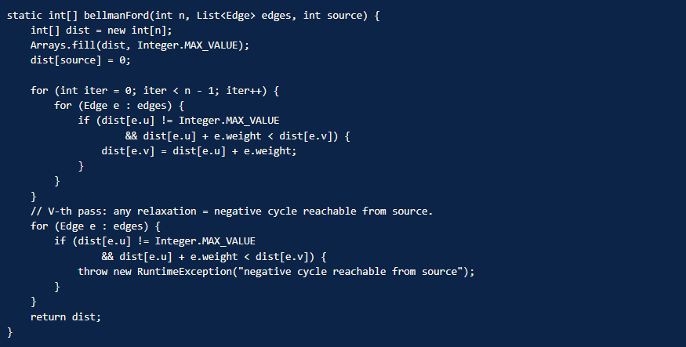
Time complexity: O(V × E). For V = 7, E = 11: (7−1) × 11 = 66 edge relaxations. Compare to Dijkstra with binary heap: O((V + E) log V) = (18) × log₂(7) ≈ 18 × 2.8 ≈ 51 operations. Bellman-Ford is ~30 % slower for this small graph, but it's the only choice when negative edges are present. For graphs without negative edges, always prefer Dijkstra.
(d)
(i) Bellman-Ford 600 times/sec from different sources.
Per-call cost: O(V × E) = 7 × 11 = 77 relaxations.
Per-second: 600 × 77 = 46 200 ops/sec.
Per-minute: 46 200 × 60 = 2.77 × 10⁶ ops/min.
(ii) Floyd-Warshall once + O(1) per query.
Floyd-Warshall preprocessing: O(V³) = 7³ = 343 operations, done once.
Per query (table lookup): O(1).
Per-minute total: 343 (preprocessing) + 36 000 queries × 1 op = ~36 343 ops/min.
Speedup: 2.77M / 36 343 ≈ 76× faster with Floyd-Warshall on this workload. The trade-off: O(V²) memory for the all-pairs distance matrix (49 cells here, trivial). For dispatcher's 600 queries/sec, Floyd-Warshall is the clear winner. It's also re-computed only when the graph itself changes (route additions, road closures), not per query.
Time Complexity:
- Bellman-Ford Shortest Path: O(V × E)
- Negative Cycle Detection: O(E)
- Space Complexity: O(V)

Git-hub link:

Student Signature Faculty Signature

