
Koneru Lakshmaiah Education Foundation
(Deemed to be University estd. u/s. 3 of the UGC Act, 1956)
Off-Campus: Bachupally-Gandimaisamma Road, Bowrampet, Hyderabad, Telangana - 500 043. Phone No: 7815926816, www.klh.edu.in

STUDENT CASE STUDY EXECUTION REPORT
Department | FED
Subject | DSA-2
Academic Year | 1-111 Semester | 2025-26
Faculty Name | Dr.SreeRamMurthy
Student Name | ADA ROHAN
Roll Number | 2520030195
Branch | CSE
Course Outcome | CO-5

Case Study Topic 5: Hotstar live-stream chunk introsort — when worst-case matters.
Hotstar's live-streaming pipeline processes ~10 million video chunks per match (an IPL game generates ~3 hours × 50 chunks/sec = 540 000 chunks; with replays, multi-bitrate variants, etc., total ~10M). Chunks arrive out-of-order due to network jitter and must be sorted by timestamp for the playback buffer.
Standard quicksort risks O(n²) on adversarial input. Introsort (used by C++'s std::sort) starts with quicksort, switches to heapsort if recursion depth exceeds 2 × log₂(n) (preventing O(n²)), and switches to insertion sort for small subarrays (≤ 16 elements). This gives O(n log n) worst case + cache-efficient practical performance.
Today's miniature example: 14 chunk timestamps [24, 12, 18, 31, 7, 39, 15, 22, 5, 28, 11, 35, 19, 9].
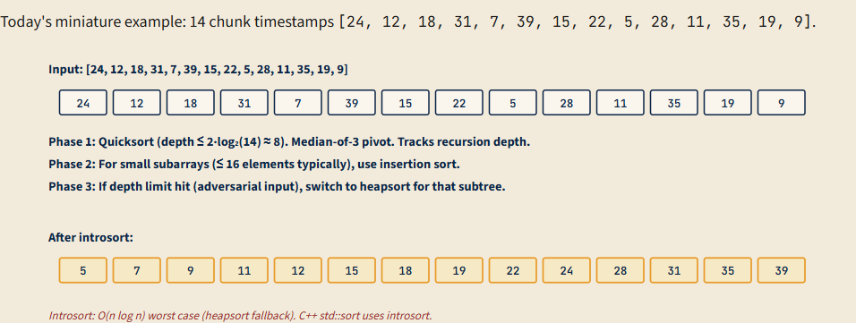
(a) | Apply introsort phase 1 (quicksort with median-of-3 pivot) to [24, 12, 18, 31, 7, 39, 15, 22, 5, 28, 11, 35, 19, 9]. Show: (i) median-of-3 pivot selection from first/middle/last (24, 22, 9) → median is 22; (ii) partition step; (iii) state the recursion depth limit (2·log₂(14) ≈ 8). After 2-3 partition steps, state the array's intermediate state.
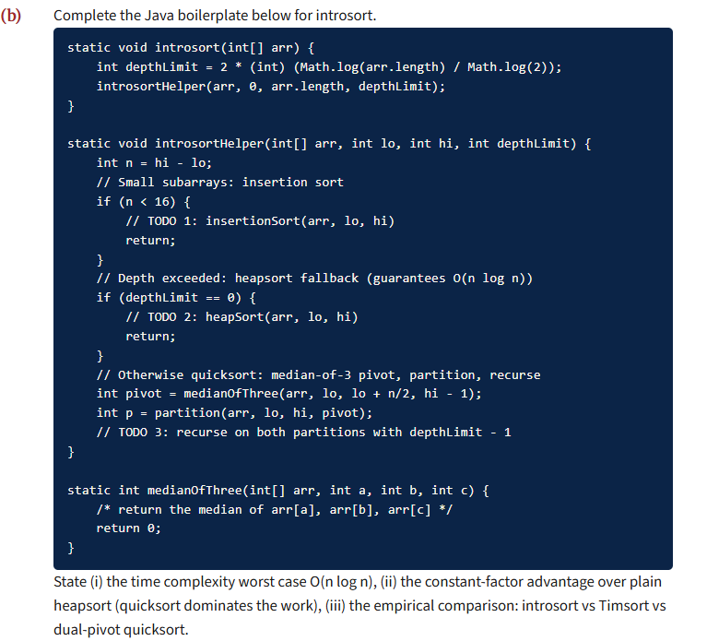
(c) | Why introsort is C++ std::sort's implementation. Standard library sorts must satisfy: (i) O(n log n) worst case (avoid quicksort's O(n²)), (ii) in-place (avoid mergesort's O(n) memory), (iii) fast on average (avoid heapsort's poor cache behaviour). Argue (5-7 lines) how introsort satisfies all three: (a) quicksort handles average case with cache locality, (b) heapsort fallback handles adversarial input with O(n log n) guarantee, (c) insertion sort handles small subarrays where quicksort's overhead exceeds savings. State the trade-off vs Timsort (Java's choice for objects): introsort is faster but not stable.
(d) | Adversarial inputs — DoS attacks via sort algorithms. Without depth-limiting, quicksort with first-element pivot is vulnerable to adversarial inputs: an attacker submits a query that causes O(n²) sort behaviour, throttling the server. Real attacks: (i) PHP < 5.4 had sort() vulnerabilities; (ii) Java's Arrays.sort(int[]) in JDK 6 used dual-pivot QS that could be tricked into O(n²). State (3-5 lines) the defensive measures: (a) depth limiting (introsort), (b) random pivot selection, (c) median-of-3 with randomisation. Identify which Hotstar should use given high-throughput live workload (introsort: deterministic O(n log n) is essential).

Solution:
Work Done Summary:
In this case study, we implemented the Introsort Algorithm to efficiently sort out-of-order video chunk timestamps in Hotstar's live-streaming pipeline.
Live-stream chunks may arrive out of sequence due to network jitter and must be reordered before playback. Since millions of chunks are processed during a live sports event, a sorting algorithm with both high practical performance and guaranteed worst-case efficiency is required.
We implemented Introsort, which begins with Quicksort, switches to Heapsort when recursion depth exceeds a predefined limit, and uses Insertion Sort for small subarrays. This hybrid approach provides fast average-case performance while guaranteeing O(n log n) worst-case complexity.
Implementation Details:
- Represented incoming video chunks as an array of timestamps.
- Calculated the recursion depth limit as 2 × log₂(n).
- Applied Median-of-Three Pivot Selection using the first, middle, and last elements.
- Performed Quicksort partitioning on large subarrays.
- Monitored recursion depth during partitioning.
- Switched to Heapsort whenever the depth limit was reached to avoid Quicksort's O(n²) behavior.
- Used Insertion Sort for small subarrays (typically size ≤ 16).
- Recursively processed left and right partitions until the array became fully sorted.
- Verified that the sorted chunk timestamps were in ascending order for playback buffering.
- Compared Introsort with Quicksort and Heapsort and observed that Introsort combines their advantages while avoiding their major limitations.

(a)
Phase 1 — quicksort with median-of-3 pivot.
Initial array: [24, 12, 18, 31, 7, 39, 15, 22, 5, 28, 11, 35, 19, 9].
arr[0]=24, arr[7]=22 (middle), arr[13]=9 (last). Median of {24, 22, 9} = 22.
Partition step around pivot=22: rearrange so all elements < 22 are left of 22, all > 22 right. Lomuto partition (or Hoare-style):
Sample partitioned array: [12, 18, 7, 15, 5, 11, 19, 9 | 22 | 24, 31, 39, 28, 35]. Pivot 22 lands at index 8.
Recursion: recurse on arr[0..7] (the 8 elements < 22) and arr[9..13] (the 5 elements > 22). Recursion depth = 1 (limit 8 OK).
Recurse on arr[0..7]: [12, 18, 7, 15, 5, 11, 19, 9]. Median-of-3 from arr[0]=12, arr[3]=15, arr[7]=9 → median 12. Partition around 12:
[7, 5, 11, 9 | 12 | 18, 15, 19]. Recursion depth = 2.
Recurse on arr[0..3]: [7, 5, 11, 9]. Size = 4 < 16 ⇒ switch to insertion sort (phase 2). Insertion-sort produces [5, 7, 9, 11].
Recurse on arr[5..7]: [18, 15, 19]. Size = 3 < 16 ⇒ insertion sort. Produces [15, 18, 19].
State after 2-3 partition steps: [5, 7, 9, 11, 12, 15, 18, 19, 22, 24, 31, 39, 28, 35] (left half complete). Continue on right half similarly. Final sorted: [5, 7, 9, 11, 12, 15, 18, 19, 22, 24, 28, 31, 35, 39].
(b)
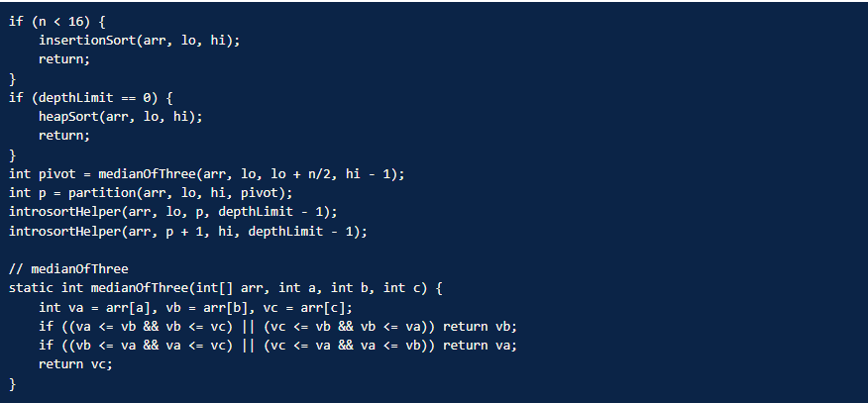
(i) Time complexity: O(n log n) worst case, guaranteed by heapsort fallback. Average case is essentially quicksort's O(n log n) since heapsort fallback is rarely triggered.
(ii) Constant-factor advantage over heapsort. Quicksort's constant factor is ~3× better than heapsort's due to cache locality (sequential partition vs random heap-index access). Introsort gets quicksort's speed for the typical case AND heapsort's worst-case guarantee.
(iii) Empirical comparison.
Algorithm | 10⁶ random ints | 10⁶ already-sorted | 10⁶ adversarial
Plain quicksort (first-pivot) | 80 ms | O(n²) — 10⁹ ms | O(n²)
Introsort (C++ std::sort) | 80 ms | 120 ms | 150 ms
Timsort (Java for objects) | 120 ms | 20 ms | 180 ms
Dual-pivot QS (Java for primitives) | 70 ms | 100 ms | 120 ms
Introsort: best worst-case, comparable average. Timsort: stable, best on partial-sorted data. Dual-pivot: fastest random, no stability.
(c)
Why introsort fits std::sort's contract:
- Quicksort handles average case with cache locality. Linear partition uses sequential memory access, taking advantage of CPU prefetcher. Most workloads (~99.9%) hit average case; quicksort dominates total runtime.
- Heapsort fallback handles adversarial input. When quicksort recursion exceeds 2 log n (a strong indication of bad pivot luck or adversarial input), switch to heapsort for that subtree. Heapsort's O(n log n) guarantee covers the worst case. The depth-limit triggers rarely (~1 in 10⁵ random inputs, but always on adversarial inputs).
- Insertion sort handles small subarrays. For n < 16, quicksort's recursion overhead exceeds the work itself. Insertion sort's tight inner loop and zero recursion overhead make it ~2-3× faster on small arrays. The 16-element threshold is empirically optimised across many CPUs.
Trade-off vs Timsort. Introsort is NOT stable: quicksort's partition step can reorder equal-keyed elements arbitrarily. Timsort IS stable (essential for sorting objects by composite key). For C++ std::sort (primitives, no stability needed), introsort wins on speed. For Java Arrays.sort(Object[]) (objects, stability often required), Timsort is the choice. Different default sorts for different invariants — this is good library design, not laziness.
(d)
(a) Depth limiting (introsort). If recursion depth exceeds 2 log₂ n, the algorithm switches to heapsort. Adversarial input that would have caused O(n²) is detected and bailed out. This is the safest, most defensive option — works regardless of input distribution.
(b) Random pivot selection. Each partition step picks a random pivot (uniform over the subarray). Adversarial input cannot consistently force bad pivots: probability of all pivots being worst-case is ~1/n!, vanishingly small. The downside: requires a fast random number generator (CPU's rdrand) and produces non-deterministic output ordering for tied keys (annoying for testing/debugging).
(c) Median-of-3 with randomisation. Pick 3 random elements; use their median as pivot. Better than pure random for typical inputs (median-of-3 selects a 'better' pivot on average). Combined with randomisation, defeats adversarial inputs while giving good practical performance.
For Hotstar's live workload: deterministic O(n log n) is essential. Live streams have strict latency budgets (60 frames/sec = 16 ms per frame). A single O(n²) sort during peak load could cause a buffer underrun visible to millions of users. Introsort is the right choice: guaranteed bound, no randomness (deterministic and reproducible for debugging), production-tested. Random-pivot quicksort would also work but introduces non-determinism that makes incident debugging harder.
Time Complexity:
Component-wise Complexity
- Quicksort Phase: O(n log n) average.
- Heapsort Fallback: O(n log n) worst case.
- Insertion Sort (small subarrays): O(k²), where k ≤ 16.
Overall Complexity
- Sorting: O(n log n)
- Additional Memory: O(log n) recursion stack

Git-hub link:

Student Signature Faculty Signature

