|  |  |
| --- | --- |
| **Project Case** |  |
| COMP6144  Web Programming |
| **Computer Science** | **O202-COMP6144-TD01-00** |
| ***Valid on*** *Odd Semester Year 2019/2020* | **Revision 00** |

1. Seluruh kelompok tidak diperkenankan untuk:

*The whole group is not allowed to:*

* + - Melihat sebagian atau seluruh proyek kelompok lain,

*Seeing a part or the whole project from other groups*

* + - Menyadur sebagian maupun seluruh proyek dari buku,

*Adapted a part or the whole project from the figure*

* + - Mendownload sebagian maupun seluruh proyek dari internet,

*Downloading a part or the whole project from the internet,*

* + - Mengerjakan soal yang tidak sesuai dengan tema yang ada di soal proyek,

*Working with another theme which is not in accordance with the existing theme in the matter of the project,*

* + - Melakukan tindakan kecurangan lainnya,

*Committing other dishonest actions,*

* + - Secara sengaja maupun tidak sengaja melakukan segala tindakan kelalaian yang menyebabkan hasil karyanya berhasil dicontek oleh orang lain / kelompok lain.

*Accidentally or intentionally conduct any failure action that cause the results of the project was copied by someone else / other groups.*

1. Jika kelompok terbukti melakukan tindakan seperti yang dijelaskan butir 1 di atas, maka **nilai kelompok** yang melakukan kecurangan (menyontek maupun dicontek) akan di – **NOL** – kan.

*If the group is proved to the actions described in point 1 above, the score of the group which committed dishonest acts (cheating or being cheated) will be “Zero”*

1. Perhatikan jadwal pengumpulan proyek, segala jenis pengumpulan proyek di luar jadwal tidak dilayani.

*Pay attention to the submission schedule for the project, all kinds of submission outside the project schedule will not be accepted*

1. Jangan lupa untuk melihat kriteria penilaian proyek yang ditempel di papan pengumuman, atau tanya asisten anda.

*Don’t forget to look at the project assessment criteria that posted on the announcement board, or ask your teaching assistant.*

1. Persentase penilaiaan untuk matakuliah ini adalah sebagai berikut:

*Marking percentage for this subject is described as follows:*

|  |  |  |
| --- | --- | --- |
| **Tugas Mandiri**  *Assignment* | **Proyek**  *Project* | **UAP**  *Final Exam* |
| - | 100% | - |

1. Software yang digunakan pada matakuliah ini adalah sebagai berikut:

*Software will be used in this subject are described as follows:*

|  |
| --- |
| **Software**  *Software* |
| PHP Composer  PHP Storm 2019.1  Laravel Framework 5.8  XAMPP 3.23 (Apache, PHP >= 7, MySQL)  Firefox / Chrome |

## Ekstensi file yang harus disertakan dalam pengumpulan tugas mandiri dan proyek untuk matakuliah ini adalah sebagai berikut:

*File extensions should be included in assignment and project collection for this subject are described as follows:*

|  |  |
| --- | --- |
| **Tugas Mandiri**  *Assignment* | **Proyek**  *Project* |
| - | Folder Project (PHP, SQL, Image Files (JPG / PNG), ENV, HTML, CSS, SCSS, JS, JSON, HTACCESS, ARTISAN) |

## Soal

*Case*

General Provisions:

* Use **MySQL** asdatabase and **Laravel Migration** features
* **All file upload** feature such as image and document must be **stored to server storage**
* Use PHP Framework **Laravel 5.8** to build the project
* Use Laravel **MVC** concept (**Model**, **View**, **Controller**) to build the project
* Use **Eloquent Query / Query Builder** to work with database
* You are free to design your own database table **based on given requirements**
* Print screen given below is only an example. You are free to create your own user interfaces
* It is **prohibited** to install any kind of Laravel packages. You must use fresh installation of **Laravel 5.8**
* Only **validation** in the **backend** (using Laravel) will be graded

**Online Florist**

**Online Florist** is a famous flower shop in Indonesia. To expand its business, **Online Florist** wants to create a website for their store. In that website, user can find information about the **Flower shop** flower and order it. This website enables the customers to know what kind of flowers **Online Florist** are selling.

As a web developer, you are asked to create a website using **Laravel** **5.8** for this online flower shop. There are two types of user’s role in this website: **Admin** and **Member**.

Each page shows **greeting to user**, and **current** **date** **time**. The descriptions for each page are:

1. Login Page

This page is accessible only to **guest**. This page allows user to log in to the website. Display an **error message** on the login page if user enters wrong combination of **Email** and **Password**.

If user has entered correct **Email** and **Password**, redirect user to the Home Page based on the user’s role. If user checks the “**Remember Me**” checkbox, the website will save the **Email** and **Password** using cookies for **1 hour**.

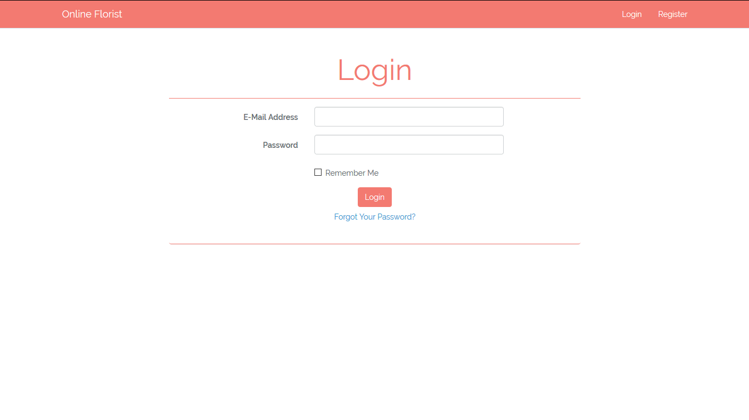

***Figure 1. Login Page***

1. Register Page

This page is accessible only to **guest**. This page allows guests to **register** themselves as **Online Florist** member. Display an **error message** if user input incorrect personal data.

The following table shows the existing fields on this page and the validation for each field:

|  |  |
| --- | --- |
| **Field** | **Information** |
| **Email** | Must be filled with **email** and **unique** |
| **Name** | Must be filled with **string** |
| **Password** | Must be filled with **alpha dash** and at least **5 characters length** |
| **Confirm Password** | Must be filled and **same with password** |
| **Phone** | Must be filled in **integer format** with **minimum 8 characters and maximum 12 characters** |
| **Gender** | Must be selected in **male** or **female** |
| **Address** | Must be filled and **minimum 10 characters** |
| **Profile Picture** | Must be selected and must match one of the **allowed MIME types** (**jpeg, png, jpg**) |

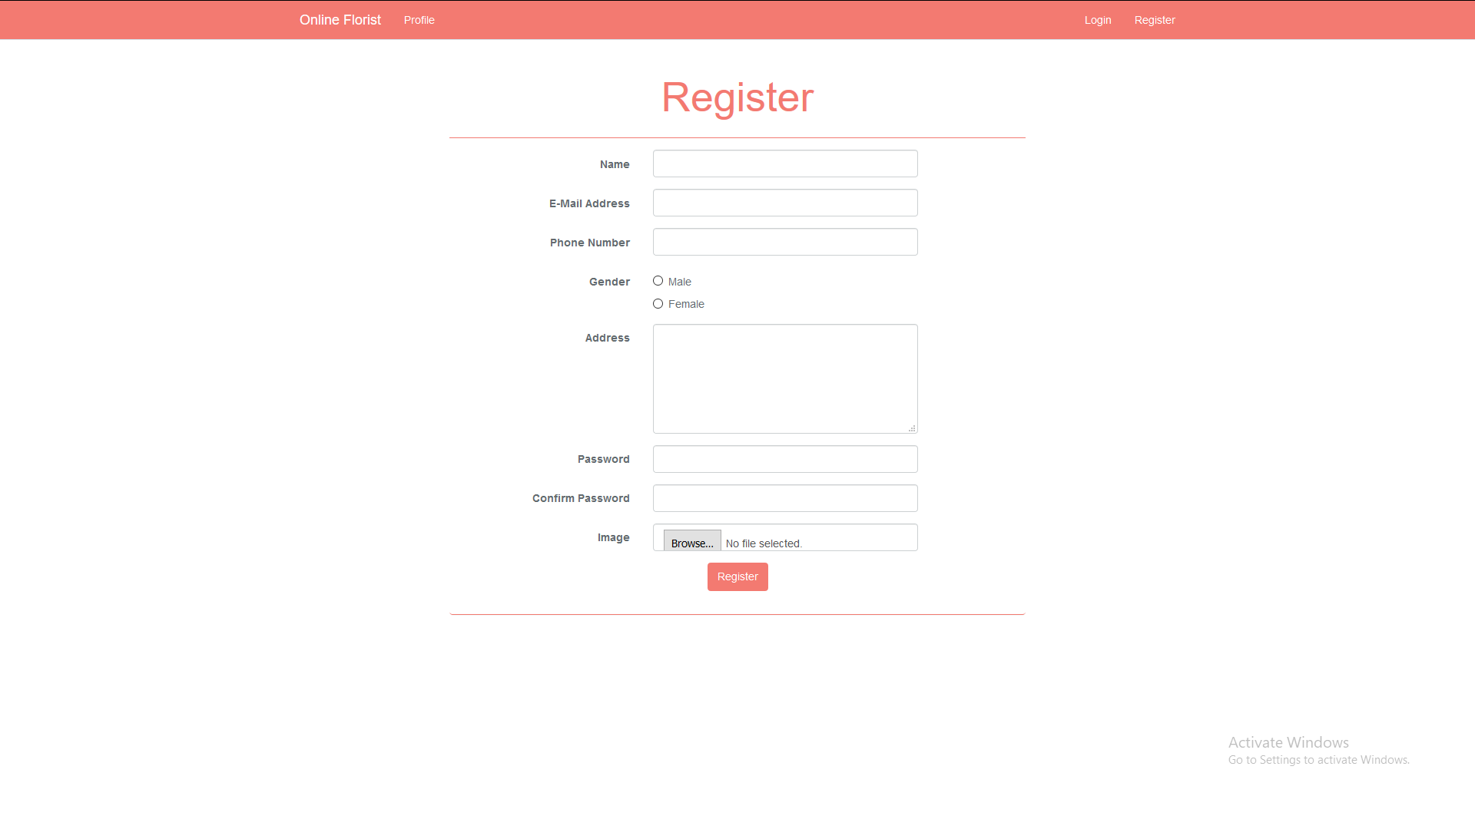

***Figure 2. Register Page***

1. Home Page

This page is accessible to all users. This page allows user to see all **Online Florist’s flowers information**. This page allows user to **search flower by** **name or description**. Flowers information is displayed using **pagination** with **10 flowers for each page**.

In this page, there is an **Order** button. If **user** click **Order** button, then **insert** selected flower **to member’s cart with quantity of 1**. If the flower has already existed in member’s cart, then increase cart’s flower quantity by one.

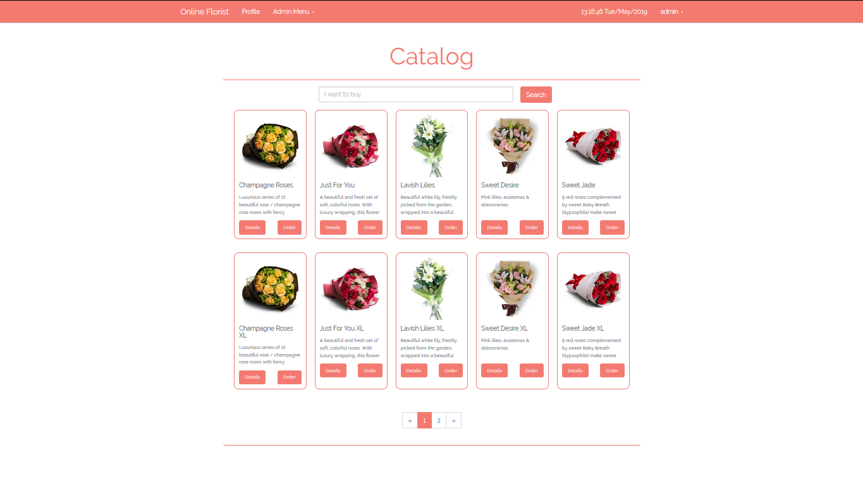

***Figure 3. Home Page***

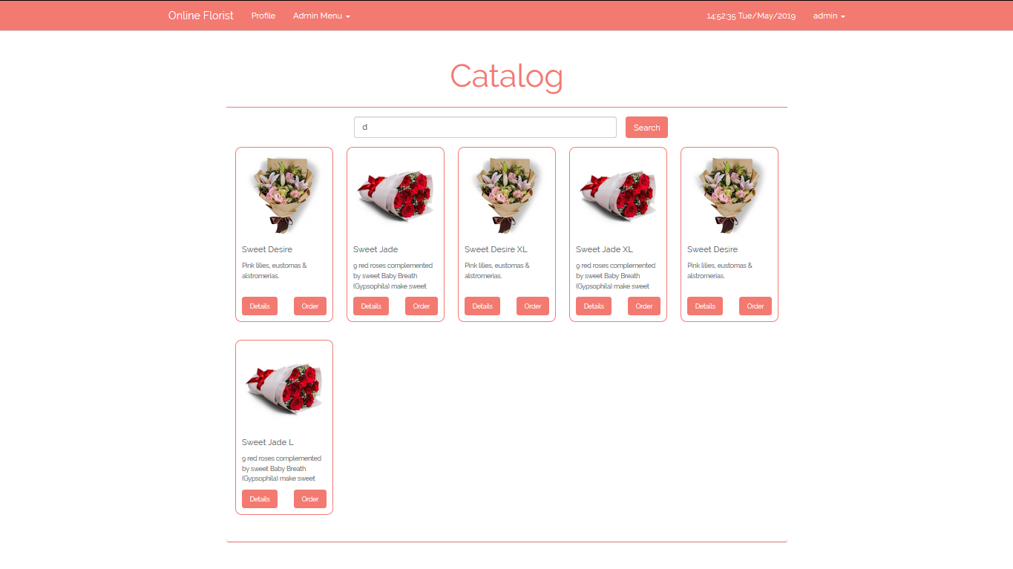

***Figure 4. Searching flower with “d” keyword***

1. Flower Details Page

This page is accessible for **all users**. If user click the **Details button** in homepage, redirect user to this details page. This page displays all the **flower details** such as **flower’s name, flower’s description, flower’s price,** and **flower’s stock**. User could fill the **quantity** number before adding the item to cart. Validate that quantity must be **more than 0**.

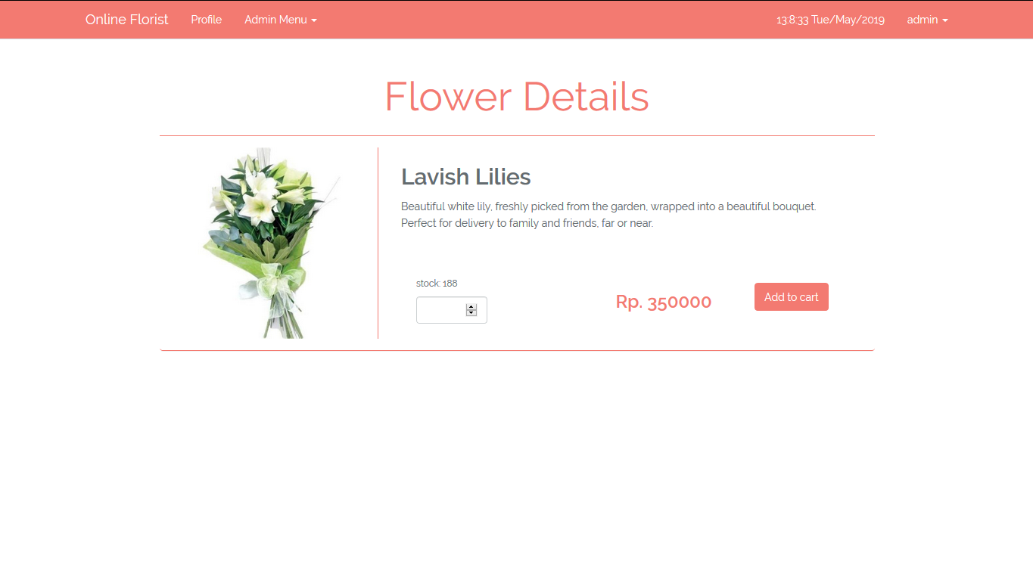

***Figure 4. Flower Details***

1. Cart Page

This page is accessible to all users. This page displays all flowers that have been added into user’s shopping cart. Display cart information such as f**lower’s picture**, **flower’s name**, **flower’s quantity**, **flower’s** **price**, **shipping method**,and **total price**.

There are two buttons in this page, **Remove** button for each flower on cart and **Checkout** button. If **users** click **Remove** button, then **remove selected flower** from the **cart**, and if **users** click **Checkout** button, then **all shopping cart** **data** will be **deleted** and **insert** current transaction data into user’s **transaction history**, then redirect user to home page.

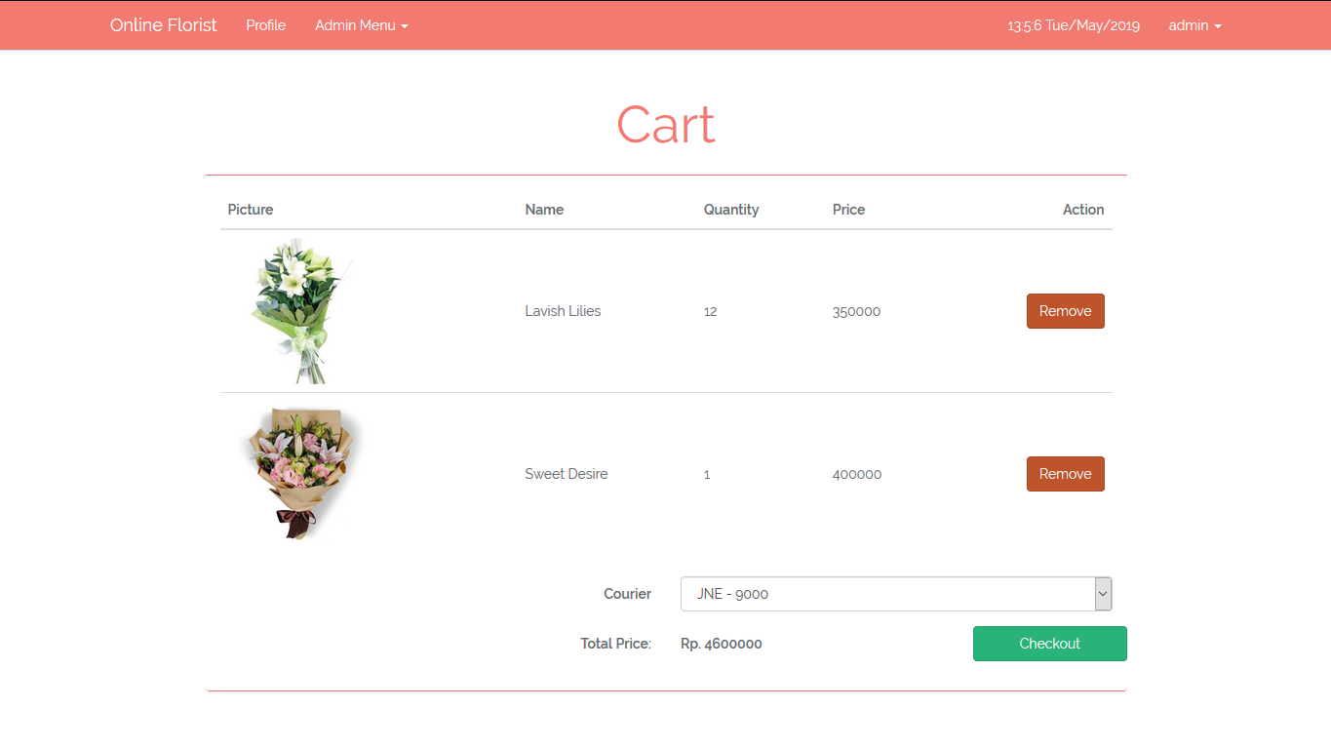

***Figure 5. Cart Page***

1. Manage Flowers

This page is accessible only to admin. This page allows **admin** to **insert**, **update** and **delete** the flower. This page will be shown if **admin** clicks **Manage Flowers** button in **Admin Menu** at header section. Flower list is displayed using **paging** with **10 flowers for each page**.

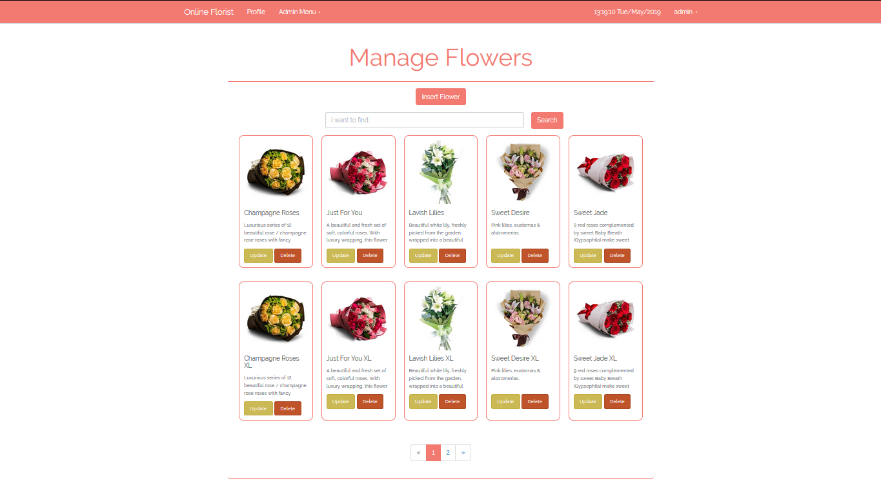

***Figure 6. Manage Flowers Page***

If **admin** click **Insert New Flower** button, redirect admin to **Insert Flower page**. **Admin** can fill the **Insert Flower Form** and click **Insert** button to insert new flower data into database. Display **an** **error message** if **admin** input incorrect flower data on **Insert Flower Form**.

The following table shows existing fields in the **Insert Flower Form** and the validation for each field:

|  |  |
| --- | --- |
| **Field** | **Information** |
| **Name** | Must be filled with **at least 3 characters length** |
| **Type** | Must be **selected** |
| **Price** | Must be filled, **numeric**, and **at least 10000** |
| **Description** | Must be filled **between 20- and 200-characters length** |
| **Stock** | Must be filled, **numeric**,and **more than 0** |
| **Image** | Must be selected and must match one of the **allowed MIME types (jpeg, png, jpg)** |

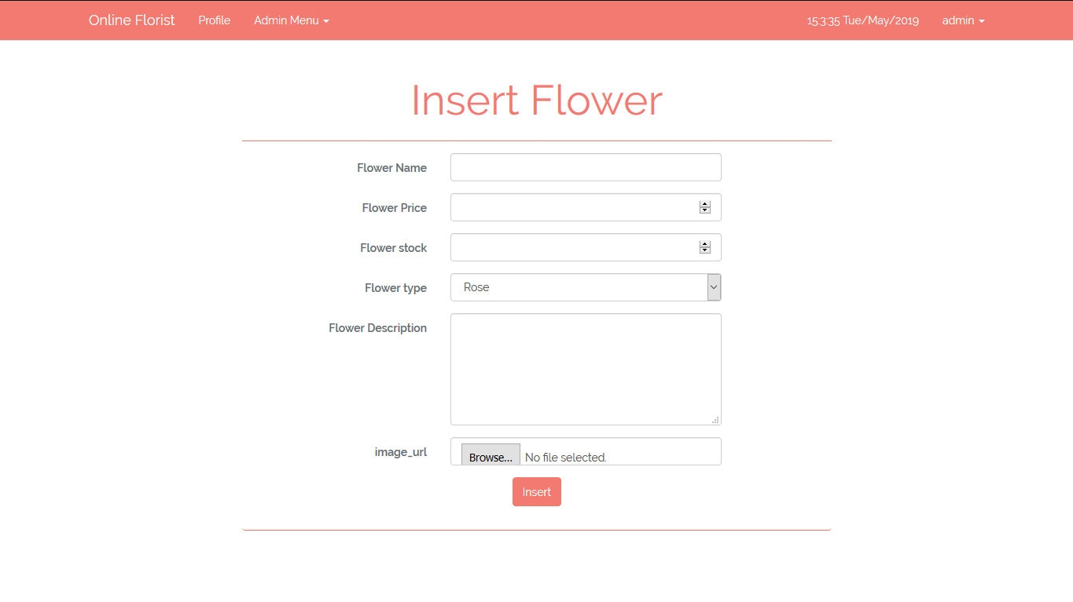

***Figure 7. Insert New Flower Page***

Each flower in the lists have ‘**Update**’ and ‘**Delete**’ buttons:

* If **admin** click **Update** button, redirect admin to **Update Flower** page
* If **admin** click **Delete** button, **delete** selected flower

1. Update Flower Page

This page is accessible only to admin. This page allows **admin** to update existing flower. This page will be shown if **admin** clicks **Update Flower** button in **Manage** **Flower** page. Display **an** **error message** if **admin** input incorrect flower data.

The following table shows existing fields in the page and the validation for each field:

|  |  |
| --- | --- |
| **Field** | **Information** |
| **Name** | Must be filled with **at least 3 characters length** |
| **Type** | Must be **selected** |
| **Price** | Must be filled, **numeric**, and **at least 10000** |
| **Description** | Must be filled **between 20- and 200-characters length** |
| **Stock** | Must be filled, **numeric**,and **more than 0** |
| **Image** | Must be selected and must match one of the **allowed MIME types (jpeg, png, jpg)** |

If admin click **Update** button, then update current selected flower with updated data. After that, redirect admin to **Manage Flower** page.

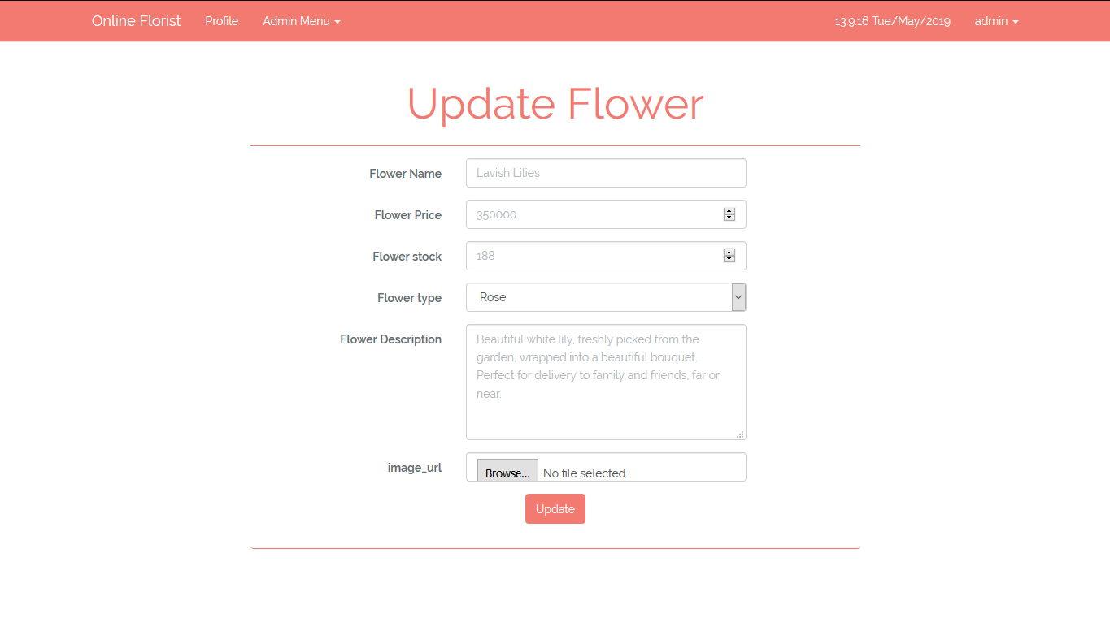

***Figure 8. Update Flower Page***

1. Manage Flower Types

This page is accessible only to admin. This page allows **admin** to **insert**, **update**, and **delete** flower genres. Flower Type list are displayed using **Pagination** with **10** types for each page

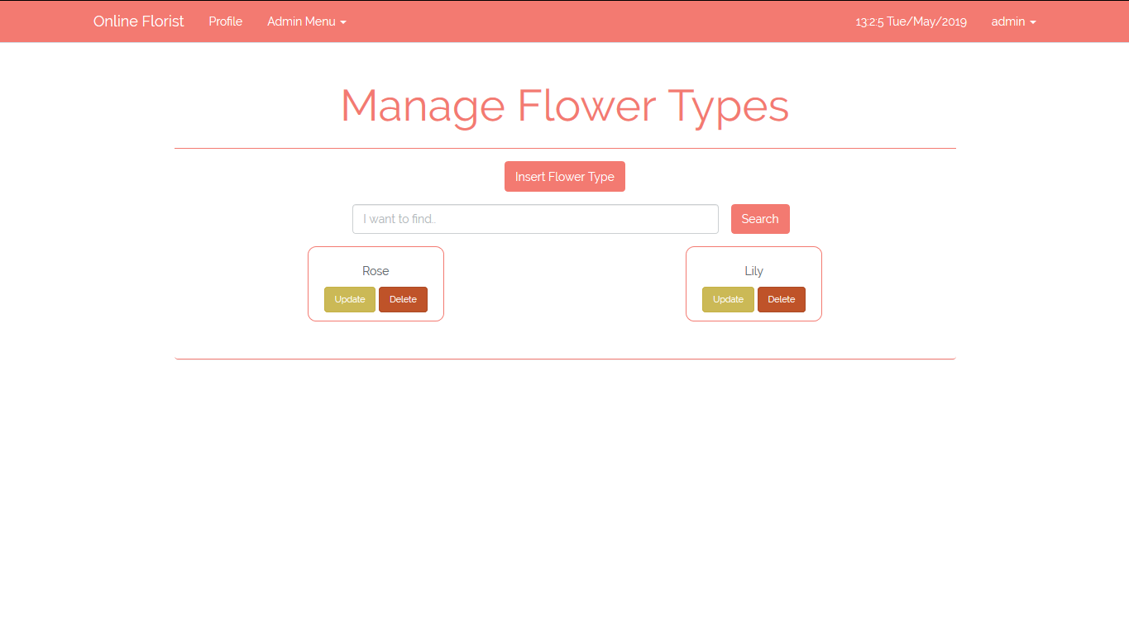

***Figure 9. Manage Flower Types***

If **admin** click **Insert New Flower Type** button, redirect user to **Insert Flower Type** page. **Admin** can fill the **Insert Type Form** and click **Insert** button to insert new type data into database. Display **error message** if **admin** input incorrect flower type data on **Insert Flower Type Form**.

The following table shows existing fields in the **Insert Flower Type Form** and the validation for each field:

|  |  |
| --- | --- |
| **Field** | **Information** |
| **Type Name** | Must be filled, **unique**, and **minimum 4 characters length** |

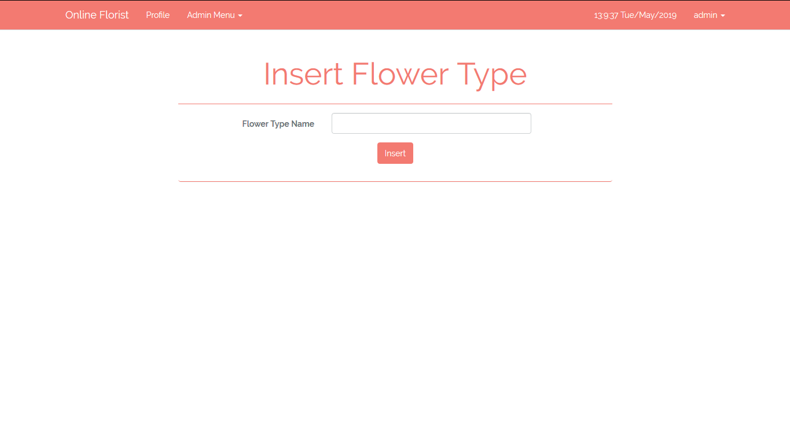

***Figure 10. Insert Flower Type Page***

Each genre in the lists have ‘**Update**’and ‘**Delete**’buttons:

* If **admin** click **Update** button, redirect admin to **Update Genre** page
* If **admin** click **Delete** button, **delete** selected genre

1. Update Flower Type Page

This page is accessible only to admin. This page allows **admin** to update existing flower’s type. This page will be shown if **admin** clicks **Update Type** button in **Manage** **Type** page. Display **error message** if **admin** input incorrect type data.

The following table shows existing fields in the page and the validation for each field:

|  |  |
| --- | --- |
| **Field** | **Information** |
| **Type Name** | Must be filled, **unique**, and **minimum 4 characters length** |

If admin click **Update** button, then update current selected type with updated data. After that, redirect admin to **Manage Flower Type** page.

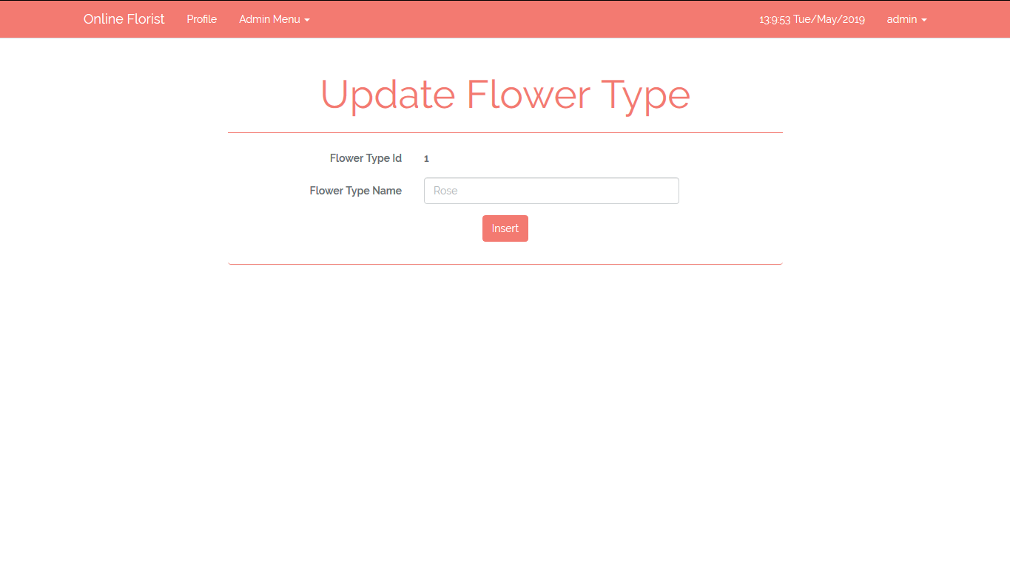

***Figure 11. Update Flower Type Page***

1. Manage Couriers Page

This page is accessible only to admin. This page allows **admin** to **insert**, **update**, and **delete** flower couriers. Courier list are displayed using **pagination** with **10** Couriers for each page.

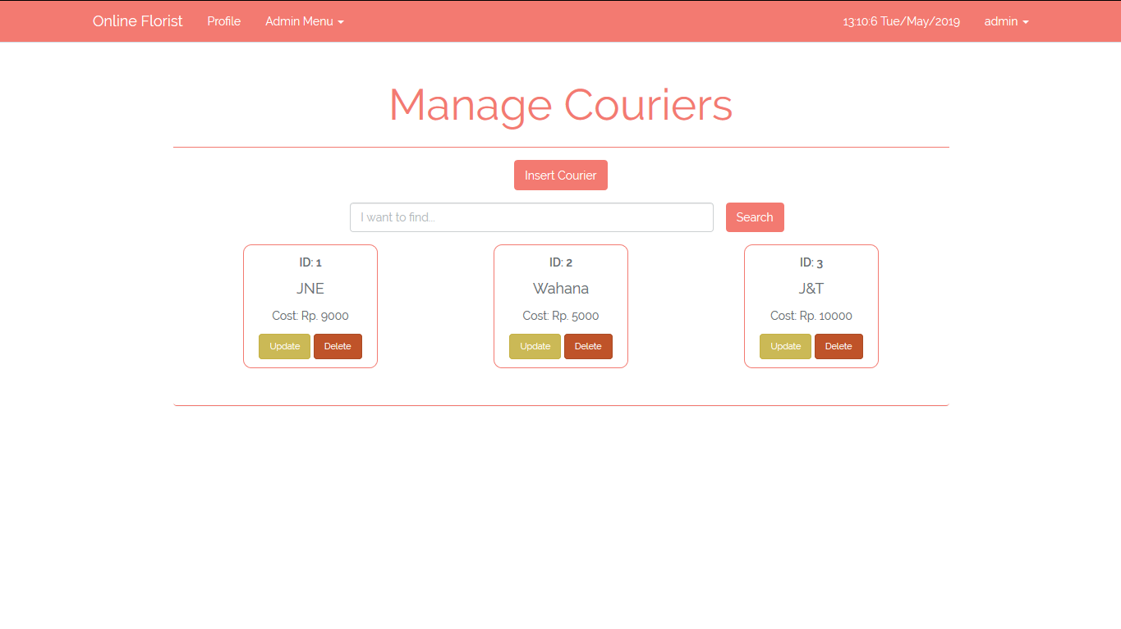

***Figure 12. Manage Couriers***

If **admin** click **Insert New Courier** button, redirect user to **Insert Courier** page. **Admin** can fill the **Insert Courier Form** and click **Insert** button to insert new courier data into database. Display **error message** if **admin** input incorrect courier data on **Insert Courier Form**.

The following table shows existing fields in the **Insert Courier Form** and the validation for each field:

|  |  |
| --- | --- |
| **Field** | **Information** |
| **Courier Name** | Must be filled with **at least 3 characters length** |
| **Shipping Cost** | Must be filled, **numeric**, and **at least 3000** |

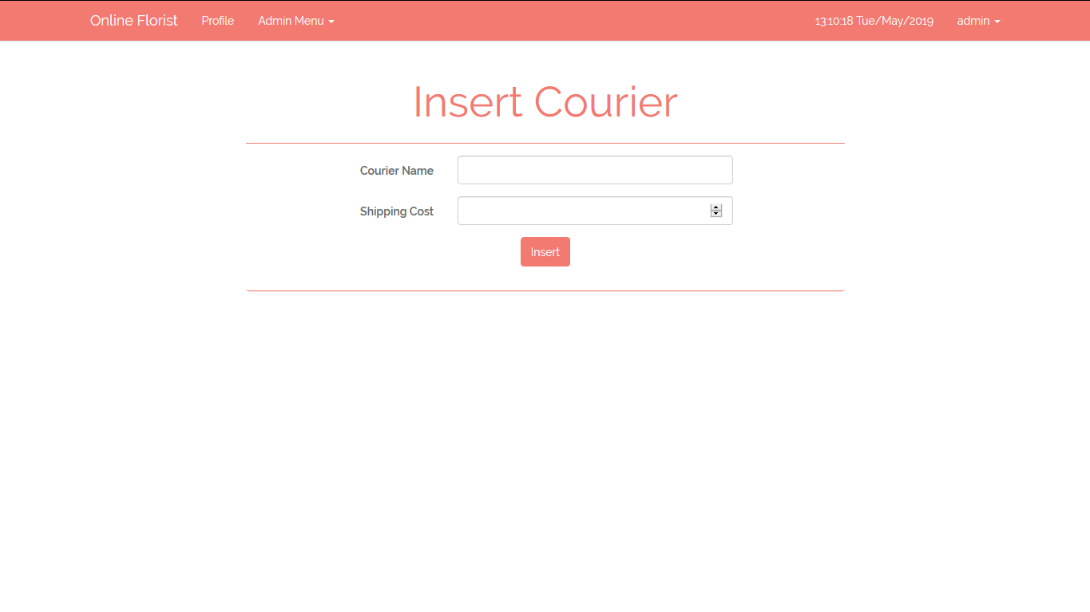

***Figure 13. Insert Courier***

Each author in the lists have ‘**Update**’and ‘**Delete**’ buttons:

* If **admin** click **Update** button, redirect admin to **Update Courier** page
* If **admin** click **Delete** button, **delete** selected Courier

1. Update Courier Page

This page is accessible only to admin. This page allows **admin** to update existing Courier. This page will be shown if **admin** clicks **Update Courier** button in **Manage** **Courier** page. Display **error message** if **admin** input incorrect courier data.

The following table shows existing fields in the page and the validation for each field:

|  |  |
| --- | --- |
| **Field** | **Information** |
| **Courier Name** | Must be filled with **at least 3 characters length** |
| **Shipping Cost** | Must be filled, **numeric**, and **at least 3000** |

If admin click **Update** button, then update current selected Courier with updated data. After that, redirect admin to **Manage Courier** page.

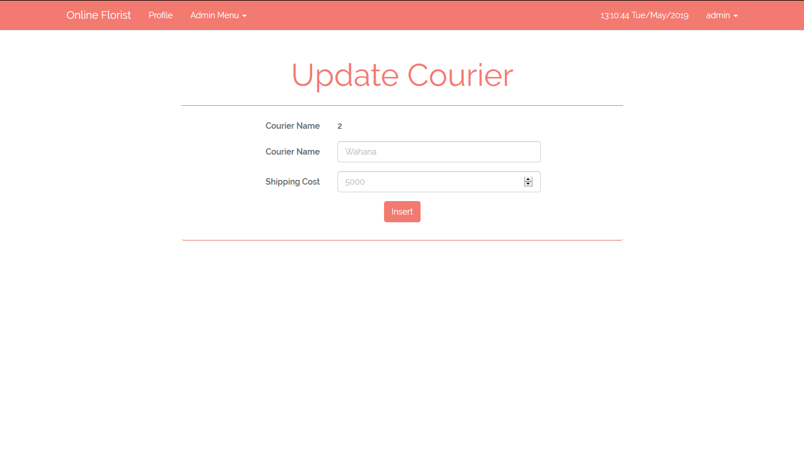

***Figure 14. Update Courier***

1. Profile Page

This page is accessible only to **admin** and **member**. This page allows **admin** and **member** to **view** and **update** their personal data. Display **error message** if **admin** or **member** input incorrect personal data.

The following table shows existing fields in this page and the validation for each field:

|  |  |
| --- | --- |
| **Field** | **Information** |
| **Email** | Must be filled with **email** and **unique** |
| **Name** | Must be filled with **string format** |
| **Phone** | Must be filled in **integer format** with **minimum 8 characters and maximum 12 characters** |
| **Gender** | Must be selected in **male** or **female** |
| **Address** | Must be filled and **minimum 10 characters** |
| **Profile Picture** | Must be selected and must match one of the **allowed MIME types** (**jpeg, png, jpg**) |

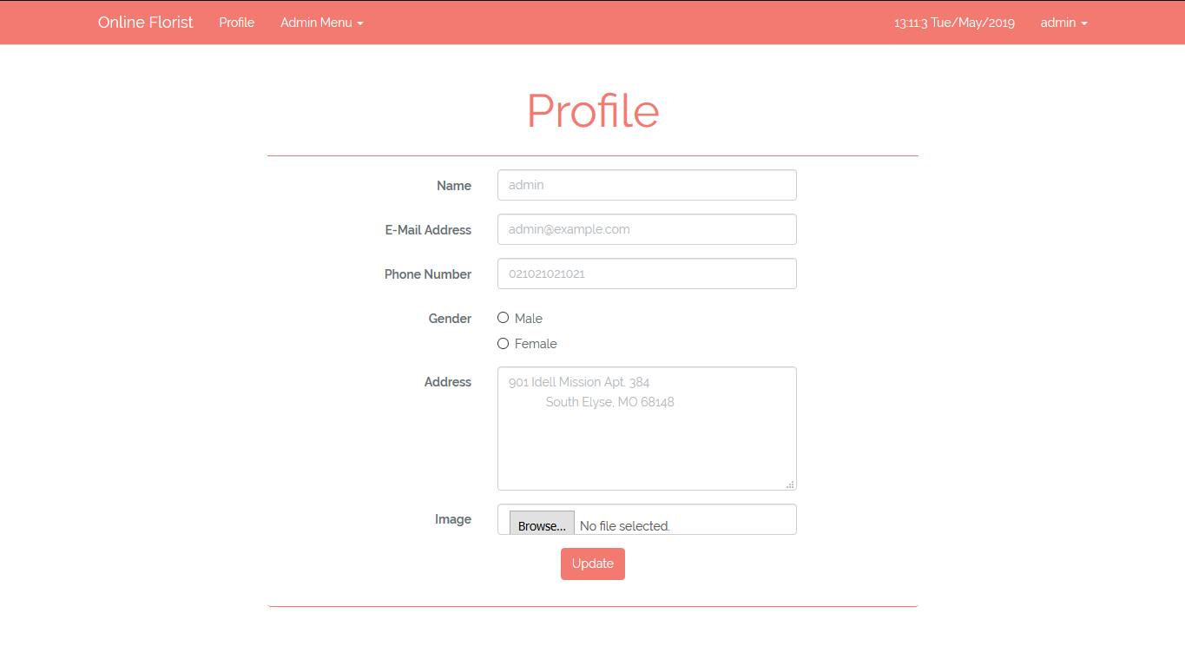

***Figure 15. Profile Page***

1. Manage Users

This page is accessible only to **admin**. This page allows **admin** to **update** and **delete** users that already registered in **Online Florist**.

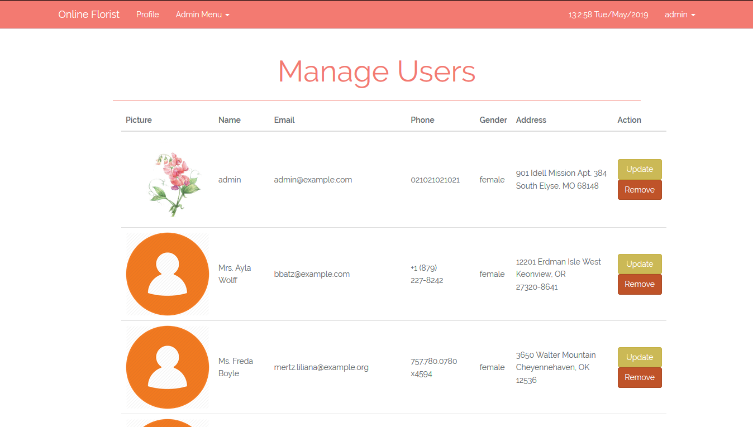

***Figure 16. Manage Users Page***

Each user in the lists have ‘**Update**’and ‘**Remove**’buttons:

* If **admin** click **Update** button, redirect user to **Update User** page
* If **admin** click **Remove** button, **delete** selected user

1. Update Users Page

This page is accessible only to admin. This page allows **admin** to update existing user. This section will be shown if **admin** clicks **Update** button in **Manage** **Users** page. Display **error message** if **admin** input incorrect user’s data.

The following table shows existing fields in the page and the validation for each field:

|  |  |
| --- | --- |
| **Field** | **Information** |
| **Email** | Must be filled with **email** and **unique** |
| **Name** | Must be filled with **string format** |
| **Phone** | Must be filled in **integer format** with **minimum 8 characters and maximum 12 characters** |
| **Gender** | Must be selected in **male** or **female** |
| **Address** | Must be filled and **minimum 10 characters** |
| **Profile Picture** | Must be selected and must match one of the **allowed MIME types** (**jpeg, png, jpg**) |

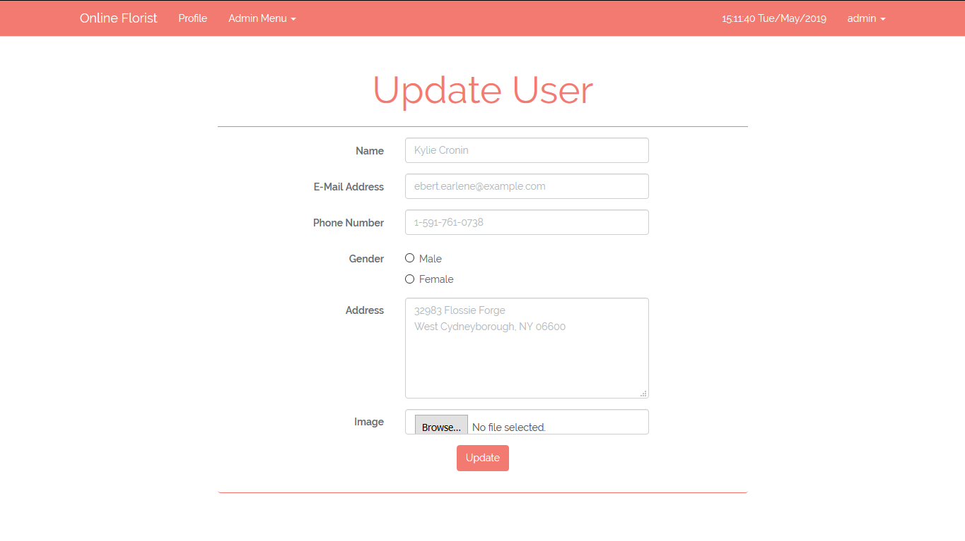

***Figure 17. Update User Page***

1. Transaction History

This page is only accessible for **admin** to show all transaction history. The information of transaction that must be shown are **transaction id, transaction date, member’s name, courier, flower’s picture**, **flower’s name**, **flower’s quantity**, **flower’s price**, and **total price**.

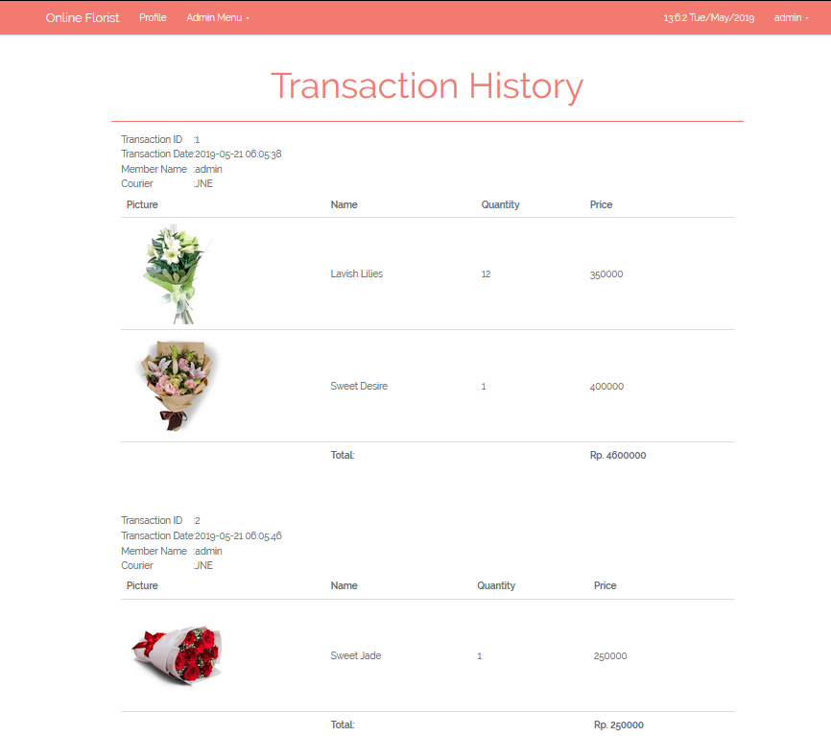

***Figure 18. Transaction History Page***

Here are the rules that you must follow to create your project:

1. Use appropriate software for this subject based on **Sistem Praktikum** that can be downloaded from Binusmaya.
2. Collect appropriate files for this subject based on **Sistem Praktikum** that can be downloaded from Binusmaya.
3. Include the other files that can support your project, such as:
   * All files in your project
   * Other files (image, audio, video, etc.) used in your project
   * *.DOC file (documentation of your project) that contains all pages in your project, reference links of additional files (image, audio, video, etc.) used in your project, the description about how to use your application, etc.
4. If there are some hidden creativities, please note them in the existing documentation because they can greatly affect your project score