|  |  |  |
| --- | --- | --- |
| Description: Cisco Corporate Logo | Document Number | EDCS-1019795 |
| Owner | Patricia Rivera |
| Next Review Date | October 1, 2018 |
|  |  |
|  |  |
| TAC Collaboration Process | | | |

Table of Contents

1 Purpose 4

2 Scope 4

3 Customer Data Protection 4

4 Overview 4

5 Collaboration Roles 5

6 Collaboration Process Flow 8

7 TAC Collaboration Process 8

7.1 CSE CaseMon Log In 9

7.2 Manager/Proxy CaseMon Log In 9

7.3 Collaboration Accept or Decline 10

7.4 Initial Engagement Assessment 10

7.5 “Sneaker-Net” Collaboration (Local Collaboration) 10

7.6 General Collaboration Involving CSEs (Skills Finder) 11

7.7 Urgent Collaboration Requests 12

7.8 Post to Tech Zone Non-Urgent Collaboration 13

7.9 Manage Collaboration Status 14

7.10 Change of Ownership 14

7.11 Internal Collaboration Evaluation 17

7.12 Content of Collaboration (Documentation of collaboration work) 17

7.13 CSE CaseMon Log Out 18

7.14 Manager/Proxy CaseMon Log Out 18

8 Process Compliance 18

8.1 Compliance Effective Date 18

8.2 Compliance Measurement 18

8.3 Compliance Exceptions 18

8.4 Non-Compliance 19

8.5 Compliance Effective Date 19

9 Related Policies, Processes and Procedures 19

10 Defined Terms 19

11 Approvals 19

12 Revision History 19

# Purpose

This document defines the TAC collaborative support processes and describes the workflows and roles used by Customer Support Engineers (CSEs) in proactive collaboration support engagements.

# Scope

This process applies to the following organizations in regard to their support of collaboration support philosophies and tools:

|  |  |
| --- | --- |
| **Organizations Affected** |  |
| TAC (Global/Regional) | **X** |
| High Touch Technical Support (HTTS) | **X** |
| Global Delivery Partners (GDP) | **X** |
| Customer Interaction Network (CIN) | **X** |
| Cloud & Managed Services (CMS) |  |
| Global Service Logistics & Operations (SLO) |  |
| Services Entitlement Team |  |
| Technical Services Product Management (TSPM) |  |
| Failure Analysis Operations (FA) |  |
| Media Convergence Server (MCS) Support |  |

# Customer Data Protection

This process may involve usage of customer-related information. CSEs should understand the importance of protecting different types of customer data. For more information about your responsibilities in customer data protection (CDP), refer to [Customer Data Protection Policies site](http://wwwin.cisco.com/c/cec/organizations/cisco-services/resources/data-protection/cdp-policy.html).

# Overview

The TAC collaborative environment is established on the premise that TAC engineers are collectively responsible, and willingly cooperates to resolve customer issues. In a collaborative work model, TAC CSEs will often accept and retain ownership of the customer support effort throughout the lifecycle of the engagement. Rather than moving cases among several owners, the owner will engage other resources as needed to move the issue toward resolution.

Not all customer issues require collaborative support. When an engineer is able to determine the resolution without collaboration, then there is no need to bring in additional resources.

In some instances, an engagement may cross multiple products packaged as a solution, requiring a triage approach to resolution. Complex solutions may require many engineers with varied skill sets to solve a customer issue. In these situations, multiple engineers will collaborate to determine the primary technical area to determine the case Owner.

# Collaboration Roles

The collaboration roles that TAC engineers and managers fulfill are “Owner”, “Key Contributor” and “Participant”. When appropriate, TAC managers may assist the owner and Collaborating CSEs in providing support. This section describes the collaborating scenarios and roles.

| **Role** | **Actions** |
| --- | --- |
| **Owner** | **Definition** - CSE who accepts ownership of a case. This engineer is responsible for the entire case - from end to end.  Case Owner’s tasks include but are not limited to the following:   * Identify & document issue. * Complete & document basic troubleshooting steps. * Manage customer’s expectations & interactions with team members. * Ensure all team members update case notes. * Document final resolution. * Review case notes for completeness. * Close case. * Submit case survey.  1. **Responsibility** - Owner holds the ultimate responsibility for issue resolution. There is a single Owner for each support case at any given time. When necessary, to meet customer needs, the person fulfilling the role of Owner may deem it necessary to pass the role of the Owner to a different CSE. See 5.11. Change of Ownership for details clarifying when this change may occur. 2. **Obtain Informal Assistance** – Owner requests informal assistance from others to provide skills or expertise. Refer to Section 7.5 and 7.6 for types of informal assistance. 3. Obtain Formal engagement – Owner requests formal engagement from others to participate as collaborating CSEs to the case. 4. **Collaboration** ‑ After submitting a Collaboration Request, Owners can instantly see the names of potential collaborators, sorted by relevancy. 5. **Documentation** – Owner documents the resolution of case for reuse by others. 6. **Feedback** – Owner provides feedback on the quality of collaborations. |
| **Key Contributor** | **Definition** - A participant clicks “Accept” on a Collaboration Request (COL) in “My Required Work” or “My Opt-In” queue to become a “Key Contributor” for the Collaboration Request or is added to the case team via the “Add a Team Member” button, or adds himself via “Add Me to the Case Team”.   1. Acceptance ‑ once accepted, the Collaboration Request moves into Backlog of the “Key Contributor,” and is reflected as “Work Type: COL – Key Contributor.” 2. Formal engagement – Key Contributor acts as a collaborative resource for Owner and is formally engaged via the Initiate Collaboration Request process. 3. Support – Key Contributor supports the Owner of engagements (cases) as though the Owner was the end customer. 4. Assistance – Key Contributor assists in driving engagements (cases) to resolution by providing expertise and active technical support. 5. Follow-up – Key Contributor proactively follows up with the owner with support efforts, communicates frequently, and updates engagement (case) status following the Case Handling Process. 6. Customer contact – Key Contributor, with Owner approval, contacts the customer directly. 7. Owner can remove or change the role of Key Contributor provided they have a mutual agreement. 8. Removal –To remove the Key Contributor from the case team, the Owner uses the Remove option found in the Team Management page. Invoking this option removes the Collaboration Request from the Backlog of the Key Contributor, and a mutual survey is triggered. 9. Role change ‑ Owner can change the Role from “Key Contributor” to “Participant”. Upon such a role change, the Collaboration Request moves from “Work Type: COL – Key Contributor” to “Work Type: COL – Participant”, and a mutual survey is triggered. Such a role change typically occurs when the work is complete, and the Key Participant prefers a passive role when following the case to conclusion. |
| **Participant** | **Definition** - Acts as a collaborative resource for Owner   1. Acts as a collaborative resource for Owner ‑ Multiple 1:1 collaborations between the Owner CSE and Participating CSEs can occur outside of the “Initiate Collaboration Request” process for both Urgent and Non-Urgent Collaboration Requests. 2. Supports the Owner – Participant provide support to the Owner of engagements as though the Owner was the end customer. 3. Assists the Owner – Participant assists Owner in driving engagements to resolution by providing the Owner with support based on the collaborating CSE’s skills and expertise. 4. Can initiate self-participation – By using the “Response” function to become Participant, Participant’s Collaboration Requests (COL) stay in “My Opt-in Work” and appear in the Participant’s Backlog. In the backlog section, “Work Type: COL – Participant.” 5. Can remove participation ‑ Participants can leave the case team (click the “Remove” button) and the Collaboration Request will be removed from the Backlog. 6. Can be removed ‑ Alternatively, Owner can remove the Participant from the case team by clicking the “Remove” button. 7. Can change role ‑ Participants can change their role to “Key Contributor,” and the Collaboration Request moves from “Work Type: COL – Participant” to “Work Type: COL – Key Contributor”. |
| **Manager** | **Definition** – Function Managers ensure engineers are ready for collaboration work by making certain they are thoroughly familiar with new collaboration tools and that their skillset proficiencies are appropriately updated in Resource Profile Manager (RPM). They also verify that engineers are taking requests, driving them to solution and providing feedback on requestors. Managers also validate that engineers are performing required tasks for each of the three formal collaboration roles Owner, Key Contributor, and Participating CSE.   1. Collaboration response ‑ Managers collaborate as needed in response to requests for management assistance. 2. Monitor totality of work ‑ Managers’ report on teamwork in total. Teams take initial ownership of issues directed specifically to that team, but also work collaboratively with other teams. Thus, Managers should view the work in total, reporting on it as part of their normal business reviews with peers and their managers, and ensuring that the metrics and goals are being met. |
| **Duty Manager** | **Definition**: Duty Managers are available to assist CSEs and customers when an escalation resource is required for the COL request by looking at the list of targeted engineers for the COL request. |

# Collaboration Process Flow

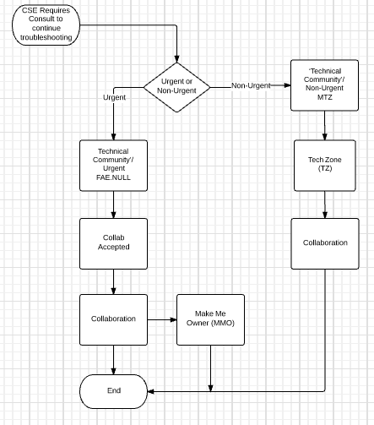

# TAC Collaboration Process

In the collaborative environment, all engineers will have equal responsibility for driving resolution. However, the Owner, in collaboration with Key Contributors and Participating CSEs, is accountable for the final resolution. When engineers are called in to assist with an engagement, they should view the Owner much as they would the end customer.

Refer to the [TAC Integrated Engagement Case Management Process](http://wwwin-eng.cisco.com/BMS/CA/CSE_Global/1002858_Global_TAC_Case_Management_Process.docx) for instructions on Integrated Engagement case handling and ownership, and the CaseMon 2.1 [Training](http://glms.cisco.com/ems?ssp=OfferingRegistration&id=V0JUMDAyOTY0ODA=) for instructions for collaborating with global/partner technical resources.

# CSE CaseMon Log In

CSE’s use the following table when logging into Casemon

| **Action** | **Description** |
| --- | --- |
| Log into CaseMon 2.1 | * Update user profile as desired. CSEs can elect to be available to accept Non-Urgent collaboration requests and/or to take cases from their “My Required Work” queue. * Select Collaboration when accepting Non-Urgent collaboration requests, or select the non-default Work Routing profiles when taking cases from “My Required Work” queue. * Set Deactivation Time. |
| Select CaseMon Notification Preferences | * New S1/S2 case in “My Required Work” queue * New call for S1/S2 case in “My Required Work” queue * New S3/S4 case in “My Required Work” queue * New “Urgent Collaboration” requests in “My Required Work” queue * My “Urgent Collaboration” requests was accepted * SLA missed for S1/S2 cases or Urgent Collaboration request * New Case in non-soft Assign Queue * New Case in Opt-In Work Queue |
| Assigned as primary target for a Required Work Queue item | * Due Date (via) * Reminder (via) |
| Select On-Hold Notifications Preferences | * Due Date (via) * Reminder (via) |
| Select Notify Me on Case Changes Made by Others Notification Preferences | * Alert (via) |

# Manager/Proxy CaseMon Log In

Managers and/or Proxy use the following table when logging into Casemon

| **Action** | **Description** |
| --- | --- |
| Determine availability of all planned CSEs | 1. Review “My Work Routing” availability in CaseMon. 2. Coordinate CSE availability with CSEs, or enable CSE availability. 3. Review CSE queues throughout queue time. |

# Collaboration Accept or Decline

Collaboration requests are presented in the support engineer’s “My Required Work” (MRW) queue with an “Accept” button, a “Decline” button, and a “Telephone” icon button.

* + - Click the “Accept” button to become the collaboration’s Owner, and the collaboration will move from the My Required Work queue to the Backlog. If telephone communication is associated with the case (indicated by the appearance of the telephone icon), pressing the “Accept” button will also initiate call delivery.
    - Click the “Decline” button to decline a collaboration.  The “Accept” and “Decline” buttons will move to the next case or collaboration in the MRW queue move the “Accept” and “Decline” buttons to the next case in the MRW queue. The “Accept” button will remain on the collaboration request that was declined in the event that the engineer can return to take that collaboration at a later time.

# Initial Engagement Assessment

The Owner of the customer support engagement is responsible for determining whether the customer issue can be resolved without any additional expertise or technical collaboration. In such cases, the Owner can resolve the customer issue independently if possible.

When appropriate, the Owner seeks additional expertise or technical assistance to help in efforts to resolve the customer issue.

# “Sneaker-Net” Collaboration (Local Collaboration)

When you need support for an issue that is within your technology, first attempt to get support from engineers within your local team or geographic location. When the issue is outside of your technology, or assistance is not available in your local team or geographic location, initiate an urgent collaboration request.

Follow the internal escalation path (e.g., tech lead or manager) beforehand.

When a resource is engaged to solve an issue via Sneaker-net, do not open a collaboration request. Follow the below steps to get the team member(s) added correctly into the original case.

**Note**:

* + - The **Key Contributor** drives closure to a case.
    - A **Participant** allows an engineer to passively track its progress.

| **Action** | **Description** |
| --- | --- |
| Owner Adds a Team Member | 1. In the **Team Management** section, choose **Add** a team member. 2. Update the information field to add a member.  * The Collaboration Request then appears in the Key Contributor Backlog as **Work Type: COL – Key Contributor**.  1. Email is sent to the added Key Contributor. |
| CSE, DM or Manager adds themselves | 1. Choose Add Me to the Case Team. 2. Update the information field to become a Key Contributor.  * The Collaboration Request appears in the Participant’s Backlog as Work Type: COL – Key Contributor.  1. An Email is sent to the Owner. |
| Self-Promote / Self-Demote | 1. If the added engineer is the main contributor in solving the issue, then s/he can self-promote to Key Contributor. If the added engineer is no longer an active contributor, then s/he can self demote to Participant. 2. Go back to the Team Management page and select Change Role.  * The Collaboration Request in the backlog changes to Work Type: COL – Key Contributor or Work Type: COL – Participant  1. An Email is sent to the Case Owner when a team member promotes his/her status.  * Self-promotion is an important step to ensure the key contributor gets credit for helping to solve the problem. |
| Remove a Team Member | The Case Owner can remove a team member. A Participant or Key Contributor can remove himself from the case team. |

# General Collaboration Involving CSEs (Skills Finder)

**Owner:** Only when technical assistance not specific to a case is needed.

* + - * + Click on “Skills Finder” button at top of page.
        + Select the appropriate Key Word combination.
        + When requesting Manager Collaboration, choose Technology and “Manager Intervention” Sub-technology.
        + Choose an appropriate engineer who could assist in resolving the customer issue.
        + Click “Click to Call” when desired, or IM/call if desired.
        + See the warm transfer section below.

**Collaborating CSE:** When availability is set to “Yes” in Skills Finder.

* + - * + Based on skills, CSE’s name will appear on the list as available to assist when another CSE uses Skills Finder. If assistance is provided on a case after being contacted by the Case Owner, go to Case Management page and click the "Add me to the Case Team" button to track “Participant” activity on case.

**Duty Managers:** When availability is set to “Yes” in Skills Finder.

* + - * + Assists in the support engagement when appropriate; either directly with the customer, and/or with Cisco support and product development organizations. Facilitates communications wherever necessary to assist the Owner.
        + If assistance is provided on a case after being contacted by the Case Owner, go to Case Management page and click the "Add me to the Case Team" button to track “Participant” activity on case.

# Urgent Collaboration Requests

**Owner**: When immediate technical assistance is needed to help resolve a customer issue:

1. Click “Initiate Collaboration” button in the Case Team Management page.
2. Select Technical Community” in an “urgent’ manner” from the drop down menu on the screen.
3. Describe support needed and type of assistance requested
4. Select “Target Expertise”. By default, Technology and Sub-Technology are updated from the case. If needed, choose different Technology and Sub-Technology from the drop-down box.
5. When requesting Manager Collaboration, choose Technology and “Manager Intervention” Sub-technology.
6. When a CSE accepts a request for collaboration, engage the assisting CSE through the most appropriate communication tools, i.e. telephone, email and/or instant messaging.
7. When necessary, bring in others, including managers and partners. When appropriate, engage product development engineers to assist in resolving the customer issue. Facilitate and document all customer engagement activities in the case notes. Provide all Key Contributors with feedback on the quality of the collaboration. Urgent collaboration follows SLA applicable for S1/S2 cases.
8. Urgent Collaboration requests appear in the “My Required Work” queue.
9. CSE either accepts the Collaboration Request to become the “Key Contributor,” or declines it.
10. Once accepted, the Collaboration Request is removed from “My Required Work” and moves into Backlog of the “Key Contributor.” This is reflected in the Backlog section “Work Type: COL – Key Contributor.”

|  |
| --- |
| Guidelines for accepting an urgent collaboration.  **Urgent Collaboration on a P1 case – 5 mins**  **Urgent Collaboration on a P2 case – 7 mins**  **Urgent Collaboration on a P3/P4 case – 10 mins** |
| If declined, Collaboration Request stays in “My Required Work” and the “Accept Button” appears on the next line item in “My Required Work”. |

**Key Contributors** can support in the following ways:

* + - * + Respond to requests for technical assistance.
        + Proactively follow up with the Owner of the engagement.
        + Provide collaboration process feedback on the quality of the collaboration.

**Duty Manager:** Assist CSE using the most appropriate communication tools, such as telephone, email, and/or instant messaging.

* + - * + Complete case Reviews on the Case Team Management page and proactively collaborate on cases as a Participant by using the "Add Me to the Case Team" button.

When the request is not accepted within the guidelines for accepting an urgent collaboration request:

* + 1. **This is an optional step**, a CSE may choose to go directly to next step. A CSE may choose to create a Jabber/WebEx Connect group chat by clicking on the chat icon in the upper left corner of the targeted CSE list pop-up window.  Note:  This should be used with caution, as some collaboration requests are known to target 50+ CSEs. If this method does not result in needed assistance in a timely manner, see next step.
    2. The CSE engages the appropriate team manager to understand the delay and determine when the collaboration request will be answered. A CSE can see who the Manager is by clicking the bowling pin icon in the Team Management Pad window.  Attempt to contact every Manager in the list in the order of top-to-bottom using all possible contact methods including IM (preferred), Desk phone, Mobile Phone until you get a Manager response.  If none of the managers respond after trying IM, desk phone and mobile phone, then contact the on-shift TAC Duty Manager.
    3. If the on-shift TAC Duty Manager is engaged and 15 minutes has elapsed with no FTS Collaboration Accept, the DM reaches out to team managers directly to coordinate Collaboration acceptance. At the DM’s discretion, the DM (only) may also choose to autoroute the case, see section 5.11.4 for instructions. Only use this option when all other methods fail.

# Post to Tech Zone Non-Urgent Collaboration

**Owner**: In cases where there is no requirement for immediate technical assistance within a particular time frame, and when the issue relates to guidance only, consult Tech Zone:

* + - * + Click “Initiate Collaboration” button in the Case Team Management page.
        + Select Technical Community” in an “urgent’ manner” from the drop down menu on the screen.
        + Select the option for “Target Expertise”. By default, Technology and Sub-Technology are pre-populated from the case; if necessary, be sure to choose a different Technology and Sub-Technology from the drop-down box.
        + Populate the TechZone subject and body with details about the assistance requested.
        + When necessary, bring in others, including managers and partners. When appropriate, engage product development engineers to assist in resolving the customer issue. Facilitate and document all customer engagement activities in the case notes. Provide all collaborators with feedback about the quality of the collaboration.

The Tech Zone post appears in the “Tech Zone Opt-In” section. A CSE can respond to a Tech Zone post by clicking on the subject hyperlink.

# Manage Collaboration Status

Owner and Key Contributors: Update the status of an Action Item by using the icons available on the Case Team Member panel in the Team Management page of the Backlog.

* + - * + Action Item status for each case appears in the Backlog.
        + “Action Item Pending” icon – Use this icon to reflect that the user is working on an activity whose status must be reported back to the Case Team. **“No Action Item Pending”** icon – Use this icon to reflect that the user is not responsible for any activity status report to the Case Team.

# Change of Ownership

Owner - Prior to changing ownership of a case, the collaboration must be accepted.  A CSE is expected to take ownership of a collaboration request if it appears in the top of the queue. In case of warm transfers where CIN is engaged, please refer to [Worldwide CIN to TAC S1/S2 Phone Line Handoff Procedure](http://wwwin-eng.cisco.com/BMS/CA/CSE_Global/EDCS-633639_WWTAC_S1_S2_Hand-off.doc) before accepting the ownership. Ownership may then be transferred to a more appropriate CSE, provided this is necessary. Customers are typically put on hold while the current Owner is synching up with the new Owner. However, this is up to the discretion of the current Owner.

If Change of Ownership is attempted for a reasonable amount of time but still fails, refer to the Case Transfer Process.

* + 1. **Ownership change reasons**

**Different Technology Identified:**

If the problem is related to a different T/ST/PC (Cross-technology), update the case stating the need for cross-technology support. Engage team resources and then initiate all possible means of collaboration with the cross-technology group.

1. If it makes good business sense, and the Owner and the Collaborator agrees that the issue is a problem or bug in the cross-technology, the collaborator may take ownership of the case.
2. The Collaborator chooses the ‘Make Me Owner’ option in MWZ and selects the appropriate reason for change of ownership.
3. If the Collaborator disagrees with the owner on the reasons for the transfer, the collaborator and owner should engage with the customer to agree on the technology to support.
   1. If cross-technology collaboration is agreed, the collaborator may take ownership of the case.
   2. If the issue is confirmed to be in the same technology supported by the owner, a new collaboration request should be initiated. Follow the Sun (FTS) collaboration request is submitted if the next case owner needs to be engaged.

**Additional Skill Required – Same Tech**

Owner needs help in same T/ST/PC. (e.g. GDP to BB). After exhausting their local resources, the owner can open a collaboration request. The owner manages the case with support from Collaborator.  If the Owner and Collaborator agree that the Owner is no longer adding value and is not growing his knowledge by staying involved with case, the Collaborator may take ownership of the case.

**CAP Case/S1/S2:**

This transfer occurs when the support effort has become part of the Customer Assurance Program (CAP). S1/S2 situations that require hand-off to a different workgroup/CSE, also fall into this exception.

**Lab recreates – Devices not available:**

The customer engagement requires a lab recreation of the customer issue, yet the owner lacks the necessary equipment for such a lab recreation (e.g., GDP Owner).

**Customer Request:**

The customer specifically requests a change in case ownership or escalation.

**End of Day**

This process ensures that case ownership is seamlessly transferred between TAC Support Teams at time of shift change, 24x7, 7 days a week.

* + - This transition occurs via Warm Handoff, and begins with a verbal communication between two engineers and the customer, and concludes with an agreement to transfer ownership made formal by the new owner accepting ownership of the case.
    - The goal is to re-handoff to a Previous Owner who is already familiar with the case and is available at the needed time whenever possible. This ensures the case remains with the same Tier.
    - Look at the existing case team members who may be Previous Owners to determine if any are in the appropriate time zone or shift.
    - Then use the existing ‘Click to X’ icons to reach out to them. There is a flag in the Team Management Pad to indicate Previous Case Owners.
    - If there is more than one case team member flagged as a Previous Owner, you can ‘Click to Chat’ or ‘Click to Group Chat’ to determine who is most able to take the case ownership.

**Warm Handoff**

All ownership changes described above are done through a warm handoff via the collaboration process as follows.

|  |
| --- |
| 1. Current Owner identifies the need for a warm transfer and documents the reason in the case. Also before initiating the collaboration request, the CSE makes sure the Problem Description, Business Impact and Action Plan are up to date. |
| 1. Current Owner creates an Urgent collaboration request and selects a Case Transfer Reason. |
| 1. Other Transfer Reasons inlcude: Additional Skills Required – Same Tech, Different Technology Identified and Previous Owenr Not Available1. All CSEs with the skill in an active profile see the collaboration request in their Required Work queue |
| 1. An available engineer reviews the case and accepts the collaboration. Accept the collaboration request within 15 minutes. |
| 1. The Collaborator then contacts the Case Owner and the case is reviewed together. |
| 1. Current Owner introduces the new engineer to the customer and informs the customer of the ownership change.  The Collaborator clicks the “Make Me Owner” button and selects Case Transfer Reason |
| 1. New Owner takes control of the call and the case |
| 1. The previous owner asks for the customer’s permission to leave the call and may involve his Manager/Duty Manager as required to ensure smooth exit from the case. |
| 1. The previous owner leaves the call and documents the customer’s approval to do so in the case as external customer viewable notes.  A flag is placed next to the previous owner’s name in the Team Management Pad to indicate that they previously owned the case. A future stretch goal of this process is for the customer to be able to rate whether the warm handoff was well executed. |
| 1. Repeat steps above for each time zone transfer as needed.  When the case returns to the time zone where the collaboration request was first initiated, the Previous Owner is contacted first to see if he/she can accept ownership of the case.  If the Previous Owner is not available, initiate an urgent collaboration request (Step 2). |
| **HTTS Change of Ownership**: HTTS follows the same Change of Ownership process as TAC. |

* + 1. **Case ownership transfer using case routing rather than collaboration:**

Whenever a case transfers to a new Owner without using the “Make Me Owner” button, all existing collaboration requests are closed and any Collaborating CSEs will be released from the case.  During case transfer, the current owner may include the names of the case team in the re-queue reason. CSEs accepting ownership for a case having previous collaboration activity may look at the re-queue reason or the previous logs from “Collaboration Activity - Assistance Requested” to find all Collaborating CSEs listed.  The new Owner may choose to renew collaborations with previous Collaborating CSEs if they are available, or the new Owner may choose to open new collaboration requests.

If Change of ownership is attempted and fails to result in a new owner, follow the warm hand-off case transfer section in the [TAC Case Transfer Process](http://wwwin-eng.cisco.com/BMS/CA/CSE_Global/731005_Global_TAC_SR_Transfer_Process.doc).

# Internal Collaboration Evaluation

Instructions related to case closure can be found in the [TAC Integrated Engagement Case Management Process](http://wwwin-eng.cisco.com/BMS/CA/CSE_Global/1002858_Global_TAC_Case_Management_Process.docx) (EDCS -1002858). When a case (ENG) is transferred or closed, all Collaboration Requests associated with that case are then marked as “Closed” in the activity log. Owners and Key Contributors receive an email request to complete a Collaboration Process Survey when a collaboration case is closed or transferred. Surveys are also sent when a Key Contributor is downgraded to a Participant by the Owner or as a result of the “Make Me Owner” button.

* + - * + Owner and Key-Contributor must complete the internal Collaboration Process Survey and managers will also receive a copy of the completed surveys.
        + If the tool(s) in use feature a community forum, discussion board, etc., it is appropriate for the Owner to access the site and document the results.

# Content of Collaboration (Documentation of collaboration work)

* **Features of a Case (ENG) with an Owner, without any collaboration, include:**
  + - * + The “Problem Management” area, under the “Collaboration” tab, documents symptoms and/or describes problems.
        + A snapshot can be added at any time to the case history by clicking either “Copy to External Notes” or “Copy to Internal Notes”.
        + Upon case resolution, the Owner can click on the button for “Publish to Tech Zone” and share the summary in the Tech Zone knowledge database.
* **Features of a Case (ENG) with a Case Team include the points described below.** Case Teams are comprised of the Owner and one or more collaborators, Key Contributor(s) and/ or Participant(s):
  + - * + Case Team members document symptoms, describe problems, etc. in the “Problem Management Area” under the “Collaboration Tab.” Multiple users can edit a collaboration.
        + Upon case resolution, the Owner or a Case Team member can share, with one click, the summary in the Tech Zone knowledge data base
* **For “Post to Tech Zone” collaborations**, the discussions occur only within Tech Zone. Tech Zone **offers** copy/paste features to “consolidate” a discussion into a knowledge article in the Tech Zone TKB, the knowledge database.

# CSE CaseMon Log Out

Open Active Profiles and uncheck all profiles, or logout of CaseMon.

# Manager/Proxy CaseMon Log Out

Ensure all CSEs are not available for “My Work Routing” – toggle if necessary.

# Process Compliance

# Compliance Effective Date

This process becomes effective upon the last date of approval as noted in EDCS.

# Compliance Measurement

Compliance with Cisco processes is required. Compliance to this process may be verified through various methods, including but not limited to, reports from available business tools, internal and external audits, self-assessment, and/or feedback to the process owner. TAC managers will enforce compliance with this process.

# Compliance Exceptions

SBSC doesn’t use the collaboration tool and TAC should not create a collaboration request to reach SBSC for consulting on a case but should follow the process flow as explained in sec 5.7 of [TAC Case Transfer Process](http://wwwin-eng.cisco.com/BMS/CA/CSE_Global/731005_Global_TAC_SR_Transfer_Process.doc)document.

Exceptions to the terms of this process are handled on a case-by-case basis only. Exceptions require written approval by Executive (Director or above) to non-comply for strategic business reasons. Documented exceptions and justifications will be communicated to affected technical services organizations immediately upon approval.

Any records of exceptions including Theater-specific handling requirements (local processes) should be approved and archived according to the [Cisco Records Management Process](http://wwwin.cisco.com/process/bes/iso/doc_control.shtml), and not on an individual’s laptop.

# Non-Compliance

Compliance with Cisco processes is required. Deviations or non-compliance with this process, including attempts to circumvent the stated process by bypassing or knowingly manipulating the process, system, or data may result in disciplinary actions per Cisco’s company policies, up to and including termination.

# Compliance Effective Date

This procedure becomes effective upon the last date of approval as noted in EDCS.

# Related Policies, Processes and Procedures

Refer to the TS Service Delivery Policy, Process and Procedures Web Site for all policies, processes and procedures related to TS Service Delivery <http://wwwin.cisco.com/CustAdv/ts/tso/globalops/gsde/ServiceDeliveryPPPs.shtml>

# Defined Terms

Defined terms are located in EDCS as [1147899 TAC Glossary of Terms](http://wwwin-eng.cisco.com/BMS/CA/CSE_Global/1147899_Global_TAC_Glossary.docx).

# Approvals

For a record of the approval history go to this document’s EDCS "[File Information](http://wwwin-eng.cisco.com/cgi-bin/edcs/edcs_info?EDCS-1019795)" page.

| Organization | Name |
| --- | --- |
| TAC Americas Delivery | Ullie Versavel |
| TAC Americas Delivery | Hector Acevedo |
| Global Delivery Partner (GDP) Marketplace | Fabio De Moraes |
| TAC AP Delivery - Sydney | Allyn Medway |
| TAC – Cloud & Small Serviceability | Jay Pederson |
| TAC - EMEAR | Adrian Purcarea |
| HTTS | Derek Hampton |

# Revision History

EDCS history at <http://wwwin-eng.cisco.com/cgi-bin/edcs/edcs_info?3351906#History>

.

#### Appendix - Golden Rules Sub-process

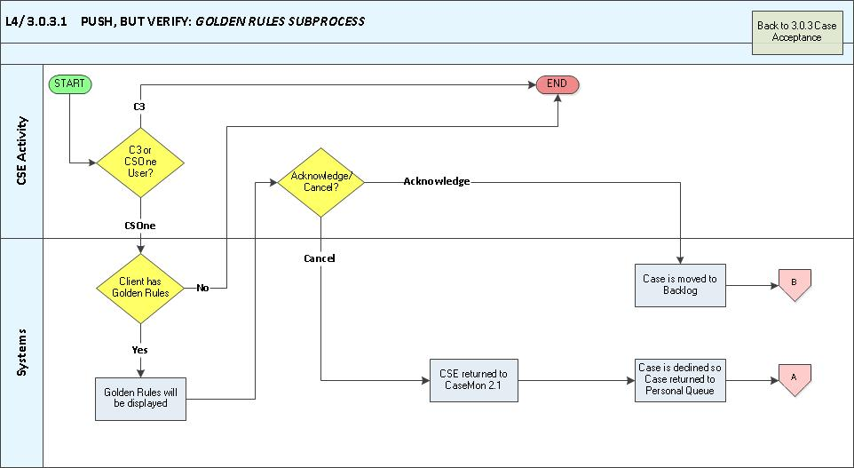

#### Appendix - Initial Engagement Assessment

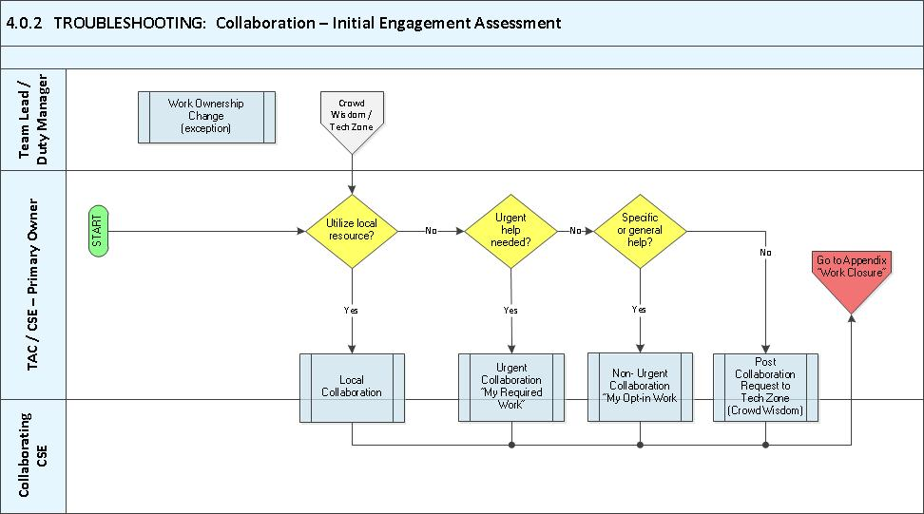

#### Appendix - Local Collaboration

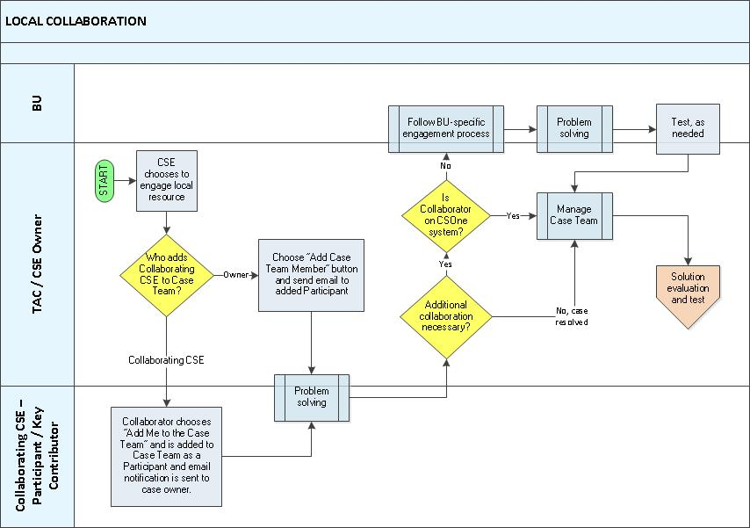

#### Appendix - URGENT Collaboration Involving CSEs



#### Appendix - Non Urgent Collaboration Involving CSEs - Detailed



#### Appendix VII - Post-Engagement Activities

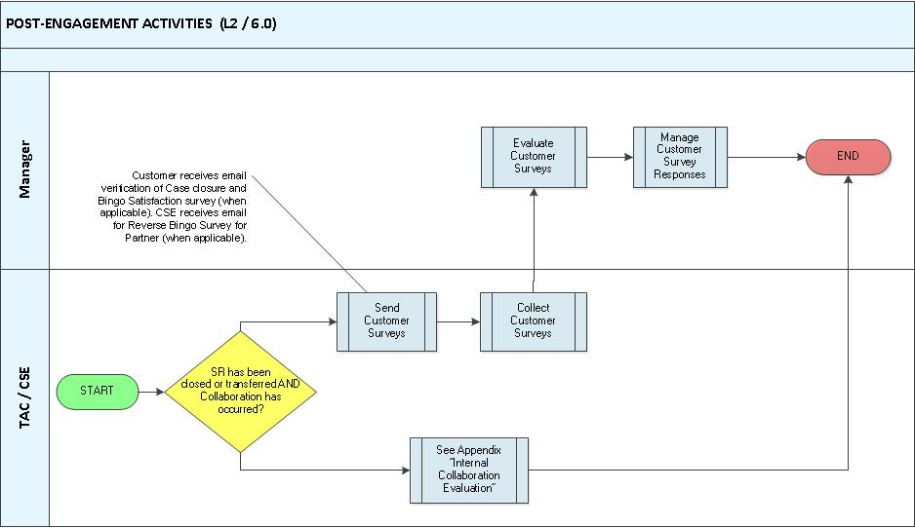

#### Appendix VIII - Internal Collaboration Evaluation

