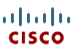 | Document Number | EDCS- 731005
 | Last Revision Date | October 30, 2016
 | Procedure Owner | Patricia Rivera
 | Next Review Date | October 1, 2018
 | Document Type | Process
TAC Case Transfer Process

Table of Contents
1 Purpose 3
2 Scope 3
3 Customer Data Protection 3
4 Overview 3
5 Process 4
5.1 Case Transfer 4
5.2 Case Transfer Reasons 5
5.3 Case Transfer Process Flow 6
5.4 Case Transfer Process 6
5.5 BB TAC Guidance 8
5.6 Case Transfer Actions by Severity Matrix 8
5.7 Case Internal Note Content 9
5.8 Case Misqueue 10
5.8.1 When to Misqueue a Case 10
5.8.2 How to Misqueue a Case 10
Casemon 10
5.9 Small Business Service Center 10
5.9.1 SBSC Process Flow 11
5.9.2 SBSC Process Steps 11
5.10 Escalation 12
6 Process Compliance 13
6.1 Compliance Effective Date 13
6.2 Compliance Exceptions 13
6.3 Non-Compliance 13
7 Related Policies, Processes, and Procedures 13
8 Definitions 13
9 Approvals 14
10 Revision History 14

Purpose
This process provides foundational governance for Case transfers within all support centers. It outlines the steps to transfer ownership of a Case, regardless of organization and/or location.

Scope
This process applies to all CSEs in the following organizations:

Organizations Affected
TAC (Global/Regional) | X
High Touch Technical Support (HTTS) | X
Global Delivery Partners (GDP) | X
Customer Interaction Network (CIN) | X
Cloud & Managed Services (CMS) | X
Global Service Logistics & Operations (SLO)
Services Entitlement Team
Technical Services Product Management (TSPM)
Failure Analysis Operations (FA)
Media Convergence Server(MCS) Support

Customer Data Protection
This process may involve usage of customer-related information. CSEs should understand the importance of protecting different types of customer data. For more information about your responsibilities in customer data protection (CDP), refer to Customer Data Protection Policies site.

Overview
Appropriate case transfers provide customers access to the best available technical support regardless of time and/or geographical location.
This document ensures that transferring a Case from one Workgroup to another, or from one Technical Assistance Center (TAC) Theater to another, is performed in compliance with processes documented to address theater differences while continuing to provide Cisco customers the best available technical support.

Process

Case Transfer
A case transfer should occur whenever the accepting engineer/case owner has performed any degree of troubleshooting, isolation, etc. This is true even if there has been no direct contact with the customer and/or partner. This warm handoff is best accomplished via a change-of-ownership urgent collab.
Please note that simply updating case data and auto-routing when the prior owner has made substantive progress causes delays – even if all GCI has been entered.
Case Transfer vs. Auto-Route:
- Case Transfer (via change-of-ownership urgent collab, all severities)
  - Any degree of substantive progress (troubleshooting, isolation, with or without contact with Customer/Partner).
- Update Case & Auto-Route (reQ)
  - Only when no substantive progress – troubleshooting or isolation with/without customer contact - has been made.

NOTE: Case Transfers are only conducted by these job roles or organizations: CIN, TAC CSE, GDP TAC CSE, TAC Manager, TAC Duty Manager, Licensing, Entitlement, HTTS (ASH), HTTS Duty Manager, HTTS Managers and HTTS CSE.

Other teams follow the below steps for any case requeues.
- Contact the CIN for 'requeue assistance.’ Requeue is when CSE isn't available and immediate assistance or time zone alignment is needed. Please ensure that a requeue is in the best interest of the customer for timely resolution.
- Contact the TAC Manager or Duty Manager for ‘escalation assistance.’ Escalation should be pursued when timeliness of resolution, engineer technical skill or communications are in question or there is perceived lack of needed urgency.
- Cases escalated from a GDP TAC vendor to a BB TAC will remain in the BB TAC. Use RDMT to determine the receiving BB team, selecting “High Tier” routing. Once escalated from a GDP TAC vendor to a BB Workgroup, subsequent transfers of the Case should only be between BB CSEs/Workgroups even when there is a change of technology unless the technology is supported only within GDP.
- With the exception of GDP to BB technical escalations, a Case shall transfer between GDP and BB TAC Workgroups as required to provide the customer the most appropriate TAC support.
- CSEs will comply with the TAC Case Escalation Process EDCS 861921.

Case Transfer Reasons
Case transfers may be justified by the following reasons:
Reason | Description
Incorrect Keyword | Update the case notes with proper case transfer justification when the customer engagement has incorrect keyword combinations.
Different Technology Identified | When the problem is related to a different T/ST/PC (Cross-technology), do the following:  - Update the case stating the need for cross-technology support.  - Engage team resources to initiate all possible means of collaboration with the cross-technology group by following the Collaboration Process.  Note: Follow the Sun Collaboration requests are intended to be used only for collaboration requests within the same T/ST/PC.
CAP Case/S1/S2 | This transfer occurs when the support effort has become part of the Customer Assurance Program (CAP). S1/S2 situations that require hand-off to a different workgroup/CSE, also fall into this exception.
Lab recreates – Devices not available | The customer engagement requires a lab recreation of the customer issue, yet the owner lacks the necessary equipment for such a lab recreation (e.g., GDP Owner).
Owner not available | The current owner is unavailable because they are out of the office. In this scenario, there is no Key Contributor on the Case Team available to take ownership of the case. This also occurs when the DM or line manager needs to get some traction on a case.
Customer Request | The customer specifically requests a change in case ownership or wants the case escalated.
Manager authorized Request | A Cisco TAC Team Technology Manager or Cisco TAC Duty Manager authorizes escalation due to other business reasons.
Customer prefers a different time zone | A customer can only gather information after hours, and/or the customer requires that work on the case begin immediately (as opposed to waiting for the original CSE to be back on shift).
Follow the Sun (FTS) | This transfers a case between TAC Support Teams at time of shift change, 24x7.This transition occurs via Warm Handoff - begins with a verbal communication between two engineers and the customer - and concludes with an agreement between the current and accepting owner to transfer ownership of the case.

Case Transfer Process Flow
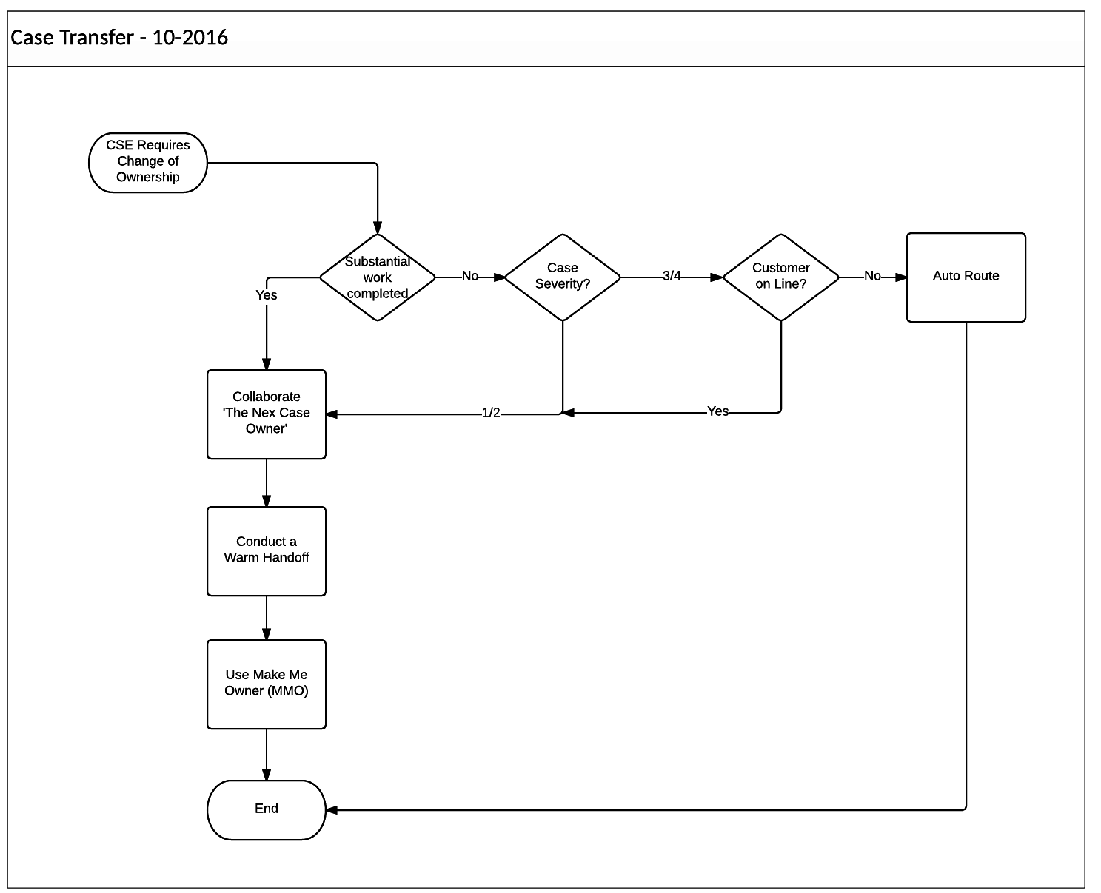

Case Transfer Process
A case transfer is initiated if the CSE needs to hand the case to another engineer. Use specific, concise problem descriptions in Case subject headers when transferring a Case.

Before initiating the warm handoff process, the CSE must make sure the problem description and action plan are up to date.


- If the engineer has completed work on the case, initiate a collaboration. Complete a warm handoff via ‘Make me owner’ (MMO) option in the tool.
- If the engineer has not completed any troubleshooting on the case, transfer the case based on the case severity.
Sev 1 / Sev 2 Case:
- Current Owner identifies the need for a warm transfer and documents the reason in the case. Also before initiating the collaboration request, the CSE makes sure the Problem Description, Business Impact and Action Plan are up to date.
- Current Owner creates an Urgent collaboration request and selects a Case Transfer Reason.
- For cases that require warm transfer at end of shift, choose Transfer Reason “Follow the Sun”
- Other Transfer Reasons inlcude: Additional Skills Required – Same Tech, Different Technology Identified and Previous Owenr Not Available1. All CSEs with the skill in an active profile see the collaboration request in their Required Work queue
- An available engineer reviews the case and accepts the collaboration. Accept the collaboration request within 15 minutes, which is the same SLA applicable for S1/S2 cases.
- The Collaborator then contacts the Case Owner and the case is reviewed together.
- Current Owner introduces the new engineer to the customer and informs the customer of the ownership change. The Collaborator clicks the “Make Me Owner” button and selects Case Transfer Reason
- New Owner takes control of the call and the case
- The previous owner asks for the customer’s permission to leave the call and may involve his Manager/Duty Manager as required to ensure smooth exit from the case.
- The previous owner leaves the call and documents the customer’s approval to do so in the case as external customer viewable notes. A flag is placed next to the previous owner’s name in the Team Management Pad to indicate that they previously owned the case. A future stretch goal of this process is for the customer to be able to rate whether the warm handoff was well executed.
- Repeat steps above for each time zone transfer as needed. When the case returns to the time zone where the collaboration request was first initiated, the Previous Owner is contacted first to see if he/she can accept ownership of the case. If the Previous Owner is not available, initiate an urgent collaboration request (Step 2).
Sev 3 / 4 Case:
- If the customer is still on the line, the engineer initiates collaboration. Complete a warm handoff via the Urgent Collaboration tool with ‘Follow the Sun’ as the reason.
- If the customer is not on the phone, AutoRoute the case.

BB TAC Guidance
- MWZ users will use the Transfer option in Routing tab. Within the Transfer option, the CSE will select the “Manual” option to route the case to a specific BB queue.
- The Case will be placed in the receiving team’s Queue prior to the sending CSE calling the S1/S2 number/Casemon hotline of the receiving team.

Case Transfer Actions by Severity Matrix
Select the appropriate customer engagement situation and complete the indicated steps.

Activity Steps | S1/S2  Case customer  on phone | S1/S2:  Case customer  not on phone | S3  Case customer  on phone | S3  Case customer  not on phone  and ALL S4 Cases
Update Case notes and title per the CSE Case Handling Procedure  TAC Case Management Process(for Casemon users) | X | X | X | X
Sending CSE: Contact receiving team at the start of their shift. Sending CSE to remain available 30 mins after the receiving team has started their shift  - Contact Team Lead, Manager, or the Duty Manager when receiving Workgroup is operating with reduced staffing (On Call), via S1/S2 phone or instant messaging (e.g. WebEx Connect). Team Lead will provide name of CSE available for Case transfer.  - Provide Case number to be transferred to Team Lead or DM  - Advise customer of pending transfer | X | X | X
Receiving Workgroup is not on On-Call staffing: If no answer within 5 minutes, call the team manager, if no immediate answer, page team manager, if no response in 5 minutes contact DM.  Receiving Workgroup is on On-Call staffing: If no answer within 10 minutes, contact the DM. | X |  | X
If WebEx or Conference call is established, 10 minutes prior to end of sending CSE work hours, sending CSE will extend WebEx invite or provide Conference call information to receiving CSE. Sending CSE will introduce receiving CSE to customer and troubleshooting team | X | X | X
Receiving CSE accepts Case in C3/Casemon | X | X | X
Sending CSE is available for questions | X | X | X | X
Sending CSE attempts to call customer and conference in receiving CSE with customer to establish new contact information and transfer of call/Case |  | X

Case Internal Note Content
Use an Internal “Requeue Reason” or “Warm Handoff – Please add Case note describing warm handoff reason and action”
- Document the reason for the transfer in the Case Notes.
- A brief comment (1 to 2 lines) to explain why the Case was transferred

Case Misqueue
A Systematic MISQ is identified as any SR moved prior to acceptance or within 1 hour of creation or 1st acceptance unless any of the pre-defined exclusions apply.
See Appendix A for Misqueue Exceptions.

When to Transfer a case a a Misqueue
Cases may be transferred as a Misqueue for the following reasons:
- A CIN agent has misqueued the case (CIN created cases)
(e.g. the wrong sub-technology was selected in RDMT which is not in line with the customer problem description / equipment type etc.)
- The customer selected the wrong Tech or Sub-Tech in SCM.

How to Transfer a Case as a Misqueue
Use the following table for guidelines on how to misqueue a case:
Tool | Action
Casemon | - Select Transfer option in Routing tab.  - Select ‘Manual’ or ‘Auto-route’ as applicable.  - Select ‘Misqueue’ as the reason for the transfer.  - Update the requird fields.  - If applicable, Select ‘Notify Customer via Email’.  - Click ‘Route’ to complete the case handoff.
If the case is misqueued the engineer must triage the case to determine where it should go.

Small Business Service Center
SBSC doesn’t use the collaboration tool and TAC will not create a collaboration request to reach SBSC for consulting on a case but will follow the process flow as given below.
Cisco TAC will follow the guidelines in this section when delivering technical support to a customer shared by TAC and the Small Business Service Center (SBSC). By following these guidelines, the best interests of the customer will be served by the collaboration between Cisco TAC and Cisco SBSC. Where a customer has support contracts with both Cisco TAC and SBSC, TAC and SBSC will work together to isolate and resolve the problem.

SBSC Process Flow

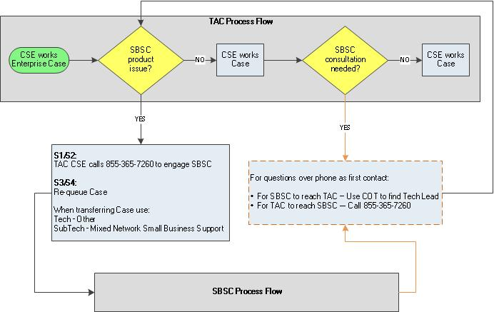

SBSC Process Steps
Action | Description
- Start | CSE is working with a customer on a technical problem with a Cisco product(s).
- SBSC Identification | After initial troubleshooting, CSE believes the issue to be with a SBSC product. A list of these products can be accessed in RDMT from the US-STAC queue or EU-STAC queue. Click here to access RDMT.  CSE advises the customer that resolution of the problem requires the involvement of an SBSC engineer, and instructs the customer will go through the SBSC entitlement process.
- Case Transfer (Case Severity S1– S4) | CSE transfers the existing C3/Casemon case to the SBSC engineer based on severity:  - During this call, the CSE informs an SBSC engineer of the details of the case.  - Refer to Section 5.6 Case Transfer Actions by Severity Matrix. If needed, the SBSC support line number is 855-365-7260.  CSE requeues the case using Tech: Other SubTech: Mixed Network Small Business Support.
- TAC -> SBSC Consultation | If consultation may resolve the case (instead of transferring the case to the SBSC team), the TAC CSE calls the SBSC support center (855-365-7260) to speak with an SBSC engineer. If this discussion reveals that a transfer of the case is required, then return to step three. Do not IM or directly call the team leads listed in the RDMT.
- SBSC -> TAC Consultation | If SBSC needs TAC Collaboration to determine where the issue exists (SBSC vs Enterprise Products) use RDMT/KWL to determine the right team.  - Contact the P1/P2 line of the appropriate TAC team for assistance  Note: If unable to determine the appropriate TAC team using RDMT/KWL, contact CIN to have your call routed to the correct team.  Upon determining that the customer needs TAC support, SBSC creates a new TAC case as follows:  - Call the CIN(Frontline TAC to create a new Service Request.  - The SBSC Service Request number will be included in the TAC Case as an internal note.  CIN Agent will then route the case to the appropriate TAC Team.
- Cisco TAC troubleshoots | Cisco TAC CSE troubleshoots issue and collaborates with SBSC engineer and customer to resolve the case.

Escalation
Consult with your tech lead or team manager for any technical assistance with tools or process. Refer to the TAC Case Escalation Procedure for guidance on how to escalate Cases. Non-technical escalations are directed to the CSE's manager or the Duty Manager.

Process Compliance
Compliance with Cisco processes is required. Compliance to this process may be verified through various methods, including but not limited to, reports from available business tools, internal and external audits, self-assessment, and/or feedback to the process owner. TAC managers will enforce compliance with this process.

Compliance Effective Date
This process becomes effective upon the last date of approval as noted in EDCS.

Compliance Exceptions
Exceptions to the terms of this process are handled on a case-by-case basis only. Exceptions require written approval by Executive (Director or above) to non-comply for strategic business reasons. Documented exceptions and justifications will be communicated to affected technical services organizations immediately upon approval.
Any records of exceptions including Theater-specific handling requirements (local processes) should be approved and archived according to the Cisco Records Management Process, and not on an individual’s laptop.

Non-Compliance
Compliance with Cisco processes is required. Deviations or non-compliance with this process, including attempts to circumvent the stated process by bypassing or knowingly manipulating the process, system, or data may result in disciplinary actions per Cisco’s company policies, up to and including termination.

Related Policies, Processes, and Procedures
CSE Case Handling Procedure EDCS – 679046 ( For C3 Users)
TAC Case Management Process EDCS – 1002858 ( For Casemon Users)
TAC and CMS Collaboration Procedure EDCS - 694356
TAC Escalation Process EDCS - 861921

Definitions
Defined terms are located in EDCS as 1147899 TAC Glossary of Terms.

Approvals
For a record of the approval history, go to this document’s EDCS location; from that page, click on the link for “View Approval Record”.

Organization | Name
TAC Americas Delivery | Ullie Versavel
TAC Americas Delivery | Hector Acevedo
Global Delivery Partner (GDP) Marketplace | Fabio De Moraes
TAC AP Delivery - Sydney | Allyn Medway
TAC – Cloud & Small Serviceability | Jay Pederson
TAC - Emear | Adrian Purcarea
HTTS | Derek Hampton

Revision History
The revision history can be found in the following link.

Appendix A – Misqueue Exclusions
Pre-Defined Exclusions:
- Entitlement-Enterprise (either 1st queue or 2nd queue), CRC-Global, HTTS-GLOBAL, Asia-China-Entitlement (either 1st queue or 2nd queue), ASIA-KOREA-ENTITLEMENT (either 1st queue or 2nd queue), CRC-CHINA (either 1st queue or 2nd queue), JAPAN-GCC (only 1st queue), WW-Scheduled-Response (either 1st queue or 2nd queue), OMC-Entitlement, 1st queue: B2B-VCE AND 2nd queue: WW-DCN-Solutions (re-queued automatically, e.g. 634331185), 1st queue: JAPAN-ENT-DOA AND 2nd queue: JAPAN-HARDWARE.

- If the 1st queue or 2nd queue is “UNDISPATCHED”, skip the “UNDISPATCHED” queue and show the next real queue name.

- Remove case which 1st queue and 2nd queue are the same queue from the Mis-Q tagging. (CSE’s internal agreement, one CSE accepts the case from TAC queue and puts the case back to the same TAC queue quickly, then another CSE accepts the case, e.g. 634320867; or some contract based routing SRs etc.)

- Exclude moves that occur without changing the Tech/Sub Tech/Problem Code (e.g. CR-CUCM to IND-CUCM, Engineer going off shift, gentlemen’s agreement etc.)

Note: Moves with no keyword change will be tracked in a separate report for further analysis

