 | Document Number | EDCS-873191
 | Policy Owner | Patricia Rivera
 | Content SME: | Lyn Fitzsimmons
 | Last Revision Date: | August 3, 2017
 | Next Review Date | June 1, 2018
Global TAC Return Materials Authorization (RMA) Process

Table of Contents
1 Purpose 4
2 Scope 4
3 RMA Process Flow 5
4 Opening a Case 7
4.1 Receiving Support 7
4.2 TAC Pre-RMA Support 7
4.2.1 MFS Pre-RMA Support 7
5 RMA Entitlement and Escalation Support 8
5.1 EMEA Only RMA Entitlement Support 8
5.2 Account Team Entitlement Exception Requests 8
5.3 LSC Duty Manager (DM) Engagement 9
5.4 Contacting LSC Entitlement and Global Service Relations (GSR) 9
5.5 Failing Entitlement 10
6 Creating a RMA Service Order 10
6.1 RMA Service Order - Original Equipment Manufacturing (OEM) 10
6.2 RMA Service Order - Hardware New 11
6.3 RMA Service Order – Advance Replacement 11
6.4 RMA Service Order - Premium 12
6.5 RMA Service Order - Warranty 12
7 Field / Security Notice (FN / SN) 13
7.1 Internal or External FN / SN Found 13
7.2 UMPIRE (Upgrades Management Program Including Reporting) 14
7.3 No FN/SN Umpire Programs Found 14
7.4 Internal or External Umpire Program Found 14
8 RMA Exceptions/Special Handling 15
8.1 RMA Entitlement Exception Requests 15
8.2 RMA Exception/Special handling – through pre-defined rules 15
8.3 Proactive RMAs 16
8.4 3-Way RMA 16
8.5 International Orders 18
8.6 Next Flight Out (NFO) and Weekend / Holiday Delivery Processing 18
8.7 Equipment and Type Limitations 18
8.8 Loaner Equipment 19
8.9 Service Coverage 19
8.9.1 Certificate of Insurance (COI) – Liability Request 19
9 Assembly and Configuration 19
10 Parts Return 21
10.1 Return Addresses 21
11 RMA Request - Customer Follow-up Support 21
11.1 Failure to Meet Delivery Commitment Date 22
12 RMA / SORT Training 22
12.1 New Access Training 22
12.2 Refresher Training and Assessment 22
13 Process Compliance 23
13.1 Compliance Effective Date 23
13.2 Compliance Measurements 23
13.3 Compliance Exceptions 23
13.4 Non-Compliance 23
14 Related Policy, Process, or Procedure 23
15 Supporting Documents and Tools 23
16 Definitions 24
17 Approvals 24
18 Revision History 24
Appendix A – Team Descriptions 25
Appendix B – Entitlement Criteria 26
Appendix C - Entitlement Engagement and Exceptions 27
Appendix D - Service Delivery Guidelines 32
Appendix E - GSSC Global Heavyweight Policy 33
Appendix F - Field Replaceable Units (FRU) Quantity Limits 34
Appendix G - Packing Instructions for All Return Shipments 34
Appendix H - Field / Security Notice and Umpire Process 35
Appendix I – 3-Way RMA Process Flow 36

Purpose
This document outlines the process to create a Return Materials Authorization (RMA), and to send Field Replacement Units (FRU) (hardware, firmware, system software) to Cisco customers to resolve their networking issues. This process reflects input from Logistics Support Center (LSC), Entitlement, and Technical Assistance Center (TAC) worldwide.

Scope
This process applies to the following organizations:

Organizations Affected
TAC (Global/Regional) | X
High Touch Technical Support (HTTS) | X
Global TAC Sourced Support (Contact Center Services) | X
Global TAC Sourced Support (CSE Services) | X
Cloud & Managed Services (CMS)
Global Licensing Operations (GLO)
Global Service Logistics & Operations (SLO) | X
Services Entitlement Team | X
Technical Services Product Management (TSPM)
Failure Analysis Operations (FA)
Media Convergence Server (MCS) Support

Please see Appendix A for a description of the teams involved in the RMA process.

RMA Process Flow
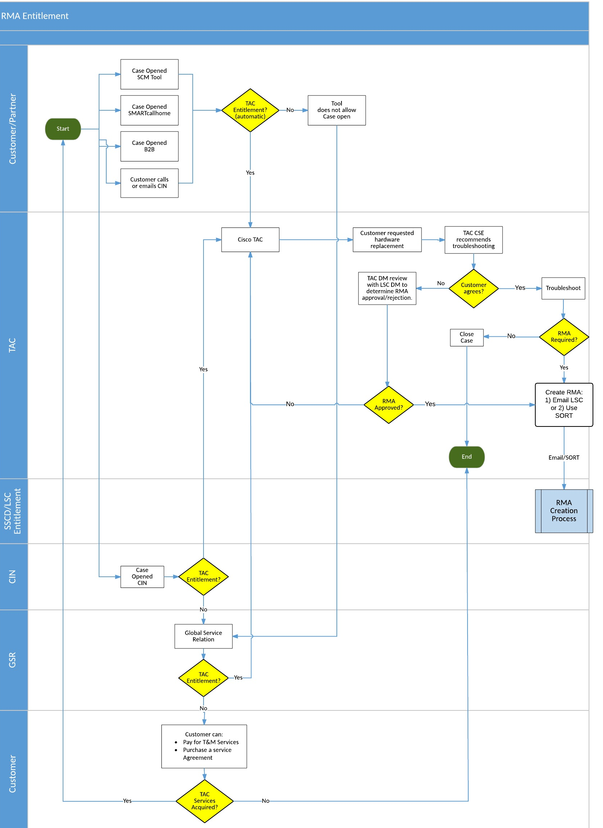

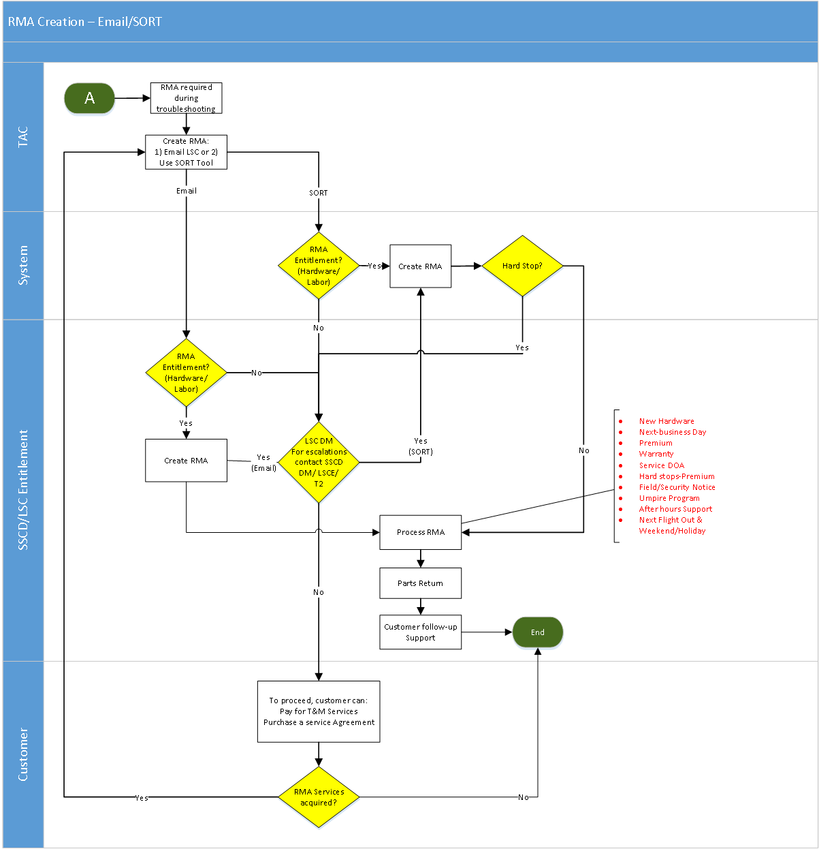

Opening a Case
A customer can open a case for TAC support using one of the following methods:

- Global TAC Sourced Support - Contact Center Services Agent
  - Customer calls CIN
  - Customer sends email

- Case opening Tool
  - SCM Tool/C3
  - SMART Call Home tool
  - B2B Tool
  - Cisco Technical Support Mobile App

Receiving Support
    - Case is opened.
    - Verify TAC entitlement (Regardless of the way the case was opened.)
    - Once entitlement is verified, send the case to TAC for support.
If entitlement cannot be verified, route the case according to the following:
- Entitlement Support - route the case to Global Service Relations.
- Hardware replacement entitlement issues, route the case to the logistics entitlement team.

TAC Pre-RMA Support
For cases where the customer requests hardware replacement, TAC should encourage troubleshooting the issue BEFORE shipping out a hardware replacement. Inform the customer that troubleshooting their network first is the fastest and most efficient way to address a problem.
- CSEs may contact their managers when customers refuse to troubleshoot down to the individual part (FRU) level prior to an RMA or when troubleshooting is being questioned. If the CSE’s manager is not available, engage the TAC DM.
- The engaged manager or TAC DM needs to review the request with LSC DM to get an exception for troubleshooting requirement and verify availability of parts.
      - MFS Pre-RMA Support
- MFS case should automatically be routed to MFS LSC queue for RMA support. DO NOT PROCESS ANY MFS RMAs.

RMA Entitlement and Escalation Support
TAC is not authorized to create unentitled (a.k.a. “Non-Contract”) RMAs unless approved by LSC Entitlement. For Hardware entitlement and RMA exception requests and support, please contact the LSC Entitlement Team at the numbers listed LSC/GSR contact information section.
See Appendix B for Entitlement Criteria
See Appendix C for Entitlement Engagement and exceptions to these requirements.

EMEA Only RMA Entitlement Support
- Use the SORT tool and verify entitlement.
- If entitlement cannot be verified through the SORT tool, engage LSC for support.
- Email LSC with request to create RMA
- The RMA By LSC is an additional option for Europe and the Emerging East Backbone TAC to submit a RMA.

Account Team Entitlement Exception Requests
Account team members are not authorized to approve entitlement exceptions. The following guidelines apply to account team entitlement exception requests:
- Can only request an exception with business justification and the ultimate decision lies with the on SSCD DM/LSCE/T2.
- May occasionally request a RMA for part different from the part under contract. However, these are exception cases and require approval from SSCD DM/LSCE/T2. Refer to Appendix C - Entitlement Engagement and Exceptions.
Note: Customer Satisfaction should not normally be used as a reason to supply an otherwise unentitled RMA to a customer. “Customer Sat” RMAs are expected to fall into one of the approved in-policy entitlement exception categories. For those approved in-policy reasons, a part may be shipped from Manufacturing if parts are not available from normal sources. Approval from the LSC Duty Manager is required.
We always want to help unentitled customers obtain the help they need. If you are working with an unentitled customer, ask them to contact their account team or point of sale to update their service contract.
Furthermore:
- TAC can also hand off cases to the Service Relations Team (queue "Entitlement-Enterprise" in CSOne)
- TAC Frontline should NOT refer to, or mention the Cisco Entitlement Exception Management (CEEM) program to customers.

LSC Duty Manager (DM) Engagement
Escalations for RMA entitlement issues should first be directed to the LSC Entitlement.
If LSC Entitlement is unable to resolve the request, the SSCD DM/LSCE/T2 can be requested for further escalation.
Use the following steps to engage the Duty Manager:
To engage the Duty Manager for escalation, do the following:
- Go to the following webpage: http://tools.cisco.com/support/dmrtool/home.dm
- To contact the On-Shift Duty Manager:
  - Enter the Theater Name
  - Press the Search button
  - Theater On-Shift Duty Manager information will display.
- Refer to Duty manager Roster & Schedule to identify the SSCD DM/LSCE/T2 on shift.
- Questions/Escalations related to a replacement SO must be directed to Customer Service cs-support@cisco.com.

Contacting LSC Entitlement and Global Service Relations (GSR)
Use the following table to contact LSC or Global Service Relations.

Region | Contact Information
Americas | +1 919 574 1662 or +1 408 902 6769
EEME | +32 2 704 5131
APAC | +61 2 8446 7434
Japan | +81 3 6738 5696
LSC Entitlement: | Select Option 1
Global Service Relations | Select Option 2

Failing Entitlement
If an RMA goes on Entitlement Failure Hold, the RMA will be picked up by the Logistics team on shift:
- For Premium RMAs: Within 15 minutes. All theatres handle Premium RMAs using a follow the sun model.
- For Standard RMAs: The SLA for standard RMAs could be different for each region. If the RMA is created while the theatre is off shift, the RMA hold will not be picked up until the theatre is back on shift.
- Standard RMAs do Not ship after theatre business hours; therefore, will remain until the following business hours start, per each theatre.
- -------------Notes--------------------------------------------------------------------------------------------------------------------------------------------------------------------------------------------------------------------------------------
- Do not call Entitlement (Logistic Support Center or Global Service Relations) for an entitlement check before attempting to create the RMA with the SORT tool. Instead, rely on the messaging in the SORT tool while creating the RMA to determine if entitlement requirements have been met.
- Refer to LSC Entitlement and Engagement section for instructions on why, when, and how to contact Logistics Entitlement.
- Verify the customer onsite contact number and address while creating RMA to avoid any potential delivery delays.
- Use special instructions field rather than additional comments section in SORT for any actions from Logistics Team.
- User Field Engineer section to add any notes for the field engineer.
Backup RMA Process: If SORT Submit is deemed inoperable, reference the Global Service Supply Chain and TAC SVO Down Procedure that outlines the procedure for continued service order processing. In addition, use this procedure for rectifying requests upon restoration of SORT Submit service.

Creating a RMA Service Order
The following sections cover the types of RMA that can be created. For Assembly and Configuration information, please see Section 9 of this document.

RMA Service Order - Original Equipment Manufacturing (OEM)
- OEM MCS / Unity server support is always via NBD service level due to the weight limitations.
- Only countries that are NOT supported by OEM (see country list at List of Countries NOT Supported by OEM) can be serviced by using the Cisco RMA process. Customer must agree to pay for all import taxes and duties. All import rules and regulations will apply. Refer to the MCS Support procedure EDCS-977381.
Logistics will not support an RMA if B2B CoSentry TAC team has not been engaged, OEM vendor engaged, troubleshooting has been performed & parts replaced

RMA Service Order - Hardware New
- CAP Customer (Customer Assurance Program) – Required replacing faulty part equipment for a CAP customer.
- Pending Upgrades - Field notice is pending approval; for details on Field Notices refer Sec 6.7. To ensure a replacement order is generated through Manufacturing, TAC will be requested to create a Hardware New (HWWN) request if a problem is consistent with the pending Field Notice.
- For Coding examples – Reference OM document – DOA-HWWN Coding to Create RMA EDCS 1445504.

- After creating a Hardware New RMA in SORT, it gets automatically closed and a replacement sales order and return only RMA are then created.
- For status update of the Sales Order, please contact Customer Services at the following numbers.
EMEA - +31 20 485 45 00
Others - +1800-553-2447 Opt 2 (wait for automated voice to say “Opt2” before selecting Opt2)
- Sales Order Look Up Tool - https://cisco-apps.cisco.com/cisco/psn/commerce
-------------------Note----------------------------------------------------------------------------------------------------------------------------------------------------------------------------------------------------------------------------------------------
Long Lead Times – New Hardware replacements are not shipped within the usual NBD or Premium ETA due to reasons listed below. It can take up to several weeks for the parts to ship and be delivered. The expected ship date is documented on the corresponding sales order.
  - Equipment is a result of acquisition
  - Equipment is too new and service has not yet received seed stock, or
  - Planner foresees a delay in repair cycle. This is usually approved by the planner.

RMA Service Order – Advance Replacement
- Advanced Replacement is considered a Service Level option based on the customer's contract.
- There are several options under the Reaction Hour/Date for Advanced Replacement:
  - Same Day Ship Regional
  - Next Business Day
  - 8th Business Day
  - 10th Business Day
  - Same Day Ship
- In case of Next Business Day (NBD), all advance replacement RMA requests must be placed before NBD dispatch deadlines to be shipped the same day requested. These times are for Cisco logistics centers or depots that the part will ship from.
- Any RMA created after 17:00 local time to the respective theater’s depot, will ship NBD during the next Business day.
- Cut off time for Config RMAs is ~13:00, which gives the Config team time for assembly and testing.
- Orders must be submitted in the SORT Submit tool before 3 p.m. local time at the center supporting the request. Any RMAs created after 3pm LT, will be taken as the next business day order.
NOTE:
- For shipments going overseas via APO/FPO or FedEx the shipping method must be changed from Next Business Day (NBD) to Same Day Ship (SDS) due to Transit times to Afghanistan, Kuwait & any other country that RMA is shipped to from the US.
- Please refer to slides 5 & 6 of the RMA Requirements PowerPoint package for guidelines to create RMA for APO/FPO or Military base.

RMA Service Order - Premium
- "Premium RMAs" are RMAs done for customers with a 4-hour, 2-hour, or Premium Next Business Day replacement contract for parts and/or labor.
- These contracts are identified in SORT as a "service level" with "Premium Parts."
- In almost all cases, an upgrade to a Premium RMA from an Advanced Replacement RMA is not possible, unless stock check has been completed and approved by LSC Entitlement.

RMA Service Order - Warranty
RMAs entitled under warranty should be created at the service level associated with the warranty. A service level other than what the terms of Warranty specify must be approved by LSC Entitlement or SSCD DM/LSCE/T2.
For details on Warranty Service Levels and Warranty Entitlement refer Appendix D.

Field / Security Notice (FN / SN)
- A notification published for significant HW, SW or Other issues that directly involve Cisco products and typically require an upgrade, work-around or other customer action.
- Typically published externally on Cisco.com but may be restricted to Cisco-Internal only publishing.
- Following tools can be used to identify FN associated with a product:
- TAC Support Library - http://www-tac.cisco.com/Support_Library/
- Field notice tool - http://wwwin.cisco.com/pcgi-bin/CustAdv/PSE/tools/FNsearch.cgi
- Cisco Security Advisories - http://tools.cisco.com/security/center/publicationListing.x

Internal or External FN / SN Found
- CSE identifies the customer product being impacted by the existing FN/SN.
- CSE to update SR and follow the “Workaround / Solution” section of the FN/SN to appropriately address HW failure
- Fix On Failure or HW replacement is required – CSE creates an RMA flagged as follows:
  - Failure Class = Administrative Request
  - Failure Code = Field Notice Alert
- Follow instructions in the FN/SN for RMA entitlement, RMA creation, and RMA service level. Most FNs / SNs will utilize the UMPIRE process for hardware replacement. Utilize the UMPIRE process to create RMAs when indicated. (See instructions below in section 6.7.2 – 6.7.4) If RMA is not indicated as a remedy for the FN/SN, DO not provide a RMA. If RMA is indicated as a remedy but no instructions are provided, use Standard Next Business Day (NBD) service level.
-------------------------Note:
- Internal FN should not be disclosed to customer for any reason. An exception should only be made if there is data in the FN that can be shared with the customer.
- Standard SLAs may not apply for Field Notice replacements; refer to the “Workaround / Solution” section of the FN/SN for additional guidance.
- Do not mention anything about the Field Notice in the Failure Description field when creating an RMA for an internal-only field notice. The customer will be able to see the contents of the Failure Description field and therefore it is critical that internal details (such as the internal-only Field Notice) are not shared in that field.
- TAC documents resolution and closes SR when replacement has been received and fix has been confirmed.

UMPIRE (Upgrades Management Program Including Reporting)
UMPIRE is a standard process Cisco uses to upgrade/replace large volumes of defective hardware in the field with new, repaired or refurbished product of equal or greater functionality. It is typically associated with a FN/SN but may be launched without a FN/SN for issue impacting 1 ~ 2 customers. Umpire programs can be external or internal.
UMPIRE Process - CEC - Cisco Confidential
---------------------Note--------------------------------------------------------------------------------------------------------------------------------------------------------------------------
In case when CSE did not notice an active FN/Umpire program and creates RMA, SSC would reject the RMA. CSE would follow steps in 6.4 for active FN and follow steps in 6.5 for active umpire program. SLA’s do not apply for UMPIRE replacements. During RMA creation, once PID is entered, Part Notes will indicate if there is active Field Notice/Umpire program. There will be an FN# and URL to FN.

No FN/SN Umpire Programs Found
- TAC troubleshoots and decides a HW replacement is needed
- No existing FN/SN or UMPIRE programs found
- Standard entitlement and RMA creation processes are followed

Internal or External Umpire Program Found
- TAC troubleshoots and decides a HW replacement is needed.
- CSE identifies the customer product being impacted by the existing UMPIRE.
- CSE or Customer completes the UMPIRE Upgrade Form and submits form for processing (Form can be found in the field notice tool associated with the Field notice)
- RMA is created by Customer Service Help desk
- TAC documents resolution and closes SR when replacement has been received and fix has been confirmed
------------------------Note------------------------------------------------------------------------------------------------------------------------------------------------------------------------------------------------------------------------------------
If the customer requests failure analysis, reference Global TAC CSE Failure Analysis Process #701038 to create the FA case.

RMA Exceptions/Special Handling
All RMA exceptions require SSCD DM/LSCE/T2 approval. For details of exceptions refer to Appendix C.

RMA Entitlement Exception Requests
Before any unentitled RMAs are created, LSC Entitlement must be engaged to ensure that
- The RMA requests meets the criteria of an in-policy entitlement exception
- Out-of-policy exception requests follow any required in-theatre exception processes including documentation of approvals from required Service Sales Directors or LSC Duty Managers
- Part availability is confirmed by LSC before RMA creation in order to avoid setting customer expectations incorrectly and to avoid raiding parts being reserved for entitled customers to fulfill orders for any unentitled customers
In situations where TAC users do not have access to create unentitled RMAs. LSC will create the RMA once the criteria listed above are confirmed. TAC may create a temporary RMA up to the point where they receive a hard stop, save the order as a temporary RMA, and then engage LSC to complete the RMA creation after validation of RMA Entitlement Exception requirements.

RMA Exception/Special handling – through pre-defined rules
EXCEPTION HANDLING is a capability that builds in a workflow for certain RMA exception approvals into the SORT tool itself. TAC no longer has to request manual approvals (for pre-defined scenarios) with LSC or SSCD DM. Once the pre-defined business rule is met (during RMA creation), it will put the TSO (temporary service order) on HOLD and trigger an exception request to either LSC or SSCD DM. LSC or DM can then APPROVE, REJECT or CONDITIONALLY APPROVE the TSO.
Approve – If LSC/DM approves the exception request, it will automatically submit the TSO into an ORDER. TAC will be notified via email & the SR will be updated automatically.
Reject – If LSC/DM rejects the exceptions request, TAC will be notified with appropriate comments. The SR will be updated as well. The TSO is then unlocked for TAC to go back and make edits and re-submit based on LSC/DM comments
Conditionally Approve – LSC/DM can conditionally approve. This will unlock the TSO, for LSC/DM to make the change before submitting the order. LSC/DM will consult with TAC before conditionally approving.
The approvals will be handled like any entitlement exception approval today.
Here are some examples of pre-defined rules for which automated exception handling process will apply. This list will continue to grow as and when we keep adding new rules.
- TAC is requesting a Loaner RMA (typically a proactive RMA). The rule will be triggered when Failure Code is selected as ARLN.
- TAC is requesting an RMA over entitlement failure. The rule will trigger when entitlement failure variance reason is selected as Fire/Safety/Health or Acquisition RMA- Legacy SN not in IB
- TAC is requesting an RMA which needs service level uplift. The rule will trigger when service level variance reason is selected as Billable Service Order or Authorized by Discrepancy Team
- TAC is requesting a MFG New → Orders for next business day delivery, received after 3pm local warehouse time, will be processed the next business day. Shipping dates are subject to manufacture lead times.

Proactive RMAs
As a TAC engineer, when you suspect a proactive RMA is requested, do the following:

- Proactive RMAs require approval from the LSC DM prior to creation. No proactive RMA will be processed without SSCD DM/LSCE/T2 approval.
- For APAC and Europe, LSC team will create the RMA.
- For America, TAC will create the RMA and should obtain the necessary approval from the SSCD DM/LSCE/T2 before creating the RMA. Approval from SSCD DM/LSCE/T2 must be documented by the respective DM in the service request notes using the required LSC process / template.

3-Way RMA
The Cisco Spares Onsite Service (SoS) is intended to supplement a current support agreement for Cisco products and is only available when product(s) in a customer’s network are supported through a minimum of Cisco’s core device level maintenance services such as Cisco’s Smart Net Total Care and Cisco’s SP Base, amongst other core services. Customer entitlement will continue on Foundation Contract (SNTC, SP Base etc.)
TAC assists with 3-Way RMA, where applicable. The 3-Way RMA process follows the RMA Entitlement Escalation Support outlined in this document in Section 4.4 above.
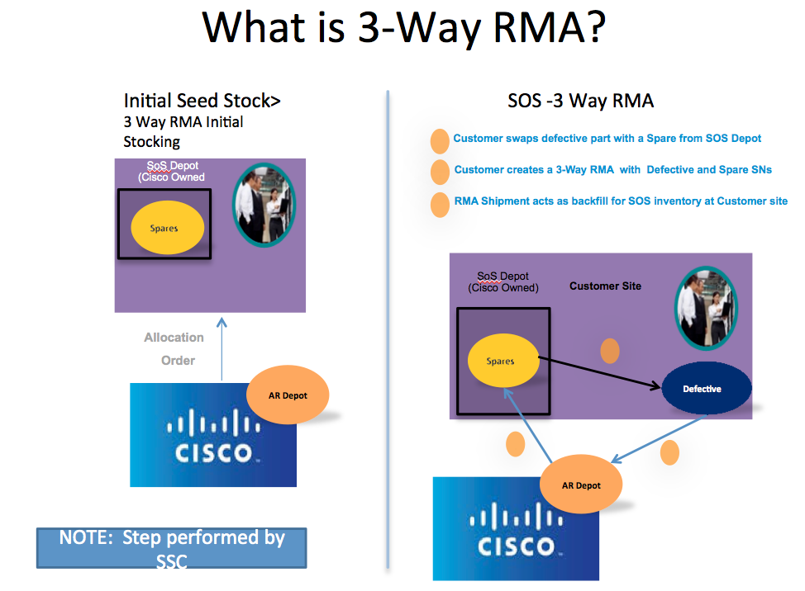

Currently, the customer calls the 800 # for support and selects the option to get SoS inventory replenishment. This is transparent to TAC. However, when a customer makes the request via the SORT tool, TAC will see a SoS pop-up menu and complete the Serial numbers for replenishment.
The following is a sample of the pop-up message engineers will see when the customer is eligible for Spares onsite (SOS) or 3-way RMA.
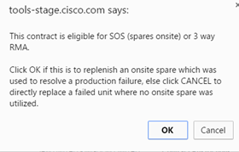

If using the 3-Way RMA, select OK, otherwise select cancel to process a standard RMA (2-Way). See Appendix I for the 3-Way RMA Process Flow.

International Orders
The Customer is responsible for Duties & Taxes for parts shipping International from US NBD depot U06. The Customer must confirm, in writing, to LSC that they agree to pay D&Ts prior to parts shipping. Case notes must be updated with agreement email from customer.
Contact LSC, in the respective region of the customer, with additional questions and inquiries.

Next Flight Out (NFO) and Weekend / Holiday Delivery Processing
LSC Entitlement should always be contacted prior to creating an RMA for expedited service to ensure that the customer is not subject to fees for Time and Materials. Parts for RMA - NBD service orders will be sent in the most expedient method possible.
- Reference Logistics for special instructions on arrangements for these actions:
  - NFO can take from 8-18 hours to deliver. Time Requirements should be provided to customer prior to creating the RMA in order to level set their expectations.
  - For any NFO that is approved, the customer must be present at the shipping address and ready to receive the package.

For details, refer Appendix C.

Equipment and Type Limitations
Any Heavyweight shipment is defined as FRU (product over 150 lbs. or with total dimensions [length + height] exceeding 82 inches) and must normally be dispatched by 8 a.m. local time from the respective logistics center location for next business day delivery. If it is not ordered by 8 a.m. local time, then the order will be shipped by commercially reasonable means. This usually means delivery, at minimum, two days later. See Service Delivery Operations for more details. Warranty support for UCS-B and UCS-C Series Blades and Servers is NBD (Next Business Day) and is applicable globally.
For FRU Availability Confirmation, contact Logistics Entitlement and provide this information:
  - SR number
  - Customer name
  - Part number
  - Serial number
  - Problem summary
  - NBD or 4H replacement
Refer to Appendix E – Field Replaceable Units for details on GSSC Global Heavyweight Policy and Appendix F for details on FRU Quantity Limits

Loaner Equipment
Loaner requests are a temporary equipment work around. Loaner requests must be approved by SSCD-DM/LSCE/T2. Contact LSC Entitlement for loaner equipment availability.

Service Coverage
Customer locations for which the RMA is requested may not be under the service coverage. In such situations SSCD DM/LSCE/T2 may need to be engaged.
      - Certificate of Insurance (COI) – Liability Request
Customer requests Certificate of Insurance – Liability from the Third-Party Maintenance (TPM) vendor, (Field Engineer) see description below.
Global Risk Management Form – Certificate of Insurance

- RMA Originator provides customer with COI form to fill out with their information
- Customer returns form to RMA Originator asking for COI
- RMA Originator attaches completed COI form to Service Request.
- RMA for FE is created must be scheduled 3 days out from day of request.
- RMA Originator: when creating RMA Special Instructions must be added that customer is requesting COI (if not added RMA will be process without COI). Special Instructions should be:
- Customer requests Certificate of Insurance. COI form has been attached to the Service Request.
- Logistics must send COI form to TPM vendor to request COI information.
- TPM has up to 3 business days to provide said information.
- Once COI form has been returned by TPM vendor Logistics will send completed form to the customer and update case notes.
Certificate of Insurance (COI): A document issued by an insurance company/broker that is used to verify the existence of insurance coverage under specific conditions granted to listed individuals. More specifically, the document lists the effective date of the policy, the type of insurance coverage purchased, and the types and dollar amount of applicable liability. A certificate of insurance is often demanded in situations where liability and large losses are a concern

Assembly and Configuration
Requests for assembly and subsequent Networking Software (IOS, IOS XE, IOS XR, NX-OS, and CATOS) uploads are a courtesy that Cisco can provide, for most equipment.
→There is no contractual obligation for Cisco to support this type of request. Config is only supported Monday – Friday during standard business hours and orders must be submitted prior to cut off times.
Configuration product support
Customers can request their parts be assembled prior to shipping, but the CSE must use the Configuration tool when creating the RMA.
→Not all equipment is supported for networking software. We do not have a list of that equipment and will not be able to provide that information.
If the CSE is unable to find the networking software when creating the RMA, that means our Config team has not activated that part or networking software in their system yet, and are unable to update the networking software or assemble the parts.
Strong encryption software
→Any networking software requested that has “k9” encryption in it must be requested using the Config tool when the RMA is created, otherwise the part will be shipped with the default networking software listed. Special Handling CANNOT be used in place of the Config Tool.
Due to US Federal Government regulations, Cisco is no longer allowed to support any requests for “k9” without using the Config tool because all “k9” networking software is monitored by our government.
Reference the License Transfer Option section in this document for instructions on how to open a case with the Config team.
If the Config tool does not present the networking software you are searching for that means it is not supported at this time by the Config center and the part must be sent to the customer with default networking software.
TAC has the ability to assist the customer with loading “k9” encrypted networking software utilizing cisco.com.
License transfer option
Transferring licenses within a configured RMA will be made available to a limited set of products. This service provides the customer an alternative to the process of transferring their existing licenses via SLT (Software Licensing Tool). The RMA creator will not see a difference in the Configurator itself when choosing the hardware and/or software for assembly. A new set of windows will be initiated (if the product has been enabled with this option) upon successful selection for configuration prior to being returned to SORT’s Review and Complete Your Order page. Please note that it is highly recommended to enter a value in each field that is presented and that the values expected are case-sensitive.
Our FAQs are now accessible at https://cisco.jiveon.com/docs/DOC-321469
If the “k9” encrypted IOS you are requesting is not available via the Config tool, please submit feedback to the Config team via the instructions listed below.
Open a case with us for any inquiries you may have by following the instructions below.
- Access SVO Feedback (https://tools.cisco.com/support/serviceordertool/feedback.svo?app_id=SVOSUBMIT )
- Select “Service Configurator” from the Tools dropdown.
- Select the appropriate option from the Category dropdown (this topic would fall under “Other”).
- Enter applicable information in the text box.

Parts Return
Each shipment includes instructions for returning the failed part(s) to Cisco. A Prepaid Airway Bill (PPAWB) is included per box. It’s for all RMA that is supported from Services supply chain. These are usually "GROUND" service level for returns. If the POWR tool was used, a pick-up will be scheduled automatically. If prepaid waybill(s) was used, the customer will need to use their organization's outgoing shipping to return the package. The shipping costs will be covered by Cisco.
-------------------------------Note------------------------------------------------------------------------------------------------------------------------------------------------------------------------------------------------------------------------------------
Not all countries and/or all Theatres support using the POWR tool to return defectives. Some countries and/or Theatres require that the customer be responsible for paying for and returning product.

***For contracted Service RMA returns within U.S., Canada, European Union, Norway, Switzerland, Iceland and Israel please visit: Product Online Web Returns (POWR) Tool

Return Addresses
- Refer to Return Material Authorization (RMA) instructions for Cisco authorized return locations
- Cisco Product Online Web Returns (POWR) Tool
- For additional addresses or questions, refer to the Return Material Authorization document.
- For packing details, refer Appendix G.

RMA Request - Customer Follow-up Support
Follow-up with the customer on RMA orders to confirm product receipt.
- Contact the customer via email or telephone.
- Verify product receipt at the customer site using details provided within the RMA. If unsure, contact LSC.
- Advice customers to track product transit status at Cisco.com and at transport / delivery companies' websites by using their tracking tools.
- Provide new Sales Order and corresponding RMA number to the customer.
- Refer the Shipping and Logistics page to track the new order.

Failure to Meet Delivery Commitment Date
If the customer did not receive the order by the expected commit date, the CSE will determine the status of the RMA. The CSE is responsible for checking the case notes and then reviewing the RMA to see if there are POD details or OM note on the Notes tab prior to contacting LSC:
- Check the Order Status Tool or SORT Status Tool depending on the order type, e.g., CS Order / RMA or Service Order.
- Contact Logistic Support (LSC) if information in Status Tool is unclear
- Contact customer personnel if Transport / Delivery Company show delivery of the RMA.

RMA / SORT Training

New Access Training
New SORT Access Training is for all users who want to access SORT for RMA creation. Training modules are located at Service Order RMA SORT Training in EMS.
Once new users have completed training, they will be required to pass the COLT SORT Assessment before access to the SORT Tool can be granted in OnRamp.
Round Trip RMA training.

Refresher Training and Assessment
Users who need to regain access to SORT are encouraged to take the refresher training course in EMS entitled: “SORT Refresher June 2009”.
TAC SORT Users will be required to complete the COLT SORT Assessment at a minimum of every two years in order retain their access to SORT.

Process Compliance

Compliance Effective Date
This process becomes effective upon the last date of approval as noted in Cisco’s document management system.

Compliance Measurements
Compliance with Cisco processes is required. Compliance to this process may be verified through various methods, including but not limited to, reports from available business tools, internal and external audits, self-assessment, and/or feedback to the policy owner. TAC managers will enforce compliance with this policy.

Compliance Exceptions
Exceptions to the terms of this process are handled on a case-by-case basis only. Exceptions require written approval by Executive (Director or above) to non-comply for strategic business reasons. Documented exceptions and justifications will be communicated to affected technical services organizations immediately upon approval.
Any records of exceptions including Theater-specific handling requirements (local processes) should be approved and archived according to the Cisco Records Management Process, and not on an individual’s laptop.

Non-Compliance
Compliance with Cisco processes is required. Deviations or non-compliance with this process, including attempts to circumvent the stated process by bypassing or knowingly manipulating the process, system, or data may result in disciplinary actions per Cisco’s company policies, up to and including termination.

Related Policy, Process, or Procedure
Service Entitlement Policy
Order Management - Global Expedited Services (NFO) Dispatch WI Procedure
New Product DOA Replacement Policy
TAC Case management process

Supporting Documents and Tools
The following documents support this process:
Cisco Product Warranties
Customs - Theatre
Field Notice Search Tool
FN/Umpire Program Training
Return A Product
Global Logistics Entitlement Failure Hold Work Instructions
Global Logistics RMA Entitlement Determination Work Instructions
Global OM APJC Services Entitlement Exception Request Process

SSCD tool used in case of logistics delivery issues analysis - http://wwwin.cisco.com/CustAdv/ts/tso/uscan/sdo/satt.shtml

Tool for Asia Pacific - http://tac-syd-001/brr/

Definitions
Defined terms are located at 1147899 TAC Glossary of Terms.

Approvals
For a record of the approval history, go to this document’s information page.
Organization | Name
TAC Americas Delivery (East) | Ullie Versavel
TAC Americas Delivery (West) | Hector Acevedo
Global TAC Sourced Support – CSE Services | Brian Fady (Proxy - Michele Paino)
Global TAC Sourced Support – Contact Center Services | Brian Fady (Proxy - Brendon Nilson)
TAC AP Delivery | Allyn Medway
TAC - EMEAR | Adrian Purcarea
HTTS | Derek Hampton (Proxy – Miles Cooper)
Cloud Support, CALO & Incident Mgnt | Marty Martinez
TS APJ+GC | Colin Soh
TS EMEAR | Rik Boven
TS Americas | Marty Pantoja

Revision History
The revision history is located at the following link:
https://docs.cisco.com/share/page/site/nextgen-edcs/document-details?nodeRef=workspace://SpacesStore/db977962-cd32-4a99-9ffc-5c5c49fbde6f

Appendix A – Team Descriptions
Team | Description
LSC Entitlement | LSC Entitlement does not process RMA requests. LSC Entitlement supports:  - Inbound phone calls from Cisco Internal to review entitlement  - OMC-ENTITLEMENT queue by reviewing Entitlement for Service Request  - Entitlement Failure Holds to ensure entitlement is being enforced at the contracted service level  For further entitlement inquiries please reference the RMA Entitlement Determination Work Instruction: http://wwwin-eng.cisco.com/BMS/CA/GPS/SSCD_Global_OM/Global_RMA_Entitlement_Determination_WI_Procedure.doc
Service Supply Chain (and) Delivery (Logistics) | Creates Service Orders for customers through inbound phone calls for selected Next Business Day and Premium Contracts.  - LSC does not create warranty, RTF, DOA or Demo Depot requests  - LSC performs full entitlement check before RMA creations  - LSC is able to take a partially completed order that has been saved as a temporary order by a TAC CSE and complete the order.  - LSC is the only team able to create orders that bypass hard stop controls. (Entitlement and exception processes are followed before creating unentitled RMAs)
Global TAC Sourced Support - Contact Center Services | Global TAC Sourced Support - Contact Center Services is the first human interaction point into Cisco and has a direct impact on the way that customers, partners and employees perceive Cisco’s value. With every interaction, our contact center agents represent Cisco Brand -- they are a trusted resource that customers go to when they have problems.  Global TAC Sourced Support - Contact Center Services helps improve access to Cisco by providing a person for customers to go to when they are stuck. They help customers by connecting them with experts in other organizations, providing answers to questions or resolving their issue and guiding customers to online resources – from answers in the Cisco community to tools available on Cisco.com.
Global Service Relations (GSR) | Global Service Relations is a 24x7 operation. The goal of Service Relations is to assist the CSE and customers by verifying entitlement to the Technical Services being requested. They will assist with providing options for support when entitlement cannot be validated. GSR handles entitlement issues related to TAC cases. LSC Entitlement handles entitlement issues related to RMAs.
Technical Assistance Center (TAC) | The Technical Assistance Center (TAC) is a worldwide organization that provides timely, accurate issue resolution from highly qualified experts with a rich history of innovation.  At Cisco, Service Supply Chain (SSC) is the organization that delivers the right goods and services to the right place at the right time, in the proper quantity, and at an acceptable cost. The Service Supply Chain is a cyclical process that ultimately is meant to drive the customer experience, and consists of several key processes or steps including: (  Plan inventory  Order parts  Deliver parts  Onsite service  Return parts and process returned parts  Repair parts
Licensing | The Global Licensing Operations team is available 24 x 7 x 365. Software licensing is a company-wide strategic initiative. By focusing on these things that will make it easier to do business with Cisco, we will bring the scales back into balance and improve customer satisfaction.

Appendix B – Entitlement Criteria
A customer/partner is entitled to an RMA when the Cisco product to be replaced meets one of the following criteria:
- Service Contract – The serial number is linked to a valid contract in CSCC, and the contract links to the correct company. If this is a NBD or AR RMA, a contract should always be used to open the order with the serial number added to the appropriate field. Some service levels may require the inclusion of the part ID and the requested location and the service level requested.
- Repair and Replace Actions - Repair and Replace refer to "RTF" and is identified by contract entitlement. Email to lmo-help@cisco.com (US) or euro-lsc@cisco.com / emerging-lsc@cisco.com(EMEA) or apac-lsc@cisco.com(APAC). Contact LSC for assistance with creating the orders. Warranty – The product is covered under a valid hardware warranty, and the user is entitled to receive warranty support. Direct customers are entitled to hardware support directly from Cisco. Indirect customers refer to their point of sale for a hardware replacement, except for those customers in the US, Canada and Australia. Customers with refurbished products are also entitled to get warranty support directly from Cisco. For more details, refer to https://cisco.jiveon.com/docs/DOC-1026023
- Field Notice / Security Notice – FN/SN may allow hardware replacement as the remedy for the FN/SN. See details in section 6.7.
- Demos / Evaluation Equipment – Products sourced through the Demo Loan program are entitled for support. Refer to the following links for more information:
- CCRE - Cisco Certified Refurbished Equipment
http://wwwin.cisco.com/FinAdm/csc/remarketing/program_overview.shtml
  - eSTAR - Demo Loan Program
http://wwwin.cisco.com/cisco/ops/gbs/cpe/cvs/dlp/#tab=0
  - Try and Buy
http://wwwin.cisco.com/cisco/ops/gbs/cpe/cvs/dlp/tab/#tab=0
RMAs can be created in the following cases:
- Request passes entitlement check related to one of the four entitlement categories listed above.
- Request falls under an in-policy entitlement exception in compliance with the CA Entitlement Policy .
- Request does not fall in above 2 categories – but CEEM exception request approval process is followed and any required in-theatre processes to request entitlement exceptions have been followed and properly documented. See CEEM Jive Community for more information.

Appendix C - Entitlement Engagement and Exceptions
Contact LSC Entitlement for the following reasons only:
- Entitlement Holds, Hard Stops, or RMA Entitlement Exceptions –LSC Entitlement must be engaged on unentitled RMA exception approvals. This includes, but is not limited to RMAs that go on Entitlement Holds or SORT Hard Stops that prevent RMA creation.
- Contract Association Support - If the contract that entitles the RMA is not associated with the customer's Cisco.com ID, engage LSC Entitlement to determine if it is possible to associate the contract to the customer's profile prior to RMA creation. Be prepared to provide LSC Entitlement with the customer's Cisco.com ID and the customer provided Serial Number and/or Contract. This will allow you to create the RMA using the correct contract and correct service level.
- Entitlement Messaging and Hard Stops – Assistance with questions concerning hard stop controls or other entitlement messages.
- Time and Materials – Assistance with Time and Materials quotes for unentitled RMAs or uplift of service from the entitled service level to a faster service level.
- Part Availability – Questions about part availability:
  - Contact LSC Entitlement for requests for expedited service
  - Warranty downgrades
  - RMA or line(s) cancelled
  - Full chassis part availability if warranted by adequate troubleshooting (TAC DM should be engaged if customer is unwilling to troubleshoot).
  - Multiple parts
  - Delivery uplifts

Below requires approval from SSCD DM/LSCE/T2:

Exception | Guidelines
Customer Assurance Program (CAP) Manager Request | Service Request/Orders for Critical customers’ accounts may bypass entitlement requirements, when requested by the CAP Manager.  Prior to creating the RMA, a member of the CAP team should verify part availability via the OM Duty Manager. http://tools.cisco.com/support/dmrtool/home.dm
Accounts Team Requested  Entitlement Exceptions  Requests for Expedited RMA Service Level above what the customer is entitled to receive | Account team members do not have the authority to approve entitlement bypass. They can only request an exception with business justification and RMA entitlement exceptions must be requested via the Cisco Entitlement Exception Management (CEEM) Process. See CEEM Jive Community for more information. In most theatres, RMA exception approvals are made by Service Sales Directors who are responsible for service sales for that customer or line of business. LSC Duty Managers may also make CEEM approvals in extremely urgent, high customer impact situations where approval from the Service Sales Director is not possible in the timeframe required.  CSE Responsibilities:  If the account teams’ request meets the above guidelines, the CSE should complete the following steps to open an RMA:  - Confirm CEEM Exception Approval.  Case notes must be updated with an Approved CEEM Exception Request record.  - Call LSC Entitlement to check availability of the hardware and the Service Level Agreement on which the parts will be dispatched. LSC Entitlement may collaborate with the parts planner to determine if request can be supported. LSC Entitlement may reach out to their escalations team and/or the SSCD DM/LSCE/T2 to get assistance when the Planner is not available.  - Once LSC Entitlement confirms part availability, create the RMA and under additional comments include a note about the request from accounts team. If the RMA request is for a different part, mention that the part(s) being shipped will not be the same to be returned. Also, mention the part ID to be returned in the notes.  - The RMA will be updated by LSC (a ship only line for part(s) being sent and a return only line for the part(s) being returned) to reflect the Instructions that Asset Recovery is aware of this so the customer does not face any problems with parts being rejected.  - The RMA will be processed.  - If request is not approved, C customer should be conveyed on the status and direct to the Accounts team.
Accounts Team request for parts different from parts under contract. | Reasons for request as follows:  - Network design issue that requires different hardware  - Hardware upgrade required to support a new feature  - Other reasons with proper justification  Requires SSCD DM/LSCE/T2 approval and also any in-theatre entitlement exception processes must be followed and properly documented.
Product Security Incidence Response Team (PSIRT) notice | Security Advisories and Security Notices may entitle a customer to receive access to TAC Services, RMA, software patches or upgrades, and/or technical information to mitigate the security hole, as described in the terms of each specific PSIRT Notice.
Product Field Notices | May entitle a customer to receive access to TAC Services, RMA, software patches or upgrades, and/or technical information. This is to mitigate the product defect, as described in the terms of the specific Product Field Notice.
Life or death situations | For any Severity 1 situations impacting an emergency center, such as hospitals, policy, fire departments or emergency response centers (911, etc.) which causes a life-threatening situation for the public, Cisco will provide Technical Assistance and /or Hardware replacements. Verify part availability with the OM Duty Manager prior to creating the RMA. http://tools.cisco.com/support/dmrtool/home.dm
Time and Materials | Customers may purchase one-time technical support or RMA incident if excess parts are available at the requested service and Cisco can obtain payment for the service. This can be done either via Credit Card or purchase order. TAC agent would engage LSC Entitlement to ask for T&M quote. This is a ONE Time last resort and is extremely expensive.
Acquisitions | RMAs for acquisition products where the legacy install base (IB) records are not stored in our systems. In most of these situations, TAC should have an alternate method of checking RMA entitlement often using legacy systems from the acquisition company.
"Act of God” | An "Act of God" is a natural disaster or accident that causes damage outside of the normal wear and tear expected on a piece of equipment. Examples are flood, lightning strike, power surge/outage, fire, user dropped it, or anything outside of normal wear and tear that causes damage or destroys the unit. These issues are not covered under the terms of Cisco service contracts or warranty. See Global Asset Destruction Policy for Service RMAs #999488  Engage the CAP WW Field Liaison - Initial contact for Act of God.
Act of any third party | Theft or accidental damage to Cisco product. Contact the LSC Entitlement team before proceeding. Please see the ‘Loaner Equipment’ information in this document.
Damaged on Arrival | When Customer states Cisco product arrived damaged (classified as "Damaged on Arrival") direct to the Returns Resolution Team.
Mis-shipments | Customer received the wrong new part(s) from manufacturing. Contact the Returns Resolution Team.
Trade-In Returns and Upgrade Orders | Contact the Trade-In or Upgrade Team by email. For Trade-Ins, email to Trade-In Returns. For Upgrades, email to Upgrade Orders.
Under-shipments | New part(s) missing in an order from manufacturing. Contact the LSC Entitlement team before proceeding.
Proactive RMAs | RMAs are sometimes raised for invalid reasons: customers might be entitled, yet there is no hardware failure or service to be restored. A proactive RMA or a just-in-case RMA is then raised to have a spare part available during a network upgrade for instance. In many cases the same part/same serial number is returned to Cisco, unopened and unused. This phenomenon is called Round Trips, Boomerangs, Shot Gunning etc. This is not only costly to Cisco, it also impacts other customers in real need of a hardware replacement, and may cause out-of-stock situations where Cisco could fail to meet customer SLAs.
RMAs for Customer Satisfactions | Customer Satisfaction should not normally be used as a reason to supply an otherwise unentitled RMA to a customer. “Customer Sat” RMAs are expected to fall into one of the approved in-policy entitlement exception categories. For those approved in-policy reasons, a part may be shipped from Manufacturing if parts are not available from normal sources. Approval from the LSC Duty Manager is required.  Those that do not fall into approved in-policy reasons must engage account team for further assistance.
International Orders | Customs is extremely important for APAC and the Emerging Markets East and West. This includes, but not limited to, Russia, Israel, Turkey, Middle East, and Africa. Contact the LSC, in the respective region of the customer, with additional questions and inquiries.  - ** The Customer is responsible for Duties & Taxes for parts shipping International from US NBD depot U06. The Customer must confirm, in writing, to LSC that they agree to pay D&Ts prior to parts shipping. Case notes must be updated with agreement email from customer.  - In case of NBD service orders, Cisco logistics centers that stock and ship parts normally observe local holidays. This means that parts shipped, for example, to Amsterdam may not always arrive the next day if the logistics center is on holiday when the RMA is created.
Next Flight Out (NFO) and Weekend / Holiday Delivery Processing | Requests for Expedited Shipping levels above the level that the customer is entitled to receive must follow the CEEM Process described above.  - Expedited Service (e.g. Next Flight Out - NFO) is not considered a Service Level option but is a ship method.  - Specific NFO Instructions - NFO is a ship method in the SORT Submit Tool. Ship Method options are based on the warehouse assigned to the order.  - Call LSC Entitlement for customer billing issues if NFO is needed for extraneous technical service.  - NFOs are expensive – SSCD DM/LSCE/T2 Approval is required.  - Delivery of NFO will be delayed or denied if SSCD DM/LSCE/T2 Approval is not listed in the case notes.  - Create a Service Order  - Change ship method to "Next Flight Out" on the confirmation page. This triggers a page to the logistics team.  - NFO is not available in Japan, Emerging Markets East-EME, Emerging Markets West-EMW, and most of APAC (except for Australia)  - All NFO orders are reviewed by Logistics prior to being dispatched.  - Order Management - The requirements and process used by Theatre Logistics Operations groups for dispatching Global Standard Service Orders for Expedited Service Dispatch (NFO) are addressed in the Global Expedited Services (NFO) Dispatch WI Procedure.
Loaner Equipment | Loaner requests processing guidelines:  - Prior to creating the RMA, loaners must be approved by SSCD-DM/LSCE/T2.  - Set the proper expectations with the customer:  - Loaner is based on best effort basis and subject to availability of inventory, customer’s situation and circumstances, irrespective of customer’s service levels.  - Loaner is not provided for manufacturing shortages, missed-shipments, product allocation issues, demo, evaluation requests or other sales related projects.  - Only customers with a valid and active Cisco service contract are authorized to receive equipment for system related problems associated with potentially defective part(s). Without a maintenance contract Cisco has no legal agreement and has no legal recourse to collect equipment or monies from customer, if equipment was not returned

Appendix D - Service Delivery Guidelines
The requirements and process used by Theatre Logistics Operations groups for dispatching Global Standard Service Orders for OEM MCS product can be located in Global OEM (MCS) Dispatch WI Procedure.

Service Contract Type | Cut-off Time | Service Level | Depot
SIS98 | Raised before  3:00 pm local time | Same day ship | Country Depot
SIS98 | Raised after  3:00 pm local time | Next-business-day ship | Country Depot
SMARTnet 24x7x4 | – | Dispatch/Deliver per contract | 4-hrs Depot
SMARTnet 8x5xNBD | Raised before  3:00 pm local time | Same day ship, 24-hr delivery guaranteed | Country Depot
SMARTnet 8x5xNBD | Raised after  3:00 pm local time | Next-business-day ship, 24-hr delivery guarantee | Country Depot

Warranty Service Levels
  - 10-Day Advance Replacement - At RMA creation, replacement parts are shipped and failed parts need to be returned within 10 business days.
  - Return to Factory - Cisco will ship replacement parts within 10 business days from receipt of original part.
  - Advanced Replacement - Next Business Day (AR-NBD) or Advanced Replacement - Same Day Ship (AR-SDS)
Warranty Entitlement
  - RMA for products under the UCS Warranty or the Enhanced Limited Lifetime Warranty ( WARR-ELTD-LIFE-HW) are supported by Cisco directly for all customers in all locations regardless of whether they purchased directly from Cisco , a reseller, or a partner.
- RMA for all other Cisco warranties (excluding products handled by the Small Business Support Center) are supported directly by Cisco for customers worldwide who purchased directly from Cisco and for products purchased in the US, Canada, Australia, and New Zealand. Customers who purchased from partners and resellers in other locations get warranty RMA support from their point of sale, not from Cisco.
- The LSC Entitlement team can determine if Cisco can provide the replacement part or if the customer must go back to their reseller.

Appendix E - GSSC Global Heavyweight Policy
Heavyweight and Oversized Equipment is defined as a FRU supported by Cisco Services which due to its physical weight and/or dimensions cannot be safely moved by one person. Specifically:

- Packaged equipment weighing over 50 lbs (23kg).
- Packaged material for which the physical dimensions: length plus girth (the distance around the thickest part of the packaged equipment) exceeds 78 inches (2 meters)
Cisco acknowledges that special requirements are necessary to deliver and warehouse Heavyweight and Oversized equipment which may require a larger van, truck or aircraft; more than one person for handling; larger dock doors; materials handling and/or other equipment; and access to other than commercial flights. Cisco’s policy regarding service levels for equipment which is Heavyweight and/or Oversized is:

    - 8x5xNext Business Day will be shipped as Business Day (NBD); however NBD delivery lead-times times are dependent on the capability of Cisco’s carrier service to deliver NBD from main and country depots. In those cases where NBD service is not available between the origin and destination, Heavyweight and Oversized Equipment will be shipped same day. Support can vary by country to country so please refer to SAM (Service availability tool) as single source of truth

    - 8x5x4, 24x7x4, 8x5x2 and 24x7x2 are selectively available or are available with longer delivery lead-times. Support can vary by country to country so please refer to the SAM (Service availability tool) as the source of information.
Note:
The premium stocking flag for each part must be enabled to allow a part to be allocated and supported from a premium depot. This is decided by BU as part of the initial service plan and some parts will not be spared in the premium depots due to Size (weight),

    - Besides the general terms, some sites located in the EMEAR theatre are subject to additional terms:

- Service levels 8x5x4, 24x7x4, 8x5x2, 24x7x2: will be delivered on a best-effort basis.
- Product exception: The GSR 16, CRS chassis and certain other products (such as plasma screens for Telepresence) are an exception to the theater specific policy. These products can only be shipped on a Next Business Day / Same Day Ship basis from the main warehouse in the country. The TPL Vendor will contact customer to schedule the delivery. The TPL Vendor responsibility stops at delivery to the dock. The end-customer is responsible to move the heavy weight parts to its final location within the end-customer premises.
- Costs: Shipping heavy and oversized equipment may incur more labor and higher cost. Therefore in order to reflect higher costs without introducing a level of complexity in the pricing scheme, 4 hour and 2-hour service levels will be on best effort basis and will be priced on case to case basis depending upon type of part and nature of delivery. The customer typically does not see these costs.

Appendix F - Field Replaceable Units (FRU) Quantity Limits
Customer requests for equipment may exceed stocking levels of FRU parts stored at service logistics warehouses. Stocking follows the expectation that, as per contracts, a replacement will be provided after troubleshooting to the individual piece level, and more than one part may be scheduled for later delivery.
To assure next day delivery for all RMA requests, LSC has implemented the following ordering quantity limits:
- For non-premium and standard orders, the Qty threshold is 2 or more per line and / or order of the same part. When RMA goes on hold, Logistics checks contracted entitlement.
- For premium orders, the Qty threshold is 3 per line or order of the same part. Additionally, there is a premium order Qty threshold hold applied when more than 5 parts are requested on the same order.
- When a Qty threshold is reached, a Qty threshold hold is applied to the order and the LSC manages the hold.

Appendix G - Packing Instructions for All Return Shipments
- Use the disposable grounding wrist straps to avoid static damage when handling parts.
- Reuse the packaging from the replacement parts to return the replaced hardware.
- Securely seal the box(es).
- Write the corresponding RMA number(s) prominently on the outside of each box.
- On the outside of the box, fix the prepaid waybill or the shipping label printed from the POWR tool so the shipping address is visible.
- If the POWR tool was used, a pick-up will be scheduled automatically. If a prepaid waybill(s) was used, the customer will need to use their organization's outgoing shipping to return the package. The shipping costs will be covered by Cisco.
- Note that it may take as many as seven (7) days for Cisco to receive the return shipment.

Appendix H - Field / Security Notice and Umpire Process
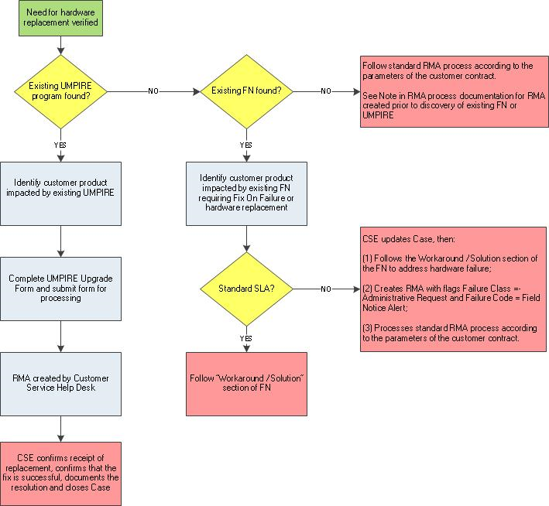

Appendix I – 3-Way RMA Process Flow
