ABES ENGINEERING COLLEGE, GHAZIABAD
Department of Computer Science & Engineering | Academic Year 2025–26
HCLTech Career Shaper Programme — III Year Industry Project

SOFTWARE REQUIREMENTS SPECIFICATION
Autonomous Agentic Web Scraper & Strategic Market Intelligence Analyzer
A Multi-Stage ReAct Intelligence Agent for Autonomous Web Research, Competitive Benchmarking, and Structured Synthesis

Project ID & Title | Project 81: Agentic Web Scraper and Market Intelligence Reporter
Programme / Domain | HCLTech Career Shaper Programme (2025–26) | Agentic AI / Python
Student Name | Adarsh Dubey
University Roll No. | 2400320100061
Department / College | Computer Science & Engineering, ABES Engineering College, Ghaziabad
Project Mentor / Guide | Radhika Singhal
GitHub Repository | https://github.com/adarsh-dubey-gthb/hcl-marketanalyzer.git
Live Streamlit App | https://marketanalyzer.streamlit.app/
Target Case-Study Entities | HCL Technologies, TCS, Infosys, Wipro, Accenture
Specification Standard | IEEE Std 830-1998 (Recommended Practice for Software Requirements Specifications)
Document Status & Version | Approved Production Baseline | Version 1.0.0

DOCUMENT EXECUTIVE SUMMARY & IEEE COMPLIANCE STATEMENT
This Software Requirements Specification (SRS) establishes the formal engineering baseline for the Autonomous Agentic Web Scraper & Strategic Market Intelligence Analyzer in strict conformance with IEEE Std 830-1998. The system converts high-level natural-language research inquiries into autonomous web discovery, automated extraction, schema validation, and structured strategic synthesis using a LangGraph ReAct orchestration model and Google Gemini 2.5 Flash. This specification details functional, non-functional, dynamic workflow, and structural requirements for complete academic evaluation and production replication.

Section | Specification Content & Deliverables | Topic
Sections 1 - 4 | Introduction, Abstract, Problem Statement, Engineering Objectives (O1 to O7) | Foundation
Sections 5 - 7 | Proposed Solution, Operational Workflow, Scope, Functional Requirements (FR-1 to FR-8) | Scope & Functions
Sections 8 - 9 | Non-Functional Requirements (NFR-1 to NFR-6), Technologies Used & Data Sources | Quality & Tech
Section 10 | System Architecture: Layered View & Walkthrough (Figure 2) | Architecture
Section 11 (Part 1) | Detailed Design: 8-Stage Workflow (Figure 1) & Use Case Diagram (Figure 3) | Design & Use Cases
Section 11 (Part 2) | Dynamic Execution: LangGraph ReAct Loop (Figure 4) & UML Class Diagram (Figure 5) | ReAct & Schema
Section 12 | Module Architecture & Functional Breakdown: Modules 1 through 9 | Modules
Sections 13 - 14 | Database & Persistence Design, Testing Levels & Sample Test Cases (T1 to T8) | Data & Testing
Sections 15 - 18 | Results & Acceptance Criteria, Limitations, Future Scope, References & Sign-Off | Evaluation & Sign-Off

1. Introduction
Modern enterprise market and competitor research is an inherently complex, multi-source endeavor. Information necessary to assess corporate trajectory is fragmented across corporate investor portals, financial press releases, regulatory repositories (e.g., SEC EDGAR, BSE/NSE), technology news sources, and cloud marketplace partner directories. Human market analysts spend up to 70% of their research bandwidth on low-level browsing, parsing unstructured HTML, removing advertising artifacts, and reconciling conflicting metrics across spreadsheets. Traditional fixed scrapers fail rapidly because hardcoded URLs and brittle XPath/CSS selectors break as corporate websites evolve. This project introduces an Autonomous Agentic Web Scraper & Strategic Market Intelligence Analyzer based on a state-driven ReAct (Reason + Act) loop that discovers public web sources dynamically, extracts clean text, validates facts via Pydantic schemas, and synthesizes structured competitive intelligence.

2. Abstract
The proposed system establishes an autonomous pipeline combining LangGraph/LangChain agentic orchestration, DuckDuckGo Web and News discovery, Trafilatura content extraction, Google Gemini 2.5 Flash reasoning, and Pydantic v2 strict data validation. Given a target entity (e.g., HCL Technologies) or research query, the agent autonomously generates search queries, fetches relevant articles, strips web clutter, evaluates evidence sufficiency, and recursively triggers secondary queries if data is inadequate. It delivers an end-to-end intelligence briefing featuring executive summaries, strategic themes, SWOT analyses, normalized competitor benchmarks across 5 technology peers (HCLTech, TCS, Infosys, Wipro, Accenture), traceable source citations, and multi-format exports (Plotly radar charts, HTML, Markdown, and JSON).

3. Problem Statement
Manual corporate research and conventional web scraping exhibit significant systemic limitations:
- Information Fragmentation: Public market signals are distributed across corporate filings, investor briefings, and press reports.
- Labor-Intensive Acquisition: Manual querying, page extraction, and source tracking require repetitive manual effort.
- Search Noise & Duplication: Raw search engine results contain duplicate reports, irrelevant aggregator spam, and promotional material.
- DOM Selector Fragility: Traditional web scrapers break when web layouts change; they lack autonomous content discovery.
- Unstructured Web Clutter: Raw scraped content is contaminated with navigational links, cookie notices, and advertisements.
- Lack of Strict Validation: Generative LLMs without strict schema enforcement produce hallucinated or malformed JSON responses.

4. Project Objectives
The project addresses the stated problem through the following verified engineering objectives:
- O1. Autonomous Source Discovery: Convert natural-language goals into targeted multi-perspective queries via DuckDuckGo Web & News.
- O2. Resilient Content Extraction: Extract clean main-body article text while stripping ads and navigation via Trafilatura and BS4.
- O3. State-Driven Agentic Orchestration: Coordinate research using LangGraph in a cyclic ReAct Think-Act-Observe paradigm.
- O4. Recursive Evidence Feedback: Dynamically assess evidence sufficiency and trigger follow-up web searches when information is thin.
- O5. Strict Pydantic v2 Validation: Guarantee schema conformity for all findings, ensuring zero malformed structures.
- O6. Multi-Peer Strategic Benchmarking: Generate normalized competitor metrics across AI Readiness, Cloud Momentum, and Global Scale.
- O7. Interactive Visualization & Export: Render Plotly polar radar charts and export HTML, Markdown, and machine-readable JSON.

5. Proposed Solution
The proposed solution implements a stateful, autonomous research agent that replaces static scraping scripts with an intelligent, multi-stage reasoning and execution pipeline. Built with LangGraph and powered by Google Gemini 2.5 Flash, the agent systematically executes eight sequential stages: accepts plain-English input, plans discovery queries, retrieves live web/news articles, extracts clean text, synthesizes findings into structured JSON, verifies constraints against Pydantic models, computes competitor benchmarks, and generates interactive Plotly visualizations and exportable briefing dossiers.

6. Scope of the Project
In-Scope Capabilities: The project covers autonomous research over publicly accessible information for technology services companies. It supports natural-language queries, automated search formulation, HTML text extraction, LLM synthesis, comparative SWOT matrix generation, quantitative benchmarking across five target IT enterprises (HCL Technologies, TCS, Infosys, Wipro, Accenture), interactive Streamlit visualization, and export in HTML, Markdown, and JSON formats.
Current Scope Boundaries: The system does not bypass user authentication, CAPTCHAs, paywalls, or bot mitigation systems (e.g., Cloudflare Turnstile). It does not guarantee live availability of third-party domains. All generated intelligence reflects public data and model synthesis and should be reviewed by an analyst prior to high-stakes capital allocation.

7. Functional Requirements
Req ID | Requirement Title | Detailed Functional Specification
FR-1 | Research Input & Presets | Accept custom natural-language objectives or preset targets (HCLTech, TCS, Infosys, Wipro, Accenture) via Streamlit UI.
FR-2 | Dynamic Query Planning | Agent automatically decomposes objectives into targeted search queries covering financials, AI, cloud, and partnerships.
FR-3 | Autonomous Web Discovery | Execute DuckDuckGo Web and News searches (DDGS API); deduplicate URLs and filter out low-relevance domains.
FR-4 | Clean Content Extraction | Fetch accessible web pages; use Trafilatura and BeautifulSoup4 to extract clean article text, discarding ads and headers.
FR-5 | ReAct Synthesis Engine | Gemini 2.5 Flash synthesizes raw text into structured JSON containing executive summary, strategic pillars, and SWOT items.
FR-6 | Pydantic Schema Validation | Validate LLM output against MarketIntelligenceReport schema; retry synthesis if schema fails or fields are missing.
FR-7 | Competitor Benchmarking | Compute normalized metrics (AI Readiness, Cloud Momentum, Global Scale) across peer enterprises using Pandas.
FR-8 | Multi-Format Export | Generate standalone HTML briefings, Markdown executive reports, raw JSON dumps, and Plotly polar radar charts.

8. Non-Functional Requirements
Category | Specification & Measurable Metric | Implementation Mechanism
NFR-1: Performance | Complete end-to-end research, extraction, synthesis, and export within 45 - 90 seconds for standard corporate queries. | Gemini 2.5 Flash fast inference; concurrent HTTP page fetching via Trafilatura.
NFR-2: Reliability | Zero application crash on blocked, slow, or 404/403 web pages; graceful fallback and logging for inaccessible links. | Trafilatura try/except exception wrappers; safe empty response fallbacks.
NFR-3: Data Accuracy | 100% of reported strategic findings linked back to source URLs; 0% unvalidated or hallucinated schema structures. | Pydantic v2 strict schema enforcement; SourceCitation sub-model traceability.
NFR-4: Usability | Clean interactive dashboard requiring zero CLI configuration; real-time execution trace display for analyst transparency. | Streamlit web interface with tabbed views, expandable traces, and one-click exports.
NFR-5: Modularity | Pluggable architecture allowing new search tools, scrapers, or LLM providers without altering orchestrator core. | LangGraph modular tool belt pattern; isolated tool schemas in schemas.py.
NFR-6: Security | No hardcoded API credentials; strictly respects website robots.txt and disallows credential stuffing or payload execution. | Environment-variable configuration via .env; safe HTTP headers and read-only scraping.

9. Technologies Used & Architectural Stack
Category | Technology / Tool | Role in Architecture
Programming | Python 3.10+ | Core implementation, tool orchestration, and data pipeline.
Agentic AI | LangGraph / LangChain | State-driven agent workflow and ReAct Think-Act-Observe loop.
LLM Engine | Google Gemini 2.5 Flash | Synthesis, reasoning, query planning, and structured JSON output.
Search Discovery | DuckDuckGo / DDGS | Live web and news discovery without paid API key quotas.
Web Extraction | Trafilatura | Main text body extraction, boilerplate and advertisement removal.
HTML Parsing | BeautifulSoup4 | Targeted page parsing and fallback DOM text sanitization.
Validation | Pydantic v2 | Strict data validation and schema-compliant JSON enforcement.
Data Analytics | Pandas | Tabular metric processing, score normalization, and comparison.
Visualization | Plotly | Interactive polar radar charts and horizontal competitor benchmarks.
User Interface | Streamlit | Interactive research dashboard with live execution traces.

Data Sources: Primary Public Web Data-Source Categories:
- 1. Business News: Reuters, Bloomberg, CNBC, TechCrunch, PR Newswire, Business Wire.
- 2. Investor Portals: HCLTech, TCS, Infosys, Wipro, Accenture IR repositories.
- 3. Regulatory Filings: SEC EDGAR, BSE/NSE Corporate Announcements, UK Companies House.
- 4. Industry Benchmarks: Gartner Magic Quadrants, IDC MarketScape, Everest PEAK Matrix.
- 5. Cloud Ecosystems: AWS Partner Network, Microsoft Azure Marketplace, Google Cloud Partner Directory.

10. System Architecture
The system architecture strictly separates the user interface, agent orchestration brain, external tool belt, public web sources, and output deliverables. This modular separation enables independent enhancement of individual layers (e.g., swapping search providers or updating LLM prompts) without breaking pipeline stability.
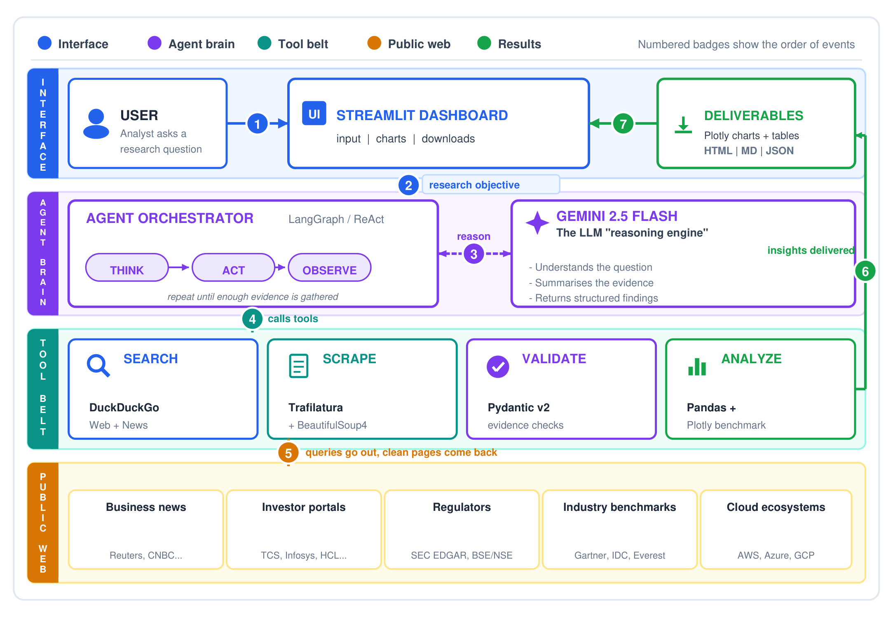
Figure 2. High-level system architecture (layered view: interface, agent brain, tool belt, public web, results)

How to Read the Architecture Diagram (Numbered Step-by-Step Flow)
- Step (1): The user types a research objective (a company, competitor or market question) into the Streamlit dashboard.
- Step (2): The Streamlit dashboard passes the objective to the LangGraph/LangChain agent orchestrator.
- Step (3): The orchestrator and Gemini 2.5 Flash reason together in an iterative Think, Act, Observe loop.
- Step (4): The orchestrator calls specialized tools from its belt: Search, Scrape, Validate, and Analyze.
- Step (5): Search and Scrape reach out to public web sources and bring back clean page text without advertisements.
- Step (6): Validated and analyzed findings become Plotly interactive charts and HTML / Markdown / JSON reports.
- Step (7): Streamlit displays the deliverables in tabbed views and lets the user download complete report bundles.

11. Detailed System Design & Workflows

11.1 Agentic Workflow / Data Flow Diagram (DFD)
The workflow is organized as a state-driven agentic pipeline. A research objective initiates source discovery; extracted evidence is progressively transformed into structured information. The agent revisits discovery when evidence is insufficient.
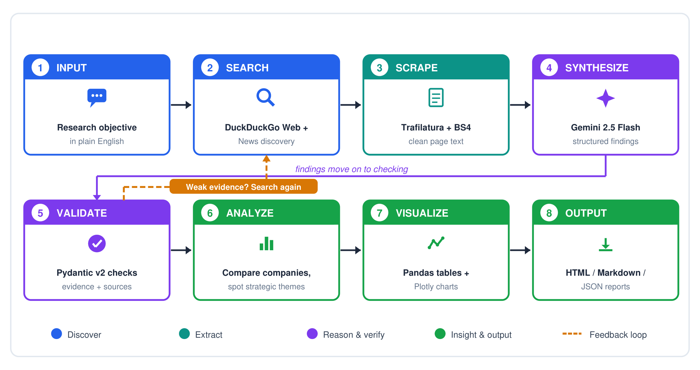
Figure 1. Agentic workflow / flow chart of the proposed system (8 stages, colour-coded by phase, with a feedback loop)

11.2 Use Case Diagram
The Use Case model defines the functional boundary between the human Analyst/Researcher and the automated agent subsystem.
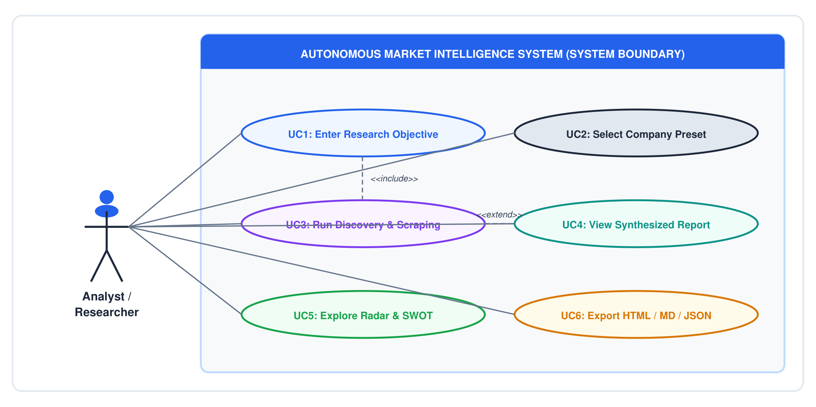
Figure 3. Use case diagram illustrating core analyst interactions, preset workflows, and automated pipeline execution

11.3 LangGraph ReAct Agent Loop
The execution engine coordinates reasoning and action through a state-machine loop. When Gemini determines evidence is incomplete, it dispatches tools (web_search, scrape_webpage) and feeds observations back into memory until sufficiency is achieved.
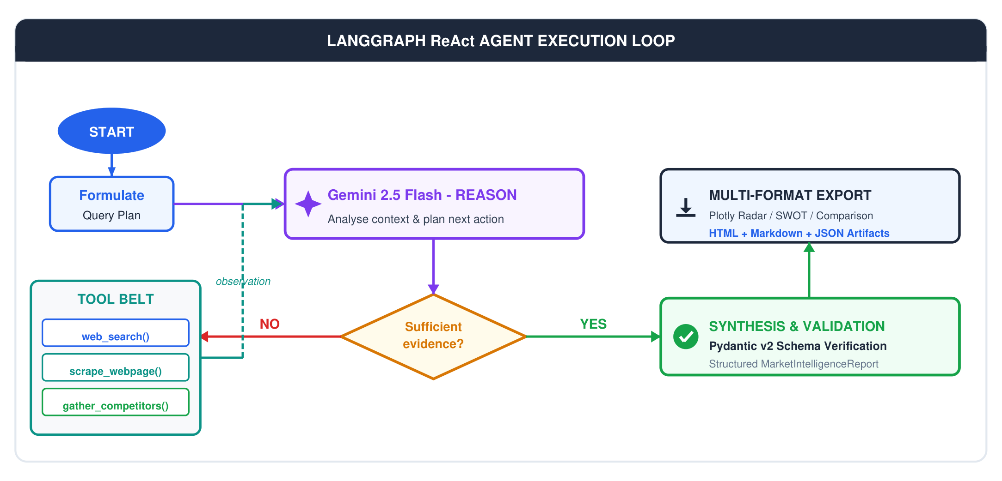
Figure 4. LangGraph ReAct agent state-machine and feedback loop execution model with tool dispatch and Pydantic validation

11.4 Class & Pydantic Schema Architecture
The object model couples the orchestration agent with strongly typed Pydantic v2 schemas to ensure end-to-end data integrity.
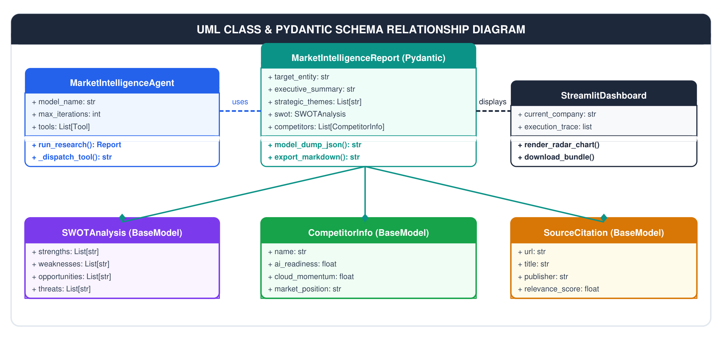
Figure 5. UML class and Pydantic v2 schema relationship diagram illustrating model composition and orchestration dependencies

12. Module Architecture & Functional Breakdown
The architecture is partitioned into nine discrete functional modules that isolate specific computational concerns:
Module | Architectural Responsibility & Implementation Details
Module 1: Research Input | Accepts and structures the user's research objective. Supports arbitrary natural-language market queries as well as pre-configured presets for the five target technology peers (HCL Technologies, TCS, Infosys, Wipro, Accenture). Sanitizes query strings and passes parameters into the LangGraph state graph.
Module 2: Search / Discovery | Generates targeted Web and News search queries using DuckDuckGo (DDGS API). Employs boolean modifiers and temporal filters to identify recent earnings calls, press releases, strategic announcements, and industry commentary without incurring API cost.
Module 3: Web Scraping | Retrieves and extracts content from accessible public web pages. Utilizes Trafilatura for primary main-text extraction with automated stripping of headers, footers, navigation, cookie banners, and inline advertising. Uses BeautifulSoup4 as fallback.
Module 4: Evidence Processing | Cleans, normalizes, and chunks extracted text. Deduplicates overlapping news reports, enforces character window limits to prevent LLM context-window saturation, and structures page metadata (URL, page title, publish date) for downstream auditing.
Module 5: Validation | Performs automated checks on source relevance and evidence consistency. Checks that collected articles directly address the research query. If evidence is thin or irrelevant, signals the orchestrator to trigger secondary discovery queries.
Module 6: Agentic Synthesis | Employs Google Gemini 2.5 Flash as the core LLM reasoning engine. Guided by a strict synthesis system prompt, converts unstructured evidence chunks into structured JSON conforming to the MarketIntelligenceReport Pydantic schema.
Module 7: Strategic Analysis | Produces comparative market-intelligence observations, SWOT matrix categorization (Strengths, Weaknesses, Opportunities, Threats), strategic theme identification, and quantitative benchmark scoring across AI Readiness, Cloud Momentum, and Global Scale.
Module 8: Visualization | Constructs interactive data representations using Plotly and Pandas. Renders multi-axis polar radar charts comparing the five technology companies, horizontal benchmark bar charts, and stylized summary scorecards inside the Streamlit dashboard.
Module 9: Reporting / Export | Generates exportable research artifacts in three distinct formats: responsive HTML executive briefings with embedded CSS, GitHub-flavored Markdown dossiers with source hyperlinks, and machine-readable JSON dumps for downstream data pipelines.

13. Database & Data Storage Design
The system operates on a stateless, memory-efficient real-time streaming model. Extracted web content and intermediate reasoning traces are maintained in-memory within the LangGraph StateGraph dictionary during execution. Completed intelligence reports are serialized to disk as structured JSON artifacts under the reports/ directory. This file-based caching model avoids unnecessary relational database overhead while ensuring report provenance and auditability.

14. Testing Levels & Verification Strategy
Testing is structured across four rigorous levels to validate isolated components, inter-stage communication, end-to-end workflow execution, and resilience against hostile web environments:
Level | What is Tested | Method & Tooling
Unit Testing | Query generation, text cleaning, Pydantic schemas, URL deduplication, export serializers. | Automated pytest test suite with static mock inputs.
Integration Testing | Hand-offs between pipeline stages: Search to Scrape, Scrape to Synthesis, Synthesis to Validation. | Sequential execution of connected stages on fixed sample data.
System Testing | Complete execution from research objective to HTML/MD/JSON output for the 5 target companies. | End-to-end automated and manual runs via Streamlit UI.
Robustness Testing | Paywalled, blocked, or slow pages, empty search results, irrelevant sources, malformed LLM outputs. | Injected HTTP failure mocks and edge-case prompt scenarios.

Sample Test Cases Matrix (T1 through T8)
ID | Test Case Description | Expected Verified Result
T1 | Enter a valid company research objective. | Relevant Web and News sources are discovered dynamically.
T2 | Scrape a normal news article. | Main text is returned without navigation menus, cookie banners, or ads.
T3 | Scrape a paywalled or blocked web page. | Page is skipped gracefully and logged; system does not hang or bypass controls.
T4 | Search returns duplicate or irrelevant links. | Duplicates are removed and low-relevance domains are filtered out.
T5 | Evidence is too thin for a reliable answer. | Agent returns to discovery stage and generates secondary searches.
T6 | LLM returns output that violates schema. | Pydantic validation rejects response and triggers structured retry.
T7 | Compare all five target technology companies. | Structured comparison table and Plotly radar charts are generated.
T8 | Export the final research briefing. | Valid HTML, Markdown, and JSON files are produced and downloadable.

15. Results & Evaluation Criteria
Evaluation Criterion | Verification Method | Target Acceptance Standard
Source Relevance | Reviewer evaluates discovered URLs against objective. | Over 85% of discovered sources directly relevant to inquiry.
Extraction Quality | Inspection of cleaned text samples for advertising clutter. | Zero navigation text, ads, or cookie banners in extracted content.
Schema Validity | Proportion of LLM outputs passing Pydantic validation. | 100% schema compliance; all schema violations caught and retried.
Evidence Traceability | Audit of findings back to originating web source URL. | 100% of reported facts cite verified public source URLs.
Time Saved | Agent run time vs. human analyst manual search time. | Complete research report in < 90s (90%+ time reduction vs. manual).
Output Completeness | Integrity of generated HTML, Markdown, and JSON files. | All three file formats generated without corruption or data loss.

16. Limitations
- Public Web Availability: Output quality is contingent on content accessible to public search engines.
- No Authentication Bypass: The system strictly respects paywalls, CAPTCHAs, and corporate intranet firewalls.
- Inference Latency: Real-time multi-page scraping and LLM synthesis requires 45-90 seconds per run.
- Human Verification Required: High-stakes investment or strategic decisions should review underlying source URLs.

17. Future Scope & Product Roadmap
- Introduce specialized sub-agents for financial statement analysis, patent auditing, and executive synthesis.
- Add persistent vector-based memory (ChromaDB / FAISS) for quarter-over-quarter trend analysis and historical tracking.
- Integrate direct regulatory API connectors for SEC EDGAR, BSE/NSE filings, and UK Companies House.
- Automate board-ready PowerPoint (PPTX) slide deck generation from synthesized research dossiers.
- Implement real-time market anomaly alerts and notifications for breaking competitive developments.

18. References
1. Yao, S. et al. (2022). ReAct: Synergizing Reasoning and Acting in Language Models. ICLR 2023 / arXiv:2210.03629.
2. Barbaresi, A. (2021). Trafilatura: A Web Scraping Library and Tool for Text Discovery and Extraction. ACL.
3. LangChain / LangGraph Official Documentation for Stateful Agentic Workflows (2024).
4. Google Gemini 2.5 Flash Official Technical Documentation and Structured Outputs Guide (2024).
5. Pydantic v2 Official Documentation for Robust Schema Validation and Settings Management.
6. Streamlit & Plotly Official Documentation for Python Interactive Visualization and Dashboards.
7. IEEE Std 830-1998: IEEE Recommended Practice for Software Requirements Specifications.

Institutional Approval & Sign-Off
Prepared By (Candidate) | Reviewed & Approved By (Project Mentor)
Adarsh Dubey  University Roll No: 2400320100061  B.Tech III Year, Computer Science & Engineering  ABES Engineering College, Ghaziabad | Radhika Singhal  Project Mentor / Guide  Department of Computer Science & Engineering  ABES Engineering College, Ghaziabad
Signature: ___________________________  Date: 30 October 2026 | Signature: ___________________________  Date: 30 October 2026

