IITB Research Internship - NDVI Framework
Date: 2026-05-11

Problem & Approach
The objective is to generate a national NDVI map for India using Sentinel-2 surface reflectance at 10 m resolution. The approach builds a dry-season composite and computes NDVI to capture vegetation conditions.
- Use SCL-based cloud masking for higher quality inputs.
- Compute NDVI and mosaic tiles for a national view.

Scalability Strategy
- Tile India into 2 degree grid cells to reduce export size.
- Submit batch exports and monitor tasks for completion.

Workflow Diagram
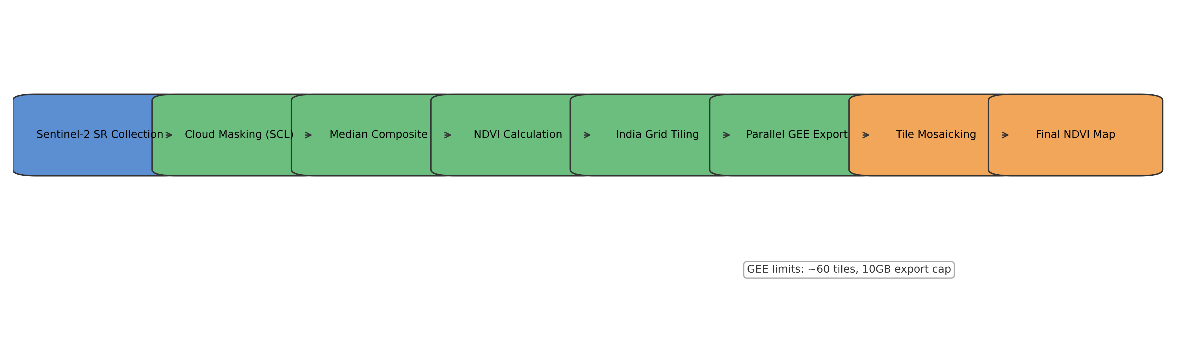

GEE Limitations Handled
- Memory and export size limits handled via tiling.
- Timeouts mitigated with batch tasks and retries.

Sample Results & Next Steps
- Outputs include per-tile NDVI GeoTIFFs and a national mosaic.
- Next steps: add QA metrics and refine cloud filtering.

