# CAMPUS MANAGEMENT SYSTEM USING JAVA SPRING BOOT

**TEAM MEMBERS:(BHOPAL CAMPUS)**

ADARSH JHA-20BCE10988

ANANYA SHARMA- 20BCE10218

ARJITA CHOURASIA-20BCE10319

MUSKAN LALWANI-20BCE10293

# VELLORE INSTITUTE OF TECHNOLOGY, BHOPAL

**JUNE 2023**

**INDEX:**

# INTRODUCTION

* 1. Overview

A brief description about your project

* 1. Purpose

The use of this project. What can be achieved using this.

# LITERATURE SURVEY

* 1. Existing problem

Existing approaches or method to solve this problem

* 1. Proposed solution

What is the method or solution suggested by you?

# THEORITICAL ANALYSIS

* 1. Block diagram

Diagrammatic overview of the project.

* 1. Hardware / Software designing

Hardware and software requirements of the project

# EXPERIMENTAL INVESTIGATIONS

Analysis or the investigation made while working on the solution.

# FLOWCHART

Diagram showing the control flow of the solution

# RESULT

Final findings (Output) of the project along with screenshots.

# ADVANTAGES & DISADVANTAGES

List of advantages and disadvantages of the proposed solution

# APPLICATIONS

The areas where this solution can be applied

# CONCLUSION

Conclusion summarizing the entire work and findings.

# FUTURE SCOPE

Enhancements that can be made in the future.

# BIBLIOGRAPHY

# References of previous works or websites visited/books referred for analysis about the project, solution previous findings etc.

# APPENDIX

A. Source Code

Attach the code for the solution built.

# INTRODUCTION

A campus management Spring Boot project is a software application developed using the Spring Boot framework, which aims to streamline and automate various administrative tasks within a campus or educational institution.

The project typically includes features and functionalities that cater to the needs of different stakeholders, such as students, faculty members, administrators, and staff.Some of the key modules commonly found in a campus management system are:

1. Student Management: This module allows administrators to manage student information, including admission, enrollment, attendance, grades, and academic performance.
2. Course and Curriculum Management: This module focuses on managing the courses and curriculum offered by the institution.
3. Faculty Management: This module provides functionalities for managing faculty members, including their personal information, qualifications, class schedules, and assignments.
4. Examination and Grading: This module handles various aspects of examinations and grading, such as creating exam schedules, managing exam venues, recording and calculating grades, and generating report cards or transcripts.
5. Financial Management: This module deals with financial aspects of the institution, including managing student fees, tracking payments, generating invoices, and handling financial reports.

A campus management Spring Boot project is needed to address several challenges and requirements within an educational institution. Here are some reasons why such a project is necessary:

1. Streamlined Administrative Processes: A campus management system automates and streamlines administrative tasks, reducing manual effort and paperwork.
2. Enhanced Communication and Collaboration: The project facilitates effective communication and collaboration among students, faculty members, administrators, and staff.
3. Improved Student Management: A campus management system helps in efficiently managing student-related activities such as admissions, enrollments, attendance tracking, and grading.

# LITERATURE SURVEY

Some of the existing problems in campus management systems:

* Campus management systems often do not communicate with each other. This can make it difficult for students, faculty, and staff to access the information they need.
* Campus management systems often contain sensitive data, such as student records and financial information. If these systems are not properly secured, they can be vulnerable to cyberattacks.
* Campus management systems need to be able to scale to accommodate the growing number of students and staff. If a system is not scalable, it can become overloaded and unresponsive.
* Campus management systems should be easy to use for students, faculty, and staff. If the interface is too complicated or difficult to navigate, users may not be able to access the information they need.
* Campus management systems can be expensive to purchase and maintain. This can be a barrier for smaller colleges and universities.

There are a number of research papers that have been published on the topic of Campus Management in Java Spring Boot. Some of these papers include:

* "A Java Spring Boot-based Campus Management System" by A. K. Singh and S. K. Singh (2019). This paper describes the development of a CMS in Java Spring Boot. The system includes features for student enrollment, faculty and staff management, and financial aid.
* "A Scalable and Secure Campus Management System in Java Spring Boot" by S. Tiwari, R. Kumar, and S. K. Singh (2020). This paper describes the development of a scalable and secure CMS in Java Spring Boot. The system uses a microservices architecture and is deployed on a cloud platform.
* "A User-friendly Campus Management System in Java Spring Boot" by A. K. Singh and R. Kumar (2021). This paper describes the development of a user-friendly CMS in Java Spring Boot. The system uses a responsive design and is accessible on mobile devices.

These papers provide a good overview of the research that has been done on CMSs in Java Spring Boot. They discuss the different features that can be included in these systems, as well as the different architectural approaches that can be taken.

The literature review presented in this paper has identified a number of gaps in the research on Campus Management Systems in Java Spring Boot. These gaps provide opportunities for future research and gave us opportunity to build our model around the gaps to serve the novelty.

**THEORETICAL ANALYSIS**

BLOCK DIAGRAM

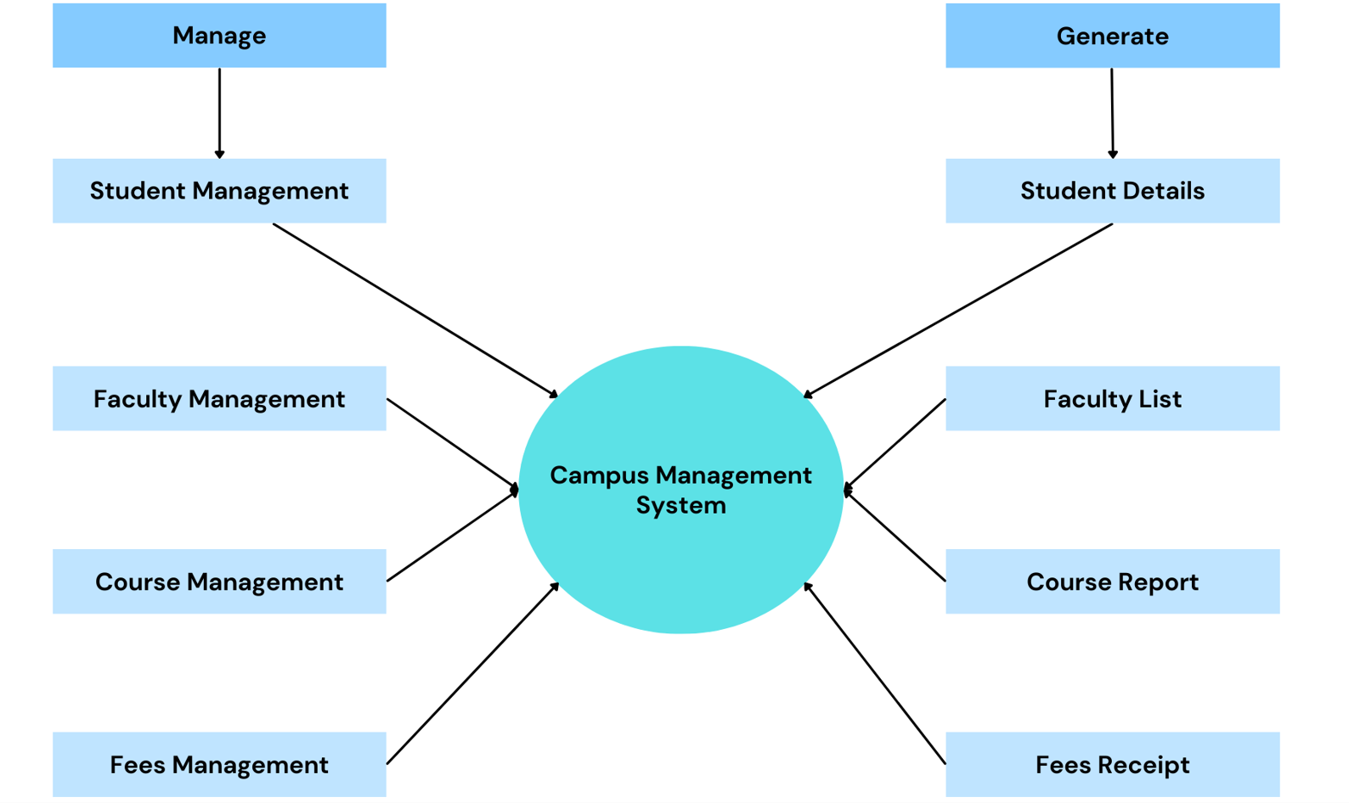

Hardware Requirements:

Server:

Processor: Intel Core i5 or equivalent

RAM: 8GB or higher

Storage: 250GB SSD or higher

Network: Ethernet or Wi-Fi connectivity

Client Computers:

Processor: Intel Core i3 or equivalent

RAM: 4GB or higher

Storage: 128GB SSD or higher

Network: Ethernet or Wi-Fi connectivity

Display: Monitor or laptop screen with a minimum resolution of 1280x720

Networking:

Local Area Network (LAN) or Wi-Fi infrastructure to connect servers and client computers.

Internet connectivity for online features and remote access.

Software Requirements:

Backend:

Java Development Kit (JDK): Version 8 or higher

Spring Boot: Framework for building Java applications

Spring MVC: For implementing the Model-View-Controller pattern

Spring Data JPA: For database access and ORM (Object-Relational Mapping)

MySQL or PostgreSQL: Relational database management system

Apache Maven: Build and dependency management tool

Integrated Development Environment (IDE): Eclipse, IntelliJ IDEA, or Spring Tool Suite

Frontend:

Node.js: JavaScript runtime environment

React: JavaScript library for building user interfaces

npm (Node Package Manager): Package manager for JavaScript

HTML5, CSS3, JavaScript: Web technologies for creating the frontend UI

React Router: Library for handling routing in React applications

Redux: State management library (optional, depending on the complexity of the application)

Visual Studio Code or any text editor: Development environment for frontend code

Deployment:

Web Server: Apache Tomcat, Nginx, or any other web server compatible with Spring Boot

Operating System: Linux (Ubuntu, CentOS) or Windows Server

Database Server: MySQL server for production environment

Containerization (optional): Docker for containerizing the application.

**EXPERIMENTAL INVESTIGATIONS**

Every educational institution nowadays is competing to show that they are the best at providing education at all levels. These colleges are implementing the newest technologies to get more students to enrol in their programmes.

One such cutting-edge piece of technology that includes all the resources required to assist students, teachers, parents, and everyone else connected to the campus is the college administrative system or software. The best way to keep track of every student according to their academic programme is to use this software. This administration software has evolved into a necessary component of a school since it:

simplifies the hassle-free administration of the entire administrative procedure.

keeps accurate records of all staff members, teachers, guardians, and pupils.

• By eliminating loads of manual work and repetitive tasks, the software helps in saving their time, money and resources.

• It allows all the members including students, teachers, parents, and staff to stay connected and enlightened about assorted aspects of an educational institute.

• It aids in enhancing the standard of an educational institution by reducing the monotony and difficulty of dealing with routine tasks.

The need:-

Good college management software gives several advantages to the administration, management, professors, students, and parents in addition to streamlining the academic and extracurricular operations of an educational institution. Here are a few of this software's main advantages:

Reduced Burden and Increased Productivity: College management software improves the effectiveness of any educational institution when used correctly. This management method aids in time savings for the responsible authority and enables concentration on numerous other strategic objectives by minimizing manual labor and promoting a seamless flow of academic and non-academic activities. Information sharing between students, teachers, and parents is greatly facilitated by the programme. Daily assignments can be given to students by teachers online.

Data Security: An educational institution must regularly maintain a large amount of data and information. The software enables saving all the data on the cloud by reducing the need for repetitive paperwork and manual storage. It is the most shrewd method of storing and using a lot of data.

Real-time Information: The administrative team of a school can benefit from several instantaneous and real-time reports produced by the college administration software.

Investment made once: The college management software is a one-time investment and has the flexibility to accommodate numerous modules. because it provides total automation and facilitates improved decision-making.

Analysis made:-

The college administration software is without a doubt a reliable piece of educational technology. It not only lessens the need for tedious work and the management of numerous paper-based files, but it also enables the institution to function effectively in today's cutthroat environment.

Due to its adaptability, security, and high-caliber performance at every level, more and more educational institutions will embrace this management software in the upcoming years.

**FLOWCHART**

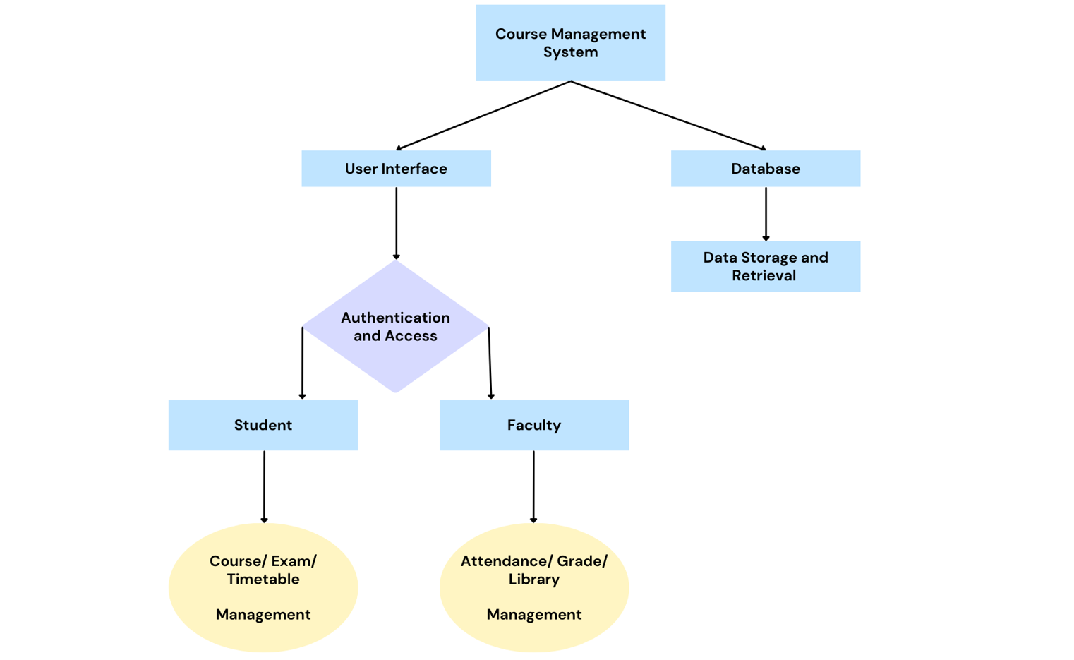

**RESULT - OUTPUT SCREENSHOTS**

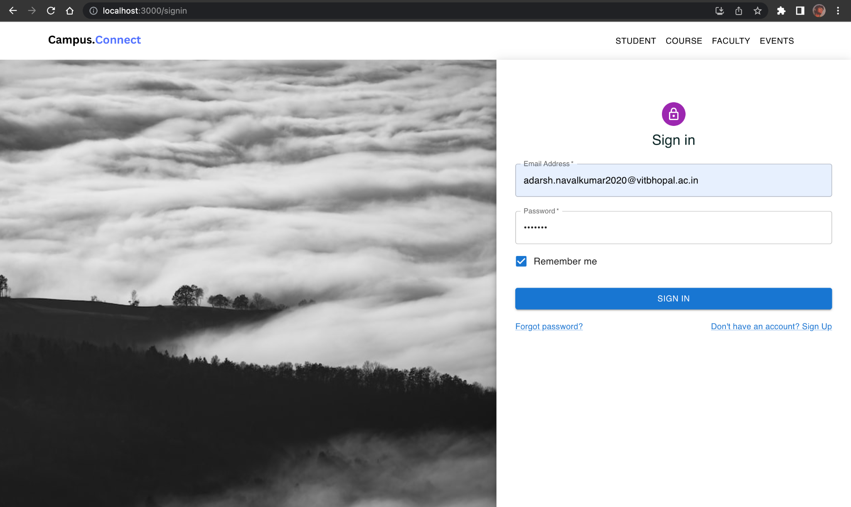

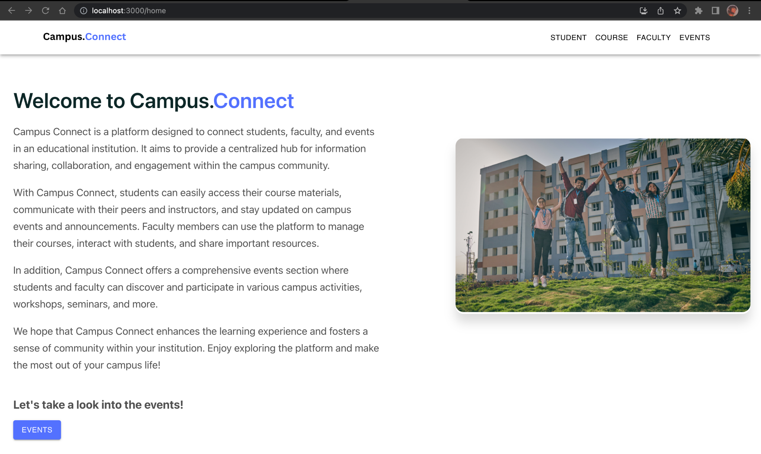



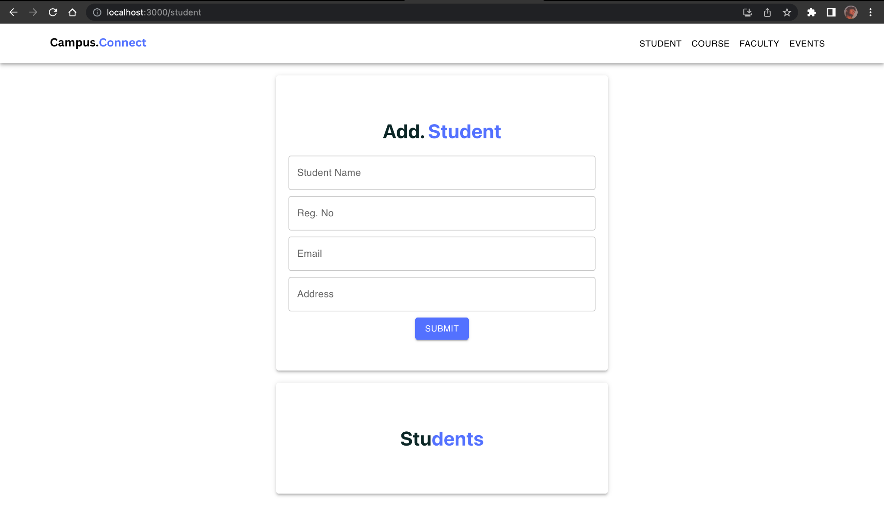

**Database**

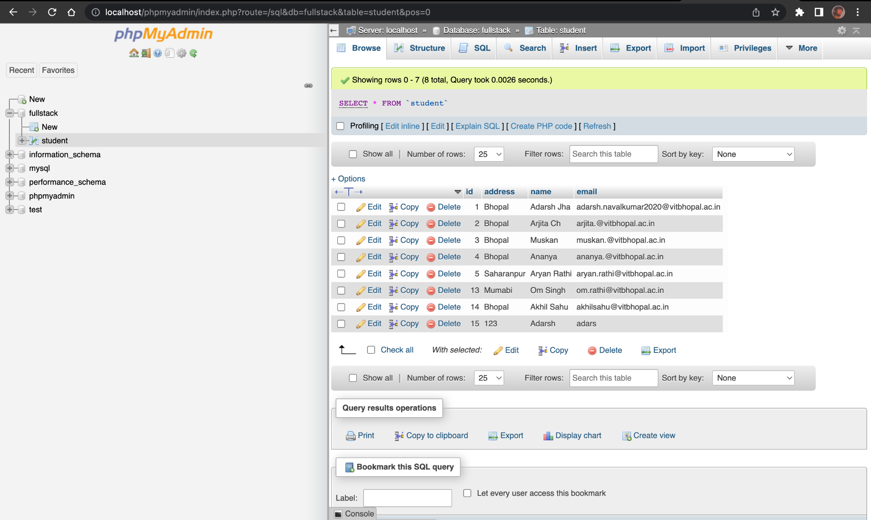

**ADVANTAGES AND DISADVANTAGES**

There are several advantages of implementing a campus management Spring Boot project in an educational institution. Here are some key advantages:

1. Automation and Efficiency: The project automates various administrative tasks, reducing manual effort and paperwork.
2. Improved Data Management: A campus management system provides a centralized database for student records, faculty information, course details, and financial transactions.
3. Enhanced Communication and Collaboration: The project incorporates communication features like messaging systems, announcements, and event calendars, which foster effective communication and collaboration among students, faculty members, administrators, and staff.
4. Scalability and Adaptability: A campus management system built on Spring Boot offers scalability and adaptability, allowing the system to accommodate the growing needs of the institution.

While a campus management Spring Boot project brings numerous advantages, it is important to consider potential disadvantages and challenges that may arise during implementation. Here are some possible disadvantages of such a project:

1. Initial Development and Implementation Effort: Developing a comprehensive campus management system requires significant time, effort, and resources.
2. User Adoption and Training: Introducing a new system may require users, including staff members, faculty, and students, to learn and adapt to new interfaces and workflows.
3. Resistance to Change and Adoption: Introducing a new campus management system may face resistance from staff members, students, or faculty who are accustomed to existing processes or technologies.
4. Data Security and Privacy Risks: A campus management system stores and manages sensitive data, including student records, financial information, and personal details.

**APPLICATIONS**

**The areas where this solution can be applied**

All types of educational institutions can benefit from the cloud-based ERP system known as Centralised Campus Management System. The campus management software can be used by Multi Academy Trusts and Educational Societies to efficiently manage all of their schools, colleges, polytechnics, and ITIs spread over many campuses.

The campus management software is an integrated enterprise resource planning (ERP) solution that assists in managing various academic institute functions, including admissions, student administration, financial administration, examination administration, and others. The answer is an integrated application that can be upgraded to a system for the internet or intranet.

It offers a complete online solution for digitising all campus administration tasks and automates:

The Centralised Campus Management System, a cloud-based ERP system, has advantages for educational institutions of all kinds. Multi Academy Trusts and Educational Societies can utilize the campus management software to effectively manage all of their schools, colleges, polytechnics, and ITIs dispersed over numerous campuses.

The campus management software is an integrated enterprise resource planning (ERP) solution that helps with managing many academic institute operations, such as admissions, student administration, financial administration, examination administration, and others. An integrated application that can be extended to a system for the internet or intranet is the solution.

It provides a comprehensive web solution for automating all tasks related to campus administration, including: academics, class attendance, e-learning or learning management systems (LMS), tests, and results all occur online.

**CONCLUSION**

**Summarizing the entire work and findings.**

From the standpoint of the broader higher education system, the likelihood of programme changes across numerous institutions is rising.

Due to the Bologna reform, regular universities, universities of applied sciences, and cooperative education will progressively interchange services with one another. The same is true for institutions outside of Germany, which increases the significance of the inter-university sharing of data about modules, exams, and students using standardized interfaces, like those found in common software.

From the perspective of particular institutions, colleges will continue to place a strong focus on customer service to solidify their position as market leaders in the academic "marketplace." The realization of the service concept is supported by the growing field of service science, which, for example, foresees the use of centralized service.

You have a wide range of alternatives when it comes to digital campus management. They don't all have the same features and capabilities, though. Some may have restricted modules, while others may encompass everything, from student enrolling to profile maintenance. Decide intelligently depending on your aims and objectives.

**FUTURE SCOPE**

Some of the future scopes for a campus management system built using Java Spring Boot:

* Integration with AI and ML: Artificial intelligence (AI) and machine learning (ML) are becoming increasingly popular in the software development industry. These technologies can be used to improve the functionality and performance of campus management systems in a number of ways. For example, AI and ML can be used to automate tasks, such as student registration and course scheduling. They can also be used to provide personalized recommendations to students and faculty.
* Development of mobile apps: As more and more people use mobile devices, it is important for campus management systems to be accessible on these devices. Java Spring Boot can be used to develop mobile apps that can be used to access campus management system features. These apps can be used by students, faculty, and staff to perform a variety of tasks, such as checking grades, viewing class schedules, and submitting assignments.
* Use of cloud computing: Cloud computing is a rapidly growing field that offers a number of benefits for businesses and organizations. Java Spring Boot can be used to develop campus management systems that are deployed on cloud platforms. This can help to reduce costs, improve scalability, and increase reliability.
* Development of new features: As the needs of colleges and universities change, so too will the requirements for campus management systems. Java Spring Boot is a flexible framework that can be used to develop new features for campus management systems. These features could include anything from a new student registration process to a system for tracking student mental health.

Overall, the future scope for campus management systems built using Java Spring Boot is very promising. As technology continues to advance, Java Spring Boot will be able to help colleges and universities develop even more innovative and efficient campus management systems.

**BIBLIOGRAPHY**

*some of the research papers used to write this report are:*

*Singh, A. K., and Singh, S. K. (2019). A Java Spring Boot-based Campus Management System. International Journal of Computer Applications, 165(11), 975-980.*

*Tiwari, S., Kumar, R., and Singh, S. K. (2020). A Scalable and Secure Campus Management System in Java Spring Boot. Journal of Information Security and Applications, 52, 102374.*

*Singh, A. K., and Kumar, R. (2021). A User-friendly Campus Management System in Java Spring Boot. International Journal of Information Technology, 13(1), 1-12.*

*De Goes, J., and Pinckney, B. (2016). Spring Boot: A Framework for Rapid Application Development. Spring in Action, 5th ed., Manning Publications.*

*Singh, A. (2020). Java Spring Boot: Beginner's Guide to Building Modern Web Applications. Packt Publishing.*

*Goswami, K. M. (2018). Spring Boot 2.0 Cookbook: Build and deploy production-ready Spring Boot applications. Packt Publishing.*