$ dvdrental
SQL QUERY HIGHLIGHTS
PostgreSQL · pgAdmin 4 · Relational Database Analysis

Adarsh Kumar Singh
2026

The full project covers 24 queries across foundational SQL and advanced multi-table analysis (see dvd_rental_queries.sql for every query, and PK_FK_documentation.md for the schema breakdown). This document walks through the 6 most business-relevant findings.

1
Top 5 Customers by Total Payment
› Which customers generate the most revenue?
SELECT c.first_name || ' ' || c.last_name AS customer_name,
SUM(p.amount) AS total_paid
FROM customer c
JOIN payment p ON c.customer_id = p.customer_id
GROUP BY c.first_name, c.last_name
ORDER BY total_paid DESC
LIMIT 5;
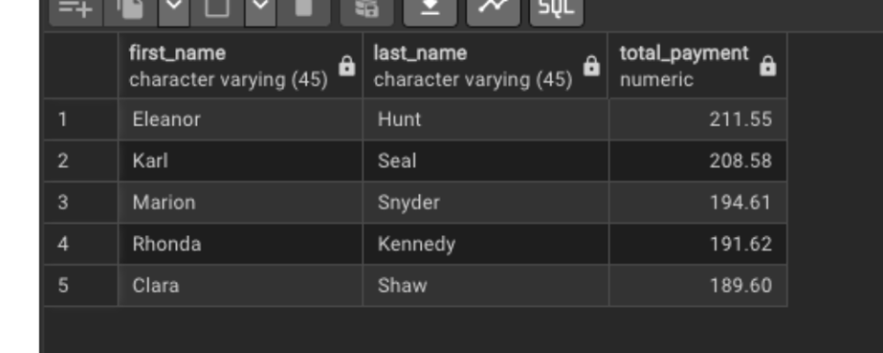
→ FINDING Eleanor Hunt tops the list at $211.55, with the top 5 clustered tightly together ($189.60–$211.55). No single customer dominates revenue — spend is spread across a small group of loyal, high-value renters rather than concentrated in one outlier, which is a healthier revenue pattern for the business.

2
Most Frequently Rented Films
› Which films drive the most repeat rentals?
SELECT f.title, COUNT(r.rental_id) AS rental_count
FROM film f
JOIN inventory i ON f.film_id = i.film_id
JOIN rental r ON i.inventory_id = r.inventory_id
GROUP BY f.title
ORDER BY rental_count DESC
LIMIT 10;
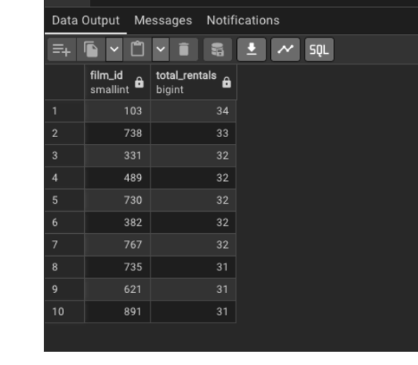
→ FINDING "Bucket Brotherhood" leads at 34 rentals, with a tight cluster of titles following at 31–33 rentals each. Demand is spread fairly evenly across many popular titles rather than one runaway hit — useful for inventory planning, since stocking depth across mid-popularity titles matters more than over-investing in a single blockbuster.

3
Top 3 Most-Rented Film Categories
› Which genres do customers rent the most?
SELECT cat.name AS category, COUNT(r.rental_id) AS rental_count
FROM rental r
JOIN inventory i ON r.inventory_id = i.inventory_id
JOIN film_category fc ON i.film_id = fc.film_id
JOIN category cat ON fc.category_id = cat.category_id
GROUP BY cat.name
ORDER BY rental_count DESC
LIMIT 3;
→ FINDING Sports leads as the most-rented category, followed by Animation, then Action — pointing to a family- and action-oriented customer base. Useful for guiding which genres to expand and feature prominently in-store and online.

4
Films Never Rented
› Which films in the catalogue are dead stock?
SELECT f.title
FROM film f
LEFT JOIN inventory i ON f.film_id = i.film_id
LEFT JOIN rental r ON i.inventory_id = r.inventory_id
WHERE r.rental_id IS NULL;
→ FINDING 42 films — roughly 4% of the catalogue — have never been rented. This is concrete and actionable: these titles tie up inventory and shelf space for zero return, and are strong candidates for promotional pricing, bundling, or removal from stock.

5
High-Value Customers (Spend > $100)
› Who are the loyal, high-spending customers worth retaining?
SELECT c.first_name || ' ' || c.last_name AS customer_name,
SUM(p.amount) AS total_spent
FROM customer c
JOIN payment p ON c.customer_id = p.customer_id
GROUP BY c.first_name, c.last_name
HAVING SUM(p.amount) > 100
ORDER BY total_spent DESC;
→ FINDING This HAVING-based filter isolates the business's most valuable customer segment after aggregation — exactly the kind of query that would feed a loyalty program or targeted retention campaign, since it identifies people already spending meaningfully rather than one-off renters.

6
Categories with Above-Average Film Length
› Which genres tend to run longer than the catalogue average?
SELECT cat.name AS category, ROUND(AVG(f.length), 2) AS avg_length
FROM film f
JOIN film_category fc ON f.film_id = fc.film_id
JOIN category cat ON fc.category_id = cat.category_id
GROUP BY cat.name
HAVING AVG(f.length) > (SELECT AVG(length) FROM film)
ORDER BY avg_length DESC;
→ FINDING Using a subquery inside HAVING to compare each category's average runtime against the overall catalogue average avoids hardcoding a threshold and lets the data define "above average" dynamically — more robust if the catalogue changes over time.

