A project report on
LIVING CODEBASE BRAIN: A CODE AND HISTORY KNOWLEDGE GRAPH FOR CHANGE-IMPACT AND RISK ANALYSIS
Submitted in partial fulfillment for the award of the degree of
Bachelor of Technology in [PROGRAM NAME WITH SPECIALIZATION]
by
[NAME OF THE CANDIDATE] ([REG. NO.])



SCHOOL OF COMPUTER SCIENCE AND ENGINEERING
[MONTH], [YEAR]

LIVING CODEBASE BRAIN: A CODE AND HISTORY KNOWLEDGE GRAPH FOR CHANGE-IMPACT AND RISK ANALYSIS
Submitted in partial fulfillment for the award of the degree of
Bachelor of Technology in [PROGRAM NAME WITH SPECIALIZATION]
by
[NAME OF THE CANDIDATE] ([REG. NO.])

SCHOOL OF COMPUTER SCIENCE AND ENGINEERING
[MONTH], [YEAR]

DECLARATION
I hereby declare that the thesis entitled “Living Codebase Brain: A Code and History Knowledge Graph for Change-Impact and Risk Analysis” submitted by [NAME OF THE CANDIDATE] ([REG. NO.]), for the award of the degree of Bachelor of Technology in [PROGRAM NAME WITH SPECIALIZATION], Vellore Institute of Technology, Chennai is a record of bonafide work carried out by me under the supervision of [GUIDE NAME].
I further declare that the work reported in this thesis has not been submitted and will not be submitted, either in part or in full, for the award of any other degree or diploma in this institute or any other institute or university.

Place: Chennai
Date: Signature of the Candidate

School of Computer Science and Engineering
CERTIFICATE
This is to certify that the report entitled “Living Codebase Brain: A Code and History Knowledge Graph for Change-Impact and Risk Analysis” is prepared and submitted by [NAME OF THE CANDIDATE] ([REG. NO.]) to Vellore Institute of Technology, Chennai, in partial fulfillment of the requirement for the award of the degree of Bachelor of Technology in [PROGRAM NAME WITH SPECIALIZATION] is a bonafide record carried out under my guidance. The project fulfills the requirements as per the regulations of this University and in my opinion meets the necessary standards for submission. The contents of this report have not been submitted and will not be submitted either in part or in full, for the award of any other degree or diploma and the same is certified.

Signature of the Guide:
Name: Dr./Prof. [GUIDE NAME]
Date:

Signature of the Examiner | Signature of the Examiner
Name: | Name:
Date: | Date:

Approved by the Head of Department,
B.Tech. [PROGRAM NAME WITH SPECIALIZATION]
Name: [HoD NAME]
Date:
(Seal of [SCHOOL])

ABSTRACT
When a developer changes a method, two questions decide how risky the change is: what else depends on it, and has this code broken before? The answers are spread across the source, the compiled dependencies, the git history and the issue tracker. Developers assemble them by hand, and AI coding assistants approximate them by searching text and reading whole files, which costs many tokens and cannot see inside libraries.
Living Codebase Brain builds one Neo4j graph that joins these sources for any Maven or Gradle JVM repository. Structure is extracted from bytecode with ASM, for the application and every dependency JAR, so call targets and overloads are exact. Class Hierarchy Analysis, inherited-call resolution and Spring injection recovery widen the call graph. Git commits, authors, per-method history, fix commits detected from commit messages, and GitHub issues and pull requests are attached to the same method nodes, with a confidence score per link.
An LLM agent queries the graph through a three-tool Model Context Protocol server. Developers are warned automatically, with no LLM involved, when a diff touches a method that was fixed before: from the command line, a git pre-commit hook, the MCP tool and a VS Code extension. One command onboards a repository.
On Spring PetClinic the graph holds 53,597 classes and 705,057 call edges; 98.2% of non-JDK call sites resolve, and queries take 12–137 ms. Across nine structural questions the graph needed 89.1% fewer tokens than grep-and-read (9.2×). A trial on the multi-module repository macrozheng/mall exposed eight problems, all fixed. 98 automated tests pass. The risk-score back-test is inconclusive on a repository this small.
Keywords: code knowledge graph, static analysis, JVM bytecode, Neo4j, mining software repositories, Model Context Protocol, large language models, change-impact analysis.

ACKNOWLEDGEMENT
It is my pleasure to express with deep sense of gratitude to [GUIDE NAME], [DESIGNATION], School of Computer Science and Engineering, Vellore Institute of Technology, Chennai, for [his/her] constant guidance, continual encouragement, understanding; more than all, [he/she] taught me patience in my endeavor. My association with [him/her] is not confined to academics only, but it is a great opportunity on my part of work with an intellectual and expert in the field of [AREA].
It is with gratitude that I would like to extend my thanks to the visionary leader Dr. G. Viswanathan our Honorable Chancellor, Mr. Sankar Viswanathan, Dr. Sekar Viswanathan, Dr. G V Selvam Vice Presidents, Dr. Sandhya Pentareddy, Executive Director, Ms. Kadhambari S. Viswanathan, Assistant Vice-President, Dr. V. S. Kanchana Bhaaskaran Vice-Chancellor, Dr. T. Thyagarajan Pro-Vice Chancellor, VIT Chennai and Dr. P. K. Manoharan, Additional Registrar for providing an exceptional working environment and inspiring all of us during the tenure of the course.
Special mention to Dr. Viswanathan V, Dean, Dr. Nithyanandam P, Associate Dean, Dr. Suganya G, Associate Dean, Dr. Sweetlin Hemalatha C, Associate Dean, School of Computer Science and Engineering, Vellore Institute of Technology, Chennai for spending their valuable time and efforts in sharing their knowledge and for helping us in every aspect.
In jubilant state, I express ingeniously my whole-hearted thanks to [HoD NAME], Head of the Department, B.Tech. [PROGRAM NAME WITH SPECIALIZATION] and the Project Coordinators for their valuable support and encouragement to take up and complete the thesis.
My sincere thanks to all the faculties and staffs at Vellore Institute of Technology, Chennai who helped me acquire the requisite knowledge. I would like to thank my parents for their support. It is indeed a pleasure to thank my friends who encouraged me to take up and complete this task.

Place: Chennai
Date: [NAME OF THE STUDENT]

CONTENTS
ABSTRACT i
ACKNOWLEDGEMENT ii
CONTENTS iv
LIST OF FIGURES vii
LIST OF TABLES viii
LIST OF ACRONYMS ix
Chapter 1 Introduction 1
1.1 BACKGROUND 1
1.2 MOTIVATION 1
1.3 PROBLEM STATEMENT 2
1.4 OBJECTIVES 3
1.5 SCOPE OF THE PROJECT 3
1.6 CONTRIBUTIONS 4
1.7 ORGANISATION OF THE REPORT 4
Chapter 2 Literature Survey 5
2.1 INTRODUCTION 5
2.2 STATIC CALL-GRAPH CONSTRUCTION 5
2.3 BYTECODE AS AN ANALYSIS SOURCE 5
2.4 GRAPH REPRESENTATIONS OF CODE 6
2.5 MINING SOFTWARE REPOSITORIES 6
2.6 LARGE LANGUAGE MODELS, RETRIEVAL AND TOOL USE 7
2.7 EXISTING CODE KNOWLEDGE-GRAPH TOOLS 8
2.8 RESEARCH GAP 8
2.9 SUMMARY 9
Chapter 3 Requirements Analysis and System Design 10
3.1 FUNCTIONAL REQUIREMENTS 10
3.2 NON-FUNCTIONAL REQUIREMENTS 11
3.3 HARDWARE AND SOFTWARE REQUIREMENTS 11
3.4 SYSTEM ARCHITECTURE 12
3.5 GRAPH DATA MODEL 13
3.5.1 NODE IDENTITY 15
3.6 DESIGN DECISIONS 15
3.7 CHANGES FROM THE ORIGINAL PROPOSAL 16
Chapter 4 Implementation 18
4.1 TECHNOLOGY STACK 18
4.2 MODULE OVERVIEW 18
4.3 BYTECODE EXTRACTOR 19
4.3.1 CLASS VISITOR 19
4.3.2 METHOD VISITOR 20
4.4 GRAPH LOADER 20
4.4.1 RESOLVING CALLS TO INHERITED METHODS 21
4.4.2 CLASS HIERARCHY ANALYSIS 21
4.4.3 SPRING DEPENDENCY-INJECTION RECOVERY 22
4.4.4 INCREMENTAL LOADING 23
4.5 GIT HISTORY LAYER 23
4.6 BUG-FIX DETECTION FROM COMMIT MESSAGES 24
4.6.1 ATTRIBUTION SCORE 25
4.7 GENERATED-CODE DETECTION 25
4.8 GITHUB LAYER 26
4.9 RISK SCORE 27
4.10 MCP SERVER 27
4.11 CHANGE CHECK 29
4.12 GIT PRE-COMMIT HOOK 30
4.13 VS CODE EXTENSION 30
4.14 ONE-COMMAND ONBOARDING 31
Chapter 5 Testing and Validation 33
5.1 TESTING STRATEGY 33
5.2 TEST SUITES 34
5.3 REPRESENTATIVE TEST CASES 35
5.4 FIELD TRIAL ON A REAL REPOSITORY 35
5.5 CORRECTNESS CHECKS AGAINST SOURCE 36
5.6 UNTESTED AREAS 36
Chapter 6 Results and Discussion 38
6.1 GRAPH CONSTRUCTION 38
6.2 CALL-SITE RESOLUTION 39
6.3 PERFORMANCE 40
6.4 TOKEN EFFICIENCY 40
6.4.1 METHODOLOGY 40
6.4.2 RESULTS 41
6.4.3 DISCUSSION 42
6.5 HISTORY AND BUG LINKING 43
6.6 CHANGE WARNINGS IN PRACTICE 43
6.7 RISK SCORE BACK-TEST 45
6.8 DISCUSSION AND THREATS TO VALIDITY 45
Chapter 7 Conclusion and Future Work 47
7.1 CONCLUSION 47
7.2 OBJECTIVES AND ACHIEVEMENT 48
7.3 LIMITATIONS 48
7.4 FUTURE WORK 48
References 50
Appendices 53
Appendix 1 Installation and Usage 53
Appendix 2 Graph Schema Returned by get_schema 54
Appendix 3 Sample Cypher Queries 54
Appendix 4 Command-Line Reference 55
Appendix 5 Selected Source Code 56

LIST OF FIGURES
Figure 3.1 Overall system architecture 12
Figure 3.2 Graph data model: structural and historical layers 13
Figure 4.1 Class Hierarchy Analysis adds MAY_CALL edges to implementations 21
Figure 4.2 Time to reflect a one-line edit in the graph 23
Figure 4.3 Interaction between developer, LLM agent, MCP server and Neo4j 27
Figure 4.4 The change check and its four delivery channels 29
Figure 4.5 Steps performed by lcb ingest 31
Figure 6.1 Resolution of call sites on PetClinic 39
Figure 6.2 Tokens per question, with and without the graph 41
Figure 6.3 Total tokens over the nine questions 42
Figure 6.4 VS Code extension marking a previously fixed method 43
Figure 6.5 Pre-commit hook blocking a flagged commit 44
Figure 6.6 Claude Code using the MCP tools 44
Figure 6.7 Neo4j Browser visualising callers of a method 44

LIST OF TABLES
Table 2.1 Comparison of approaches to code structure and history 8
Table 3.1 Functional requirements 10
Table 3.2 Non-functional requirements 11
Table 3.3 Software requirements 11
Table 3.4 Development and test machine 12
Table 3.5 Node labels 14
Table 3.6 Relationship types 14
Table 3.7 Alternatives considered and rejected 16
Table 3.8 Proposal versus implementation 17
Table 4.1 Technology stack 18
Table 4.2 Modules and their responsibilities 19
Table 4.3 Loader optimisations 21
Table 4.4 Git layer outputs 24
Table 4.5 MCP tools 28
Table 4.6 Build robustness added after the field trial 31
Table 5.1 Automated test suites 34
Table 5.2 Representative test cases 35
Table 5.3 Problems found on the mall trial and their fixes 36
Table 6.1 Graph contents for the two repositories 38
Table 6.2 Pipeline and query performance 40
Table 6.3 Token cost per question (PetClinic) 41
Table 6.4 Back-test on PetClinic (13 positive methods out of 121) 45
Table 7.1 Objectives against outcomes 48
Table A.1 Using the system after setup 53

LIST OF ACRONYMS
API | Application Programming Interface
ASM | Java bytecode manipulation and analysis framework (OW2 ASM)
AST | Abstract Syntax Tree
CHA | Class Hierarchy Analysis
CI | Continuous Integration
CLI | Command-Line Interface
CSV | Comma-Separated Values
CTE | Common Table Expression (SQL)
DI | Dependency Injection
FQN | Fully Qualified Name
IDE | Integrated Development Environment
JAR | Java Archive
JDK | Java Development Kit
JSON | JavaScript Object Notation
JVM | Java Virtual Machine
LLM | Large Language Model
LOC | Lines of Code
MCP | Model Context Protocol
MSR | Mining Software Repositories
PR | Pull Request
RAG | Retrieval-Augmented Generation
RTA | Rapid Type Analysis
SZZ | Śliwerski–Zimmermann–Zeller algorithm for bug-introducing changes
UI | User Interface

Chapter 1
Introduction

1.1 BACKGROUND
Modern software is rarely written from scratch. A typical Java web application of a few thousand lines sits on top of a framework such as Spring, which in turn pulls in well over a hundred libraries. The code a team writes is a thin layer, and most of its behaviour is decided by how that layer calls into, and is called back from, code the team did not write. The application also has a history: years of commits, bug reports and pull requests, each of which records something the team learned the hard way.
At the same time, the way software is written is changing. AI coding assistants built on large language models (LLMs) now read, explain and edit code inside the developer's editor and terminal. They work under a hard budget: every file they read is paid for in tokens, both in money and in the limited context window that the model can attend to. Research has shown that models use long contexts unevenly and lose information placed in the middle of a long prompt [15], so reading more files is not only more expensive but can also make answers worse.
Both developers and assistants therefore face the same problem: the facts needed to change code safely exist, but they are scattered and costly to assemble. This project gathers them into one queryable structure, a knowledge graph of the codebase, and puts it in front of both audiences.

1.2 MOTIVATION
When a developer changes a method, two questions are hard to answer quickly:
1. What else depends on this? This is the structural impact of the change. It includes direct callers, callers of callers, implementations reached through interfaces, and framework code that calls back into the application.
2. Has this area been fragile before? This is the historical risk. Has the method been fixed before, which issue described the bug, who changed it last, and does that person still work on the project?
Today these answers live in three disconnected places: the code (including compiled libraries), the git history, and the issue tracker. A developer stitches them together by reading code, running git blame, and searching old issues. An LLM assistant asked the same question does something more expensive and less reliable: it searches for the method name as text, reads every file that matched, and infers the answer from what it saw. On a Java codebase this approach misses everything inside dependency JARs, because there is no source to search, and it cannot tell overloaded methods apart without resolving types.
A second motivation is regression prevention. Studies of defect data show that code which has been fixed before is more likely to need fixing again [12], and that change history predicts faults well [9, 19]. Yet nothing in a developer's normal workflow says, at the moment of editing, "this method was fixed eight months ago for exactly this kind of bug". The information is in the repository, but nobody is told.

1.3 PROBLEM STATEMENT
Given a JVM repository with its version-control history and issue tracker, build a system that:
- represents the complete call structure of the application and its dependencies at method level, with exact call targets;
- attaches the history of each method (commits, authors, past bug fixes and the issues behind them) to the same method nodes;
- lets an LLM assistant answer structural and historical questions from this graph instead of reading files, at a measurably lower token cost; and
- warns developers automatically, before a commit, when a change touches a method that was fixed before.
The system must work on an arbitrary Maven or Gradle repository without per-project code, and it must not write machine-specific configuration into the repository it analyses.

1.4 OBJECTIVES
1. Extract classes, methods, call sites, inheritance and Spring dependency-injection points from JVM bytecode for the application and all of its dependency JARs.
2. Load the extracted structure into a Neo4j graph with exact method identities, and widen virtual calls with Class Hierarchy Analysis so that impact analysis does not miss callers.
3. Mine git history per method (commits, authors, last modifier) and detect bug-fix commits from commit messages, including non-English messages.
4. Link GitHub issues and pull requests to the methods they changed, with a confidence score for each link.
5. Expose the graph to LLM clients through a Model Context Protocol (MCP) server that is read-only and safe by construction.
6. Warn developers about changes to previously fixed methods through four channels: command line, git pre-commit hook, MCP tool and VS Code extension.
7. Provide one-command onboarding for any Maven or Gradle repository, and keep re-runs incremental.
8. Measure the token savings against a realistic baseline, and evaluate a combined risk score with a historical back-test.

1.5 SCOPE OF THE PROJECT
In scope. JVM languages compiled to bytecode (Java is the primary target; Kotlin, Groovy and Scala are handled by the same extractor and source-file index), Maven and Gradle builds, git history, GitHub issues and pull requests, Claude Code and other MCP clients, and VS Code as the editor integration.
Out of scope. Non-JVM languages; runtime analysis (reflection, dynamic proxies and runtime wiring remain invisible to static analysis); the JDK's own classes, which are deliberately not indexed; issue trackers other than GitHub (fix commits detected from messages still work for any tracker); and holding several repositories in one graph at the same time.

1.6 CONTRIBUTIONS
- A bytecode-based code graph that treats dependencies as first-class: the graph of the small PetClinic application holds 53,597 classes, because it contains Spring's own classes, so questions that cross the application–framework boundary can be answered at all.
- A socio-technical layer in the same graph: commits, authors, fix commits and issues are attached to individual methods, which lets one query combine "who calls this" with "has it been fixed before".
- A change check that maps a git diff to methods using old-side line numbers, so warnings stay correct after earlier edits shift the file, delivered through four channels with no LLM in the loop.
- A token benchmark showing 89.1% fewer tokens (9.2×) for structural questions, with a baseline that models how an assistant actually works rather than a whole-repository dump.
- A field trial on a real multi-module repository, with every failure it exposed documented and fixed.

1.7 ORGANISATION OF THE REPORT
Chapter 2 surveys the literature on call-graph construction, code graphs, mining software repositories and LLM tool use, and identifies the gap this project addresses. Chapter 3 states the requirements and presents the system design and data model. Chapter 4 describes the implementation of each module. Chapter 5 covers testing, including the real-repository trial. Chapter 6 presents and discusses the results. Chapter 7 concludes and outlines future work. The appendices contain the installation guide, the schema shown to the LLM, sample queries and selected source code.

Chapter 2
Literature Survey

2.1 INTRODUCTION
This project sits at the meeting point of four research areas: static call-graph construction for object-oriented languages, graph representations of code, mining software repositories, and the use of tools and retrieval by large language models. This chapter reviews each in turn and then compares existing code-graph tools with the system built here.

2.2 STATIC CALL-GRAPH CONSTRUCTION
A call graph records which methods may call which. In object-oriented languages the hard part is virtual dispatch: a call written against an interface or base class may execute any of its overrides. Dean, Grove and Chambers introduced Class Hierarchy Analysis (CHA), which resolves a virtual call to every override in the subtype hierarchy of the declared receiver type [6]. CHA is cheap and sound with respect to the class hierarchy, but over-approximates. Bacon and Sweeney's Rapid Type Analysis (RTA) prunes CHA's answer to the types actually instantiated in the program [2], and Grove et al. compared a family of such algorithms, showing the trade-off between precision and cost [8].
Full-precision frameworks such as Soot [28] and WALA [26] implement points-to analysis, which tracks which objects each variable may refer to. They are precise but heavyweight, and their cost grows quickly with the size of the analysed classpath. For change-impact analysis the direction of error matters: a blast radius that misses a caller is worse than one that lists a caller that never runs. This project therefore uses CHA, scoped to the calls that matter for application code (Section 4.4).

2.3 BYTECODE AS AN ANALYSIS SOURCE
The Java Virtual Machine specification [14] defines a class-file format in which every call site names its target explicitly by owner class, method name and descriptor, the encoded parameter and return types. Overloads are therefore distinct by construction, and the opcode (INVOKESTATIC, INVOKESPECIAL, INVOKEVIRTUAL, INVOKEINTERFACE, INVOKEDYNAMIC) states whether the target is statically bound. The ASM library [4] reads class files through a streaming visitor API and is used by the JDK itself and by most JVM tooling.
Source-level parsers offer a different trade-off. Tree-sitter [27] produces concrete syntax trees quickly and for many languages, but carries no type information; it cannot tell which findById a call refers to. Compiler-based parsers with symbol resolution need the source of every dependency, which is rarely available, while decompiling JARs back to source and re-parsing it loses the certainty that bytecode already provides. These considerations drove the choice of bytecode in this project.

2.4 GRAPH REPRESENTATIONS OF CODE
Yamaguchi et al. combined abstract syntax trees, control-flow graphs and program-dependence graphs into a single code property graph stored in a graph database, and showed that vulnerability patterns could then be expressed as graph traversals [29]. The same idea, one graph with typed nodes and relationships queried declaratively, underlies this project, applied to call structure and history rather than intra-procedural flow.
Property-graph databases store relationships as direct references, so following an edge costs the same regardless of the total graph size [22]. Cypher, Neo4j's declarative query language, expresses variable-length paths such as "every caller within three hops" as a single pattern [7, 20]. In a relational database the same query needs a recursive common table expression or repeated round trips. Cypher is also a language that LLMs write well, which matters when the model writes its own queries.

2.5 MINING SOFTWARE REPOSITORIES
Mockus and Votta showed that the reason for a change can be identified from the text of its commit message, classifying changes as corrective, adaptive or perfective with simple keyword rules [17]. Śliwerski, Zimmermann and Zeller linked fix commits to bug reports and traced each fix back to the change that introduced the bug, the approach now known as SZZ [24]. These two ideas, classifying commits from their messages and linking fixes to issues, are the basis of the history layer in this project.
A large body of work predicts defects from history. Nagappan and Ball found relative code churn to be a strong predictor of defect density [19]. Hassan measured the entropy of changes [9]. Zimmermann and Nagappan used network measures on dependency graphs [32]. Bird et al. found that components with many minor contributors, that is weak ownership, have more failures [3]. Kim et al. showed that faults cluster: a location that was recently fixed is likely to be fixed again, which their FixCache algorithm exploits [12]. Kamei et al. moved prediction to the level of individual changes, "just-in-time", so that a risky commit can be flagged when it is made [11].
This project draws on all of these. The risk score combines fan-in (structure), past fixes (FixCache's insight), churn, and author departure (ownership). The change warning applies the just-in-time idea at method granularity, at the moment of editing.

2.6 LARGE LANGUAGE MODELS, RETRIEVAL AND TOOL USE
Retrieval-augmented generation (RAG) supplies a model with retrieved documents at inference time instead of relying on what it memorised [13]. ReAct interleaves reasoning steps with actions such as searches [31], and Toolformer showed that models can learn when to call external tools [23]. For software engineering, SWE-bench measures whether models can resolve real GitHub issues [10], and SWE-agent showed that the design of the agent–computer interface, meaning which commands the model has and what they return, strongly affects success [30].
RepoGraph builds a repository-level graph of definitions and references and feeds relevant sub-graphs to the model, improving results on SWE-bench [21]. The Model Context Protocol (MCP), introduced by Anthropic in 2024, standardises how assistants discover and call such tools: a server declares tools with descriptions and typed arguments, and any compliant client can use them [1, 18]. This project exposes its graph as an MCP server, so it works with Claude Code and other MCP clients without client-specific code.

2.7 EXISTING CODE KNOWLEDGE-GRAPH TOOLS
Several open-source tools already build a graph of code structure and expose it to an LLM, among them CodeGraph, GitNexus and RepoGraph [21]. Integrated development environments offer call hierarchies for the open project. Table 2.1 compares these approaches with this project on the capabilities that matter for change-impact analysis.
Table 2.1 Comparison of approaches to code structure and history
Capability | IDE call hierarchy | Grep + read (LLM default) | Source-based code graphs | This project
Exact overload resolution | Yes | No | Partial (syntax only) | Yes (JVM descriptor)
Calls into dependency JARs | Partial | No | No | Yes, all JARs
Virtual-call expansion | Yes | No | Varies | Yes (CHA)
Git history per method | No | Manual | No | Yes
Bug fixes linked to methods | No | No | No | Yes (issues + fix commits)
Warning before commit | No | No | No | Yes (4 channels)
Usable by an LLM agent | No | Yes | Yes | Yes (MCP)

2.8 RESEARCH GAP
The survey shows mature techniques in each area, but they are not joined. Call-graph tools stop at structure. Defect-prediction research produces models and papers, not a warning in the editor. LLM code graphs are built from source and so do not see dependencies, and none of them attach bug history to the nodes they expose. The gap this project fills is one graph that holds exact structure (application and dependencies) and per-method history together, used both by an LLM through a standard protocol and by developers through automatic warnings.

2.9 SUMMARY
Class Hierarchy Analysis gives a sound, cheap widening of virtual calls; bytecode provides exact call targets including for libraries; property graphs make multi-hop queries natural; commit-message classification and fix–issue linking supply the history signal; and MCP provides a standard way to put the result in front of an LLM. The next chapter turns these into requirements and a design.

Chapter 3
Requirements Analysis and System Design

3.1 FUNCTIONAL REQUIREMENTS
Table 3.1 Functional requirements
ID | Requirement
FR1 | Build the target repository and collect every dependency JAR (Maven or Gradle, multi-module).
FR2 | Extract classes, methods with source line spans, call sites with opcode and line, inheritance, Spring beans and injection points from bytecode.
FR3 | Load the structure into Neo4j; widen virtual calls with CHA; resolve calls to inherited methods; resolve injection points to candidate beans.
FR4 | Ingest git history per method: commits, authors (respecting .mailmap), per-method change history and last modifier.
FR5 | Detect bug-fix commits from commit messages and link them to the methods they changed, with a confidence score.
FR6 | Ingest GitHub issues and merged pull requests and link issues to methods through Issue ← PR ← Commit → Method.
FR7 | Detect generated source code and exclude it from history and risk ranking.
FR8 | Provide an MCP server with a schema tool, a read-only Cypher tool and a change-check tool.
FR9 | Map a git diff (working tree, staged, or against a base branch) to the changed methods and report past fixes, callers, last author and risk rank.
FR10 | Deliver the change check through the CLI, a git pre-commit hook, the MCP tool and a VS Code extension.
FR11 | Onboard any repository with one command and keep re-runs incremental.
FR12 | Measure token usage of graph answers against a grep-and-read baseline.

3.2 NON-FUNCTIONAL REQUIREMENTS
Table 3.2 Non-functional requirements
Category | Requirement
Accuracy | Call targets must come from bytecode, not inference; unresolved targets are counted and reported, never invented.
Safety | The LLM-facing query endpoint must be read-only; the warning path must never write.
Reliability | A stopped database or failed check must never block a developer's commit.
Performance | Interactive queries in well under a second; a one-line change reflected in seconds, not minutes.
Portability | No per-repository code; works on any source layout and on macOS, Linux and Windows.
Non-intrusiveness | Nothing machine-specific is written into the analysed repository.
Honesty of output | Confidence scores are presented as rankings, not probabilities; limits of the analysis are stated to the user and the LLM.
Token economy | The schema sent to the LLM is kept compact (about 830 tokens), with details on request.

3.3 HARDWARE AND SOFTWARE REQUIREMENTS
Table 3.3 Software requirements
Component | Version used | Purpose
JDK | 21 (OpenJDK 21.0.12) | Compile and run the extractor; build target projects
Python | 3.13 | Loader, history ingestion, check, MCP server, CLI
Neo4j | 2026.09 (5.x also supported) | Graph database
Maven / Gradle | Maven 3.10; Gradle wrapper | Build target repositories
git | 2.x | History mining
GitHub CLI (gh) | optional | Issues and pull requests through GraphQL
Node.js | 24 (only to build the extension) | VS Code extension build and tests
VS Code | 1.90 or later | Editor integration
Claude Code (or any MCP client) | current | LLM agent that queries the graph

Table 3.4 Development and test machine
Item | Specification
Processor | Apple M5
Memory | 16 GB
Operating system | macOS 26.4
Minimum suggested | Any 64-bit machine with 8 GB RAM and a few GB of free disk for Neo4j and the dependency cache

3.4 SYSTEM ARCHITECTURE
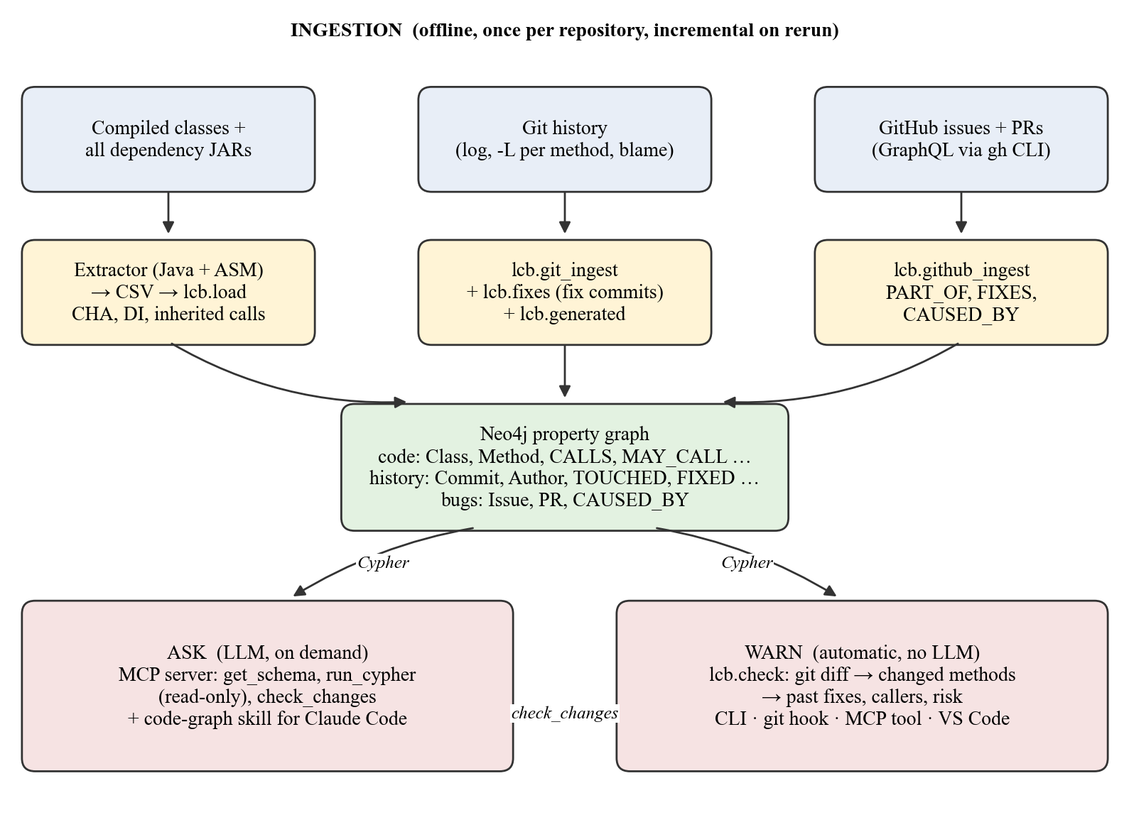
Figure 3.1 Overall system architecture
Figure 3.1 shows the architecture. It has an ingestion side and two consumer sides around one graph. Ingestion runs offline, once per repository and incrementally afterwards. It has three sources: compiled bytecode with all dependency JARs, the git history, and GitHub issues and pull requests. Each source has its own module, and all of them write to the same Neo4j graph.
The Ask side serves an LLM agent on demand. The agent connects to the MCP server, reads the schema once, and writes its own Cypher queries. The Warn side runs automatically and involves no LLM. It takes the current git diff, finds the methods it touches, and reports those that were fixed before. The MCP server's check_changes tool is the bridge: it lets the agent run the same warning after it edits code.
One rule holds everywhere: the graph is built only by ingestion. Every consumer reads from it. The MCP server rejects write queries, and the warning path never writes. This keeps the graph a derived, reproducible artifact. If it is lost, re-running ingestion rebuilds it exactly.

3.5 GRAPH DATA MODEL
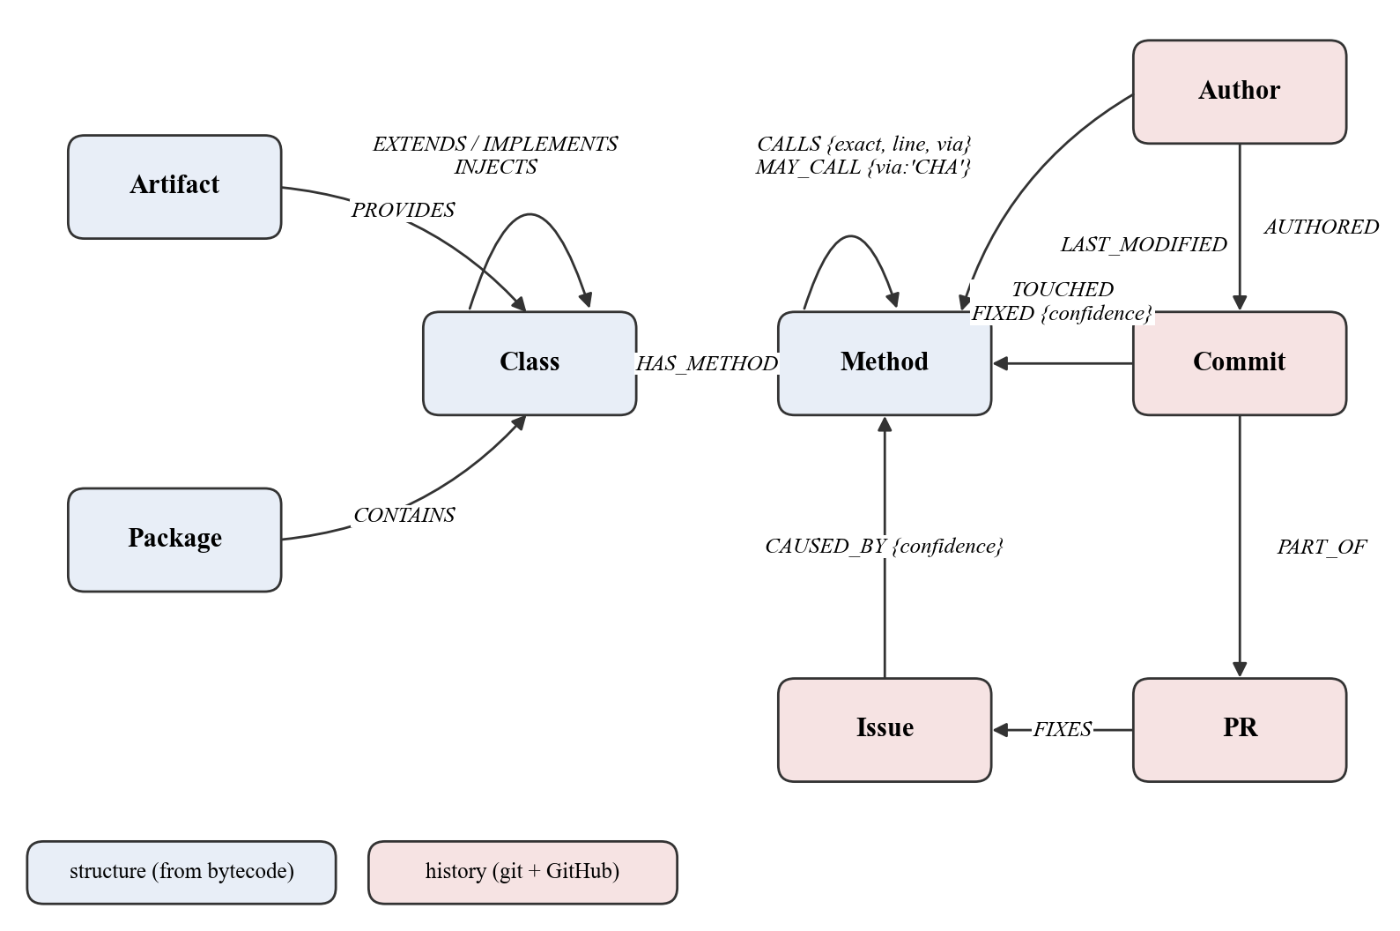
Figure 3.2 Graph data model: structural and historical layers
Figure 3.2 shows the data model. The key property is that history and bugs attach to the same Method nodes as the call graph. One query can therefore combine who calls a method, how often it has changed, and whether it has been fixed before. Table 3.5 lists the node types and Table 3.6 the relationships.
Table 3.5 Node labels
Label | Key properties | Source
Class | fqn, name, package, is_interface, is_abstract, is_external, source_file, artifact, is_spring_bean, stereotype, is_generated | bytecode
Method | fqn, owner, name, descriptor, is_static, is_abstract, is_external, line, line_end, is_bean_factory, bean_type, is_generated | bytecode
Package / Artifact | name; is_external | bytecode, JAR names
Commit | sha, message, timestamp, additions, deletions, files_changed, fix_kind, issue_refs | git
Author | email, name (folded through .mailmap) | git
Issue | number, title, state, opened_at, closed_at, labels | GitHub
PR | number, title, merged_at, files_changed | GitHub
LcbMeta | repo, ingested_at (which repository the graph holds) | ingest

Table 3.6 Relationship types
Relationship | Meaning
(Package)-[:CONTAINS]->(Class) | package membership
(Artifact)-[:PROVIDES]->(Class) | which JAR (or module) a class comes from
(Class)-[:HAS_METHOD]->(Method) | declared methods
(Class)-[:EXTENDS|IMPLEMENTS]->(Class) | type hierarchy
(Method)-[:CALLS {exact, opcode, line, via}]->(Method) | a call site; exact = statically bound; via = class named at the call site
(Method)-[:MAY_CALL {via:'CHA'}]->(Method) | possible override reached by virtual dispatch
(Class)-[:INJECTS]->(Class), -[:INJECTS_BEAN_METHOD]->(Method) | Spring injection candidates
(Author)-[:AUTHORED]->(Commit) | authorship
(Commit)-[:TOUCHED {added, removed}]->(Method) | the commit changed the method's lines
(Author)-[:LAST_MODIFIED]->(Method) | blame at HEAD over the method's span
(Commit)-[:FIXED {confidence}]->(Method) | fix commit (found from its message) changed the method
(Commit)-[:PART_OF]->(PR)-[:FIXES]->(Issue) | commit merged by a PR that closed an issue
(Issue)-[:CAUSED_BY {confidence}]->(Method) | the issue's fix changed this method

3.5.1 NODE IDENTITY
Every method is identified by its fully qualified name including the JVM descriptor, for example:
org.springframework.samples.petclinic.owner.Owner#getPet(Ljava/lang/String;)L…/Pet;
└──────────────── class fqn ────────────────┘ └ name ┘└──── JVM descriptor ────┘

Because the descriptor is part of the identity, overloads such as getPet(String) and getPet(String, boolean) are distinct nodes with no extra work. A source-parsing approach would have to resolve argument types to tell them apart. Uniqueness constraints on Class.fqn, Method.fqn, Package.name and Artifact.name give every edge insertion an index-backed lookup. The is_external flag separates application code from dependency code, which turns "my code versus the framework" into a property filter.

3.6 DESIGN DECISIONS
Several decisions shaped the system. Table 3.7 lists the main alternatives considered and why they were rejected.
Table 3.7 Alternatives considered and rejected
Considered | Rejected because
Tree-sitter (source parsing) | Syntax only, no type resolution: cannot resolve foo.bar() to a declaration or distinguish overloads, and cannot see into JARs.
Decompiling JARs, then parsing | Lossy round trip: approximate source must be re-parsed and re-resolved, losing the certainty bytecode already has.
JavaParser + SymbolSolver | Needs source for every dependency; dependencies ship as JARs.
Soot / WALA points-to analysis | Heavyweight for the value gained over scoped CHA.
jdeps | Package-level granularity only; method level is needed.
Relational database | Variable-length traversal (*1..3) becomes recursive CTEs or many round trips.
Direct dependencies only | Measured: every Spring Boot starter JAR has zero classes (they are POM aggregators), so direct-only indexed no Spring code at all.
Many pre-built MCP tools | Caps the model at anticipated questions; a schema plus a Cypher endpoint answers unanticipated ones.
LLM in the warning path | Slower, costs tokens, and is non-deterministic; a diff and two queries suffice.

The transitive dependency decision deserves emphasis because measurement overturned the original plan. The plan specified indexing direct dependencies only. Counting classes per JAR showed that spring-boot-starter-web and spring-boot-starter-data-jpa contain no classes at all, while database drivers contain over a thousand each. Direct-only indexing would have produced a graph with database drivers and not one Spring Framework class: no JpaRepository and no @Controller. The full classpath of 171 JARs loads comfortably, so it was indexed in full.

3.7 CHANGES FROM THE ORIGINAL PROPOSAL
The project proposal planned a Python or JavaScript target parsed with Tree-sitter, LangGraph agents for orchestration, and file-save-triggered AST diffs for live updates. Table 3.8 records what changed and why.
Table 3.8 Proposal versus implementation
Aspect | Proposal | Implemented | Reason
Target language | Python or JS/TS | JVM (Java, Kotlin, Groovy, Scala) | Bytecode gives exact targets and dependency coverage
Parser | Tree-sitter | ASM over bytecode | Type-resolved calls and overloads
Orchestration | LangGraph agents | MCP server used directly by the agent client | The client already runs the agent loop; fewer moving parts
Live updates | Per-save AST diff | Incremental reload by class signature; on-save check in VS Code | Graph reflects compiled state; one-line edit drops from 70 s to 7 s
Bug linkage | Fixes #N in PRs | Issues + fix commits from messages | Only 4 of about 23 fix commits on PetClinic went through an issue
Evaluation | Historical back-test | Back-test + token benchmark + real-repository trial | Back-test inconclusive on a small repository

Chapter 4
Implementation

4.1 TECHNOLOGY STACK
Table 4.1 Technology stack
Component | Choice | Version | Why
Bytecode reader | ASM (OW2) | 9.7.1 | Streaming visitor API; exact call sites with no type inference
Graph database | Neo4j | 2026.09 / 5.26 | Native graph storage; variable-length traversal
Query language | Cypher | - | Declarative path matching; LLMs write it well
Extractor runtime | Java | JDK 21 | ASM is a Java library; no cross-language boundary
Orchestration | Python | 3.13 | Neo4j driver, MCP SDK and tiktoken are first-class
Graph driver | neo4j (Python) | 5.26.0 | Official Bolt driver, batched transactions
LLM interface | mcp (Python SDK) | 2.2.0 | Standard protocol for any MCP client
Token counting | tiktoken (o200k_base) | 0.8.0 | Deterministic offline counting
Editor extension | TypeScript, VS Code API | VS Code 1.90+ | Diagnostics, hover, status bar
History sources | git CLI, GitHub GraphQL via gh | - | No managed tokens; gh handles auth

4.2 MODULE OVERVIEW
The implementation is about 4,500 lines of Python, 540 lines of Java and 330 lines of TypeScript, plus about 1,600 lines of tests. Table 4.2 lists the modules.
Table 4.2 Modules and their responsibilities
Module | LOC | Responsibility
extractor/src/Extractor.java | 537 | Bytecode → CSV: classes, methods, calls, inheritance, beans, injections
lcb/load.py | 731 | CSV → Neo4j; incremental via manifest; CHA; DI; inherited calls
lcb/git_ingest.py | 602 | Commits, authors, TOUCHED, LAST_MODIFIED, FIXED; source-file index
lcb/fixes.py | 94 | Fix-commit classifier; shared attribution score
lcb/generated.py | 109 | Generated-code detection
lcb/github_ingest.py | 464 | Issues, PRs, PART_OF, FIXES, CAUSED_BY
lcb/check.py | 374 | Diff → methods → past fixes; text and JSON output
lcb/hook.py | 145 | git pre-commit hook installer
lcb/mcp_server.py | 262 | MCP tools: get_schema, run_cypher, check_changes
lcb/ingest.py | 585 | One-command build, extract, load and history ingestion
lcb/setup.py | 190 | Ingest, then register MCP, install extension and hook
lcb/risk.py, backtest.py | 330 | Risk score and its historical back-test
lcb/bench.py, compare_runs.py | 460 | Static token benchmark; live A/B from transcripts
vscode-extension/src | 325 | core.ts (logic) and extension.ts (editor wiring)

4.3 BYTECODE EXTRACTOR
The extractor walks one or more compiled-classes directories (--classes, one per module) and every JAR in one or more dependency directories (--jars). Each .class stream is passed to ClassReader.accept(visitor, SKIP_FRAMES). Two visitors do the work.

4.3.1 CLASS VISITOR
The class visitor records the class identity, access flags, superclass and interfaces, the source file name, and Spring stereotype annotations. The class row is written in visitEnd(), not in visit(), because ASM reports the source file after visit(). Writing early would leave source_file empty and make every citation impossible. Constructor injection is resolved at the same point, because which constructor Spring would autowire is only known once all constructors have been seen.

4.3.2 METHOD VISITOR
The method visitor tracks line numbers from the LineNumberTable and keeps the minimum and maximum as line and line_end. This span is what later lets a git diff be mapped to methods. Each call instruction becomes one call row with its opcode and line:
Listing 4.1 Call-site extraction in the method visitor (Extractor.java)
@Override
public void visitMethodInsn(int opcode, String owner, String name,
String descriptor, boolean isInterface) {
// INVOKESTATIC and INVOKESPECIAL are statically bound: the target is provable.
// INVOKEVIRTUAL and INVOKEINTERFACE name only the declared type; the runtime
// target depends on dispatch, so they are marked inexact and expanded by CHA.
boolean exact = opcode == Opcodes.INVOKESTATIC || opcode ==
Opcodes.INVOKESPECIAL;
emitCall(owner, name, descriptor, opcodeName(opcode), exact);
}

Lambdas and method references compile to invokedynamic. The LambdaMetafactory bootstrap passes the implementation method as a handle, so the lambda body is recovered as a call target. On PetClinic, 20,444 of 32,041 invokedynamic sites were resolved this way. Array owners (int[].clone()) are skipped because they have no class node. Output is eight CSV files plus statistics; every field is quoted so that JVM descriptors survive intact.
For multi-module builds, a sibling module's JAR often appears among another module's dependencies. Its classes are skipped there, so module code is never indexed twice, once as application code and once as a library. The extractor processes PetClinic's 171 JARs and 54,864 classes in 8.2 seconds.

4.4 GRAPH LOADER
The loader (lcb/load.py) writes the CSVs to Neo4j in dependency order: classes, packages and artifacts, methods, inheritance, calls, and finally the CHA and dependency-injection passes. An edge is only created when both endpoints exist. A call into java.lang.String has no target node, so no edge is written, and the count of such calls is reported rather than hidden. Three techniques make the load practical at over a million rows (Table 4.3).
Table 4.3 Loader optimisations
Technique | Detail
Batched UNWIND | 5,000 rows per transaction for nodes, 20,000 for call edges: one round trip per batch instead of per row.
CREATE instead of MERGE for calls | MERGE scans existing relationships for every row. Rows are de-duplicated in Python first (1,385,958 → 1,251,830) and then created without checks.
CALL … IN TRANSACTIONS | The CHA pass writes in 500-row sub-transactions, so it never builds one huge transaction.

4.4.1 RESOLVING CALLS TO INHERITED METHODS
Bytecode names the class written at the call site, not the class that declares the method. The call PageHelper.startPage(...) compiles to PageHelper#startPage, but startPage is declared in the superclass PageMethod. No PageHelper#startPage node exists, so the first version of the loader silently dropped these edges. The fix does what the JVM's own method resolution does: walk the superclass chain, then the superinterfaces, and take the first class that declares a method with the same name and descriptor. Static interface methods are not inherited and are skipped. The edge then points at the declaring method, and CALLS.via keeps the class named in the code. On the mall repository this recovered 108,738 call edges (+9.6%), including all 28 calls to PageHelper.startPage.

4.4.2 CLASS HIERARCHY ANALYSIS
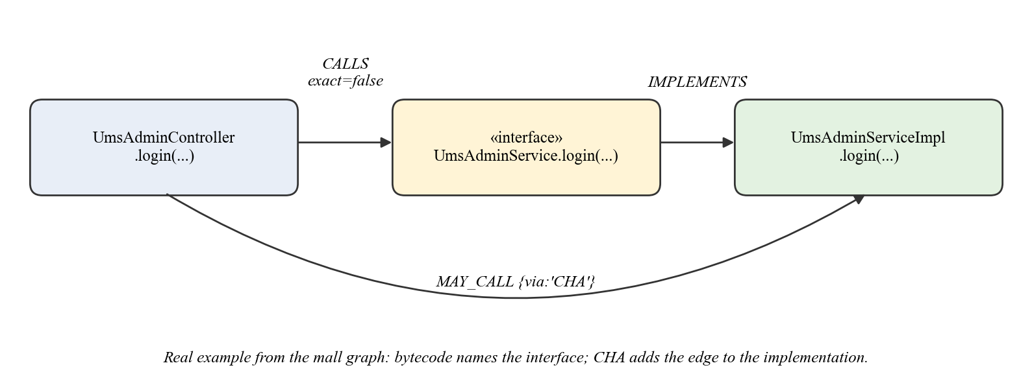
Figure 4.1 Class Hierarchy Analysis adds MAY_CALL edges to implementations
A call through an interface points at the interface method, which has no body. Figure 4.1 shows a real example from mall: UmsAdminController.login calls UmsAdminService.login, an interface method. For every inexact call, CHA finds each subtype of the declared class that declares a method with the same name and descriptor, and adds a MAY_CALL edge to it:
Listing 4.2 The CHA expansion in Cypher (simplified)
MATCH (src:Method)-[:CALLS {exact:false}]->(tgt:Method)
MATCH (base:Class)-[:HAS_METHOD]->(tgt)
CALL (src, tgt, base) {
MATCH (sub:Class)-[:EXTENDS|IMPLEMENTS*1..3]->(base)
MATCH (sub)-[:HAS_METHOD]->(impl:Method)
WHERE impl.name = tgt.name AND impl.descriptor = tgt.descriptor AND impl <> tgt
MERGE (src)-[:MAY_CALL {via:'CHA'}]->(impl)
} IN TRANSACTIONS OF 500 ROWS

CHA is deliberately scoped to two directions: calls that originate in application code ("what might my call actually reach") and calls from anywhere into an application override ("where does the framework call into us"). Expanding every virtual call inside 53,000 dependency classes would add millions of edges inside Spring that no query traverses. CHA over-approximates, which is the safe direction for impact analysis: a blast radius should not miss a caller.

4.4.3 SPRING DEPENDENCY-INJECTION RECOVERY
Beans wired at runtime have no call site in bytecode, but annotations are ordinary class-file attributes. The extractor records stereotype-annotated classes (@Component, @Service, @Repository, @Controller, @RestController, @Configuration), @Bean factory methods, and injection points: the sole constructor of a bean class, and explicit @Autowired fields and setters. The loader resolves each injection point to bean classes reachable through the hierarchy (INJECTS) or to @Bean methods with a matching return type (INJECTS_BEAN_METHOD). Multiple candidates are kept, the same stance as MAY_CALL.
One gate proved essential. Without restricting the constructor heuristic to stereotype-annotated classes, the first version produced 38,733 spurious injection points, one for every ordinary class with a single constructor. With the gate, PetClinic has 91. PetClinic's own injection points target Spring Data repository interfaces, which have no static implementation (Spring generates a proxy at run time), so they correctly stay unresolved. This is a stated limit of static analysis, not an extraction gap.

4.4.4 INCREMENTAL LOADING
A full reload rewrites about 1.25 million edges even when one line changed, which took about 70 seconds on PetClinic and defeats the idea of a living graph. Extraction stays full (it takes 8 seconds), but the write to Neo4j became incremental. Each class gets a content signature: a hash of its own row and every method, call, inheritance, bean and injection row belonging to it, each group sorted first. Signatures are stored in manifest.json. A rerun compares fresh signatures with the manifest and sends only changed classes to Neo4j.
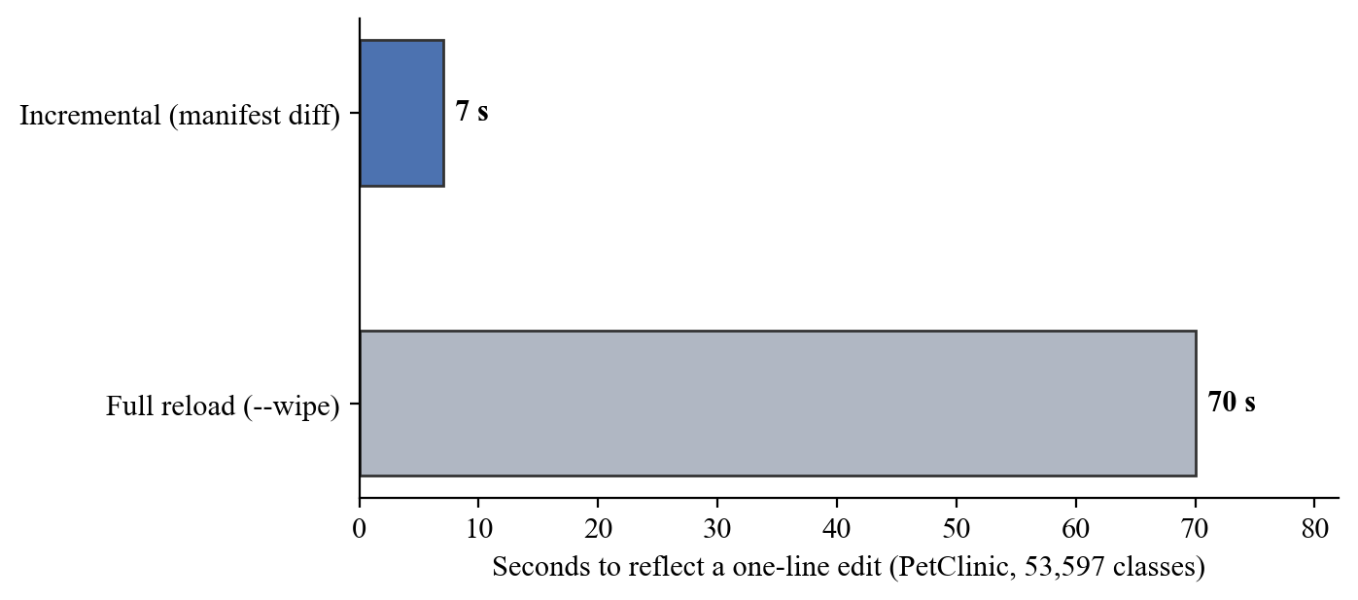
Figure 4.2 Time to reflect a one-line edit in the graph
Method nodes keep their identity across a reload, so history edges attached by the git and GitHub layers survive a structural reload of their class. Only a changed class's outgoing structural edges are rewritten, and methods that disappeared are deleted along with their history. On a one-line change to Owner.java, 1 of 53,597 classes was flagged and the reload took 7.0 seconds (Figure 4.2).
Testing the fallback path found two real bugs. If manifest.json was missing but the graph was not wiped, the first version skipped clearing stale edges and would have duplicated all 1.25 million call edges. After that was fixed, the clearing query matched on Method.owner, which had no index, and hung when every class counted as changed. Both are fixed and covered by tests.

4.5 GIT HISTORY LAYER
The git layer (lcb/git_ingest.py) attaches history to application methods. Dependency JARs have no history in the repository, so nothing is attached to them. Table 4.4 lists what it produces.
Table 4.4 Git layer outputs
Produces | How
Commit, Author, AUTHORED | git log --numstat, with identities folded through the repository's .mailmap
TOUCHED {added, removed} | git log -L<line>,<line_end>:<path> per method; git re-targets the range through history, so it stays exact after code moves
LAST_MODIFIED | git blame at HEAD over the method's span (uncommitted edits ignored)
Commit.fix_kind, issue_refs, FIXED | every subject classified by lcb/fixes.py; fix commits linked to the methods they changed

Finding source files in any layout. Bytecode records only the file name (Owner.java). A SourceIndex built from git ls-files finds the file by package path, which handles multi-module builds, same-named files in different modules, non-standard source roots, and Kotlin, Groovy and Scala sources.
Why git log -L instead of intersecting diffs. Intersecting each historical diff with a method's current line span drifts the further back the file was edited. Git's -L mode [5] renumbers the range through every earlier commit, so TOUCHED is exact for every commit, not only recent ones.
Incremental state. The last ingested commit is stored per repository in out/state/<repo>-<hash>/. A rerun reads only new commits and re-scans only methods whose file changed. Saved state from another repository, or a commit that vanished through a history rewrite, triggers a full scan. Commit classification is re-run on every ingest, so an improved fix detector also re-checks old commits. That gap was found in the mall trial.

4.6 BUG-FIX DETECTION FROM COMMIT MESSAGES
Most fixes never go through an issue. On PetClinic about 23 fix commits change application methods, and the GitHub issue chain reaches only 4 of them. So every commit subject is classified (lcb/fixes.py), following the approach of Mockus and Votta [17]:
- fix:, fix(scope): or fix!: → conventional (the author's own classification is trusted);
- a fix word such as fixed, bugfix, hotfix or regression, or the Chinese words 修复 (repair), 修正 (correct) or 解决 (resolve) → keyword;
- git's own Revert "…" subject → revert.
Excluded are merge commits (the fix itself is counted), docs:, test:, chore: and similar types, text-only fixes (typos, comments, links, README, licence), and fix words that only appear inside quotes, such as Polish "Fix content negotiation", which cite another commit. The Chinese support was added after the mall trial, whose history is largely in Chinese. 修改 ("modify") is deliberately excluded because it describes any change.

4.6.1 ATTRIBUTION SCORE
A fix commit often touches several methods, and not all of them contained the bug. Each link gets a confidence score shared with the GitHub layer:
confidence = focus × line_share × size
focus = 1 / (number of methods the commit touched)
line_share = this method's changed lines / the commit's changed lines
size = 1 / (1 + files_changed / 10)

A focused fix of one method in one file scores 1 × 1 × 1/1.1 ≈ 0.91; a sweeping refactor scores near zero. The score ranks candidates against each other and is not a calibrated probability, which is how it is presented to users and to the LLM.

4.7 GENERATED-CODE DETECTION
The mall trial revealed that 20,762 of its 22,502 "application" methods were output of MyBatis Generator. Their history was most of the ingest time and pure noise: every regeneration looked like a change to thousands of methods. Generated code stays in the call graph, because the application really calls it, but lcb/generated.py marks it is_generated. It then gets no history and no risk rank. Bytecode cannot tell (@Generated has source retention), so the repository is read in three ways:
1. Generator configurations name the packages they write: MyBatis Generator (targetPackage), OpenAPI and Swagger codegen (modelPackage, apiPackage, invokerPackage, in Maven and Gradle), and jOOQ (<target><packageName>). This catches mall, whose generated files carry no marker at all.
2. Markers in the file: a @Generated annotation or MyBatis's @mbg.generated anywhere; or "DO NOT EDIT", "auto-generated" or "Code generated by" in the header before the type declaration. Further down, "the id is auto-generated" describes data, not the file.
3. Paths containing a generated, generated-sources or generated-src folder.
On mall, 228 files were identified from its generatorConfig.xml, and the two hand-written files in the same packages were kept. A full history rebuild fell from 7 minutes to 36 seconds.

4.8 GITHUB LAYER
The GitHub layer (lcb/github_ingest.py) fetches issues and merged pull requests through GraphQL using the gh command-line tool, so no token has to be managed. The repository is read from the clone's origin remote. Raw responses are cached per repository, and a rerun paginates by update time and stops at the first item already seen. PetClinic's 392 issues and 211 pull requests take about six round trips. Three links are built:
- PART_OF connects a commit to its pull request through the merge commit;
- FIXES connects a pull request to an issue through GitHub's closing references, with a regular-expression fallback for projects that do not use them;
- CAUSED_BY connects an issue to a method by following Issue ← PR ← Commit → TOUCHED → Method, scored with the same attribution formula.
On PetClinic, 158 of 190 merge commits were linked. The other 32 belong to pull requests merged before about 2014, whose merge commits no longer exist because the early history was rewritten. They are reported, not silently dropped. On the two issues whose titles name a method explicitly, that exact method was ranked first: showVetList (confidence 0.91) and addPet (0.29).

4.9 RISK SCORE
lcb/risk.py combines structural and historical signals for each application method:
risk(m) = w1·fan_in(m) + w2·bug_signal(m) + w3·churn(m) + w4·author_departed(m)

Fan-in counts distinct callers. The bug signal sums CAUSED_BY confidence plus FIXED confidence from fix commits not already behind an issue. Churn counts distinct commits that touched the method, and author departure flags methods whose authors stopped committing. Each signal is min-max normalised to [0, 1] before weighting. Test coverage, part of the original formula, was dropped rather than faked: the extractor indexes only main classes, so there is no honest coverage signal. The weights are an equal placeholder (0.25 each), because they should be fitted against the back-test (Section 6.7), which needs a larger repository.

4.10 MCP SERVER
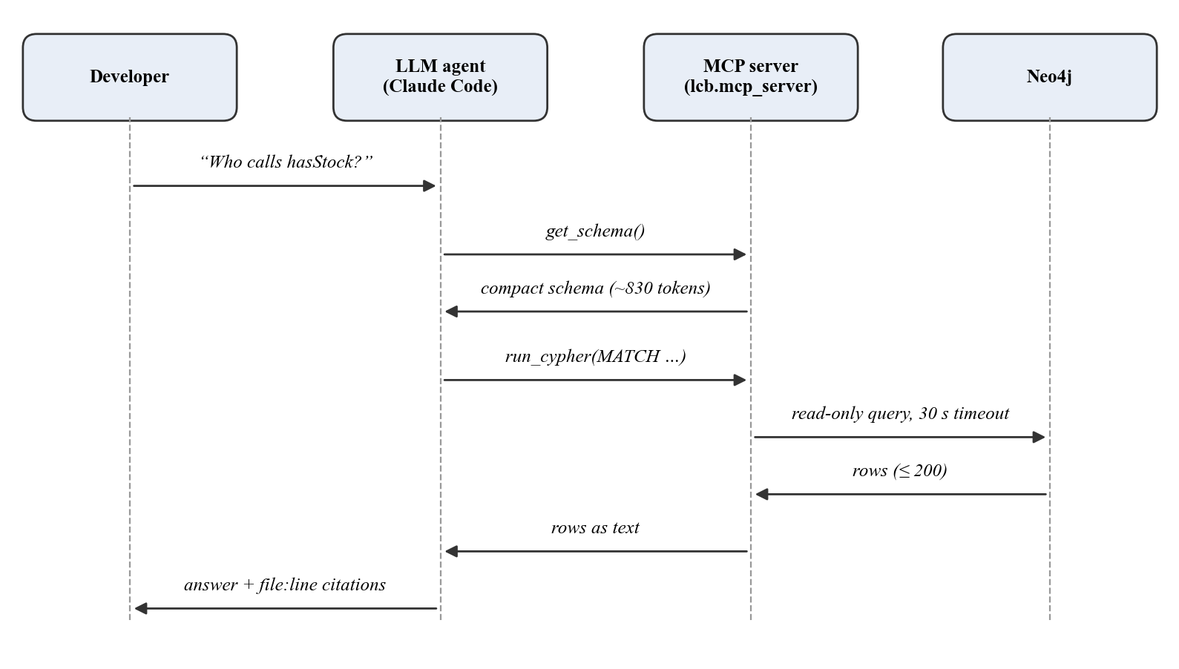
Figure 4.3 Interaction between developer, LLM agent, MCP server and Neo4j
The MCP server (lcb/mcp_server.py) is started by the MCP client over standard input/output. Figure 4.3 shows a typical exchange. It deliberately has only three tools (Table 4.5).
Table 4.5 MCP tools
Tool | Purpose
get_schema | Compact schema (about 830 tokens): labels, relationships, conventions and example queries. details=true adds longer notes on Spring DI, confidence and history limits.
run_cypher | Read-only Cypher. Write keywords rejected, results capped at 200 rows, 30-second timeout, errors returned as text so the model can correct its query.
check_changes | The change check (Section 4.11) on the working tree, staged changes or against a base ref. Its description tells the agent to call it after editing code.

Few tools, deliberately. Pre-built tools such as get_blast_radius or get_bug_history limit the model to questions the designer anticipated. A schema and a query endpoint let it answer questions nobody anticipated, which is the main argument for a graph over a search index. check_changes is the exception because it needs the git diff, which the graph does not hold.
Server instructions. In the mall trial, Claude Code saw the tools but kept grepping files out of habit, because mall has no project-specific skill file. The fix was to send short instructions when the client connects, which MCP clients place in the assistant's context:
Listing 4.3 Excerpt of the MCP server instructions
Prefer it over grep, reading files or running git log for: who calls a method or
what
it calls; the blast radius of a change; class hierarchies; which dependency JAR
provides a class; who changed a method and when; whether a method was fixed before.
Call get_schema once, then run_cypher. ...
After editing Java/Kotlin source, call check_changes before finishing.

After this change the assistant used the graph unprompted and called check_changes after its own edits. For Claude Code, a skill file (.claude/skills/code-graph/SKILL.md) adds query patterns, visualisation tips for the Neo4j Browser, and the graph's limits.
Guardrails. Write clauses (CREATE, MERGE, SET, DELETE, REMOVE, DROP, LOAD CSV, FOREACH) are rejected by a keyword scan before execution. Results are capped and transactions time out. Errors are returned rather than raised, so a malformed query costs one retry, not a failed turn. The intended production setting adds a read-only database user, so the database itself enforces the guarantee.

4.11 CHANGE CHECK
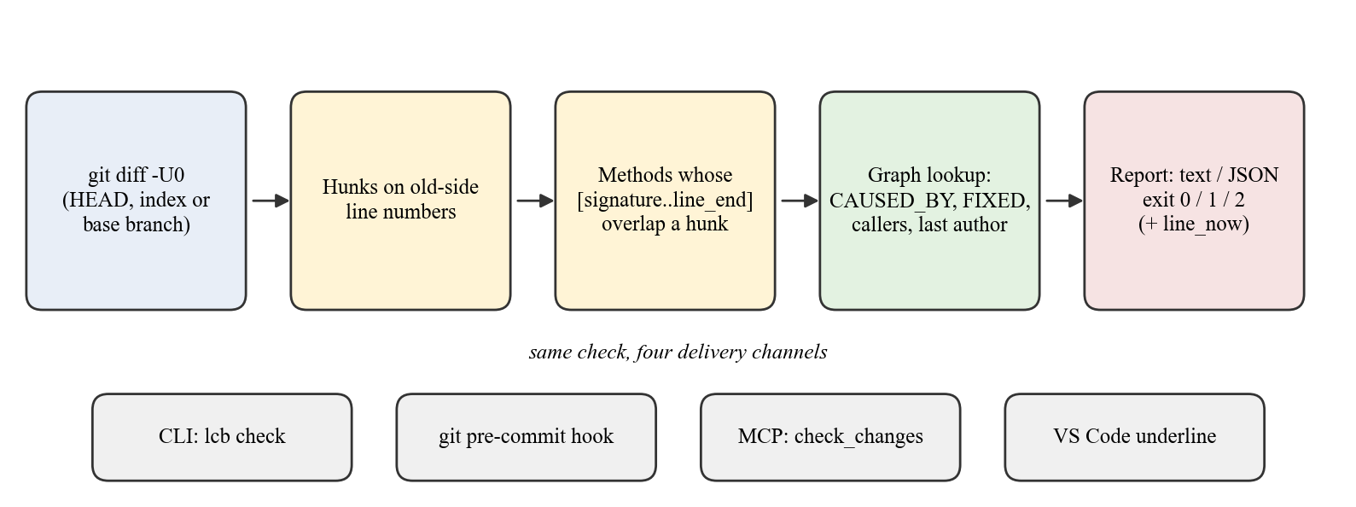
Figure 4.4 The change check and its four delivery channels
The change check (lcb/check.py) answers one question: does the current change touch a method that was fixed before? It needs no LLM; it runs one diff and two queries (Figure 4.4).
1. Run git diff -U0 against HEAD (working tree), the index (--staged, what a commit would record) or a base branch (--base main, a pull request), and parse the hunks.
2. Match hunks on the diff's old-side line numbers. These number the same version of the file that the graph's line and line_end describe, so an edit still lands on the right method after earlier edits in the file have shifted it.
3. Extend each method's span upward to its signature. Bytecode line tables start at the first statement, so the check scans the old source upward for the line naming the method, past comments and wrapped parameter lists. Editing the parameter list therefore counts as changing the method, while a line added after a method's closing brace does not flag it.
4. Look up CAUSED_BY issues and FIXED commits (skipping fix commits already behind a listed issue), plus callers, the last author and the risk rank.
5. Report as text or JSON. JSON includes line_now, the method's position in the working tree, so editors mark the right line.
Exit status is 0 when the check ran, 1 under --strict when something was flagged, and 2 when the check could not run. --quiet prints nothing unless something is flagged. Listing 4.4 is real output from PetClinic after editing one line in each of two methods.
Listing 4.4 Change-check output on PetClinic
⚠ VetController.showVetList (src/main/java/.../vet/VetController.java:45)
linked to issue #2333 (91% confidence, fixed by PR #2491): [BUG] Vets object
created but never added to model in VetController#showVetList
0 callers · last changed by simrin051 · risk rank 24 of 121
⚠ OwnerController.processFindForm (src/main/java/.../owner/OwnerController.java:97)
fixed before in bb37aad by Luiz Fernando de Andrade Gadelha, 2026-07-24
(83% confidence): "fix: normalize whitespace in owner search"
+2 weaker links (--all to show)

4.12 GIT PRE-COMMIT HOOK
lcb hook install installs the check as a pre-commit hook that runs on what is staged. If nothing is flagged, it is silent. If something is flagged, the warning is printed and the commit proceeds, or with --block it is stopped (git commit --no-verify always bypasses it). If the check cannot run, for example because Neo4j is stopped, the hook prints one line and lets the commit through: a stopped database never stops anyone committing.
The hook is written where git actually runs hooks, honouring core.hooksPath as used by Husky and similar tools. It never overwrites a hook it did not write; lcb hook print gives the lines to add to an existing hook instead. The database password is never written to disk.

4.13 VS CODE EXTENSION
The extension (vscode-extension/) shows the same check in the editor. On every save of a Java, Kotlin, Groovy or Scala file it runs lcb check --json, underlines the signature of each changed method that was fixed before (yellow by default, red with lcb.severity: error), adds an entry to the Problems panel, and shows the issue or fix commit on hover. A status-bar item shows the count, or why the check could not run.
The extension contains no analysis: core.ts turns the JSON into marks and extension.ts wires them to the editor. Every decision stays in lcb.check, so the CLI, hook, MCP tool and editor always agree. It reads ~/.lcb/config.json, written by lcb setup, so it needs no settings.

4.14 ONE-COMMAND ONBOARDING
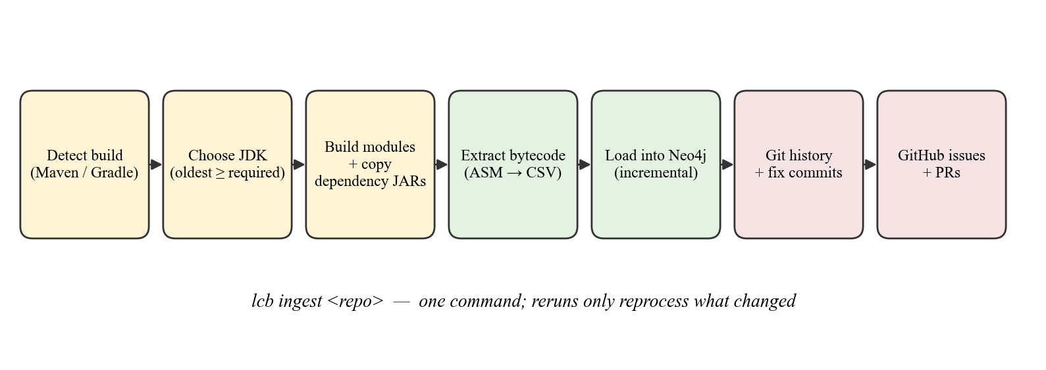
Figure 4.5 Steps performed by lcb ingest
lcb ingest <repo> runs the whole ingestion pipeline (Figure 4.5). It detects Maven or Gradle (preferring the project's own wrapper), builds every module, collects dependency JARs, finds every module's compiled classes, then extracts, loads and ingests git and GitHub history. Three behaviours were added after builds failed on the mall trial (Table 4.6).
Table 4.6 Build robustness added after the field trial
Trial failure | Behaviour now
Maven picked Java 27, newer than the project's Lombok supports, so every Lombok getter was missing | Builds with an explicit JAVA_HOME: the oldest installed JDK that the build files allow (Java 17 required → Java 21 chosen). JDKs are discovered in Homebrew, /Library/Java, /usr/lib/jvm, SDKMAN and ~/.jdks. --jdk overrides.
A stalled download hung Maven silently | 60-second download timeouts with retry; progress per module, a download count and a heartbeat after a minute of silence; full log in build.log.
A Docker plugin tried to reach the author's Docker host | Steps not needed for compiled classes are skipped: tests, Docker/Jib, style and licence checks, javadoc, signing, frontend bundles.

The graph holds one repository at a time, recorded in an LcbMeta node. Ingesting a different repository into an occupied graph is refused unless --replace is given. lcb setup <repo> runs ingest, records the installation in ~/.lcb/config.json, registers the MCP server for that repository in Claude Code (claude mcp add --scope local), installs the VS Code extension and optionally the hook. Nothing is written into the analysed repository, which matters when it is a team's shared repository. Any step that cannot run prints what to do instead without stopping the others.

Chapter 5
Testing and Validation

5.1 TESTING STRATEGY
Testing works at four levels:
1. Unit tests for pure logic: the commit-message classifier, issue references, the attribution score, build-tool detection and diff parsing.
2. End-to-end tests on scripted repositories. A test builds a small multi-module Java repository whose commits and authors are scripted, so the true history is known. It runs the real pipeline (javac, extractor, loader, git ingestion) and checks every TOUCHED, LAST_MODIFIED and FIXED edge against that known history.
3. A throwaway database. tests/neo4j_sandbox.py starts a separate Neo4j instance with its own data directory on random ports, and shuts down its whole process group afterwards. The real graph is never touched.
4. Real repositories. Spring PetClinic [25] for every change, and macrozheng/mall as a field trial (Section 5.4).
Each bug fix was also mutation-checked: reverting the fix makes the matching test fail. This shows that the test actually covers the fix rather than passing by coincidence.

5.2 TEST SUITES
Table 5.1 Automated test suites
Suite | Tests | What it covers
tests/test_check.py | 34 | Diff-to-method mapping (shifted lines, insertions, signature edits, signature finding), flagging thresholds, --staged, de-duplication, the MCP tool over the real stdio protocol, and the git hook through real git commit runs
tests/test_ingest.py | 26 | Build-tool detection; Maven and Gradle class-folder discovery; JDK choice; ingest of a two-module repository (sibling JAR skipped, cross-module calls and history, incremental rerun, refusal and --replace); generated-code detection; inherited-call resolution
tests/test_git_layer.py | 20 | Every TOUCHED, LAST_MODIFIED and FIXED edge on a scripted repository; .mailmap; uncommitted edits; incremental runs; per-repository state
tests/test_fixes.py | 5 | Commit classifier (fixes and non-fixes, English and Chinese), issue references, attribution
tests/test_setup.py | 5 | lcb setup with stand-in claude and code programs: MCP registration, extension install, user config, hook, missing tools, foreign hook left alone, nothing written into the repository
vscode-extension (npm test) | 8 | JSON to marks, messages, exit codes, settings and user config, plus two runs of the real lcb.check
Total | 98 | All passing

PYTHONPATH=. .venv-mac/bin/python -m unittest tests.test_fixes tests.test_git_layer
\
tests.test_check tests.test_ingest tests.test_setup
cd vscode-extension && npm test

5.3 REPRESENTATIVE TEST CASES
Table 5.2 Representative test cases
ID | Input / action | Expected result | Status
TC01 | Subject "fix: normalize whitespace in owner search" | conventional fix | Pass
TC02 | Subject "Fix typo in readme" | not a fix (text-only) | Pass
TC03 | Subject "Merge pull request #12 from x/fix-y" | not a fix (merge) | Pass
TC04 | Subject 'Revert "Make jar not war"' | revert | Pass
TC05 | Chinese subject "库存问题修复" (stock issue fixed) | keyword fix | Pass
TC06 | Fix commit touching one method in one file | confidence ≈ 0.91 | Pass
TC07 | Lines inserted above a method, then the method edited | the edited method is flagged, not its neighbour | Pass
TC08 | New method added after an existing method's closing brace | existing method not flagged | Pass
TC09 | Parameter list of a fixed method edited | method flagged | Pass
TC10 | git commit with --block hook on a flagged change | commit stopped, warning shown | Pass
TC11 | git commit with Neo4j stopped | one-line notice, commit proceeds | Pass
TC12 | Hook install over a hook written by another tool | existing hook left unchanged | Pass
TC13 | run_cypher with a CREATE clause | REJECTED, graph unchanged | Pass
TC14 | check_changes through the MCP stdio protocol after an edit | flagged method reported | Pass
TC15 | Ingest a second repository without --replace | refused with an explanation | Pass
TC16 | lcb setup on a repository | MCP, extension and config set up; repository files unchanged | Pass

5.4 FIELD TRIAL ON A REAL REPOSITORY
PetClinic is small and well kept, so it cannot expose every problem. The system was therefore run on macrozheng/mall [16], an e-commerce system with 7 Maven modules, 1,085 commits and commit messages largely in Chinese. Its author's setup steps were followed from a fresh clone. The trial found eight problems that PetClinic never showed, listed in Table 5.3. Each was fixed and covered by a test.
Table 5.3 Problems found on the mall trial and their fixes
# | Problem observed | Fix
1 | Chinese fix words not recognised, so almost no fix commits were found | Classifier accepts 修复 / 修正 / 解决 and excludes 文档 / 注释 / 错别字
2 | The assistant ignored the MCP tools and kept grepping | Server instructions sent on connect
3 | Old commits were not re-classified after the detector improved | Classification re-run on every ingest
4 | The build looked frozen during long downloads | Progress, heartbeat and 60 s timeouts
5 | Maven used Java 27, which broke Lombok | Oldest compatible JDK chosen automatically
6 | A Docker plugin step failed | Non-essential build steps skipped
7 | 92% of methods were generated code, dominating history time | Generated-code detection; history rebuild 7 min → 36 s
8 | Calls to inherited methods were dropped | JVM-style resolution; +108,738 call edges

After the fixes, the full workflow was verified on mall by hand: lcb setup completed without manual steps; VS Code underlined edited methods with a fix history (for example hasStock and login); Claude Code answered structural questions from the graph and called check_changes after its own edits without being asked; and the pre-commit hook in blocking mode stopped a flagged commit.

5.5 CORRECTNESS CHECKS AGAINST SOURCE
Graph answers were checked against the source code. For example, OwnerRepository.java line 36 reads public interface OwnerRepository extends JpaRepository<Owner, Integer>. The graph returns exactly that supertype and attributes it to spring-data-jpa-4.1.0.jar, a fact the source alone cannot give. The callers of OwnerRepository.findById returned by the graph match those found by reading the four controller files. For the two issues whose titles name a method, the top-ranked CAUSED_BY link was that method.

5.6 UNTESTED AREAS
- The Gradle path is unit-tested but has not been run against a real Gradle build, because the Gradle wrapper download was blocked on the test machine. The Maven path is verified end to end.
- The VS Code extension's editor-facing code is covered by unit tests and was verified by hand on mall, but there are no automated tests that drive a real VS Code window.

Chapter 6
Results and Discussion

6.1 GRAPH CONSTRUCTION
Table 6.1 Graph contents for the two repositories
Measure | Spring PetClinic | macrozheng/mall
Application classes | 30 | 758 (456 generated)
Classes including dependencies | 53,597 | 107,049
Methods | 446,071 | 1,106,415
CALLS edges | 705,057 | 1,237,623
MAY_CALL edges (CHA) | 41 | 1,449
Artifacts (JARs and modules) | 145 | 189
Commits | 1,042 | 1,085
TOUCHED / LAST_MODIFIED | 1,162 / 116 | 2,622 / 1,747
FIXED (fix commits → methods) | 119 | 43
Issues / merged PRs | 392 / 211 | 524 / 1
CAUSED_BY (issues → methods) | 23 | 0

PetClinic has only 30 application classes, but its dependency closure is enterprise-sized: 54,864 class rows and 1.39 million call sites. The graph holds slightly fewer nodes than extracted rows, because the same class ships in more than one JAR (duplicated and shaded classes are common on a Spring classpath) and these collapse on merge. The 1,267-class gap is deduplication, not data loss. On mall, the issue tracker is active but almost no pull requests were merged through GitHub, so no CAUSED_BY links exist. Fix commits detected from messages still produced 43 FIXED links, which shows why the message-based detector matters.

6.2 CALL-SITE RESOLUTION
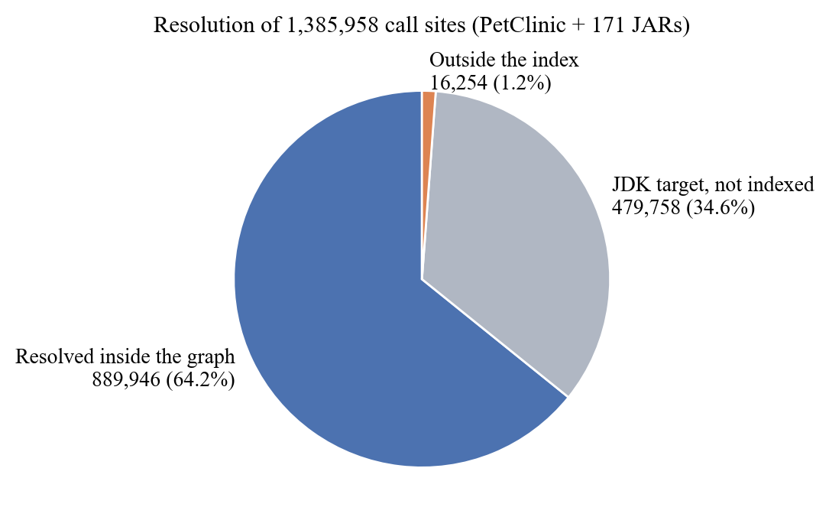
Figure 6.1 Resolution of call sites on PetClinic
Figure 6.1 shows where call targets land. 64.2% of all call sites resolve to a method in the graph, and 34.6% point into the JDK (java.*, javax.*), which is deliberately not indexed. Only 1.2% point at classes genuinely missing from the index, mostly optional dependencies such as the Kotlin standard library, protobuf and Reactor, which libraries reference conditionally but which are not on PetClinic's classpath. Excluding the JDK, 98.2% of call sites resolve. Because targets come from bytecode, there is no inference step that could resolve a call to the wrong method; the open question is only coverage.

6.3 PERFORMANCE
Table 6.2 Pipeline and query performance
Operation | Measurement
Extraction, PetClinic (54,864 classes from 171 JARs + app) | 8.2 s
Full load into Neo4j (1.25 M de-duplicated call edges) | about 2 min
Incremental reload after a one-line edit | 7.0 s (from about 70 s)
lcb ingest rerun with nothing changed, PetClinic | about 14 s
lcb ingest rerun on mall | 29 s
Full history rebuild on mall | 36 s (from 7 min)
Interactive query latency | 12–137 ms
Static token benchmark, 9 questions | 4.3 s

The figures show that the graph is cheap to keep current. The expensive step is the first build of a repository, dominated by downloading its dependencies. After that, reruns are incremental throughout, and query latency is far below what a person or an LLM turn would notice.

6.4 TOKEN EFFICIENCY

6.4.1 METHODOLOGY
The static benchmark (lcb/bench.py) asks nine structural questions about PetClinic and counts, with tiktoken's o200k_base encoding, the context each approach needs to answer them:
- With the graph: the schema, plus the Cypher query, plus the returned rows.
- Without the graph: the grep hit list, plus the full text of every file containing a match. This models what an assistant actually does, grep and then read the matching files. It is not a whole-repository dump, which would inflate the ratio.
The measurement is deliberately conservative. The schema (746 tokens at the time of measurement) is charged to the graph on every question, although in practice it is sent once per session. The baseline is charged a single read pass, although a real agent re-sends its growing transcript on every turn.

6.4.2 RESULTS
Table 6.3 Token cost per question (PetClinic)
# | Question | Graph | Baseline | Saved | Ratio
Q1 | Which methods call OwnerRepository.findById, and at what line? | 986 | 4,628 | 78.7% | 4.7×
Q2 | Blast radius: what application code transitively calls Owner.getPet, up to 3 hops? | 999 | 4,132 | 75.8% | 4.1×
Q3 | Which dependency JAR provides the Spring interface that OwnerRepository extends? | 831 | 6,860 * | 87.9% | 8.3×
Q4 | Which application methods have the most distinct callers? | 1,215 | 15,521 | 92.2% | 12.8×
Q5 | Which application classes extend or implement a type from a dependency? | 1,003 | 7,201 | 86.1% | 7.2×
Q6 | Which application methods are never called anywhere - dead code candidates? | 1,629 | 16,506 | 90.1% | 10.1×
Q7 | Which dependency JARs does the application actually call into, and how heavily? | 949 | 14,116 * | 93.3% | 14.9×
Q8 | What does OwnerController depend on, application types and framework types alike? | 970 | 1,483 | 34.6% | 1.5×
Q9 | How many classes does each dependency JAR contribute to the indexed codebase? | 1,020 | 17,529 * | 94.2% | 17.2×
 | Total | 9,602 | 87,976 | 89.1% | 9.2×

* The baseline cannot actually answer this question from application source; the figure is what it spends before failing.
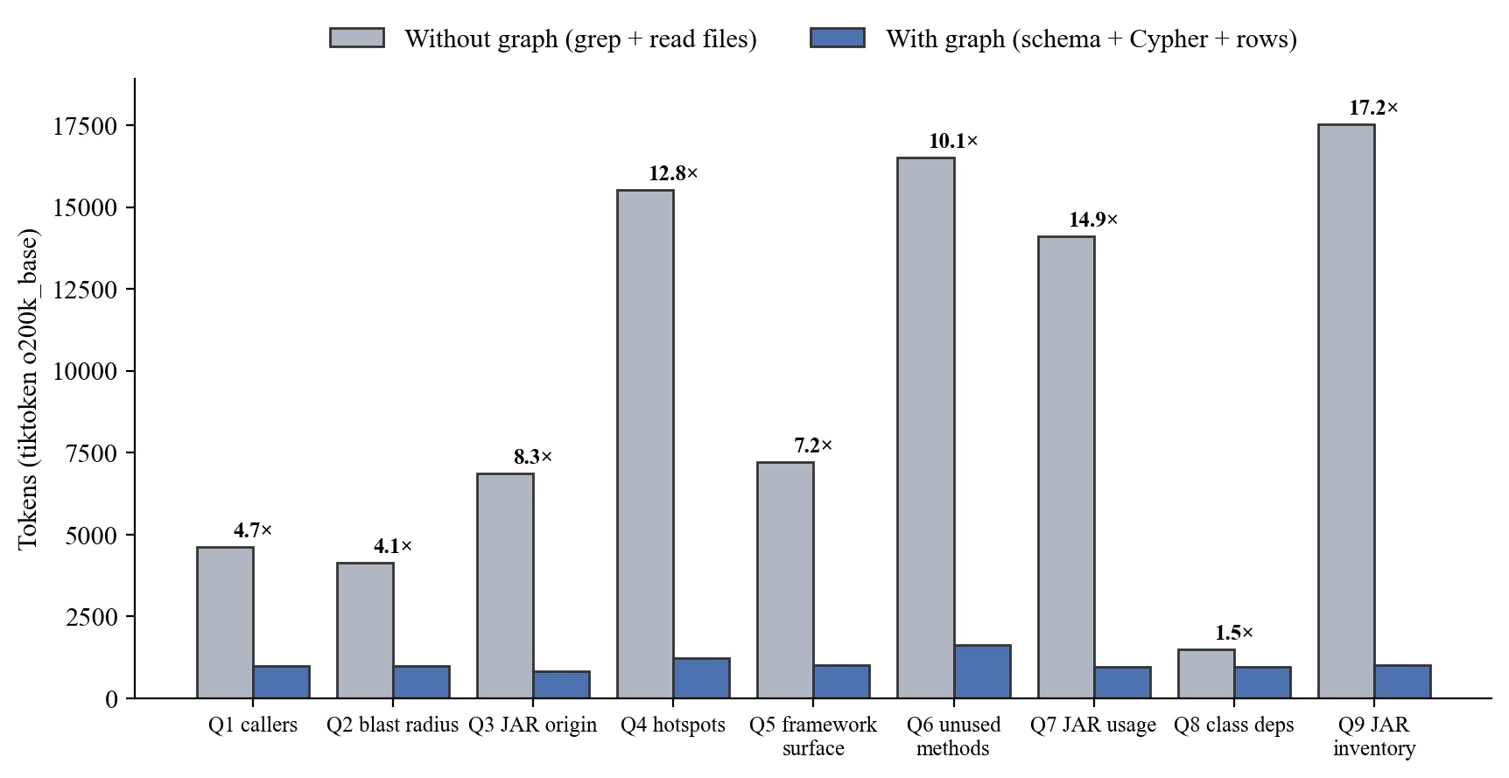
Figure 6.2 Tokens per question, with and without the graph
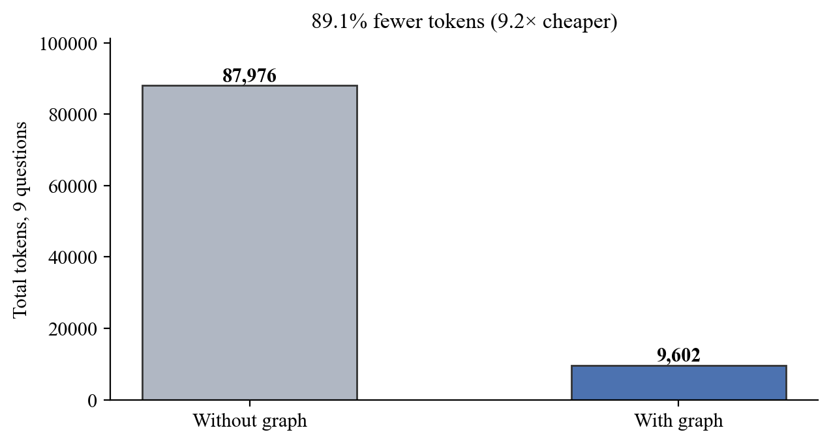
Figure 6.3 Total tokens over the nine questions
Across the nine questions the graph used 9,602 tokens against 87,976: 89.1% fewer, or 9.2× cheaper (Figure 6.2, Figure 6.3). The graph's cost is nearly flat, between about 830 and 1,630 tokens, because it is dominated by the fixed schema and the query result is compact. The baseline's cost grows with how many files a question touches.

6.4.3 DISCUSSION
- The largest savings are on aggregate questions (Q4 hotspots, Q6 unused methods, Q7 JAR usage, Q9 JAR inventory: 10–17×). Answering these by reading files needs nearly the whole codebase, while the graph answers with one aggregation.
- Three questions are not answerable from source at all (Q3, Q7, Q9). Which JAR provides a type, and how heavily each JAR is used, are facts of the compiled classpath. A grep-based assistant would spend the tokens and then guess.
- The smallest saving is Q8 (1.5×), a question about one small class. Reading one short file is cheap, so the fixed schema cost is a large share. This is the expected crossover: for questions local to a single small file, the graph is not much cheaper. It is reported rather than left out.
- Accuracy is not traded for tokens. Graph answers are exact and cite file and line, and they were checked against the source (Section 5.5).
The static benchmark is an estimate, not a recording of real sessions. A harness for live comparison (lcb/compare_runs.py) already reads real token usage, including cache reads and writes, from Claude Code session transcripts for the same question asked with and without the MCP server. Its systematic use is planned as future work (Section 7.4).

6.5 HISTORY AND BUG LINKING
On PetClinic's full history (1,042 commits back to 2013, 164 authors), 116 of the 121 application methods have TOUCHED history; the other five are abstract or have no body. About 115 commit subjects mention a fix. Of these, 20 change application methods and produce 119 FIXED links, against only 4 fix commits reachable through the GitHub issue chain. Message-based fix detection finds five times as many fixes as the issue chain alone, and it needs nothing but git, so it works for any issue tracker.
The detector is a free-text heuristic, and its errors are known: a "fix" that only renames a variable counts, and a real fix described as "handle empty owner list" does not. Precision is helped by two facts. Only commits that change application methods produce edges, so a fix to a README never reaches a method. And the attribution score pushes the links from sweeping changes towards zero.

6.6 CHANGE WARNINGS IN PRACTICE
The four delivery channels were verified on mall. Figures 6.4 to 6.7 show them in use.
[INSERT SCREENSHOT: VS Code with a method signature underlined after saving an edit, and the hover text showing the past fix (for example hasStock or login in mall)]
Figure 6.4 VS Code extension marking a previously fixed method
[INSERT SCREENSHOT: Terminal showing git commit stopped by the pre-commit hook in --block mode, with the warning text]
Figure 6.5 Pre-commit hook blocking a flagged commit
[INSERT SCREENSHOT: Claude Code session answering a structural question with run_cypher, and calling check_changes after an edit]
Figure 6.6 Claude Code using the MCP tools
[INSERT SCREENSHOT: Neo4j Browser (localhost:7474) drawing a method with its callers, e.g. the query MATCH p=(:Method)-[:CALLS]->(m:Method {name:'hasStock'}) RETURN p LIMIT 25]
Figure 6.7 Neo4j Browser visualising callers of a method
Comment-only edits inside a method also trigger the warning, because the check works at line level and does not parse what changed. This is predictable and makes the warning easy to demonstrate, but it can be noisy in daily use. An opt-in filter is listed as future work.

6.7 RISK SCORE BACK-TEST
The proposal's evaluation plan was run with lcb/backtest.py. A cutoff date T = 2023-01-01 is chosen, the 15 highest-risk methods as of T are ranked, and the result is compared with the methods that actually had issue-linked bugs closed after T. Churn, bug signal and author departure are computed only from data dated before T. Fan-in comes from the current build, because there is no historical build to analyse. Two baselines guard against rediscovering that busy code is busy: a churn-only ranking and a fan-in-only ranking.
Table 6.4 Back-test on PetClinic (13 positive methods out of 121)
Ranking | Recall@15 | Hits
Combined risk score | 2/13 | VetController.showVetList, PetValidator.validate
Fan-in only | 1/13 | Owner.addPet
Churn only | 1/13 | OwnerController.<init>

The combined score finds twice as many future bug sites as either baseline, but on 13 positives this is a direction, not evidence. Several of the missed positives (for example WebConfiguration methods and VisitController.minVisitDate) did not exist before the cutoff, so no score computed from earlier history could flag them. The instrument works; the repository is too small and too calm to validate it. Fitting the weights requires a larger, actively maintained project.

6.8 DISCUSSION AND THREATS TO VALIDITY
- Benchmark validity. The token figures are computed estimates on a question set written by the project author. The conservative choices (schema charged every time, single-pass baseline) push the ratio down. A live, repeated A/B study with correctness scoring would make the claim stronger.
- Repository size. PetClinic is small. mall is medium-sized and exposed real problems, but neither is a large industrial codebase.
- Heuristic links. Fix detection and attribution are heuristics. They rank candidates and are labelled as rankings, never as probabilities.
- Static analysis limits. Reflection, dynamic proxies and runtime wiring are invisible, and the JDK is not indexed. These limits are stated in the schema the LLM reads, so it can tell the user instead of guessing.

Chapter 7
Conclusion and Future Work

7.1 CONCLUSION
This project built Living Codebase Brain, a system that turns a JVM repository into one graph holding its exact call structure, including every dependency JAR, together with each method's history, past fixes and linked issues. The graph serves two audiences. An LLM assistant queries it through a three-tool MCP server and answers structural questions with about a tenth of the tokens that reading files needs. Developers are warned automatically, in the terminal, at commit time, inside the agent and in the editor, when a change touches code that was fixed before.
Three conclusions stand out:
1. Bytecode was the right foundation. It gave exact call targets and overload-exact identities, and made dependencies first-class. 98.2% of non-JDK call sites resolve. Three questions in the benchmark are unanswerable from source but are a single query on the graph.
2. Commit messages carry more bug history than issue trackers. Message-based detection found five times as many fixes as the issue chain on PetClinic. On mall, where almost nothing went through pull requests, it was the only source.
3. Measurement repeatedly corrected the plan. Counting classes per JAR overturned direct-only indexing. The mall trial showed that 92% of "application" methods were generated, that inherited calls were being dropped, and that an assistant ignores tools it is not told to prefer. None of these showed up on the example repository.
Not everything succeeded. The risk score's back-test is inconclusive: the combined score beat both baselines (2/13 against 1/13), but the sample is too small to fit or validate weights. The token results are a careful static estimate, not yet a live study. These are stated as open rather than presented as achievements.

7.2 OBJECTIVES AND ACHIEVEMENT
Table 7.1 Objectives against outcomes
Objective | Outcome
Bytecode extraction of application and dependencies | Achieved: 171 JARs in 8.2 s; multi-module
Graph with exact identities and CHA | Achieved: descriptor-based identity; scoped CHA; inherited calls; DI recovery
Per-method git history and fix detection | Achieved, including Chinese commit messages
GitHub issues and PRs linked to methods | Achieved, with confidence scores
Read-only MCP server | Achieved: 3 tools, guardrails, server instructions
Warnings through four channels | Achieved: CLI, hook, MCP tool, VS Code
One-command onboarding, incremental reruns | Achieved for Maven; Gradle unit-tested only
Token benchmark and risk back-test | Benchmark achieved (9.2×); back-test run but inconclusive

7.3 LIMITATIONS
- One repository per graph; switching requires --replace.
- A compiled build is required, so the graph reflects the last build, not unsaved editor buffers.
- Reflection, dynamic proxies and runtime wiring are invisible; JDK calls are not indexed.
- MAY_CALL over-approximates virtual dispatch by design.
- Fix detection and bug attribution are heuristics.
- Comment-only edits inside a method trigger the warning.
- Installation is from a clone (editable install); Neo4j and a JDK must be installed separately.

7.4 FUTURE WORK
1. Live token validation. Run the same question set through headless Claude Code sessions with and without the MCP server: several repetitions per question, fresh sessions, the same model, on at least PetClinic and mall. Record real input, output and cache tokens, cost, turns and time, and score each answer against ground truth established independently of the graph (IDE call hierarchy, git log, JAR contents). Include control questions about method internals, where the graph should not help, so the report shows where it does not win.
2. Fit the risk weights on a larger, actively maintained repository with a real bug backlog, and report recall against the churn-only and fan-in-only baselines.
3. Several repositories in one graph, by tagging nodes with a repository id, so an organisation can query across services.
4. Run the Gradle path on real Gradle builds and publish the tool as an installable package with the extractor bundled.
5. An opt-in filter for comment-only and whitespace-only edits in the change check.
6. Optional JDK indexing (java.base), at the cost of graph size, and an embedded graph store for zero-configuration use.
7. Watching build output so that the graph refreshes automatically when the IDE recompiles.

References
[1] Anthropic. (2024, November 25). Introducing the Model Context Protocol. https://www.anthropic.com/news/model-context-protocol
[2] Bacon, D. F., & Sweeney, P. F. (1996). Fast static analysis of C++ virtual function calls. In Proceedings of the 11th ACM SIGPLAN Conference on Object-Oriented Programming, Systems, Languages, and Applications (OOPSLA '96) (pp. 324–341). ACM.
[3] Bird, C., Nagappan, N., Murphy, B., Gall, H., & Devanbu, P. (2011). Don't touch my code! Examining the effects of ownership on software quality. In Proceedings of the 19th ACM SIGSOFT Symposium and the 13th European Conference on Foundations of Software Engineering (ESEC/FSE '11) (pp. 4–14). ACM.
[4] Bruneton, E., Lenglet, R., & Coupaye, T. (2002). ASM: A code manipulation tool to implement adaptable systems. In Adaptable and Extensible Component Systems. Grenoble, France.
[5] Chacon, S., & Straub, B. (2014). Pro Git (2nd ed.). Apress.
[6] Dean, J., Grove, D., & Chambers, C. (1995). Optimization of object-oriented programs using static class hierarchy analysis. In ECOOP'95 — Object-Oriented Programming (Lecture Notes in Computer Science, Vol. 952, pp. 77–101). Springer.
[7] Francis, N., Green, A., Guagliardo, P., Libkin, L., Lindaaker, T., Marsault, V., Plantikow, S., Rydberg, M., Selmer, P., & Taylor, A. (2018). Cypher: An evolving query language for property graphs. In Proceedings of the 2018 International Conference on Management of Data (SIGMOD '18) (pp. 1433–1445). ACM.
[8] Grove, D., DeFouw, G., Dean, J., & Chambers, C. (1997). Call graph construction in object-oriented languages. In Proceedings of the 12th ACM SIGPLAN Conference on Object-Oriented Programming, Systems, Languages, and Applications (OOPSLA '97) (pp. 108–124). ACM.
[9] Hassan, A. E. (2009). Predicting faults using the complexity of code changes. In Proceedings of the 31st International Conference on Software Engineering (ICSE '09) (pp. 78–88). IEEE.
[10] Jimenez, C. E., Yang, J., Wettig, A., Yao, S., Pei, K., Press, O., & Narasimhan, K. (2024). SWE-bench: Can language models resolve real-world GitHub issues? In International Conference on Learning Representations (ICLR 2024).
[11] Kamei, Y., Shihab, E., Adams, B., Hassan, A. E., Mockus, A., Sinha, A., & Ubayashi, N. (2013). A large-scale empirical study of just-in-time quality assurance. IEEE Transactions on Software Engineering, 39(6), 757–773.
[12] Kim, S., Zimmermann, T., Whitehead, E. J., Jr., & Zeller, A. (2007). Predicting faults from cached history. In Proceedings of the 29th International Conference on Software Engineering (ICSE '07) (pp. 489–498). IEEE.
[13] Lewis, P., Perez, E., Piktus, A., Petroni, F., Karpukhin, V., Goyal, N., Küttler, H., Lewis, M., Yih, W., Rocktäschel, T., Riedel, S., & Kiela, D. (2020). Retrieval-augmented generation for knowledge-intensive NLP tasks. In Advances in Neural Information Processing Systems 33 (pp. 9459–9474).
[14] Lindholm, T., Yellin, F., Bracha, G., & Buckley, A. (2014). The Java virtual machine specification, Java SE 8 edition. Addison-Wesley.
[15] Liu, N. F., Lin, K., Hewitt, J., Paranjape, A., Bevilacqua, M., Petroni, F., & Liang, P. (2024). Lost in the middle: How language models use long contexts. Transactions of the Association for Computational Linguistics, 12, 157–173.
[16] macrozheng. (n.d.). mall [Computer software]. GitHub. Retrieved October 2026, from https://github.com/macrozheng/mall
[17] Mockus, A., & Votta, L. G. (2000). Identifying reasons for software changes using historic databases. In Proceedings of the International Conference on Software Maintenance (ICSM 2000) (pp. 120–130). IEEE.
[18] Model Context Protocol. (n.d.). Model Context Protocol specification. Retrieved October 2026, from https://modelcontextprotocol.io/specification
[19] Nagappan, N., & Ball, T. (2005). Use of relative code churn measures to predict system defect density. In Proceedings of the 27th International Conference on Software Engineering (ICSE '05) (pp. 284–292). ACM.
[20] Neo4j, Inc. (n.d.). Neo4j Cypher manual. Retrieved October 2026, from https://neo4j.com/docs/cypher-manual/current/
[21] Ouyang, S., Yu, W., Ma, K., Xiao, Z., Zhang, Z., Jia, M., Han, J., Zhang, H., & Yu, D. (2025). RepoGraph: Enhancing AI software engineering with repository-level code graph. In International Conference on Learning Representations (ICLR 2025).
[22] Robinson, I., Webber, J., & Eifrem, E. (2015). Graph databases: New opportunities for connected data (2nd ed.). O'Reilly Media.
[23] Schick, T., Dwivedi-Yu, J., Dessì, R., Raileanu, R., Lomeli, M., Hambro, E., Zettlemoyer, L., Cancedda, N., & Scialom, T. (2023). Toolformer: Language models can teach themselves to use tools. In Advances in Neural Information Processing Systems 36.
[24] Śliwerski, J., Zimmermann, T., & Zeller, A. (2005). When do changes induce fixes? In Proceedings of the 2005 International Workshop on Mining Software Repositories (MSR '05) (pp. 1–5). ACM.
[25] Spring Projects. (n.d.). Spring PetClinic sample application [Computer software]. GitHub. Retrieved October 2026, from https://github.com/spring-projects/spring-petclinic
[26] T. J. Watson Libraries for Analysis. (n.d.). WALA [Computer software]. GitHub. Retrieved October 2026, from https://github.com/wala/WALA
[27] Tree-sitter. (n.d.). Tree-sitter: An incremental parsing system [Computer software]. Retrieved October 2026, from https://tree-sitter.github.io/tree-sitter/
[28] Vallée-Rai, R., Co, P., Gagnon, E., Hendren, L., Lam, P., & Sundaresan, V. (1999). Soot — a Java bytecode optimization framework. In Proceedings of the 1999 Conference of the Centre for Advanced Studies on Collaborative Research (CASCON '99). IBM Press.
[29] Yamaguchi, F., Golde, N., Arp, D., & Rieck, K. (2014). Modeling and discovering vulnerabilities with code property graphs. In 2014 IEEE Symposium on Security and Privacy (pp. 590–604). IEEE.
[30] Yang, J., Jimenez, C. E., Wettig, A., Lieret, K., Yao, S., Narasimhan, K., & Press, O. (2024). SWE-agent: Agent-computer interfaces enable automated software engineering. In Advances in Neural Information Processing Systems 37.
[31] Yao, S., Zhao, J., Yu, D., Du, N., Shafran, I., Narasimhan, K., & Cao, Y. (2023). ReAct: Synergizing reasoning and acting in language models. In International Conference on Learning Representations (ICLR 2023).
[32] Zimmermann, T., & Nagappan, N. (2008). Predicting defects using network analysis on dependency graphs. In Proceedings of the 30th International Conference on Software Engineering (ICSE '08) (pp. 531–540). ACM.

Appendices
The appendices give supplementary material referred to in the main text: installation and usage (Appendix 1), the schema shown to the LLM (Appendix 2), sample queries (Appendix 3), the command-line reference (Appendix 4) and selected source code (Appendix 5).

Appendix 1 Installation and Usage
First time on a machine (macOS with Homebrew shown; any installation of these tools works):
brew install openjdk@21 neo4j python@3.13 maven git
brew install gh # optional: GitHub issues and PRs
neo4j-admin dbms set-initial-password lcbpassword
brew services start neo4j
git clone <project URL> lcb-home && cd lcb-home
python3 -m venv .venv && .venv/bin/pip install -e .
gh auth login # optional

For every repository (clone with full history; bug fixes are found in the history):
git clone https://github.com/<owner>/<repo>.git ~/repos/<repo>
.venv/bin/python -m lcb setup ~/repos/<repo> --replace --hook none

lcb setup builds the repository, loads it into the graph, reads its git history and GitHub issues, registers the MCP server for it in Claude Code and installs the VS Code extension. It worked if the final summary shows only [ok] lines.
Table A.1 Using the system after setup
Where | How
VS Code | Reopen VS Code and open the repository. Edit a method and save: methods with past fixes are underlined, with details on hover.
Claude Code | cd into the repository and run claude; ask "who calls X?", "has Y been fixed before?", "which JAR provides Z?".
Terminal | lcb check --repo ~/repos/<repo> lists changed methods with past fixes.
git hook | lcb hook install --repo ~/repos/<repo> [--block]; remove with hook uninstall.
After git pull | lcb ingest ~/repos/<repo> (incremental).

Appendix 2 Graph Schema Returned by get_schema
This is the compact schema the MCP server returns to the LLM (about 830 tokens). Longer notes are returned only with details=true.
Java code graph from JVM bytecode: application classes + dependency JARs, plus git
and GitHub history. Read-only.

NODES
Class fqn, name, package, is_interface, is_abstract, is_external, source_file,
artifact, is_spring_bean, stereotype, is_generated
Method fqn, owner, name, descriptor, is_static, is_abstract, is_external, line,
line_end, artifact, is_bean_factory, bean_type, is_generated
Package name Artifact name, is_external
Author email, name Commit sha, message, timestamp (epoch s), additions,
deletions, files_changed, fix_kind, issue_refs
Issue number, title, state, opened_at, closed_at, labels
PR number, title, merged_at, files_changed
LcbMeta repo, ingested_at (which repository the graph holds)

RELATIONSHIPS
Package-CONTAINS->Class Artifact-PROVIDES->Class Class-HAS_METHOD->Method
Class-EXTENDS->Class Class-IMPLEMENTS->Class
Method-CALLS{exact,opcode,line,via}->Method Method-MAY_CALL{via:'CHA'}->Method
Class-INJECTS->Class Class-INJECTS_BEAN_METHOD->Method
Author-AUTHORED->Commit Commit-TOUCHED{added,removed}->Method
Author-LAST_MODIFIED->Method
Commit-FIXED{confidence}->Method (fix found from the commit message)
Commit-PART_OF->PR-FIXES->Issue-CAUSED_BY{confidence}->Method (fix via an issue)

CONVENTIONS
Method.fqn = "<class fqn>#<name><JVM descriptor>". Match Method.name to ignore
overloads, Method.fqn for one exact overload.
is_external: false = application code, true = dependency JAR. Filter on it.
CALLS.exact: true = static/special call (provable target); false = virtual call to
the declared type. MAY_CALL adds possible overrides (widens a blast radius).
line..line_end = the method body's source lines.
confidence (FIXED, CAUSED_BY) ranks candidates; it is not a probability.
Not indexed: JDK calls (java.*, javax.*), reflection, runtime proxies, test code.
History exists only for application methods. Always LIMIT; rows cap at 200.

Appendix 3 Sample Cypher Queries
Who calls a method
MATCH (caller:Method)-[c:CALLS]->(m:Method)
MATCH (cls:Class)-[:HAS_METHOD]->(m)
WHERE cls.fqn ENDS WITH 'OwnerRepository' AND m.name = 'findById'
RETURN caller.owner, caller.name, c.line ORDER BY caller.owner;

Blast radius, application code only (3 hops)
MATCH (m:Method {name:'getPet'})<-[:CALLS*1..3]-(caller:Method)
WHERE caller.is_external = false
RETURN DISTINCT caller.owner, caller.name;

Which JAR provides a supertype (not answerable from source)
MATCH (c:Class)-[:EXTENDS|IMPLEMENTS]->(p:Class)<-[:PROVIDES]-(a:Artifact)
WHERE c.fqn ENDS WITH 'OwnerRepository'
RETURN p.fqn, a.name;

Hotspots: most-called application methods
MATCH (m:Method)<-[:CALLS]-(caller:Method)
WHERE m.is_external = false
RETURN m.owner, m.name, count(DISTINCT caller) AS callers
ORDER BY callers DESC LIMIT 15;

Has this method been fixed before?
MATCH (m:Method {name:'addPet'})
OPTIONAL MATCH (i:Issue)-[:CAUSED_BY]->(m)
OPTIONAL MATCH (c:Commit)-[:FIXED]->(m)
RETURN collect(DISTINCT i.title), collect(DISTINCT c.message);

Fix commits with their methods
MATCH (c:Commit)-[f:FIXED]->(m:Method)
WHERE f.confidence >= 0.2
RETURN m.owner, m.name, c.message LIMIT 10;

Drawn as a graph in Neo4j Browser
MATCH (o:Class {name:'Owner'})-[h:HAS_METHOD]->(m:Method {name:'getPet'})
OPTIONAL MATCH p=(:Method)-[:CALLS]->(m)
RETURN o, h, m, p;

Appendix 4 Command-Line Reference
lcb setup <repo> everything: ingest, then connect MCP, VS Code, git hook
lcb ingest <repo> build, extract, load, git + GitHub history
lcb check [--repo R] ... warn about changed methods that were fixed before
lcb hook install ... git pre-commit hook
lcb mcp-config [--repo R] how to register the MCP server
lcb mcp run the MCP server (stdio)

usage: lcb check [-h] [--repo REPO] [--staged | --base BASE]
[--min-confidence MIN_CONFIDENCE] [--all] [--json] [--strict]
[--quiet]
--repo REPO git repository to check (default: current directory)
--staged check staged changes only (pre-commit)
--base BASE check everything since this ref, e.g. main (pull request)
--min-confidence CAUSED_BY confidence needed to flag a method (default 0.2)
--all also list changed methods with no bug history
--json machine-readable output
--strict exit 1 when anything is flagged
--quiet print nothing unless something is flagged (hooks)

usage: lcb setup [-h] [--skip-ingest] [--hook {warn,block,none}] [--no-mcp]
[--no-vscode] repo
--skip-ingest the graph is already loaded
--hook {warn,block,none}
git pre-commit check (default: ask in a terminal, else none)
--no-mcp do not register the MCP server
--no-vscode do not install the VS Code extension

Appendix 5 Selected Source Code
Commit-message classifier (lcb/fixes.py):
def classify(subject):
"""'conventional' | 'keyword' | 'revert' | None for a commit subject line."""
if not subject or MERGE_RE.match(subject):
return None
if REVERT_RE.match(subject):
return "revert"
if CONVENTIONAL_OTHER_RE.match(subject):
return None
if CONVENTIONAL_FIX_RE.match(subject):
return "conventional"
# A fix word inside quotes cites someone else's subject, not this commit.
unquoted = QUOTED_RE.sub(" ", subject)
if NON_CODE_RE.search(unquoted) or CJK_NON_CODE_RE.search(unquoted):
return None
if FIX_WORD_RE.search(unquoted) or CJK_FIX_RE.search(unquoted):
return "keyword"
return None

def attribution(n_methods, lines, total_lines, files_changed):
focus = 1.0 / n_methods
line_share = (lines / total_lines) if total_lines else focus
size = 1.0 / (1.0 + (files_changed or 0) / 10.0)
return round(focus * line_share * size, 4)

Read-only Cypher tool (lcb/mcp_server.py):
FORBIDDEN = ("create", "delete", "detach", "merge", "set ", "remove",
"drop", "load csv", "call db.create", "foreach")

def run_cypher(query: str) -> str:
lowered = query.lower()
for kw in FORBIDDEN:
if kw in lowered:
return f"REJECTED: query contains '{kw.strip()}'. This endpoint is
read-only."
try:
with driver().session() as s:
result = s.run(query, timeout=TIMEOUT_S)
rows = [r.data() for _, r in zip(range(MAX_ROWS), result)]
except Exception as e: # returned, not raised, so the model can self-correct
return f"ERROR: {type(e).__name__}: {e}"
...

Resolving calls to inherited methods (lcb/load.py):
def resolve(dst):
owner, _, sig = dst.partition("#")
chain, c = [], owner
while c and c not in chain: # superclass chain
chain.append(c)
c = parent.get(c)
for c in chain[1:]:
if f"{c}#{sig}" in methods:
return f"{c}#{sig}"
seen, queue = set(), [i["iface"] for c in chain for i in ifaces.get(c, [])]
while queue: # then superinterfaces, breadth first
i = queue.pop(0)
if i in seen:
continue
seen.add(i)
cand = f"{i}#{sig}"
if cand in methods and not methods[cand]: # static interface methods
return cand # are not inherited
queue += [r["iface"] for r in ifaces.get(i, [])]
return None

The complete source code is available in the project repository: [PROJECT REPOSITORY URL].

