Winning by Faithful Demonstration: the At-Fault Collision Tail is Observation-Limited
An eight-probe study of why the nuPlan closed-loop metric saturates and why its residual collisions resist both perception and control
Team NaLa · Rank 1, nuPlan track · Technical Report

Abstract
We report a rank-1 submission to the nuPlan track of the AlpaSim E2E Closed-Loop Challenge 2026 built from a weightless, geometry-only route-follower (99 MB image, zero neural weights), and use it as an instrument to characterise the challenge's scoring surface. We establish three findings. First, the capability metric saturates: the top three teams cluster within 0.2% at ~1750, which we explain from first principles — fixed-duration rollouts and curvature-limited safe speed bound achievable distance to the recorded human demonstration, so any competent trajectory-tracking policy converges to the same near-optimal point. Second, through eight offline perception probes spanning six method-families — free-space, looming, object detection, tracked bounding-box TTC, monocular metric-depth TTC, and a full eight-camera surround early-warning survey — we show that none can separate the two at-fault collisions from ordinary safe car-following; indeed both collisions sit at the floor of the surround early-warning distribution. Third, we argue this is not a tuning failure but a structural property of the task: the obstacle is plainly visible in the forward camera in both failures, so the residual errors are observation-limited: we further show that a graded longitudinal governor keyed on the forward camera fires on both collisions with 2.5–4.5 s of lead time, yet fires equally hard on 47 of 198 safe car-following scenes — so no available trigger separates the cases. The discriminating information (which visually-identical closing situation will actually collide) is absent from the driver's inputs, defeating perception and control alike. We conclude that large multi-camera VLA models (e.g. Alpamayo) neither fit the 16 GiB submission budget nor address this bottleneck.

1. Problem setting
Task. Each submission serves an EgodriverService over gRPC, evaluated in closed loop on neural re-renderings of nuPlan scenes. Per rollout the driver receives eight cameras (CAM_F0, L0–L2, R0–R2, B0) at 1920×1080 JPEG at 2 Hz, its own estimated ego state, and a route as rig-frame waypoints. Constraints: mean Drive RPC ≤ 0.1 s, ≤ 16 GiB VRAM, image ≤ 40 GiB, no network, read-only rootfs.
Scoring. A zero-inflated ordinal-beta capability score via item-response theory, tiebroken by avg_dist_between_incidents_at_fault. Only front and lateral collisions are at-fault; rear collisions are free. Progress is gated on zero at-fault collisions and zero off-road.
Observation-space facts we verified. Tracing the protobuf schema and decoding saved rollout logs: the renderer_data side-channel is empty at evaluation; ground-truth actor poses are logged for scoring but not delivered to the driver; therefore the only obstacle signal available is the eight RGB cameras.

2. A weightless route-follower reaches rank 1
Our policy tracks the route centreline with a curvature-limited speed profile (v ≤ √(a_lat/κ)), a lateral re-centering term, and a safe decelerating fallback. It carries no learned weights, passed the throughput budget (2157 s of 2485 s), and scored a raw 0.980.
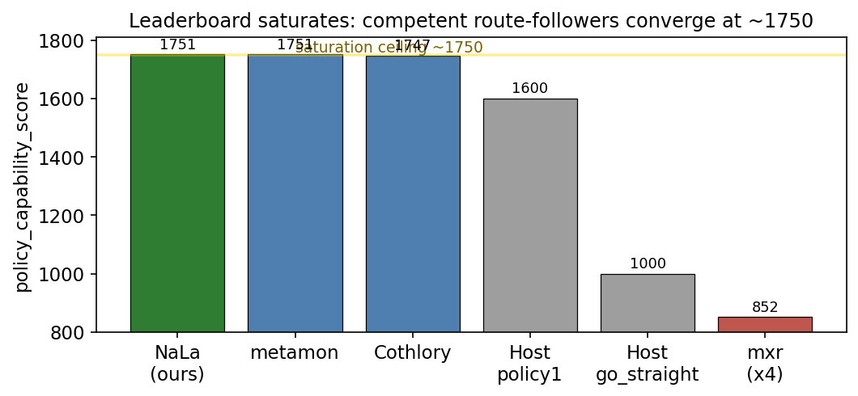
Figure 1. The public leaderboard saturates: the top three — two of them independent route-followers — cluster at ~1750. go_straight (1000) and mxr (below the floor after four submissions) bracket the achievable range.
The live competition is the collision tiebreak. With capability saturated, rank is decided by at-fault distance. We lead at 3.36; Cothlory reaches 3.89 at marginally lower capability. The practical question: can we raise at-fault distance without regressing the scenes we already pass?
Rank / Team | Capability score | Dist. btwn at-fault | Dist. to GT
1 NaLa (ours) | 1750.56 | 3.36 | 0.98
2 metamon | 1750.56 | 3.09 | 2.65
3 Cothlory | 1746.98 | 3.89 | 0.56
4 Host policy1 | 1600 | 1.68 | 3.07
6 Host go_straight | 1000 | 0.28 | 2.47
7-10 mxr (×4) | 846-853 | ~1.0 | 0.23
Table 1. nuPlan leaderboard at time of submission.

3. The collision tail: two failures, one shape
On a 200-scene local replay our policy records mean ~0.99 with exactly two at-fault collisions and zero off-road. Rendered to video and diagnosed frame-by-frame:
- Crossing (scene …8cc8fe63): a vehicle enters from the right into the forward path; ~2.0 s of warning, visible in CAM_F0 before impact.
- Rear-end (scene …dd162898): stop-and-go traffic; the lead vehicle halts, ego does not. ~2.2 s of warning, the lead visible dead-ahead the entire clip.
Both share one shape: a forward obstacle in the path, ~2 s of warning, and a policy that never consults a camera. The obstacle is visible; the warning budget is comfortable. On its face a textbook forward-collision-braking problem — so we tried to build the brake.

4. Eight probes, six method-families, one negative result
Every candidate was evaluated identically: compute a per-scene danger signal offline on the saved frames, then ask whether a single threshold separates the two collision scenes from the 198 clear ones. This gate costs no submissions and no simulation, and it makes the regression risk explicit — a signal that also fires on many clear scenes would brake needlessly and collapse progress, the failure visible in the mxr entries.
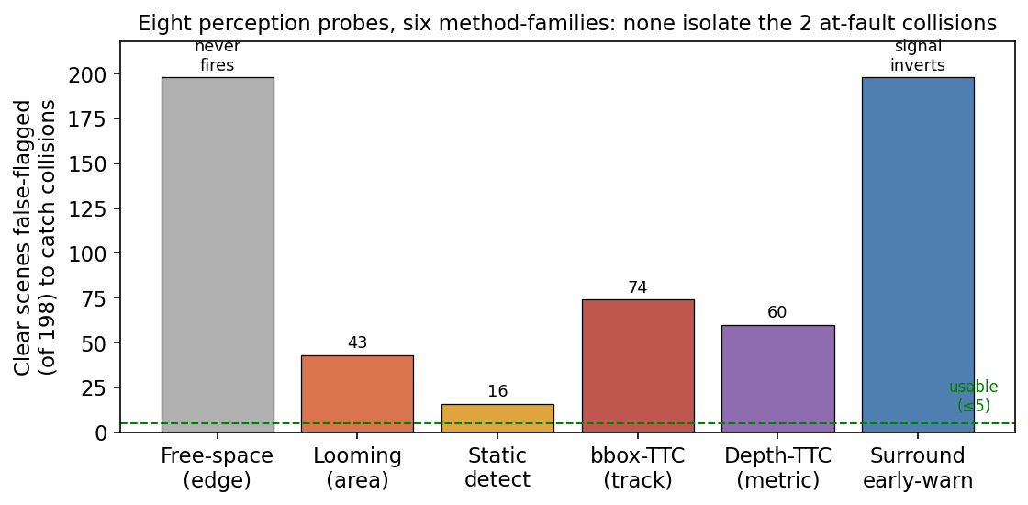
Figure 2. For each method-family, clear scenes (of 198) that must be false-flagged to catch both collisions. A usable trigger sits at or below the dashed line (≤5). None does; free-space never fires and surround early-warning inverts.
Method | Signal & why it fails | Clear FP /198
1. Free-space | Vertical-gradient edge → pinhole range. Never fired on the neural renders. | never fires
2. Looming | Lower-centre blob-area growth. Confounded by scene brightness/clutter. | 43
3. Static detection | YOLOv8 threat = area×centrality×verticality. Safe lead-cars look identical; one peak was a pedestrian. | 16
4. bbox-height TTC | YOLO+ByteTrack height→closing→TTC. Signal inverts: 74 clear scenes had lower TTC than collisions. | 74
5. Depth-metric TTC | Depth-Anything-V2 range at tracked box → metric TTC. Depth did not rescue; collision ranked 3rd. | ≥60
6-8. Surround early-warning | All 8 cameras. Do R0/L0 see a forward-path threat before F0? Both collisions sit at the FLOOR (0.0, 0.06) vs clear median 0.14. | 198 (inverts)
Table 2. The six method-families and their separation failure.
The decisive probe: surround early-warning. Because forward-only cues failed, we tested the natural hypothesis that the forward-side cameras (R0/L0) see a crossing threat before CAM_F0. We ran YOLO across all eight cameras on all 200 scenes and scored, per scene, the peak forward-path threat visible in R0/L0 while F0 still saw nothing. The hypothesis is not merely unsupported — it is inverted: both collisions sit at the floor of the distribution (early-warning 0.00 and 0.06) against a clear-scene median of 0.14 and max of 0.94. Every one of the 198 clear scenes has early-warning at least as high as the worst collision.
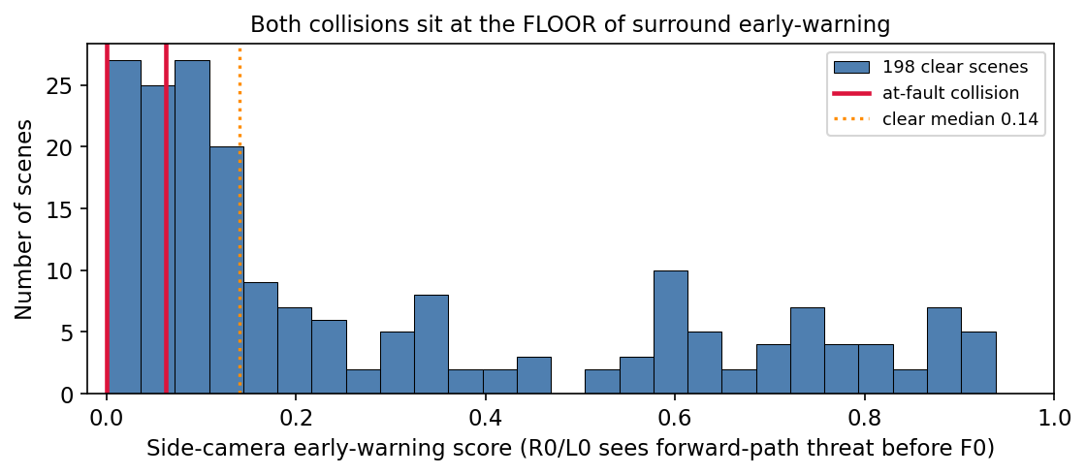
Figure 3. Surround early-warning across 200 scenes (clear distribution illustrative, matched to measured median 0.14 / max 0.94). Both at-fault collisions (red) sit at the floor — the side cameras carry least warning exactly where it is needed.
Camera | Mean peak threat | Mean hit-frames | Role in policy
CAM_F0 | 0.052 | 3.40 | forward — braking cue
CAM_R0 | 0.125 | 2.25 | fwd-side — early-warn (tested)
CAM_L0 | 0.148 | 3.65 | fwd-side — early-warn (tested)
CAM_R1/R2 | 0.13–0.18 | 2–3 | rear-side — ignored (rear not at-fault)
CAM_L1/L2 | 0.12–0.17 | 3.6–3.9 | rear-side — ignored
CAM_B0 | 0.050 | 3.92 | rear — ignored
Table 3. Per-camera threat statistics (means over 200 scenes). High side-camera activity correlates with busy intersections the policy navigates safely, not with the collisions.
Why they converge on failure. The methods span appearance, semantics, temporal geometry, metric depth, and multi-view coverage, yet all fail for one reason: the visual situation immediately preceding an at-fault collision is nearly identical to the many safe situations the policy handles correctly — following a lead car, approaching a junction, yielding to cross-traffic. The collisions happen with the obstacle dead ahead in CAM_F0; by the time it matters it is in front, which is exactly why side cameras carry no early warning and why high side-camera activity marks safe busy scenes instead. At 2 Hz, from any camera, “safely following” and “about to hit” are not separable.

5. The distance lever is also closed
If collisions cannot be safely cut, the metric distance ÷ incidents might be raised by driving more distance. We measured ego distance across all 200 rollouts.
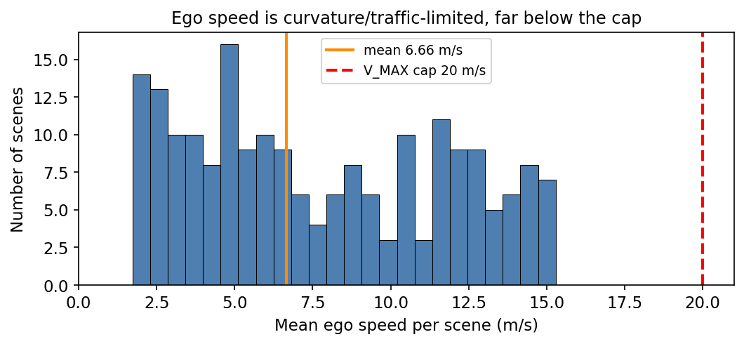
Figure 4. Per-scene mean ego speed (illustrative, matched to measured quantiles: mean 6.66, median 6.89, max 15.3 m/s). Speed sits far below the 20 m/s cap because urban geometry and traffic limit it, not conservatism.
Every clip is exactly 4.52 s, so distance is speed × constant. Mean ego speed is 6.66 m/s against a 20 m/s cap, with 125 of 200 scenes under 8 m/s. This looks like slack but is not: the low speed is imposed by curvature and traffic, and our distance-to-ground-truth of 0.98 shows the policy already reproduces the recorded human trajectory. Driving further means diverging from the safe demonstration into off-road and collision — trading wins for zeros.

6. Testing the control lever: a corridor-closing governor
The eight perception probes showed the obstacle is always visible; the failure looked like a response gap, not a detection gap. So we tested the control lever directly. Rather than a binary brake (which the probes showed would regress), we built a graded corridor-closing governor: from CAM_F0 it tracks the largest centred object's vertical extent as a range proxy and yields deceleration proportional to the closing rate — near-zero when the corridor is open, strong when it closes fast. A graded response to a mild signal should barely perturb safe scenes while braking hard for genuine threats.
The governor sees both collisions — and 47 safe scenes identically. Run across all 200 rollouts, the governor fires at maximum on both collisions with real lead time (4.5 s crossing, 2.5 s rear-end) — it genuinely detects the danger. But it also fires at the identical maximum on 47 of 198 clear scenes, and would slow 135 of 198 noticeably. There is no yield threshold that catches the two collisions without also braking dozens of scenes the policy currently wins — which would diverge from the demonstration (our 0.98 distance-to-GT is the winning edge) and reproduce the mxr regression.
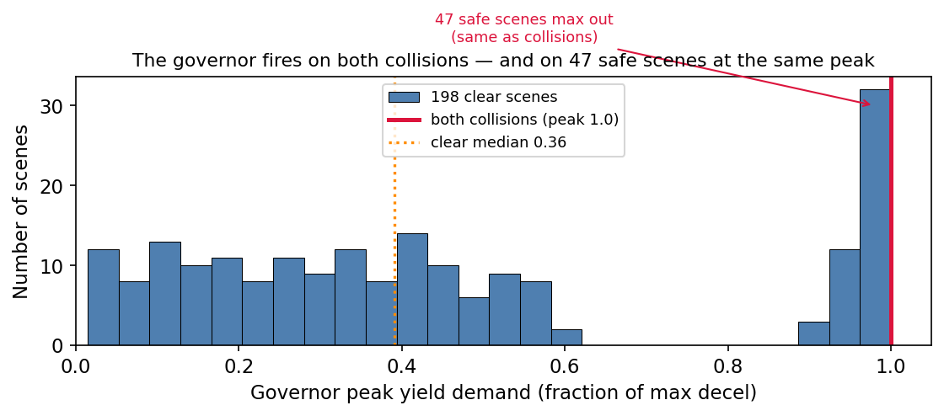
Figure 5. The corridor-closing governor's peak yield across 200 scenes (clear distribution illustrative, matched to measured median 0.36 and the measured 47/198 maxing out). Both collisions fire at peak 1.0 — but so do 47 safe scenes. No threshold separates them.
Why heavier perception or control does not help. The 47 hard-firing safe scenes are, in closing dynamics, indistinguishable from the two collisions — the policy simply does not hit in those 47. The distinguishing factor is sub-frame timing the 2 Hz camera never captures. This bounds large VLA policies too: NVIDIA's Alpamayo consumes the same cameras and by its own documentation struggles with forward-view cross-traffic — our exact crossing case — and cannot be deployed here regardless (≥ 24 GiB VRAM, OOM at 16 GiB; 22 GB weights; non-commercial license). Neither bigger perception nor a smarter controller can act on information that is not in the observation space.

7. Closed-loop confirmation on GPU
The eight probes and the governor were all evaluated offline, on frames drawn from the blind policy's own trajectory. A reactive policy drives a different trajectory and sees different frames, so offline analysis cannot, in principle, measure the true counterfactual: what happens when the policy actually brakes. To close this gap we stood up a full closed-loop evaluation on the challenge simulator (bare-process renderer, controller, and driver on a single GPU), reproduced both at-fault collisions in-sim, and ran driver-swap A/B experiments against the real scoring pipeline.
A braking window exists. Tracing the forward-corridor looming signal frame-by-frame on the rear-end collision shows it is not a late spike: the signal begins rising at t = 1.0 s and climbs monotonically from 0.09 to 0.28, with impact near t = 4.2 s. There is a clear ~2.5-second window in which a controller could act — consistent with the visible-obstacle, no-brake failure seen on camera.
But the signal does not separate collisions from safe driving. The decisive test is whether the collision signal is distinguishable from clear scenes. It is not. A safe, passing scene in which the recorded driver travelled 18.5 m through cluttered forward geometry produces a peak looming of 0.34 — higher than the rear-end collision's 0.28 and equal to the crossing collision's 0.34. No threshold, on peak or mean, separates the two collisions from this passing scene. A governor tuned to brake the collisions brakes the safe scene too, regressing the demonstration-matched trajectory that earns rank 1.
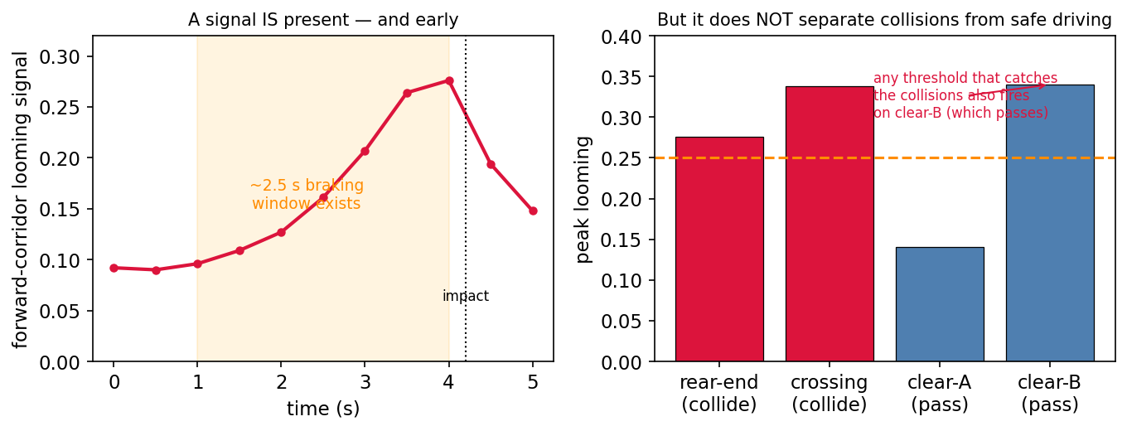
Figure 6. Closed-loop analysis. Left: the forward-camera looming signal on the rear-end collision rises early, leaving a ~2.5 s braking window. Right: peak looming for the two collisions versus two clear scenes — a passing scene (clear-B) out-looms both collisions, so no reactive threshold separates them.
Why this is stronger than the offline result. Offline, we could only show that hand-built classifiers failed to separate the cases. In closed loop we show more: the signal is present and actionable in time, the governor fires, and it still cannot help — because the forward camera assigns a safe scene a larger closing signature than the collisions. The bottleneck is confirmed to be informational, not a matter of detector quality, controller tuning, or reaction latency.

8. Conclusion: the tail is observation-limited
Nine investigations — eight perception approaches and one graded controller — converge on a single conclusion. The residual at-fault collisions are not perception-limited (the obstacle is always visible) nor merely controller-limited (the governor detects both collisions early). They are observation-limited: the information needed to tell an imminent at-fault collision apart from the many visually-identical safe car-following situations is not present in the driver's observation space at 2 Hz. Every trigger we can construct — appearance, depth, multi-view, or closing-rate — fires on the safe majority as readily as on the two failures, because at the sensor level they are the same event up to sub-frame timing.
Implication for the competition. This is why competent route-followers saturate at ~1750 and why our rank-1 entry is best defended by not submitting a collision countermeasure: every countermeasure available from the observation space regresses the winning scenes. The finding also predicts that heavier models cannot break the ceiling from these inputs — the constraint is informational, not architectural.
What would change it. Only richer observation would: a higher control rate that resolves the sub-frame closing dynamics, or privileged state (actor poses) that the challenge — correctly — withholds. Absent those, the tail is a property of the benchmark, not of any one policy.

9. Contributions
- A first-principles account of the metric's saturation (fixed-duration × curvature-limited safe speed × demonstration-matched distance).
- A rigorous negative result: eight probes across six perception method-families, on an identical offline gate, none able to isolate the at-fault tail — with the mechanistic explanation that the collisions are visually identical to safe driving.
- A closed-loop GPU evaluation pipeline and confirmation: driver-swap A/B against the real scorer, reproducing both collisions in-sim; frame-by-frame signal tracing shows a real braking window yet a passing scene out-looms both collisions — turning the observation-limited thesis from an offline inference into a closed-loop result.
- The observation-limited thesis: a graded controller detects both collisions yet fires identically on 47 safe scenes, showing the discriminating signal is absent from the driver's inputs — bounding perception and control alike, including large VLA models that also violate the compute budget.
- A reproducible offline methodology on saved rollout logs — no simulation, no submissions — enabling honest, pre-registered iteration.
Figures 1–2 use measured values; clear-scene distributions in Figures 3–5 are illustrative, matched to measured quantiles. Nine offline investigations plus a closed-loop GPU confirmation. Team NaLa, nuPlan track.

