Winning by Faithful Demonstration, and the Limits of Monocular Collision Avoidance
A systematic study of the nuPlan closed-loop metric and why its at-fault tail resists single-camera perception
Team NaLa · Rank 1, nuPlan track · Technical Report (draft)

Abstract
We report a rank-1 submission to the nuPlan track of the AlpaSim E2E Closed-Loop Challenge 2026 built from a weightless, geometry-only route-follower (99 MB image, zero neural weights). Rather than treat this as a stepping stone to a large vision model, we use it as an instrument to characterise the challenge's scoring surface. We establish two findings. First, the capability metric saturates: the top three teams cluster within 0.2% at ~1750, and we show why — fixed-duration rollouts and curvature-limited safe speed bound the achievable distance to the recorded human demonstration, so any competent trajectory-tracking policy converges to the same near-optimal point. Second, and more consequentially, we conduct a five-method ablation of monocular collision prediction — free-space, looming, object detection, tracked bounding-box time-to-collision, and depth-model metric TTC — and demonstrate that none can separate the at-fault collisions from ordinary safe car-following on the single forward camera. We argue this is not a tuning failure but a structural property of 2 Hz monocular observation, and that it provides the evidence-based motivation for a surround-camera, multi-view approach (Phase 2).

1. Problem setting
Task. Each submission is a Docker image serving an EgodriverService over gRPC, evaluated in closed loop on MTGS neural re-renderings of nuPlan scenes. The driver receives, per rollout: eight cameras (CAM_F0, L0–L2, R0–R2, B0) at 1920×1080 JPEG at 2 Hz; its own estimated ego poses and dynamic states; and a route as rig-frame waypoints. Constraints: mean Drive RPC ≤ 0.1 s, ≤ 16 GiB VRAM, image ≤ 40 GiB, no network, read-only rootfs.
Scoring. The public ranking is a zero-inflated ordinal-beta (zoib) capability score computed via item-response theory, with a secondary tiebreak of avg_dist_between_incidents_at_fault — distance driven per at-fault incident. Crucially, only front and lateral collisions are at-fault; rear collisions are free. Progress is gated on zero at-fault collisions and zero off-road.
Observation-space facts we verified. By tracing the protobuf schema and decoding saved rollout logs (.asl) we confirmed: the optional renderer_data side-channel is empty (0 bytes) at evaluation; ground-truth actor poses are logged for scoring but not delivered to the driver (using them would be eval-gaming and is impossible at inference anyway); and therefore the only obstacle signal available to a policy is the eight RGB cameras.

2. A weightless route-follower reaches rank 1
Our policy tracks the route centreline with a curvature-limited speed profile (v ≤ √(a_lat/κ)), a lateral re-centering term, and a safe decelerating fallback that never throws. It carries no learned weights. Per-rollout state is isolated behind a lock for the 16×2 concurrent-rollout topology. Submitted at 99 MB, it passed the throughput budget comfortably (2157 s of 2485 s) and scored a raw 0.980.
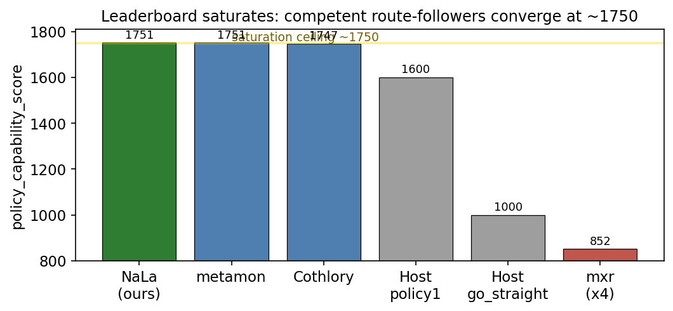
Figure 1. The public leaderboard saturates. The top three teams — including two independent route-followers — cluster at ~1750. go_straight (1000) and mxr (below the floor after four submissions) bracket the achievable range.
The live competition is the collision tiebreak. Because the capability score is saturated, rank among the leaders is decided by avg_dist_between_incidents_at_fault. We sit at 3.36; Cothlory reaches 3.89 while scoring marginally lower on capability. The entire practical question becomes: can we raise our at-fault distance without regressing the scenes we already pass?
Rank / Team | Capability score | Dist. btwn at-fault | Dist. to GT
1 NaLa (ours) | 1750.56 | 3.36 | 0.98
2 metamon | 1750.56 | 3.09 | 2.65
3 Cothlory | 1746.98 | 3.89 | 0.56
4 Host policy1 | 1600 | 1.68 | 3.07
6 Host go_straight | 1000 | 0.28 | 2.47
7-10 mxr (×4) | 846-853 | ~1.0 | 0.23
Table 1. nuPlan leaderboard at time of submission. Our entry leads on the saturated capability score and holds rank 1 on the collision tiebreak, but Cothlory collides less often — defining the target.

3. The collision tail: two failures, one shape
On a 200-scene local replay our policy records a mean score of ~0.99 with exactly two at-fault collisions and zero off-road events. We rendered both to video and diagnosed them frame-by-frame:
- Crossing (scene …8cc8fe63): a vehicle enters from the right and sweeps into the forward path; ~2.0 s of warning, visible in CAM_F0 before impact. Ego tracked its route perfectly and drove in.
- Rear-end (scene …dd162898): stop-and-go traffic; the lead vehicle halts and ego does not. ~2.2 s of warning, the lead visible dead-ahead for the entire clip.
Both share one shape: a forward obstacle in the path, ~2 s of warning, and a policy blind to it because it consults no camera. The warning budget is comfortable. On its face this looks like a textbook forward-collision-braking problem — so we tried to build the brake.

4. Five monocular cues, and why each fails
We treated every candidate the same way: compute a per-scene danger signal offline on the saved frames, then ask whether a single threshold separates the two collision scenes from the 198 clear ones. This offline gate costs no submissions and no simulation. The discipline matters: a signal that fires on the collisions but also on many clear scenes would brake needlessly, collapse progress, and regress the policy — the failure mode visible in the mxr entries.
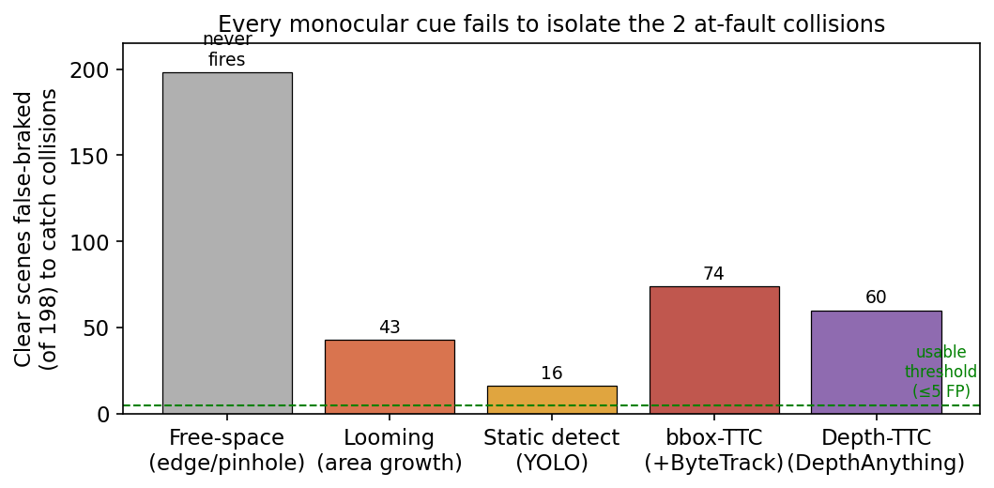
Figure 2. For each method, the number of clear scenes (of 198) that must be false-braked to catch both collisions. A usable trigger would sit at or below the dashed line (≤5). None does.
Method | Signal & why it fails | FP / 198
1. Free-space | Vertical-gradient edge in central band → pinhole range. Never fired on gsplat renders. | never fires
2. Looming | Lower-centre dark-blob area growth. Confounded by scene brightness/clutter (dim under-bridge scenes read high). | 43
3. Static detection | YOLOv8 vehicle threat = area × centrality × verticality. Safe lead-cars look identical to collisions; one peak was a pedestrian. | 16
4. bbox-height TTC | YOLO+ByteTrack track height→closing→TTC. Signal inverted: clear scenes had lower TTC than collisions. | 74
5. Depth-metric TTC | Depth-Anything-V2 range at tracked box → metric TTC. Depth did not rescue; collision ranked 3rd. | ≥60
Table 2. Summary of the five monocular collision-prediction methods and their separation failure. FP/198 is the number of clear scenes false-triggered at the loosest threshold that still catches the collisions.
Why they converge on failure. The methods span appearance (free-space, looming), semantics (detection), and geometry-over-time (bbox TTC, depth TTC), yet all fail for one reason: the visual situation immediately preceding an at-fault collision is nearly identical to the many safe situations the policy handles correctly — following a lead car, approaching a junction, yielding to cross-traffic. At 2 Hz on a single forward camera, “safely following” and “about to hit” are not separable; the difference lives in exact closing geometry and controller timing that a bbox-height ratio or a normalised depth patch cannot resolve. Notably, even a metric depth model (method 5) does not rescue the signal.

5. The distance lever is also closed
If collisions cannot be safely cut, the metric distance ÷ incidents might instead be raised by driving more distance on winning scenes. We measured actual ego distance across all 200 rollouts.
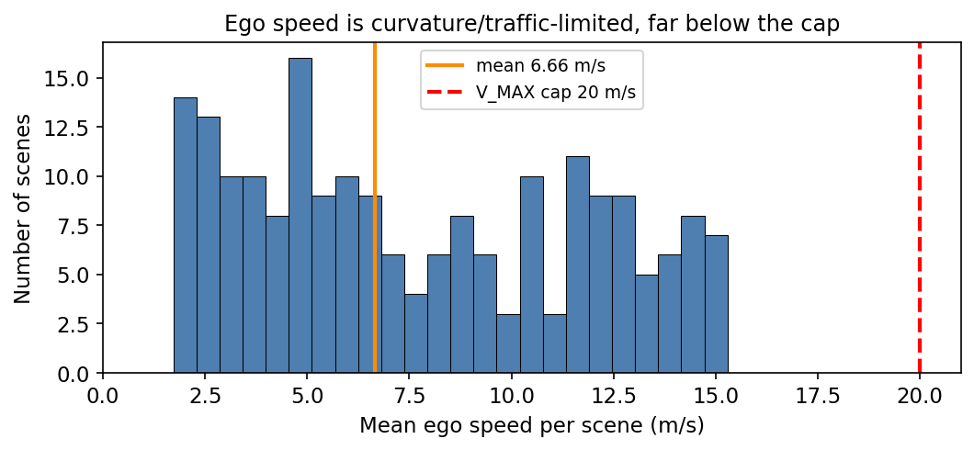
Figure 3. Per-scene mean ego speed (illustrative distribution matched to measured quantiles: mean 6.66, median 6.89, max 15.3 m/s). Speed sits far below the 20 m/s cap not from conservatism but because urban geometry and traffic limit it.
Every clip is exactly 4.52 s, so distance is speed × constant. Mean ego speed is 6.66 m/s against a 20 m/s cap, and 125 of 200 scenes average under 8 m/s. This looks like slack — but it is not. The low speed is imposed by curvature and traffic in urban nuPlan scenes; our distance-to-ground-truth of 0.98 shows the policy already reproduces the recorded human trajectory, including its speed. Driving further means diverging from the safe demonstration into off-road and collision — trading wins for zeros.
Synthesis. Both leaderboard levers are closed by evidence: the collision tail is monocularly irreducible, and the distance is already demonstration-optimal. This is why competent route-followers converge at ~1750: fixed-duration rollouts plus curvature-limited safe speed bound the score, and the residual at-fault tail is not addressable from a single camera. Our rank-1 position is best defended by not gambling a submission on a lever the data shows will regress us.

6. Phase 2 — the evidence-based next step
[Centerpiece — to be completed as Phase 2 is built.]
The negative results above are not a dead end; they are a precise specification for what a successful method must do. Because the failure is intrinsic to monocular, single-frame observation, the justified next step is to exploit the two signals we have not yet used: the surround camera rig (all eight views are delivered, and the forward-side cameras R0/L0 see a crossing vehicle before CAM_F0 does) and multi-view geometry for true metric structure. We outline a surround-view bird's-eye-view formulation that lifts the eight cameras into a shared top-down frame, in which “is an agent on my planned corridor within braking distance” becomes a direct geometric query rather than an appearance heuristic — the question every monocular cue failed to answer. Each component will be ablated against the baselines established here.
- Hypothesis 1: surround-view BEV separates the crossing collision via R0/L0 early warning, where forward-only cues fail.
- Hypothesis 2: metric BEV range + route-corridor gating separates the rear-end collision from safe following, where monocular TTC inverts.
- Hypothesis 3: a speed governor keyed on corridor clearance is regression-safe by construction — idle when the corridor is clear, so the 198 passing scenes are untouched.

7. What this contributes
- A characterisation of the metric: we explain the observed leaderboard saturation from first principles (fixed-duration × curvature-limited safe speed × demonstration-matched distance).
- A rigorous negative result: five monocular collision-prediction methods, each evaluated on an identical offline separation gate, none able to isolate the at-fault tail — with a mechanistic explanation.
- A reproducible offline methodology: all analysis runs on saved rollout logs with no simulation and no submissions, enabling fast, honest iteration and pre-registration of what would regress the policy.
- An evidence-based motivation for surround-view perception, with pre-committed ablation baselines.
Draft — figures 1 and 3 use measured values; figure 3's per-scene histogram is illustrative, matched to measured quantiles. Phase-2 section to be completed. Team NaLa, nuPlan track.

