DUNDU — APP LAUNCH PLAN
Stage-wise plan — Software → Purchase → Delivery & Return
Prepared 2026-09-04 — grounded in the current codebase (spec.md / detail.md) plus business decisions still open

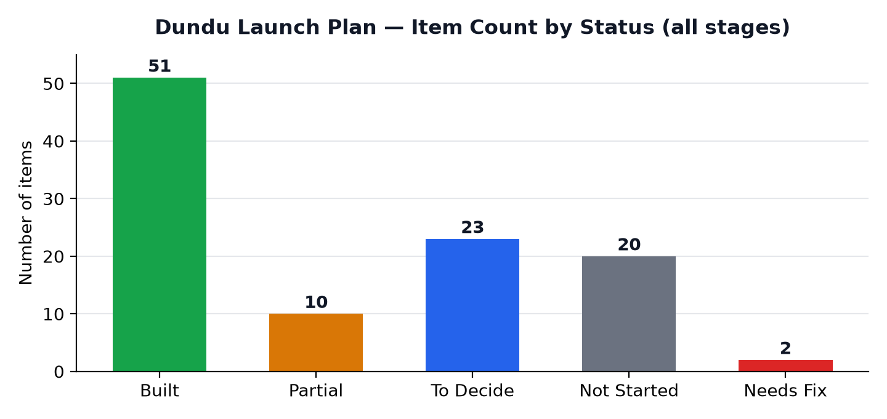

Status Legend
Built (51) | Partial (10) | To Decide (23) | Not Started (20) | Needs Fix (2)

STAGE 1 — SOFTWARE

1.1 Platforms Overview
Platform | Technology | Audience | Status | Notes
Admin Panel (admin/) | React.js + Tailwind CSS, Vite :3001 | Super Admin & Branch Admin | Built | Manages the entire online store
Web Storefront (web/) | React.js, Vite :3000 | Customers (browser) | Built | Public storefront + account area
Mobile App (mobile/) | React Native, Expo SDK 54 | Customers + Delivery Staff | Built | Two nav worlds: shopping app vs delivery-staff app, from one login
Backend API (backend/) | Node.js + Express, :5000 | Shared by admin/web/mobile | Built | PostgreSQL DB; REST API under /api
Offline System (dundu-offline/) | React + Node, planned :5001 | In-store branch staff | Not Started | Folder does not exist yet — separate DB (dundu_offline), no shared code with online system

1.2 Admin Panel — Dashboard & Analytics
Feature | What It Covers | Status | Notes
Dashboard | Total sales, total orders, total users, revenue graph, recent orders | Built
Inventory Dashboard | Stock levels across products/variants | Built
Product Insights | Overview / Categories / Product Demand / Variants tabs | Built
Sales Report | Daily sales report (branch billing) | Built
Finance Report | Revenue/finance rollups | Built
User Activity | Login logs + product view logs per user | Built
User Insights | Aggregated customer behaviour stats | Built
Birthday Ticker | Upcoming customer birthdays, shown in TopBar | Built

1.2 Admin Panel — Catalog Management
Feature | What It Covers | Status | Notes
Products | Add/Edit/Delete/Hide, Mark Featured, Mark Offer Product. Fields: category, name, brand, description, material, type, gender, age group, size, color, price, offer price, stock, SKU, product code, images, variants (size/color/stock/SKU) | Built
Categories | Women, Kids, Newborn, Maternity | Built
Combos | Bundle builder: combo price/offer price/stock + selectable product slots | Built | No web UI yet — admin + mobile only
Brands | Brand list management | Built
Product Materials | Material list management | Built
Reviews | Approve/manage customer reviews, or create admin-authored reviews | Built
New Arrivals | Flag/curate new-arrival products | Built

1.2 Admin Panel — Orders & Fulfilment
Feature | What It Covers | Status | Notes
Order List / Detail | Full order record, line items, customer, address | Built
Order Status Update | Pending → Packed → Shipped → Delivered | Built
Invoice Download | PDF invoice per delivered order | Built
Returns | Approve / Reject return requests | Built | Permission-gated ('returns') for branch admins
Cart Monitor | View active carts + abandoned-cart tracking | Built
Wishlists | View customer wishlists | Built

1.2 Admin Panel — Marketing & Engagement
Feature | What It Covers | Status | Notes
Announcements | Top-bar marquee text, colors, active toggle | Built
Banners | Home banner slider + badge text/color | Built
Coupons | Coupon codes applied at checkout | Built
Loyalty Cards | Points + total spend, keyed by phone number | Built
Referral System | Referral code per user, reward on successful referral | Built
WhatsApp Broadcast | Bulk WhatsApp message to customer list | Built | Needs live WhatsApp API creds
Spin Wheel | Weighted prize segments, per-user targeting (new/existing/VIP), time-slot windows, per-user enable toggle, forced popup, redemption log | Built | Web: passive only (auto-applies a won reward)
Scratch Card | Prize pool, min-order eligibility, cooldown, date window, forced popup | Built | No web UI
Festival Theme | Seasonal name/emoji/colors/banner + optional popup with coupon | Built | No web UI
First Purchase Offer | Flat discount or order-value slabs, auto-apply or coupon | Built | No dedicated web/mobile UI found — verify before relying on it
Birthday Campaign | 7-day-ahead lookup, WhatsApp send, configurable discount % | Built
Free Shipping Nudge | Threshold-based nudge (₹500 seen in mobile) | Partial | Mobile only — check web gap

1.2 Admin Panel — Users, Staff & Settings
Feature | What It Covers | Status | Notes
User List / Detail | Browse customers, block user, order history, addresses | Built
Admins | Add admin, assign role & permissions, branch access | Built | Permission set: billing, orders, returns, loyalty, reports
Delivery Staff | Manage delivery-staff accounts | Built
General Settings | Store-wide configuration | Built
Payment Methods | Configure accepted payment methods | Built | Backend gateway code covers Razorpay only
Delivery Settings | Delivery rules configuration | Built | Confirm shipping-fee rule engine is complete
Return Settings | Return-policy configuration | Built | Actual policy values still a business decision
Splash Screen | Mobile app splash screen config | Built
App Update Notice | Force/soft update messaging for mobile app | Built

1.3 Business Identity Setup (do before go-live)
Requirement | What's Needed | Purpose | Status | Notes
Business Bank Account | Current account in Dundu's registered business name | Receive gateway settlements (Razorpay/Cashfree/PhonePe) + COD reconciliation | To Decide
Business PAN / GST | Registered as required for the business entity | Required to open current account + gateway KYC | To Decide
Dundu Business Phone Number | A dedicated number, not a personal one | Customer support line shown in app/web footer & invoices | To Decide
WhatsApp Business Number | Same or separate number, registered on WhatsApp Business Platform (Meta) or via Twilio WhatsApp API | Order status messages, OTP, marketing broadcast, cart-reminder nudges (spec §4) | To Decide | Backend service (services/whatsapp) exists; needs live API credentials
Business Email | e.g. support@dundu.com / orders@dundu.com | Support inbox, password-reset emails, invoices, Play Store/App Store developer contact | To Decide
Domain Name | e.g. dunduonline.com | Web hosting, business email, brand presence | To Decide
User Phone Verification (OTP) | WhatsApp/SMS OTP at signup & login | Confirms a real registered user before checkout | Needs Fix | otp.service.js queries columns (target/purpose) that don't exist in the otps table — verify/fix before go-live
User Email Verification | Not currently built | Optional extra verification / recovery channel | Not Started | Decide if needed before launch

1.4 Deployment — Web, Backend, Play Store, App Store
Item | What's Involved | Status | Notes
Backend Hosting | Cloud VM/container host (Railway, Render, DigitalOcean, AWS, etc.) + PostgreSQL DB provisioning | To Decide | docker-compose.yml already containerizes backend+db
Web + Admin Hosting | Domain + SSL + nginx serving web(:3000) & admin(:3001), proxying /api & /uploads to backend | To Decide | Covered by root docker-compose.yml
Production Environment Secrets | Real values for JWT secret, Razorpay keys, Twilio creds, Cloudinary, Google OAuth | To Decide | Full list in backend/.env.example
Database Migration on Deploy | Run node-pg-migrate on first boot & after every new migration | To Decide | docker compose exec backend npm run migrate — not automatic
Payment Gateway — Live Keys | Razorpay live mode credentials + business KYC | Partial | Cashfree / PhonePe named in spec but not coded yet
Android Build | Expo EAS Build → .aab | Not Started | mobile/ is Expo SDK 54, EAS-ready
Google Play Store Listing | Developer account (~$25 one-time), store listing, screenshots, privacy policy, content rating, internal test → production rollout | Not Started
iOS Build | Expo EAS Build → .ipa | Not Started
Apple App Store Listing | Apple Developer account (~$99/yr), App Store Connect listing, screenshots, privacy nutrition label, App Review | Not Started
Mobile Config for Production | Point EXPO_PUBLIC_API_URL at the live backend domain | Not Started | Currently falls back to a hardcoded dev LAN IP if unset
Offline System Build + Deploy | dundu-offline/ super-admin + branch-admin + backend-offline, separate deploy on :5001 | Not Started | Code doesn't exist yet — fully separate project

STAGE 2 — PURCHASE (SOURCING)

2.1 Sourcing by Category
Category | Where to Purchase (fill in) | Why Here (fill in reasoning) | Status | Notes
Women | — to decide — | — cost / quality / MOQ / proximity — | To Decide | App category: Women
Kids | — to decide — | — cost / quality / MOQ / proximity — | To Decide | App category: Kids
Newborn | — to decide — | — cost / quality / MOQ / proximity — | To Decide | App category: Newborn — needs safety-certified fabric (non-toxic dye, soft-cotton GSM)
Maternity | — to decide — | — cost / quality / MOQ / proximity — | To Decide | App category: Maternity — comfort/fabric-specialist supplier

2.2 Supplier Decision Checklist (answer per supplier)
Criteria | Question to Answer | Status | Notes
Cost | Per-unit cost vs target retail price & margin | To Decide
Quality | Sample check — fabric GSM, stitching, print quality | To Decide
MOQ | Minimum order quantity the supplier requires | To Decide
Location | Local vs outstation — freight cost & lead time | To Decide
Reliability | Delivery consistency, past buyer reviews/references | To Decide
Payment Terms | Advance % required, credit period offered | To Decide
Supplier Return Policy | Terms for returning defective/wrong goods to the supplier | To Decide
Certification (Newborn) | Safety standard / non-toxic dye certification | To Decide

STAGE 3 — DELIVERY & RETURN

3.1 Delivery
Component | Condition / Detail | Status | Notes
In-house Delivery Flow | Delivery-staff role in mobile app: Home → Scan pickup QR → Complete delivery | Built | delivery_qr_token, picked_up_by/at, delivered_by/completed_at all tracked
3rd-Party Courier Fields | courier_name / courier_tracking_number / courier_phone stored on order | Built | Manual entry only — no live courier API integration
Order Status Notifications | WhatsApp message on Packed/Shipped/Delivered | Built | Needs live WhatsApp API credentials to actually send
Delivery Zones / Serviceable Areas | Define which pin codes / cities are serviceable | Not Started | Business decision
Delivery Charges Rule | Flat fee, distance-based, or free-above-threshold | Partial | ₹500 free-shipping nudge exists in mobile; confirm full rule in Admin > Delivery Settings
Delivery Timeline / SLA | Target duration for each status step, communicated to customer | Not Started | Business decision

3.2 Returns
Component | Condition / Rule | Status | Notes
Return Window | e.g. "7 days from delivery" — exact number still to decide | To Decide | return_status + return_requested states already exist in schema
Return Request Flow | Customer requests a return from Order Detail (web & mobile) | Built
Return Approval | Admin approves/rejects under Admin > Returns | Built | Permission-gated ('returns')
Refund Method | Original payment method vs wallet credit vs bank transfer | Not Started | Business decision — no wallet system built yet
Exchange vs Refund-Only | Whether size/color exchange is offered, or refund only | Not Started | Business decision
Return Shipping Cost | Who bears the return freight — customer or Dundu | Not Started | Business decision
COD Order Refunds | Refund route for orders with no original online payment | Not Started | Business decision — likely bank transfer/UPI payout

FEATURE STATUS MATRIX

Cross-platform feature coverage
Feature | Admin | Web | Mobile | Backend | Status | Notes
Spin Wheel | Full config | Passive (auto-applies win) | Full UI | Full (7 migrations) | Partial | Web experience gap
Scratch Card | Full config | None | Full UI | Full (self-migrated tables) | Partial | Web experience gap
Festival Theme | Config page | None | Full theming + popup | Settings-table only | Partial | Web experience gap
First Purchase Offer | Config page | Not found | Not explicit | Settings-table only | Partial | Needs a real consuming UI
Birthday Campaign | Full | Full popup | Full popup | Full | Built
Free Shipping Nudge | Check Settings | Not found | Full | Threshold-based | Partial | Web experience gap
Combos (Bundles) | Full CRUD | Not found | Full screens | Full (cart + tables) | Partial | Web experience gap
Offline / Branch System | N/A | N/A | N/A | N/A | Not Started | Planned only — code doesn't exist
Payment Gateway | Razorpay only | Razorpay only | Razorpay only | Razorpay only | Partial | Cashfree/PhonePe named in spec, not implemented
OTP Service | — | — | — | Column mismatch bug | Needs Fix | Verify before relying on OTP login
Wallet | — | — | — | — | Not Started | Recommended future feature (spec §6)
Multi-language Support | — | — | — | — | Not Started | Recommended future feature (spec §6)
Live Delivery Tracking | — | — | — | — | Not Started | Recommended future feature (spec §6)
AI Product Suggestions | — | — | — | — | Not Started | Recommended future feature (spec §6)
Vendor Panel | — | — | — | — | Not Started | Recommended future feature (spec §6)

