|  |  |
| --- | --- |
|  |  |
| OnMart |  |
| **Online market for purchasing footwears, Movie tickets and ordering food online.** |  |
|  | ADARSH GUPTA |
|  |  |

|  |  |  |
| --- | --- | --- |
|  | ABSTRACTNow a days the life style of the people is different. People feel uncomfortable and time consuming for going crowded markets.So, E-Shopping is a boon as it saves lot of time. Online shopping is a process whereby consumers directly buy goods, services etc. from a seller without an intermediary service over the Internet.Shoppers can visit web stores from the comfort of their house and shop as by sitting in front of the computer. Online market stores are usually available 24 hours a day and many consumers have internet access both at work and at home. So, it is very convenient for them to shop Online.One of the most enticing factors about online shopping, particularly during holiday season is, it alleviates the need to wait in long lines or search from a store for a particular item. Variety of goods are available online. |  |

### Table of Contents

|  |  |
| --- | --- |
| Content | p. |
| Introduction | 1 |
| Experiment Techniques and Discussions | 2 |
| Summary | 14 |
| References | 15 |
| Link for the live project | 15 |

### Introduction

Online shopping is becoming increasingly popular for variety of reasons.

There are certainly outside factors such as increasing gas prices, difficulty in

getting to traditional stores and hassles often associated with shopping malls and

other traditional stores to contribute to the increased interest in online shopping.

Consumers can get full information about the product with its reviews being

passed by the existing users. If one wants to buy a product he/she is no longer

limited to asking the friends and families because there are many products reviews

on the web which gives opinions of the existing users of the product.

Online shopping sites contain wide variety of goods both high quality and

mild quality keeping in mind the level of people.

Online shopping is becoming increasingly popular for variety of reasons. There are certainly outside factors such as increasing fuel prices, difficulty in getting to traditional stores and hassles often associated with shopping malls and other traditional stores to contribute to the increased interest in online shopping.

Consumers can get full information about the product with its reviews being passed by the existing users. If one wants to buy a product, he/she is no longer limited to asking the friends and families because there are many products reviews on the web which gives opinions of the existing users of the product.

Online shopping sites contain wide variety of goods both high quality and mild quality keeping in mind the level of people.

### About this project

This project is developed with NetBeans IDE. So, question arises what is NetBeans IDE?

NetBeans IDE lets you quickly and easily develop Java desktop, mobile, and web applications, as well as HTML5 applications with HTML, JavaScript, and CSS. The IDE also provides a great set of tools for PHP and C/C++ developers. It is free and open source and has a large community of users and developers around the world.

## 1

### Experimental Techniques and Discussions

In this project I have created five frames to use. So, let’s start breaking down each frame one by one in order.

1. **Login Form**

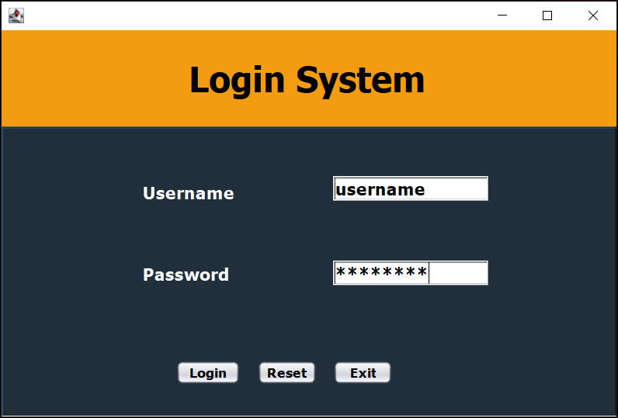

This is just a basic login form; it will give you access when you type “username” in username field and “password” in password field.

## 2

**Basic flow chart for login button: -**

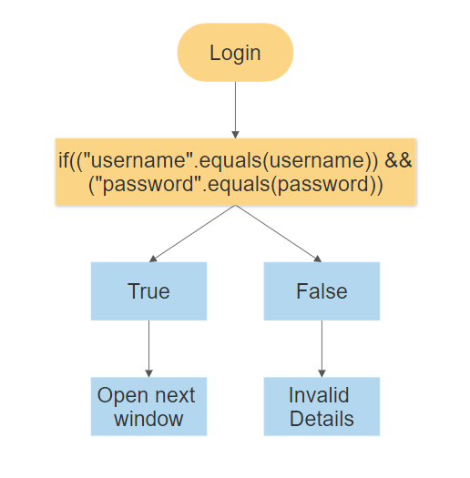

**Pseudo code for this frame: -**

**Login Button: -**

String username= jTextField1.getText();

String password= jPasswordField1.getText();

if(("username".equals(username)) && ("password".equals(password))){

jTextField1.setText(null);

jPasswordField1.setText(null);

Options opt= new Options();

opt.setVisible(true); //opens next frame

setVisible(false);

}

else{

JOptionPane.showMessageDialog(null, "Invalid Details.", "Login Error",

JOptionPane.ERROR_MESSAGE); //show error

jPasswordField1.setText(null); } }

## 3

**Reset Button: -**

jTextField1.setText(null);

jPasswordField1.setText(null);

**Exit Button: -**

System.exit(0);

**2) Options Form**

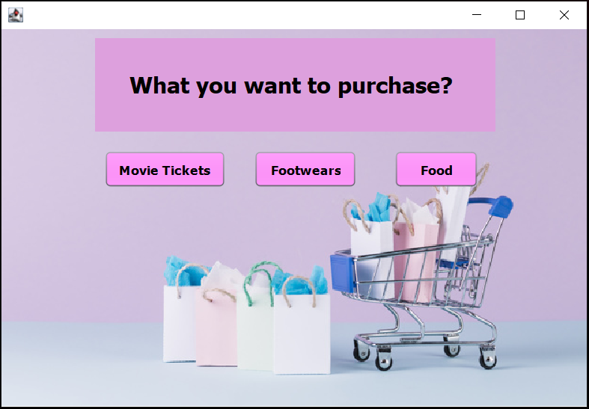

This form provides you with the options to choose from,

You may want to buy movie tickets or try some cool footwears or you want to satisfy your hunger.

Click on any one of the buttons and you will be redirected to that window.

## 4

**Pseudo code for this frame: -**

**Movie tickets Button: -**

Theater_Booking tickets= new Theater_Booking(); // Creating object for theater booking frame

tickets.setVisible(true); // Showing theater booking frame

setVisible(false); // Hiding this frame

**Footwears Buuton: -**

SHOEfACTORY foot= new SHOEfACTORY();

foot.setVisible(true);

setVisible(false);

**Food Button: -**

PizzaCafe food=new PizzaCafe();

food.setVisible(true);

setVisible(false);

## 5

**3) Theater Booking**

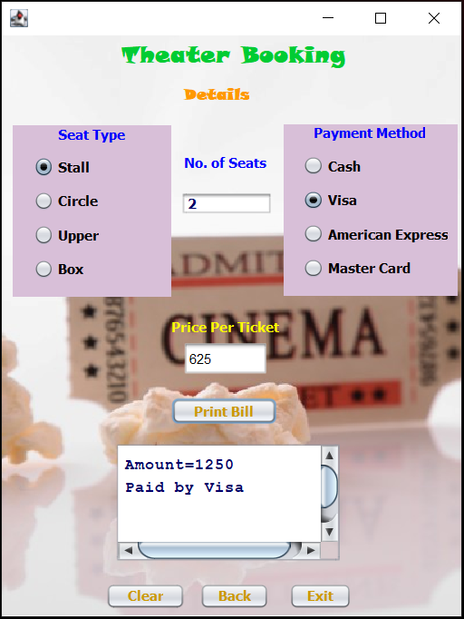

Here we are, now you just have to specify the details for your movie tickets like which seat type you want to choose, how many seats you want to select and no. of seats and it will print your bill.

## 6

**Basic flow chart for print bill button: -**

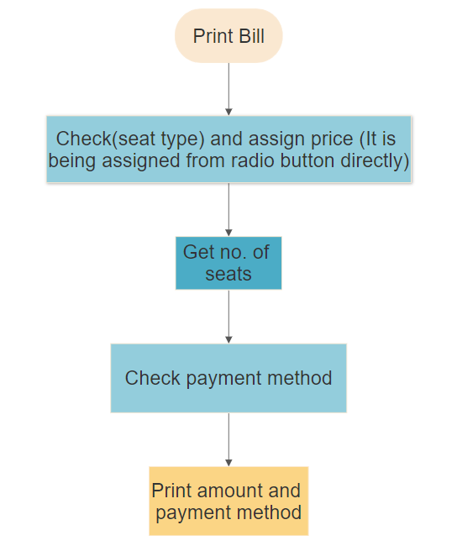

**Pseudo code for this frame: -**

**Print Bill Button: -**

int Seat=Integer.parseInt(jTextField1.getText());

int Price=Integer.parseInt(jTextField2.getText());

int t=Seat*Price;

if(jRadioButton5.isSelected())

jTextArea1.setText("Amount="+t+"\nPaid by Cash");

else if(jRadioButton6.isSelected())

jTextArea1.setText("Amount="+t+"\nPaid by Visa" );

else if(jRadioButton7.isSelected())

jTextArea1.setText("Amount="+t+"\nPaid by American Express");

jTextArea1.setText("Amount="+t+"\nPaid by Master Card");

else

## 7

**Seat type radio Buttons: -**

if(jRadioButton1.isSelected())

jTextField2.setText(""+625);

if(jRadioButton2.isSelected())

jTextField2.setText(""+750);

if(jRadioButton3.isSelected())

jTextField2.setText(""+850);

if(jRadioButton4.isSelected())

jTextField2.setText(""+1000);

**Back Button: -**

setVisible(false); // Hiding this frame

Options opt= new Options(); //Creating an object for Options frame

opt.setVisible(true); // Showing Options frame

**4) Shoe Factory**

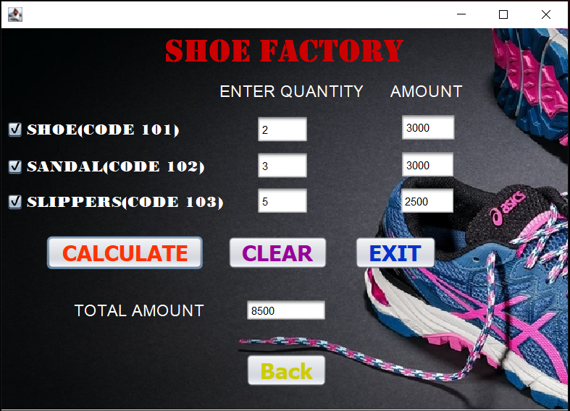

## 8

Now, just enter the quantity against the product you want and click on the check box the total amount for that product will be displayed and now when you are done with this, click on calculate button and the total amount for all the products will be shown.

**Basic flow chart for checkboxes: -**

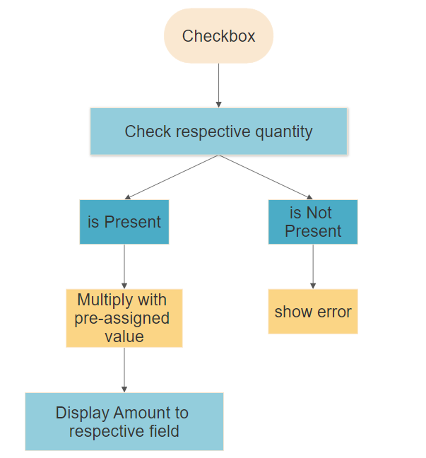

## 9

**Pseudo code for this frame: -**

**Shoe Checkbox: -**

if(qty1.getText().isBlank()){

JOptionPane.showMessageDialog(null, "First enter respective quantity.");

shoebox.setSelected(false);

}

else{

qty=Integer.parseInt(qty1.getText());

amount1=1500*qty;

shoeamt.setText(""+amount1);}

**Sandal Checkbox: -**

if(qty2.getText().isBlank()){

JOptionPane.showMessageDialog(null, "First enter respective quantity.");

sandalbox.setSelected(false);

}

else{

qty=Integer.parseInt(qty2.getText());

amount2=1000*qty;

sandalamt.setText(""+amount2);}

**Slipper Checkbox: -**

if(qty3.getText().isBlank()){

JOptionPane.showMessageDialog(null, "First enter respective quantity.");

slipperbox.setSelected(false);

}

else{

qty=Integer.parseInt(qty3.getText());

amount3=500*qty;

slipperamt.setText(""+amount3);}

**Calculate Button: -**

amount=amount1+amount2+amount3;

totalamt.setText(""+amount);

**Back Button: -**

setVisible(false); // Hiding this frame

Options opt= new Options(); //Creating an object for Options frame

opt.setVisible(true); // Showing Options frame

## 10

**5) Pizza Café**

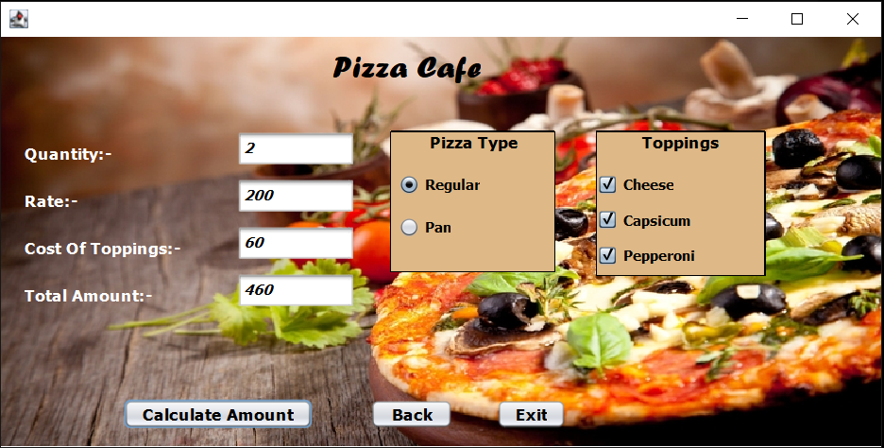

In this frame just enter the quantity of your delicious pizzas, select the base for your pizza and choose the toppings you want and hit calculate amount button to get your final amount.

## 11

**Basic flow chart for calculate amount button: -**

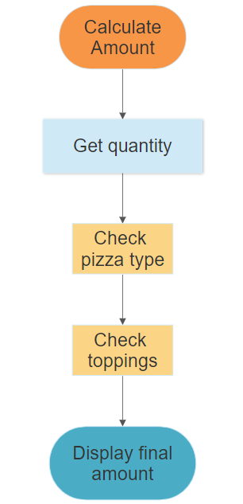

**Pseudo code for this frame: -**

**Regular Radio Button: -**

jTextField3.setText(""+200);

rate=200;

**Pan Radio Button: -**

jTextField3.setText(""+250);

rate=250;

## 12

**Calculate amount Button: -**

quan=Integer.parseInt(jTextField2.getText());

if(jCheckBox1.isSelected())

top=20;

if(jCheckBox2.isSelected())

top=20;

if(jCheckBox3.isSelected())

top=20;

jCheckBox3.isSelected()==false)

if(jCheckBox1.isSelected()==false && jCheckBox2.isSelected()==false &&

top=0;

if(jCheckBox1.isSelected() && jCheckBox2.isSelected())

top=40;

if(jCheckBox2.isSelected() && jCheckBox3.isSelected())

top=40;

if(jCheckBox1.isSelected() && jCheckBox3.isSelected())

top=40;

if(jCheckBox1.isSelected() && jCheckBox2.isSelected() && jCheckBox3.isSelected())

top=60;

jTextField4.setText(""+top);

int amt=((quan*rate)+top);

jTextField5.setText(""+amt);

**Back Button: -**

setVisible(false); // Hiding this frame

Options opt= new Options(); //Creating an object for Options frame

opt.setVisible(true); // Showing Options frame

## 13

### Summary

NetBeans IDE is really a powerful tool to make Java,

HTML, CSS applications really fast. The IDE is designed to limit coding errors and facilitate error correction with tools such as the NetBeans Find Bugs to locate and fix common Java coding problems and Debugger to manage complex code with field watches, breakpoints and execution monitoring.

**In this project I learnt: -**

* Developed a user interface within the Java GUI Application using NetBeans IDE components such as Textbox, Label, Buttons, Table, Messagebox, etc.
* Parsing between multiple form application.

**Future ideas include: -**

* Implement a database management system to save all current sessions and ability to have many users.

## 14

# **References**

**(2020). Retrieved from Apache NetBeans: https://netbeans.org/**

**Gnanadhas, D. M. (2014, June). Retrieved from ResearchGate: https://www.researchgate.net/publication/264556861_Online_Shopping_-_An_Overview**

**Rouse, M. (2014, March). Retrieved from TheServerSide.com: https://www.theserverside.com/definition/NetBeans**

**Sunitha, C. (2014, June). Retrieved from ResearchGate: https://www.researchgate.net/publication/264556861_Online_Shopping_-_An_Overview**

### Link for the live project

* [**https://github.com/adarsh046/OnMart_OnlineMarket**](https://github.com/adarsh046/OnMart_OnlineMarket)

## 15