**Embedded System Design PROJECT ON**

**Automatic Braking System using LPC2138**

**Submitted By**

|  |  |  |
| --- | --- | --- |
| **Sr. No** | **Name** | **PRN** |
| **1.** | **Soham Pande** | **22310019** |
| **2.** | **Amit Khedkar** | **22410012** |
| **3.** | **Prasad Datekar** | **22410018** |
| **4.** | **Abhinav Chate** | **22410021** |
| **5.** | **Adarsh Nalawade** | **22410067** |

**For**

**T.Y. B. Tech (Electronics Engineering)**

**Under the Guidance Of**

# Mr. S.R.Khedkar



**Department of Electronics Engineering**

**Walchand College of Engineering, Sangli.**

**2024-25**

**Brief Introduction :**

This project implements an Automatic Braking System using the LPC2138 microcontroller, which is part of the ARM7 family. The system is designed to detect obstacles using an ultrasonic sensor and control a motor based on the distance measured. This application is particularly valuable in robotics and automotive systems, where safety and obstacle avoidance are critical. The motor control system implements PWM-based DC motor speed control with variable braking force, allowing real-time speed adjustments based on obstacle proximity and emergency stop functionality for critical situations. This implementation demonstrates the practical application of embedded systems in safety-critical applications, effectively combining real-time sensor data processing with precise motor control.

**Flow chart :**

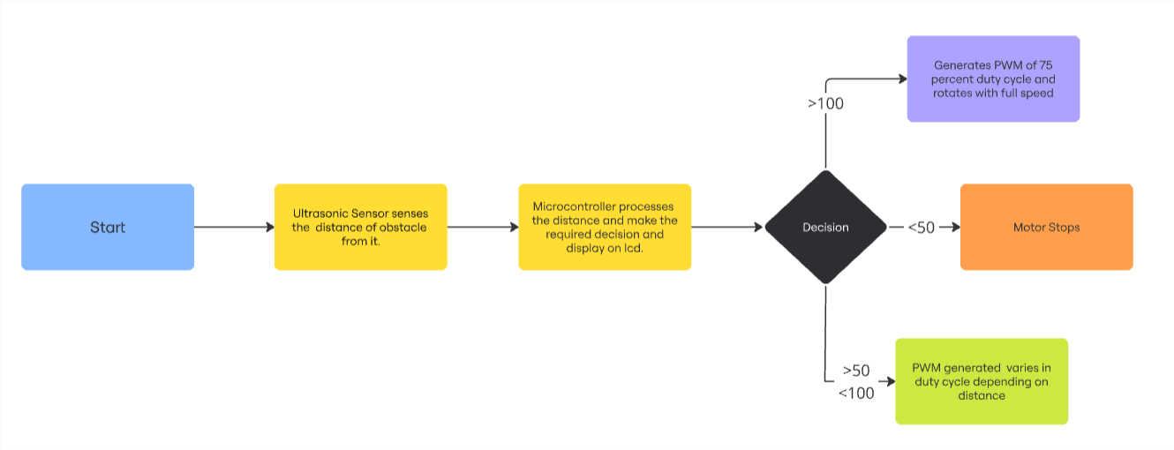

**Project Objectives:**

1. Primary Objectives:

* To design and implement an automatic braking system using LPC2138 microcontroller
* To develop accurate obstacle detection using ultrasonic sensor technology
* To create a reliable motor control system with variable braking force
* To ensure real-time response for collision prevention

1. Technical Objectives:

* To achieve distance measurement accuracy within ±3cm using HC-SR04 sensor
* To implement PWM-based motor control with response time under 100ms
* To optimize the system performance using ARM7's timer and GPIO capabilities
* To establish reliable communication between sensor, controller, and motor modules

1. Safety Objectives:

* To incorporate fail-safe mechanisms for system reliability
* To implement emergency stop functionality for critical situations
* To develop configurable safety threshold distances
* To ensure consistent system status monitoring

1. Development Objectives:

* To create modular and maintainable embedded software
* To optimize resource utilization of the microcontroller
* To document system architecture and implementation details
* To validate system performance through comprehensive testing

**Block Diagram:**

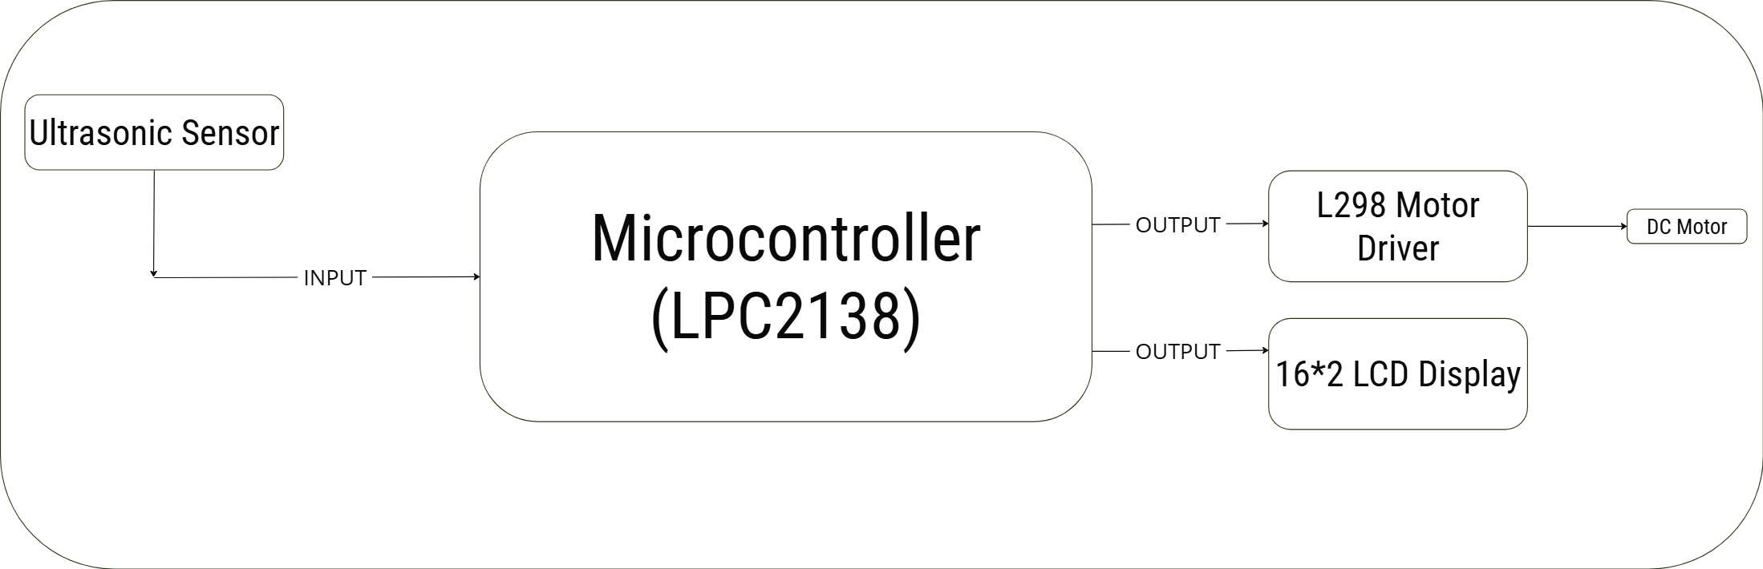

**Working :**

Working of the Automatic Braking System:

1. Sensor Operation:

* HC-SR04 ultrasonic sensor emits sound waves
* Sound waves reflect from obstacles in the path
* Echo signal received by sensor indicates distance
* Distance calculated using timer values and speed of sound
* Controller receives continuous distance measurements

1. Distance Processing:

* LPC2138 processes echo pulse duration
* Measurements filtered for noise reduction
* Multiple readings averaged for accuracy
* Distance values compared with preset thresholds which are given below

1. Motor Control Mechanism:

* Three distance zones implemented:
  + Safe Zone (>100cm): Full motor speed
  + Warning Zone (50-100cm): Reduced speed
  + Danger Zone (<50cm): Emergency brake engaged
* PWM signals generated for speed control
* Braking force varies with obstacle proximity
* Emergency stop activated in critical situations

1. System Response:

* Real-time distance monitoring (every 100ms)
* Immediate speed adjustment based on distance
* Gradual braking for smooth deceleration
* Emergency braking for sudden obstacles
* System status indicated through LCD display such as crash warning, safe distance etc.

**Resources Required:**

|  |  |
| --- | --- |
| **Sr no.** | **Name Of Component** |
| **1.** | LPC2138 evaluation board |
| **2.** | Ultrasonic Sensor |
| **3.** | 16*2 Alphanumeric Display |
| **4.** | L298 Motor Driver |
| **5.** | DC Motor |

**Code:**

#include <lpc213x.h>

#include "Timer.h"

#include "Ultrasonic.h"

#include "LCD.H"

void delay()

{

unsigned int i;

for(i=0;i<1275;i++);

}

unsigned int range, i;

unsigned int value;

void motor_forward(int speed) {

IOSET1 = 1<<16;

IOCLR1 = 1<<17;

PWMMR1=speed;

PWMLER=1<<1;

}

void motor_stop() {

IOCLR0|=3<<16;

PWMMR1=0;

PWMLER=1<<1;

}

int main() {

VPBDIV = 0x01;

IODIR0 |= 0x00FF3400;

IODIR1 = 3<<16;

IOSET1 = 1<<16;

IOCLR0|=~(1<<17);

PINSEL0|=2<<0;

PWMTCR = 0x02;

PWMPR = 235164;

PWMMR0 = 255;

PWMMR1=40;

PWMMCR = 0X02;

PWMLER = 0x03;

PWMPCR = 1<<9;

PWMTCR = 0x09;

ultrasonic_init();

lcd_init();

show("Distance :");

while (1) {

cmd(0x8A);

range = get_range();

dat((range / 100) % 10 + 48);

dat((range / 10) % 10 + 48);

dat((range % 10) + 48);

show("cm");

if (range < 50) {

motor_stop();

cmd(0xC0);

show("CRASH WARNING ");

}

else if (range <= 100 && range >= 50) {

int speed = (100 - range) * 2;

motor_forward(speed);

cmd(0xC0);

show("CRASH WARNING ");

}

else if (range > 100) {

motor_forward(254);

cmd(0xC0);

show("You are safe :) ");

}

}

    return 0;

}

**Proteus Simulation:**

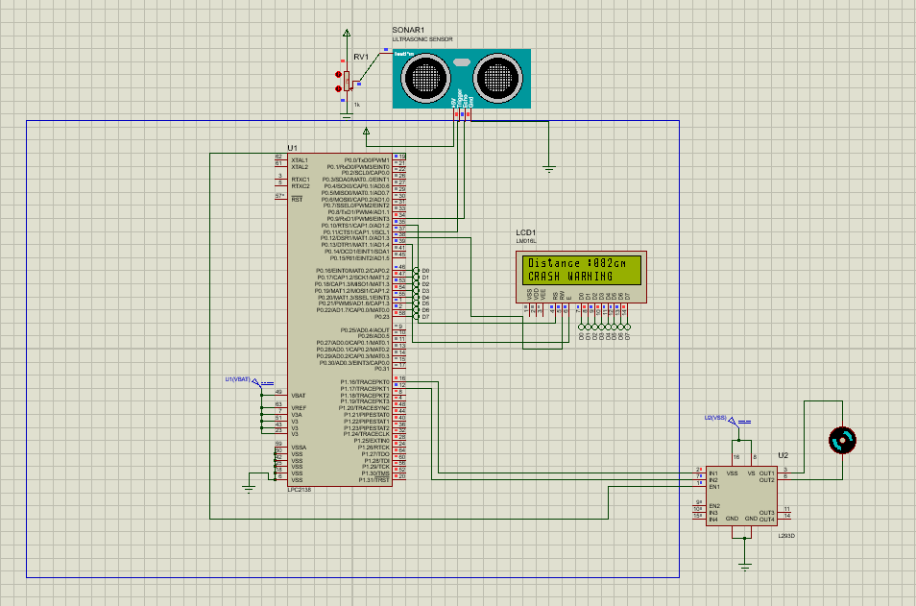

**Advantages & Disadvantages :**

Advantages:

1. Safety Benefits:

* Prevents collisions through early obstacle detection
* Reduces human reaction time dependency
* Minimizes accident risks in autonomous systems
* Provides consistent braking response

1. Technical Benefits:

* Real-time distance monitoring capability
* Precise speed control through PWM
* Configurable safety thresholds
* Low-cost implementation using standard components

1. System Features:

* Easy integration with existing systems
* Modular design for simple maintenance
* Fail-safe operation
* Scalable architecture for different applications

Applications:

1. Automotive Industry:

* Advanced driver assistance systems (ADAS)
* Autonomous vehicles
* Parking assistance systems
* Smart car safety features

1. Industrial Automation:

* Automated guided vehicles (AGVs)
* Warehouse robots
* Material handling equipment
* Assembly line automation

1. Robotics:

* Mobile robots
* Service robots
* Educational robots
* Research platforms

1. Transportation:

* Smart trolleys
* Electric vehicles
* Public transport systems
* Loading/unloading systems

1. Safety Systems:

* Industrial safety barriers
* Automated doors
* Security systems
* Personnel safety equipment