RESEARCH METHODOLOGY PROJECT — PROBLEM STATEMENT AND PROPOSAL (REVISED)
Reinforcement Learning for Load Balancing under Partial Observability
Belief-state estimation, model-free adaptation, and an honest comparison with classical and optimal dispatchers
Prepared by: [Name(s)] | B.Tech Information Technology, IIIT Allahabad
Version 2 — 24 September 2026. This document replaces the original proposal (Problem_Statement_Proposal.docx).
Base paper: K. Chawla, “Reinforcement Learning-Based Adaptive Load Balancing for Dynamic Cloud Environments,” arXiv:2409.04896, 2024.

0. What changed from the original proposal
The original proposal was written before any code existed. Building the prototype and running 695 experiments showed that several of its statements were too strong or did not match what was built. This version keeps the original motivation but corrects those statements.
Original statement | Revised statement | Reason
“This gap has not been addressed in the reviewed literature.” | Partial observability, POMDPs and state estimation are well studied separately; RL load-balancing work such as Chawla (2024) typically assumes perfect monitoring. We study their combination in a controlled setting. | Avoid an unsupported novelty claim
RL is expected to outperform traditional algorithms. | RL outperforms Round Robin and Least Connections, but Shortest Expected Delay (SED) is already optimal at the tested load; RL only matches it. RL's advantage is expected when the dispatcher's model (server speeds) is wrong. | Measured: RL 1.13–1.20 vs SED 1.14 = optimum
Workload prediction will recover the loss from partial observability. | Workload prediction was implemented and tested; it did not help and is reported as a negative result. Recovery comes from state estimation, not prediction. | Measured: forecast (C7) worse than plain partial-obs RL (C6)
Observation = state + Gaussian noise; state includes CPU load and response time. | State = queue lengths only; noise is discrete ±1 with probability p; delay = k-slot-old snapshot. | Keeps the tabular state space at 5^5 = 3,125 and the exact model tractable
Value/Policy Iteration is an upper-reference for all configurations. | VI/PI give the exact optimum only for steady traffic with full observability. | Exact model exists only for that case
Six configurations compared. | Nine implemented (C1–C9); three more planned (C10–C12), plus a model-mismatch experiment. | Scope grew with the prototype

1. Background and motivation
Load balancing assigns each incoming request to one of several servers so that response time stays low and no server is overloaded. Classical dispatchers use fixed rules: Round Robin ignores server state, Least Connections (Join-the-Shortest-Queue) uses queue lengths, and Shortest Expected Delay (SED) uses queue lengths and server speeds. Reinforcement learning (RL) dispatchers learn a rule from experience instead.
Chawla (2024) trains a tabular Q-learning dispatcher in CloudSim and reports better response time, utilisation and completion rate than Round Robin, Least Connections and weighted balancing. Like most RL load-balancing studies, it assumes the dispatcher observes every server's exact, current state.
Real monitoring does not provide that. Metrics are scraped every few seconds, aggregated, and transmitted over a network, so the dispatcher acts on information that is stale and sometimes noisy. Under these conditions the dispatcher faces a Partially Observable Markov Decision Process (POMDP), and a policy learned as if the state were fully observed can behave badly.
A second practical gap: every model-based rule (SED, Value Iteration) needs the servers' service rates. In real clusters these rates drift (noisy neighbours, throttling, failing hardware), so a rule configured with yesterday's speeds may be badly wrong today. A model-free learner does not need them.

2. Related work and positioning
Area | What it offers | How this project relates
RL load balancing (Chawla 2024; deep-RL LB for dense networks, arXiv:1906.00767) | Learned dispatchers beat simple rules under full observability | Reproduces the result, adds a stronger classical baseline (SED) and the exact optimum (VI/PI), then removes the full-observability assumption
Queueing theory (JSQ, SED) | Near-optimal heuristics when state and speeds are known | Used as strong baselines; shows when learning is and is not needed
POMDPs and belief states (Kaelbling, Littman & Cassandra 1998; Cassandra's tutorial) | The belief is a sufficient statistic for optimal control under partial observability | We derive an exact, cheap belief for this system by exploiting per-server independence
Restless bandits (Whittle 1988; professor's work on sensor scheduling) | Which arms (sensors, servers) to observe under a budget | Stretch goal: which servers to poll when monitoring is limited
Positioning. The contribution is not a new RL algorithm. It is (i) a controlled, reproducible study of how partial observability and model mismatch affect classical, optimal and learned dispatchers, and (ii) an exact, factorised belief-state estimator that improves both classical and learned dispatchers under stale monitoring.

3. Problem statement
Problem statement. To design, implement and evaluate a load-balancing framework in which a dispatcher routes jobs to heterogeneous servers using delayed and/or noisy observations of their queues (a POMDP), and to determine: (a) how much performance classical (Round Robin, Least Connections, SED), optimal (Value/Policy Iteration) and learned (Q-learning) dispatchers lose under realistic monitoring; (b) whether an exact belief-state estimator, built from the dispatcher's own dispatch log, recovers that loss for both classical and learned dispatchers; and (c) under what conditions — such as mis-specified server speeds — a model-free RL dispatcher outperforms model-based rules. Evaluation uses a custom, fully seeded simulator with steady, bursty and cyclical traffic, reporting response time, dropped jobs and estimation error over multiple random seeds.

4. Research questions
RQ | Question | Status
RQ1 | How much does each dispatcher degrade under noisy, delayed and noisy+delayed observations? | Answered in prototype 1
RQ2 | Does adding a traffic forecast to the RL state recover the loss? | Answered: no
RQ3 | How much of the loss does a state estimator recover — dispatch corrector vs. exact belief filter — for SED and for Q-learning? | Corrector done; belief filter planned (prototype evidence positive)
RQ4 | When server speeds are mis-specified, does model-free Q-learning outperform model-based rules? | Planned (quick test positive)
RQ5 | Does a confidence-gated hybrid (Q-learning when the belief is confident, belief-SED otherwise) give the best overall dispatcher, including at heavy load? | Planned (stretch)

5. Objectives
# | Objective | Status
O1 | Formulate load balancing as an MDP; build a seeded simulator with heterogeneous servers, bounded queues and three traffic patterns | Done
O2 | Implement Round Robin, Least Connections and Shortest Expected Delay | Done
O3 | Build the exact transition model and solve it with Value and Policy Iteration | Done
O4 | Implement tabular Q-learning; tune α, γ; compare with the optimum under full observability | Done
O5 | Implement noisy, delayed and noisy+delayed observation models (POMDP) | Done
O6 | Implement and test two recovery mechanisms: EMA traffic forecast, dispatch-corrected estimator | Done
O7 | Run the full experiment (C1–C9, 3 traffic, 7 observation modes, 5 seeds); 24 unit tests | Done
O8 | Fix evaluation issues: corrector must receive noisy input; paired seeds; drop rate; SED+corrector control (C10) | Planned
O9 | Implement the exact per-server Bayesian belief filter; configs C11 (Q + belief), C12 (SED + belief) | Planned
O10 | Model-mismatch experiment: true server speeds differ from those assumed by model-based rules | Planned
O11 | Confidence-gated hybrid; heavy-load setting; 10 seeds with statistical tests | Planned

6. System model
Time is divided into slots t = 0, 1, 2, … There are N = 5 servers with service probabilities μ = (0.9, 0.7, 0.5, 0.4, 0.3) and queue capacity q_max = 4. Each queue is FIFO and stores the arrival slot of every job.

Arrivals
At most one job arrives per slot:
(1)
The three traffic patterns set λ_t as follows. Steady: λ_t = λ = 0.8. Bursty (two-state Markov-modulated): λ_low = 0.3, λ_high = 0.95, p_lh = 0.05, p_hl = 0.10 (long-run mean ≈ 0.52). Cyclical (T = 200 slots, λ ∈ [0.3, 0.95], mean 0.625):
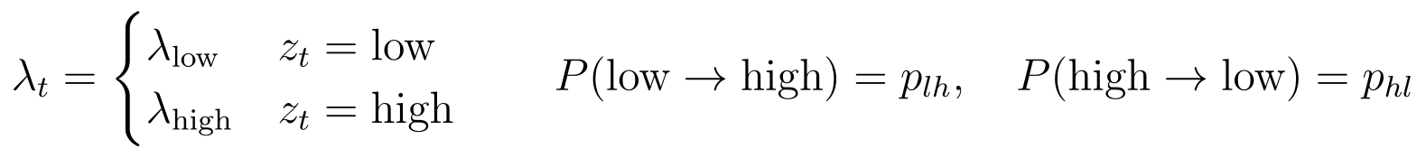 | (2)
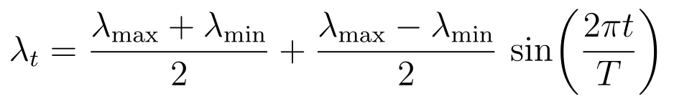 | (3)

Dispatch, drops and service
If a job arrives it joins the queue of the chosen server a_t; if that queue is full the job is dropped (an overload event D_t = 1). Then every non-empty server completes its head-of-line job with probability μ_i:
(4)
(5)

Reward, response time and load
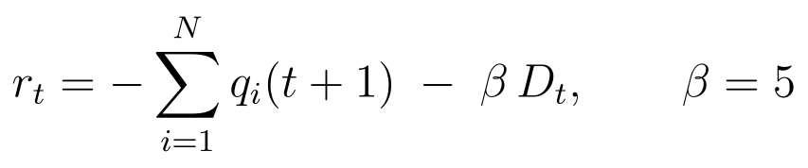 | (6)
The reward penalises the total number of jobs waiting plus a drop penalty β = 5. By Little's law, minimising the average number of jobs in the system minimises average response time at a fixed throughput, so the queue sum is an immediate, dense proxy for delay:
(7)
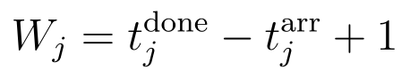 | (8)
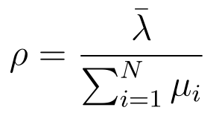 | (9)
With steady traffic ρ = 0.8 / 2.8 ≈ 0.29 (light load). A heavy-load variant halves every μ_i (ρ ≈ 0.57).

7. MDP and POMDP formulation

Fully observable MDP
(10)
The state is the queue-length vector, encoded as a single integer by mixed-radix encoding. The action is the server index. Transitions follow Section 6; the discount factor is γ = 0.95 (chosen by grid search from {0.9, 0.95}).

Partially observable extension (POMDP)
(11)
The dispatcher never sees s_t directly. It receives an observation from one of seven monitoring modes:
Mode | Observation model | Parameters
full | o_t = s_t | —
noise_low / noise_high | Each queue independently shifted by ±1 with probability p, clipped (eq. 12) | p = 0.1 / 0.3
delay_2 / 5 / 10 | o_t = s_(t−k), the true state k slots ago (eq. 13) | k = 2, 5, 10
noise_delay | Noisy k-slot-old snapshot (eq. 14) | k = 5, p = 0.15
(12)
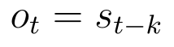 | (13)
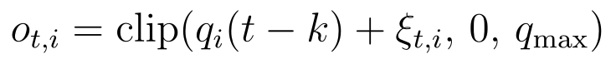 | (14)
The dispatcher does know its own past actions and whether a job arrived in each slot — this information is not hidden and is the basis of both estimators in Section 8.

8. Algorithms
Every dispatcher receives an estimate q̂ of the queue vector from the estimation layer (raw observation, dispatch corrector, or belief filter) and returns a server index.

8.1 Classical baselines
Round Robin cycles through servers and ignores state. Least Connections joins the shortest estimated queue. Shortest Expected Delay joins the server with the smallest expected completion time of the new job; it needs the service rates μ_i. Ties are broken uniformly at random.
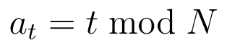 | (15)
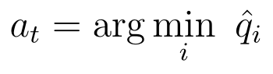 | (16)
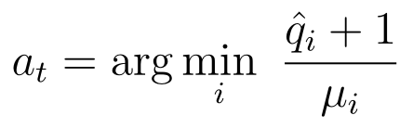 | (17)

8.2 Value Iteration and Policy Iteration (exact optimum)
For steady traffic with full observability the exact transition model P(s′|s,a) is built by enumerating the arrival branch (probability λ) and the no-arrival branch, each followed by all 2^b completion patterns of the b busy servers (at most 64 successors per state-action). The expected reward is:
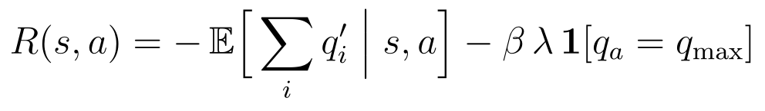 | (18)
The optimal value function satisfies the Bellman optimality equation, solved by Value Iteration:
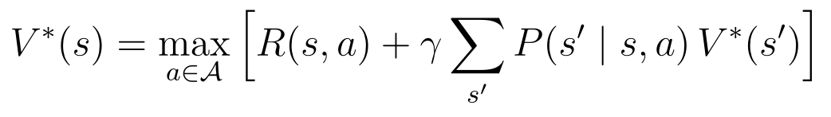 | (19)
(20)
Policy Iteration alternates exact policy evaluation and greedy improvement until the policy is stable:
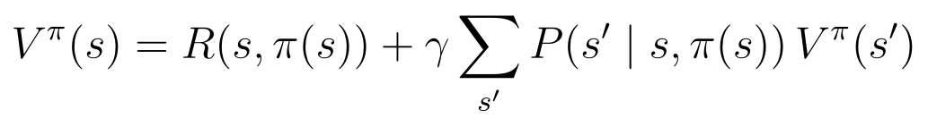 | (21)
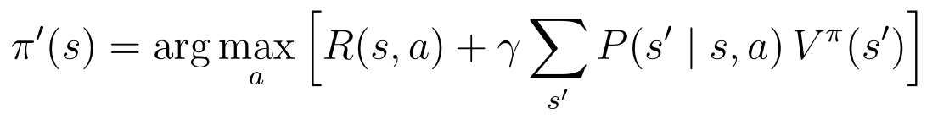 | (22)
Both converge in about 8–11 s for 3,125 states and agree on 100% of states. The resulting table is the optimal dispatcher for that setting and serves as the reference optimum.

8.3 Tabular Q-learning
Q-learning learns action values from experience without the model or the service rates:
(23)
(24)
The Q-table has one row per estimated state (3,125, or 9,375 with the forecast feature), initialised to zero. Training runs 80,000 slots with ε-greedy exploration; evaluation runs 20,000 slots with ε = 0 and no updates. α ∈ {0.05, 0.1, 0.2} and γ ∈ {0.9, 0.95} are chosen per traffic pattern by grid search on two tuning seeds (selected: steady α = 0.05; bursty and cyclical α = 0.2; γ = 0.95). Under partial observability Q-learning is applied to the estimate as if it were the state; this has no convergence guarantee, which is why the quality of the estimate matters.

8.4 Traffic forecast feature (implemented; negative result)
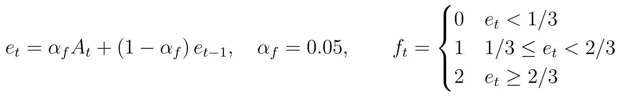 | (25)
The bucket f_t is appended to the observation. Result: it did not help, because the missing information is the queue state, not the arrival rate; under steady traffic the bucket is constant; and the larger table is under-trained. Kept as an ablation.

8.5 Dispatch-corrected estimator (implemented)
The dispatcher rolls a stale snapshot forward using the number of jobs N_i(t−k, t] it sent to server i since the snapshot, and subtracts the expected completions:
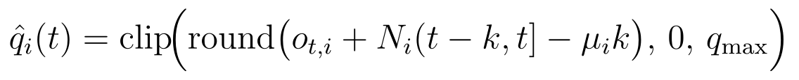 | (26)
It is exact at k = 0, cheap, and helps Q-learning under delay. Its limitations motivate Section 8.6: it assumes every server was busy for all k slots (over-subtracts for idle servers), counts dispatched jobs even if they were dropped, cannot use noisy snapshots, and gives a point estimate with no uncertainty.

8.6 Exact per-server Bayesian belief filter (proposed, main contribution)
Key observation. Given the dispatcher's own log of actions and arrivals, each server's queue evolves independently: server i gains a job only when the dispatcher sent one there (known), and loses one only through its own Bernoulli(μ_i) service. Observation noise is also independent per server. Therefore the POMDP belief over 3,125 joint states factorises exactly into N marginals over {0, …, q_max}:
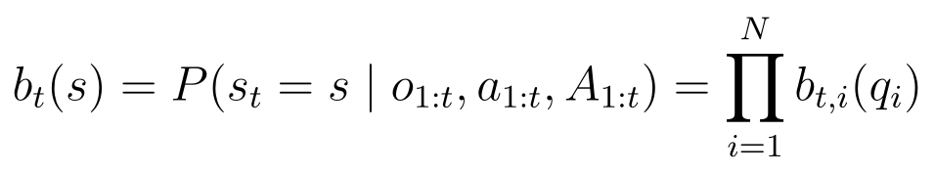 | (27)
Each marginal is updated with three small matrices: the service matrix S_i, the arrival matrix A (a full queue stays full — the job is dropped), and the observation likelihood L:
(28)
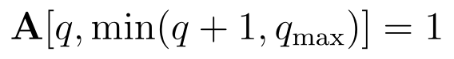 | (29)
(30)
Each slot the filter applies a prediction step (dispatch and service) and a correction step (Bayes' rule with the reading):
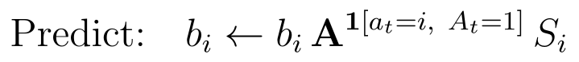 | (31)
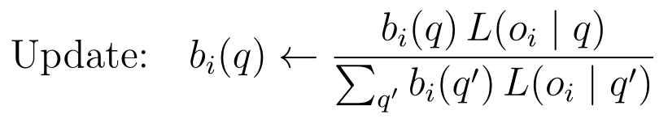 | (32)
With delay k, the filter keeps the belief at the snapshot time t−k, corrects it with the delayed reading, and rolls it forward through the k logged slots to the present:
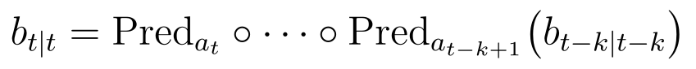 | (33)
The policy receives the rounded posterior mean (so the Q-table stays at 3,125 states), and the posterior standard deviation is available as a confidence signal:
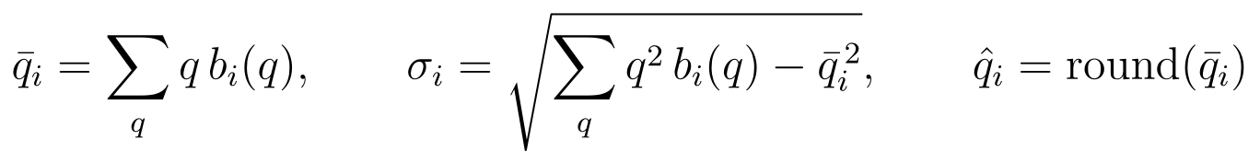 | (34)

Algorithm (per slot)
input: action a_t, arrival A_t, monitor reading o_t (for time t-k)
log.append((a_t, A_t))
if len(log) > k: # snapshot time advances by one slot
(a, A) = log.pop_oldest()
b_snap = Predict(b_snap, a, A)
b_snap = Update(b_snap, o_t) # Bayes correction with the (noisy) reading
b = b_snap
for (a, A) in log: b = Predict(b, a, A) # roll forward to the present
return round(mean(b)), std(b)

Predict(b, a, A): if A = 1: b[a] = b[a] @ A_matrix; for all i: b[i] = b[i] @ S_i
Update(b, o): b[i] = b[i] * L[o_i, :] / sum(b[i] * L[o_i, :]) for all i
Properties. Exact (not approximate) for this model, including idle servers, drops and discrete noise; reduces to the true state when k = 0 and p = 0; cost O(N·k·(q_max+1)²) per slot — about 1,250 multiply-adds for k = 10; needs μ (like SED).

8.7 Confidence-gated hybrid (proposed)
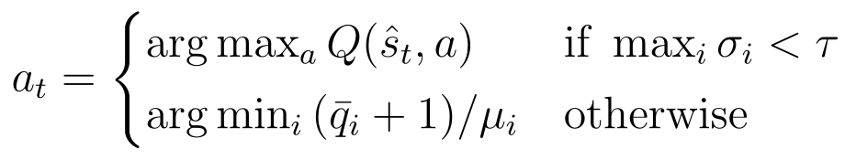 | (35)
The learned policy is used when the belief is sharp; otherwise the dispatcher falls back to SED on the posterior mean. This targets the two failure modes seen in the prototype: unstable Q-learning under stale data, and poor tabular learning at heavy load. τ is chosen on tuning seeds (0.5 in the prototype).

8.8 Model-mismatch setting (proposed)
(36)
The simulator uses the true service rates μ^true, while SED, VI/PI, the corrector and the belief filter use the configured (nominal) rates μ^nom. Test case: μ^true = (0.3, 0.7, 0.5, 0.4, 0.9) — the fastest server has degraded and the slowest was upgraded. Q-learning never uses μ, so it can adapt.

9. Experimental design

9.1 Configurations
ID | Dispatcher | Estimator / observation | Modes | Status
C1 | Round Robin | ignored | all 7 | Done
C2 | Least Connections | raw | all 7 | Done
C3 | SED | raw | all 7 | Done
C4 | Value/Policy Iteration | true state | full, steady | Done
C5 | Q-learning | true state | full | Done
C6 | Q-learning | raw partial observation | 6 partial | Done
C7 | Q-learning | raw + forecast bucket | 6 partial | Done
C8 | Q-learning | dispatch corrector | 6 partial | Done (fix: noisy input)
C9 | Least Connections | dispatch corrector | 6 partial | Done (fix: noisy input)
C10 | SED | dispatch corrector (fair control) | 6 partial | Planned
C11 | Q-learning | belief filter | 6 partial | Planned
C12 | SED | belief filter | 6 partial | Planned
MM | all of the above | model-mismatch config (μ^true ≠ μ^nom) | all | Planned

9.2 Parameters
Parameter | Value
Servers, capacities | N = 5, μ = (0.9, 0.7, 0.5, 0.4, 0.3), q_max = 4; heavy load: μ/2
Traffic | steady λ = 0.8; bursty 0.3/0.95 with p_lh = 0.05, p_hl = 0.10; cyclical 0.3–0.95, period 200
Observation | p ∈ {0.1, 0.3}; k ∈ {2, 5, 10}; noise+delay k = 5, p = 0.15
Reward | β = 5
Q-learning | 80,000 training slots, 20,000 evaluation slots; ε 1 → 0.05 over first half; α, γ grid-searched
Seeds | 5 (prototype) → 10 (final); every method evaluated on the same seeds (paired comparison)
Hybrid threshold | τ = 0.5 (to be tuned)

9.3 Metrics
Primary: average response time over completed jobs J, reported together with the drop rate (a policy must not look fast by dropping jobs).
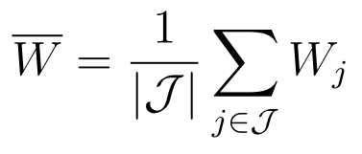 | (37)
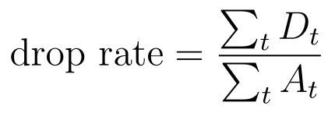 | (38)
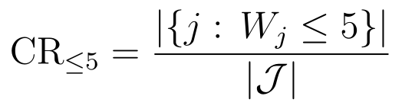 | (39)
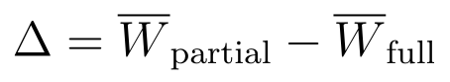 | (40)
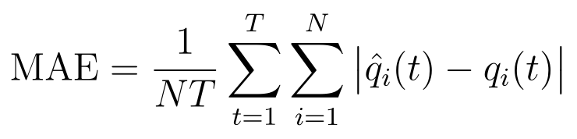 | (41)
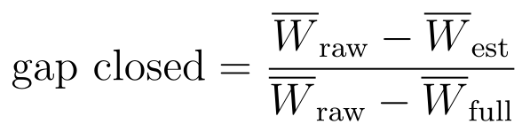 | (42)
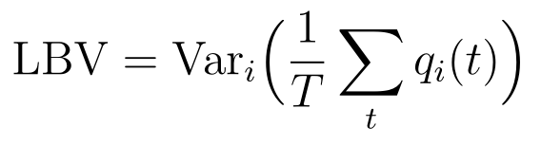 | (43)
(44)
All metrics are reported as mean ± standard deviation over seeds. Recovery mechanisms are compared on delay modes separately from noise modes.

10. Current status and preliminary findings
Finding | Evidence (prototype 1)
RL beats Round Robin and Least Connections | Full observability: Q-learning 1.13–1.20 slots vs RR 2.23–2.32 and LC 1.96–1.98
SED already equals the optimum at this load; RL only matches it | SED = VI = 1.138 (identical trajectories); Q-learning 1.134–1.195
Delay hurts much more than noise | SED +37–47% at k = 10; ≈ +6% at p = 0.3
Naive Q-learning on stale data is unstable | C6: seed std up to 0.5–0.7 slots; up to ~180 dropped jobs per run
Forecast does not help | C7 degradation +0.57 vs C6 +0.46
Corrector helps Q-learning | Delay modes: C8 beats C6 for all three traffic patterns
Evaluation issues found | Corrector received noise-free input in noise modes; unpaired seeds; drops not counted in response time
Belief filter (prototype, 3 seeds) | Lower estimation error than the corrector in every mode; heavy load, k = 10: removes ~two-thirds of the delay damage for SED (corrector ~45%)
Model mismatch (quick test, 3 seeds) | SED with wrong speeds 2.21 (worse than LC 1.97); Q-learning 1.14 = ideal

11. Expected contributions
- A reproducible, unit-tested simulator and experiment pipeline comparing classical, optimal (VI/PI) and learned dispatchers under seven monitoring modes.
- Quantified degradation of each dispatcher under noisy and delayed monitoring, with the finding that delay dominates.
- An exact, factorised belief-state estimator for this load-balancing POMDP, with evidence that it improves both SED and Q-learning over a heuristic corrector.
- Evidence on when model-free RL is worth using: it matches but does not beat a correct model, and outperforms model-based rules when the model (service rates) is wrong.
- A confidence-gated hybrid dispatcher combining learned and model-based decisions (stretch).

What this project does not claim
- That RL is generally better than classical load balancing.
- That partial observability in load balancing has never been studied.
- That results transfer directly to production clusters (simulation only, single dispatcher, discrete-time Bernoulli arrivals).

12. Scope and limitations
- Simulation only; one arrival per slot (keeps the exact model tractable) — hence light nominal load, addressed by a heavy-load variant.
- Tabular methods only; state = queue lengths (5^5 states). Deep RL and richer state (CPU, memory) are out of scope.
- Single centralised dispatcher; multi-dispatcher (multi-agent) settings are future work.
- The belief filter and SED assume known service rates; the model-mismatch experiment tests the consequence.
- Uniform delay k for all servers; asynchronous per-server ages and a polling budget (restless-bandit formulation) are a stretch goal.

13. Timeline
Phase | Work | Status
Weeks 1–6 | MDP / RL / POMDP fundamentals | Done
Weeks 7–10 | Simulator, baselines, VI/PI, Q-learning, partial observability, forecast, corrector, tests | Done
Week 11 | Full experiment (695 runs), plots, prototype-1 report | Done
Week 12 | Fix evaluation issues (O8); rerun grid | Planned
Week 13 | Belief filter, C11/C12 (O9) | Planned
Week 14 | Model-mismatch experiment (O10) | Planned
Week 15 | Heavy load, 10 seeds, statistics; hybrid if time allows (O11) | Planned
Week 16 | Final report and presentation | Planned

References
[1] K. Chawla, “Reinforcement Learning-Based Adaptive Load Balancing for Dynamic Cloud Environments,” arXiv:2409.04896, 2024.
[2] “Load Balancing for Ultra-Dense Networks: A Deep Reinforcement Learning Based Approach,” arXiv:1906.00767.
[3] R. S. Sutton and A. G. Barto, Reinforcement Learning: An Introduction, 2nd ed., MIT Press, 2018.
[4] L. P. Kaelbling, M. L. Littman and A. R. Cassandra, “Planning and acting in partially observable stochastic domains,” Artificial Intelligence, 101, 1998.
[5] A. R. Cassandra, “A Tutorial on Partially Observable Markov Decision Processes.”
[6] P. Whittle, “Restless bandits: activity allocation in a changing world,” Journal of Applied Probability, 25A, 1988.
[7] Professor's related work: “Restless bandits for sensor scheduling in energy constrained networks,” ICC 2022; “Constrained restless bandits for dynamic scheduling in cyber-physical systems,” arXiv:1904.08962.

