RESEARCH METHODOLOGY PROJECT — TOPICS AND WORKFLOW (REVISED)
Topics Used and Project Workflow
RL-based load balancing under partial observability: what the project uses, how it is built, and how it runs
Prepared by: [Name(s)] | B.Tech Information Technology, IIIT Allahabad
Version 2 — 24 September 2026. Replaces Topics_and_Flow_Overview.docx; companion to Problem_Statement_Proposal_v2.docx.
Colour code in every diagram: green = done, orange = current review, blue = planned, red = new contribution.

1. Topics and concepts used
Group | Topic | Where it is used
A. Decision theory | Markov Decision Process (states, actions, transitions, rewards, discount γ) | Formal model of load balancing (proposal §7)
 | Markov property; Bellman optimality equation; value and policy functions | Value/Policy Iteration; Q-learning target
 | Partially Observable MDP (POMDP); observations; belief state | Noisy/delayed monitoring; belief filter
B. Planning algorithms | Value Iteration, Policy Iteration (evaluation + improvement) | Exact optimum for steady traffic (C4)
C. Reinforcement learning | Tabular Q-learning; temporal-difference error; ε-greedy with linear decay | Learned dispatchers (C5–C8, C11)
 | Hyper-parameter grid search (α, γ); convergence measurement | Tuning per traffic pattern
D. Queueing and load balancing | Bernoulli arrivals, service probabilities, bounded FIFO queues, drops; Little's law; load ρ | Simulator and reward design
 | Round Robin, Least Connections (JSQ), Shortest Expected Delay | Classical baselines (C1–C3)
E. Estimation under uncertainty | Stale and noisy observations; dispatch-corrected estimate | Recovery mechanism (C8–C10)
 | Discrete Bayes filter (HMM forward pass): predict / update; factorised belief; posterior mean and standard deviation | Belief filter — new contribution (C11, C12)
 | Exponential moving average forecast | Traffic forecast feature (C7, negative result)
F. Robustness | Model mismatch (true vs assumed service rates); confidence-gated fallback | Mismatch experiment; hybrid dispatcher
G. Research methodology | Controlled simulation; seeds and reproducibility; paired comparison; mean ± std; ablations; negative results | Experiment design and reporting
H. Software engineering | Modular Python package; mixed-radix state encoding; independent RNG streams; unit tests; YAML configs | lb_rl codebase, 24 (→ 27) tests

2. Research workflow
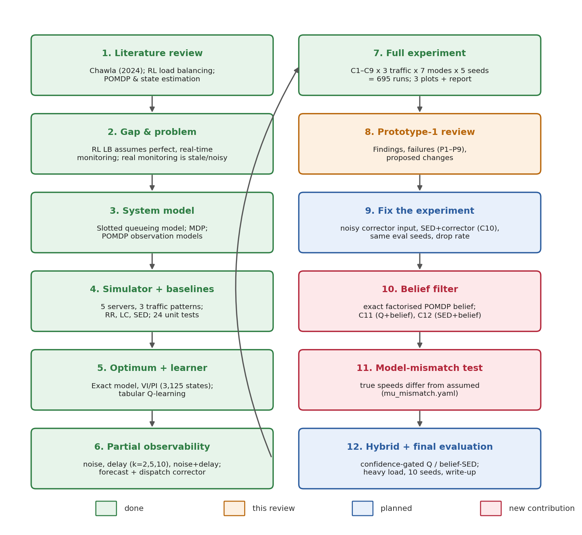
Figure 1 — Research workflow. Steps 1–7 are complete; step 8 is the current review; steps 9–12 are planned.
Step | What happens | Output
1. Literature review | Read Chawla (2024) and related RL load-balancing, POMDP and queueing work | Base paper, gap
2. Gap and problem | Identify the full-observability assumption and the known-speed assumption of model-based rules | Problem statement, RQ1–RQ5
3. System model | Define slots, arrivals, service, drops, reward; MDP and POMDP | Equations (proposal §6–7)
4. Simulator + baselines | Implement env, traffic, servers; RR, LC, SED; unit tests | lb_rl/env, agents/baselines.py
5. Optimum + learner | Build exact P and R; Value/Policy Iteration; tabular Q-learning with tuning | Reference optimum; learned policy
6. Partial observability | Noise, delay and noise+delay wrappers; forecast and dispatch corrector | observation/wrappers.py
7. Full experiment | C1–C9 × 3 traffic × 7 modes × 5 seeds = 695 runs | results.csv, 3 plots, REPORT.md
8. Prototype-1 review | Present what works, what fails (P1–P9), what will change | Feedback
9. Fix the experiment | Corrector gets noisy input; SED + corrector (C10); paired seeds; drop rate; delay-mode findings | Trustworthy baseline numbers
10. Belief filter | Exact per-server Bayesian filter; C11 and C12 | Main result (RQ3)
11. Model mismatch | Simulator uses true speeds, model-based rules use assumed speeds | Where RL wins (RQ4)
12. Hybrid + final evaluation | Confidence-gated dispatcher; heavy load; 10 seeds; statistics; write-up | Final report (RQ5)

3. Runtime workflow — one time slot
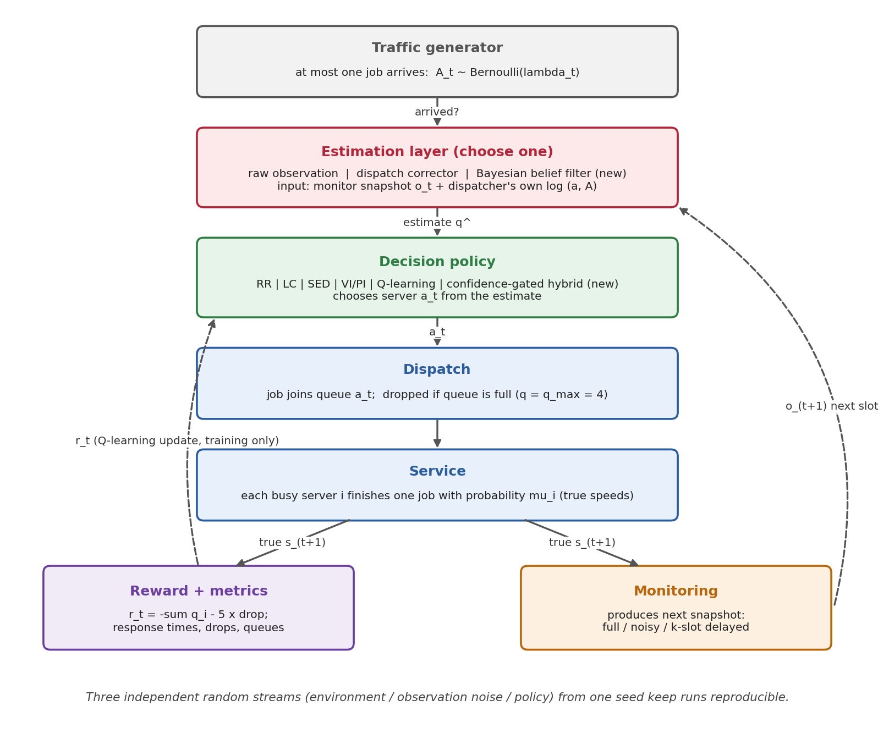
Figure 2 — What happens in every slot, including the new estimation layer and hybrid policy.
- Arrival. The traffic generator decides whether a job arrives (probability λ_t: steady, bursty or cyclical).
- Estimation. The estimation layer turns the monitor's latest snapshot and the dispatcher's own log into an estimate q̂ of the current queues: raw (use the snapshot as is), dispatch corrector, or belief filter.
- Decision. The policy picks a server a_t from q̂: Round Robin, Least Connections, SED, the VI/PI table, Q-learning, or the confidence-gated hybrid.
- Dispatch. The job joins queue a_t; if that queue already holds q_max = 4 jobs, it is dropped (overload event).
- Service. Each busy server finishes its first job with probability μ_i. In the mismatch experiment these are the true speeds, which differ from the speeds the model-based rules believe.
- Reward and metrics. r_t = −Σ q_i − 5 × drop is computed on the true state; response times, drops and queue lengths are recorded.
- Monitoring. The monitor produces the next snapshot (full, noisy, k-slot delayed, or both), which feeds step 2 in the next slot.
- Learning (training only). Q-learning updates its table with r_t; during evaluation the table is frozen.
Reproducibility. The environment, the observation noise and the policy each draw from their own random stream, all created from one seed. Changing the monitoring mode therefore never changes the traffic, and Round Robin — which ignores observations — gives identical results in every mode (checked by a unit test).

4. Estimation layer workflow
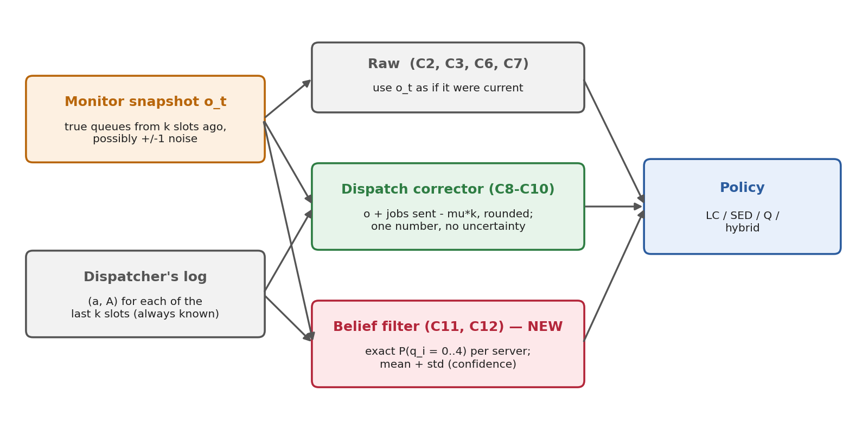
Figure 3 — Three ways to turn a stale/noisy snapshot and the dispatch log into a queue estimate.
Estimator | How it works | Strengths | Weaknesses | Configs
Raw | Uses the snapshot directly | Simple | Wrong by k slots; noise passes through | C2, C3, C6, C7
Dispatch corrector | snapshot + jobs sent since − μ·k, rounded | Cheap; uses known dispatches | Over-subtracts for idle servers; ignores drops and noise; no uncertainty | C8, C9, C10
Belief filter (new) | Exact probability of each queue length per server, updated every slot | Exact; handles idle, drops, noise; gives confidence | Needs μ (like SED); k small matrix products per slot | C11, C12

5. Belief filter workflow (new contribution)
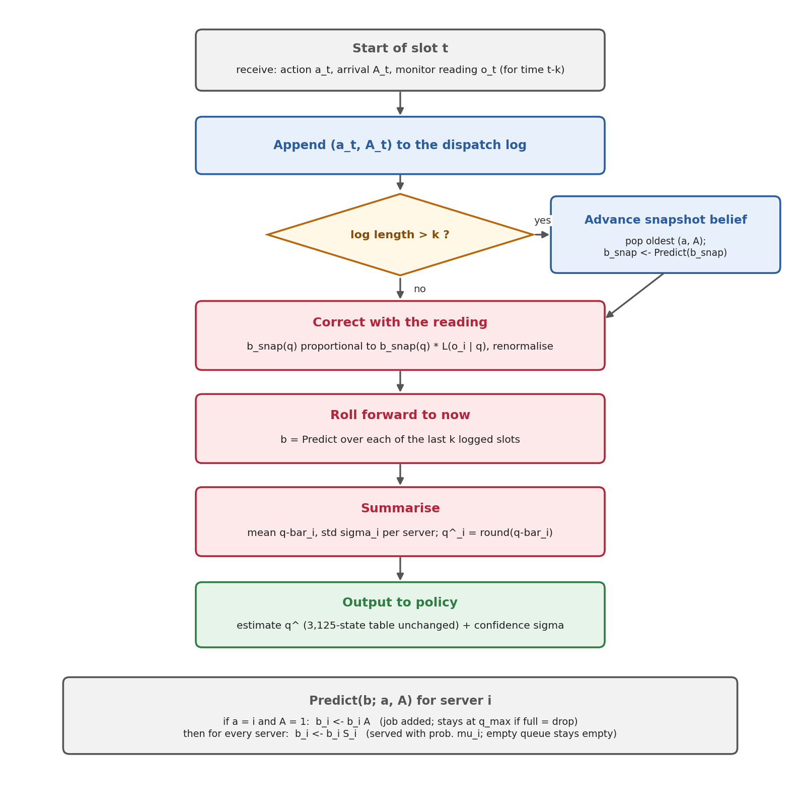
Figure 4 — Per-slot algorithm of the exact per-server Bayesian belief filter.

Step by step
- Log the decision. Append the action and whether a job arrived; the dispatcher always knows these.
- Advance the snapshot belief. Once the log holds more than k entries, the snapshot time moves forward one slot: remove the oldest entry and apply one prediction step to the snapshot belief.
- Correct with the reading. Multiply the snapshot belief by the likelihood of the reading (±1 noise model) and renormalise — Bayes' rule. With no noise this simply confirms the true snapshot.
- Roll forward to now. Apply one prediction step for each of the last k logged slots (known dispatches, random services).
- Summarise. Compute each server's expected queue length (mean) and spread (standard deviation).
- Output. The rounded mean goes to the policy (Q-table size unchanged); the standard deviation is the confidence used by the hybrid.
The prediction step is exact because servers are independent given the dispatch log. It uses two 5 × 5 matrices: A (a new job raises the queue by one, a full queue stays full = drop) and S_i (a busy server finishes a job with probability μ_i, an empty one stays empty). This is what fixes the corrector's biases.

6. Q-learning training and evaluation workflow
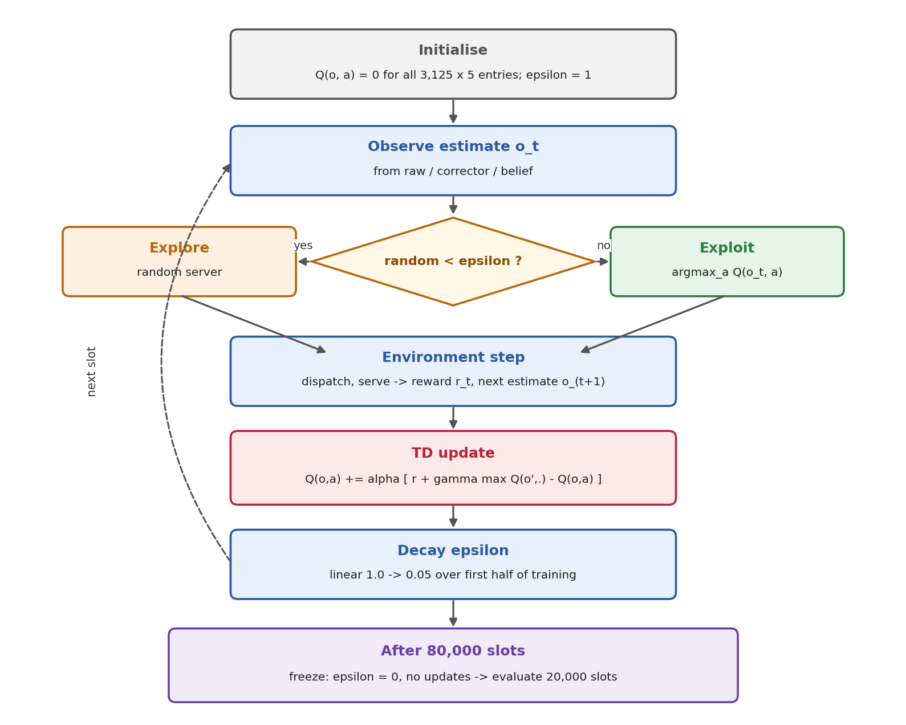
Figure 5 — Training loop of the tabular Q-learning dispatcher and the switch to evaluation.
Phase | Details
Initialise | Q-table 3,125 × 5 (9,375 × 5 with the forecast feature), all zeros; ε = 1
Each training slot | Observe estimate → choose action (ε-greedy) → environment step → TD update → decay ε
Exploration schedule | ε falls linearly from 1.0 to 0.05 over the first 40,000 of 80,000 training slots
Tuning | α ∈ {0.05, 0.1, 0.2}, γ ∈ {0.9, 0.95} grid-searched per traffic pattern on two tuning seeds
Evaluation | 20,000 slots, ε = 0, no updates, fresh estimator instance, seed + 10,000 (same for every method)

7. Hybrid decision workflow (planned)
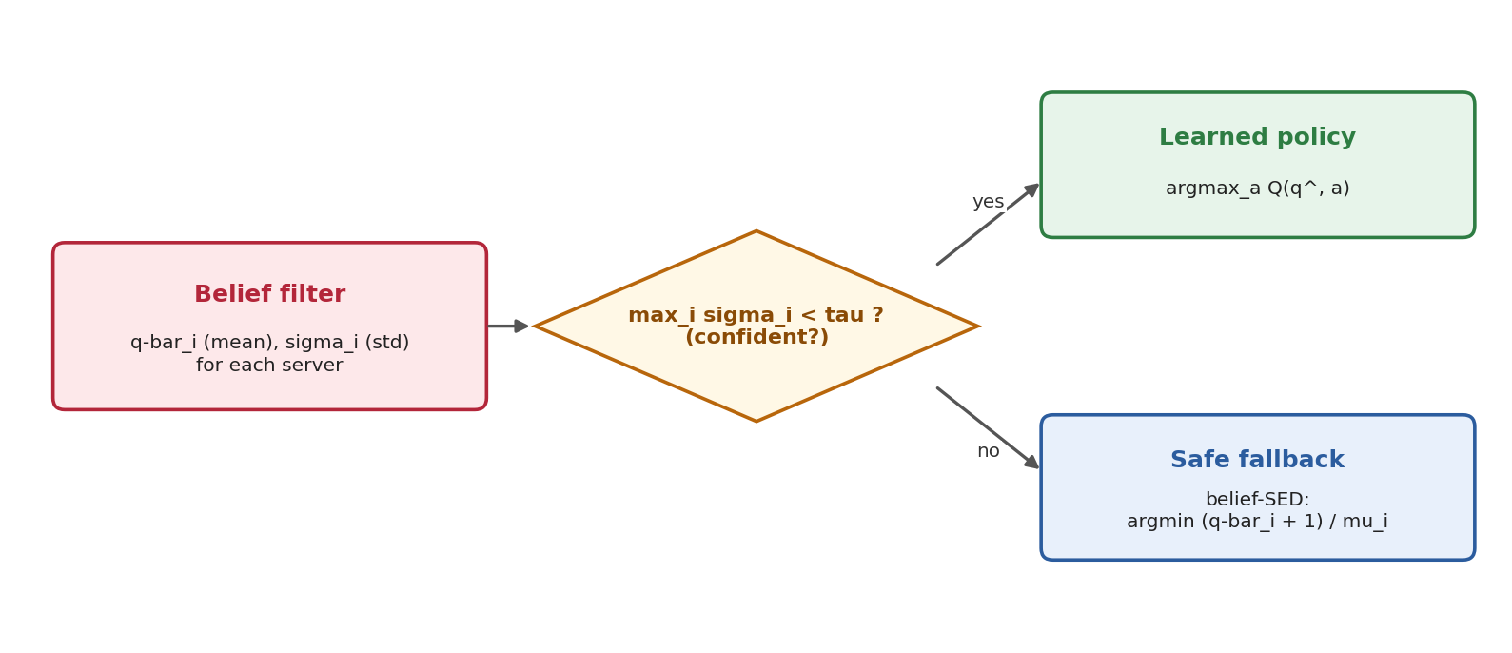
Figure 6 — Confidence-gated hybrid: learned policy when the belief is sharp, belief-SED otherwise.
If the largest posterior standard deviation across servers is below a threshold τ, the dispatcher trusts its learned Q-policy on the belief mean. Otherwise it falls back to SED on the belief mean, which is robust and needs no learning. In the prototype this was the best learning-based dispatcher in every setting tested and stayed close to SED at heavy load, where plain Q-learning failed.

8. Experiment workflow
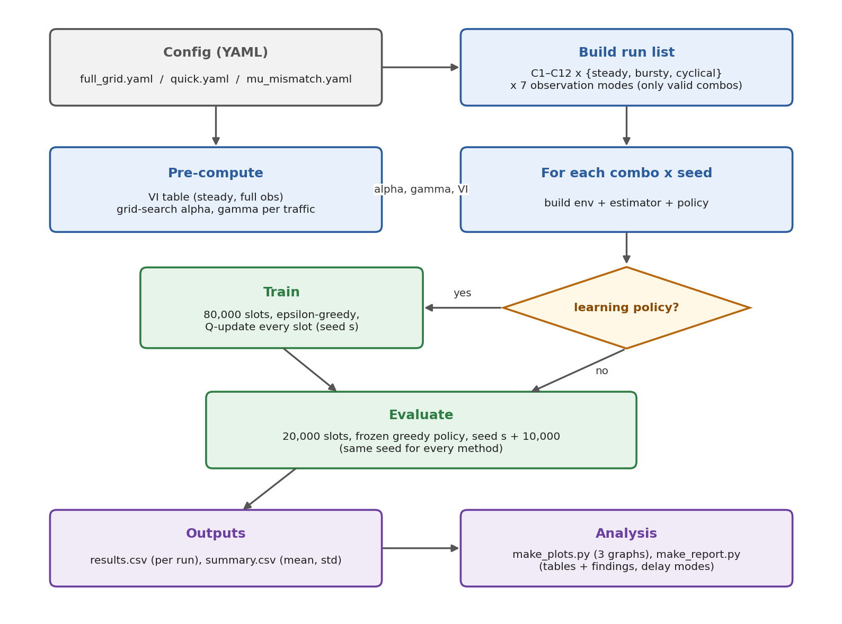
Figure 7 — From a configuration file to results, plots and the report (scripts/run_grid.py and friends).
Stage | Script / file | What it does
Configure | configs/full_grid.yaml, quick.yaml, mu_mismatch.yaml (new) | Servers, traffic, observation modes, Q-learning grid, seeds, config list
Enumerate | run_grid.py: build_run_list() | All valid (config, traffic, mode) combinations (139 now; more with C10–C12)
Pre-compute | run_grid.py | Exact model + VI (steady, full obs); α, γ grid search per traffic
Train | eval/runner.py: rollout(learn=True) | 80,000 slots for learning configs
Evaluate | eval/runner.py: rollout() | 20,000 slots, same seed for all methods
Record | eval/metrics.py | Response time, drops, drop rate, completion ≤ 5 slots, load-balance variance, convergence
Summarise | results/raw/results.csv, results/summary.csv | Per-run rows; mean and std per cell
Visualise | make_plots.py | Response time vs delay; degradation per config; overload events per config
Report | make_report.py | Tables per traffic pattern and findings (delay modes, with drops)

Commands
python -m pytest -q # unit tests
python scripts/run_grid.py --config configs/quick.yaml # smoke run
python scripts/run_grid.py --config configs/full_grid.yaml # full experiment
python scripts/make_plots.py && python scripts/make_report.py
python scripts/run_grid.py --config configs/mu_mismatch.yaml --out-dir results_mu_mismatch

9. Code structure
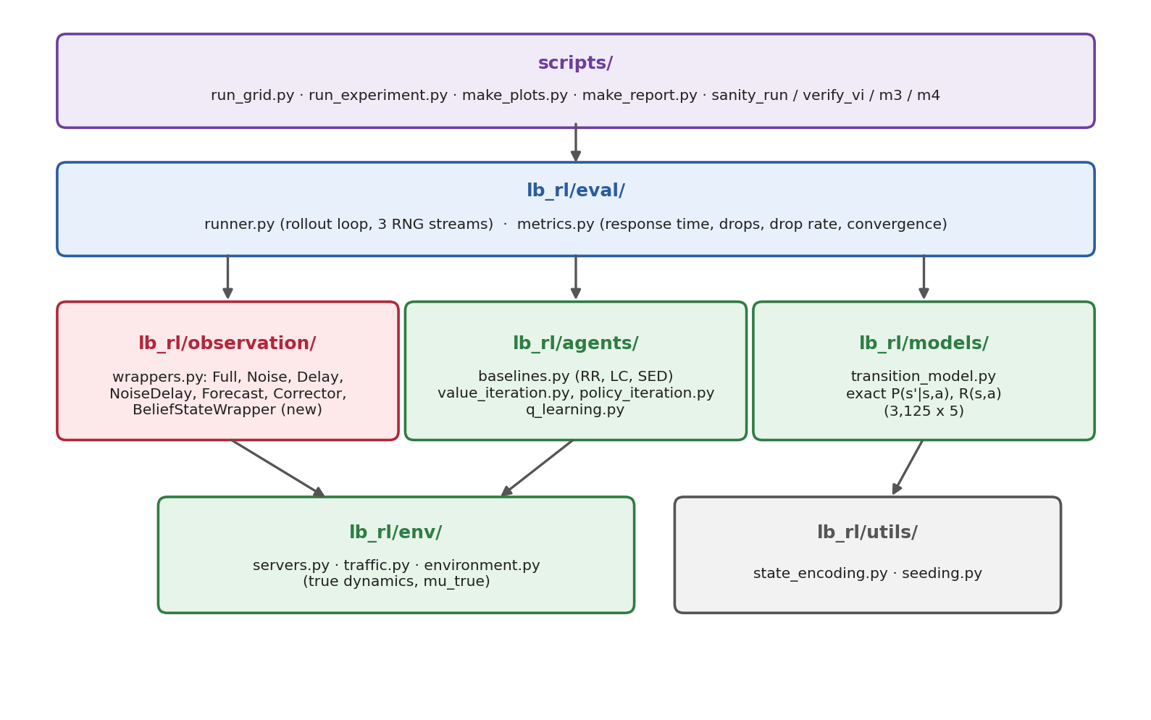
Figure 8 — Package layers. Scripts call the evaluation layer, which drives estimators, agents and the environment.
File | Responsibility
lb_rl/env/servers.py | ServerPool: bounded FIFO queues of arrival slots; dispatch (drop if full); Bernoulli service
lb_rl/env/traffic.py | SteadyTraffic, BurstyTraffic (two-state Markov-modulated), CyclicalTraffic
lb_rl/env/environment.py | LoadBalancingEnv.step: arrival → dispatch → service → reward
lb_rl/observation/wrappers.py | Full, Noise, Delay, NoiseDelay observations; ArrivalForecastWrapper; DispatchCorrectorWrapper; BeliefStateWrapper (new)
lb_rl/agents/baselines.py | RoundRobin, LeastConnections, ShortestExpectedDelay
lb_rl/models/transition_model.py | Exact P(s′|s,a) and R(s,a) for steady traffic, full observability
lb_rl/agents/value_iteration.py, policy_iteration.py | Solvers and greedy table policies
lb_rl/agents/q_learning.py | QLearningAgent: Q-table, ε schedule, TD update, greedy mode
lb_rl/eval/runner.py, metrics.py | Rollout loop with independent RNG streams; metric accumulation
lb_rl/utils/state_encoding.py, seeding.py | Mixed-radix encode/decode of states; RNG creation
scripts/ | Milestone checks (M1–M4), grid runner, single-run debugger, plots, report
tests/ | 24 unit tests (27 after the planned changes)

10. Build status
Component | Status | Notes
Simulator, traffic patterns, drops, reward | Done | Job conservation verified by test
Round Robin, Least Connections, SED | Done
Exact model, Value Iteration, Policy Iteration | Done | Agree on 100% of 3,125 states
Tabular Q-learning + tuning | Done | Matches optimum under full observability
Noise, delay, noise+delay observations | Done
Forecast feature | Done | Negative result; kept as ablation
Dispatch corrector | Done — fix needed | Must receive noisy input
Full experiment, 3 plots, report | Done | 695 runs, 5 seeds
Evaluation fixes (paired seeds, drop rate, SED+corrector control) | Planned | Code changes prepared
Belief filter + C11/C12 | Planned | Prototype tested
Model-mismatch experiment | Planned | Quick test: Q-learning 1.14 vs SED (wrong speeds) 2.21
Hybrid, heavy load, 10 seeds, statistics | Planned | Stretch

11. One-line summary
We model load balancing as an MDP, solve it exactly (Value/Policy Iteration) and with Q-learning, and compare against Round Robin, Least Connections and SED; we then make monitoring realistic (noisy and delayed, a POMDP), show that stale information hurts every smart dispatcher, and recover the loss with an exact, factorised belief filter — while testing where model-free RL genuinely helps: when the dispatcher's model of server speeds is wrong.

