* I started with finding the top percentile customers returning for maximum times. My approach was calculating the return percentage out of the total orders made by the customer and then finding out the relevant customers returning the most. The file I am sharing will give you the top 20 percentile customers returning most. It can be changed accordingly as per the necessity. In the file, you will get to see some customers who have ordered very few times. They can be filtered accordingly after setting the minimum number of orders.
* As per the requirements of the project and better understanding, I started considering different factors. I have considered few factors the details of which can be found below:
* **Return vs order (Customer Wise):** Found out the total returns and total orders for each customer made in the last two months. This can be represented by the below graph: 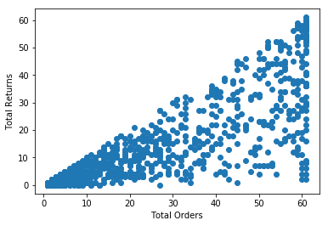

As can be seen from the above graph, for higher return%, it shows a linear behavior.

* **Customer SKU Analysis:** For each customer tried to see if there is any issue with a particular SKU which is the reason of return by the customer. It came out that there were some SKUs for some customer which he is returning frequently on reasons not supporting his return. For example,

|  |  |  |  |  |  |  |
| --- | --- | --- | --- | --- | --- | --- |
| **Customer Id** | **SKU Id** | **Total orders** | **Total returns** | **Returns supporting customer** | **Fraud Return** | **fraud%** |
| 2544 | 64 | 44 | 43 | 23 | 20 | 0.454545 |

You can have look at the data for detail.

* **Locality:** Analysed locality-wise total returns and total orders made in last two months. All localities except Thirumenahalli showed return around or less than 40%. Thirumenahalli locality had only one customer due to which it showed a return of around 70%.

Also, if total returns vs total orders is plotted locality wise, it shows a linear behaviour.

* **Locality SKU:** To check whether any particular SKU had an issue with the return in a particular locality. SKUs showing higher fraud return% had very less orders except for one SKU in Thirumanehalli and one in Thippasandra which had orders around 30.