IILM UNIVERSITY
School of Computer Science and Engineering

INTERNSHIP REPORT
Data Science Internship

Submitted in partial fulfilment of the requirements
for the degree of Bachelor of Technology in Computer Science and Engineering

Student Name | Adarsh Singh
Roll / Enrollment Number | 25SCS1003005017
Section | 2CSE15
Semester | 3rd Semester
Session / Batch | 2025–29
Internship Organization | SkillCraft Technology
Internship Role | Data Science Intern
Internship Duration | 19 July 2026 – 19 August 2026
Internship ID | SCT/JUL26/4532

Greater Noida, Uttar Pradesh

INTERNSHIP COMPLETION CERTIFICATE
The following certificate was issued by SkillCraft Technology and confirms successful completion of a one-month Data Science internship by Adarsh Singh from 19 July 2026 to 19 August 2026. The original certificate is reproduced below without modification.
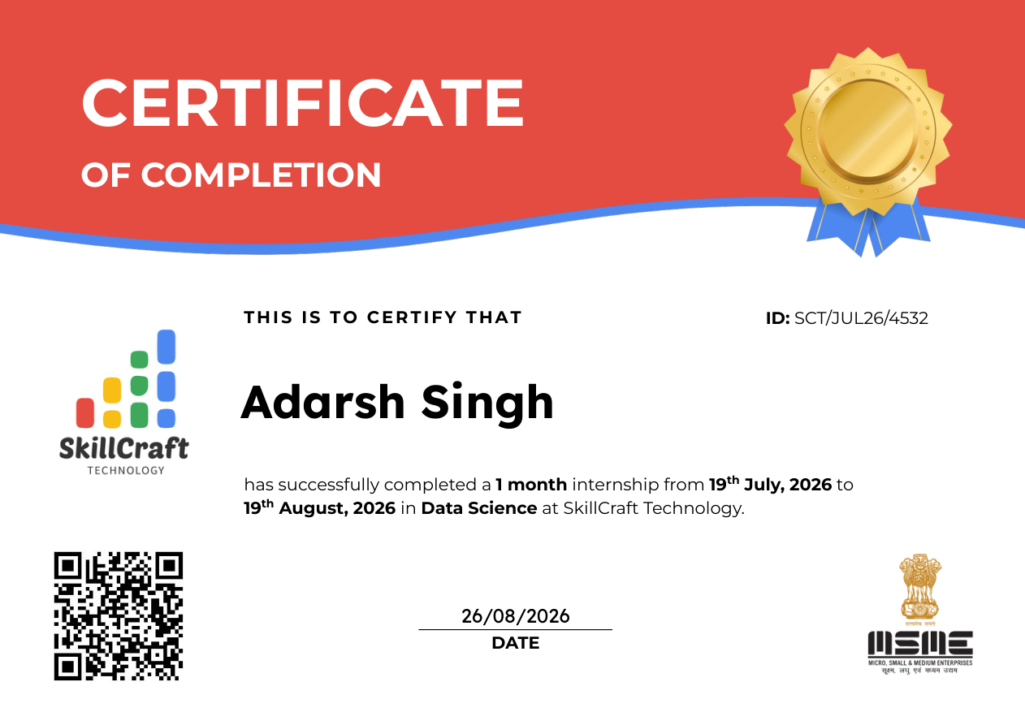

CANDIDATE'S DECLARATION
I, Adarsh Singh, hereby declare that this internship report is submitted in partial fulfilment of the requirements for the Bachelor of Technology in Computer Science and Engineering at IILM University, Greater Noida. The report documents my internship as a Data Science Intern at SkillCraft Technology from 19 July 2026 to 19 August 2026.
The factual internship particulars in this report are based on the internship offer letter and completion certificate supplied for this submission. Where the available official documents do not specify a project name, dataset, technology stack, detailed task list, or numerical project results, this report does not present such information as confirmed fact.

Name | Adarsh Singh
Roll / Enrollment Number | 25SCS1003005017
Program | B.Tech CSE
Semester | 3rd Semester
Section | 2CSE15
Place | Greater Noida
Date | 31 August 2026

ACKNOWLEDGEMENT
I would like to express my sincere gratitude to IILM University, Greater Noida, and the School of Computer Science and Engineering for providing the opportunity to undertake an internship as part of the B.Tech CSE curriculum.
I am thankful to the faculty and internship coordination team for their academic guidance and support during the internship documentation and submission process.
I also acknowledge SkillCraft Technology for providing the Data Science internship opportunity and for the internship documentation confirming my participation and successful completion.
Finally, I am grateful to my parents and friends for their encouragement and support throughout the internship period and during the preparation of this report.

EXECUTIVE SUMMARY
This report presents the internship experience of Adarsh Singh, a B.Tech Computer Science and Engineering student at IILM University, Greater Noida. The internship was undertaken with SkillCraft Technology in the role of Data Science Intern for one month, from 19 July 2026 to 19 August 2026.
The official internship offer letter and completion certificate establish the organization, role, duration and internship identification details. They do not provide a named project, dataset, detailed task list, technology stack or quantitative project outcomes. Accordingly, this report separates verified internship information from general academic discussion of the Data Science workflow.
The internship is documented as a practical, industry-oriented learning experience in Data Science. The report therefore focuses on the internship context, objectives, conceptual workflow, professional learning, skills development, limitations of the available documentation and the confirmed outcome of successful completion.

TABLE OF CONTENTS
- 1. Introduction
- 2. Internship Overview
- 3. Organization Profile
- 4. Internship Objectives
- 5. Scope of the Internship
- 6. Data Science Overview
- 7. Conceptual Data Science Workflow
- 8. Methodology
- 9. Professional Learning Experience
- 10. Skills and Knowledge Gained
- 11. Challenges and Problem-Solving Approach
- 12. Outcomes and Learning
- 13. Limitations of Available Documentation
- 14. Conclusion
- 15. References
- 16. Appendix

1. INTRODUCTION
Internships provide students with an opportunity to connect academic learning with professional environments. For a Computer Science and Engineering student, an internship can provide exposure to industry practices, structured problem solving, communication, documentation and the application of computing concepts to practical contexts.
The present internship was undertaken in the domain of Data Science at SkillCraft Technology. The official documents identify Adarsh Singh as a Data Science Intern and confirm a one-month internship period from 19 July 2026 to 19 August 2026.

1.1 Purpose of the Report
The purpose of this report is to document the internship context, objectives, learning experience and confirmed completion of the internship. It also provides an academic overview of a general Data Science workflow while clearly distinguishing conceptual material from project-specific facts that are not present in the supplied official documents.

1.2 Report Organization
The report begins with the internship overview and organization profile, followed by objectives and scope. It then introduces Data Science and presents a conceptual workflow covering data collection, cleaning, exploratory analysis, model building, evaluation and reporting. Later chapters discuss professional learning, skills, challenges, outcomes and documentation limitations.

2. INTERNSHIP OVERVIEW
Organization | SkillCraft Technology
Position | Data Science Intern
Domain | Data Science
Duration | 1 Month
Start Date | 19 July 2026
End Date | 19 August 2026
Internship ID | SCT/JUL26/4532
Student | Adarsh Singh
University | IILM University, Greater Noida

2.1 Internship Context
The internship formed part of the student's academic and professional learning journey. The official offer letter states that the internship was offered in the position of Data Science Intern and that the program was scheduled from 19 July 2026 to 19 August 2026. The completion certificate subsequently confirms successful completion of the one-month internship.

2.2 Academic Relevance
Data Science is closely related to Computer Science and Engineering because it combines computational thinking, data handling, analytical reasoning and model-oriented problem solving. Exposure to the domain can help a student understand how structured data workflows are used to derive insights and support decisions.

3. ORGANIZATION PROFILE
SkillCraft Technology is the organization identified in the internship offer letter and completion certificate. The supplied official communication identifies the internship as a Data Science internship and provides the internship identification number SCT/JUL26/4532.
The offer letter and certificate also provide the organization's website as skillcrafttech.com and identify the organization in connection with the internship. The available documents do not provide sufficient verified information about the organization's founding history, detailed service portfolio, clients, revenue, achievements or internal departments. Such details are therefore not presented as established facts in this report.

3.1 Internship Documentation
- Internship Offer Letter dated 18 July 2026.
- Internship Completion Certificate dated 26 August 2026.
- Internship ID: SCT/JUL26/4532.
- Role: Data Science Intern.
- Internship period: 19 July 2026 to 19 August 2026.

4. INTERNSHIP OBJECTIVES
The available official documents confirm the internship role and domain but do not provide a project-specific objective list. The following objectives describe the academic purpose of the internship and are intentionally framed at the general internship level.
- Gain practical exposure to the Data Science domain in an organizational environment.
- Relate academic concepts from B.Tech CSE to industry-oriented learning.
- Develop familiarity with professional communication, documentation and reporting.
- Understand the stages of a typical Data Science workflow at a conceptual level.
- Complete the internship requirements and document the experience appropriately.

4.1 Expected Learning Orientation
The internship experience is viewed as an opportunity to strengthen analytical thinking, understand professional expectations and build confidence in communicating technical concepts. Project-specific objectives cannot be verified from the supplied official documents and are therefore not claimed here.

5. SCOPE OF THE INTERNSHIP
Based on the supplied official documents, the confirmed scope of the internship is the Data Science domain over a one-month period at SkillCraft Technology. The documents do not specify a particular application, dataset, model, dashboard, deployment target or named project.

5.1 In-Scope Academic Areas
- Understanding the role and purpose of Data Science in practical environments.
- Understanding the stages of a standard data-oriented workflow.
- Connecting academic concepts with professional learning.
- Developing documentation and presentation skills.
- Reflecting on professional and technical learning gained during the internship.

5.2 Scope Boundary
Specific project features, modules, datasets, implementation details and deliverables are outside the verified scope of the available documentation. They should only be added if supported by separate internship records or guidance from the organization or college.

6. DATA SCIENCE OVERVIEW
Data Science is a multidisciplinary field concerned with extracting useful information and insights from data. A typical workflow involves defining a problem, obtaining relevant data, preparing it, exploring patterns, developing analytical or predictive approaches, evaluating results and communicating findings.

6.1 Importance of Data Science
- Supports structured analysis of data.
- Helps identify patterns, trends and relationships.
- Can support evidence-based decision making.
- Combines computational methods with analytical reasoning.
- Encourages reproducible and documented approaches to data analysis.

6.2 Data Science in an Internship Context
For an intern, exposure to Data Science can involve learning how analytical problems are framed, how data quality affects analysis, how results are interpreted and how technical work is communicated. The exact activities undertaken during this internship are not itemized in the supplied offer letter or certificate, so this section remains conceptual.

7. CONCEPTUAL DATA SCIENCE WORKFLOW
The following workflow is a general academic representation of a commonly used Data Science process. It is illustrative and should not be interpreted as a confirmed record of the exact workflow used in the internship.
1  Data  Collection | 2  Data  Cleaning | 3  Exploratory  Analysis | 4  Model  Building | 5  Evaluation | 6  Reporting

7.1 Data Collection
Relevant data is identified and obtained from appropriate sources. The quality, relevance and completeness of the data influence all subsequent stages.

7.2 Data Cleaning
Raw data may contain missing values, inconsistent formats, duplicates or other quality issues. Cleaning prepares data for meaningful analysis.

7.3 Exploratory Analysis
Exploratory analysis examines distributions, relationships, trends and unusual observations. It helps develop an understanding of the dataset before more advanced analysis.

7.4 Model Building
Where a modelling task is appropriate, a suitable analytical or machine-learning approach can be developed from the prepared data. The specific model used in this internship is not documented in the supplied materials.

7.5 Evaluation
An analytical approach should be evaluated using appropriate criteria. No project-specific performance metrics or accuracy figures are available in the supplied official documents.

7.6 Reporting
Findings, limitations and conclusions should be communicated clearly through documentation or presentations.

8. METHODOLOGY
Because the supplied offer letter and completion certificate do not document a project-specific methodology, this chapter describes a general methodology suitable for academic understanding of a Data Science internship.
- Understand the problem or analytical requirement.
- Identify and prepare relevant data.
- Inspect data quality and perform necessary cleaning.
- Conduct exploratory analysis to identify meaningful patterns.
- Select an appropriate analytical or modelling approach when required.
- Evaluate the approach using suitable criteria.
- Document observations, limitations and conclusions.
This methodology is presented as a conceptual academic framework rather than as a claim that every listed step was performed during the internship.

9. PROFESSIONAL LEARNING EXPERIENCE
The internship provided a structured opportunity to engage with the professional context of Data Science. Even where project-specific task records are unavailable, an internship of this nature supports learning around professional discipline, communication, documentation and the relationship between academic concepts and workplace expectations.

9.1 Professional Exposure
- Understanding the expectations associated with an internship role.
- Recognizing the importance of clear technical and professional communication.
- Developing awareness of structured documentation and reporting.
- Understanding the value of time management and responsible completion of assigned work.

9.2 Academic Connection
The experience complements B.Tech CSE coursework by placing Data Science within an organizational learning context. The internship documentation confirms the role and duration, while detailed project evidence would be needed to describe specific implementation activities.

10. SKILLS AND KNOWLEDGE GAINED

10.1 Professional Skills
- Professional communication and presentation.
- Documentation and report preparation.
- Time management and task organization.
- Ability to reflect on learning and communicate outcomes.

10.2 Data Science Understanding
- Awareness of the end-to-end Data Science workflow.
- Understanding the importance of data preparation and quality.
- Awareness of exploratory analysis and evaluation.
- Understanding that project results must be supported by evidence.
The official internship documents do not list a specific programming language, library, framework or software tool. Therefore, no particular technology stack is claimed as a verified internship skill in this report.

11. CHALLENGES AND PROBLEM-SOLVING APPROACH
The supplied internship documents do not record specific challenges faced during the internship. It would therefore be inappropriate to attribute particular technical problems or solutions to the internship without supporting evidence.

11.1 General Problem-Solving Principles
- Clarify the requirement before starting technical work.
- Break a complex problem into manageable stages.
- Validate inputs and intermediate results.
- Document assumptions and limitations.
- Review outcomes before presenting conclusions.

11.2 Documentation Discipline
A key lesson from preparing this report is that internship claims should be traceable to evidence. Where a project detail is unavailable, it is better to state the limitation clearly than to introduce unsupported technical or numerical claims.

12. OUTCOMES AND LEARNING
The confirmed outcome documented by the completion certificate is successful completion of the one-month Data Science internship at SkillCraft Technology from 19 July 2026 to 19 August 2026. The certificate carries Internship ID SCT/JUL26/4532.

12.1 Confirmed Outcome
- Successful completion of the internship.
- Completion certificate issued by SkillCraft Technology.
- Internship domain: Data Science.
- Internship duration: one month.

12.2 Project-Specific Results
The available official documents do not provide project-specific accuracy, performance percentages, datasets, business impact figures or other quantitative results. No such figures are fabricated or presented as confirmed outcomes in this report.

13. LIMITATIONS OF AVAILABLE DOCUMENTATION
This report is intentionally evidence-based. The available offer letter and completion certificate establish the internship identity, organization, role, dates and internship ID, but they do not provide a detailed project synopsis or technical activity log.
- No named project is specified in the available official internship documents.
- No dataset is identified.
- No confirmed technology or software stack is listed.
- No detailed day-to-day task list is provided.
- No project-specific performance metrics are provided.
- No verified project deliverables are listed.
If separate project records, mentor feedback, task sheets or GitHub evidence are available, they can be used to extend the report with verified project-specific details.

14. CONCLUSION
Adarsh Singh successfully completed a one-month Data Science internship at SkillCraft Technology from 19 July 2026 to 19 August 2026, as confirmed by the internship completion certificate and supporting offer letter.
The internship represents an opportunity to connect B.Tech CSE learning with an industry-oriented environment. The experience supports professional learning in communication, documentation, structured problem solving and understanding of Data Science as a practical field.
Because the supplied official documents do not specify a named project, dataset, technical stack or numerical project results, this report deliberately avoids unsupported claims. The resulting document presents verified internship information alongside clearly labelled conceptual Data Science material.

15. REFERENCES
- SkillCraft Technology, Internship Offer Letter issued to Adarsh Singh, dated 18 July 2026, Internship ID SCT/JUL26/4532.
- SkillCraft Technology, Internship Completion Certificate issued to Adarsh Singh, dated 26 August 2026, Internship ID SCT/JUL26/4532.
- SkillCraft Technology official website: skillcrafttech.com (as identified in the internship communication).
- CRISP-DM, Cross Industry Standard Process for Data Mining — referenced as a general conceptual framework for Data Science workflow discussion.
- IILM University, School of Computer Science and Engineering — internship reporting context provided through the student's submission requirements.

16. APPENDIX

Appendix A — Internship Completion Certificate


Appendix B — Internship Offer Letter
