HAD lab
USN: 1NT20IS400
NAME: ADARSH ED
C3 BATCH
Exercise-II
Create an Android application to demonstrate the working of Implicit Intent
activity_main.xml
<?xml version="1.0" encoding="utf-8"?>
<androidx.constraintlayout.widget.ConstraintLayout xmlns:android="http://schemas.android.com/apk/res/android"
xmlns:app="http://schemas.android.com/apk/res-auto"
xmlns:tools="http://schemas.android.com/tools"
android:layout_width="match_parent"
android:layout_height="match_parent"
tools:context=".MainActivity">
<Button
android:id="@+id/dial"
android:layout_width="wrap_content"
android:layout_height="wrap_content"
android:layout_marginBottom="280dp"
android:text="DIAL"
app:layout_constraintBottom_toBottomOf="parent"
app:layout_constraintEnd_toEndOf="parent"
app:layout_constraintHorizontal_bias="0.498"
app:layout_constraintStart_toStartOf="parent"
app:layout_constraintTop_toBottomOf="@+id/number"
app:layout_constraintVertical_bias="0.159" />
<EditText
android:id="@+id/number"
android:layout_width="wrap_content"
android:layout_height="wrap_content"
android:ems="10"
android:gravity="bottom|center"
android:inputType="phone"
android:minHeight="48dp"
android:text="____________"
app:layout_constraintBottom_toBottomOf="parent"
app:layout_constraintEnd_toEndOf="parent"
app:layout_constraintHorizontal_bias="0.497"
app:layout_constraintStart_toStartOf="parent"
app:layout_constraintTop_toTopOf="parent"
app:layout_constraintVertical_bias="0.12" />
</androidx.constraintlayout.widget.ConstraintLayout>

MainActivity.java
package com.example.implicit;
import androidx.appcompat.app.AppCompatActivity;
import android.annotation.SuppressLint;
import android.content.Intent;
import android.net.Uri;
import android.os.Bundle;
import android.view.View;
import android.widget.Button;
import android.widget.EditText;
public class MainActivity extends AppCompatActivity {
@Override
protected void onCreate(Bundle savedInstanceState) {
super.onCreate(savedInstanceState);
setContentView(R.layout.activity_main);
EditText t1 = findViewById(R.id.number);
Button call = findViewById(R.id.dial);
call.setOnClickListener(new View.OnClickListener() {
@Override
public void onClick(View view) {
String num = t1.getText().toString();
Intent it = new Intent(Intent.ACTION_DIAL);
it.setData(Uri.parse("tel:"+num));
startActivity(it);
}
});
}
}

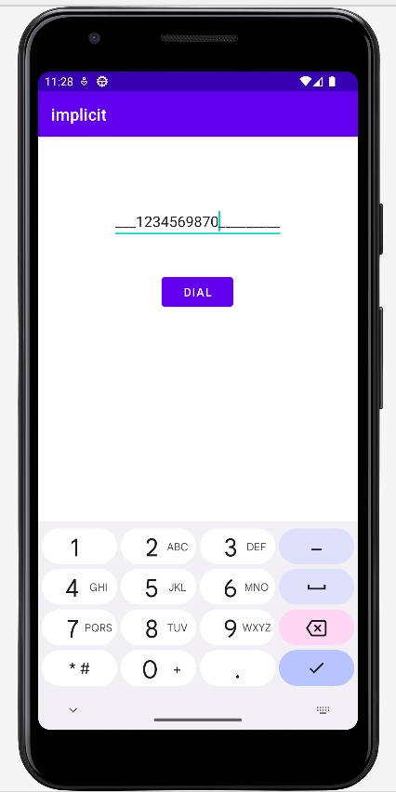
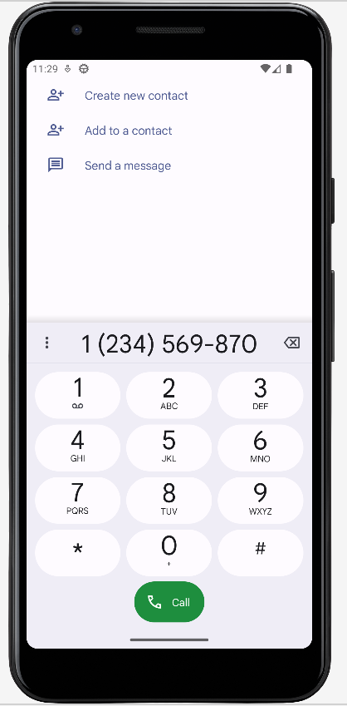

(a) Implicit Intent Front Activity (b) Implicit Intent Second Activity

Exercise-I
Create an Android application to demonstrate the working of Explicit Intent
activity_main.xml
<?xml version="1.0" encoding="utf-8"?>
<LinearLayout xmlns:android="http://schemas.android.com/apk/res/android"
xmlns:app="http://schemas.android.com/apk/res-auto"
xmlns:tools="http://schemas.android.com/tools"
android:layout_width="match_parent"
android:layout_height="match_parent"
android:background="#039BE5"
android:orientation="vertical"
tools:context=".MainActivity">
<TextView
android:layout_width="match_parent"
android:layout_height="wrap_content"
android:layout_marginTop="15dp"
android:layout_marginBottom="15dp"
android:fontFamily="serif"
android:gravity="center"
android:text="EXPLICIT"
android:textColor="@color/white"
android:textSize="50dp"
android:textStyle="bold" />
<EditText
android:id="@+id/text"
android:layout_width="match_parent"
android:layout_height="wrap_content"
android:layout_marginLeft="20dp"
android:layout_marginTop="200dp"
android:layout_marginRight="20dp"
android:background="@color/white"
android:gravity="center"
android:hint="enter your name here"
android:textColor="@color/black"
android:textSize="45dp"
android:textStyle="normal" />
<Button
android:id="@+id/button"
android:layout_width="match_parent"
android:layout_height="wrap_content"
android:layout_margin="35dp"
android:text="CLICK"
android:textStyle="bold"
android:textSize="30dp" />
</LinearLayout>

MainActivity.java
package com.example.intent;
import androidx.appcompat.app.AppCompatActivity;
import android.content.Intent;
import android.os.Bundle;
import android.view.View;
import android.widget.Button;
import android.widget.EditText;
public class MainActivity extends AppCompatActivity {
EditText text;
Button button;
@Override
protected void onCreate(Bundle savedInstanceState) {
super.onCreate(savedInstanceState);
setContentView(R.layout.activity_main);
text=findViewById(R.id.text);
button=findViewById(R.id.button);
button.setOnClickListener(new View.OnClickListener() {
@Override
public void onClick(View view) {
Intent it=new Intent(MainActivity.this,secActivity2.class);
Bundle b=new Bundle();
b.putString("text",text.getText().toString());
it.putExtras(b);
startActivity(it);
}
});
}
}

activity_sec2.xml
<?xml version="1.0" encoding="utf-8"?>
<LinearLayout xmlns:android="http://schemas.android.com/apk/res/android"
xmlns:app="http://schemas.android.com/apk/res-auto"
xmlns:tools="http://schemas.android.com/tools"
android:layout_width="match_parent"
android:layout_height="match_parent"
android:background="#039BE5"
tools:context=".secActivity2">
<TextView
android:layout_width="match_parent"
android:layout_height="match_parent"
android:id="@+id/mytext"
android:gravity="center"
android:text="NAME"
android:fontFamily="serif-monospace"
android:textSize="50dp"
android:textStyle="bold"
android:textAlignment="center"
android:textColor="@color/white"
/>
</LinearLayout>

secActivity2.java
package com.example.intent;
import androidx.appcompat.app.AppCompatActivity;
import android.os.Bundle;
import android.widget.TextView;
public class secActivity2 extends AppCompatActivity {
TextView t;
String nameFromFirst="";
@Override
protected void onCreate(Bundle savedInstanceState) {
super.onCreate(savedInstanceState);
setContentView(R.layout.activity_sec2);
t=findViewById(R.id.mytext);
nameFromFirst=getIntent().getStringExtra("text");
t.setText(nameFromFirst);
}
}

