Flutter UI:Scaffold & safeArea

USN: 1NT20IS400
NAME: ADARSH ED
C3 BATCH

Without safe area – Main.dart
import 'package:flutter/cupertino.dart';
import 'package:flutter/material.dart';
void main() {
runApp(MaterialApp(
home: Text('Without SafeArea-sooraj',
textAlign: TextAlign.center,
style: TextStyle(
fontSize: 40.0,
fontWeight: FontWeight.w800,
color: Colors.deepOrangeAccent,
),
)
));
}
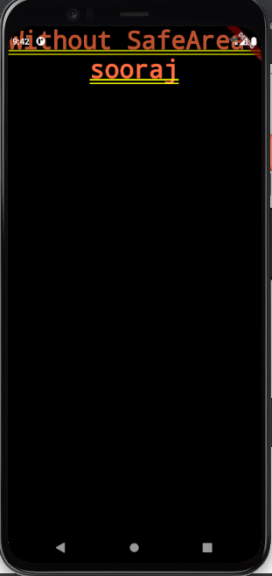

WithsafeArea- Main.dart

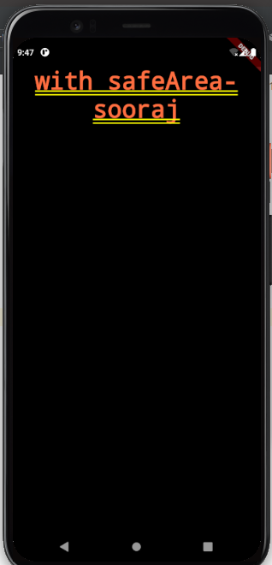
import 'package:flutter/cupertino.dart';
import 'package:flutter/material.dart';
void main() {
runApp(MaterialApp(
home: SafeArea(child:Text('with safeArea-sooraj',
textAlign: TextAlign.center,
style: TextStyle(
fontSize: 40.0,
fontWeight: FontWeight.w800,
color: Colors.deepOrangeAccent,
),
),
)
));
}

Scaffold-Area

import 'package:flutter/cupertino.dart';
import 'package:flutter/material.dart';
void main() {
runApp(MaterialApp(
home: Scaffold(
appBar: AppBar(
title: Text('Scaffold-safeArea'
),
),
body: Container(
child: Center(
child:Text(
'Hai im sooraj'
),
),
),
)
));
}

