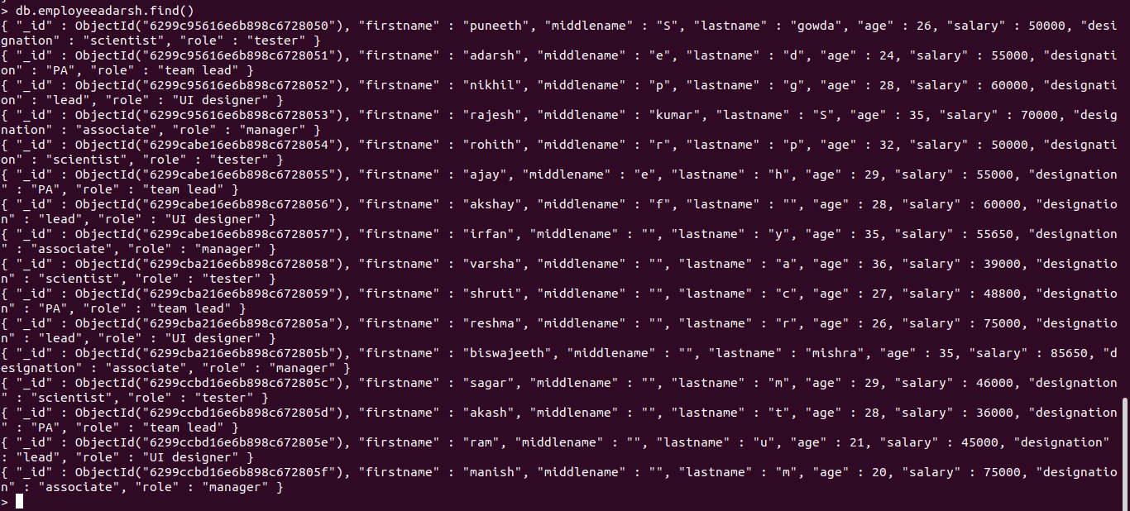
NAME: ADARSH ED
USN: 1NT20IS400
BATCH: C3

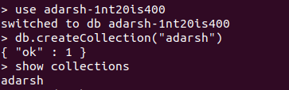
DATABASE CREATION:

OUERIES:

1. Populate the database with atleast 15 documents:
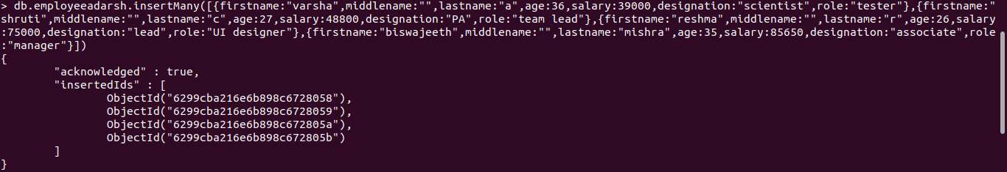

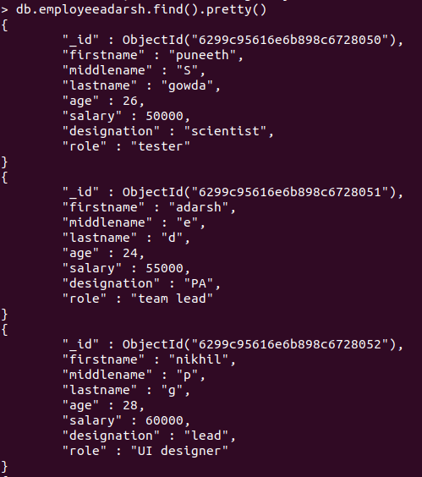
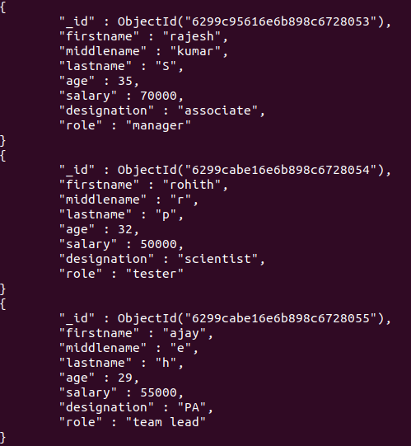

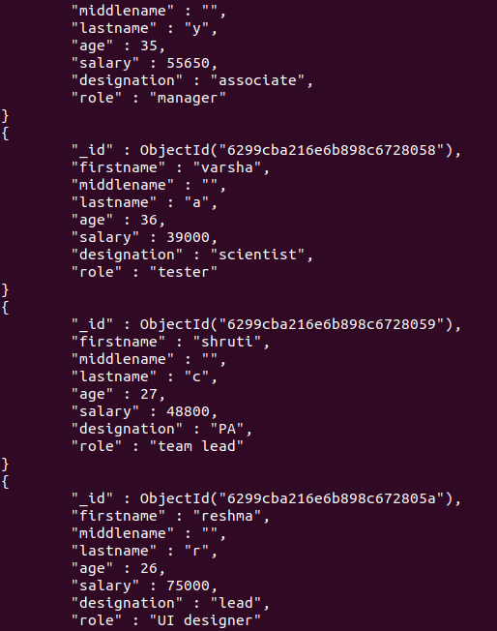

2. List all the records having salary in the range of 20000 – 35000(Exclusive):

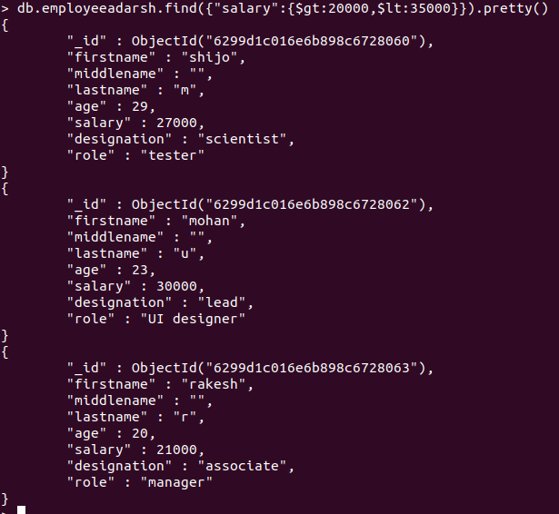
3. List all the Employee whose Middle name is "kumar":

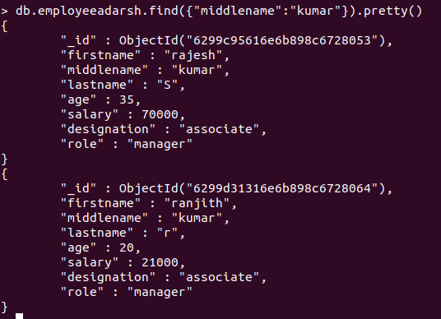

4. Count the number of Employees who has a role "Manager" in the Role field:

5. Find out all the documents who have age < 35 and salary in the range of 30000- 35000:

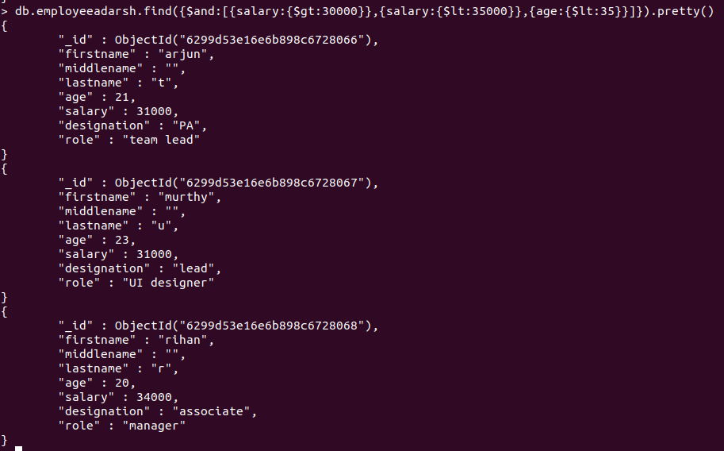

6. Delete an Employee whose "Firstname" is "Rajesh" and having the designation as "Scientist”:

7. Update all the Employees whose role is "Team Lead" with a salary of 55650 INR:

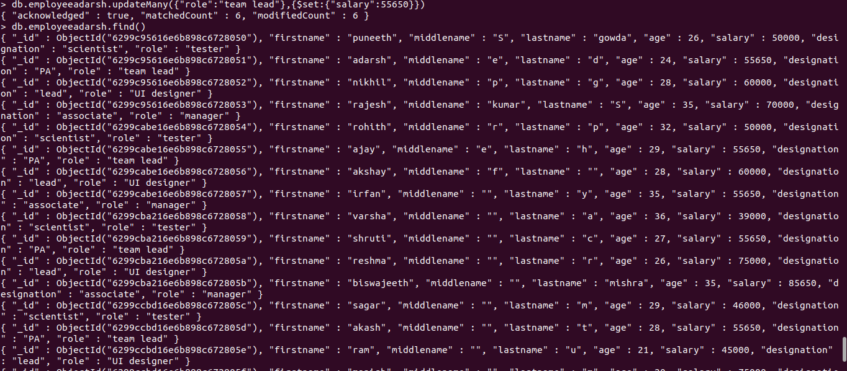
8. Group all the Employees by their age(common age should be there) and calculate the average salary obtained in the each group:

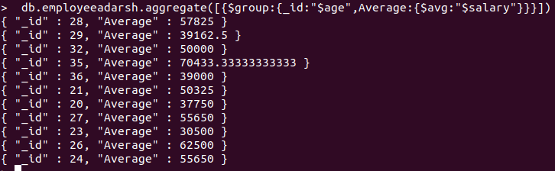
9. Apply the map-reduce to perform the above operation and obtain the results:

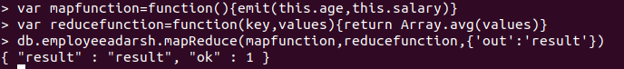
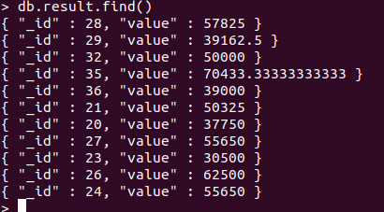

HADOOP
EXPERIMENT 1

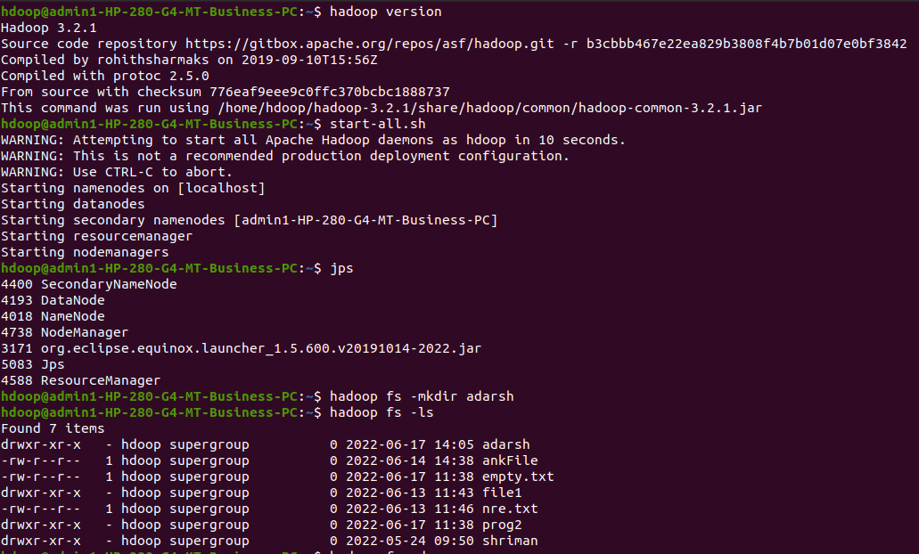
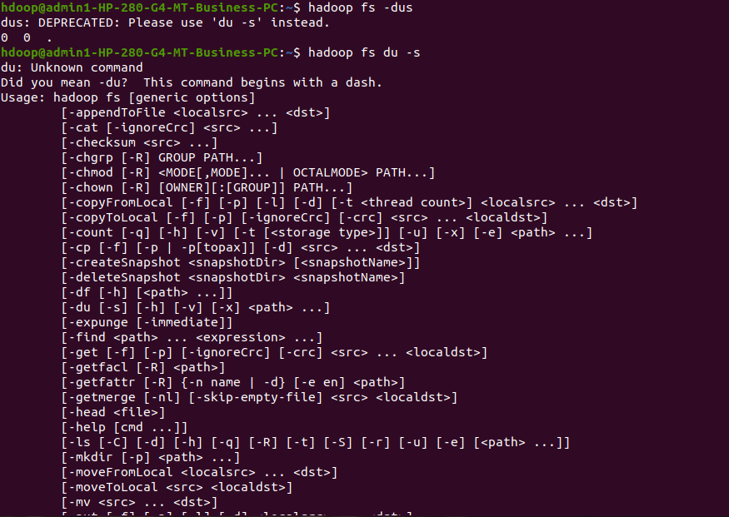
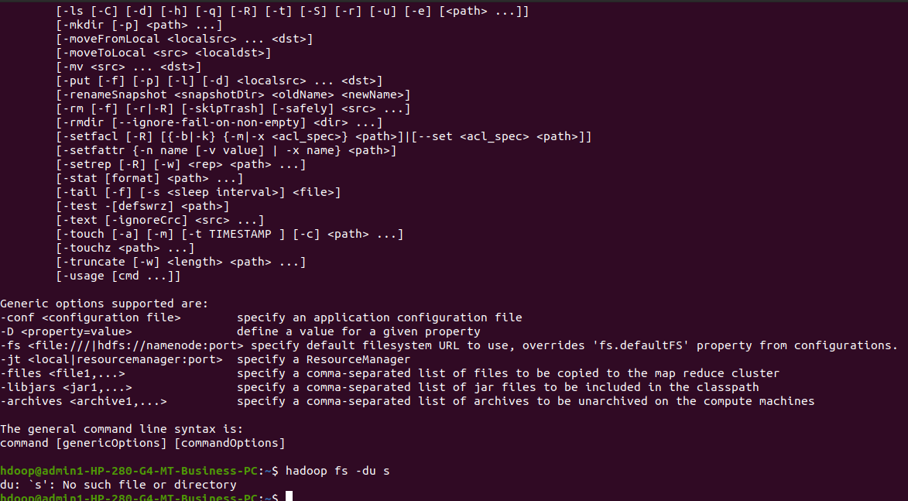

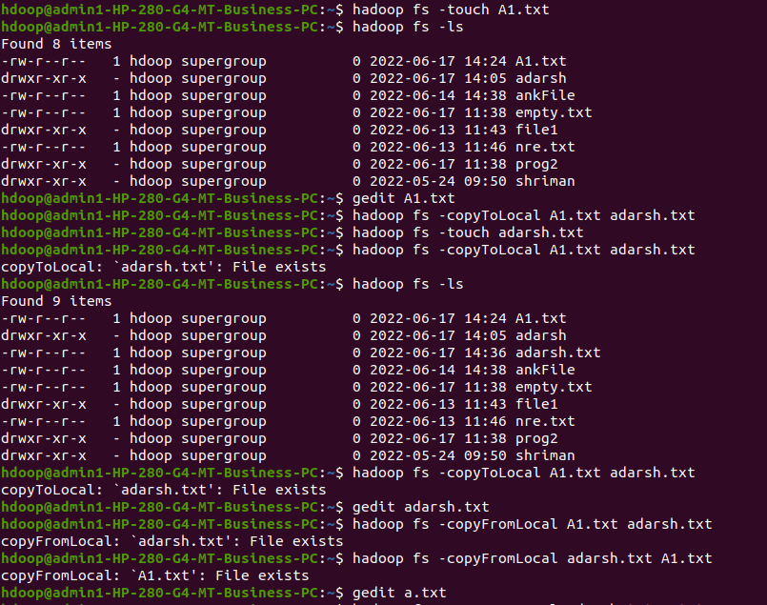

EXPERIMENT 2

