**A 2D array that represents the colums and rows**

Airplane seats can be of various format (i.e the way seats are in)

**In first line of Input** :describes the seats are in

eg:(3,2)(4,3)(2,3)(3,4) c-column,r-row

3-c,2-r followed by other inputas shown below it will be constructed

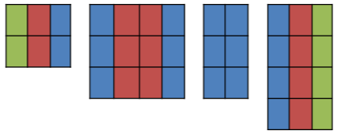

**Second line of Input**:number of passengers waiting a queue