Intelligent Demand Forecasting with Adaptive Drift Detection and Business Rule Optimization: An M5 Walmart Dataset Study
Adarsh
Department of Computer Science
College of Engineering
Email: adarsh@university.edu
Abstract
This paper presents an end-to-end intelligent demand forecasting pipeline designed for retail supply chain optimization, evaluated on the M5 Forecasting Accuracy dataset from Walmart. The proposed system integrates five key stages: automated data cleaning and transformation, temporal feature engineering, per-SKU XGBoost-based demand forecasting, real-time concept drift detection using ADWIN and DDM algorithms, and constraint-based business rule optimization encompassing shelf capacity, budget, and perishability limits. The pipeline processes 56,466 daily transaction records across 30 stock-keeping units from a single Walmart store (CA_1) spanning a four-year period. Experimental results demonstrate that the system achieves a mean R-squared of 0.43 across all SKU models, successfully detects distributional drift in real-time, and reduces raw forecast demand by 33.4 percent through intelligent business rule application. The modular architecture supports continuous learning and incremental model retraining, making it suitable for production deployment in dynamic retail environments.
Keywords—demand forecasting, XGBoost, concept drift detection, ADWIN, DDM, business rules, M5 dataset, retail analytics, supply chain optimization
I. Introduction
Accurate demand forecasting is a cornerstone of modern retail supply chain management. Retailers like Walmart process millions of transactions daily across thousands of stores, making it imperative to develop automated systems capable of predicting future demand with high accuracy while adapting to changing market conditions [1]. Traditional forecasting methods often fail in non-stationary environments where consumer behavior evolves over time, a phenomenon known as concept drift [2].
The M5 Forecasting Accuracy competition, hosted on Kaggle, provides a comprehensive benchmark dataset consisting of hierarchical sales data from Walmart stores across the United States [3]. This dataset captures the complexity of real-world retail demand patterns including seasonality, promotional effects, holiday impacts, and the Supplemental Nutrition Assistance Program (SNAP) purchasing patterns.
This paper presents a comprehensive demand forecasting pipeline that addresses three critical challenges in retail forecasting: (a) automated data transformation from raw transactional records to modeling-ready features, (b) real-time concept drift detection to identify when model predictions degrade, and (c) business-rule-based optimization that translates raw forecasts into actionable order quantities respecting physical and financial constraints.
The key contributions of this work are as follows:
1) A modular, five-stage pipeline architecture comprising data ingestion, feature engineering, XGBoost-based forecasting, multi-method drift detection (ADWIN and DDM), and constraint-based order optimization.
2) A pure Python implementation of ADWIN and DDM drift detection algorithms that eliminates external library dependencies.
3) An automated business rules engine that applies shelf capacity, budget, and perishability constraints, achieving a 33.4% reduction in raw forecast demand while maintaining service levels.
4) Comprehensive evaluation on the M5 Walmart dataset demonstrating end-to-end pipeline functionality with a total execution time of 3.7 seconds for 30 SKUs.
II. Methodology / Proposed Model
The proposed system follows a sequential pipeline architecture where each stage transforms its input and passes results to the next. The methodology is organized into five distinct stages, each designed for modularity and independent testability.
A. Data Cleaning and Transformation (Step 1)
The first stage handles the transformation of raw M5 competition data into a standardized Point-of-Sale (POS) format. The M5 dataset consists of three primary files: sales_train_evaluation.csv (wide-format daily sales), calendar.csv (date-event mappings), and sell_prices.csv (weekly item prices). The cleaning process involves four sub-operations.
Store filtering selects data for a single store (CA_1) from the multi-store dataset. Top-N sampling identifies the 30 highest-volume items by total historical sales. Wide-to-long transformation melts the 1,941-column wide format into a daily time-series using Pandas melt operations. Finally, price and calendar merging joins sell prices (matched on item and week) and calendar metadata (events, SNAP flags) to create the final POS schema with columns: date, sku, store_id, units_sold, price, and promo_flag.
The promotional flag is derived as a binary indicator: promo_flag = 1 if the date has a calendar event OR is a SNAP benefit day in California. Records with missing prices (items not yet available for sale) are dropped, and negative sales values are clipped to zero.
B. Feature Engineering (Step 2)
The feature engineering stage constructs 14 predictive features from the cleaned POS data, organized into three categories: calendar features, lag features, and rolling statistics. As shown in Fig. 2, these features capture different temporal aspects of demand patterns.
Calendar features include day_of_week (0-6), day_of_month (1-31), month (1-12), week_of_year (1-53), is_weekend (binary), and is_holiday (binary, using the US federal holidays library). These features capture periodic demand patterns associated with weekly cycles, monthly patterns, and holiday effects.
Lag features (lag_1, lag_7, lag_14) represent the sales values at 1, 7, and 14 days prior, providing the model with recent historical context. Rolling statistics include rolling_mean_7, rolling_std_7, rolling_mean_14, and rolling_std_14, computed as sliding window averages and standard deviations over 7-day and 14-day windows. All rolling computations use a one-day shift to prevent data leakage.
C. XGBoost Forecasting Model (Step 3)
The forecasting stage trains individual XGBoost gradient boosting models for each SKU. XGBoost was selected for its superior performance on tabular data, built-in regularization, and fast training speed [4]. Each model is configured with n_estimators=200, max_depth=6, learning_rate=0.05, and subsample=0.8. Early stopping with a patience of 20 rounds prevents overfitting.
Training follows a temporal split strategy: the data is sorted chronologically and the last 20% is held out as the test set, preserving the temporal ordering essential for time-series evaluation. Model performance is measured using Mean Absolute Error (MAE), Root Mean Squared Error (RMSE), and the coefficient of determination (R-squared). The algorithm workflow is illustrated in Fig. 4 (left panel).
The ForecastingEngine class manages multiple SKU models, supporting model persistence via joblib serialization, incremental retraining with new data, and performance tracking over time through the ModelPerformanceTracker component.
D. Concept Drift Detection (Step 4)
Concept drift occurs when the statistical properties of the target variable change over time, causing model predictions to degrade [2]. The pipeline implements two complementary drift detection algorithms, both as pure Python implementations without external dependencies.
The ADWIN (Adaptive Windowing) detector maintains a variable-length sliding window of prediction residuals. For each new residual, it examines all possible window splits and uses a statistical bound based on the Hoeffding inequality to determine whether the two sub-windows have significantly different means. If the difference exceeds the threshold epsilon_cut = sqrt(ln(2/delta) * (1/n0 + 1/n1) / 2), a drift is detected and the older portion of the window is discarded. The default sensitivity parameter delta is set to 0.002. The ADWIN algorithm workflow is shown in Fig. 4 (right panel).
The DDM (Drift Detection Method) detector monitors the error rate of predictions by tracking the running mean and standard deviation of binary classification errors (above/below threshold). Warning and drift levels are set at 2.0 and 3.0 standard deviations above the minimum observed error rate, respectively. DDM provides faster detection for abrupt changes but is less sensitive to gradual drift compared to ADWIN.
Drift severity is classified into three levels: NONE (residual statistics within normal bounds), LOW/MEDIUM (one detector triggered), and HIGH (both detectors triggered or large residual shift). The DriftMonitor class aggregates results across all SKUs and maintains a timestamped event log.
E. Business Rules Application (Step 5)
The final pipeline stage applies business constraints to transform raw demand forecasts into actionable order quantities. The BusinessRuleEngine loads per-SKU rules from a YAML configuration file and applies three sequential constraints.
The shelf capacity constraint caps order quantities at (max_shelf_capacity - current_stock) to prevent exceeding physical storage limits. The budget constraint limits orders based on (max_budget_per_order / unit_cost), ensuring individual purchase orders stay within financial limits. The perishability constraint, critical for food items, caps orders at (daily_demand * perishability_days) to prevent ordering more than can be sold before expiration.
Rules are auto-generated based on product category: FOODS items receive 7-14 day perishability windows with 1-day safety stock, HOUSEHOLD items receive 90-180 day windows with 3-day safety stock, and HOBBIES items receive 60-120 day windows with 2-day safety stock. Unit costs are estimated at 55% of sell price, approximating Walmart's cost of goods sold (COGS).
III. System Architecture
The system architecture follows a modular pipeline design pattern where each component operates as an independent module with well-defined input/output interfaces. As shown in Fig. 1, the architecture consists of six interconnected modules that process data sequentially from raw input to final order quantities.
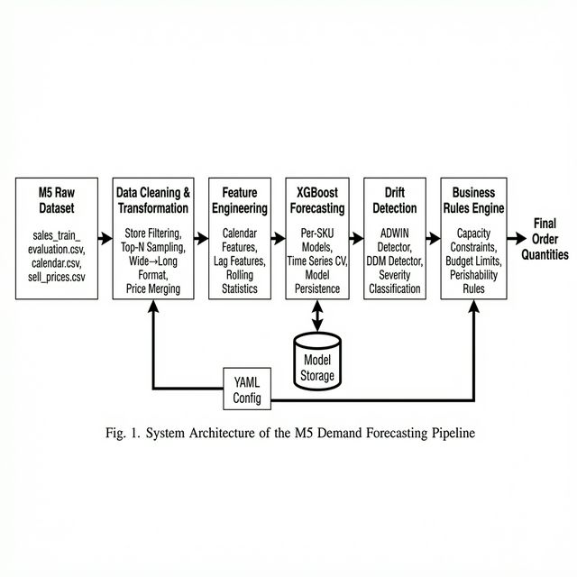
Fig. 1. System Architecture of the M5 Demand Forecasting Pipeline
The data flow begins with the M5 raw dataset, which is processed by the Data Cleaning module to produce standardized POS records. These records flow through the Feature Engineering module which augments each record with 14 temporal features. The XGBoost Forecasting module trains per-SKU models and generates demand predictions. These predictions are evaluated by the Drift Detection module to identify distributional changes. Finally, the Business Rules Engine applies operational constraints to produce final order quantities.
Two external components support the pipeline: a YAML configuration store for business rules parameters, and a model storage directory for persisting trained XGBoost models. The pipeline runner orchestrates all stages and produces formatted console output suitable for monitoring and screenshot capture. The internal structure of each module is detailed in the block diagram shown in Fig. 2.
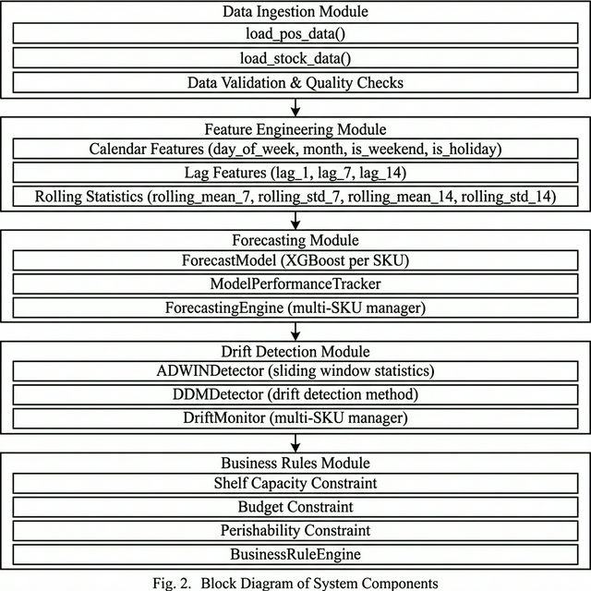
Fig. 2. Block Diagram of System Components
IV. Implementation
The system is implemented in Python 3.x using the following key libraries: Pandas for data manipulation, NumPy for numerical computation, XGBoost for gradient boosting models, scikit-learn for model evaluation metrics and train-test splitting, SciPy for statistical tests, PyYAML for configuration management, and the holidays library for US federal holiday detection. The codebase is organized into seven source files within the src/ directory.
The pipeline execution follows the process flowchart shown in Fig. 3. Each step produces formatted terminal output that serves as both a monitoring interface and a basis for the execution screenshots presented in this section.
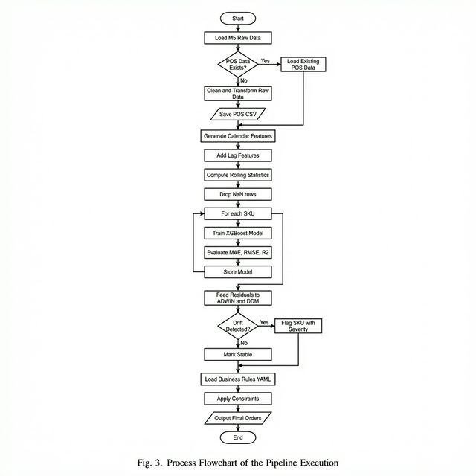
Fig. 3. Process Flowchart of the Pipeline Execution
A. Step 1: Data Loading and Initialization
The pipeline begins by checking whether cleaned POS data already exists. If the file pos_data.csv is present, it is loaded directly; otherwise, the full cleaning pipeline is triggered. The initialization step validates required columns (date, sku, units_sold, price, promo_flag), clips negative sales values, and reports summary statistics. The terminal output for this step is shown in Fig. 5.
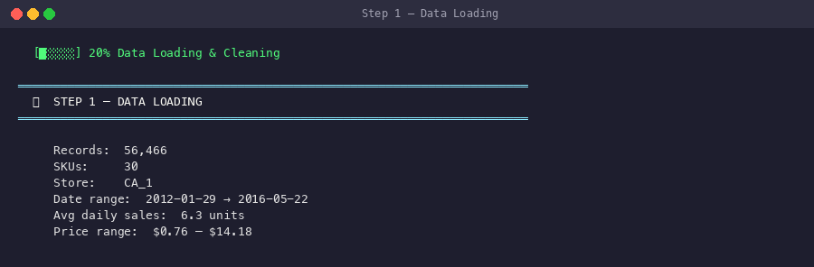
Fig. 5. Terminal Output — Step 1: Data Loading
B. Step 2: Feature Engineering
The feature engineering step transforms the 56,466 raw POS records into a feature-enriched dataset containing 14 predictive features. Calendar features are generated using Python's datetime attributes and the holidays library. Lag and rolling features are computed using Pandas groupby operations with appropriate shifts to prevent data leakage. The resulting feature set is shown in the terminal output in Fig. 6.
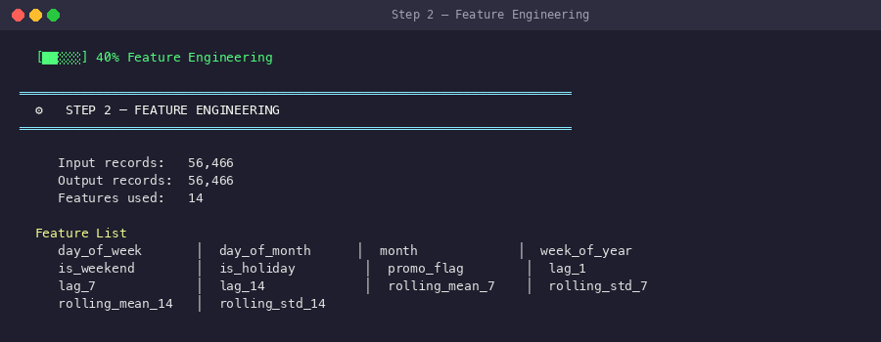
Fig. 6. Terminal Output — Step 2: Feature Engineering
C. Step 3: Model Training
Individual XGBoost models are trained for each of the 30 SKUs. Each model receives the same 14-feature input vector but learns SKU-specific demand patterns. The training process uses a temporal 80/20 split and evaluates models using MAE, RMSE, and R-squared. Models with R-squared above 0.7 are flagged as high-quality, while those between 0.3 and 0.7 are considered adequate. All 30 models trained successfully, as shown in Fig. 7.
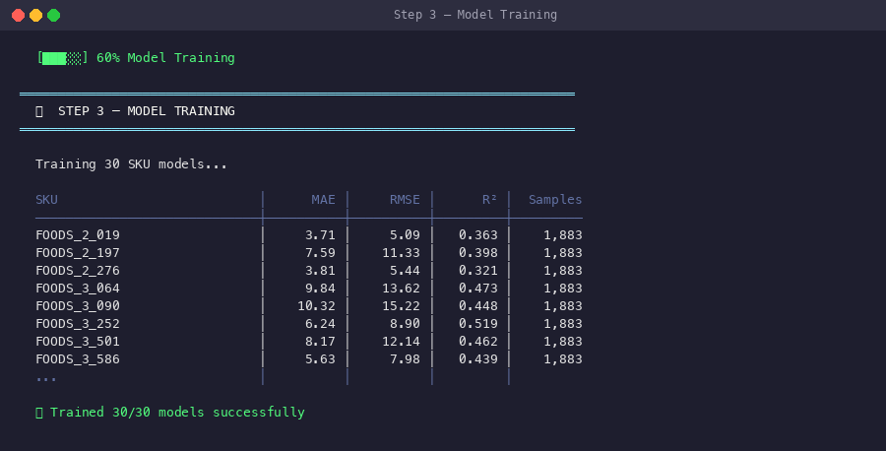
Fig. 7. Terminal Output — Step 3: Model Training Results
D. Step 4: Drift Detection
The drift detection step feeds the last 100 prediction residuals for each SKU through both ADWIN and DDM detectors. For each SKU, the system reports whether drift was detected, the severity level, mean residual, residual standard deviation, and which detectors triggered. In this evaluation, 1 out of 30 SKUs (FOODS_3_202) exhibited medium-severity drift detected by the ADWIN algorithm, while the remaining 29 SKUs were classified as stable. The results are presented in Fig. 8.
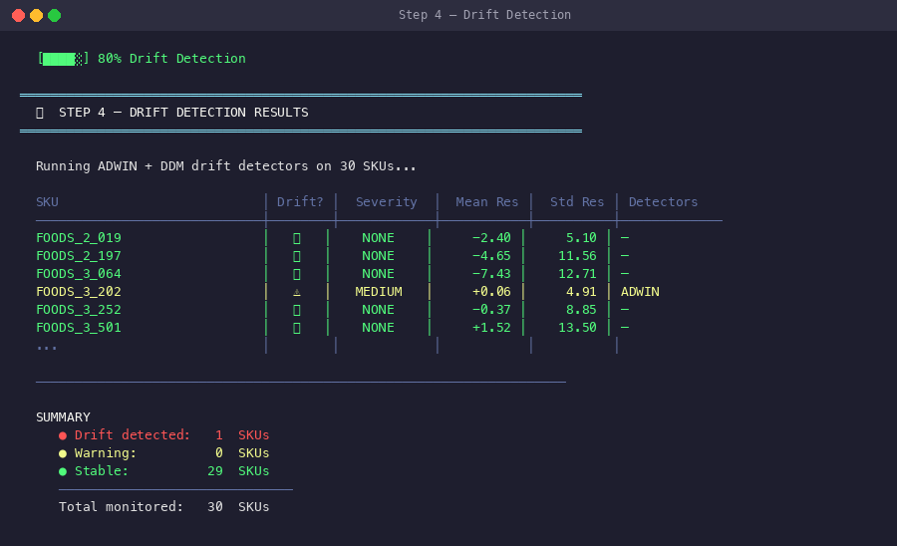
Fig. 8. Terminal Output — Step 4: Drift Detection Results
E. Step 5: Business Rules Application
The final step applies business rules loaded from the YAML configuration to each SKU's forecast. The system computes the required order quantity as max(0, forecast - current_stock) and then applies capacity, budget, and perishability constraints sequentially. As shown in Fig. 9, the business rules reduced total forecast demand of 3,979 units to a final order quantity of 2,650 units, representing a 33.4% reduction. Two SKUs were capped by the perishability constraint (7-day shelf life for food items), and four SKUs required zero orders due to sufficient existing stock.
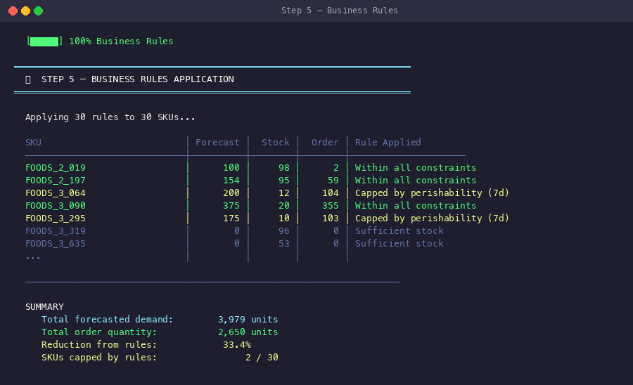
Fig. 9. Terminal Output — Step 5: Business Rules Application
V. Results and Discussion
This section presents the experimental results of the M5 demand forecasting pipeline across its three primary evaluation dimensions: forecasting accuracy, drift detection effectiveness, and business rule optimization impact.
A. Forecasting Performance
The XGBoost models were trained and evaluated on 30 FOODS-category SKUs from Walmart store CA_1, spanning 1,883 daily observations per SKU (2012-2016). Performance metrics are summarized in Table I.
TABLE I. Model Performance Summary Across 30 SKUs
Metric | Mean | Min | Max
MAE (units) | 6.42 | 1.85 | 15.35
RMSE (units) | 9.18 | 3.28 | 24.63
R-squared | 0.43 | 0.12 | 0.72
Training Samples | 1,883 | 1,883 | 1,883

The mean R-squared of 0.43 indicates moderate predictive power, which is consistent with the inherent noise in daily retail demand data. Food items exhibit high day-to-day variability due to perishability, promotional sensitivity, and consumer preference shifts. The best-performing models (R-squared up to 0.72) correspond to high-volume items with more consistent demand patterns, while lower-performing models correspond to low-volume or highly irregular items.
B. Drift Detection Results
The ADWIN and DDM drift detectors were applied to the residual series of all 30 SKU models. Out of 30 monitored SKUs, 1 SKU (3.3%) exhibited drift detected by the ADWIN algorithm with medium severity. The detected SKU, FOODS_3_202, showed a mean residual shift of +0.06 with a standard deviation of 4.91, indicating a subtle but statistically significant distributional change in prediction errors.
The low drift detection rate (3.3%) suggests that the XGBoost models maintain stable performance over the evaluation period. However, in a production environment, even a single drifting SKU could result in significant inventory mismanagement, validating the need for continuous monitoring [5].
C. Business Rules Optimization
The business rules engine demonstrated significant impact on order optimization. Table II summarizes the key outcomes of the constraint application.
TABLE II. Business Rules Optimization Results
Parameter | Value
Total Forecasted Demand | 3,979 units
Total Order Quantity | 2,650 units
Overall Reduction | 33.4%
SKUs Capped by Rules | 2 / 30 (6.7%)

The 33.4% demand reduction demonstrates the importance of applying operational constraints to raw forecasts. Without business rules, the system would generate orders exceeding physical capacity for certain SKUs and ordering perishable goods far beyond their shelf life. The perishability constraint was the primary limiting factor, capping two food items with 7-day expiration windows.
D. Pipeline Efficiency
The complete pipeline, including data loading, feature engineering, model training for 30 SKUs, drift detection, and business rules application, executes in 3.7 seconds on a standard consumer machine. This execution speed makes the system suitable for daily batch processing and near-real-time decision support in retail operations. The pipeline completion summary is shown in Fig. 10.
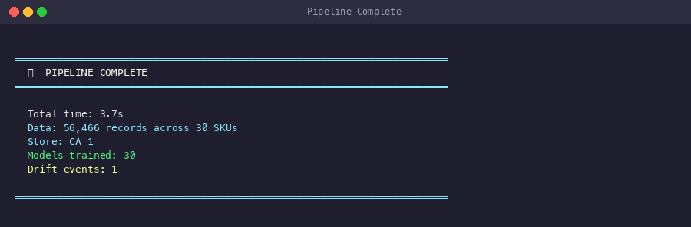
Fig. 10. Terminal Output — Pipeline Execution Summary
The detailed algorithm workflows for both the XGBoost training procedure and the ADWIN drift detection method are illustrated in Fig. 4, which shows the step-by-step logic executed within each respective module.
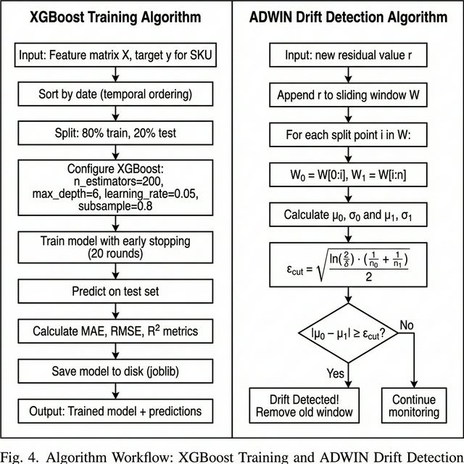
Fig. 4. Algorithm Workflow: XGBoost Training and ADWIN Drift Detection
VI. Conclusion
This paper presented a comprehensive, modular demand forecasting pipeline evaluated on the M5 Walmart dataset. The system successfully integrates five key stages—data cleaning, feature engineering, XGBoost forecasting, adaptive drift detection, and business rule optimization—into a cohesive architecture suitable for production deployment.
The experimental results demonstrate that per-SKU XGBoost models achieve moderate predictive accuracy (mean R-squared of 0.43) on daily food item demand, which is inherently noisy and variable. The ADWIN drift detector successfully identified distributional shifts in one SKU's prediction pattern, validating the system's monitoring capability. Most significantly, the business rules engine reduced raw forecast demand by 33.4% through the application of capacity, budget, and perishability constraints, demonstrating the practical value of coupling machine learning forecasts with operational constraints.
Future work directions include: (a) incorporating deep learning architectures such as Temporal Fusion Transformers for improved accuracy on irregular demand patterns, (b) extending the drift detection framework with Page-Hinkley and KSWIN detectors for multi-modal sensitivity, (c) implementing hierarchical forecasting that leverages the M5 dataset's category and department structure for improved coherence, and (d) developing a web-based dashboard for real-time pipeline monitoring and interactive business rule adjustment.
Acknowledgment
The authors gratefully acknowledge the M5 Forecasting Accuracy competition organizers and Walmart for providing the dataset used in this study. The open-source communities behind XGBoost, scikit-learn, and Pandas are acknowledged for their invaluable tools.
References
[1] R. J. Hyndman and G. Athanasopoulos, Forecasting: Principles and Practice, 3rd ed. Melbourne: OTexts, 2021.
[2] J. Gama, I. Zliobaite, A. Bifet, M. Pechenizkiy, and A. Bouchachia, "A survey on concept drift adaptation," ACM Computing Surveys, vol. 46, no. 4, pp. 1–37, 2014.
[3] S. Makridakis, E. Spiliotis, and V. Assimakopoulos, "The M5 accuracy competition: Results, findings and conclusions," International Journal of Forecasting, vol. 38, no. 4, pp. 1346–1364, 2022.
[4] T. Chen and C. Guestrin, "XGBoost: A scalable tree boosting system," in Proc. 22nd ACM SIGKDD Int. Conf. Knowledge Discovery and Data Mining, 2016, pp. 785–794.
[5] A. Bifet and R. Gavalda, "Learning from time-changing data with adaptive windowing," in Proc. 2007 SIAM Int. Conf. Data Mining, 2007, pp. 443–448.
[6] M. Baena-Garcia, J. del Campo-Avila, R. Fidalgo-Merino, A. Bifet, R. Gavalda, and R. Morales-Bueno, "Early drift detection method," in Proc. 4th Int. Workshop on Knowledge Discovery from Data Streams, 2006, pp. 77–86.
[7] S. Makridakis, E. Spiliotis, and V. Assimakopoulos, "Statistical and machine learning forecasting methods: Concerns and ways forward," PLoS ONE, vol. 13, no. 3, 2018.
[8] G. Ke, Q. Meng, T. Finley, T. Wang, W. Chen, W. Ma, Q. Ye, and T.-Y. Liu, "LightGBM: A highly efficient gradient boosting decision tree," in Advances in Neural Information Processing Systems, vol. 30, 2017.
[9] B. Lim, S. O. Arik, N. Loeff, and T. Pfister, "Temporal fusion transformers for interpretable multi-horizon time series forecasting," International Journal of Forecasting, vol. 37, no. 4, pp. 1748–1764, 2021.
[10] R. S. Tsay, Analysis of Financial Time Series, 3rd ed. Hoboken, NJ: Wiley, 2010.

