**Azure Infrastructure as a Service**

**Hands-On-Lab**

What we will be covering in this HOL:

* Setting up the Environment
* Provisioning the VM (using portal, powershell)
* Management of VM using Chef

**Setting up the right Environment:**

Step1: Create a Virtual Network

Step 2: Setup your Storage Account

Step 3: Setup you VM :

Step 4: Attach new disks to your VMs

Step 5: Connect to VM

Step1: Create a Virtual Network

1. Login to the manage.windowsazure.com

(Creating VNETs is not yet available on portal.azure.com)

1. Create a Virtual Network:
   1. Click on New->Network Services-> Quick Create
   2. Fill in details of your Network (Name, Address Space, Location)

Step 2: Setup your Storage Account

1. Login to portal.azure.com
2. Click on New-> Everything-> Storage, cache, +backup -> Storage-> Create
3. Enter details of Name, Pricing Tier, Resource Group (you may wish to create a new one to logically group all your resources in this group), Location

Step 3: Setup your VM:

1. Login to portal.azure.com
2. Click on New->Windows Server 2012 R2 DataCenter (or any other image)
3. In the ‘Create VM’ option that opens:
   1. Enter Hostname, UserAdmin, Password
   2. Select Pricing Tier (A2 Standard)
   3. Select Optional Configuration:
      1. Go to network and select above created network
      2. Go to Storage Account and select above created Storage Account
      3. Click on OK
   4. Once in the Create VM pane, go to Resource Group and select the above created Resource Group
   5. Select Location
   6. Click on Create

(Your VM will take about 5-10 mins to create)

Step 4: Attach new disks to your VMs

1. Once your VM is created, look into the Startup Pane of your portal, you will see your created VM
2. Click on VM-> All settings-> Disks
3. You should see your OS Disk. Click on Attach New on the top pane
4. In the Storage Account, choose previously created account
5. In the Storage Container, choose vhds container
6. Provide a name, size of 6GB and click on OK to add disk

Step 5: Connect to VM

1. Click on Connect at the top of the screen
2. Click on the downloaded RDP file, enter username, password and login
3. Initialize your attached disk and install your dev environment

**Creating an image of the VM**

Now that you have created your dev environment, you could capture this image for future deployments rather than recreate every time.

Step1: Use System Prep tool in VM

1. Once you have connected to the VM:
   1. Windows key + type “command”
   2. Right click on “command Prompt” -> Run as Administrator
   3. Type : cd %windir%\system32\sysprep
   4. Type: sysprep.exe
   5. In the System Cleanup Action list, select “Enter System Out of Box Experience”
   6. Ensure “Generalize”checkbox is selected
   7. Shutdown Options, select Shutdown

(The VM will shutdown now and you will lose your Remote Connection Now)

Step 2: Capture image from portal

1. Login to manage.windowsazure.com
2. Select your VM instance
3. Click on Capture at the bottom of the screen
4. Enter your image name, description
5. Select the checkbox for “I have run Sysprep on the virtual machine”

That’s it! You have captured your development machine image and you could use it to redeploy your VM when you want to.

**Provision the VM**

This can be done in 3 ways:

1. Azure Management Portal (manage.windowsazure.com)
   1. Login to Portal
   2. Click on New-> Compute->Virtual Machine
   3. Fill in the details and click on Create
2. Preview(portal.azure.com) portal
   1. Login to portal.azure.com
   2. Click on New->Everything->Virtual Machine -> Select your image
   3. Fill in the details and click on create
3. Power Shell
   1. Start Azure PowerShell session
   2. Set the environment:
      1. Add the Azure Account which you will be using:

PS C:\> Add-AzureAccount

VERBOSE: Account "adarshadatta@outlook.com" has been added.

VERBOSE: Subscription "Azure Pass" is selected as the default subscription.

VERBOSE: To view all the subscriptions, please use Get-AzureSubscription.

VERBOSE: To switch to a different subscription, please use Select-AzureSubscription.

Id Type Subscriptions Tenants

-- ---- ------------- -------

* + 1. Get the Subscription ids associated with your account:

PS C:\> Get-AzureSubscription | Format-Table -Property SubscriptionName

SubscriptionName

----------------

Azure Pass

Visual Studio Ultimate with MSDN

MSDN Dev/Test Pay-As-You-Go

* + 1. Select the subscription that you want to use:

PS C:\> Select-AzureSubscription "Visual Studio Ultimate with MSDN"

* 1. Provision the VM:
     1. Get an imagename:

PS C:\> Get-AzureVMImage | Format-Table -Property Imagename

PS C:\> $imageName = "ad072bd3082149369c449ba5832401ae__Windows-Server-RDSHwO13P-on-Windows-Server-2012-R2-20140421-1748"

* + 1. $vm1 = New-AzureVMConfig *-Name* "myvm" -InstanceSize "Small" -Image $imagename
    2. $vm1 | Add-AzureProvisioningConfig -Windows -AdminUserName $un -Password $pwd
    3. $vm1 | New-AzureVM -ServiceName "mycloudsvc1" -Location "East US"

**Using Chef to Manage your VMs:**

Step 1: Prepare your workstation

Step 2: Create a Managed Server Account

Step 3: Install Knife Dev Kit

Step 1: Prepare your workstation:

(This is on a Windows Box, commands run through Command Prompt: Win+r->cmd)

1. Create C:\chef
2. Create C:\chef\cookbooks
3. Get the publish settings file from your Azure account:  <https://manage.windowsazure.com/publishsettings/>

Step 2: Create a Managed Chef account:

1. Go to <https://manage.chef.io/signup>, and sign up. You will be prompted to create an organization. Once you create, then you will be prompted to download the starter kit:

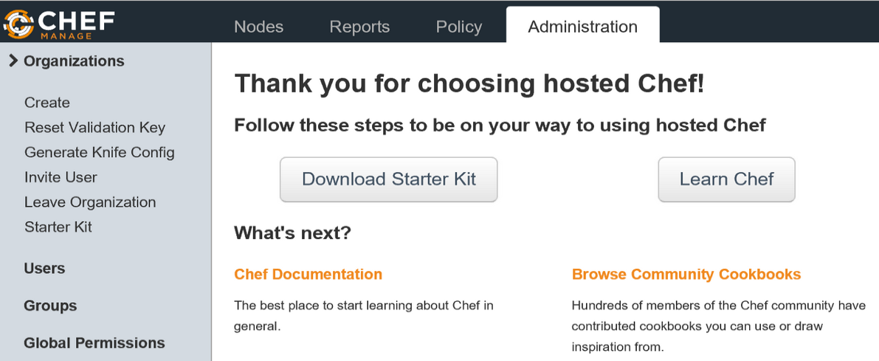

1. Extract the contents of the starter kit to C:\chef
2. Copy all the files from chef-starter\chef-repo.chef to c:\chef
3. You should be having at least 4 files in the directory:
   1. **-validator.pem
   2. ***. Publishsettings
   3. **.pem
   4. Knife.rb

(PEM files contain the org and admin keys where as the .publishsetting file contains your subscription details. Knife.rb is the knife configuration)

1. Lets edit the knife.rb file:
   1. Change the cookbook_path to [“#{current_dir}/cookbooks”]
   2. Add the publish settings file to the knife.rb: “<yourfilena,e>.publishsettings”

It should resemble this:

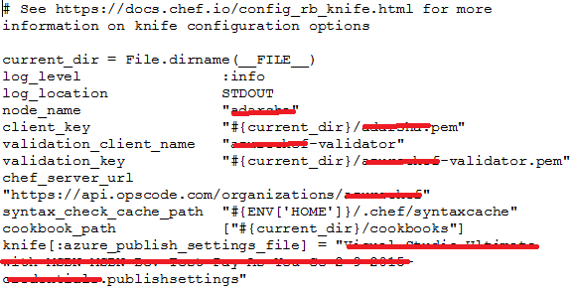

Step 3: Install the Chef Dev Kit

1. Download the Chef DK from <http://downloads.getchef.com/chef-dk/windows> and install it (use default path and settings).
2. Ensure that your Path variable includes: C:\opscode\chefdk\bin;C:\opscode\chefdk\embedded\bin;c:\users\yourusername.chefdk\gem\ruby\2.0.0\bin
3. Install the Knife Azure Plugin:

Chef gem install knife-azure –pre

1. That’s it! You are done with the set up. Execute the following to confirm the correct setup:

Knife azure image list

1. You could spin up a VM with the following command:

c:\chef>knife azure server create --azure-dns-name DevCampChefDemo --azure-vm-size Medium -I a699494373c04fc0bc8f2bb1389d6106__Windows-Server-2012-R2-201412.01-en.us-127GB.vhd --azure-service-location 'East US' --winrm-user adarsha --winrm-password '<password>'

(Note: you would want to run the following command to know the options available to you while creating your VM:

knife azure server create –help  
)

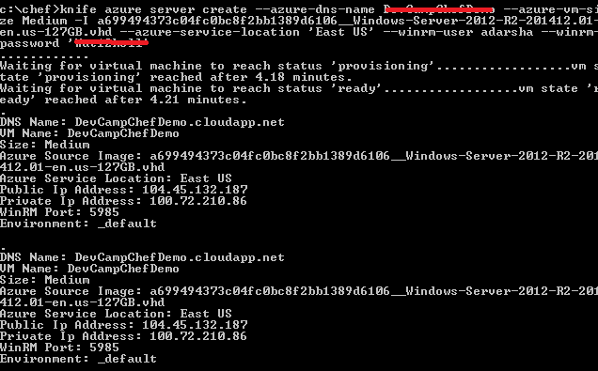

You can login to your portal to see the provisioning in progress:

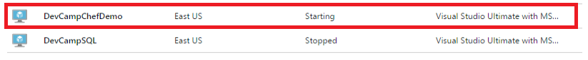

For Commands and references you can refer the following: <https://github.com/chef/knife-azure>