University of Calgary

Project Proposal

|  |  |
| --- | --- |
| To: | Dr. Nathaly Verwaal |
| TA: | Lorans Alabood |
| From: | Bernard Joshua Isaac  Gao Aaron  Kanel Adarsha  Ahmed Obad |
| Team: | T04-Team15-L01 |
| Date: | July 16, 2019 |
| Re: | Card Match Memory Game |

# Description:

The category our group chosen is a “Board Game”. We have created a turn-based board game which gives users the option to play against a computer or have two players play against each other. The java program compiles and responds to user inputs based upon the position of the board input. The computer can store memory on locations of card flips and would match cards accordingly to the difficulty selected for the game. The graphical user interface for “PLAYER VS COMPUTER” will be available on the final project.

Our purpose is to create an interactive game where the objective is based on the memory of both the user and the computer program.

# Overview of the Game :

The game generates random pairs of cards. The objective is to allow the interaction of two players taking turns flipping two cards. The cards selected must match to be eliminated from the field of play and a score would be earned. Throughout the alternation of each player, if a player consecutively matches two cards without fail, the player would gain bonus points for each consecutive match until they fail to match the card then the point system would reset back to granting 1 score per match. After all cards have been matched and eliminated from the field of play, the player with the highest number of points will win the game and the message “PLAYER (#), WINS!” is displayed. If both players achieve the same number of points, then the game would display “DRAW!” In the case that the player plays a match against a computer, if computer wins it would display “COMPUTER WINS!”

The game will prompt the user at the start of the game. Players get the option of selecting three buttons “ COMPUTER VS PLAYER”, “HUMAN MULTIPLAYER”, OR ”EXIT”.Then, the player selects the level of difficulty for the computer which would range from “EASY”. “MEDIUM”, and “HARD”. Each level of difficulty will result in a higher number of cards and a higher probability of the computer matching the cards. “EXIT” would allow the user to close the program and end the game.

As a bonus feature music, sounds and pictures will be added to the program along with a game controller.

# Specifications:

The cards will consist of various objects with sound of the objects. Each time a card is flipped there will be an animation of the card flipping.

* EASY LEVEL = 4x4
* MEDIUM LEVEL = 5X5
* HARD LEVEL = 6X6

# Standard Game Example:

The user will be shown a home screen of a 4 X 4 game will look like this in a text base interface.

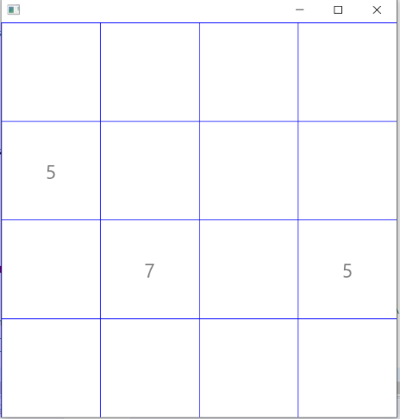And the home screen of a 4 X 4 game will look like this in a graphical user interface:

# Features

* Can play against computer player and human player.
* Able to choose level of difficulty from easy, medium and hard.
* Have GUI and text-based game
* Properly functioning game with winning and losing and exiting of the game.

# Features not done due to challenges

* Adding pictures
* Hand controller