NEXUS
Architecture & Process Flow Guide
Personal Intelligence & Growth Network

Purpose of this document
This guide explains the NEXUS architecture diagram and process flow in simple language. It describes what each component does, how information moves through the system, and how a solved problem becomes reusable knowledge and personalized growth guidance.

See. Solve. Learn. Grow. Remember.

1. NEXUS in simple words
NEXUS is a privacy-first AI platform for developers. When a developer faces a technical problem, NEXUS first tries to help using relevant project context. If the AI answer is not enough, it can help find a suitable human expert. If that expert is unavailable, a proposed Visual Expert can offer evidence-based guidance. After the solution is tested and verified, NEXUS stores the problem and its solution so that the knowledge can help others later. SkillQuest then uses approved evidence from real work to suggest practical ways for the developer to improve.
The main loop
Developer encounters a problem → WorkLens investigates → developer evaluates the answer → human or Visual Expert if needed → verify the fix → save it in ProblemDNA → SkillQuest gives growth insights.

2. Architecture diagram: the system blueprint
The architecture diagram shows the main parts of NEXUS and how they connect. Think of it as a map of the system: each component has a particular responsibility, and information moves between components to complete the overall job.
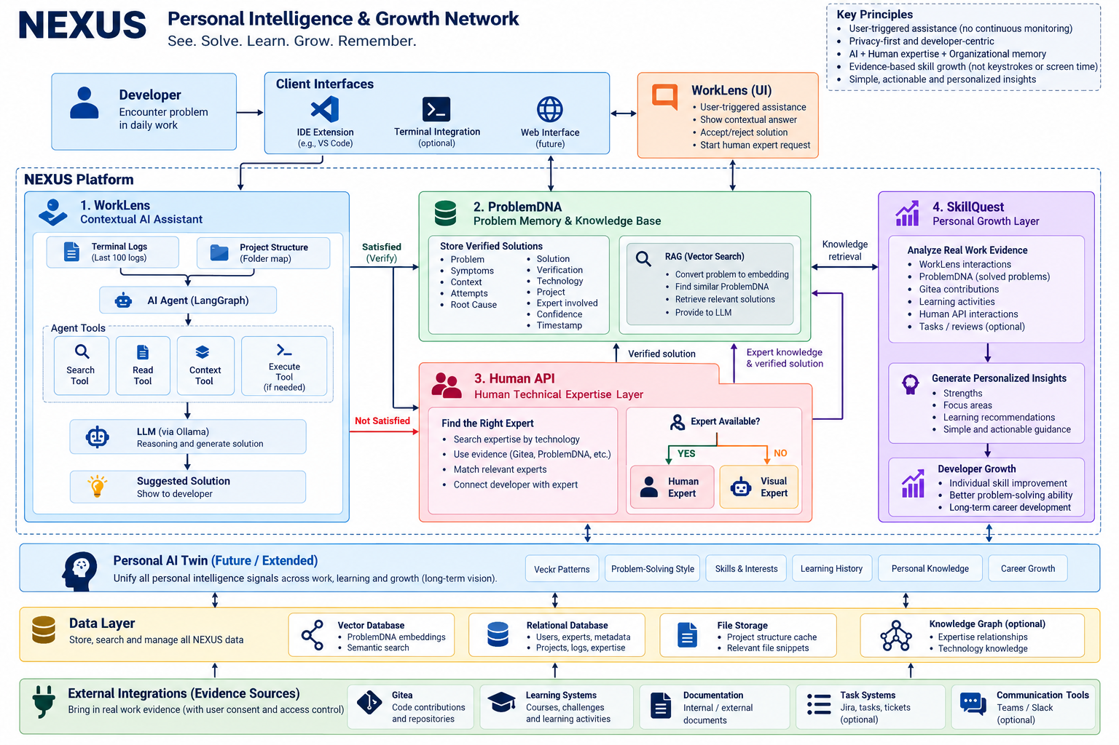
Figure 1. NEXUS architecture overview.

2.1 Developer interface layer
This is where the developer starts using NEXUS. The interface may be an IDE extension such as a VS Code extension, an optional terminal integration, or a future web interface. The developer manually asks for help, shares an error, and reviews the suggested solution.
- Example input: an error message, a question, or a relevant code snippet.
- Privacy principle: assistance is user-triggered; NEXUS is not intended to continuously record the screen or log keystrokes.

2.2 WorkLens — contextual AI assistant
WorkLens is the part that investigates the developer’s problem. It uses project context rather than relying only on a short question. Depending on permissions and implementation, it may use recent terminal logs (the current design specifies the latest 100 entries), a folder map, relevant files, code and the developer’s question.
- It does not need to read every file in the repository.
- It gathers enough relevant evidence for the AI to reason about the current problem.
- It produces a suggested fix and explains how the developer can check it.

2.3 AI Agent and its tools
The AI Agent decides what information or action is needed next. It is not the same thing as the language model. The LLM generates reasoning and text; the agent manages the investigation and chooses tools.
Tool / technology | Simple explanation
Search Tool | Finds relevant file paths, imports, functions or references. Its exact implementation is not finalized.
Read Tool | Reads the contents of a file selected as relevant.
Context Tool | Combines the error, logs, code, project information and question into a useful context package.
Execute Tool | Can run an approved command, test or build when needed. Allowed operations and permissions still need to be defined.
LangGraph | Coordinates the multi-step agent workflow and its states/transitions.
Ollama + selected LLM | Ollama runs the selected language model; the exact model has not yet been finalized.

2.4 ProblemDNA — reusable problem memory
ProblemDNA stores structured records of technical problems and their verified solutions. It can capture the symptoms, context, attempted fixes, root cause, solution, verification evidence, technology, project, timestamp and other relevant metadata. It also helps WorkLens find similar past problems.
For semantic retrieval, a problem description can be converted into an embedding (a numerical representation of its meaning). A vector database can find related records even when a new developer describes the problem using different words. RAG then provides the retrieved records to the LLM as supporting evidence.

2.5 Human API and Visual Expert
Human API is the expertise-discovery layer. If the developer is not satisfied with WorkLens, it looks for people whose demonstrated experience matches the problem. Evidence can include relevant repository work, verified ProblemDNA records and mentoring outcomes. A contribution alone does not prove expertise.
If a suitable human expert is unavailable, the revised concept proposes Visual Expert: an AI-based fallback that could use approved examples of an expert’s problem-solving patterns. Visual Expert is a design concept, not an already-trained clone. Its model design, consent rules, evaluation and privacy controls remain open decisions.

2.6 SkillQuest — personal growth layer
SkillQuest analyzes approved evidence from real work, such as WorkLens interactions, verified problems, repository contributions, learning activities and mentoring outcomes. It identifies strengths, recurring difficulties and practical next steps. It is intended to provide understandable recommendations rather than a large collection of unexplained scores.

2.7 Personal AI Twin, data layer and integrations
The Personal AI Twin is a longer-term concept for bringing together approved signals about a person’s work, learning, skills and goals. The data layer supports storage and retrieval. Possible stores include a relational database for users and metadata, a vector database for embeddings, file storage for permitted artifacts, and an optional knowledge graph for relationships between technologies, projects and experts.
Possible external evidence sources include Gitea.

3. Process flow diagram: how NEXUS works
The process flow diagram shows the order of actions and the decisions made during a real problem-solving session. The six stages below explain the flow from the developer’s first error to the final growth recommendations.
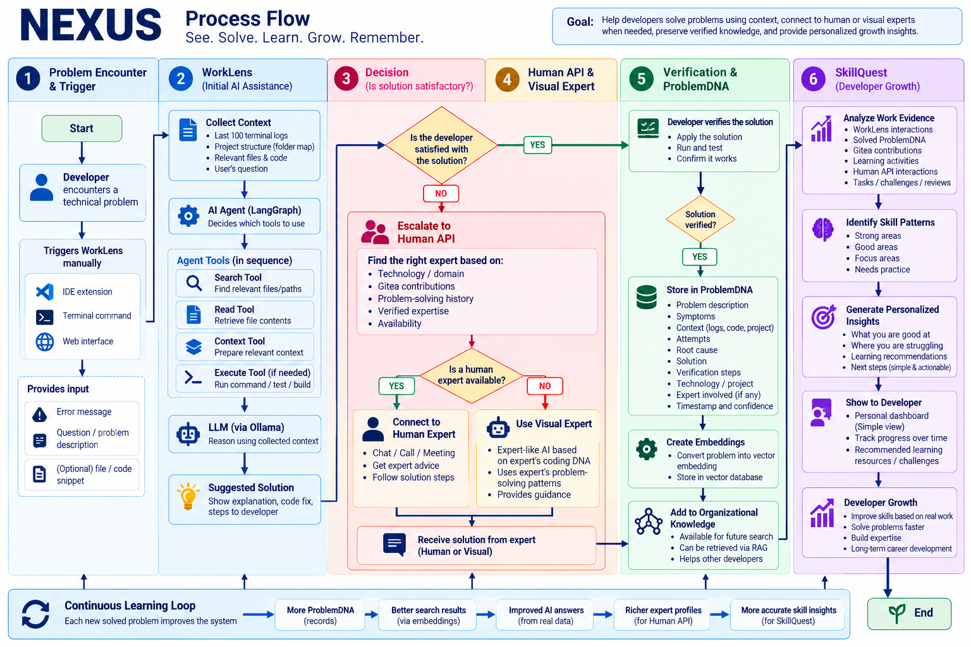
Figure 2. NEXUS end-to-end process flow.

Stage 1 — Developer encounters a problem
The developer sees an error or unexpected behavior and manually triggers WorkLens. The developer supplies a question or error description and may provide a relevant snippet. WorkLens collects only the permitted context needed for the task.
Example
A React application reports: “Module not found: Can't resolve './ProductCard'.”

Stage 2 — WorkLens investigates
- Collect context: read the error, recent terminal logs and project folder map.
- Plan the investigation: the AI Agent decides what evidence is missing.
- Search: locate files that reference ProductCard.
- Read: inspect the relevant import and the actual component filename.
- Prepare context: combine the error and relevant evidence for the LLM.
- Retrieve prior knowledge: if useful, search ProblemDNA for similar verified cases.
- Execute if needed: run an approved test or command only when the investigation requires it.
- Generate an answer: the LLM proposes a likely cause and a fix.
In this example, WorkLens may discover that the code imports ProductCard while the actual file is named ProductCards.jsx. It can recommend correcting the import path or filename. The recommendation is not yet verified.

Stage 3 — The developer evaluates the answer
The developer decides whether the answer is useful. If satisfied, the developer tries the fix and proceeds to verification. If not satisfied, WorkLens escalates the problem to Human API. Satisfaction is feedback; it is not proof that the fix is technically correct.

Stage 4 — Human API or Visual Expert helps
Human API searches for a relevant expert using the problem domain and available evidence. If an appropriate person is available, the developer can connect with them. If no suitable person is available, the proposed Visual Expert can provide guidance from approved evidence and problem-solving patterns. If neither route resolves the problem, the case remains open for further diagnosis or escalation.

Stage 5 — Verify and save in ProblemDNA
The developer applies the fix and checks the expected result. Depending on the problem, verification may include running the application, repeating the failed action, checking an API response or running tests. Only after suitable verification should the record be marked verified.
A ProblemDNA record can include:
- Problem description and symptoms
- Project context, relevant logs and code references
- Attempts made and the root cause
- Solution and verification steps/evidence
- Technology, project, source, timestamp and confidence
- Expert involvement, where relevant and permitted
NEXUS can then generate an embedding and index the record in a vector database. A future developer with a similar problem can retrieve it through semantic search and use it as evidence for a new answer.

Stage 6 — SkillQuest provides growth insights
SkillQuest analyzes relevant work evidence over time. It looks for patterns, such as areas where the developer solves problems independently and areas where similar difficulties keep recurring. It then provides a small number of actionable recommendations, such as practising API error handling or authentication flows.

4. Continuous learning loop
Every verified solution can add to the organizational knowledge base. Better knowledge coverage may improve future retrieval; relevant retrieved evidence can help ground WorkLens answers; verified problem-solving and mentoring evidence can help Human API matching; and the growing evidence base can support more useful SkillQuest insights.
- More verified ProblemDNA records.
- More opportunities to retrieve similar, relevant problems.
- Better-grounded answers when the retrieved record matches the current context.
- Richer evidence about technical experience and expertise.
- More personalized growth recommendations.
Important
This loop does not mean the model automatically becomes smarter after every case. Results depend on record quality, retrieval relevance, evaluation, permissions and deliberate system improvements.

5. How the two diagrams differ
Aspect | Architecture diagram | Process flow diagram
Main question | What components exist and how do they connect? | What happens first, next and after each decision?
Focus | Components, data stores and integrations | Actions, decision branches and outcomes
Example | WorkLens connects to tools, LLM and ProblemDNA | WorkLens investigates, asks if the answer worked, then verifies or escalates
Outcome | A blueprint for designing the system | An operational path through the system

6. Recommended implementation order
Phase 1 — WorkLens MVP: Build the user-triggered interface, context collection, Search/Read/Context tools and Ollama-based diagnosis.
Phase 2 — Verification and ProblemDNA: Store structured records, capture verification outcomes and add semantic retrieval.
Phase 3 — Human API: Add expert profiles, evidence-based matching, availability and expert requests.
Phase 4 — SkillQuest: Generate understandable recommendations from verified problem-solving evidence.
Phase 5 — Visual Expert: Prototype retrieval-based guidance with consent, attribution, evaluation and uncertainty handling.
Phase 6 — Integrations and Personal AI Twin: Add approved external sources and expand the long-term personal intelligence layer.

7. Key design principles
- Privacy-first: assistance is triggered by the developer and uses approved context.
- Least privilege: project files, logs, integrations and execution tools should have explicit permissions.
- Human-in-the-loop: developers and experts can evaluate, correct and verify proposed solutions.
- Evidence-based memory: only appropriately verified outcomes should be marked as verified knowledge.
- Honest uncertainty: when the system cannot establish a solution, it should say so and continue escalation.
- Responsible growth insights: SkillQuest should explain its evidence and avoid surveillance-style performance scoring.

8. Final summary
NEXUS connects contextual AI assistance, human expertise, reusable problem memory and personalized growth. WorkLens helps investigate a problem; Human API and the proposed Visual Expert provide escalation paths; ProblemDNA preserves verified solutions; and SkillQuest turns approved work evidence into practical development guidance. The architecture diagram shows the system’s building blocks, while the process flow diagram explains how those blocks work together from the first error through verification and future learning.
One-line explanation
NEXUS helps developers solve problems with context, preserve what works, find expertise when needed, and learn from real work.

