**CS211**



**Assignment 2**

**Full Name: Adarsh Anand**

**Roll No: 2003101**

**Date of Submission: 23 /02/ 2022**

**Branch: CSE**

**Question 1) Complete the following code snippet to add 10 numbers stored consecutively in data memory. Print the result.**

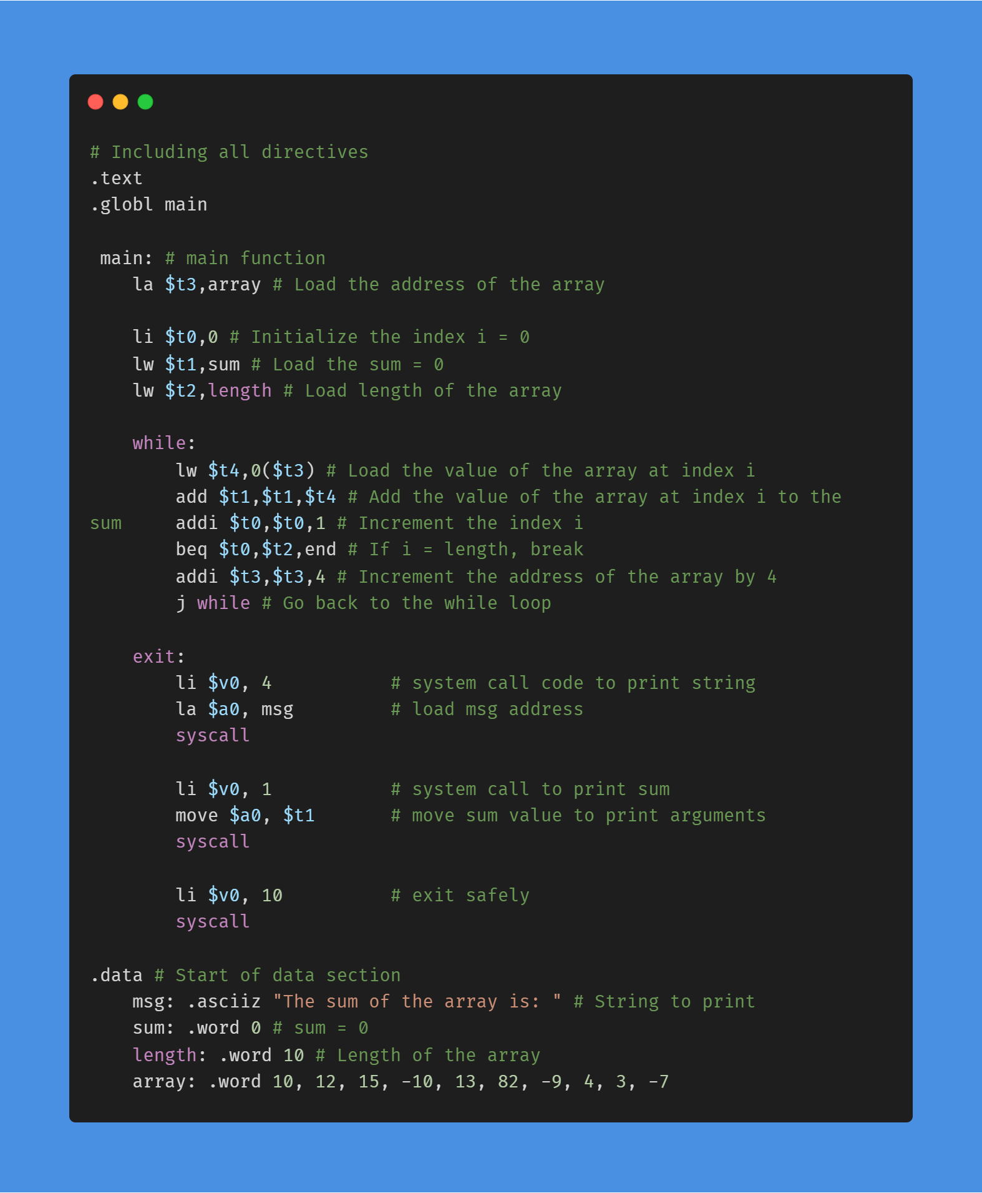

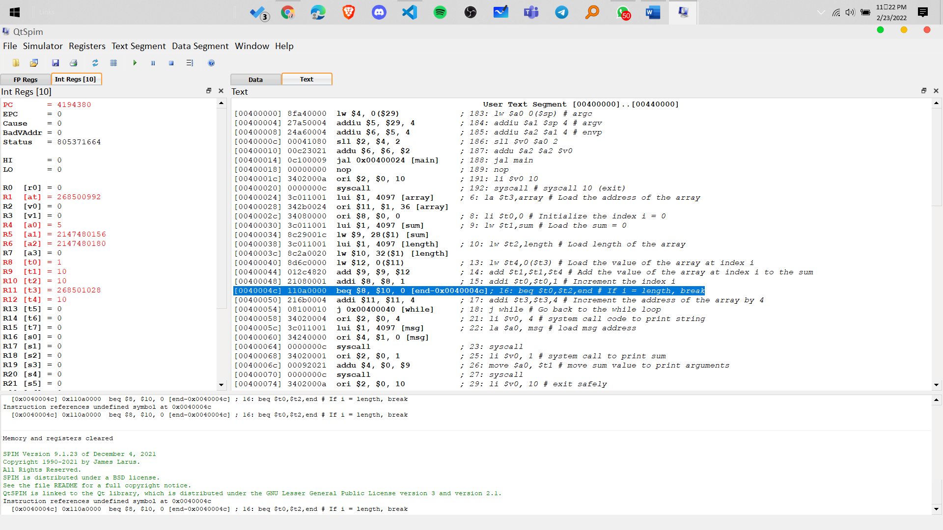

We have 5 steps initially to store value in register 7 step per loop and 3 step to end the loop so total we go across approx. 78 steps.

**Question 2) Include the following numbers in the array data segment of question 1. 10,20,30,40,50,77**

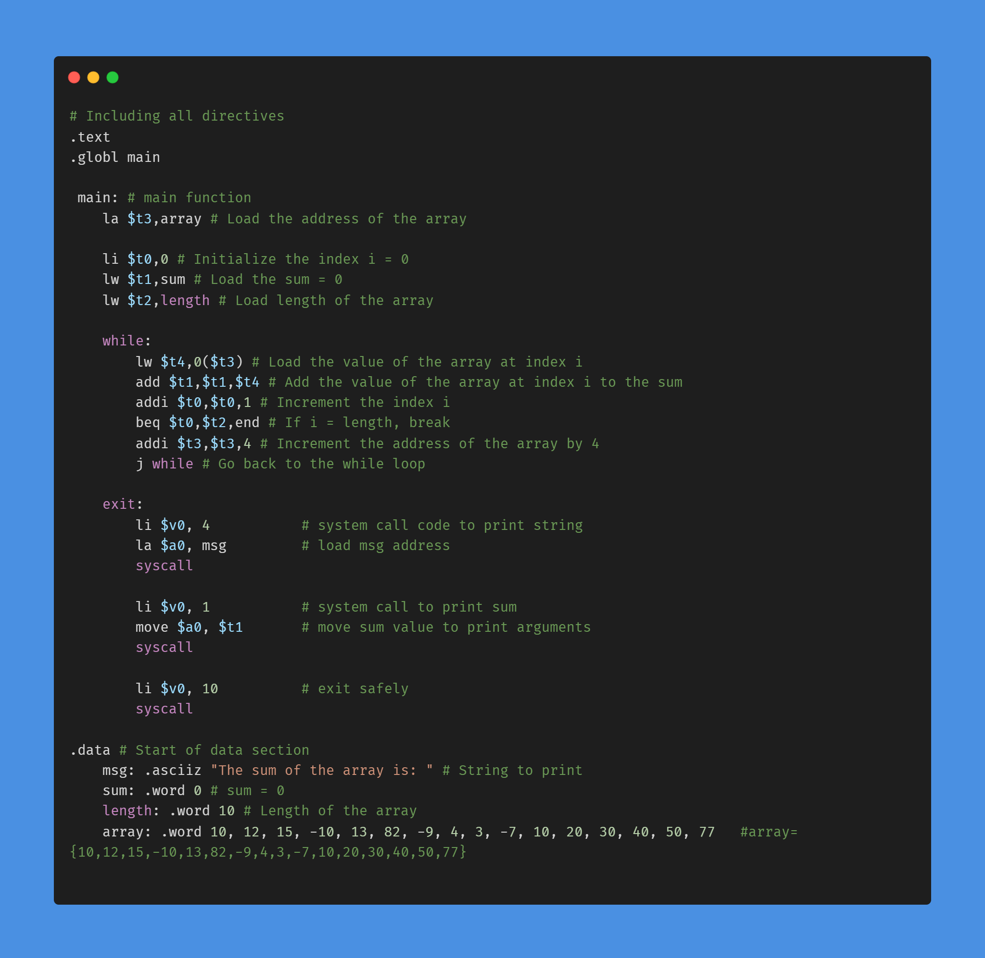

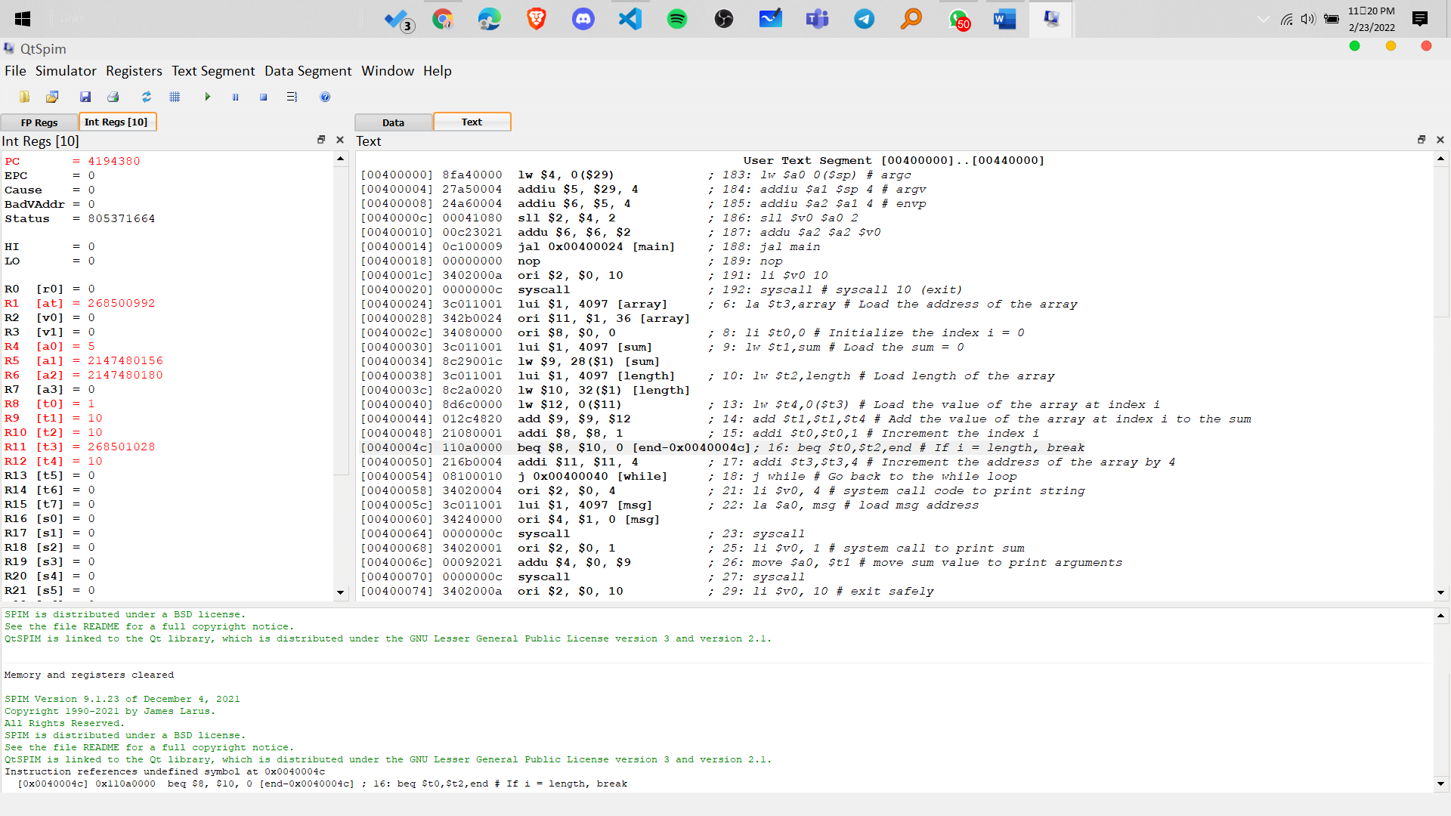

We have 5 steps initially to store value in register 7 step per loop and 3 step to end the loop so total we go across approx. 120 steps.

Summary of the code -

I write the code for adding the elements of the array and printing the sum. I also used the system call to print the sum and the string. Using a while loop, I iterated through the array and added the elements to the sum. I also used the system call to print the sum and the string.

Question 3

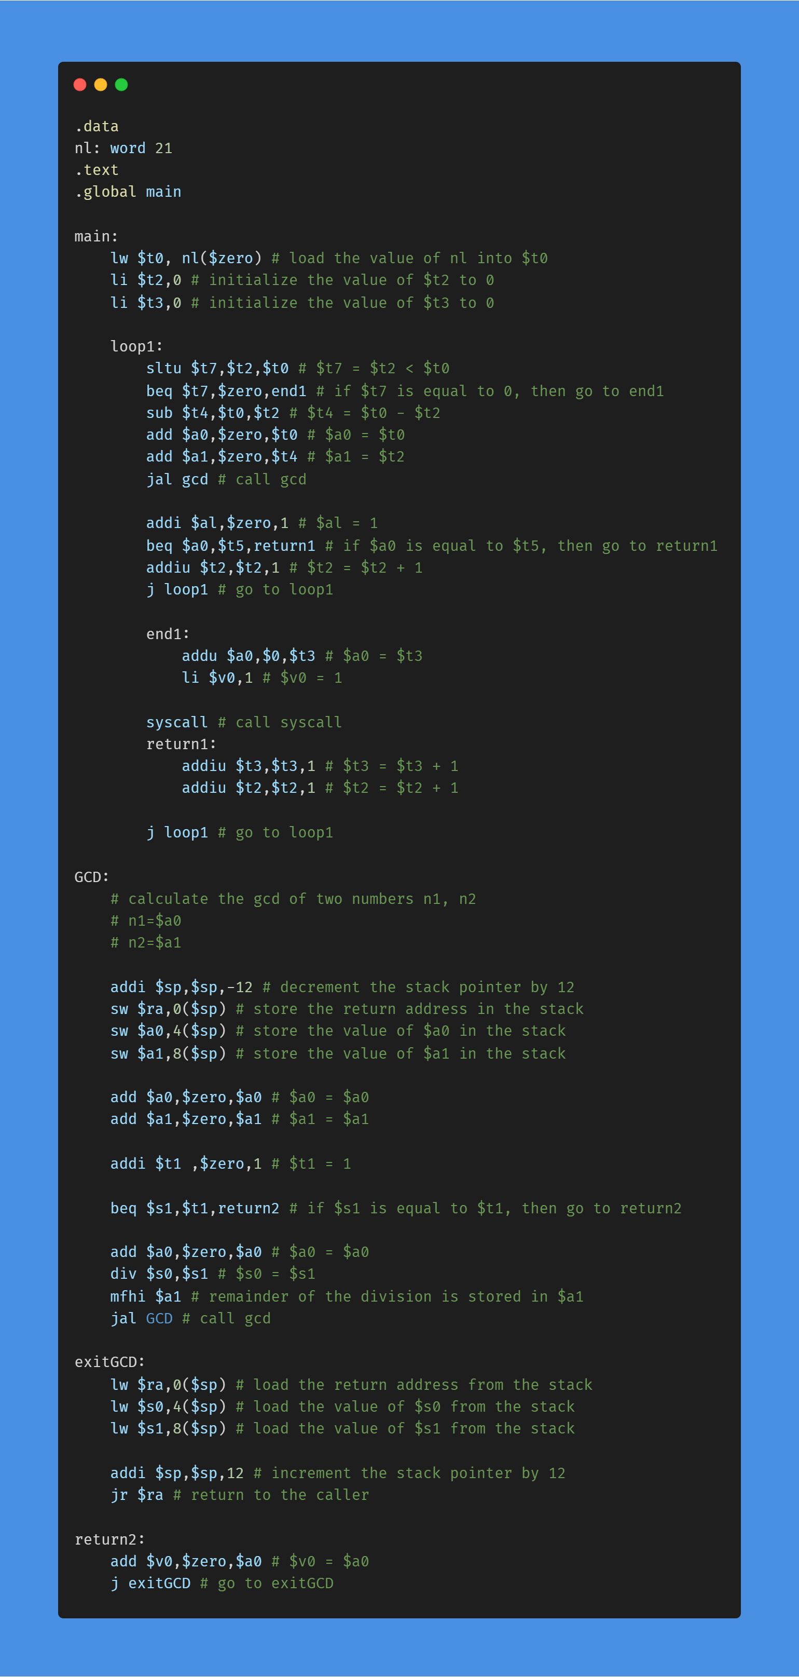

 Summary of the code –

 I take the input number 21 and store it in $t0. I write GCD as a function and call it from main. After calling GCD, I check if the value of $a0 is equal to $t5. If it is, then I return 1. If it is not, then I add 1 to $t2 and call GCD again. I do this until $t2 is equal to $t0. I return the value of $t3. So Phi(21) = 4. Euler Phi function is computed.