**CAD_PHASE 4**

Certainly, in addition to setting up the IBM Cloud Visual Recognition service and designing the web interface, you will also need to continue building the image recognition system by implementing the image classification process and generating captions for the recognized images. Here's a more detailed plan for these aspects:

**INTEGRATING IBM CLOUD VISUAL RECOGNITION:**

1. A screenshot of a computer

   Description automatically generatedUse the API key and URL obtained from your IBM Cloud Visual Recognition service credentials in your web application.
2. 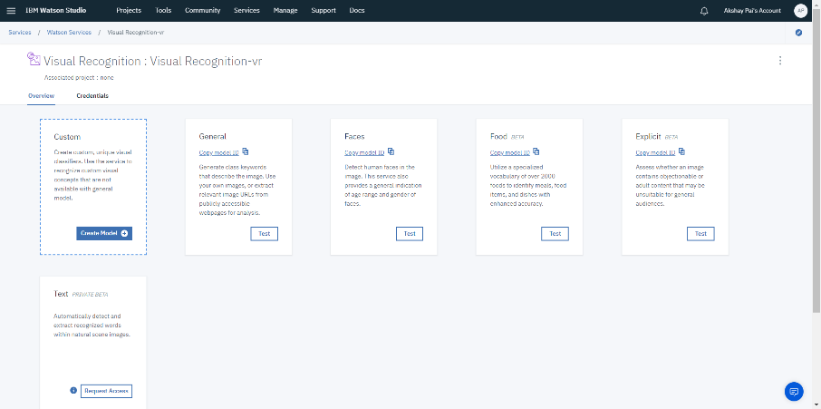Implement the image classification process by allowing users to upload images through your web interface.
3. When a user uploads an image, your application should make a POST request to the IBM Cloud Visual Recognition API, passing the uploaded image for classification.
4. Handle the response from the API, which typically includes information about the recognized objects or concepts in the image.

**GENERATING AI-GENERATED CAPTIONS:**

1. Once you receive the results from the Visual Recognition API, use natural language generation (NLG) techniques to create captions for the recognized images.
2. You can develop this caption generation functionality by writing code or using existing NLG libraries and tools. The captions should describe the content of the image based on the recognition results.
3. Combine the recognition results with the NLG-generated captions to provide users with informative descriptions of the uploaded images.
4. Display the AI-generated captions alongside the images in your web interface.

**TESTING AND OPTIMIZATION**:

1. Thoroughly test the entire system to ensure that image recognition and caption generation work seamlessly.
2. Consider optimizing your application's performance by handling errors gracefully and implementing features like image validation, user feedback, and responsive design.
3. Pay attention to the user experience to make it intuitive and user-friendly.
4. Consider additional features, such as image tagging, user accounts, or a database for storing recognized images and captions.

**DOCUMENTATION:**

Document the implementation details, including the integration with IBM Cloud Visual Recognition, the caption generation process, and the structure of your web application.

By integrating IBM Cloud Visual Recognition with the caption generation process, you will create a comprehensive image recognition system that not only identifies objects in images but also provides meaningful descriptions, enhancing the user experience and usefulness of your project.