**Group Members:** Burma Adarsh, Adam Bulgatz, Joshua Miller, and Joshua Pinkston

**Phase 1: Compression**

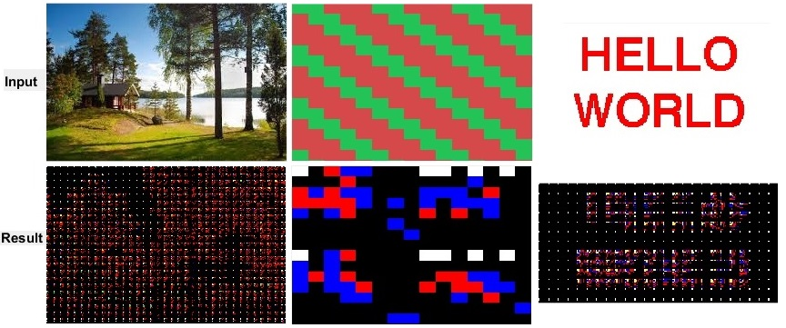

[discussion of results]

**Phase 2: Decompression**

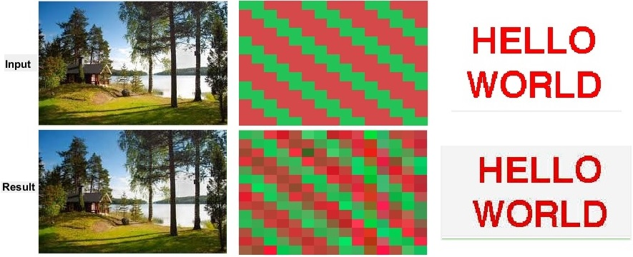

[discussion of results]

**Phase 3: Error Computation**

[image? I don’t think there’s anything to display…]

[discussion of results]

**Phase 4: Display**

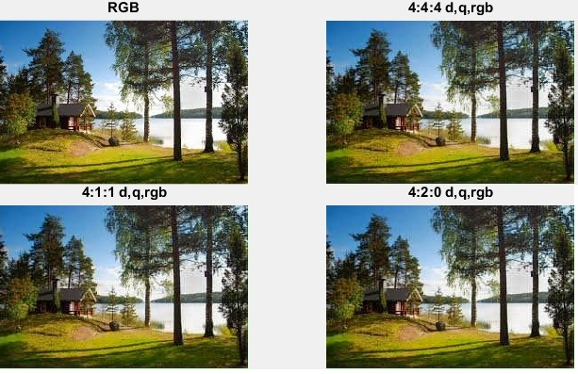

[discussion of results]

Number of group meetings: 4

Date – Group members in attendance

3/22 – Adarsh, Adam, Josh Miller, and Josh Pinkston

3/23 – Adam and Josh Miller

3/24 – Adam, Josh Miller, and Josh Pinkston

3/29 – Adarsh, Adam, Josh Miller, and Josh Pinkston

[we didn’t really have very many meetings]