**REPORT**

**Reference Images:**

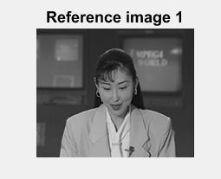 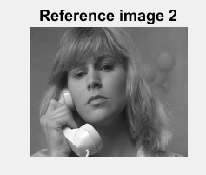

**Target Images:**

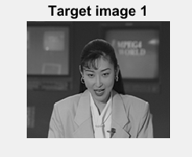 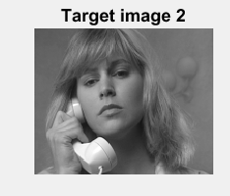

**Part 1:**

**Implemention Logarithmic search motion vector estimation:**

**Inputs :** Reference image, Target Image, Macro block size , search parameter.

**Output:** Motion vector matrix (size : 2 * (number of macro blocks))

1. Start with search location at the center
2. Select an initial step size say 2^(L -1) , where L = log p to the base 2
3. Displace through 8 locations at a distance of S from center on the X and Y axes and calculate MAD’s at each location(cost matrix (3*3) including center).
4. Find the location of point with least cost function.
5. set S = S/2
6. If a point other than center is the best matching point,
   1. Select this point as the new center
   2. Repeat steps 3 to 6 until step size S< 1
7. If S = 1, all 8 locations around the center at a [distance](https://en.wikipedia.org/wiki/Distance) S are searched
8. Set the motion vector as the point with least cost function

**Part 2:**

**Creation of Motion Compensated image:**

**Inputs:** reference image and motion vectors (and the MB size)

**Output:** motion compensated image (predicted/estimated frame)

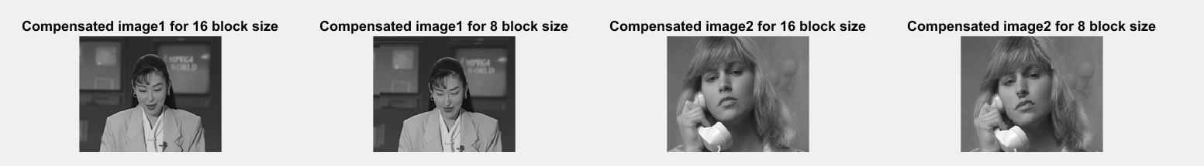

**Part 3:**

**Error/Difference Computations:**

FD(i,j) = |Target(i,j) – Reference(i,j)| (image)

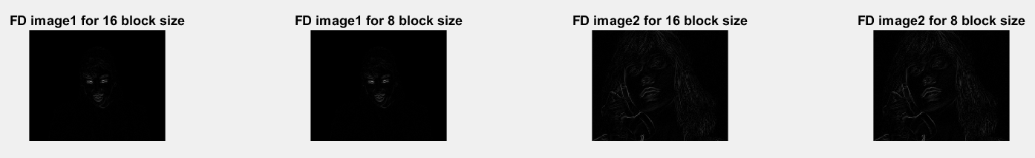

DFD(i,j) = |Target(i,j) – MotionComp(i,j)| (image)

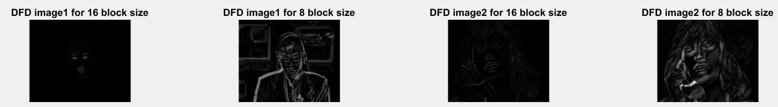

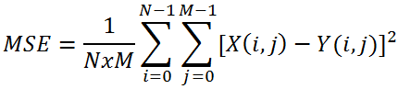

PSNR = 20 * log10 (255/SQRT(MSE))

**Part 4:**

**Display:**

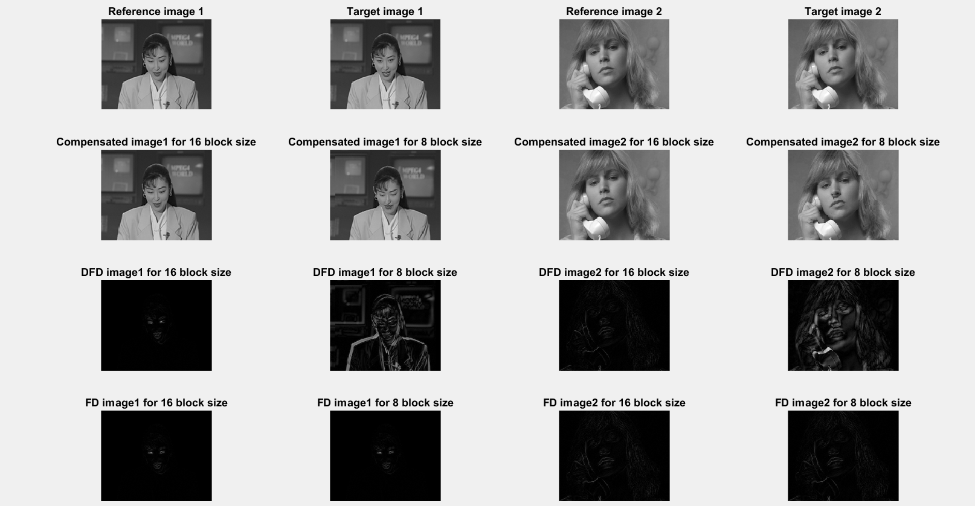

**Motion vector visualization:**

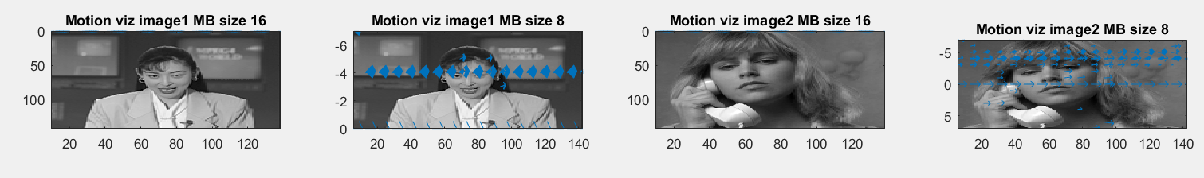

Comparison of two settings (N=16 vs. N=8)

N=8 macro block size provides better quality.

PSNR and MSE is more in case of N = 8 when compared to N=16 so I think N=8 is closer view and accurate estimation when compared to N=16.

**Execution Instructions:**

Run Runme.m (change directory and run from command window)

**Note:** expand figure window to view properly.

PSNR, MSE calculations are displayed on the command window.

**Team:** Adarsh Burma (individual) was part of Team (Josh Miller, Josh Pinkston , Adam Bulgatz) previous project.