**BUDT703 0506 01 Proposal**

Submitted By: TerpRank

Course, Section, & Team: BUDT703_0506_01

**TerpRank Ranks**

* Mission Statement:-

Identify the best pair of student and B-School, the one they desire and deserve.

Provide B-schools insights into specific areas they must revamp to lift their rankings.

* Mission Objectives:-

1. To study the impact of tuition fees on school rankings
2. To compare admitted students’ GMAT, GRE scores, and GPAs with respect to schools’ Employer Reputation
3. Compare the universities on the basis of actual rankings and students’ ratings
4. Identify the difference in the number of applicants when the application fee is greater or lesser than $200.

* Business Processes/Transactions: -

1. Compare admitted students’ average GMAT, GRE scores and GPAs with respect to schools’ employer reputation and rankings.
2. Compare admitted students’ GMAT, GRE scores and GPAs with respect to school rankings.

* Entities, Attributes and Primary Keys :

1. Location(**locationID**, city, state, zipCode)
2. UniversityDetails(**universityId**, universityName)
3. UniversityYearRecords (**year,** avgGRE, avgGMAT, avgGPA , avgTuitionFees, noOfApplicants, acceptanceRatio, avgAge, avgWorkExperience, applicationFee, femalePercentage, empRateAtGraduation , empRateAfterThreeMonths, classSize, avgOfferedIncome, percentageOfFacultyWithPhD, studentRatingsOfFaculty, studentRatingsOfProgramme, studentRatingsOfFacilities, academicReputation, employerReputation, facultyStudentRatio, citationsPerFaculty, internationalFacultyRatio, internationalStudentRatio, compensation, learning, networking, entrepreneurship, rank)
4. UniversityContactDetails (**departmentName**, contactName, contactPhone

* Entites: -

1. Location:

Contains different locations where universities can be located

1. UniversityDetails:

Contacts a unique university ID along with the name of the university

1. UniversityContactDetails:

Contains contact name and phone number for different departments (admission, finance) for all the universities

1. UniveristyYearRecords:

Contains information regarding the student quality (average GRE Score, years of work experience prior to coming to the school), faculty quality (no of citations per faculty, alumni feedback), diversity (international student/national student ratio, female percentage), placement record (employment rate after graduation, average offered incomes), financial records (tuition fees) and admission details (number of students applied, acceptance rate)

* ER Schema:-

where: Binary Relationship

1 UniversityDetails to only 1 Location

1 Location to 1 or more UniversityDetails

contact_at: Binary Relationship

  1 UniversityDetails to 1 or more UniversityContactDetails

  1 UniversityContactDetails to 1 UniversityDetails

record: Binary Relationship

1 UniversityDetails to 1 or more UniversityYearRecords

1 UniversityYearRecords to 1 or more UniversityDetails

* ER Diagram:-

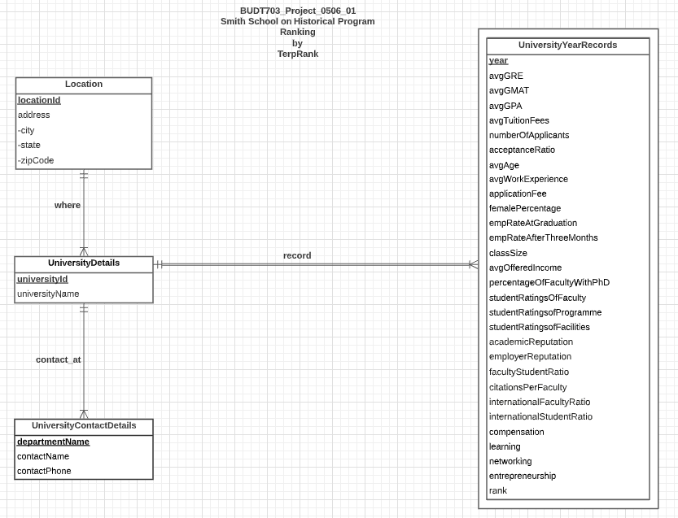

* Relational Schema:-

1. Location( **locationID**, city, state, zipCode)
2. UniversityDetails(***locationId* , universityId**, universityName)
3. UniversityYearRecords (***universityId***, **year,** avgGRE, avgGMAT, avgGPA , avgTuitionFees, noOfApplicants, acceptanceRatio, avgAge, avgWorkExperience, applicationFee, femalePercentage, empRateAtGraduation , empRateAfterThreeMonths, classSize, avgOfferedIncome, percentageOfFacultyWithPhD, studentRatingsOfFaculty, studentRatingsOfProgramme, studentRatingsOfFacilities, academicReputation, employerReputation, facultyStudentRatio, citationsPerFaculty, internationalFacultyRatio, internationalStudentRatio, compensation, learning, networking, entrepreneurship, rank)
4. UniversityContactDetails (***universityId*, departmentName**, contactName, contactPhone)

* Business Rules:-

[R1]: When a location is updated in the database, corresponding university details should be updated too in the database.

[R2]: When a location is deleted in the database, the university information must be updated accordingly.

[R3]: When a university is deleted from the database, all the records of the university must be deleted from the database.

[R4]: When a university details are updated, there should not be any changes in the year records of the university.

[R5]: When a university is deleted from the database, all the contact information of the university must be deleted from the database as well.

[R6]: When a university details are updated, all the contact information must be updated accordingly.

* Referential Integrity:-

|  |  |  |  |  |  |  |  |
| --- | --- | --- | --- | --- | --- | --- | --- |
| Relation | Foreign Key | Base Relation | Primary Key | Business Rule | Constraint: ON DELETE | Business Rule | Constraint: ON UPDATE |
| UniversityDetails | locationID | Location | locationID | R1 | CASCADE | R2 | CASCADE |
| UniversityYearRecords | universityID | UniversityDetails | universityID | R3 | CASCADE | R4 | NO ACTION |
| UniversityContactDetails | universityID | UniversityDetails | universityID | R5 | CASCADE | R6 | CASCADE |

* Data:-

Link:- [BUDT703_0506_01_Database](https://docs.google.com/spreadsheets/d/1GRLsVhInuG2rUVKnqsm06gcMY3XAbpRHqeae9tvc7QA/edit%23gid=1922259088)

* Data Snapshots:-

1. Location:-

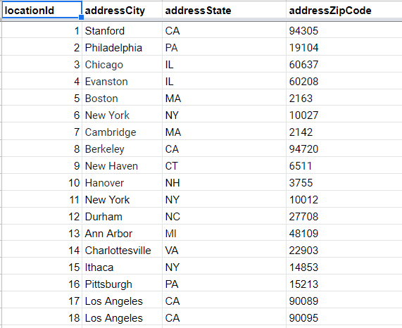

1. UniversityDetails:-

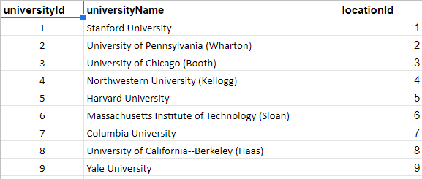

1. UniversityYearRecords:-



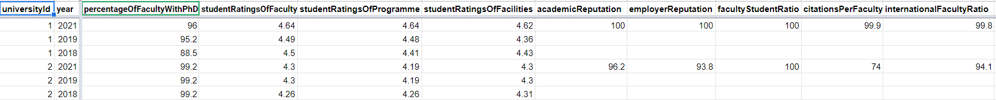

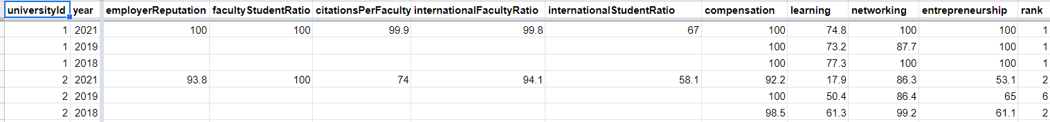

1. UniversityContactDetails:-

