

**A**

**PROJECT REPORT**

**ON**

**“HOTEL MANAGEMENT SYSTEM”**

**BACHELOR OF BUSINESS ADMINISTRATION**

**(COMPUTER APPLICATION)**

**Sem-V**

**2021-2022.**

**SUBMITTED TO**

**Savitribai Phule Pune University**

**DEVELOPED BY:**

**Chate Adarsh Vikas,**

**UNDER THE GUIDANCE OF**

**Prof. Asha Mane.**

**Annasaheb Magar Mahavidyalaya**

**Hadapsar, Pune - 411028.**



Pune District Education Association’s

Annasaheb Magar Mahavidyalaya, Hadapsar Pune

Hadapsar, Pune - 411 028.

**DEPARTMENT OF B.B.A (C.A)**

Certificate

This Is to Certify That Mr. Chate Adarsh Vikas Student of Bachelor of Business Administration (Computer Application) Has Satisfactory Completed the Project Work in “Hotel Management System” as Per the Syllabus Laid Down by The Savitribai Phule Pune University During the Academic Year 2021-2022 And Entered Up His Project Report Therefore Currently and Correctly.

Date:-­

_____________________________________________________________________________________________________

Exam Seat No:- Exam Seat No:-

Project In-charge:- Head of Department:-

Internal Examiner:- External Examiner:-

**Acknowledgement**

A lot of hard work and effort the project was later successfully completed.

Here we gladly present this project report on “Hotel management System” as part of the 5th semester BBA (C.A). At this time of submitting this report, we use this opportunity to mention those people who helped us in many ways. We take this chance to thank God, for blessing us with his grace and taking our endeavour to a successful culmination. We extend our sincere and sincere thanks to our esteemed guide, Mrs. Mane A.C. for providing us with the right guidance and advice on important occasions and to show us the right way. We extend our sincere thanks to our respected Head of the Department Mrs. Mane A.C, for allowing us to use the facilities available. We would like to thank the other faculty members also, on this occasion. Last but not the least, we would like to thank friends for the support and encouragement they have given us during the course of our work.

|  |
| --- |
| **INDEX** |

|  |  |  |
| --- | --- | --- |
| **Chapter**  **No.** | **Particular Name** | **Page**  **No.** |
| ***1*** | **INTRODUCTION**  1.1 Organization Profile  1.2 Introduction of System  1.3 Problem Statement  1.4 Proposed of System  1.5 Scope and Limitation of Existing System | 5  6  7  8  9 |
| ***2*** | **SYSTEM ANALYSIS**  2.1 Existing System  2.2 Project Perspective  2.3 Requirement Analysis  2.4 Feasibility Study  2.5 Fact Finding Technique  2.6 Implementation Details | 10  11  12  13-14  15  16-17 |
| ***3*** | **SYSTEM DESIGN**  3.1 Design Constraint  3.2 Entity Relationship Diagram [ERD]  3.3 Data Flow Diagram [DFD]  3.4 Data Dictionary  3.5 File Design | 18  19  20-22  23-25  26-30 |
| ***4*** | **INPUT/OUTPUT AND REPORT** | 31-37 |
| ***5*** | **TESTING**  5.1 Test plan  5.2 Black Box Testing  5.3 White Box Testing  5.4 Validation Test Cases and Result | 38  39  40  41 |
| ***6*** | **ADVANTAGES AND LIMITATIONS** | 42 |
| ***7*** | **CONCLUSION** | 43 |
| ***8*** | **FUTURE ENHANCEMENT** | 44 |
| ***9*** | **BIBLIOGRAPHY AND REFERENCES** | 45 |

1. **INTRODUCTION**
   1. **Organization Profile**

**Organization Name** :- Balaji Hotel.

**Organization Address** :- 52, Pune - Solapur Rd, Near Indraprastha

Society, Hadapsar, Pune, Maharashtra411028.

**Manager Name**  :- --------------.

**Mobile Number** :- 709-705-7777.

**Established In** :- 2021.

**Email** :- balajihotel7@gmail.com

**Working Profile**  :- Hotel Management System Provides various

facilities to maintain the user, Reservations of

Rooms, Customer Records, Payments, Bill

reports, and others related to hotel.

**1.2 Introduction to System**

**Project Name:-** Hotel Management System.

**Name Of Organization:-** Balaji Hotel.

**Project Descriptions :-**

The Project of “Hotel Management System” on basis of the providing Hotel services including all the Services given by the Hotels Agency.

The Project of “Hotel Management System” on basis of the providing Hotel services facilities for booking hotels, Events, holiday apartments including all the Services given by the Hotels and other accommodations for customers. Balaji Hotels manager They operate their business in Pune . Any customers need to book hotel, or apartment they need to visit their office which for checking the availability as well as negotiation. Recently they have decided to change their booking pattern from manual to web based system. It will help them to manage the customers booking easily and also to keep the customers data safer. It will also help staffs to keep in track their customer’s online booking request as well as easily to reply feedback to the customer.

* 1. **Problem Statement**

As Hotels Booking Is Having Manual Booking System, They Are Facing Some Problems Issuing Booking Requests of Customers. All The Necessary Booking Stuffs Are Being Done in Hard Copy. So, It Become Much Difficult for Staffs to Keep the Records Updated All the Time.

As For Example, If the Customers Need to Change the Check in Date It Become Difficult for Them to Find Out the Customers Booking Details for Updating as There Are So Many Customers Booking Records. Again, Regarding Current System Customers Cannot Give Feedback Online and Also Staff Cannot Reply to Them Promptly.

Besides Tourists from Other location Need to Call Directly for Booking Purposes. So, They Cannot Get the Chance to View Their Apartment Rooms or Hotels Rooms Before They Make Book.

* 1. **Proposed System**

The purpose of this project is to create a functional website for users to reserve the hotel room across the world. Users of this website will be able use an easy-to-use interface in order to search, sort, reserve room and services across the world. Create an account option will secure their data and allow easy access to various services and facilities.

One of the main purposes of this project is to allow customer to have online booking of room and other services with registered business partner.It is difficult to maintain bulk of record in manual.

The basic requirements state that the users will be able to search for room based on and able to make instant online payment. They will also be able to navigate through available other options by category, or by using a well-executed search function. The website will be maintained and managed by administrator. They will have the authority to manage the products and offers.

* Efficient data management and reusability.
* Highly accessible for users.
* Enable easy authorized modification of data
* To enable automated data entry methods.
* Security of User information and other can maintain.
* On a figure tip, we can access any information with proper authority.
* The proposed system will available and function 24*7 and accessible

for worldwide. Thus, the customers can use the system very easily.

* 1. **Scope and Limitation Of existing System**
* **Scope of existing System :**

1. System management manually .
2. Human interaction is required to create booking.
3. Not needed electricity and any electronic devices.
4. Store data in using paper format.
5. Borrowed items can be written off.

* **Limitation:**

1. Increases the paper work.
2. Time Consuming.
3. Non-secure.
4. No method to trace details.
5. Human errors.
6. **SYSTEM ANALYSIS**

**2.1 Existing System**

* **Study Of Existing System**

The current manual reservation system uses paper and direct human interaction to book the hotel room and manage reservations. This makes delays exchanging of information in the hotel.

The existing system is a manual one and there is lot of issues like erroneous data, slow process, lack of security etc. Finding out the final payment amount completely relies on the hotel manager and if he is absent, it takes a long time to find out the details during check out and is prone to errors.

* **Advantages Of the Existing System**

1. Employee with the no computer skill or any special skill is required.
2. No need to rely on any device to access or use data.
3. Human interaction is required to create booking.

* **Disadvantages Of the Existing System**

1. It is difficult to maintain bulk of record in manual.
2. Lot of paperwork.
3. Non-secure.
4. No method to trace details.
5. Human errors.
6. The manual system is too slow.
7. Searching is more time consuming.

**2.2 Project Perspective**

* In this system make easier and more attractive.
* This system will be fully online in the future.
* In the System, payment options and all other futures

will be added to this system.

* In this system , we will make sure that records are

auto-saved and records will not be corrupt.

**2.3 Requirement Analysis**

Requirement’s analysis is the analysis definition process of requirements, is the start of the planning and development period of the project. Needs analysis task is to thoroughly describe the function and performance of the software, identify limits of software design and software interface details with other elements of the system, defining the effectiveness of software requirements. Requirement’s analysis includes business requirements, functional requirements and development requirements.

**2.4 Feasibility Study**

The feasibility study helps to know whether the system implemented is economically viable and beneficial to organization. A feasibility study conducted once the problem is clearly understood is a high-level capsule version of the complete system analysis and design process The purpose is to determine at the minimum expense and how quickly resolve the problem and to determine what her problem is solved the following feasibility in the following ways There are three types of feasibility study.

1.technical feasibility

2. operational feasibility

3. Economical feasibility.

1. **Technical Feasibility:**

The technical feasibility of work performance can affect study and ability to achieve limitations.

Acceptable Systems Software developed to manage hotel reservation systems is used in client servers.

The project is technically feasible as a front end with architecture html, css, JavaScript, php and SQL Server back end.

1. **Operational Feasibility:**

The main objective of the program is to develop a web-based application that facilitates online reservations.

This is because all the users in his project of hotel accommodation arrangement through internet are trained in this field The project can be executed.

* The proposed system offers greater level of user friendliness.
* The proposed system produces best results and gives high performance. It can be implemented easily. So, this project is operationally feasible.

1. **Economical Feasibility:**

Economic feasibility analysis includes a broad range of tests that include long-term cooperative income strategies, cost of resources needed for development, cost-benefit analysis.

In the existing system, they had to maintain many registers/books is a costly affair. This can be reduced by keeping data in a digital format that is reliable and cheaper. Since the development cost for the system satisfies the organization therefore the software is economically feasible.

* The costs conduct a full system investigation.
* The cost of the hardware and software.
* The benefits in the form of reduced costs or fewer costly errors. Since the system is developed as part of project work, there is no manual cost to spend for the proposed system.

**2.5 Fact Finding Techniques**

Various Fact-Finding Techniques Were Used to Collect Detailed Information About Each and Every Aspect of the “Hotel Management System”. In Order to Gather and Analysis the Relevant Information the Following Fact-Finding Techniques Were Adopted.

**Observation**

The Hotel manager was interviewed to know how the hotel handles any issue or complains from the any guest and then discussed how the proposed system will convenient for customers to make reservation/booking at any time. From the interview the hotel manager was able to provide few requirements needed for the website and a survey was carried out in the hotel with few guests who were willing to fill the questionnaires.

**STUDY OF DOCUMENTS (Record Review):**

Various documents involved in the process of new client & different types of customers and discount facility and billing system were studied. Such documents were useful in designing various input documents in the proposed system.

**INTERVIEW:**

Timely discussions with concerned persons i.e., Balaji Hotels Manager, Staff of the Balaji Hotels to understand the exact requirement of the system. The discussions were also useful in bringing new ideas in making the system more effective.

* 1. **Implementation Details**

**Hardware Specifications**

* For the Development System following Hardware and Software are Required.
* **Hardware Requirements (minimum ):**
* Desktop PC or a Laptop.
* Printer.
* Hardware Requirements Processor: Intel i3 or Higher.
* Disk space: 120 GB or Higher.
* RAM : 4 GB or Higher.
* Ethernet card with an Internet and Internet zone/ Connection.

* For Server-Side Requirements. ( Hosting - after completing development)

* **Hardware Requirements :**
* 20 GB Cloud Storage (HDD/SSD)
* 4 Gb or more RAM

**Software Specifications**

* For the Development System following Hardware and Software are Required.
* **Software Requirements**
* Windows 7 or Windows or higher versions of OS.
* Any Latest Web Browser. (Preferably, Mozilla Firefox, Google chrome)
* Visual Studio as an IDE. or any other IDE.
* XAMPP Server or any other local server.
* Front End: HTML, CSS, JavaScript.
* Back End: Php, MySQL.
* For Server-Side Requirements. ( Hosting - after completing development)
* **Software Requirements :**
* cPanel
* MySQL (5.5 or higher)
* PHP (7.2 or higher)
* **Client-Side Requirements For accessing the System :**
* Client-Side can have any One Device - Smartphone, Tablet , Computer etc.
* Client-Side Requirements should be a good internet connection.
* Platform for use: Open any One new updated Web Browsers like Google Chrome, Firefox, Safari etc.

1. **SYSTEM DESIGN**

**3.1 Design Constraint**

This “Hotel MANAGEMENT SYSTEM” running in Any device browsers environment. The Hotel management system developed in PHP language Using database in MySQL .

To developed this system also use these languages - we use the html, css, JavaScript.

**3.2 Entity Relationship Diagram [ERD]**

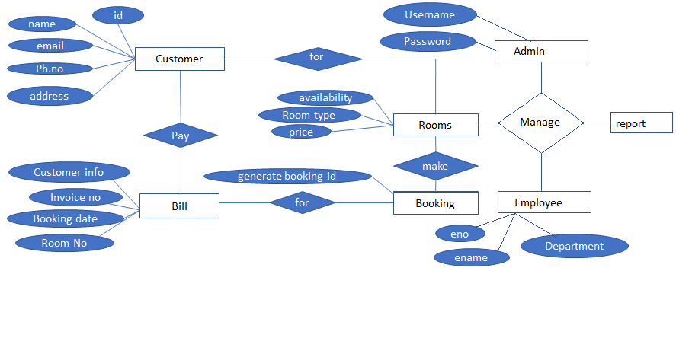

**3.3 Data Flow Diagram [DFD]**

**Level: 0**

Room

Admin

Username

customer

Rooms Type Rate

Admin

password

Customer details add

0.00.0

Login Successful

Booking details

Booking

Information Customer

customer

Booking

Booking

Details

Employee details

Employee

Manage Employee

Employee

Bill Details

Bill

Data Manage

Management

**Level:**

Admin

admin login

Admin

Admin

1.0

Login

Bill, bookings info.

Bill

Pay Customer

Generate booking

customer

Select Room

Booking

Rooms

customer information

Room

Customer

Continuous on next page

Calculation’s,

Generate

inv.no

Bill

Booking

Room

Customer

4.0

Booking

Info.

5.0

Bill

Generate

2.0

Customers

Records

3.0

Room

details

6.0

Employee

Management

Employee info.

Employee

Employee info.

Booking’s ,billings info.

All Bookings Info. and payment info

Employee Details

Billing info.

Employee

Bill

Booking

Room

Admin

Customer

Employee Info.

Room manage

Customer data

Management

Booking details

Room details

Customer Info.

Admin login

7.0

Report Generation

Employee

**3.4 Data Dictionary**

|  |  |  |  |  |
| --- | --- | --- | --- | --- |
| Database  Name | Table  Name | Field  Name | Field Type,  Size | Key Type |
| balajihotel | id_card_type | icard_id | int(3) | Primary Key |
|  |  | icard_type | varchar(30) |  |
| balajihotel | Customer | cid | int(5) | Primary Key |
|  |  | fname | varchar(15) |  |
|  |  | lname | varchar(15) |  |
|  |  | ph_no | bigint(13) |  |
|  |  | email | varchar(30) |  |
|  |  | icard_id | int(3) | Foreign Key |
|  |  | id_number | varchar(20) |  |
|  |  | createdate | varchar(22) |  |
|  |  | invnum | varchar(10) |  |
|  |  | address | varchar(40) |  |
| balajihotel | room_type | rty_id | int(3) | Primary Key |
|  |  | roomty | varchar(25) |  |
|  |  | price | int(8) |  |
|  |  | rtstatus | int(3) |  |
| balajihotel | rooms | rid | int(3) |  |
|  |  | rno | varchar(5) | Primary Key |
|  |  | rty_id | int(2) | Foreign Key |
|  |  | status | int(3) |  |
|  |  | chkin | int(3) |  |
|  |  | chkout | int(3) |  |
|  |  | rdelete | int(3) |  |
| balajihotel | bookings | bid | int(5) | Primary Key |
|  |  | cid | int(5) | Foreign Key |
|  |  | rno | varchar(5) | Foreign Key |
|  |  | rty_id | int(3) | Foreign Key |
|  |  | bdate | varchar(22) |  |
|  |  | ckindate | varchar(15) |  |
|  |  | ckoutdate | varchar(15) |  |
|  |  | pkprice | int(6) |  |
|  |  | nofday | int(3) |  |
|  |  | tprice | int(6) |  |
|  |  | remprice | varchar(6) |  |
|  |  | paystatus | varchar(6) |  |
|  |  | invno | varchar(10) |  |
|  |  | bkstatus | int(3) |  |
| balajihotel | log | lid | int(3) | Primary Key |
|  |  | usname | varchar(15) |  |
|  |  | pass | varchar(15) |  |
| balajihotel | cancelbookings | ccid | int(5) | Primary Key |
|  |  | cid | int(5) | Foreign Key |
|  |  | name | varchar(15) |  |
|  |  | rno | varchar(5) | Foreign Key |
|  |  | ckindate | varchar(15) |  |
|  |  | ckoutdate | varchar(15) |  |
|  |  | pkprice | int(6) |  |
|  |  | nofday | int(3) |  |
|  |  | tprice | int(6) |  |
|  |  | invno | varchar(10) |  |
|  |  | canceldt | varchar(22) |  |
|  |  | cancelreas | varchar(40) |  |
|  |  | bnkname | varchar(30) |  |
|  |  | accno | varchar(30) |  |
|  |  | ifscc | varchar(20) |  |
|  |  | upiid | varchar(40) |  |
|  |  | cancelpaystatus | varchar(6) |  |
| balajihotel | cancelpayment | cpid | int(5) | Primary Key |
|  |  | ccid | int(5) | Foreign Key |
|  |  | transactionid | varchar(40) |  |
|  |  | pamount | varchar(9) |  |
|  |  | reduceper | varchar(5) |  |
|  |  | paidamount | varchar(9) |  |
|  |  | paiddate | varchar(25) |  |
|  |  | profit_amt | varchar(10) |  |
| balajihotel | mesg | srno | int(11) | Primary Key |
|  |  | fname | varchar(12) |  |
|  |  | lname | varchar(12) |  |
|  |  | contactus | varchar(13) |  |
|  |  | subdate | varchar(20) |  |
|  |  | messub | text |  |
| balajihotel | empdgon | edid | int(3) | Primary Key |
|  |  | edname | varchar(25) |  |
|  |  | esalary | varchar(9) |  |
|  |  | edstatus | int(3) |  |
| balajihotel | empattend | aeid | int(5) | Primary Key |
|  |  | eid | int(5) | Foreign Key |
|  |  | achkdate | varchar(25) |  |
|  |  | eastatus | int(3) |  |
|  |  | eapaystatus | int(3) |  |
| balajihotel | empdetail | eid | int(5) | Primary Key |
|  |  | efname | varchar(15) |  |
|  |  | elname | varchar(15) |  |
|  |  | eph_no | bigint(13) |  |
|  |  | eemail | varchar(30) |  |
|  |  | icard_id | int(3) | Foreign Key |
|  |  | eid_number | varchar(20) |  |
|  |  | createdate | varchar(22) |  |
|  |  | edname | varchar(25) | Foreign Key |
|  |  | eaddress | varchar(40) |  |
|  |  | estatus | int(3) |  |

**3.5 File Design**

**identity type:**

|  |  |  |  |  |  |  |
| --- | --- | --- | --- | --- | --- | --- |
| Field | Type | Null | Key | Default | Extra |  |
| icard_id | int(3) | NO | PRI | *NULL* |  |  |
| icard_type | varchar(30) | NO |  | *NULL* |  |  |

**Customer :**

|  |  |  |  |  |  |  |
| --- | --- | --- | --- | --- | --- | --- |
| Field | Type | Null | Key | Default | Extra |  |
| cid | int(5) | NO | PRI | *NULL* | auto_increment |  |
| fname | varchar(15) | YES |  | *NULL* |  |  |
| lname | varchar(15) | YES |  | *NULL* |  |  |
| ph_no | bigint(13) | YES |  | *NULL* |  |  |
| email | varchar(30) | YES |  | *NULL* |  |  |
| icard_id | int(3) | YES |  | *NULL* |  |  |
| id_number | varchar(20) | YES |  | *NULL* |  |  |
| createdate | varchar(22) | YES |  | *NULL* |  |  |
| invnum | varchar(10) | YES |  | *NULL* |  |  |
| address | varchar(40) | YES |  | *NULL* |  |  |

**Room Type**

|  |  |  |  |  |  |  |
| --- | --- | --- | --- | --- | --- | --- |
| Field | Type | Null | Key | Default | Extra |  |
| rty_id | int(3) | NO | PRI | *NULL* |  |  |
| roomty | varchar(25) | YES |  | *NULL* |  |  |
| price | int(8) | YES |  | *NULL* |  |  |
| rtstatus | int(3) | YES |  | *NULL* |  |  |

**Rooms**

|  |  |  |  |  |  |  |
| --- | --- | --- | --- | --- | --- | --- |
| Field | Type | Null | Key | Default | Extra |  |
| rid | int(3) | YES |  | *NULL* |  |  |
| rno | varchar(5) | NO | PRI | *NULL* |  |  |
| rty_id | int(2) | YES |  | *NULL* |  |  |
| status | int(3) | YES |  | *NULL* |  |  |
| chkin | int(3) | YES |  | *NULL* |  |  |
| chkout | int(3) | YES |  | *NULL* |  |  |
| rdelete | int(3) | YES |  | *NULL* |  |  |

**Bookings**

|  |  |  |  |  |  |  |
| --- | --- | --- | --- | --- | --- | --- |
| Field | Type | Null | Key | Default | Extra |  |
| bid | int(5) | NO | PRI | *NULL* | auto_increment |  |
| cid | int(5) | YES |  | *NULL* |  |  |
| rno | varchar(5) | YES |  | *NULL* |  |  |
| rty_id | int(3) | YES |  | *NULL* |  |  |
| bdate | varchar(22) | YES |  | *NULL* |  |  |
| ckindate | varchar(15) | YES |  | *NULL* |  |  |
| ckoutdate | varchar(15) | YES |  | *NULL* |  |  |
| pkprice | int(6) | YES |  | *NULL* |  |  |
| nofday | int(3) | YES |  | *NULL* |  |  |
| tprice | int(6) | YES |  | *NULL* |  |  |
| remprice | varchar(6) | YES |  | *NULL* |  |  |
| paystatus | varchar(6) | YES |  | *NULL* |  |  |
| invno | varchar(10) | YES |  | *NULL* |  |  |
| bkstatus | int(3) | YES |  | *NULL* |  |  |

**Login**

|  |  |  |  |  |  |  |
| --- | --- | --- | --- | --- | --- | --- |
| Field | Type | Null | Key | Default | Extra |  |
| lid | int(3) | NO | PRI | *NULL* | auto_increment |  |
| usname | varchar(15) | NO |  | *NULL* |  |  |
| pass | varchar(15) | NO |  | *NULL* |  |  |

**Cancel bookings**

|  |  |  |  |  |  |  |
| --- | --- | --- | --- | --- | --- | --- |
| Field | Type | Null | Key | Default | Extra |  |
| ccid | int(5) | NO | PRI | *NULL* | auto_increment |  |
| cid | int(5) | YES |  | *NULL* |  |  |
| name | varchar(15) | YES |  | *NULL* |  |  |
| rno | varchar(5) | YES |  | *NULL* |  |  |
| ckindate | varchar(15) | YES |  | *NULL* |  |  |
| ckoutdate | varchar(15) | YES |  | *NULL* |  |  |
| pkprice | int(6) | YES |  | *NULL* |  |  |
| nofday | int(3) | YES |  | *NULL* |  |  |
| tprice | int(6) | YES |  | *NULL* |  |  |
| invno | varchar(10) | YES |  | *NULL* |  |  |
| canceldt | varchar(22) | YES |  | *NULL* |  |  |
| cancelreas | varchar(40) | YES |  | *NULL* |  |  |
| bnkname | varchar(30) | YES |  | *NULL* |  |  |
| accno | varchar(30) | YES |  | *NULL* |  |  |
| ifscc | varchar(20) | YES |  | *NULL* |  |  |
| upiid | varchar(40) | YES |  | *NULL* |  |  |
| cancelpaystatus | varchar(6) | YES |  | *NULL* |  |  |

**Cancel Payments**

|  |  |  |  |  |  |  |
| --- | --- | --- | --- | --- | --- | --- |
| Field | Type | Null | Key | Default | Extra |  |
| cpid | int(5) | NO | PRI | *NULL* | auto_increment |  |
| ccid | int(5) | YES |  | *NULL* |  |  |
| transactionid | varchar(40) | YES |  | *NULL* |  |  |
| pamount | varchar(9) | YES |  | *NULL* |  |  |
| reduceper | varchar(5) | YES |  | *NULL* |  |  |
| paidamount | varchar(9) | YES |  | *NULL* |  |  |
| paiddate | varchar(25) | YES |  | *NULL* |  |  |
| profit_amt | varchar(10) | YES |  | *NULL* |  |  |

**Messages**

|  |  |  |  |  |  |  |
| --- | --- | --- | --- | --- | --- | --- |
| Field | Type | Null | Key | Default | Extra |  |
| srno | int(11) | NO | PRI | *NULL* | auto_increment |  |
| fname | varchar(12) | YES |  | *NULL* |  |  |
| lname | varchar(12) | YES |  | *NULL* |  |  |
| contactus | varchar(13) | YES |  | *NULL* |  |  |
| subdate | varchar(20) | YES |  | *NULL* |  |  |
| messub | text | YES |  | *NULL* |  |  |

**Employee Desingnation**

|  |  |  |  |  |  |  |
| --- | --- | --- | --- | --- | --- | --- |
| Field | Type | Null | Key | Default | Extra |  |
| edid | int(3) | NO | PRI | *NULL* |  |  |
| edname | varchar(25) | YES |  | *NULL* |  |  |
| esalary | varchar(9) | YES |  | *NULL* |  |  |
| edstatus | int(3) | YES |  | *NULL* |  |  |

**Employee Attendance**

|  |  |  |  |  |  |  |
| --- | --- | --- | --- | --- | --- | --- |
| Field | Type | Null | Key | Default | Extra |  |
| aeid | int(5) | NO | PRI | *NULL* | auto_increment |  |
| eid | int(5) | YES |  | *NULL* |  |  |
| achkdate | varchar(25) | YES |  | *NULL* |  |  |
| eastatus | int(3) | YES |  | *NULL* |  |  |
| eapaystatus | int(3) | YES |  | *NULL* |  |  |

**Employee details**

|  |  |  |  |  |  |  |
| --- | --- | --- | --- | --- | --- | --- |
| Field | Type | Null | Key | Default | Extra |  |
| eid | int(5) | NO | PRI | *NULL* | auto_increment |  |
| efname | varchar(15) | YES |  | *NULL* |  |  |
| elname | varchar(15) | YES |  | *NULL* |  |  |
| eph_no | bigint(13) | YES |  | *NULL* |  |  |
| eemail | varchar(30) | YES |  | *NULL* |  |  |
| icard_id | int(3) | YES |  | *NULL* |  |  |
| eid_number | varchar(20) | YES |  | *NULL* |  |  |
| createdate | varchar(22) | YES |  | *NULL* |  |  |
| edname | varchar(25) | YES |  | *NULL* |  |  |
| eaddress | varchar(40) | YES |  | *NULL* |  |  |
| estatus | int(3) | YES |  | *NULL* |  |  |

1. **INPUT / OUTPUT AND REPORT**





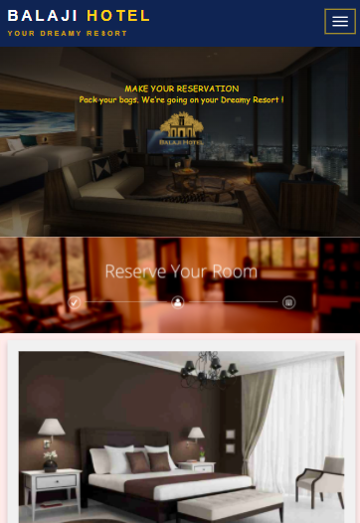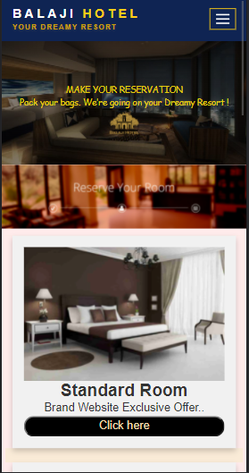

**SCREENSHOTS**

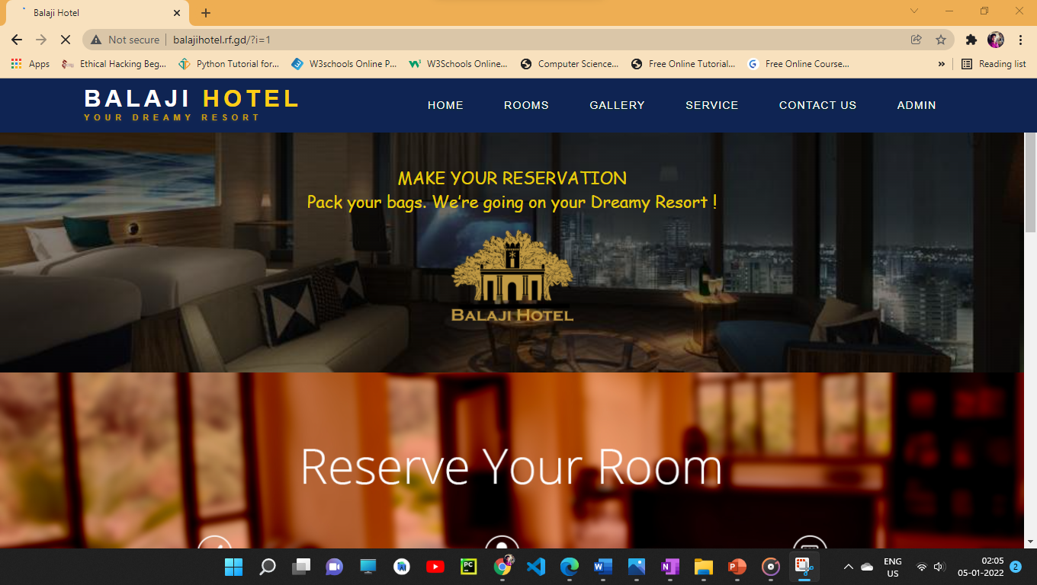

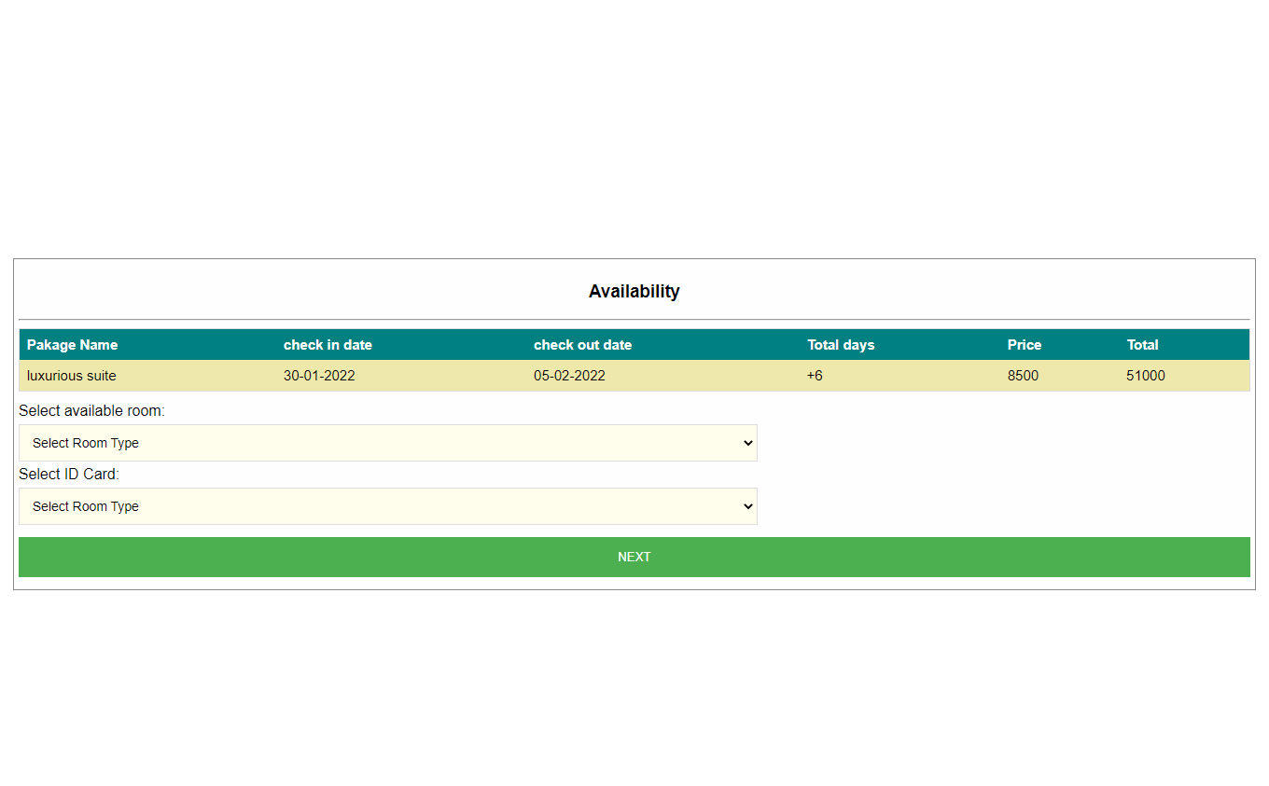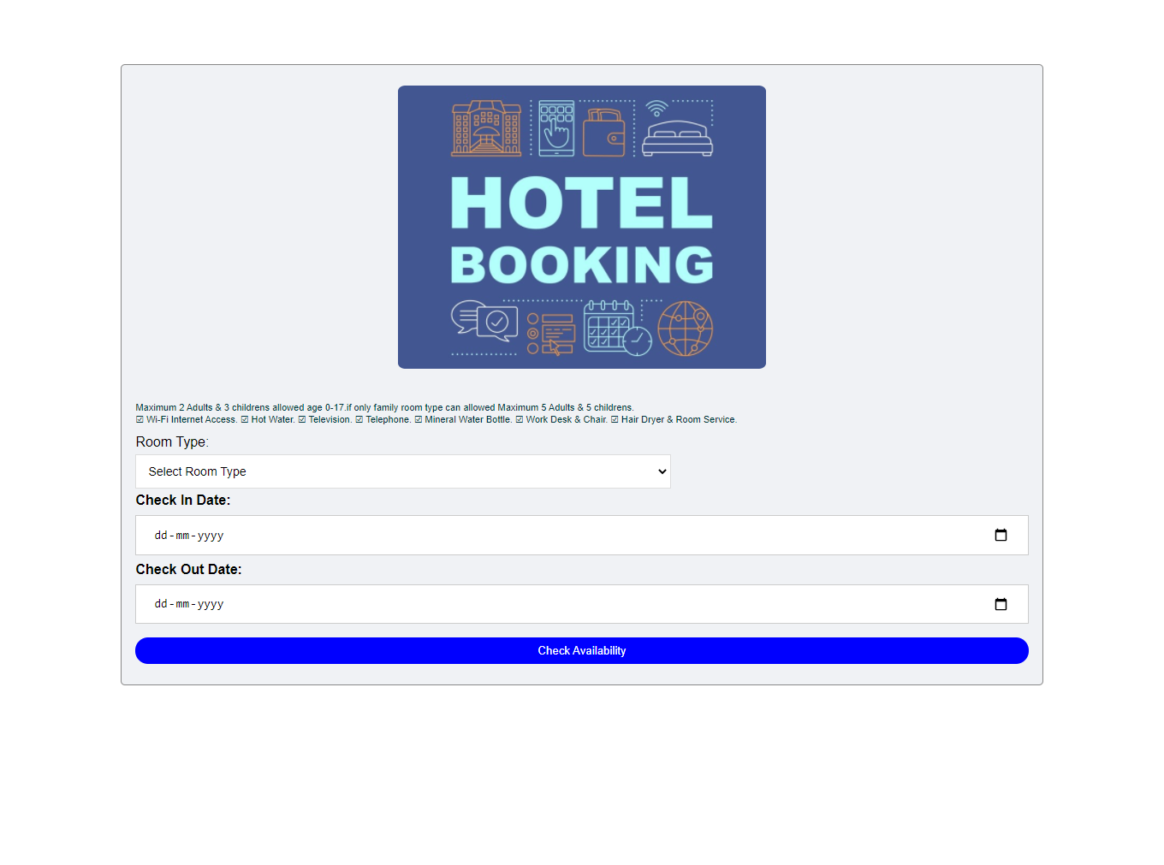

**Select Room Type**

**Check Rooms Availability**

**Fill Customer details And Pay**

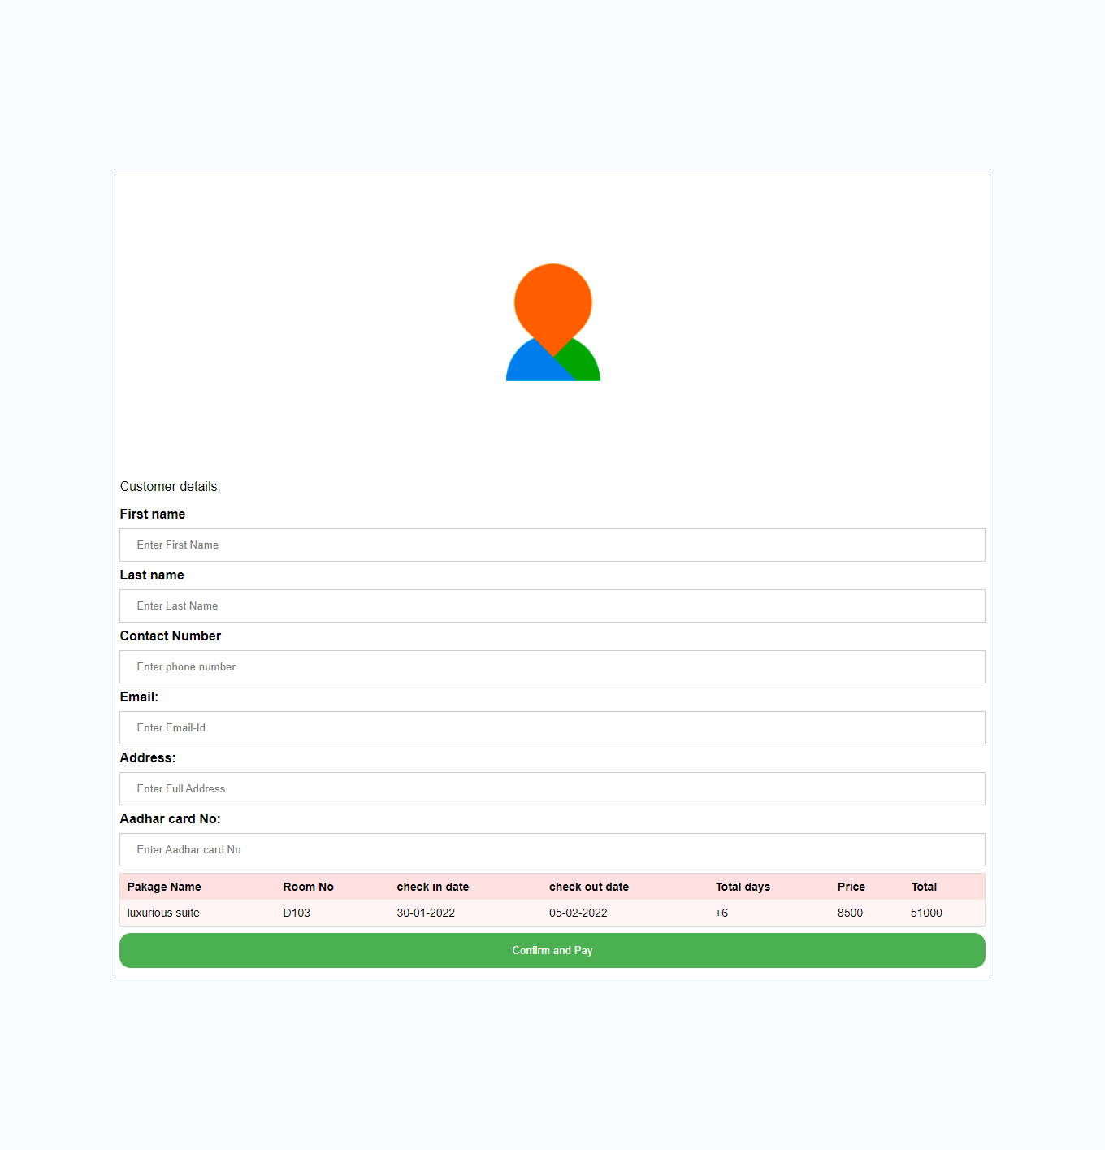

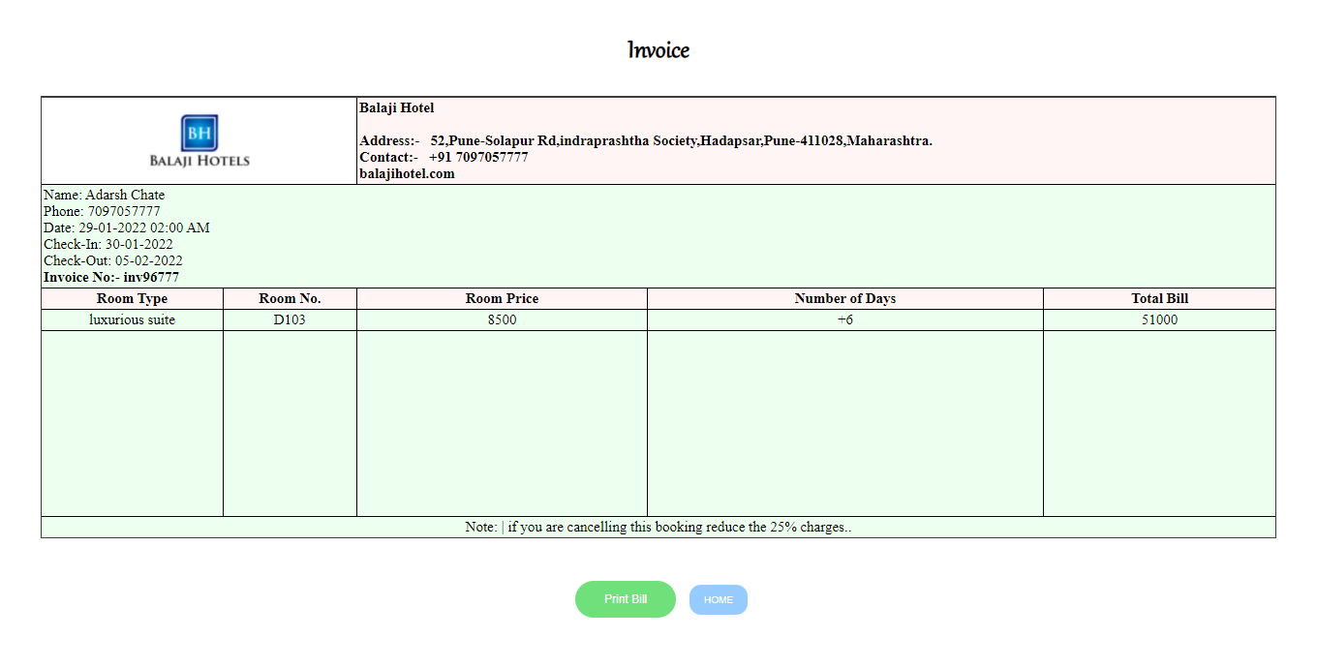

**Admin Login**

**Final Invoice / Bill**

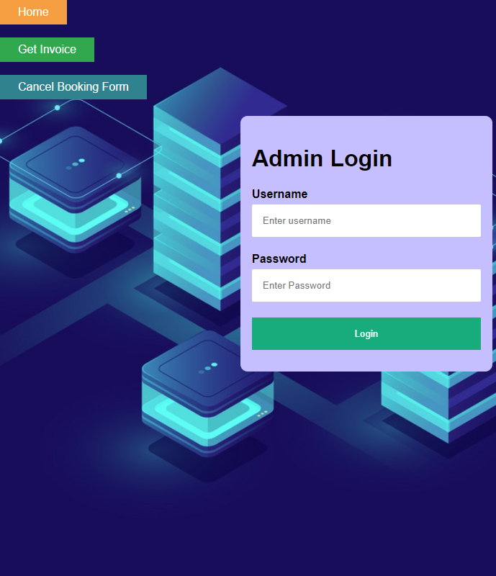

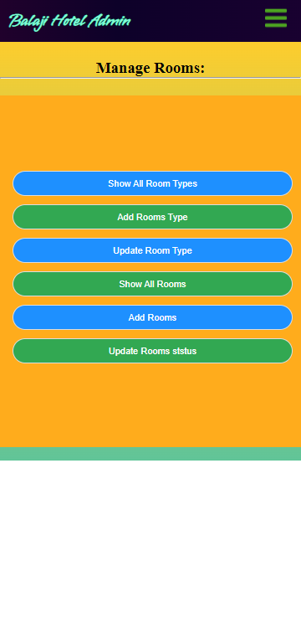

**Admin Manage Reservation Data**

**Admin Manage Rooms**

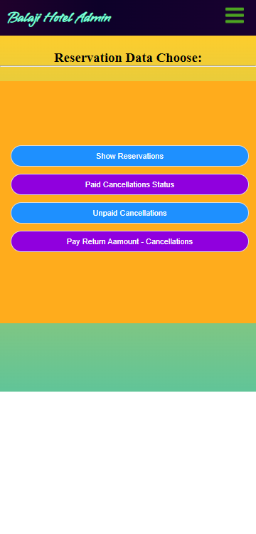

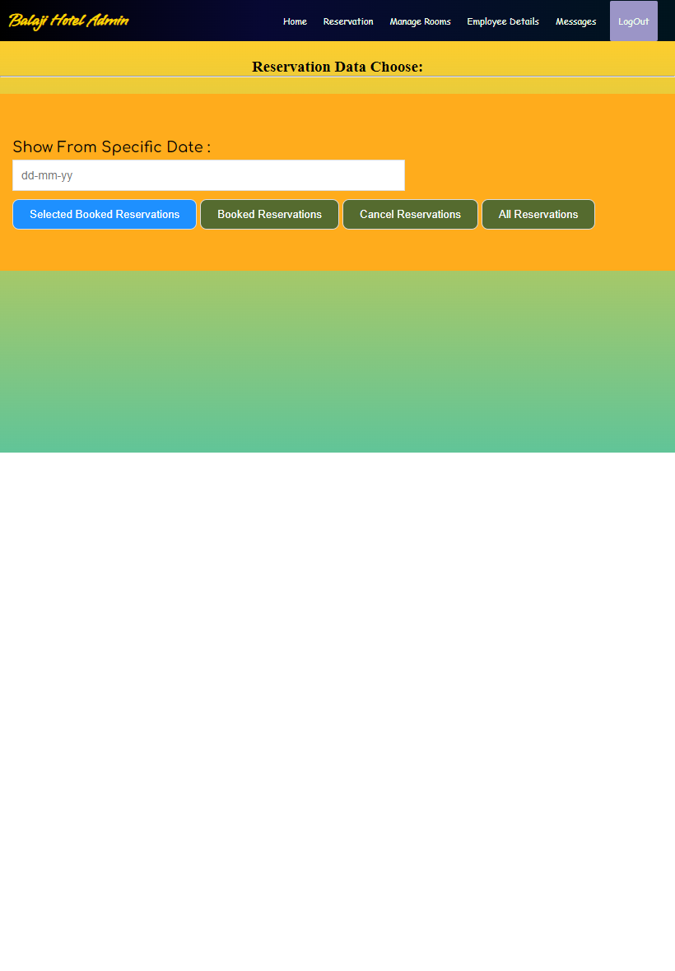

**Admin View reservation Data**

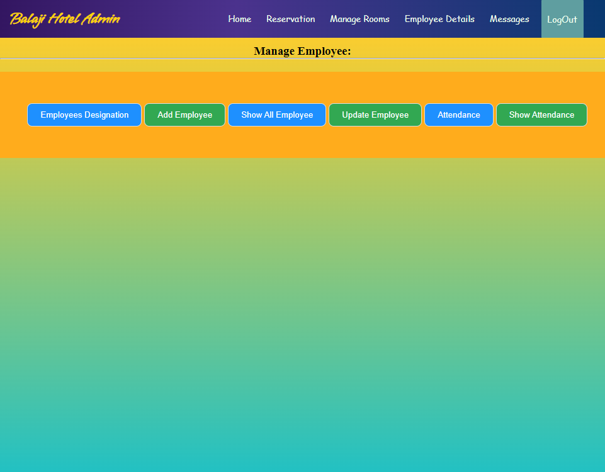

**Admin Manage Employee**

**Admin views feedbacks / Massages**

**Admin Manage Login**

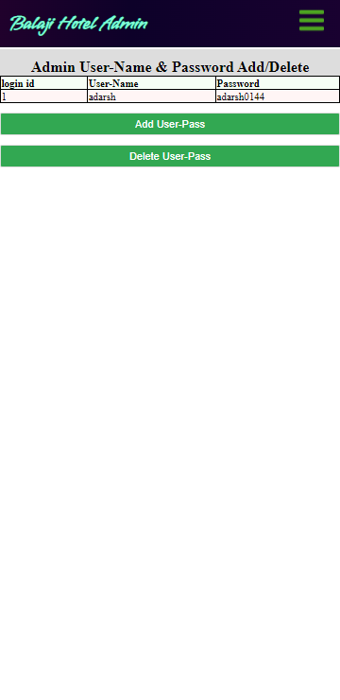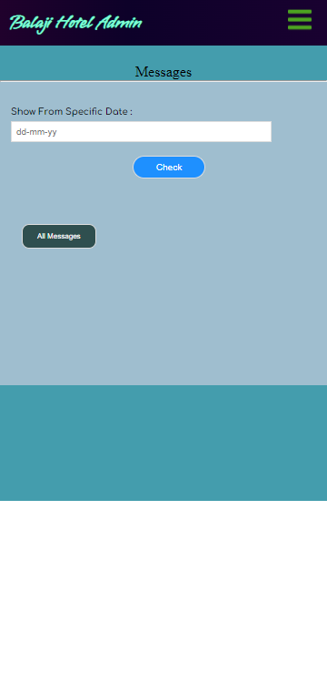

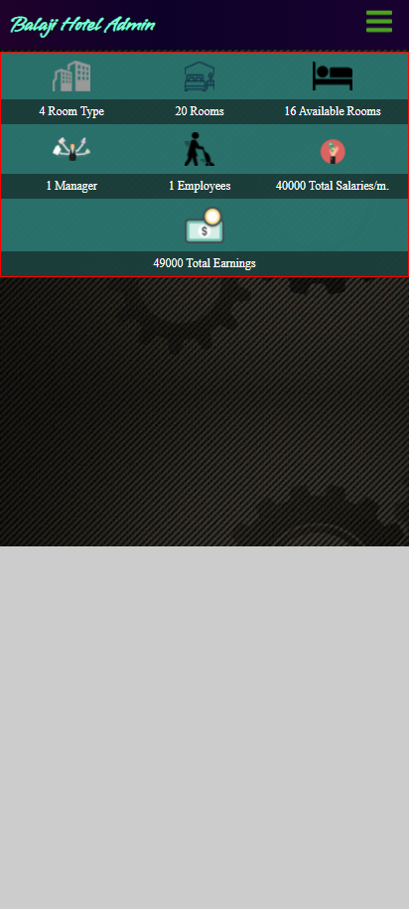

**Admin views Report**

1. **TESTING**

**5.1 Test Plan**

* Software testing is critical element of the software quality assurance and represents the ultimate review of specification , design and coding. “Testing is a process of executing a program with the intent of finding error.”
* **Objectives :**
* The objective of the system are as follows :
* To design different tests that uncovers the error with minimum time and cost.
* To check the software function appears to be working according to specifications given by user.
* A successful test is one that uncovers with the existing system.
* The Software delivered interfaces correctly with the existing system.
* **Types Of Testing :**
* Executing the program with the help of test cases and test data generated does testing the testing techniques are used are described as follows:

**5.2 Black Box Testing**

* The end user has concluded Black Box Testing. The user is most concerned with the inputs that the system accepted and the output that if generated.
* Using this approach, it is useful in the finding the incorrect or missing function , interface errors , errors in database . initialization and termination errors . The user has checked every GUI form and Reports for error.

**5.3 White Box Testing:**

* White box testing sometimes called as Glass-Box testing . It tests the logic or the code written for the system.
* Using this approach , the paths within the module were exercised so that the flow of controls and won’t lead us to make design errors. All the conditions/decision were checked once their true and false side. Loops were tested as their operational boundaries.

**5.4 Validation Test Cases and Result**

* **System Testing :**
* Software and hardware are integrated and fill ranges of the system tests are conducted in an attempt to uncover the error at the software the error at the software interfaces . The backend connectivity (ROLE DB) was checked.
* **Integration Testing :**
* Integration testing is also used to test between the different stages of the project . The entire program was tested as a whole.
* **Load Testing :**
* The system was tested with load testing . The records were added to the system till it failed . The total numbers of transaction are considered as maximum load for the system speed cube compromised.
* **Stress Testing :**
* Stress testing ensures that a system can process its intended workload.
* Loading is steadily increased till the system fails.
* **Modules Testing :**
* Each module was tested for its functionality . The validations were tested in this approach.

1. **ADVANTAGES AND LIMITATIONS**

**Advantages :**

* Easy to registration.
* Fast System Connectivity
* No data duplication.
* No Paper Work Required.
* Time Efficient.
* Cost Efficient.
* Automatic data validation.
* User friendly environment.
* Data security and reliability.
* Fast data insertion & retrieval.
* Easy performance check.

**Limitation :**

* This system is fully online so a good internet connection is mandatory to both side client-side and also server-side.
* Employee or customer with no computer skill or any basic website handling skill is required.

1. **CONCLUSION**

This project is designed to meet the requirements of Online Hotel Management System. It has been developed in PHP, Servlets keeping in mind the specifications of the system.

The conclusion of this project is A Hotel management system is an Online management system. The proposed system will keep a track of Workers, Residents, Accounts and generation of report regarding the present status. This project has GUI based Web Application that will help in storing, updating and retrieving the information through various user-friendly menu-driven modules.

1. **FUTURE ENHANCEMENT**

**Scope of Improvement**

Nowadays hotel is providing many other facilities, this project can also be improved with the improvement in the Hotels. The utmost care and backup procedures must be established to ensure 100% successful implementation of the computerized Web-based booking system.

In the future, we may offer web services to large companies such as service providers e.g., makemytrip, trivago, goibibo . This will make it easier for the customer to book or find a hotel, and the business will improve even more.

1. **BIBLIOGRAPHY AND REFERENCES**

* BOOK REFERRED:

Murach’s PHP and MySQL (2nd Edition)by Joel Murach and Ray Harris

* SITE REFERRED:

[www.tutorialspoint.com/php/](http://www.tutorialspoint.com/php/)

[www.javatpoint.com/php-tutorial](http://www.javatpoint.com/php-tutorial)