**Question 3**

**Cumulative Distribution Function**

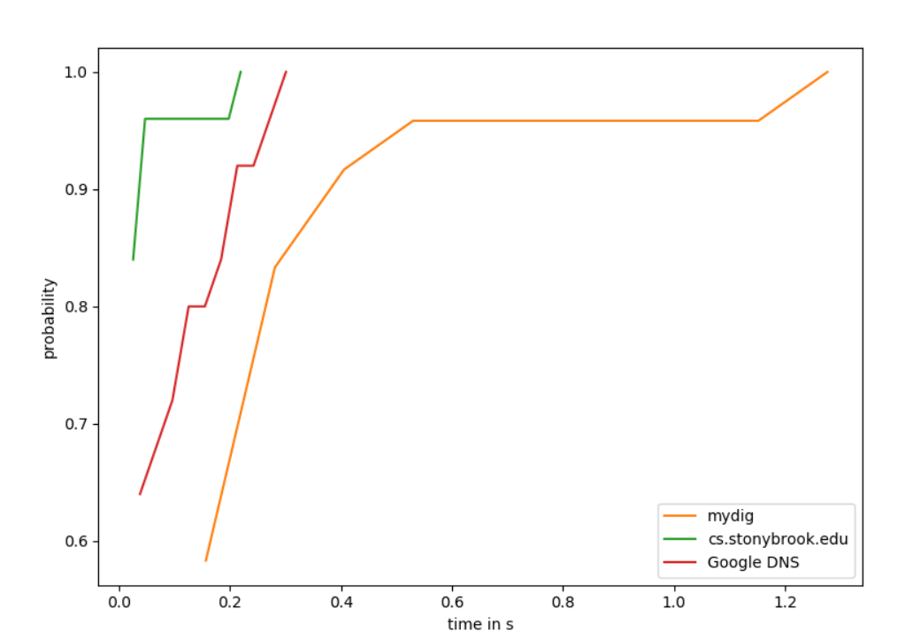

**1.Explanation of Graph:**

The faster a curve reaches a probability of “1”, the faster it resolved a URL.

**1.1 cs.stonybrook.edu: Default resolver:**

The department resolver is the fastest. The graph tells us that most URLs are resolved within 0.1 seconds. A smaller set are resolved in 0.2 seconds. But all records are resolved within 0.2 seconds.

**1.2 Google DNS: 8.8.8.8**

Google DNS performs the “next best”. Most queries are resolved within .3s. The resolution time is “evenly distributed” between 0.05s and 0.3s.

**1.3 mydig**

mydig turns out to be the slowest resolver, taking up 1.2s to resolve a URL to an IP address. But thankfully, most are resolved in less than 0.6s (as the probability crosses 0.9 around that time). A few take over 1s to resolve.

**2.Conclusion:**

The fastest resolver is cs.stonybrook.edu. Google DNS performs competitively, but mydig is the slowest by far (possible because it does not cache any website).