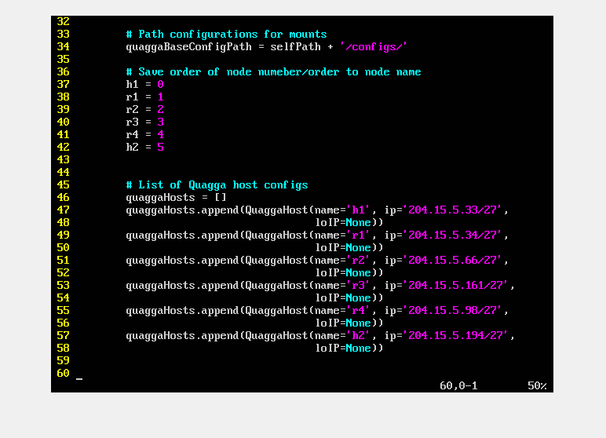

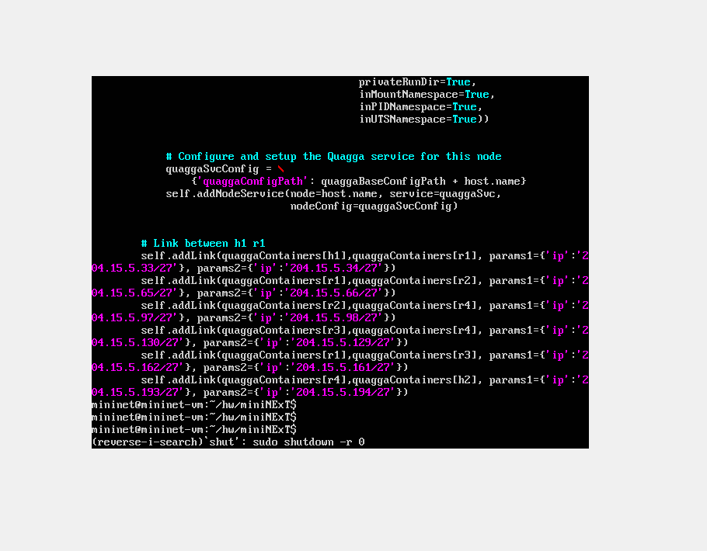

Part B2:

a)

Routing table

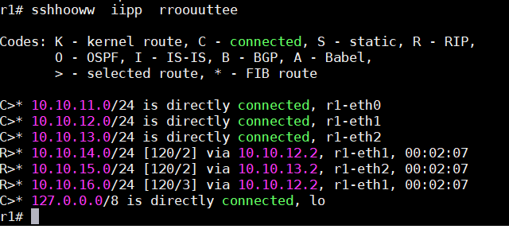

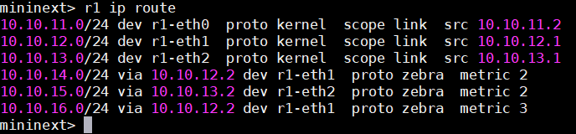

R2

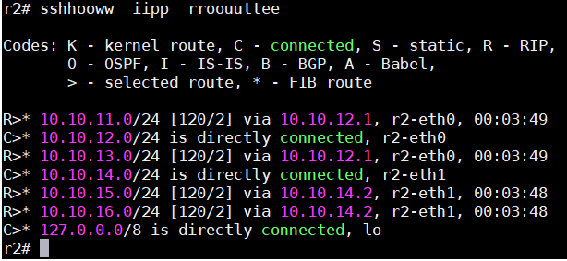

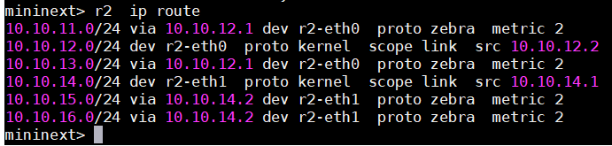

R3

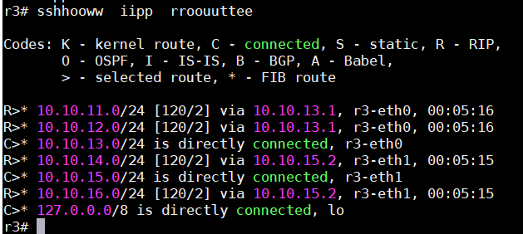

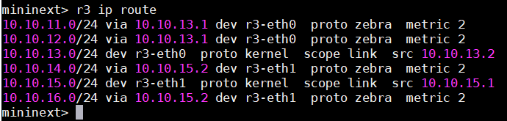

R4

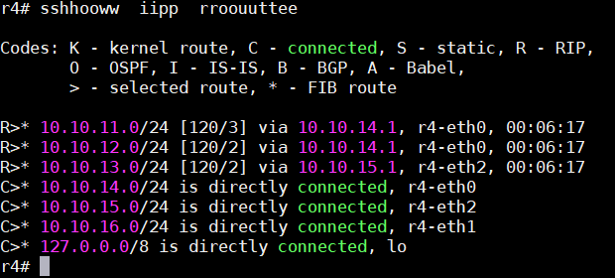

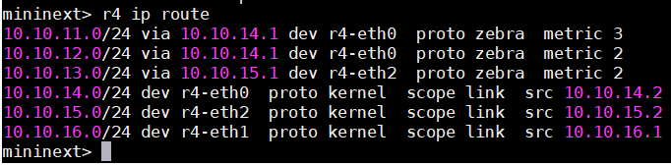

H1

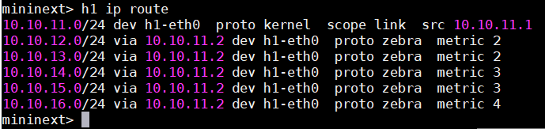

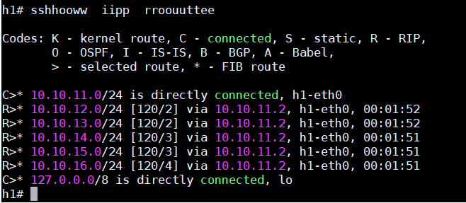

H2

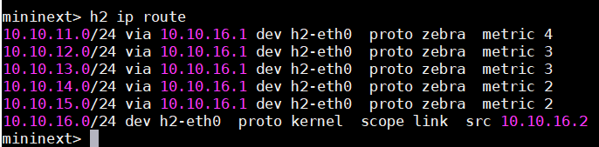

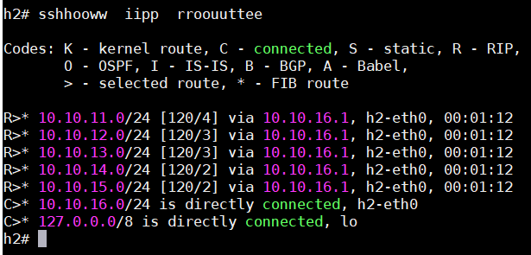

b) Traceroute h1 to h2

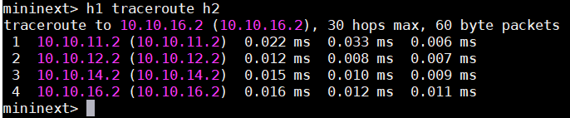

c) Time to ping

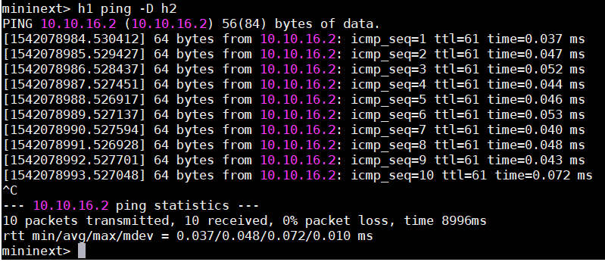

d) Convergence time:

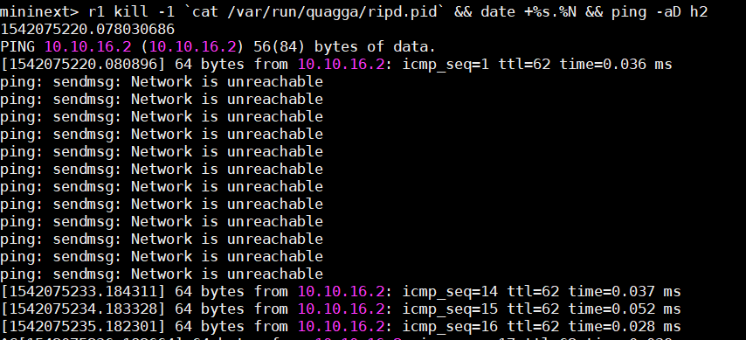

B3:

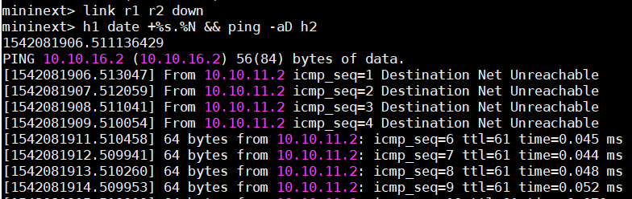

After:

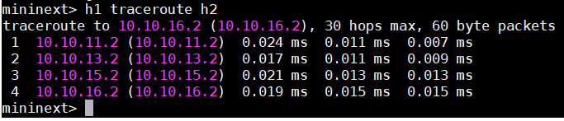

References:

1. <https://www.nongnu.org/quagga/docs/docs-multi/Starting-and-Stopping-ripd.html#Starting-and-Stopping-ripd>
2. <https://www.linux.com/learn/intro-to-linux/2018/3/dynamic-linux-routing-quagga>
3. <https://www.brianlinkletter.com/how-to-build-a-network-of-linux-routers-using-quagga/>
4. <https://cyruslab.net/2012/05/12/install-and-start-quagga/>
5. <https://wiki.gentoo.org/wiki/Quagga#Show_routing_table>