
BCSE307P COMPILER DESIGN LAB PROJECT
(Slot: G2+TG2)
AUTOMATED LLM/AGENT-GUIDED COMPILER CODE OPTIMIZATION
Submitted by:
Registration Number | Name
24BCE2972 | Adarsh Sharma Badhai (Team Leader)
24BAI0345 | Nirupam Raut
Under the guidance of:
Prof. Mukhtar Ahmad Sofi
School of Computer Science and Engineering (SCOPE)
October 2026
ABSTRACT
Standard compilers apply a fixed chain of optimization passes, rarely confirming if a specific transformation actually improved the code’s efficiency. We built a fully automated, multi-agent system to optimize Three-Address Code (TAC) dynamically. Instead of a static pipeline, an orchestrator loop analyzes the code, ranks available opportunities, and proposes transformations using either a rule-based engine or a Google Gemini LLM fallback. Two more LLMs are supported behind the same interface: Groq in the cloud, and a local model served by Ollama that works with no internet connection. A rejected LLM answer is sent back once with the reason. To guarantee correctness, every proposed change must pass a strict dual-verification gate: differential testing across 25+ input sets and symbolic polynomial equivalence for straight-line logic. Loop-free programs with branches are also proved equivalent by the Z3 SMT solver. If a candidate passes, a static cost model evaluates the precise performance benefit before accepting it. Tested on a dataset of 500 programs spanning seven structural categories, the rule-based agent alone achieved an 82.5% cost reduction. Integrating Gemini pushed this to 91.5%, largely by successfully rewriting complex loops and conditionals that standard rules missed. Groq reached 90.9% and the local model 83.3%. The dual-verification system successfully blocked all 26 of Gemini’s incorrect suggestions, proving that language models can be safely integrated into compiler optimization when constrained by formal equivalence checks, resulting in a zero false-positive rate. It also blocked all 6 incorrect suggestions from Groq and all 113 from the local model, so every run finished with zero false positives. On 500 real Codeforces programs the rules cut the static cost by 52.3% and the execution time by 25.2%, and an LLM raised the cost reduction to 53.6% (Gemini), 53.2% (Groq) and 52.4% (Ollama). 253 of them are proved equivalent for every input.
TABLE OF CONTENTS
CHAPTER 1 INTRODUCTION 5
1.1 Background 5
1.2 Motivation 6
1.3 Scope of the Project 7
CHAPTER 2 PROJECT DESCRIPTION AND GOALS 9
2.1 Literature Review 9
2.1.1 Classical Compiler Optimization 9
2.1.2 Superoptimization and Stochastic Search 9
2.1.3 Translation Validation 10
2.1.4 Large Language Models for Code Transformation 10
2.1.5 Multi-Agent Architectures 10
2.2 Gaps Identified 10
2.3 Objectives 11
2.4 Problem Statement 12
2.5 Project Plan 12
CHAPTER 3 TECHNICAL SPECIFICATION 14
3.1 Requirements 14
3.1.1 Functional Requirements 14
3.1.2 Non-Functional Requirements 15
3.2 System Specification 15
3.2.1 Hardware Specification 15
3.2.2 Software Specification 16
CHAPTER 4 DESIGN APPROACH AND DETAILS 17
4.1 Datasets 17
4.1.1 Real-Program Dataset 17
4.2 System Architecture 18
4.2.1 Routing Between the Rules and the LLM 20
4.2.2 LLM Backends 20
4.3 Algorithms 21
4.3.1 Liveness Analysis (Backward May-Analysis) 21
4.3.2 Available-Copy Analysis (Forward Must-Analysis) 21
4.3.3 Symbolic Polynomial Normalization 21
4.3.4 Differential Testing 21
4.3.5 SMT Verification 22
4.3.6 Cost Model: Static Cost and Execution Time 23
4.3.7 LLM Self-Repair 23
4.4 Design 24
4.4.1 Data Flow Diagram 24
4.4.2 Class Diagram 25
CHAPTER 5 IMPLEMENTATION 26
5.1 Module Description 26
5.1.1 Module 1: Front End (src/frontend/) 26
5.1.2 Module 2: TAC Representation and Interpreter (src/tac/) 26
5.1.3 Module 3: Agent Components (src/agents/) 27
5.1.4 Module 4: Optimization Specialist and Routing 27
5.1.5 Module 5: LLM Optimizer (src/agents/optimizer_llm.py) 28
5.1.6 Module 6: Visualization and Demo 28
5.1.7 Module 7: Verification, Cost and Dataset Extensions 29
5.2 Testing 29
CHAPTER 6 RESULTS AND DISCUSSION 32
6.1 Detailed Results 32
6.1.1 Comparing the Three LLMs 33
6.1.2 Results on Real Programs 33
6.2 Output Screenshots 43
6.2.1 Sample Run 43
6.2.2 Sankey Diagram: Proposal Flow 44
6.2.3 Grouped Bar Chart: Outcomes by Optimization Type 45
6.2.4 Line Chart: Cost Trajectory over Iterations 45
6.2.5 Pie Chart: Accepted Optimization Types 46
6.2.6 Scatter Plot: Steps vs. Cost Improvement 46
6.2.7 Heatmap: Category vs. Optimization Type 47
6.2.8 Comparison Charts: Rule-Only vs. Rule + LLM 47
6.2.9 Analysis Charts for the Groq Run 48
6.2.10 Analysis Charts for the Ollama Run 51
6.3 Performance Analysis and Evaluation 54
6.3.1 Limitations 56
REFERENCES 57

CHAPTER 1
INTRODUCTION

1.1 Background
Compiler optimization sits at the boundary between language semantics and machine performance. Since the 1970s, production compilers have shipped with a fixed menu of transformation passes (constant folding, dead-code elimination, loop-invariant code motion, register allocation, and so on) executed in a hardwired order chosen by the compiler engineers. GCC, for instance, runs over two hundred passes in its -O2 pipeline (Stallman et al., 2023). LLVM follows a similar philosophy, chaining dozens of analysis and transform passes into a predetermined sequence (Lattner & Adve, 2004).
The trouble with a fixed pipeline is that it cannot adapt. A program dominated by redundant subexpressions might benefit from aggressive common-subexpression elimination early on, while a program littered with dead stores would be better served by liveness-based cleanup first. The compiler has no way to reason about which pass to run next, or to judge whether a transformation it just applied actually made things better.
Two lines of research have tried to address this rigidity. The first is superoptimization, pioneered by Massalin in 1987 and later scaled up by the STOKE project (Massalin, 1987; Phothilimthana et al., 2016). Superoptimizers search exhaustively (or stochastically) for the shortest instruction sequence that produces the same output, and they verify candidates through testing or SMT solving. They work well on tiny basic blocks but run into combinatorial walls on anything larger.
The second line comes from the recent wave of large language models applied to code. Codex and Code Llama showed that transformer-based models can generate syntactically correct programs from natural-language descriptions (Chen et al., 2021; Rozière et al., 2023). Meta’s LLM Compiler project trained models specifically on LLVM IR and used them to predict which pass ordering would yield the best binary (Cummins et al., 2024). CompilerGym framed pass selection as a reinforcement-learning problem (Cummins et al., 2022). But all of these treat the compiler as a black box whose knobs are being tuned; none of them propose new code-level transformations and verify them against the original semantics.
Translation validation, introduced by Pnueli, Siegel, and Singerman and later refined by Necula, takes the opposite approach (Necula, 2000; Pnueli et al., 1998). Rather than trusting the compiler, it checks after the fact that the output program is semantically equivalent to the input. The idea is sound, but it has mostly been applied as a post-hoc auditor, not as an online decision-maker that guides the optimization process.
Our project brings these threads together. We build a multi-agent system whose orchestrator loop reasons about what to optimize, delegates the actual transformation to either a rule-based engine or an LLM, verifies every candidate through differential testing and symbolic equivalence, and only commits changes that are verified correct and measurably cheaper. The agent runs autonomously from start to finish; no human touches the intermediate code.

1.2 Motivation
We started this project out of a straightforward frustration: compilers are not transparent about why they apply a particular optimization, and they never explain whether a transformation they skipped might have been worthwhile. For a Compiler Design course, understanding optimization is at least as important as implementing parsing and code generation, yet most course projects stop at the TAC generation stage and never close the loop back to correctness.
Two developments made the idea feasible. First, free LLMs are now easy to reach. Our first prototype used a paid API, which made a 500-program run impractical, so we moved to options that cost nothing: Google Gemini and Groq on their free tiers, and a model that runs on our own laptop through Ollama. The local model also removes the dependence on an internet connection and on a daily quota. Second, differential testing is cheap: running a TAC interpreter on a few hundred input vectors takes a fraction of a second per program, so a brute-force equivalence check fits comfortably inside an iterative loop.
The gap we wanted to fill was the absence of any system that pairs an LLM proposer with a verification gate. LLMs hallucinate; that is well documented. But if every suggestion is tested before it is accepted, the hallucination rate becomes a measurable rejection rate rather than a silent bug rate. We thought that would be an interesting thing to quantify, and the results bore it out: 7.65% of Gemini’s proposals, 1.9% of Groq’s and 57% of the local model’s turned out to be wrong, and the verifier caught all of them.

1.3 Scope of the Project
The project covers the following:
- A complete front-end pipeline (lexer, recursive-descent parser, AST, TAC generator) for a small C-like language with integers, arithmetic, comparisons, logical operators, if/else, while, for, and print, and a second front end that accepts a subset of real C for the live demo.
- A TAC interpreter that can execute programs with user-supplied input variables, including division-by-zero trapping and loop-timeout detection.
- Dataflow analyses on the instruction-level control-flow graph: liveness, available copies, and definite assignment.
- Six rule-based optimization passes: constant folding, algebraic simplification, dead-code elimination, common-subexpression elimination, strength reduction, and copy propagation.
- An Optimization Specialist that routes every step to the rule-based optimizer or to an LLM, in one of three modes (rule, hybrid, llm).
- Three LLM proposers behind one interface: Google Gemini, Groq, and a local model served by Ollama for offline use, with structured prompting, response parsing, and automatic retry or disable on API errors.
- A three-stage verifier: differential testing (random, edge, boundary, small-scope, pairwise and wide-range input sets), symbolic polynomial equivalence checking, and an SMT proof with Z3 for programs without loops.
- LLM self-repair: a rejected LLM answer is sent back once with the reason.
- A cost evaluator with a weighted static cost and a measured execution time; either can be the accept/reject gate.
- An orchestrator that ties these components into an autonomous loop running up to 50 iterations per program.
- A 500-program generated dataset covering seven structural categories (arithmetic, nested, repeated-expression, dead-code, loops, conditionals, mixed), and a second dataset of 500 real programs in the same categories.
- Seven visualization charts and a per-program decision log recording every step the agent took, including every routing decision.
What the project does not cover:
- Backend code generation (register allocation, instruction selection, machine code emission).
- Interprocedural or whole-program optimization (function inlining, call-graph analysis).
- Floating-point arithmetic, arrays or string types.
- SMT proofs for programs with loops (those stay tested).
- Execution time on real hardware: the time is an abstract cycle count.

CHAPTER 2
PROJECT DESCRIPTION AND GOALS

2.1 Literature Review

2.1.1 Classical Compiler Optimization
The Dragon Book (Aho et al., 2006) remains the standard reference for dataflow-driven optimization. It describes the lattice-theoretic framework underpinning constant propagation, liveness analysis, and available-expression analysis, and it lays out the algorithms for dead-code elimination, common-subexpression elimination, and loop-invariant code motion. Our implementation follows the Dragon Book’s formulation of liveness and available-copy analysis closely, adapting the iterative fixed-point algorithms to operate at the instruction level rather than the basic-block level.
Muchnick’s textbook (Muchnick, 1997) goes deeper into SSA form, partial redundancy elimination, and global value numbering. We did not adopt SSA (our TAC stays in a simpler named-variable form), but Muchnick’s treatment of copy propagation and algebraic simplification informed several of our rule-based transformations.

2.1.2 Superoptimization and Stochastic Search
Massalin’s 1987 superoptimizer (Massalin, 1987) was the first system to enumerate all possible instruction sequences of increasing length and test each one against the original program. The approach is exact but impractical beyond five or six instructions. STOKE (Phothilimthana et al., 2016) replaced exhaustive search with Markov-chain Monte Carlo sampling, trading completeness for scalability. STOKE verifies candidates using a combination of test-case evaluation and, optionally, an SMT solver. Our differential-testing verifier is conceptually similar to STOKE’s test-case phase, though we add symbolic polynomial normalization as a second check.

2.1.3 Translation Validation
Pnueli et al. introduced translation validation as a way to verify each run of a compiler rather than verifying the compiler itself (Pnueli et al., 1998). Necula extended the idea to handle optimizations like loop unrolling and strength reduction by constructing a simulation relation between the source and target programs (Necula, 2000). Our symbolic verifier is a lightweight variant of this idea: it traces both programs symbolically and compares canonical polynomial representations of the printed output expressions.

2.1.4 Large Language Models for Code Transformation
Codex (Chen et al., 2021) demonstrated that language models trained on code can solve programming problems with surprisingly high accuracy. Code Llama (Rozière et al., 2023) extended this to open-weight models fine-tuned on code-heavy corpora. More recently, Meta’s LLM Compiler (Cummins et al., 2024) fine-tuned Code Llama on 546 billion tokens of LLVM IR and assembly, training it to predict optimized IR and optimal pass orderings. CompilerGym (Cummins et al., 2022) framed compiler optimization as a reinforcement-learning environment. Our work differs from these in a fundamental way: we use the LLM not to pick a pass ordering but to directly propose a rewritten TAC program, and we verify the proposal before accepting it. Open-weight code models can also be run locally (Ollama, 2026), which lets the same proposer work with no internet connection.

2.1.5 Multi-Agent Architectures
AutoGen (Wu et al., 2023) showed that multi-agent conversations, where different agents take on different roles, can solve complex tasks more reliably than a single monolithic prompt. CrewAI and similar frameworks have since popularized the pattern for code generation and research workflows. Our orchestrator–specialist architecture borrows from this idea: the orchestrator does not itself know how to fold constants or eliminate dead code; it delegates to specialist agents and arbitrates their output through the verifier and cost evaluator.

2.2 Gaps Identified
After surveying the literature, we identified the following gaps:
- Classical compilers do not reason about which pass to apply next or whether a transformation was actually beneficial. The pass ordering is hardwired.
- Superoptimizers handle small code fragments well but cannot scale to programs with loops and branches.
- LLM-based code tools produce plausible output but provide no correctness guarantee. An LLM can silently change program semantics, and the user has no way to know without manual inspection.
- Existing LLM-compiler work focuses on pass ordering or flag selection, not on proposing new code-level transformations.
- No prior system combines an LLM-based transformation proposer with a formal or semi-formal verification gate that blocks incorrect suggestions automatically.
- LLM-based tools usually depend on one cloud provider: without a connection, a key or remaining quota they stop working.

2.3 Objectives
- Build a multi-agent architecture with five clearly separated components: an orchestrator, a code analysis specialist, an optimization specialist (rule-based and LLM-based), a verification module, and a cost evaluator.
- Implement the orchestrator loop: analyze, propose, verify, evaluate, accept or reject, and repeat until no opportunity remains.
- Detect six types of optimization opportunities (constant folding, algebraic simplification, dead-code elimination, common-subexpression elimination, strength reduction, copy propagation) and apply the highest-priority one at each step.
- Implement dual verification: differential testing on many input sets and symbolic polynomial equivalence for straight-line code.
- Accept a transformation only when both verification and cost evaluation confirm it is correct and beneficial.
- Integrate free LLMs (Google Gemini and Groq) as proposers, with the same verification gates as rule-based proposals, and let one component decide for every step whether the rules or the LLM should propose.
- Keep the system usable with no internet connection by supporting a local model.
- Measure execution time as well as static cost, so that work removed from a loop counts for more.
- Prove equivalence for all inputs wherever that is possible, instead of only testing it.
- Give an LLM whose answer was rejected the reason and one more attempt.
- Evaluate the system on programs written by people, not only on generated ones.
- Run the agent on 500 programs across seven categories and report verification pass rate, acceptance rate, cost reduction, convergence steps, LLM validity rate, and false-positive rate.
- Produce seven visualization charts summarizing the agent’s behavior across the dataset.

2.4 Problem Statement
Given a program written in a C-like source language, automatically lower it to Three-Address Code and then iteratively optimize the TAC through an autonomous agent loop that (a) identifies optimization opportunities using dataflow analysis, (b) proposes a single transformation per iteration, either rule-based or LLM-generated, as decided by a router, (c) verifies the candidate against the current program through differential testing and symbolic equivalence, (d) accepts the change only if the weighted cost strictly decreases, and (e) repeats until convergence. The system must achieve an average cost reduction above 30% across a 500-program dataset, with a false-positive rate of exactly zero, and it must keep working when no LLM can be reached.

2.5 Project Plan
Table 2.1: Project timeline and milestones
Phase | Task | Duration
1 | Literature survey; define source language grammar; design TAC instruction set | Weeks 1–2
2 | Implement lexer, parser, AST, TAC generator, and TAC interpreter | Weeks 3–4
3 | Implement dataflow analyses (CFG, liveness, available copies, definite assignment) | Week 5
4 | Build the five agent components (analyzer, rule optimizer, verifier, cost evaluator, decision logger) | Weeks 5–7
5 | Wire agents into the orchestrator loop; run on small test programs; debug | Week 7
6 | Generate the 500-program dataset; run the rule-based agent on all programs; collect metrics | Week 8
7 | Integrate Google Gemini LLM proposer; run the combined agent; compare with rule-only baseline | Week 9
8 | Build visualization charts; write decision-log exporter | Weeks 9–10
9 | Add the Optimization Specialist router; add the Groq and Ollama backends and the offline mode | Week 11
10 | Test the verifier itself (fuzzing, mutation testing); add small-scope and pairwise input sets | Week 12
11 | Full runs with all three LLMs; C front end and live demo; report | Weeks 12–13
12 | LLM self-repair; execution time in the cost evaluator; SMT verification with Z3 | Week 14
13 | Real-program dataset from Codeforces submissions; strict mode of the C front end | Week 15
14 | Runs on the real programs; independent re-check; wide-range inputs; final report | Week 16

CHAPTER 3
TECHNICAL SPECIFICATION

3.1 Requirements

3.1.1 Functional Requirements
- Source-to-TAC compilation: The system shall accept programs written in the defined C-like language and produce correct Three-Address Code through lexing, parsing, and code generation.
- Optimization opportunity detection: The code analyzer shall identify constant-folding, algebraic-simplification, dead-code-elimination, common-subexpression, strength-reduction, and copy-propagation opportunities from the TAC, using dataflow analysis on the instruction-level control-flow graph.
- Routing and transformation proposal: The Optimization Specialist shall route each step to the rule-based optimizer or to an LLM and record the reason. The rule-based optimizer shall apply exactly one transformation per iteration. The LLM optimizer shall, when invoked, send the current TAC to the configured model (Gemini, Groq or a local Ollama model) and parse the returned candidate.
- Dual verification: Every candidate (rule-based or LLM-generated) shall pass differential testing on at least 25 input sets and, for straight-line code, symbolic polynomial equivalence checking, before being considered for acceptance.
- Cost-based acceptance: A candidate shall be accepted only if its weighted static cost is strictly lower than the current program’s cost.
- Iterative convergence: The orchestrator shall repeat the loop until no opportunity remains or the iteration cap (50) is reached.
- Decision logging: Every iteration shall be logged with the opportunity analyzed, the route chosen, the transformation proposed, the verification outcome, the cost change, and the accept/reject decision. Logs shall be saved in both human-readable text and structured JSON.
- Metrics and visualization: The system shall compute verification pass rate, acceptance rate, average cost reduction, convergence steps, LLM validity rate, and false-positive count, and produce seven charts.

3.1.2 Non-Functional Requirements
- Correctness guarantee: The false-positive rate must be exactly 0%. No incorrectly optimized program shall pass the verification gate.
- Modularity: Each agent component shall be a separate Python class with a documented input/output interface, so that new optimizations, verification methods or LLM providers can be added without modifying other components.
- Performance: A single program shall be optimized in well under a second with the rules alone and in a few seconds with a cloud LLM. The full 500-program dataset shall complete in under 3 minutes without an LLM and in under 45 minutes with a cloud LLM.
- Graceful degradation: If the LLM is unavailable (missing key, quota exhaustion, network failure, local server stopped), the system shall fall back to rule-based optimization and log the reason.
- Offline operation: The whole agent, including an LLM proposer, shall be able to run with no internet connection.
- Reproducibility: The dataset generator shall produce identical programs when run with the same parameters. Metrics and logs shall be saved in machine-readable formats.

3.2 System Specification

3.2.1 Hardware Specification
Table 3.1: Hardware configuration used for development and testing
Component | Specification
Processor | Intel Core i5 / AMD Ryzen 5 or equivalent (the runs were made on a 13th-generation Intel Core i5 laptop)
RAM | 8 GB minimum; 16 GB for the local model
Storage | 500 MB free disk space; a further 4.7 GB for the local model
Network | Internet connection for the Gemini and Groq calls only; none in offline mode

3.2.2 Software Specification
Table 3.2: Software stack
Software | Version | Purpose
Python | 3.10+ | Core language (uses match statements)
google-genai | $≥$1.0 | Gemini API client
Groq API | HTTP | Called with the Python standard library; no package needed
Ollama | 0.40 | Local model server, with the model qwen2.5-coder:7b
matplotlib | $≥$3.8 | Bar, line, scatter, heatmap charts
plotly | $≥$5.18 | Interactive Sankey diagram
seaborn | $≥$0.13 | Heatmap styling
numpy | $≥$1.26 | Trend-line computation
kaleido | $≥$0.2.1 | Plotly PNG export
pytest | $≥$8.0 | Unit and integration testing
z3-solver | $≥$4.12 | SMT proofs for programs without loops (optional)
pyarrow | $≥$15 | Reading the Codeforces data files (dataset building only)

CHAPTER 4
DESIGN APPROACH AND DETAILS

4.1 Datasets
We wrote a Python generator (dataset/generator.py) that creates 500 source programs spread across seven categories. Each category targets a different mix of optimization opportunities, so the agent faces a range of challenges rather than the same pattern repeated.
Table 4.1: Dataset composition
Category | Count | What it tests
Arithmetic-only | 60 | Straight-line constant expressions (int k = 1 + 14)
Nested expressions | 60 | Multi-level parenthesized sub-expressions requiring many temporaries
Repeated expressions | 60 | Identical sub-expressions computed more than once (CSE targets)
Dead code | 60 | Variables assigned but never read or printed
Loops | 80 | for/while loops with loop-invariant computations and dead stores inside the body
Conditionals | 80 | if/else branches with algebraic identities (x * 1, x + 0)
Mixed | 100 | Programs combining two or more of the above in a single source file
Programs that use input variables (read-before-write) list them in an // inputs: header comment. The verifier feeds those variables many different values during differential testing. Programs without input variables have exactly one possible execution, so a single test run constitutes a proof of equivalence.

4.1.1 Real-Program Dataset
The generated programs are written to contain what the optimizer looks for. To see how the system behaves on code that people actually wrote, we built a second dataset of 500 real programs. They are accepted submissions to Codeforces problems, taken from the dataset open-r1/codeforces-submissions on Hugging Face (open-r1, 2025), which holds 12.6 million submissions under the CC-BY-4.0 licence.
A submission is usable when (i) the judge accepted it, (ii) the C front end compiles it in strict mode, (iii) it prints something, and (iv) it finishes within 20,000 steps on every input set the verifier would try, since otherwise no change to it could be verified. Of 469,491 accepted C and C++ submissions examined (six of the dataset’s 36 files), 9,489 were usable (2.0%), from 234 problems. The others mostly use arrays, further functions, floating point or macros, or read their input inside a loop, none of which the front end supports.
From the usable submissions, 500 were chosen in exactly the proportions of the generated dataset (Table 4.2). Programs that compile to the same TAC count once, each category is filled one program per problem per round, and within a problem the newest submission goes first. The 500 come from 207 problems; 86 were submitted as C and 414 as C-style C++, that is, C++ submissions that use only scanf and printf and nothing else from C++.
Table 4.2: Real-program dataset: composition and how a category is decided
Category | Programs | Problems | Decided by
Arithmetic-only | 60 | 16 | Straight-line code, shallow arithmetic
Nested expressions | 60 | 25 | An expression three or more operators deep
Repeated expressions | 60 | 60 | The same expression written twice
Dead code | 60 | 60 | A stored value that is never read
Loops | 80 | 48 | A loop and no branch
Conditionals | 80 | 79 | A branch and no loop
Mixed | 100 | 91 | A loop and a branch
A stored value that is never read, or an expression written twice, decides the category first, because that is what the generator builds its dead-code and repeated-expression programs around. Everything else is classified by its control flow. Straight-line solutions are rare on Codeforces, so the arithmetic and nested categories draw on fewer problems than the others.
For these programs the front end works in strict mode, which keeps everything a run shows. Text printed by printf, puts or putchar becomes a print of a code that stands for that text, so an optimization that changed which message is printed would fail verification. A return in the middle of main becomes a jump to the end of the program. An expression a && b is refused when b contains a division, because TAC evaluates both sides and C would not.

4.2 System Architecture
Figure 4.1 shows the architecture. Source code enters at the top left, passes through the front end (lexer, parser, AST, TAC generator), and arrives at the agent loop. The Orchestrator controls the cycle: it asks the Code Analysis Specialist to scan the TAC, hands the step to the Optimization Specialist, which routes it to the rules or to an LLM, has the candidate verified, has its cost evaluated, and decides whether to accept. The loop repeats until nothing is left to try. The run then ends with a final check of the optimized program against the original, and its outputs are the optimized TAC, the per-program decision log, the metrics files and the charts.
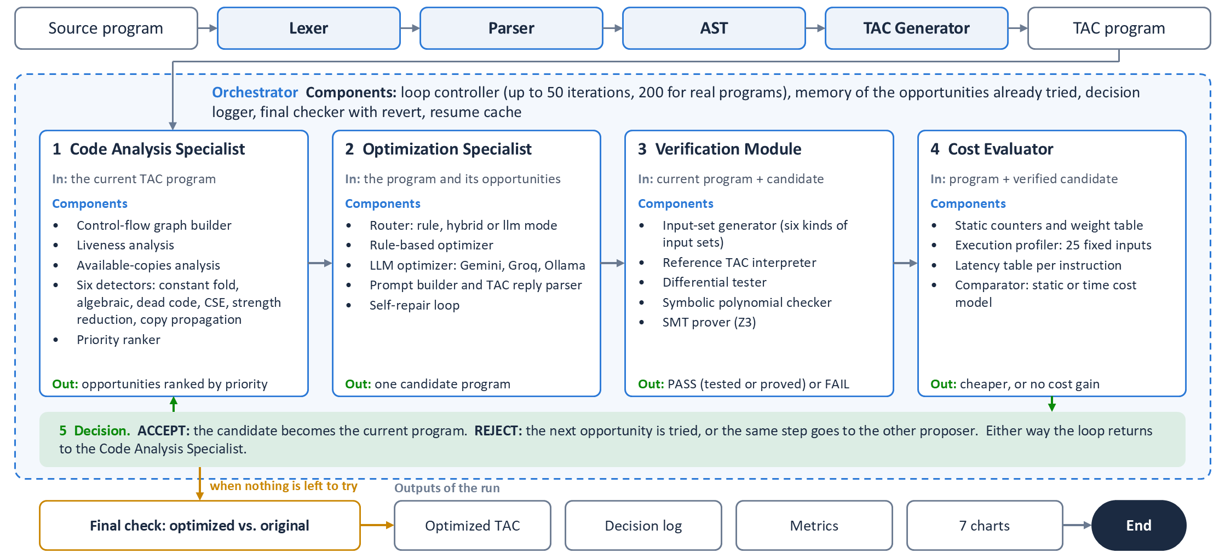
Figure 4.1: System architecture: the front end, the agent loop with the components of each agent, and the end of a run
- Orchestrator. Runs the loop for up to 50 iterations per program, remembers which opportunities were already turned down, logs every decision, and re-verifies the final program against the untouched original.
- Code Analysis Specialist. Builds the control-flow graph, runs the liveness and available-copies analyses, and returns the opportunities it finds, ranked by priority (constant folding 100, algebraic simplification 90, dead code 80, CSE 70, strength reduction 60, copy propagation 50).
- Optimization Specialist. Decides who proposes the next change and returns one candidate program. Option A is the rule-based optimizer, which applies the highest-priority opportunity to a copy of the program. Option B is an LLM, which receives the TAC and is asked for one semantics-preserving optimization.
- Verification Module. Runs the current program and the candidate on the same inputs and compares printed output and failure mode; for straight-line code it also checks symbolic equivalence.
- Cost Evaluator. Computes the weighted cost of both programs and accepts the change only if the cost strictly drops.

4.2.1 Routing Between the Rules and the LLM
The Optimization Specialist has three routing modes, listed in Table 4.3. Whatever the route, the proposal goes through the same verification and cost gates. The LLM is never asked about a program that is already nothing but constant print instructions, because that form is provably minimal. Every routing decision is written to the decision log together with its reason.
Table 4.3: Routing modes of the Optimization Specialist
Mode | First choice | Falls back to the other proposer when
rule | Rules | Never: the LLM is not used
hybrid | Rules | The rule proposal for the step was turned down, or the rules have nothing left to try
llm | LLM | The LLM is not running, its call budget is used up, or its proposal was turned down

4.2.2 LLM Backends
All three backends share one prompt and one reply parser, so their results are directly comparable (Table 4.4). The provider is chosen automatically: Gemini, then Groq, then Ollama, whichever is configured and reachable. An offline switch forces the local model.
Table 4.4: The three LLM backends
Backend | Model | Runs on | Notes
Gemini | gemini-3.1-flash-lite | Google cloud | Free API key; called through the SDK
Groq | gpt-oss-120b | Groq cloud | Free API key; moves to the next model when a daily quota is spent
Ollama | qwen2.5-coder:7b | The laptop | No key and no internet; falls back to the CPU if the GPU runner fails

4.3 Algorithms
The project relies on several well-known compiler algorithms, each adapted to work on individual TAC instructions rather than basic blocks.

4.3.1 Liveness Analysis (Backward May-Analysis)
Starting from the last instruction, we propagate live variable sets backward through the CFG. At each instruction, a variable is added to the live set if it is read, and removed if it is defined. The analysis iterates until no set changes. Dead-code elimination uses the resulting live-out sets: if an instruction defines a variable that is not live at its exit and cannot trap (no division by a variable), the instruction is dead.

4.3.2 Available-Copy Analysis (Forward Must-Analysis)
We track pairs $(x,y)$ meaning “$x=y$ is still valid.” At CFG joins we intersect, so a copy is available only if it reaches along every path. Whenever $x$ or $y$ is redefined, all pairs mentioning it are killed. Copy propagation uses these sets to replace uses of $x$ with $y$ wherever the copy is available.

4.3.3 Symbolic Polynomial Normalization
For straight-line code (no labels, no jumps), we trace each variable as a multivariate polynomial in the input variables. Addition, subtraction, and multiplication map directly to polynomial operations, so $x+x$ and $2×x$ normalize to the same polynomial; division and modulo produce opaque terms that are compared structurally. Two programs are symbolically equivalent if their printed expressions normalize to the same polynomial, and the set of divisors that could trap before each print is identical.

4.3.4 Differential Testing
We run the current and the candidate TAC programs through the interpreter on the same input sets. Both programs must print the same output sequence and either both succeed or both fail with the same exception type (such as a division by zero or a timeout). The input sets are built in six ways, listed in Table 4.5.
Table 4.5: Input sets used by differential testing
Input sets | What is tried | What it catches
Random | 20 sets with values from $-100$ to $100$ | General differences
Edge cases | All inputs equal to 0, 1, $-1$, 99, $-99$ | Zero and sign handling
Boundary | $c-1$, $c$, $c+1$ for every literal $c$ | Off-by-one comparisons
Small scope | Every combination of a few small values (one input: every value from $-128$ to $128$) | && against ||, a branch on a flag
Pairwise | Every two inputs with every two boundary values | Two inputs that must line up
Wide range | 60 sets with values up to a thousand, ten thousand, a million and a billion, signed values, and powers of ten with their neighbours | A change that is right only for small inputs
The last two kinds were added after mutation testing (Section 5.2) showed that random values almost never make one input zero while another is not, which is exactly what tells && from ||.
The wide-range sets were added after the re-check of the runs on real programs (Section 5.2). A run that is too long for them is skipped, so they never make a program unverifiable.

4.3.5 SMT Verification
Differential testing shows that two programs agree on the inputs that were tried. For a program with branches but no loops there are finitely many paths, so its whole behaviour can be written as one formula over its inputs. The verifier follows every path symbolically: a branch splits the path in two, and a division splits off the case in which the divisor is zero, where the run stops with what it has printed so far. The paths are then folded into a single description of a run (how it ends, how many values it prints, and the values), and the Z3 solver (de Moura & Bjørner, 2008) is asked for an input on which the descriptions of the two programs differ (Table 4.6).
Table 4.6: The three answers of the SMT stage
Answer | Meaning and consequence
unsat | No such input exists: the two programs are equivalent for all inputs. The result is recorded as proved.
sat | Z3 returns the input. It is replayed in the reference interpreter, and if the outputs really differ the proposal is rejected with that counterexample.
unknown | No answer within three seconds, usually because of non-linear arithmetic. The verdict of differential testing stands.
Integers are unbounded and division and modulo follow C, exactly as in the interpreter. The stage runs on every LLM proposal and on the end-to-end check of every program. Programs with loops are outside its scope and remain tested. As an example of what it adds: a program that prints 1 when $3x=999999$ and 0 otherwise differs from a program that always prints 0 on the single input $x=333333$, which is near no literal in either program, so every test passes. Z3 finds that input immediately.

4.3.6 Cost Model: Static Cost and Execution Time
The static cost of a program is a weighted count of its instructions, arithmetic operations, temporaries, copies and branches. It cannot see how often an instruction runs. The Cost Evaluator therefore also measures execution time: the program is run on 25 fixed inputs (20 random sets, half of them positive, and 5 edge cases), every executed instruction adds its latency from Table 4.7, and the time is the average over the runs. The values given to an input depend only on its name, so a program and a candidate are timed on the same data.
Table 4.7: Latency charged per executed instruction (abstract cycles)
Instruction | Cycles
Copy, load a constant | 1
Addition, subtraction, shift, comparison, logic | 1
Multiplication | 3
Division, modulo | 20
Unconditional jump | 1
Conditional branch | 2
Print | 1
Label | 0
Two cost models decide what counts as an improvement. Under the static model, the default, a change is accepted if the static cost drops; all results on the generated dataset use it. Under the time model a change is accepted if the measured time drops, or if the time is equal and the static cost drops. Every run reports both reductions, whichever model decides.

4.3.7 LLM Self-Repair
When an LLM answer is rejected, the reason is specific: the verifier has the inputs on which the outputs differ, or the parser has the line that is not valid TAC. The Optimization Specialist sends the model its rejected answer together with that reason and asks once more. The second answer goes through exactly the same verification and cost gates as any other proposal, so self-repair cannot make the system less safe; it can only turn a wasted call into a useful one. By default one repair is allowed per rejected answer, and repairs do not use up the budget of fresh proposals.

4.4 Design

4.4.1 Data Flow Diagram
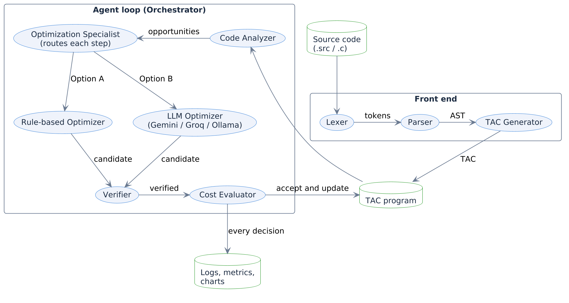
Figure 4.2: Data flow diagram showing inputs, outputs, and intermediate data at each stage

4.4.2 Class Diagram
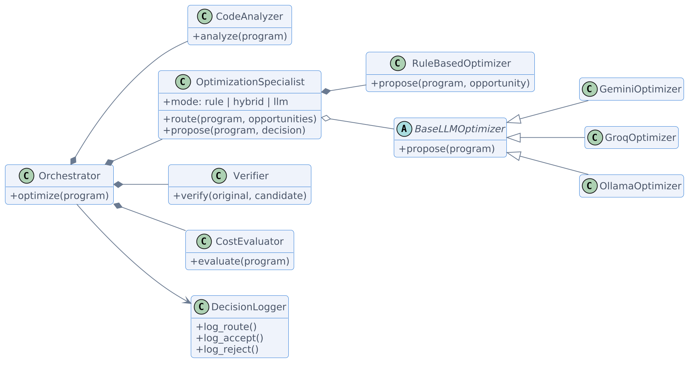
Figure 4.3: Class diagram of the agent architecture. The Optimization Specialist owns the rule-based optimizer and holds one of three interchangeable LLM backends

CHAPTER 5
IMPLEMENTATION
This chapter walks through the major modules, shows representative code fragments, and describes the test suite. All source code is in Python 3.10+.

5.1 Module Description

5.1.1 Module 1: Front End (src/frontend/)
The front end has four files: lexer.py (tokenization), ast_nodes.py (AST dataclasses), parser.py (recursive-descent parser), and tac_generator.py (AST-to-TAC lowering). A convenience function compile_source(text) chains the stages. A second front end, c_frontend.py, parses a subset of real C into the same AST, so an ordinary .c file can go through the same agents in the live demo.
Listing 5.1: From tac_generator.py: lowering an if statement that has an else part to TAC (trimmed)
def _gen_if(self, stmt: IfStmt) -> None:
cond = self._gen_expr(stmt.condition)
l_else = self._new_label()
l_end = self._new_label()
self._emit(TACInstruction(TACOp.IF_FALSE_GOTO, arg1=cond, label=l_else))
self._gen_block(stmt.then_body)
self._emit(TACInstruction(TACOp.GOTO, label=l_end))
self._emit(TACInstruction(TACOp.LABEL, label=l_else))
self._gen_block(stmt.else_body)
self._emit(TACInstruction(TACOp.LABEL, label=l_end))

5.1.2 Module 2: TAC Representation and Interpreter (src/tac/)
The TAC subsystem defines TACInstruction (a dataclass with fields op, result, arg1, operator, arg2), TACProgram (a container with serialization, deep copy, and input-variable detection), and TACInterpreter (an execution engine that returns printed output as a list of integers). The interpreter enforces C-style truncating division and raises typed exceptions (DivisionByZeroError, ExecutionTimeout, UndefinedVariableError) that the verifier distinguishes when comparing runs.
dataflow.py holds the CFG builder and the analyses: liveness, available copies, definite assignment, and reachability. All follow the textbook iterative fixed-point pattern.

5.1.3 Module 3: Agent Components (src/agents/)
The five components are separate classes. orchestrator.py runs the loop; code_analyzer.py finds opportunities; optimization_specialist.py routes each step and owns optimizer_rule.py and optimizer_llm.py; verifier.py and cost_evaluator.py are the two gates. Listing 5.2 is the core logic of the Orchestrator. It enforces our safety rules: a change is only kept if it passes verification and reduces the static cost. If the proposal for a step is turned down, the Specialist may hand the same step to the other proposer.
Listing 5.2: The Orchestrator loop (trimmed, from orchestrator.py)
for iteration in range(1, self.max_iterations + 1):
# 1. ANALYZE (leaving out opportunities already turned down)
opportunities = [o for o in self.analyzer.analyze(current)
if self._opportunity_key(o) not in attempted]
# 2-5. PROPOSE -> VERIFY -> EVALUATE -> ACCEPT/REJECT
tried, outcome = [], None
while outcome not in ("accepted", "unverifiable"):
decision = specialist.route(current, opportunities,
llm_calls, tried)
if decision.route is None:
break # nobody can propose anything more
tried.append(decision.route)
proposal = specialist.propose(current, decision, opportunities)
outcome = self._judge(iteration, current, proposal)
if outcome == "accepted":
current = proposal.candidate
attempted.clear() # new opportunities may appear
if outcome != "accepted" and not opportunities:
break # converged: nothing left to try
The verifier (verifier.py, 386 lines) runs differential testing first. If the program has no control flow, it also runs the symbolic trace and requires both to agree. The cost evaluator (cost_evaluator.py, 64 lines) counts instructions, arithmetic operations, temporary variables, memory operations (copies), and branch operations, multiplies each by a fixed weight (1.0, 2.0, 0.5, 1.5 and 1.0), and sums them into a single scalar.

5.1.4 Module 4: Optimization Specialist and Routing
The routing decision is a short method of the Optimization Specialist (Listing 5.3). The mode sets the order in which the two proposers are considered, and a proposer is skipped when it has nothing to offer.
Listing 5.3: The routing decision (trimmed, from optimization_specialist.py)
def route(self, program, opportunities, llm_calls=0, tried=()):
order = ([Route.RULE, Route.LLM] if self.mode != "llm"
else [Route.LLM, Route.RULE])
if not self.llm_attached:
order = [Route.RULE]
passed_over, llm_note = [], ""
for route in order:
if route in tried:
name = "rule-based" if route is Route.RULE else "LLM"
passed_over.append(f"the {name} proposal was turned down")
elif route is Route.RULE and not opportunities:
passed_over.append("the rules have nothing left to try")
elif route is Route.LLM and (
llm_note := self._llm_blocker(program, llm_calls)):
passed_over.append(f"LLM not used, {llm_note}")
else:
reason = self._reason(route, opportunities, passed_over)
return RoutingDecision(route, reason, llm_note)
return RoutingDecision(None, "; ".join(passed_over), llm_note)

5.1.5 Module 5: LLM Optimizer (src/agents/optimizer_llm.py)
The LLM optimizer defines a base class BaseLLMOptimizer with a shared prompt template and response parser, and three concrete subclasses: GeminiOptimizer calls the Google Gen AI SDK, GroqOptimizer calls Groq’s HTTP API and moves to the next model when a daily quota is spent, and OllamaOptimizer calls a model running on the same machine. The prompt asks the model to propose “exactly one semantics-preserving optimization” and return the result inside <tac> tags. The parser strips markdown fences and line-number prefixes before feeding the text to TACProgram.from_string().
The first prototype also had a provider for a paid API. It was removed, because a paid key made large-scale runs impractical; the three providers that remain are all free to use.

5.1.6 Module 6: Visualization and Demo
charts.py produces seven chart types: (1) Sankey diagram of proposal flow, (2) grouped bar chart of outcomes per optimization type, (3) line chart of cost trajectory for five representative programs, (4) donut chart of accepted optimization types, (5) scatter plot of agent steps vs. cost improvement with trend lines, (6) heatmap of category vs. optimization type, and (7) a comparison bar chart of rule-only vs. rule+LLM reduction per category. report.py aggregates per-program results into the metrics summary (JSON and CSV) and formats the human-readable metrics table. demo.py is a terminal front end that takes a C program and walks through the whole pipeline on screen, stage by stage.

5.1.7 Module 7: Verification, Cost and Dataset Extensions
smt_verifier.py holds the SMT stage: a symbolic walk over every path of a loop-free program and the query to Z3. cost_evaluator.py gained the execution profiler and the latency table, and the interpreter can report how often each instruction ran. The self-repair loop sits in the Orchestrator right after the two gates, and the repair prompt in optimizer_llm.py. dataset/real_dataset.py builds the real-program dataset (collect, select, rebuild from the manifest). Full runs save every finished program at once, so a run that is interrupted, or stopped because a free daily quota is spent, can be resumed; ollama_demo.bat starts the offline demo with one command.

5.2 Testing
We wrote 407 automated tests across 19 test files, covering every component (Table 5.1). The LLM backends are tested against stand-in local servers, so the tests need no API key, no Ollama installation and no network.
Table 5.1: Test suite summary
Test file | Component | Tests
test_lexer.py | Lexer | 14
test_parser.py | Parser | 22
test_tac_generator.py | TAC generator | 14
test_c_frontend.py | C front end | 42
test_interpreter.py | TAC interpreter | 33
test_analyzer.py | Code analyzer | 21
test_optimizer.py | Rule and LLM optimizers | 27
test_optimization_specialist.py | Routing | 20
test_groq.py | Groq backend | 26
test_ollama.py | Ollama backend | 24
test_self_repair.py | LLM self-repair | 14
test_verifier.py | Verifier | 40
test_cost_evaluator.py | Cost evaluator | 10
test_review3_features.py | Execution time, SMT, wide-range inputs | 21
test_real_dataset.py | Real-program dataset, strict C | 26
test_orchestrator.py | Orchestrator (integration) | 16
test_demo.py | Demo front end | 21
test_bugfixes.py | Regression tests | 13
The verifier tests are worth calling out specifically. We inject incorrect transformations (wrong constant folds, operand swaps on non-commutative operators, deletion of live stores, off-by-one loop conditions, removed loop increments, deleted trapping divisions, reordered output, and dropped output) and confirm that every one is rejected. This is how we verify the verifier itself. We then tested the system at a larger scale:
- Fuzzing the rules. 5,100 random TAC programs were generated, and all 20,968 rule-based proposals for them were compared with the original on inputs the verifier does not use. None changed the program’s behaviour.
- Mutation testing the verifier. Random branching programs were changed in one place (an operator, a constant or an operand), the way a wrong LLM proposal might be. Of the first 400 mutants, the verifier accepted 194, and 13 of those behaved differently from the original. After the small-scope and pairwise input sets were added, the verifier accepted 351 of 800 mutants and none of them behaves differently.
- Re-checking the results. For every run, each final program was executed against its original on every combination of small input values plus random ones (about 64,000 executions per run). No mismatch was found.
- Replaying the Gemini run. The 383 recorded Gemini replies were replayed through the strengthened verifier. Every proposal received the same decision as before.
The same testing found one bug in the rules: strength reduction rewrote $x×2^{k}$ to a shift even for $k>64$, which the interpreter rejects. The proposal was caught by the verifier every time, and the analyzer no longer makes it.
The extensions are tested in the same way. The SMT stage is checked against hand-built pairs of programs: equivalent ones must be proved, and pairs that differ on a single input, in the order of their output, or in whether a division traps must be refuted with the right counterexample.
Re-checking the runs on real programs. Every optimized program was run against its original on inputs the verifier had not used, including values up to a million. For the rule-based runs and the Gemini and local-model runs no mismatch was found. In the Groq run the re-check found one wrong program. The model had replaced x - 1 by the constant 9 inside a loop in which x is multiplied by ten in every iteration. The change is correct while x is 10, and the loop runs a second time only for inputs of 100 or more, which none of the verifier’s input sets reached, so all 388 tests had passed. The verifier now adds the 60 wide-range input sets of Table 4.5. With them the wrong change is rejected with a counterexample. The affected program was optimized again, and the re-check of all runs on real programs (539,170 executions) now finds no mismatch. The four runs on the generated dataset were re-checked on the same wide inputs, also without a mismatch.

CHAPTER 6
RESULTS AND DISCUSSION

6.1 Detailed Results
We ran the agent four times on the full 500-program dataset: once with the rule-based optimizer only, and three times in hybrid mode, in which an LLM is asked when the rules hit a wall. Table 6.1 summarizes the headline numbers.
Table 6.1: Aggregate metrics across 500 programs
Metric | Rule-only | Rule + Gemini | Rule + Groq | Rule + Ollama
Total proposals | 10,628 | 10,978 | 11,085 | 10,805
Accepted | 10,517 | 10,828 | 10,925 | 10,579
Verification pass rate | 100.00% | 99.76% | 99.95% | 98.95%
Acceptance rate (of verified) | 98.96% | 98.87% | 98.61% | 98.94%
Avg. cost reduction | 82.49% | 91.50% | 90.89% | 83.28%
Steps to convergence (mean) | 22.2 | 22.7 | 22.9 | 22.3
LLM validity rate | — | 92.35% | 98.11% | 42.93%
False positives | 0 | 0 | 0 | 0
The rule-based agent already meets the 30% cost-reduction target for every single program. Adding a cloud LLM lifts the average by roughly nine percentage points, with the biggest gains in the categories that rules handle least well (Table 6.2).
Table 6.2: Per-category cost reduction
Category | Programs | Rule-only | + Gemini | + Groq | + Ollama
Arithmetic | 60 | 96.03% | 96.03% | 96.03% | 96.03%
Nested | 60 | 98.10% | 98.22% | 98.31% | 98.19%
Repeated expr | 60 | 80.71% | 81.65% | 80.94% | 80.71%
Dead code | 60 | 97.44% | 97.44% | 97.44% | 97.44%
Loops | 80 | 65.05% | 93.35% | 93.43% | 66.09%
Conditionals | 80 | 73.91% | 84.07% | 83.48% | 75.21%
Mixed | 100 | 77.91% | 91.56% | 89.29% | 79.96%
All | 500 | 82.49% | 91.50% | 90.89% | 83.28%
Arithmetic and dead-code programs are nearly fully reduced by rules alone, so there is not much room left for an LLM to help. Loops benefit the most (+28 percentage points with Gemini and with Groq) because the rule-based optimizer cannot evaluate a constant loop to a single value; it can fold constants inside the loop body, but the loop structure itself survives. An LLM, on the other hand, can reason that “this loop adds 3 eleven times, so the result is 33” and rewrite the entire loop as a single assignment.

6.1.1 Comparing the Three LLMs
Table 6.3 compares what each model contributed. No run made any program worse than the rule-only baseline.
Table 6.3: The three LLMs on the same 500 programs
 | Gemini | Groq | Ollama
Runs on | Google cloud | Groq cloud | Laptop (CPU)
Programs improved over rules | 196 | 181 | 32
Calls to the model | 383 | 359 | 328
Usable proposals | 340 | 318 | 198
accepted | 262 | 248 | 60
correct, but no cheaper | 52 | 64 | 25
wrong, blocked by the verifier | 26 | 6 | 113
Validity rate | 92.35% | 98.11% | 42.93%
Time for the full run | 43 min | 42 min | 2 h 14 min
Gemini and Groq reach almost the same result. Groq’s models were the most reliable: only 6 of 318 proposals were wrong. During the Groq run the first model (gpt-oss-120b) used up its free daily quota after 286 calls, and the system moved on to gpt-oss-20b for the last 148 programs without stopping. The local model was wrong more often than it was right, but because every proposal is verified this cost time and not correctness, and it still improved 32 programs with no internet connection at all.

6.1.2 Results on Real Programs
All runs in this subsection use the real-program dataset of Section 4.1.1 and allow 200 iterations per program, because real programs are longer than the generated ones.

6.1.2.1 Rule-Based Optimization
Table 6.4: Rules only: generated and real programs (static cost model)
Category | Programs | Generated | Real | Real, time | Proved
Arithmetic-only | 60 | 96.03% | 63.26% | 21.84% | 60
Nested expressions | 60 | 98.10% | 51.62% | 20.89% | 60
Repeated expressions | 60 | 80.71% | 47.08% | 25.59% | 25
Dead code | 60 | 97.44% | 56.12% | 32.08% | 29
Loops | 80 | 65.05% | 49.40% | 22.69% | 0
Conditionals | 80 | 73.91% | 53.12% | 32.31% | 79
Mixed | 100 | 77.91% | 48.75% | 21.71% | 0
All | 500 | 82.49% | 52.32% | 25.19% | 253
On the real programs the rules reduce the static cost by 52.32% on average (median 51.88%); 495 of the 500 programs improve by more than 30%. The figure is lower than on the generated set because nearly all real programs read their values with scanf, so nothing folds down to a constant. Most of what the rules remove is the redundancy of the naive TAC translation: 6,457 accepted copy propagations and 1,757 dead-code removals, against 143 common subexpressions and 41 constant folds (Figure 6.1). All 10,546 proposals passed verification; 8,450 were accepted and 2,096 gave no cost gain.
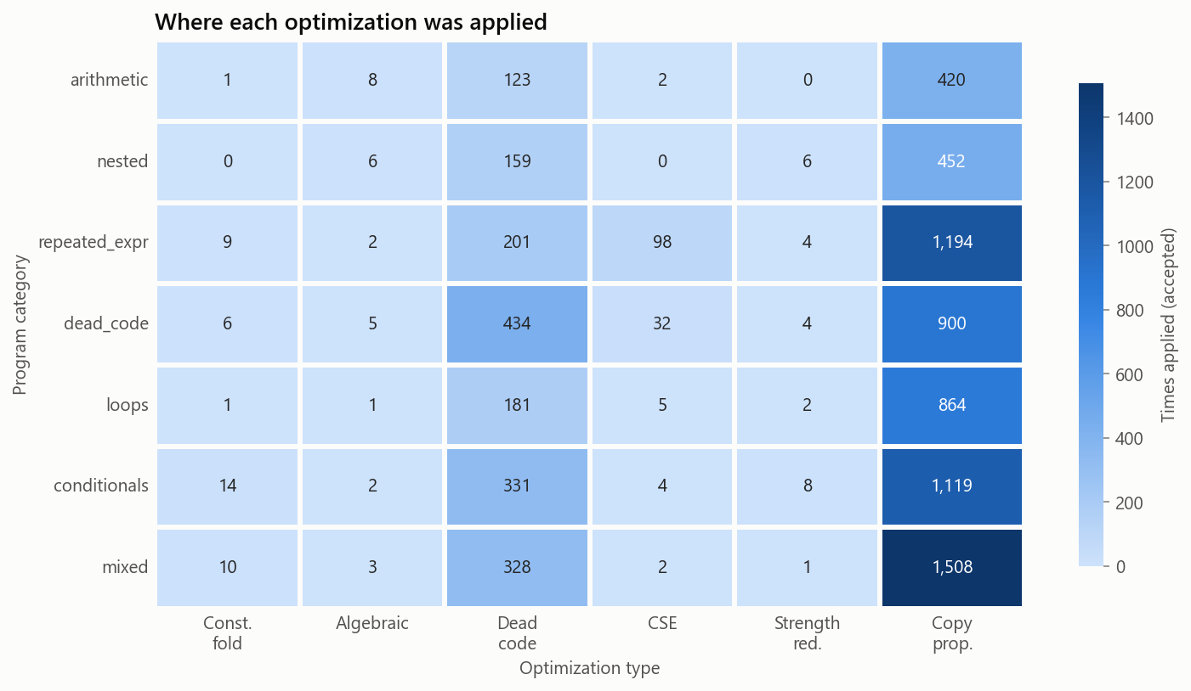
Figure 6.1: Real programs, rules only: accepted optimizations by category and type

6.1.2.2 Execution Time and the Two Cost Models
Table 6.5: Rules only on the 500 real programs under the two cost models
Metric | Static model | Time model
Average static cost reduction | 52.32% | 52.32%
Average execution-time reduction | 25.19% | 26.45%
Median execution-time reduction | 21.44% | 21.96%
Strength reductions accepted | 25 | 175
Strength reductions rejected (no gain) | 1,185 | 0
Proposals accepted | 8,450 | 8,600
False positives | 0 | 0
The execution time falls less than the static cost, because most of the removed instructions are copies, which cost one cycle each, while the divisions, multiplications and branches that dominate the running time have to stay. The time model accepts changes that the static count regards as a tie, such as replacing a multiplication by two with an addition, and so removes a little more time.

6.1.2.3 Proved Equivalence
For 253 of the 500 real programs the optimized program is proved equivalent to the original for every input: 127 by the polynomial check for straight-line code and 126 by the SMT solver. The remaining programs contain loops, or defeated the solver within its time limit, and are verified by differential testing as before. The end-to-end check never failed, so no program had to be reverted to its original.

6.1.2.4 LLM Proposers with Self-Repair
The LLM configurations were run on the real programs with self-repair switched on (Table 6.6). To stay inside the free daily quotas of the cloud providers, every fifth program is allowed two fresh LLM proposals and the others one; a rejected answer gets one repair in either case. Gemini uses gemini-3.1-flash-lite in the cloud. Groq uses its gpt-oss and qwen models in the cloud. Ollama runs qwen2.5-coder:7b on the laptop, mostly on its GPU.
Table 6.6: LLM proposers with self-repair on the real programs
Metric | Rules + Gemini | Rules + Groq | Rules + Ollama
Programs | 500 | 500 | 500
Programs the LLM was consulted on | 500 | 500 | 500
Rules alone on these programs | 52.32% | 52.32% | 52.32%
Rules + LLM | 53.60% | 53.18% | 52.42%
Programs improved by the LLM | 113 | 127 | 9
Average execution-time reduction | 26.50% | 25.34% | 25.38%
LLM calls | 735 | 855 | 687
LLM proposals accepted | 196 | 213 | 24
LLM proposals with no cost gain | 84 | 74 | 19
Wrong LLM proposals blocked | 171 | 174 | 161
LLM validity rate | 62.08% | 62.26% | 21.08%
Self-repairs accepted / tried | 30 / 213 | 69 / 311 | 7 / 162
False positives | 0 | 0 | 0
On real programs an LLM adds much less than on the generated ones. A generated loop usually has constant bounds and can be replaced by its result; a real loop depends on the input, so it has to stay. Self-repair helps the cloud models, whose rejected answers are mostly invalid TAC (a whole expression written in one instruction): told so, they often answer again in valid form. It does not help the small local model, which repeats its mistake or returns the program unchanged.
A verified LLM change is always correct and always cheaper at the moment it is accepted, but it is not always the best step: it can rewrite the code so that a rule which would have applied later no longer does. On the real programs this left 3 programs with Gemini and 2 programs with Groq slightly below the result of the rules alone (by 5 percentage points at most). The averages in Table 6.6 include these programs.
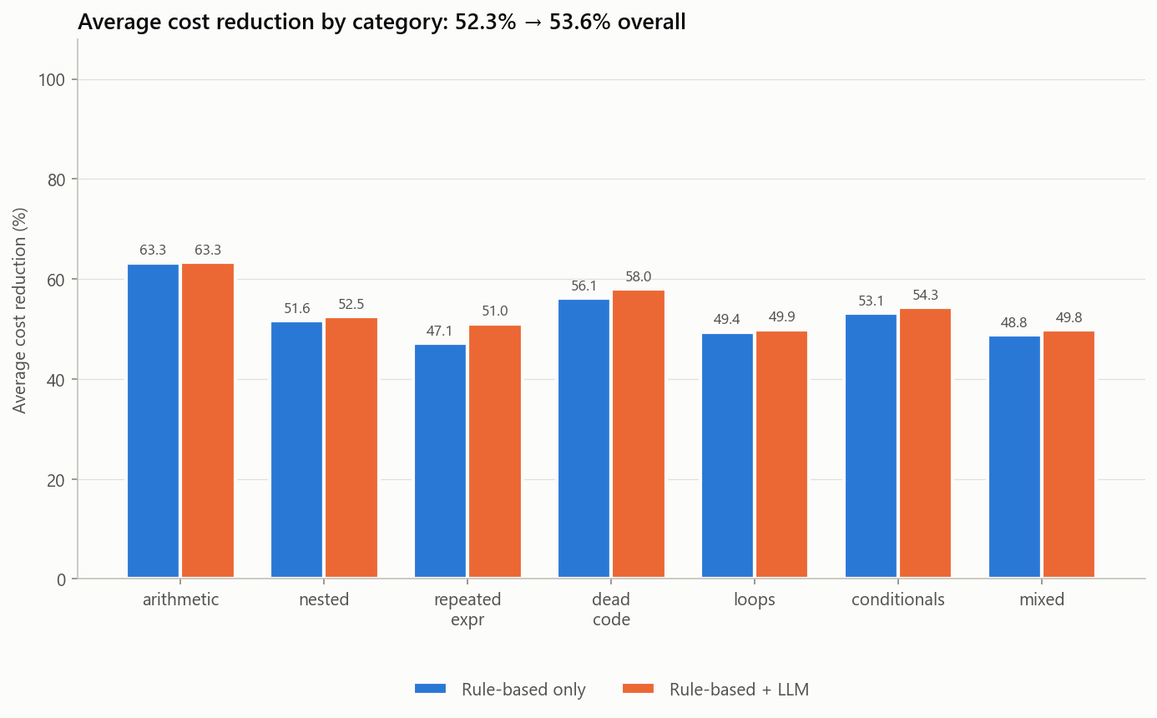
Figure 6.2: Real programs: rule-only against rule + Gemini, per category

6.1.2.5 Correct Suggestions per Optimization Type and Model
Tables 6.7 and 6.8 count the correct suggestions for every optimization type, under the rules alone and with each of the three LLMs. A suggestion is correct when it passed verification; it was then accepted, or turned down only because it did not make the program cheaper. No rule suggestion was wrong in any run. The counts of a rule type differ a little between the columns, because an accepted LLM change alters what the rules find afterwards.
Table 6.7: Correct suggestions per optimization type on the generated dataset
Optimization type | Rules | + Gemini | + Groq | + Ollama
Constant folding | 1,855 | 1,806 | 1,834 | 1,828
Algebraic simplification | 179 | 172 | 174 | 177
Dead code elimination | 1,795 | 1,890 | 1,939 | 1,846
Common subexpression (CSE) | 147 | 147 | 147 | 147
Strength reduction | 185 | 148 | 167 | 159
Copy propagation | 6,467 | 6,475 | 6,506 | 6,450
LLM proposal | — | 314 | 312 | 85
Total correct | 10,628 | 10,952 | 11,079 | 10,692
Wrong (blocked) | 0 | 26 | 6 | 113

Table 6.8: Correct suggestions per optimization type on the real programs
Optimization type | Rules | + Gemini | + Groq | + Ollama
Constant folding | 41 | 39 | 40 | 41
Algebraic simplification | 27 | 26 | 27 | 27
Dead code elimination | 1,757 | 1,766 | 1,762 | 1,759
Common subexpression (CSE) | 143 | 140 | 142 | 143
Strength reduction | 1,210 | 848 | 965 | 1,203
Copy propagation | 7,368 | 6,752 | 7,039 | 7,312
LLM proposal | — | 280 | 287 | 43
Total correct | 10,546 | 9,851 | 10,262 | 10,528
Wrong (blocked) | 0 | 171 | 174 | 161
Figure 6.3 shows where the correct LLM suggestions fall. On the generated programs they are in the loops, conditionals and mixed categories, where a loop with constant bounds can be replaced by its result. On the real programs they are spread over every category.
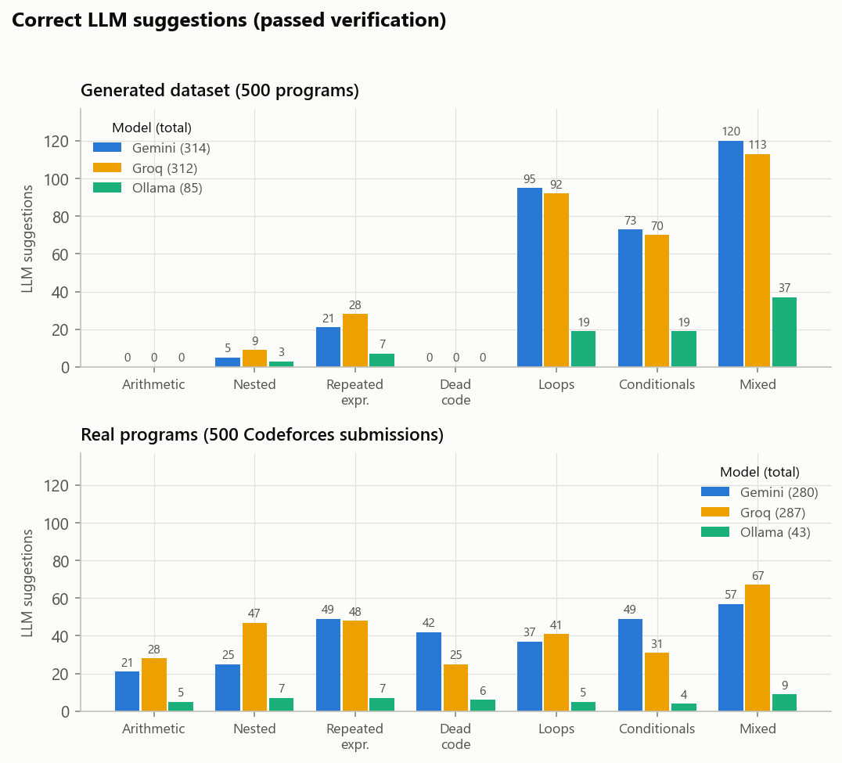
Figure 6.3: Correct LLM suggestions per program category and model

6.1.2.6 Wrong Suggestions
The wrong suggestions are shown apart in Figure 6.4. A suggestion is wrong when the verifier found an input on which the suggested program prints something else, or when its symbolic check failed. On the generated dataset there were 26 from Gemini, 6 from Groq, 113 from Ollama; on the real programs 171 from Gemini, 174 from Groq, 161 from Ollama. Every one of them was rejected before it could change the program, so no run has a false positive. The local model is wrong most often on generated loops, which it tries to fold and gets the value wrong; on real programs all three models are wrong at a similar rate, because a real loop or branch depends on the input and a rewrite that looks right on small values fails on others.
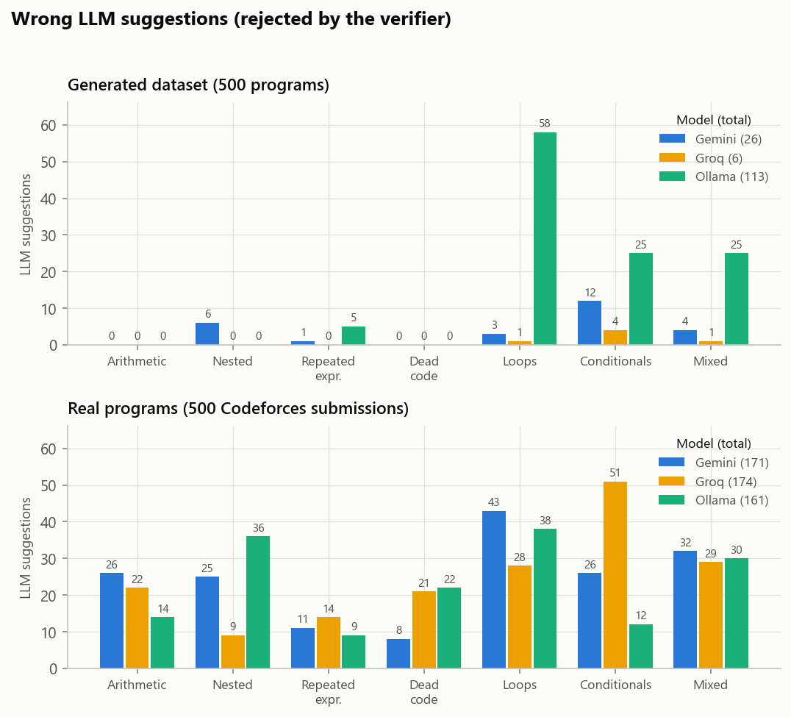
Figure 6.4: Wrong LLM suggestions per program category and model, all rejected by the verifier

6.1.2.7 Analysis Charts for the Groq Run on Real Programs
The charts below are drawn from the Groq run on the 500 real programs.
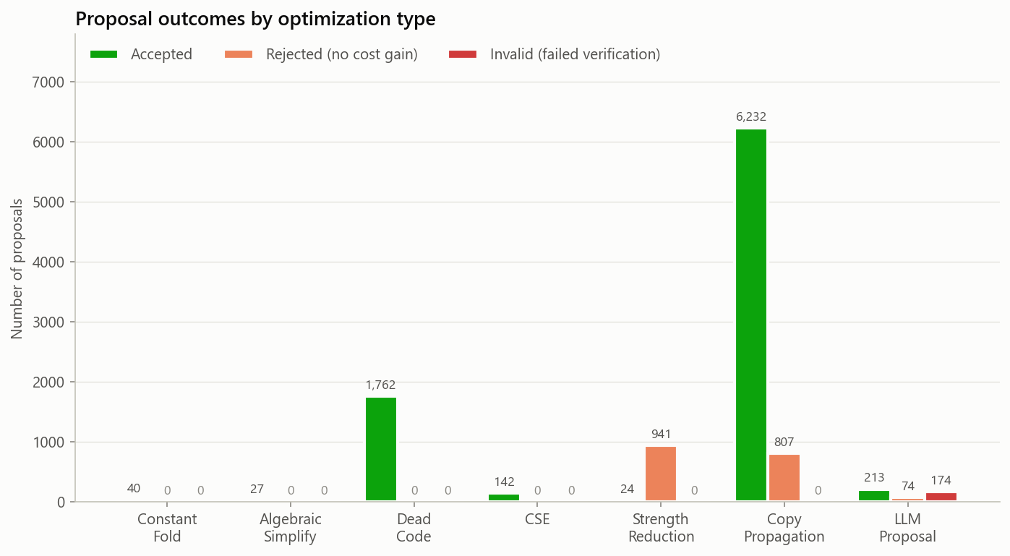
Figure 6.5: Real programs, Groq run: accept, reject, and invalid counts for each optimization type
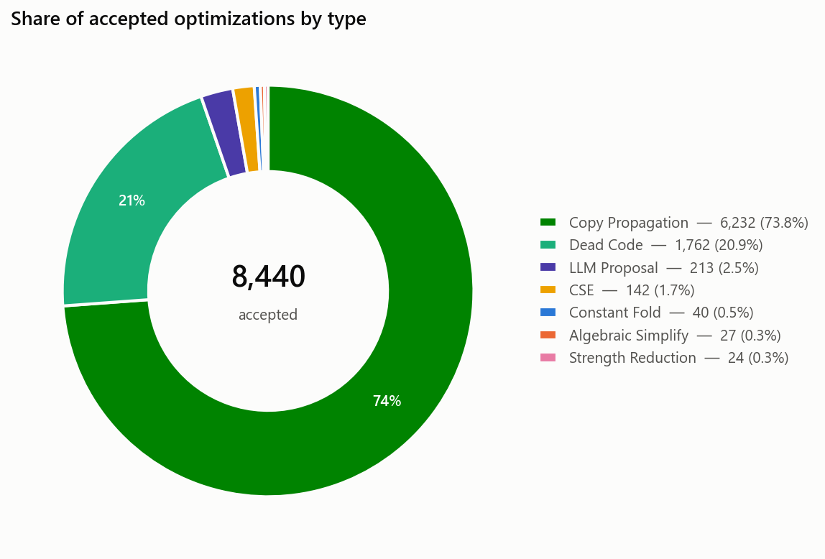
Figure 6.6: Real programs, Groq run: share of each optimization type among the accepted changes
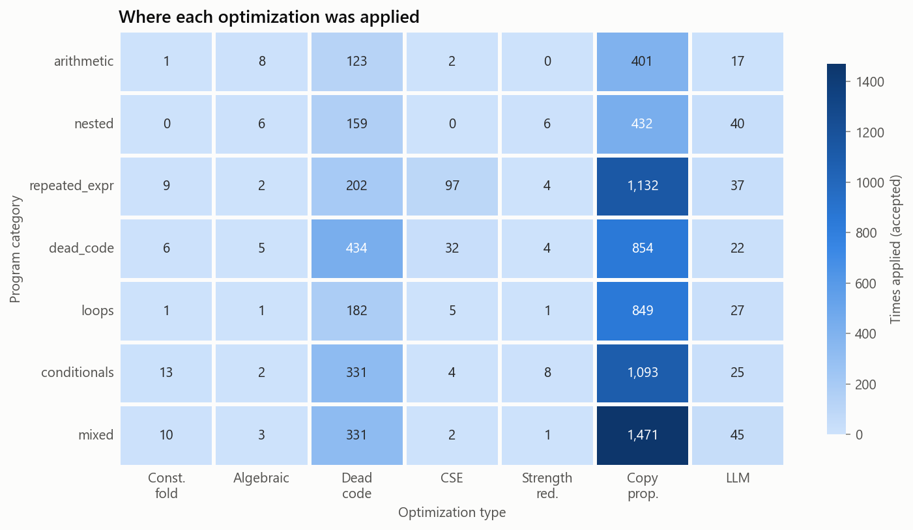
Figure 6.7: Real programs, Groq run: accepted optimizations by program category and type
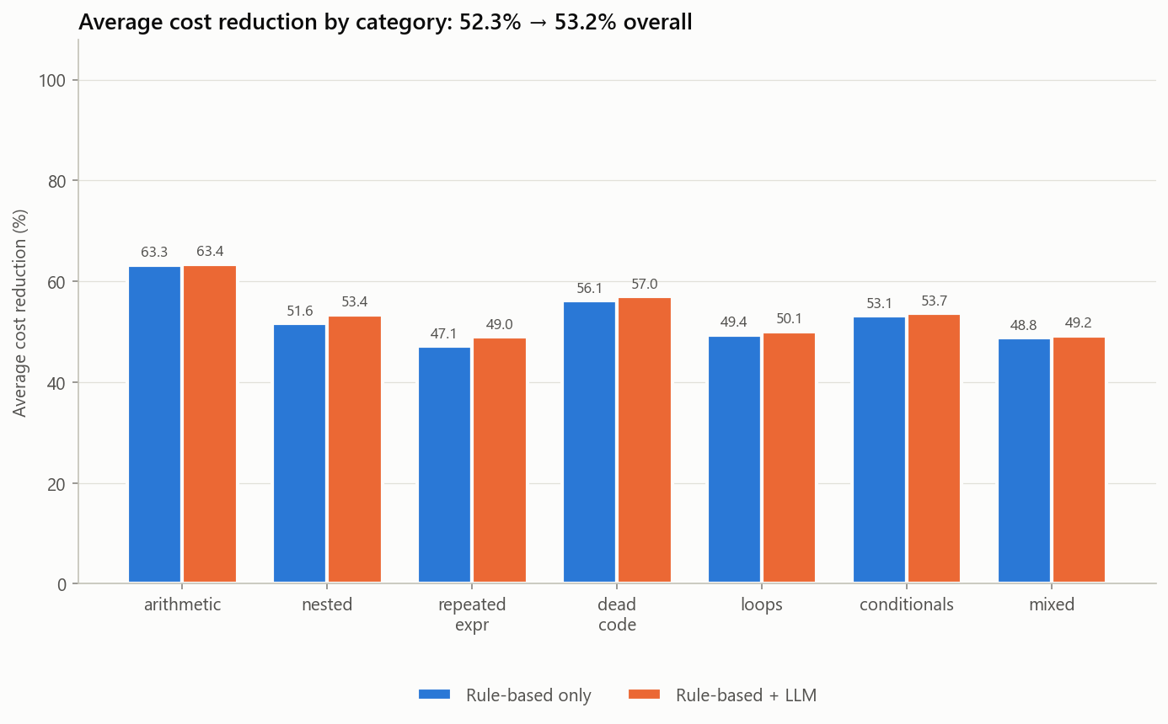
Figure 6.8: Real programs, Groq run: rule-only against rule + LLM, per category

6.1.2.8 Analysis Charts for the Ollama Run on Real Programs
The charts below are drawn from the Ollama run on the 500 real programs.
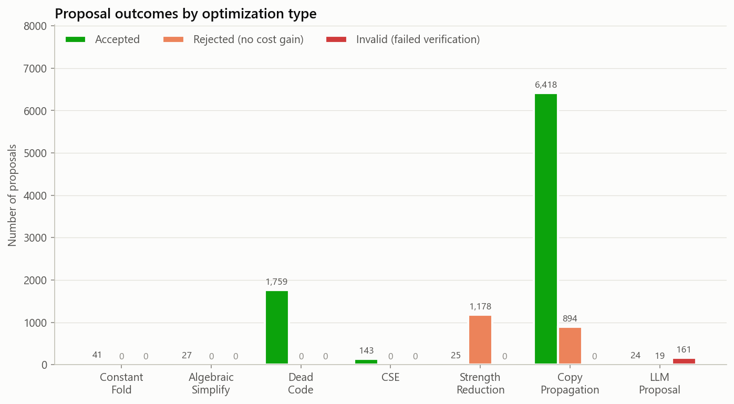
Figure 6.9: Real programs, Ollama run: accept, reject, and invalid counts for each optimization type
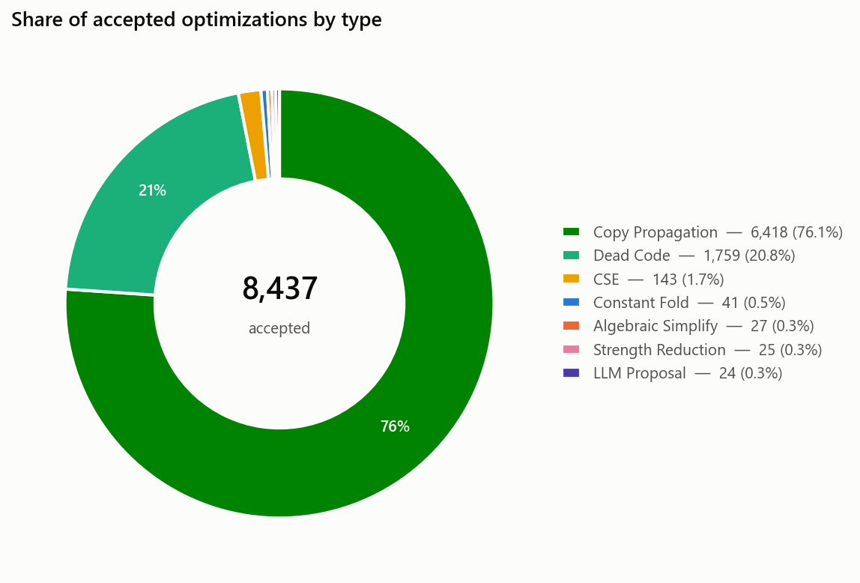
Figure 6.10: Real programs, Ollama run: share of each optimization type among the accepted changes
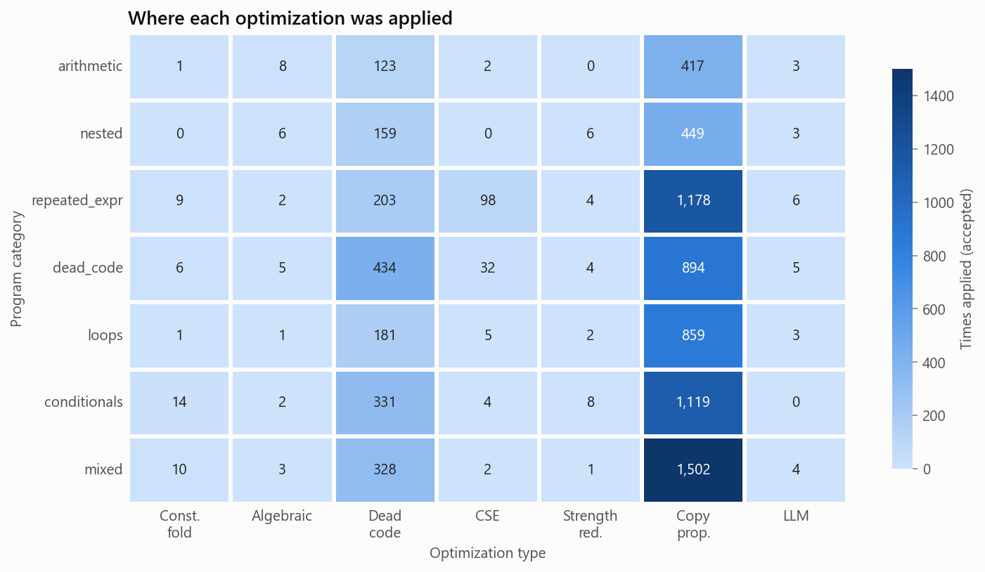
Figure 6.11: Real programs, Ollama run: accepted optimizations by program category and type
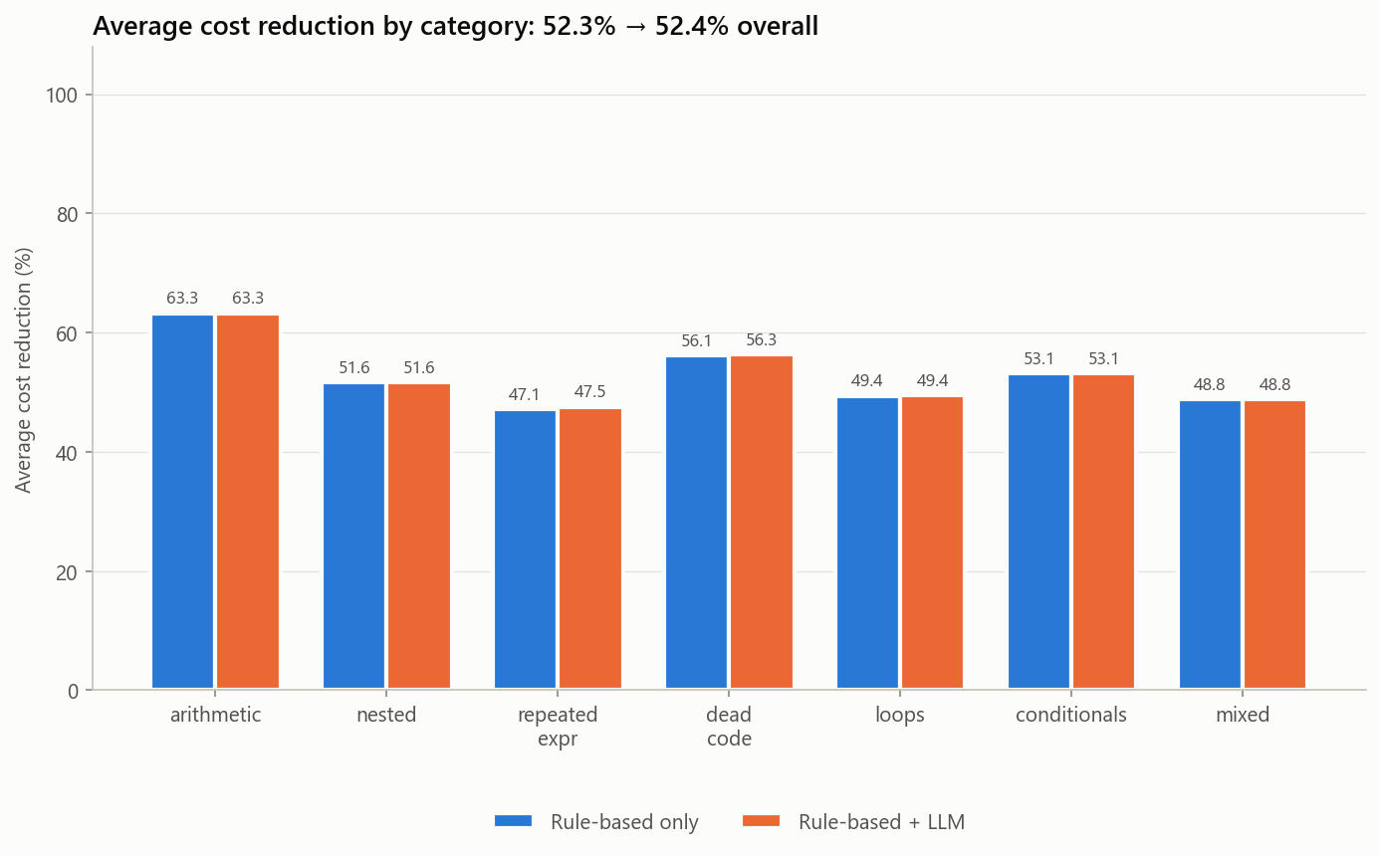
Figure 6.12: Real programs, Ollama run: rule-only against rule + LLM, per category

6.2 Output Screenshots

6.2.1 Sample Run
Listing 6.1 shows the agent working on a small C program whose loop adds the same constant ten times. The rules clean up the temporaries and fold the constant; when they have nothing left to try, the step is routed to the LLM, which replaces the loop. The whole program becomes one instruction.
Listing 6.1: A real run of the demo on a C loop, with Groq as the LLM (shortened)
int sum = 0;
for (int i = 0; i < 10; i++) {
int step = 2 + 3;
sum += step * 1;
}
printf("%d\n", sum);
22 TAC instructions, weighted cost 56.0
[ 1] COPY_PROPAGATION t0 = 0 -> uses of t0 -> 0
verified cost 56.0 -> 53.0 ACCEPTED
[ 6] CONSTANT_FOLD t6 = 2 + 3 -> t6 = 5
verified cost 41.0 -> 40.5 ACCEPTED
...
[14] COPY_PROPAGATION t11 = i + 1; i = t11 -> i = i + 1
verified cost 22.5 -> 19.5 ACCEPTED
route to LLM optimizer: the rules have nothing left to try
[15] LLM (Groq) the loop adds a constant 5 exactly ten times,
so replace it with sum = 50 and eliminate the dead loop
verified cost 19.5 -> 3.5 ACCEPTED
[16] COPY_PROPAGATION sum = 50 -> uses of sum -> 50
verified cost 3.5 -> 1.0 ACCEPTED
Optimized TAC: print 50 cost 56.0 -> 1.0 (98.2% reduction)
original prints [50], optimized prints [50]: identical output
Figures 6.5 to 6.10 are drawn from the Gemini run. Figures 6.11 to 6.13 compare each LLM run with the rule-only baseline.

6.2.2 Sankey Diagram: Proposal Flow
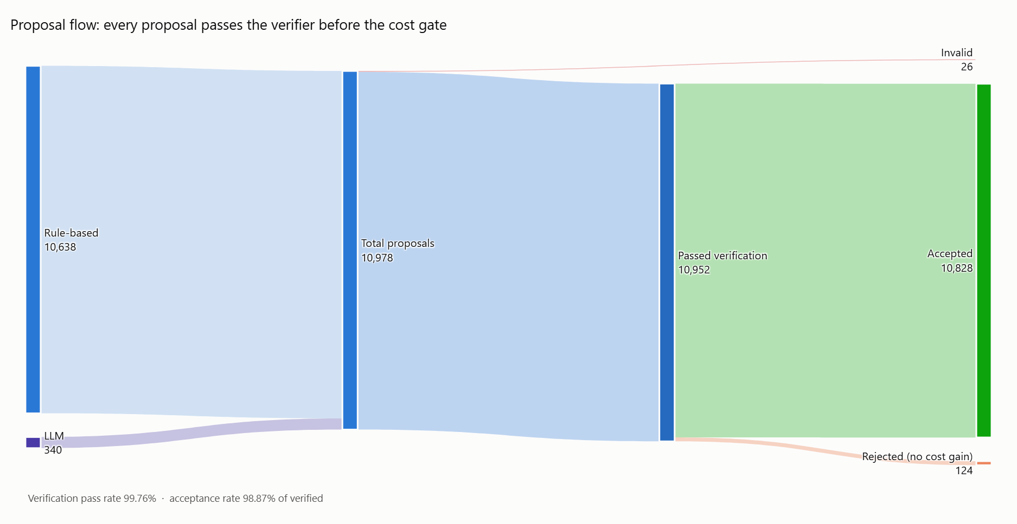
Figure 6.13: Sankey diagram showing the flow of 10,978 proposals from submission through verification to the accept/reject decision. The 26 invalid proposals are visible as a narrow band

6.2.3 Grouped Bar Chart: Outcomes by Optimization Type
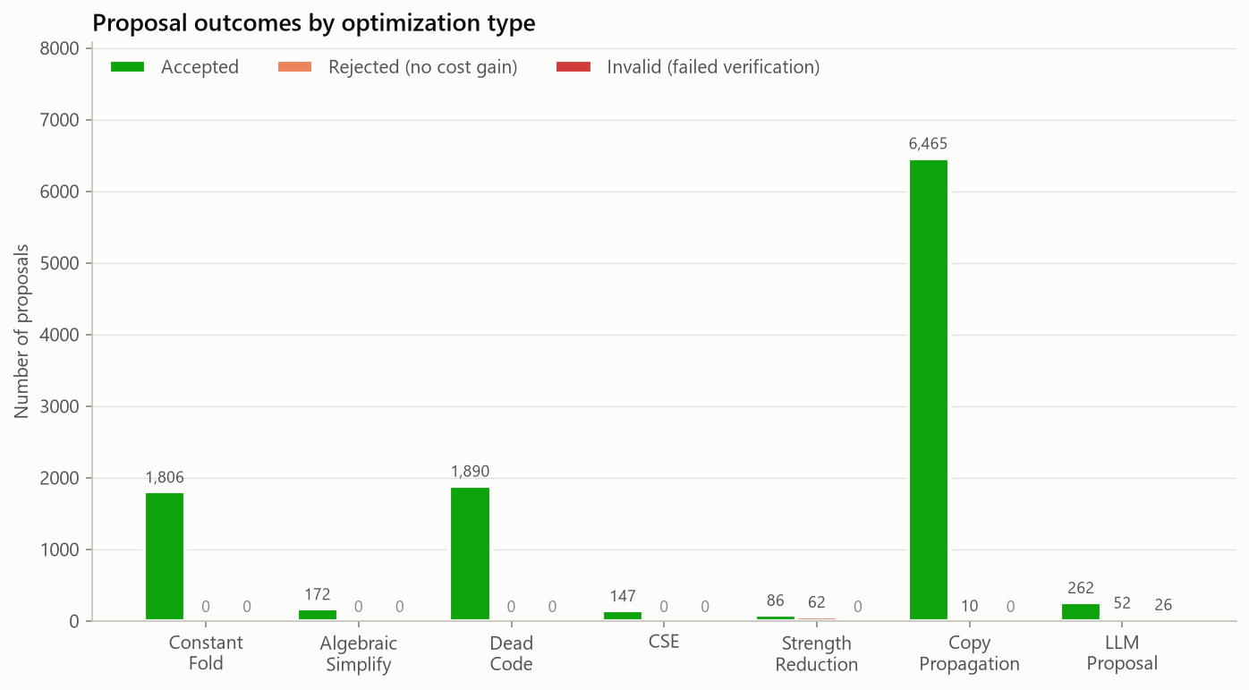
Figure 6.14: Accept, reject, and invalid counts for each optimization type. Copy propagation accounts for the most accepted changes

6.2.4 Line Chart: Cost Trajectory over Iterations
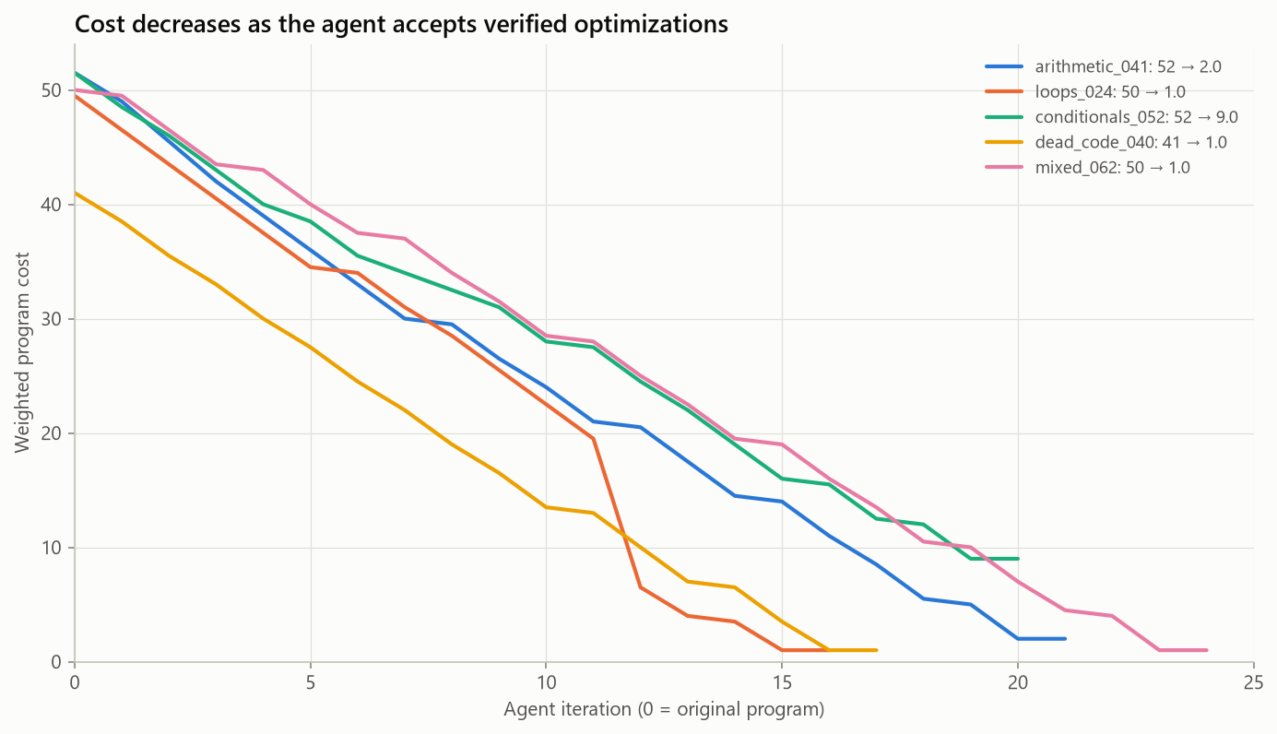
Figure 6.15: Weighted cost at each iteration for five representative programs. Cost decreases rapidly during early iterations and levels off as optimization converges

6.2.5 Pie Chart: Accepted Optimization Types
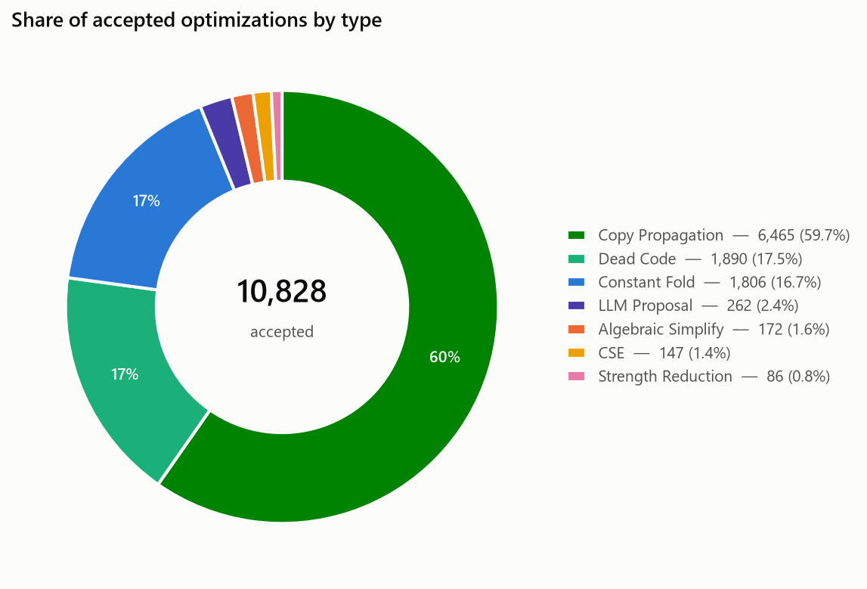
Figure 6.16: Breakdown of accepted optimizations by optimization type. Copy propagation accounts for the largest share of accepted changes

6.2.6 Scatter Plot: Steps vs. Cost Improvement
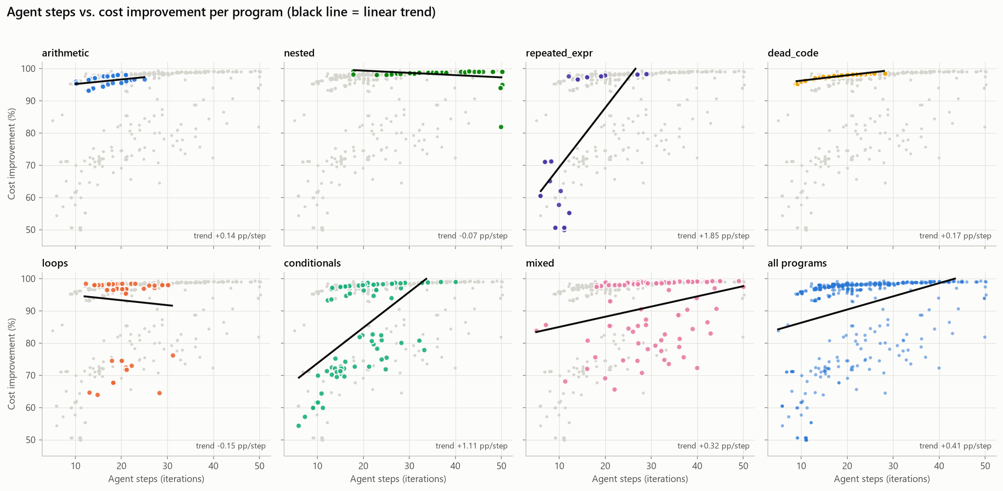
Figure 6.17: Agent steps versus percentage cost improvement across the program categories

6.2.7 Heatmap: Category vs. Optimization Type
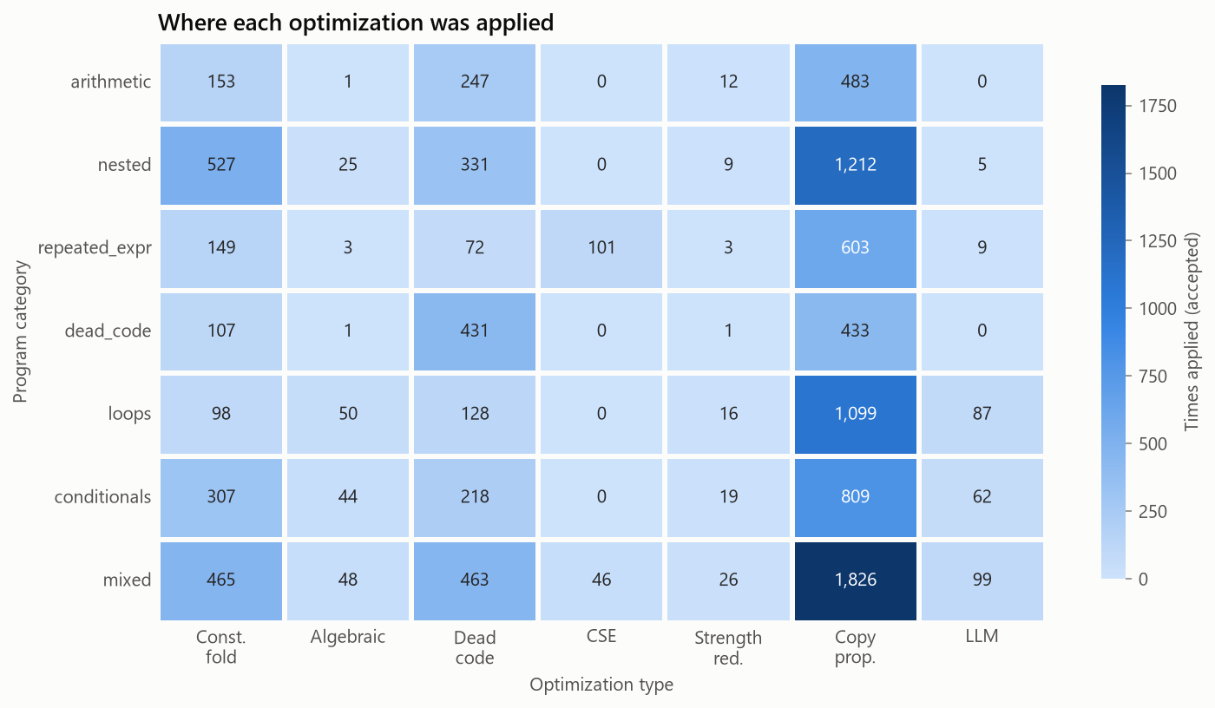
Figure 6.18: Number of accepted optimizations for each program category and optimization type

6.2.8 Comparison Charts: Rule-Only vs. Rule + LLM
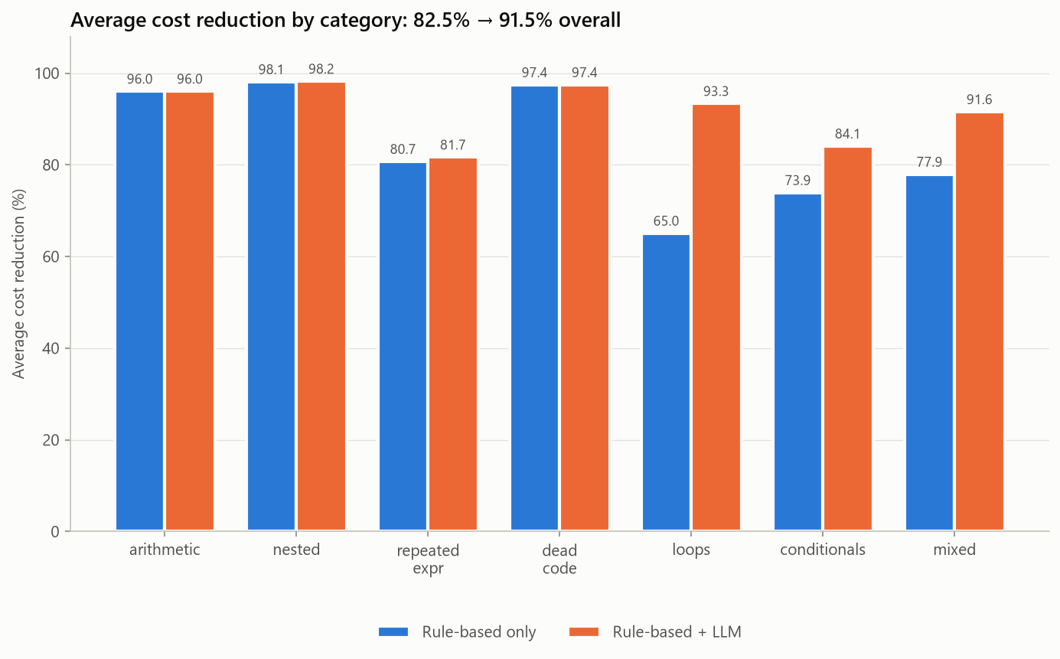
Figure 6.19: Average cost reduction per category comparing rule-only optimization with rule + Gemini. Loops rise from 65% to 93%
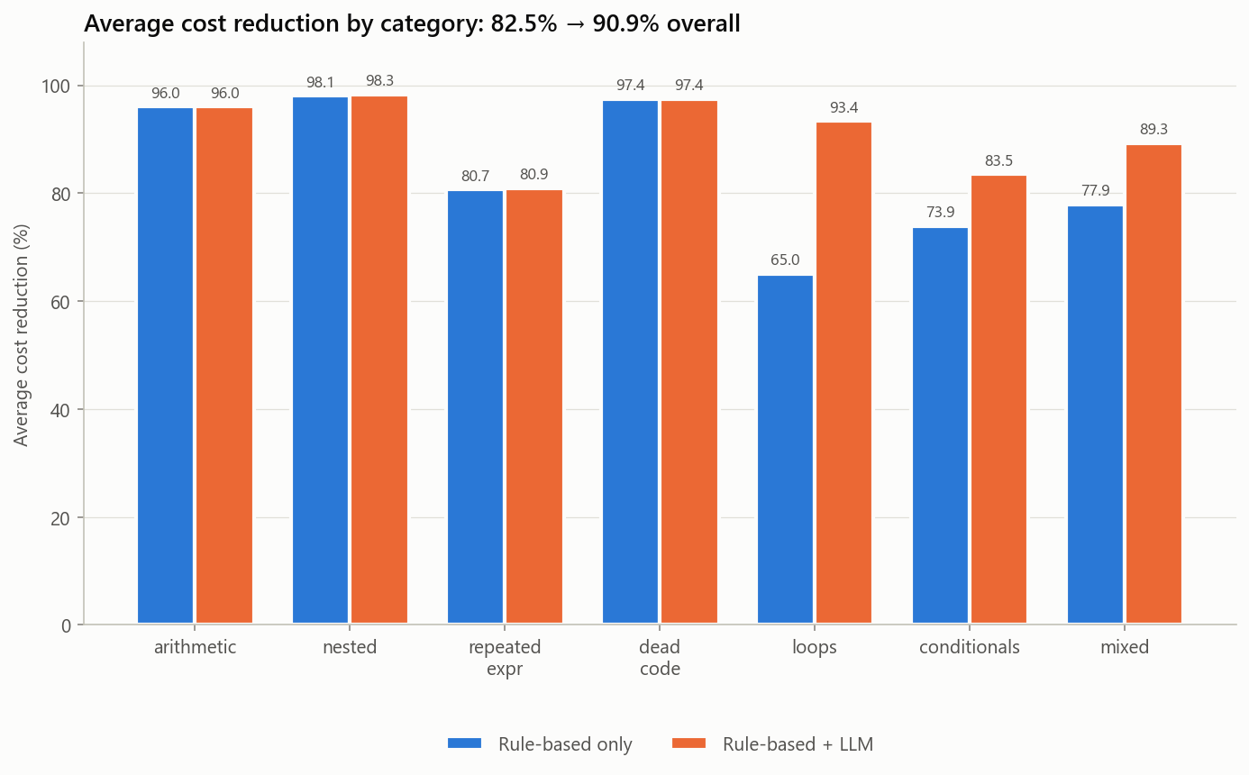
Figure 6.20: Rule-only against rule + Groq. The pattern is the same as with Gemini
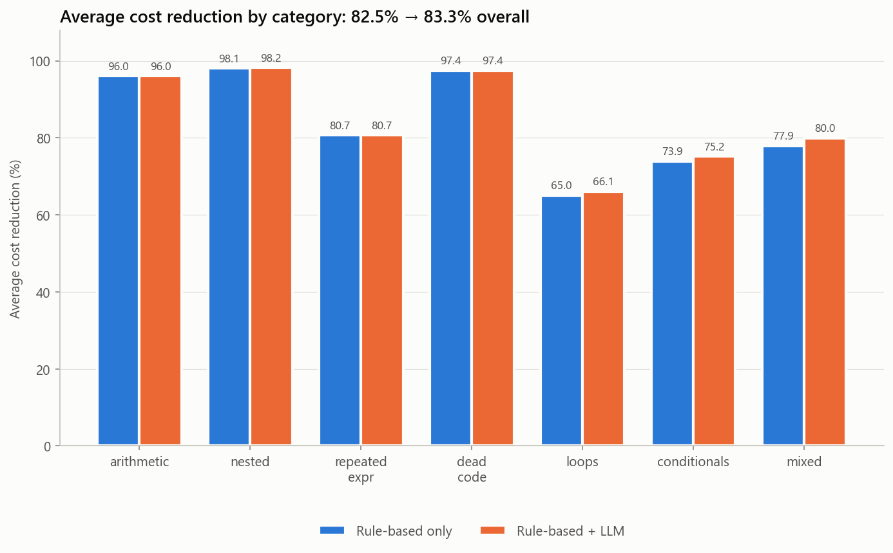
Figure 6.21: Rule-only against rule + the local Ollama model. The gains are small but come with no internet connection

6.2.9 Analysis Charts for the Groq Run
Figures 6.14 to 6.19 repeat the six charts for the run with Groq. The picture is close to the Gemini run: the same optimization types dominate, and only 6 proposals fail verification.
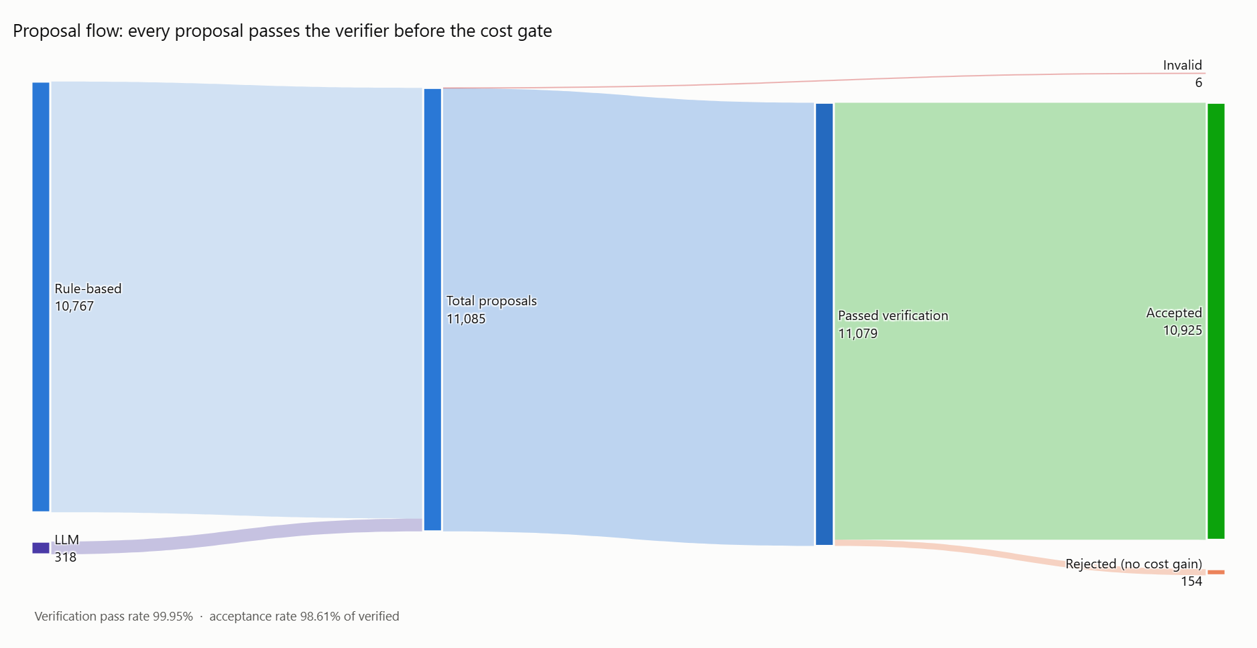
Figure 6.22: Groq run: flow of the 11,085 proposals. Only 6 LLM proposals were invalid, so the band of blocked proposals is barely visible
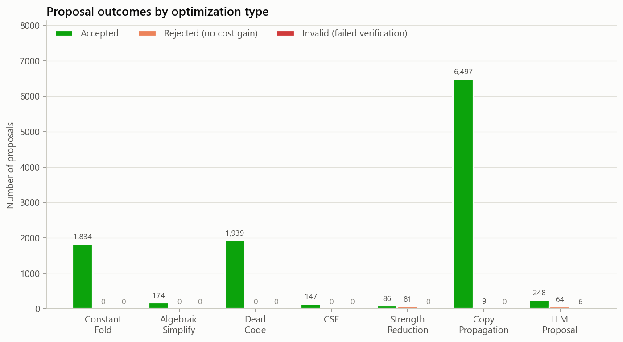
Figure 6.23: Groq run: accept, reject, and invalid counts for each optimization type
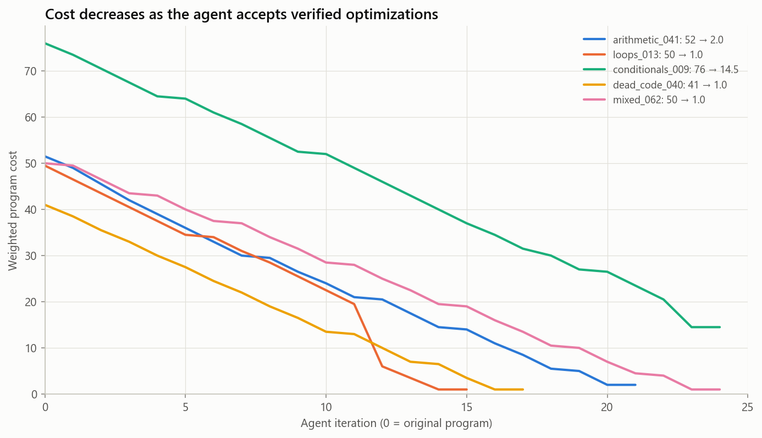
Figure 6.24: Groq run: weighted cost at each iteration for five representative programs
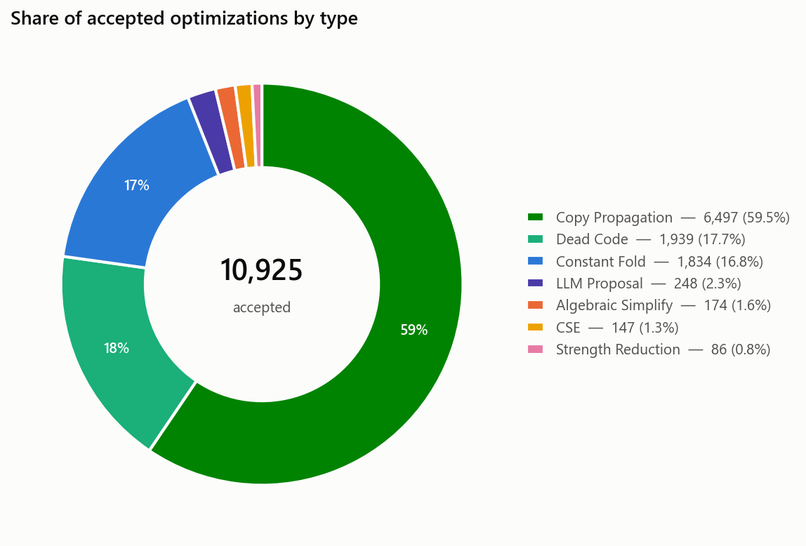
Figure 6.25: Groq run: breakdown of accepted optimizations by type
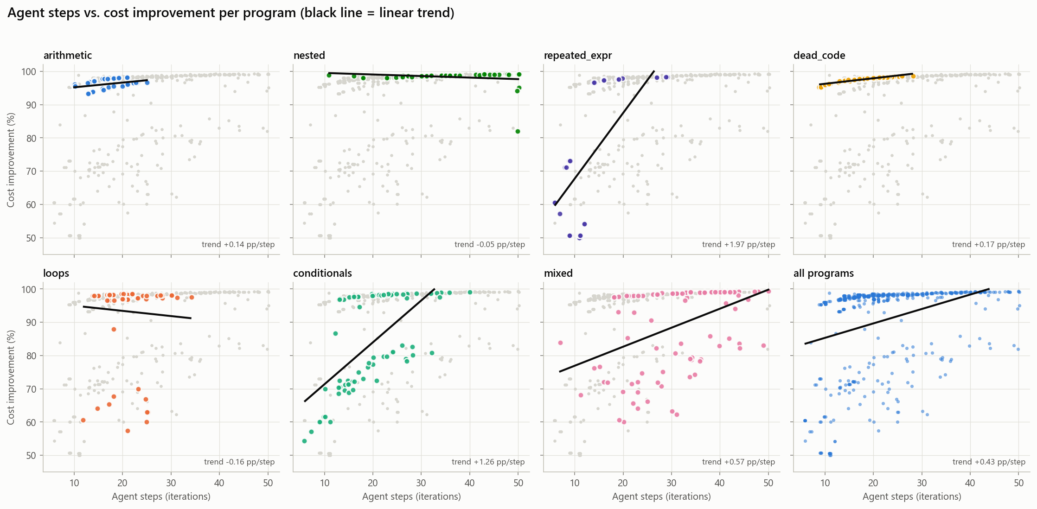
Figure 6.26: Groq run: agent steps versus percentage cost improvement
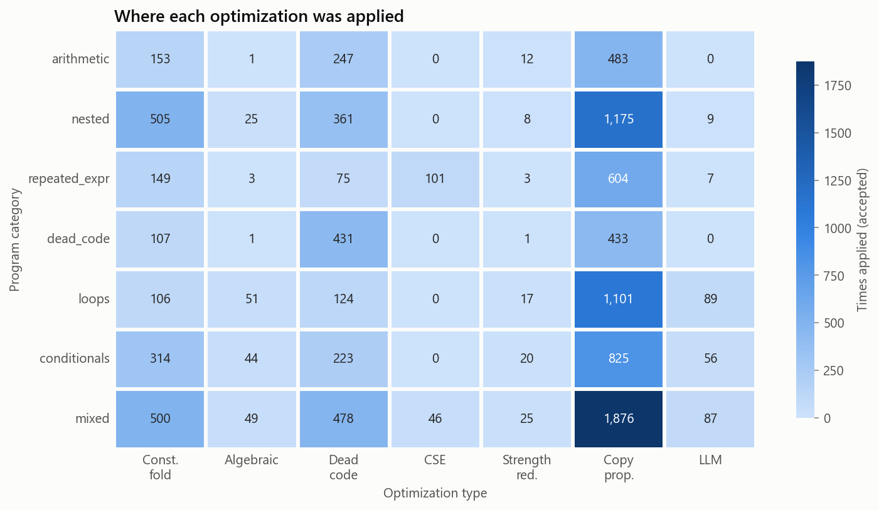
Figure 6.27: Groq run: accepted optimizations for each program category and optimization type

6.2.10 Analysis Charts for the Ollama Run
Figures 6.20 to 6.25 show the same charts for the offline run with the local model. Here the band of invalid proposals is clearly visible: 113 of the local model’s proposals were wrong, and every one was blocked by the verifier.
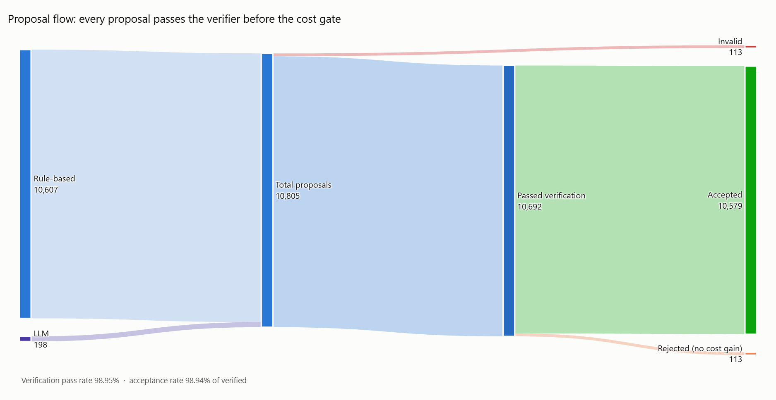
Figure 6.28: Ollama run: flow of the 10,805 proposals. The 113 invalid LLM proposals form a visible band that ends at the verifier
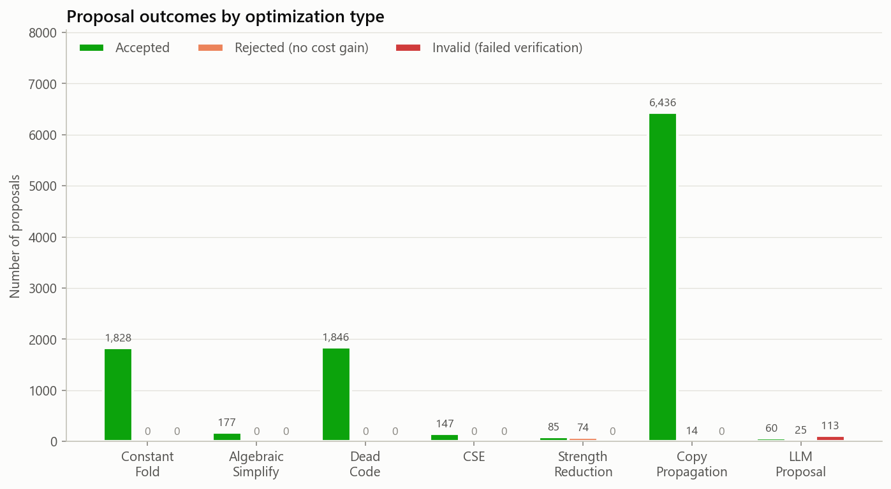
Figure 6.29: Ollama run: accept, reject, and invalid counts for each optimization type. The invalid bar belongs to the LLM proposals
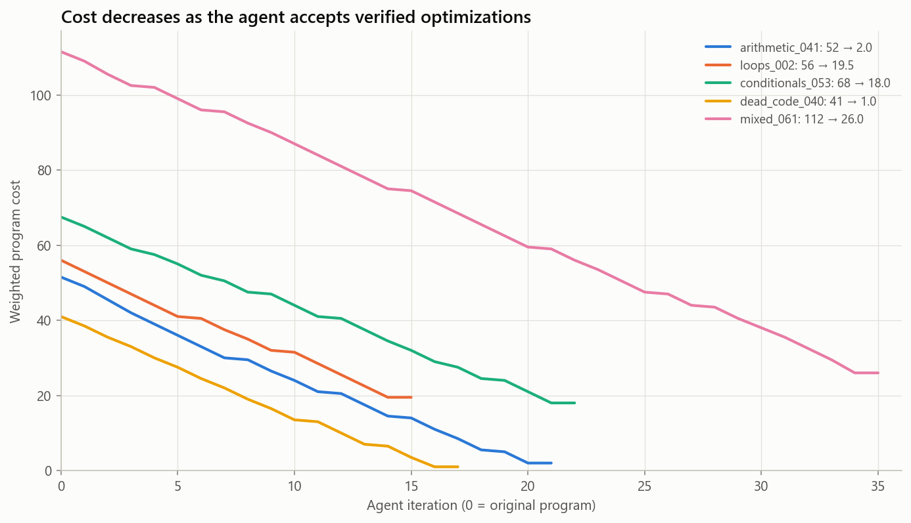
Figure 6.30: Ollama run: weighted cost at each iteration for five representative programs
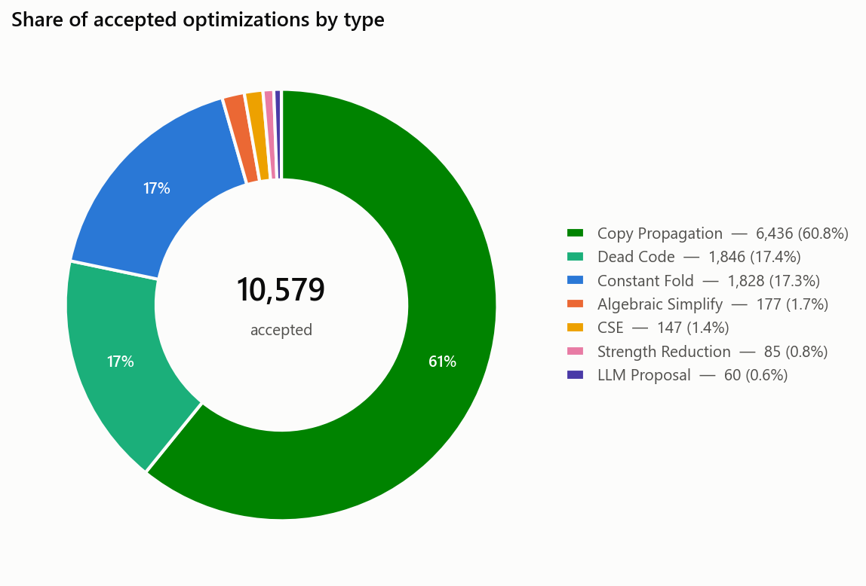
Figure 6.31: Ollama run: breakdown of accepted optimizations by type
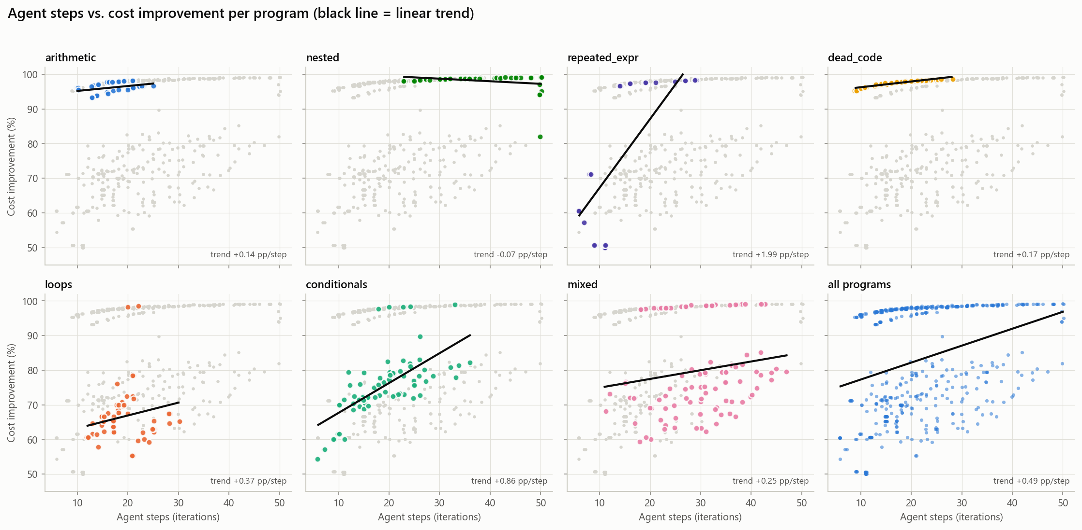
Figure 6.32: Ollama run: agent steps versus percentage cost improvement
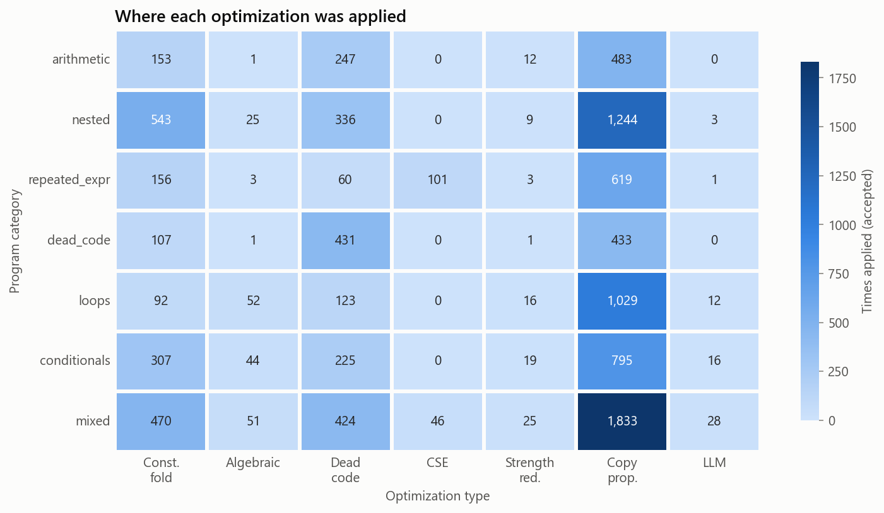
Figure 6.33: Ollama run: accepted optimizations for each program category and optimization type

6.3 Performance Analysis and Evaluation
A few observations stand out from the numbers:
The verifier works. All 10,628 rule-based proposals passed verification; not one was incorrect. This is expected, since the rules are correct by construction, but it confirms that the verifier does not produce false rejections. On the LLM side, 26 of Gemini’s 340 usable proposals (7.65%), 6 of Groq’s 318 (1.9%) and 113 of the local model’s 198 (57%) were semantically wrong, and the verifier caught every single one. The false-positive count across all four runs is zero.
Cost-neutral strength reductions get rejected, as intended. Under our weight scheme, replacing x * 2 with x + x swaps one arithmetic operation for another at the same cost. The evaluator rightly rejects these. Replacing x * 4 with x << 2, on the other hand, replaces an arithmetic operation (weight 2.0) with a non-arithmetic shift, so it is accepted. This accounts for 97 of the 111 rejections in the rule-only run.
Copy propagation is the workhorse. It accounts for about 60% of all accepted changes because each high-priority transformation (a fold, a CSE, a dead-code removal) often creates new copies that need to be propagated and cleaned up. A single constant fold might trigger three or four subsequent copy-propagation steps.
The LLM helps most where rules are structurally limited. Rules cannot “think about” what a loop computes in aggregate. They can fold constants inside the body, but the loop control flow survives. An LLM can recognize that a loop with a constant trip count and a constant body evaluates to a single value, and it proposes the collapsed form. The verifier then confirms it on its test inputs. This pattern explains the 28-point jump in the loops category.
A weak model is still safe. The local model’s low validity rate did not make the results worse, only slower. This is the main practical consequence of verifying every proposal: the choice of model affects how much is gained, never whether the result is correct.
Convergence is fast. The median program converges in 20 iterations (about 0.5 seconds rule-only). The full 500-program rule-only run finishes in under 2 minutes. With a cloud LLM the bottleneck is the pause between API calls, which the free tiers require, bringing the total to about 43 minutes. Both cloud providers also limit requests and tokens per day; the system spaces its calls, waits out per-minute limits, and for Groq moves to another model when one quota is spent, so a full run completes without supervision. The local model has no quota but took 2 hours 14 minutes on the laptop CPU.
Real programs leave less to remove. A generated program is mostly constants and collapses to a few prints. A real program computes with its input, so the instructions that do the work have to stay, and the gain comes from cleaning up the translation and the occasional redundancy the programmer left.
A proof is stronger than a test. For programs without loops, zero false positives is no longer a statement about the inputs that were tried. For the programs the solver decided, no input exists on which the optimized program behaves differently.
Tests can be passed by a wrong change. The one wrong change that the re-check found had passed 388 tests. Testing is only as good as its inputs; the lasting answers are inputs chosen to reach behaviour the program shows rarely, an independent re-check of every run, and a proof wherever one is possible.
Self-repair helps with form more than with logic. A capable model that is rejected has usually written a whole expression in one instruction; told so, it answers again in valid TAC. A small local model that got the logic wrong tends to get it wrong again, or to play safe and return the program unchanged.

6.3.1 Limitations
- The front end accepts only a subset of C: no arrays, pointers, functions other than main, floating point, or input read inside a loop. That is why only 2% of the submissions examined could be used.
- The SMT stage does not handle loops. Programs with loops are verified by differential testing, which is thorough but is not a proof.
- Integers are unbounded in TAC, so the 32-bit wrap-around of C is not modelled, and inputs are tested over the verifier’s ranges, which include values a problem statement rules out.
- Execution time is an abstract count of cycles from a fixed latency table, measured on 25 inputs. It orders programs sensibly but is not a measurement on real hardware.
- On the real programs most programs get a single LLM proposal, to stay inside the free daily quotas of the cloud providers. A larger budget might find more.

REFERENCES
Journals and Preprints:
Chen, M., Tworek, J., Jun, H., Yuan, Q., Pinto, H. P., Kaplan, J., … & Zaremba, W. (2021). Evaluating large language models trained on code. arXiv preprint arXiv:2107.03374.
Cummins, C., Seeker, V., Grubisic, D., Roziere, B., Gehring, J., Synnaeve, G., & Leather, H. (2024). Meta Large Language Model Compiler: Foundation models of compiler optimization. arXiv preprint arXiv:2407.02524.
Rozière, B., Gehring, J., Gloeckle, F., Sootla, S., Gat, I., Tan, X. E., … & Synnaeve, G. (2023). Code Llama: Open foundation models for code. arXiv preprint arXiv:2308.12950.
Wu, Q., Bansal, G., Zhang, J., Wu, Y., Li, B., Zhu, E., … & Wang, C. (2023). AutoGen: Enabling next-gen LLM applications via multi-agent conversation. arXiv preprint arXiv:2308.08155.
Conferences:
Cummins, C., Wasti, B., Guo, J., Cui, B., Ansel, J., Gomez, S., … & Leather, H. (2022). CompilerGym: Robust, performant compiler optimization environments for AI research. Proceedings of the IEEE/ACM International Symposium on Code Generation and Optimization (CGO), 92–105.
de Moura, L., & Bjørner, N. (2008). Z3: An efficient SMT solver. Proceedings of the International Conference on Tools and Algorithms for the Construction and Analysis of Systems (TACAS), 337–340.
Lattner, C., & Adve, V. (2004). LLVM: A compilation framework for lifelong program analysis & transformation. Proceedings of the IEEE/ACM International Symposium on Code Generation and Optimization (CGO), 75–86.
Massalin, H. (1987). Superoptimizer: A look at the smallest program. Proceedings of the 2nd International Conference on Architectural Support for Programming Languages and Operating Systems (ASPLOS), 122–126.
Necula, G. C. (2000). Translation validation for an optimizing compiler. Proceedings of the ACM SIGPLAN Conference on Programming Language Design and Implementation (PLDI), 83–94.
Phothilimthana, P. M., Thakur, A., Bodik, R., & Dhurjati, D. (2016). Scaling up superoptimization. Proceedings of the 21st International Conference on Architectural Support for Programming Languages and Operating Systems (ASPLOS), 297–310.
Pnueli, A., Siegel, M., & Singerman, E. (1998). Translation validation. Proceedings of the International Conference on Tools and Algorithms for the Construction and Analysis of Systems (TACAS), 151–166.
Books:
Aho, A. V., Lam, M. S., Sethi, R., & Ullman, J. D. (2006). Compilers: Principles, Techniques, and Tools (2nd ed.). Pearson.
Muchnick, S. S. (1997). Advanced Compiler Design and Implementation. Morgan Kaufmann.
Stallman, R. M., & the GCC Developer Community. (2023). Using the GNU Compiler Collection (GCC 13). Free Software Foundation.
Web links:
Groq. (2026). GroqCloud API documentation. https://console.groq.com/docs
Ollama. (2026). Ollama: Run large language models locally. https://ollama.com
open-r1. (2025). codeforces-submissions [Data set]. Hugging Face. https://huggingface.co/datasets/open-r1/codeforces-submissions

