EXPERIMENT 9

**OBJECTIVE**

Common Gateway Interface(CGI) design for transacting the databases from the client system.

**DESCRIPTION**

CGI is the part of the Web server that can communicate with other programs running on the server. With CGI, the Web server can call up a program, while passing user-specific data to the program (such as what host the user is connecting from, or input the user has supplied using HTML form syntax). The program then processes that data and the server passes the program's response back to the Web browser.

CGI turns the Web from a simple collection of static hypermedia documents into a whole new interactive medium, in which users can ask questions and run applications.

Here we can see a simple illustration of CGI:

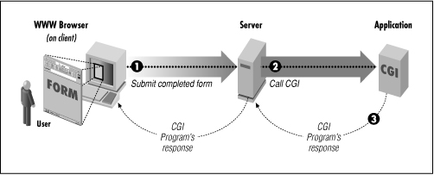

**CODE**

**Client Side**

<html>

<head>

    <title>Player Transaction</title>

</head>

<body>

    <h3>Select The Option to Transact with database</h3>

    <ol>

        <li>Add a player</li>

<li>Retrieve All players</li>

        <li>Find a player</li>

    </ol>

        <form action="" method="post" id="frm">

        <input type="text" name="topt" id="topt">

        <input type="submit" value="Submit Data">

        </form>

    <div id="add"></div>

    <script>

        let formCode=`<h1>Add A player</h1>

    <h3><p>Information Required.</p></h3>

    <form action="/cgi-bin/script1.pl" method="Post">

    <table>

        <tr>

        <td>Name:</td>

        <td><input type="text" name="name"><td>

        </tr>

        <tr>

        <td>Gender:</td>

        <td><select name="gender" size="1">

            <option>Female</option>

            <option>Male</option>

            <option>Transgender</option>

        </select></td>

        </tr>

        <tr>

            <td>Nationality:</td>

            <td><input type="text" name="profession"><td>

        </tr>

        <tr>

        <td>Sports:</td>

            <td><input type="checkbox" name="sport"

                    value="Cricket">Cricket

                <input type="checkbox" name="sport"

                    value="Hockey">Hockey

                <input type="checkbox" name="sport"

                    value="TableTennis">TableTennis

                <input type="checkbox" name="sport"

                    value="Football">Football</td>

                <input type="text" name="opt" value="1" hidden  >

        </tr>

        <tr>

        <td colspan="2"><input type="submit"></td>

        </tr>

    </table>

    </form>`;

    let e=document.getElementById('frm');

    e.addEventListener('submit',(e)=>{

        e.preventDefault();

        // console.log(document.getElementById('topt').value);

        if(document.getElementById('topt').value==1 &&

        document.getElementById('add').innerHTML.length==0){

            document.getElementById('add').innerHTML+=formCode;

        }

        if(document.getElementById('topt').value==2&&

        document.getElementById('add').innerHTML.length==0){

            document.getElementById('add').innerHTML+=`

            <form action="/cgi-bin/script1.pl" method="Post" id='getAll'>

                <input type="text" name="opt" value="2" hidden  ></form>`;

            document.getElementById('getAll').submit();

        }

        if(document.getElementById('topt').value==3&&

        document.getElementById('add').innerHTML.length==0){

            document.getElementById('add').innerHTML+=`

            <form action="/cgi-bin/script1.pl" method="Post" id='getAll'>

                <p>You Have selected to Find a player</p>

                Enter Name of Player<input type="text" name="delete" id="del" value="">

                <input type="text" name="opt" value="3" hidden  >

                <input type="submit">

                </form>`;

        }

    });

    </script>

</body>

</html>

**CGI SCRIPT**

#!"D:\Drive\xampp\perl\bin\perl.exe"

use strict;

use CGI ':standard';

my $opt=param('opt');

my $list;

print header,

start_html(),

end_html;

#Adding To server

if($opt eq 1)

{

  my $name = param('name');

  my $gender = param('gender');

  my $profession = param('profession');

  my @sports = param('sport');

  if (@sports)

{

  $list = join ', ', @sports;

}

else

{

  $list = 'Null';

}

open (FILE, ">> file3.txt");

print FILE "$name,$gender,$profession,$list";

print FILE "\n";

close FILE;

print "<h4>Successfully Submitted Data</h4>";

}

if($opt eq 2){

print "<h2>list of all Players</h2>";

# print "Content-Type: text/plain; charset=UTF-8\n\n";

my $filename = 'file3.txt';

open(my $fh, '<:encoding(UTF-8)', $filename)

  or die "Could not open file '$filename' $!";

while (my $row = <$fh>) {

  chomp $row;

  # print($row);

  my @spl=split(',',$row);

  print('<h3>',@spl[0],'</h3>');

  print('<table>');

  print ("<tr><td>Name:</td><td>", @spl[0] ,"</td></tr>");

  print ("<tr><td>Gender:</td><td>", @spl[1] ,"</td></tr>");

  print ("<tr><td>Nationality:</td><td>", @spl[2] ,"</td></tr>");

  print ("<tr><td>Sports:</td><td>", @spl[3] ,"</td></tr>");

  print('</table>');

  print('<br>');

  # h4 td($row);

}

}

if($opt eq 3){

  my $name=param('delete');

  # print "$name";

  my $filename = 'file3.txt';

  open(my $fh, '<:encoding(UTF-8)', $filename)

  or die "Could not open file '$filename' $!";

  my $found=0;

  while (my $row = <$fh>) {

  chomp $row;

  # print($row);

  my @spl=split(',',$row);

  if($name eq @spl[0] ){

    print('<h5>',@spl[0],' Found, Delails Are</h5>');

  print('<table>');

  print ("<tr><td>Name:</td><td>", @spl[0] ,"</td></tr>");

  print ("<tr><td>Gender:</td><td>", @spl[1] ,"</td></tr>");

  print ("<tr><td>Nationality:</td><td>", @spl[2] ,"</td></tr>");

  print ("<tr><td>Sports:</td><td>", @spl[3] ,"</td></tr>");

  print('</table>');

  $found=1;

  }

}

if($found eq 0){

  print "Name Not Found"; } }

**OUTPUT**

**OPTIONS AVAILABLE**

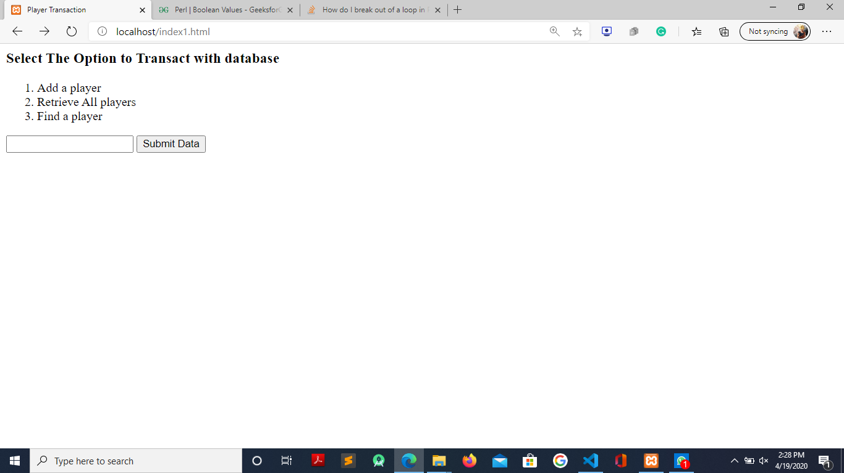

**ADDING A PLAYER**

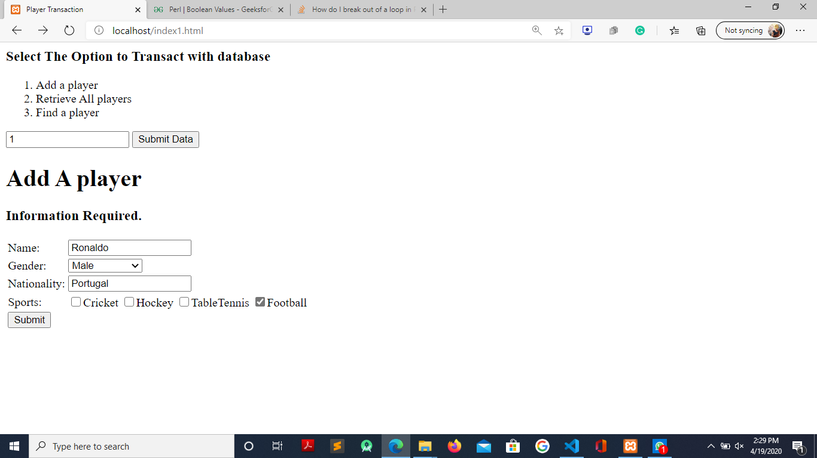

**RETREIVING ALL PLAYERS**

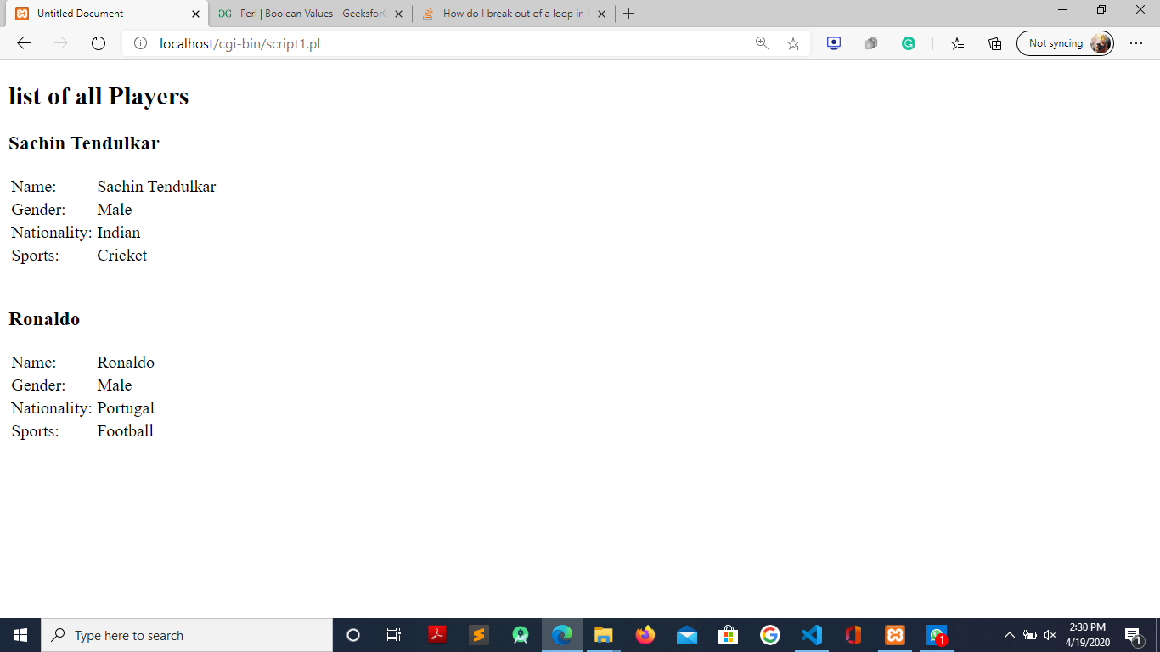

**RETREIVING A SINGLE PLAYER**

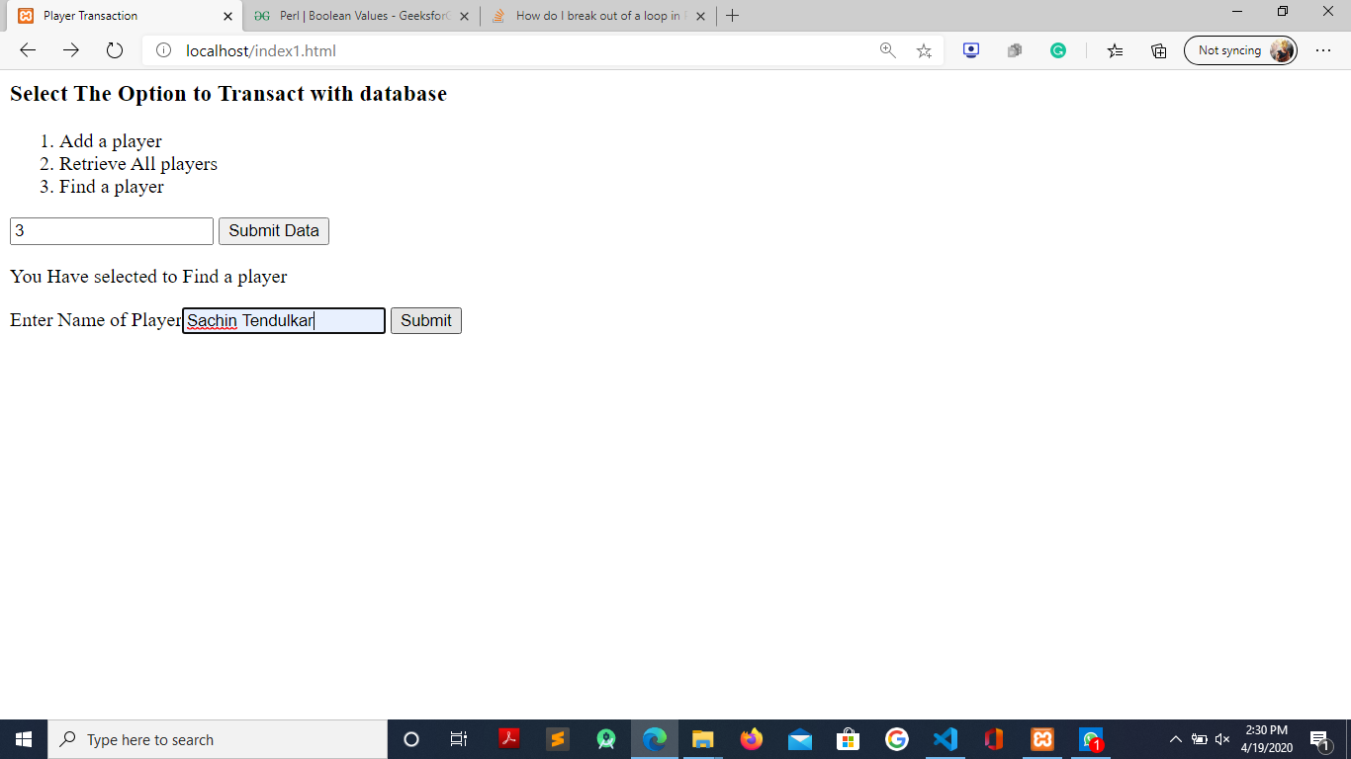

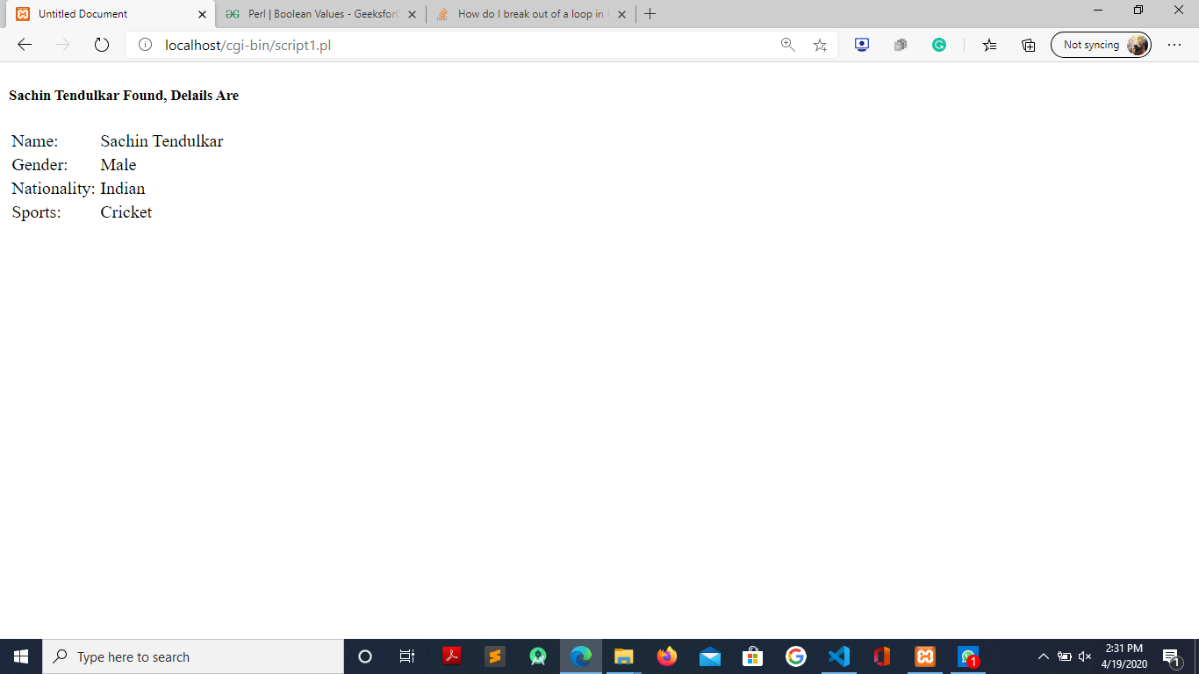

**FINDINGS AND LEARNINGS**

From this program, we learnt about the Common Gateway Interface(CGI) and the operations involved in setting up a CGI. Some of which are:

Writing CGI scripts,

Writing Forms to send/retrieve data to/from Server,

Deploying of server supporting CGI on the URL having “cgi-bin/” directory.

Also, we learnt that a CGI program retrieves the source of entry page , transforms them to HTML and prints the result.