Real-World Data Project: Retail Domain
Pricing Analysis of the Diamond Retail Market

1. Introduction
This project analyzes a real-world retail dataset covering the diamond jewelry market. The dataset contains 53,940 records describing each diamond's physical characteristics (carat, cut, color, clarity, and dimensions) alongside its retail price. The goal is to clean the data, explore pricing patterns, and present insights useful for retail pricing strategy.

2. Data Cleaning
The raw dataset was checked for missing values (none found) and inspected for invalid physical measurements. Records with zero or negative values for carat, length, width, or depth were removed as data-entry errors, along with duplicate rows.
- Original records: 53,940
- Invalid/duplicate rows removed: 165
- Final cleaned dataset: 53775 records

3. Key Statistics
- Average price: $3,931.22
- Median price: $2,401
- Correlation between carat and price: 0.922 (very strong)
- Most common cut quality: Ideal
- Clarity grade with highest average price: SI2

4. Visualizations

4.1 Price Distribution
Diamond prices are heavily right-skewed: most stones sell for under $5,000, with a long tail of high-value pieces.
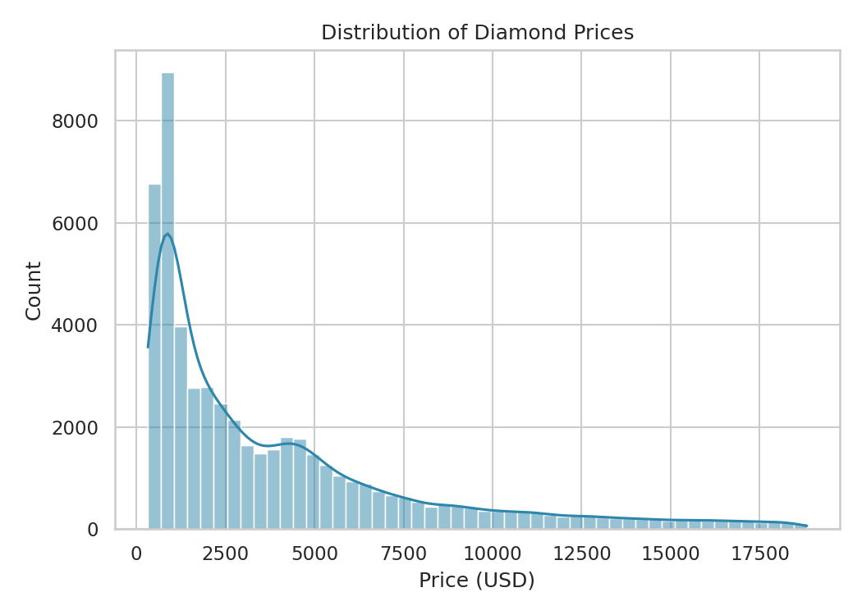

4.2 Carat vs. Price
Carat weight is the single strongest driver of price. Cut quality creates visible separation within carat bands — better cuts command a premium at the same carat weight.
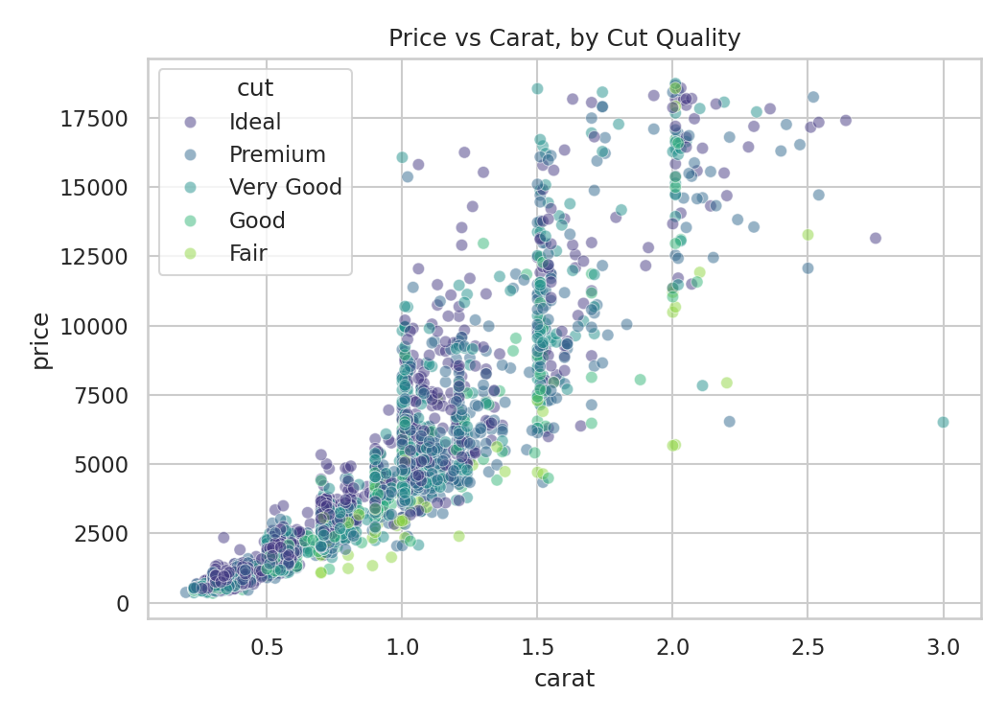

4.3 Price by Cut Quality
Interestingly, 'Fair' cut diamonds show a wide price spread, often because they are paired with larger carat weights. Cut alone is not price-determinative without accounting for carat.
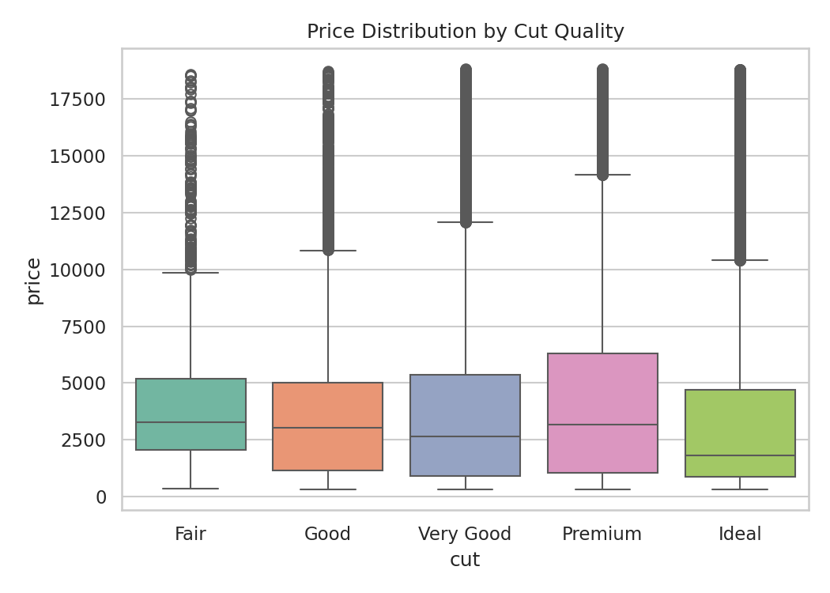

4.4 Price by Clarity Grade
Average price varies non-monotonically across clarity grades, largely because higher-clarity stones in this dataset tend to be smaller in carat, showing that clarity alone doesn't determine price — it interacts with size.
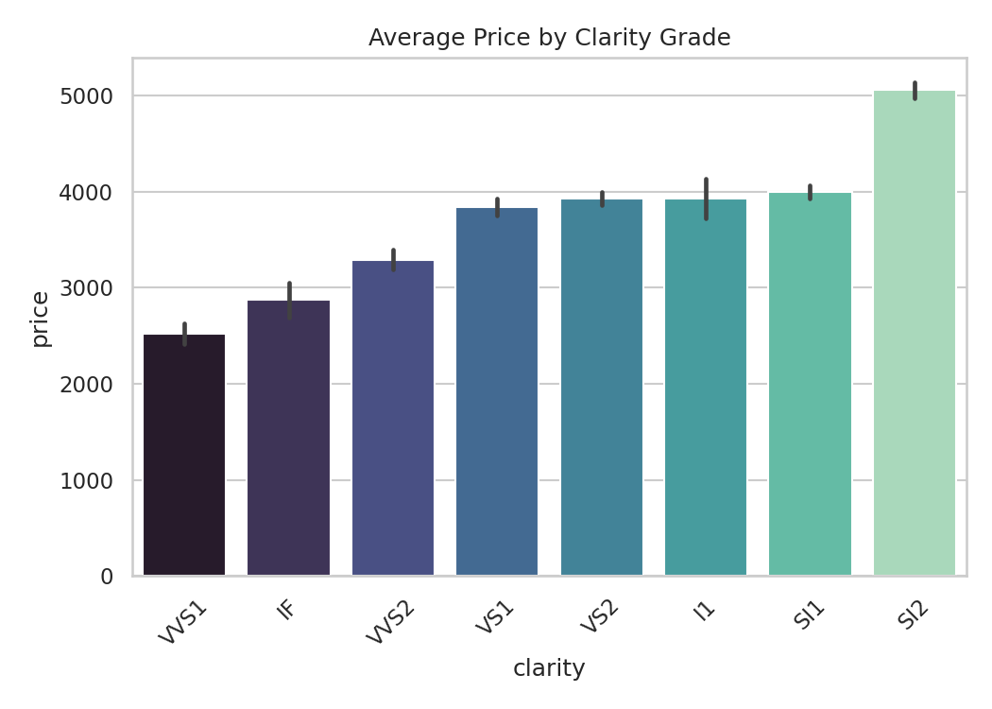

4.5 Correlation Heatmap
Carat and the physical dimensions (x, y, z) are almost perfectly correlated with price and each other, as expected since they all measure the size of the stone.
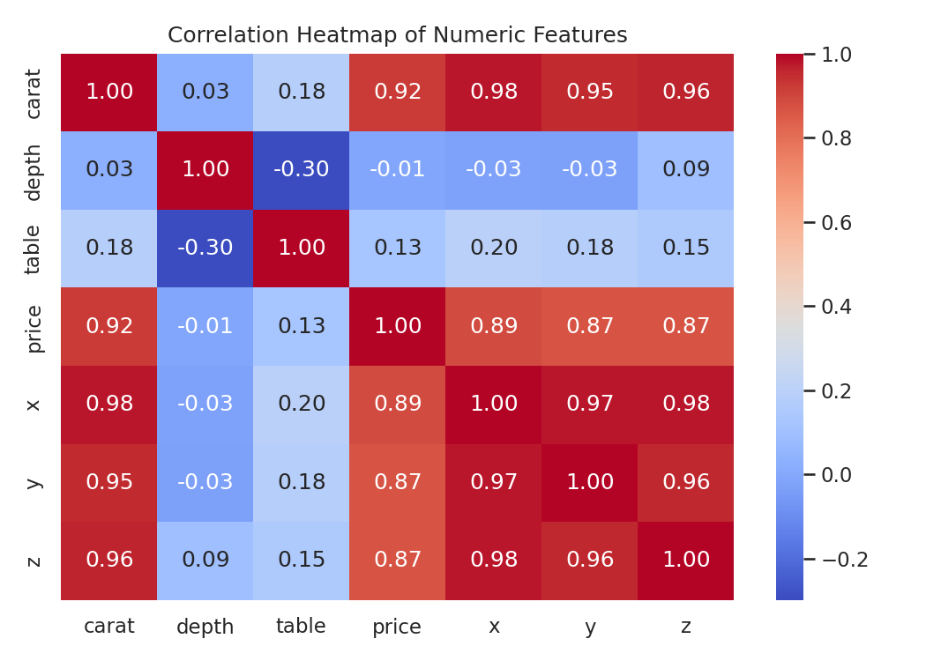

5. Business Insights
- Carat weight should be the primary lever in retail pricing models, given its 0.92 correlation with price.
- Cut and clarity add meaningful secondary value, but their effect is best understood after controlling for carat.
- Retailers could bundle 'Fair' cut, larger-carat stones as value options, since size compensates for lower cut grade in perceived value.
- Price distribution skew suggests most retail volume is in the sub-$5,000 range — inventory and marketing should weight this segment heavily.

6. Conclusion
This project demonstrated an end-to-end retail data analysis workflow: cleaning a real-world dataset, computing summary statistics, and building visual dashboards to communicate findings. The analysis confirms that carat weight is the dominant price driver in the diamond retail market, with cut and clarity playing supporting roles. These techniques — using Python, Pandas, and Seaborn — are directly transferable to pricing and inventory analysis in any retail domain.

