# Git log

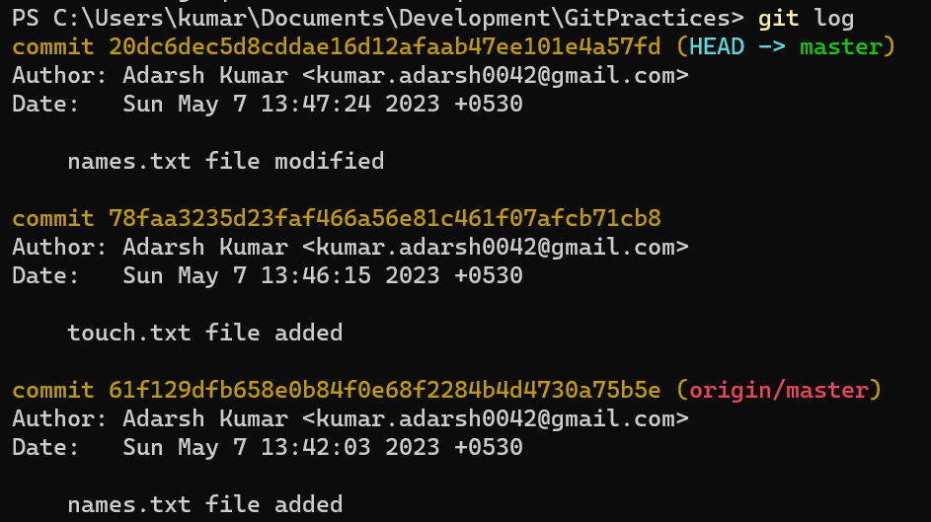

# Git remote show origin

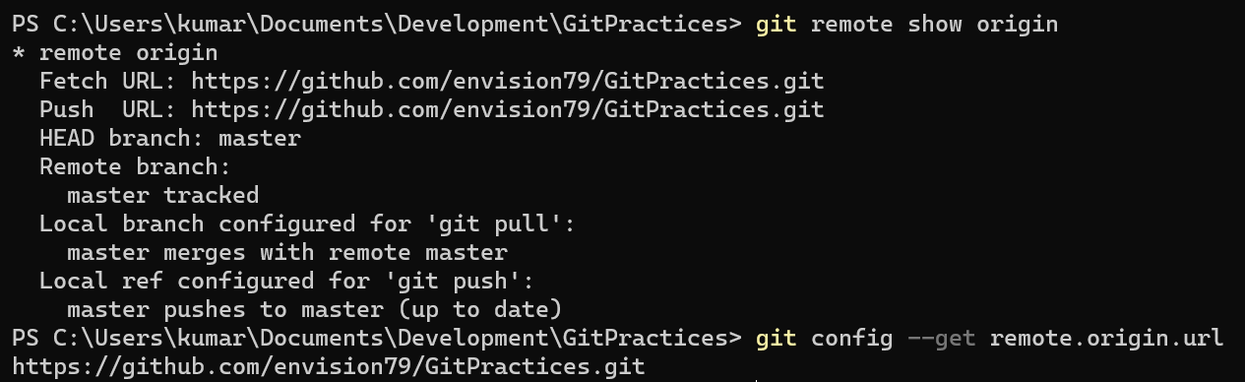

# How to initialize a git repository

Git init

Git remote add origin <https://github.com/envision79/GitPractices.git>

(Working with url, adding a url, origin is name of url you are going to add)

# Cat command

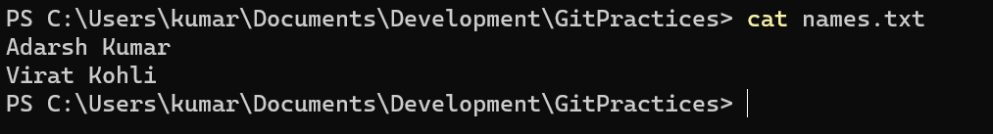

# Git restore command

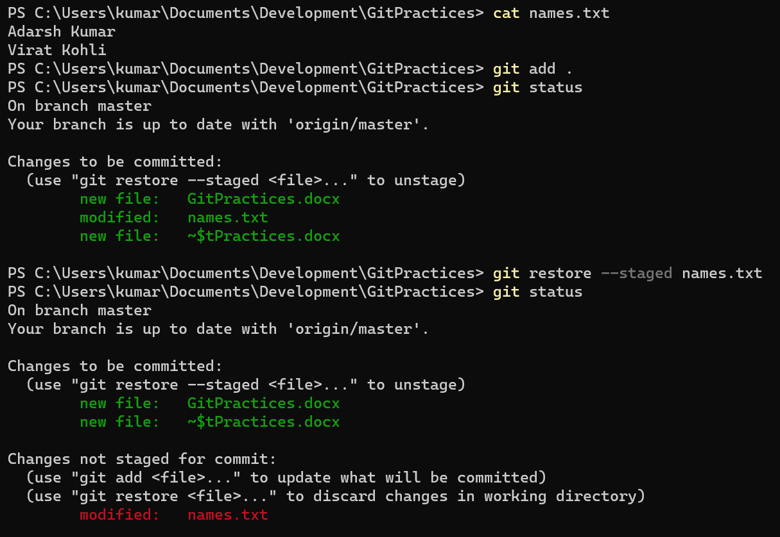

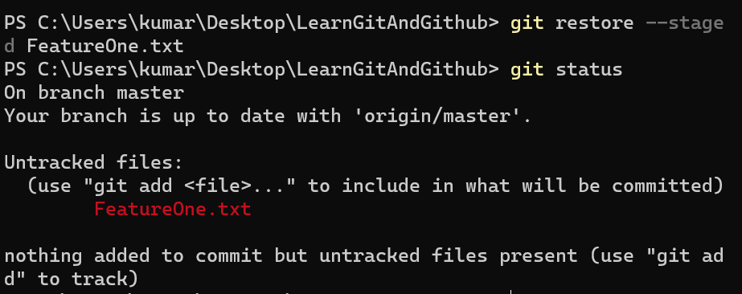

# Analogy as a wedding

Git add = staged

Git commit = photo clicked

# Git reset command

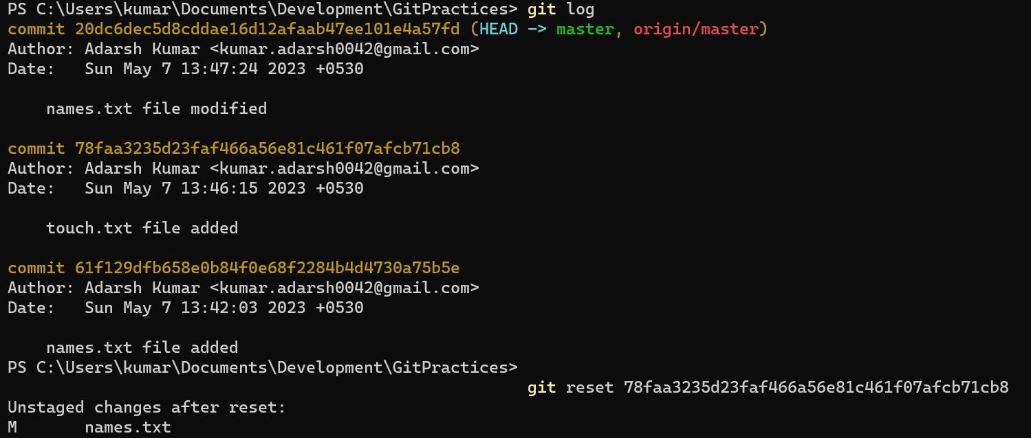

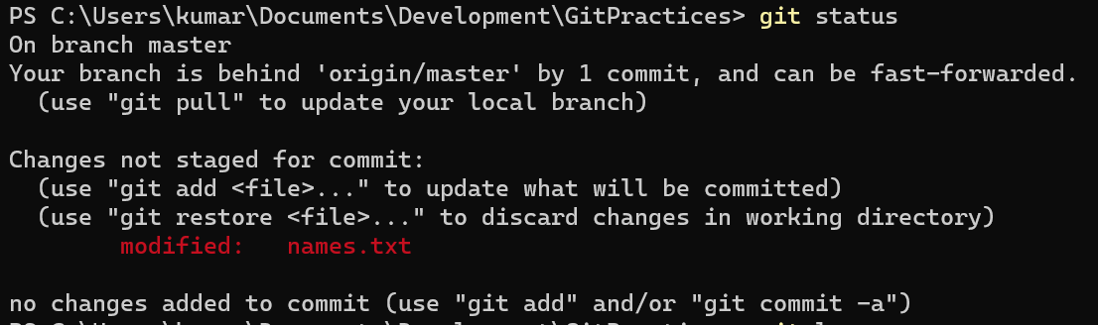Now what happened to the files that were touched after this command where we have reset. They will now will be in unstaged area

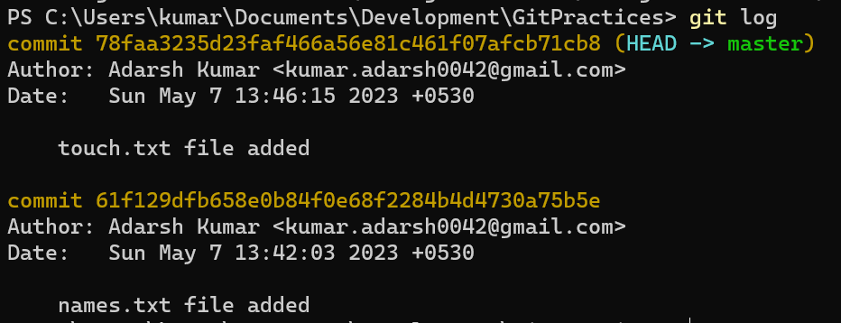

# GIT STASH

Go to the backstage whenever we want you to comeback we will get you back!

If you want to try out something new then you want to remove you changes but not want to save that as a commit. Whenever I want to get that thing back I can get that back

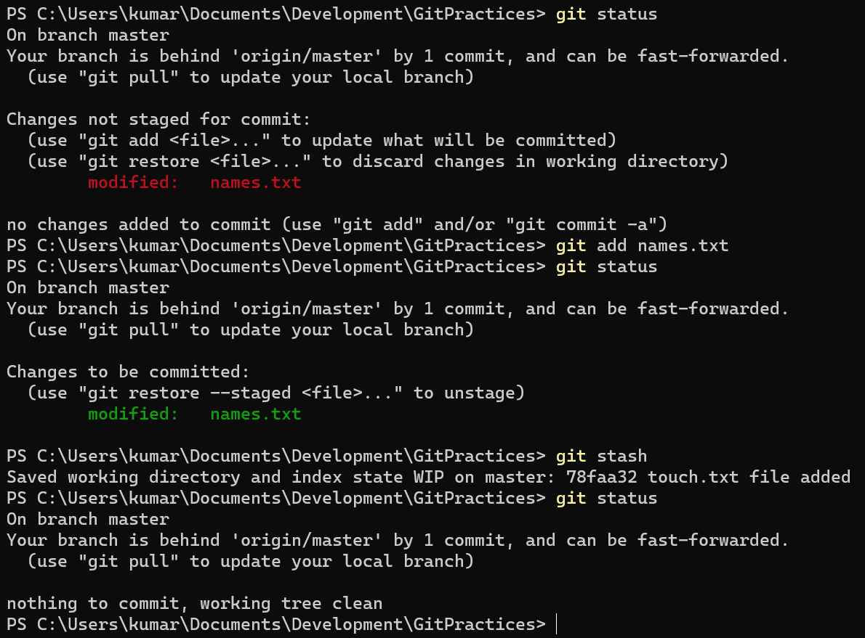

GET STASHED CHANGES BACK

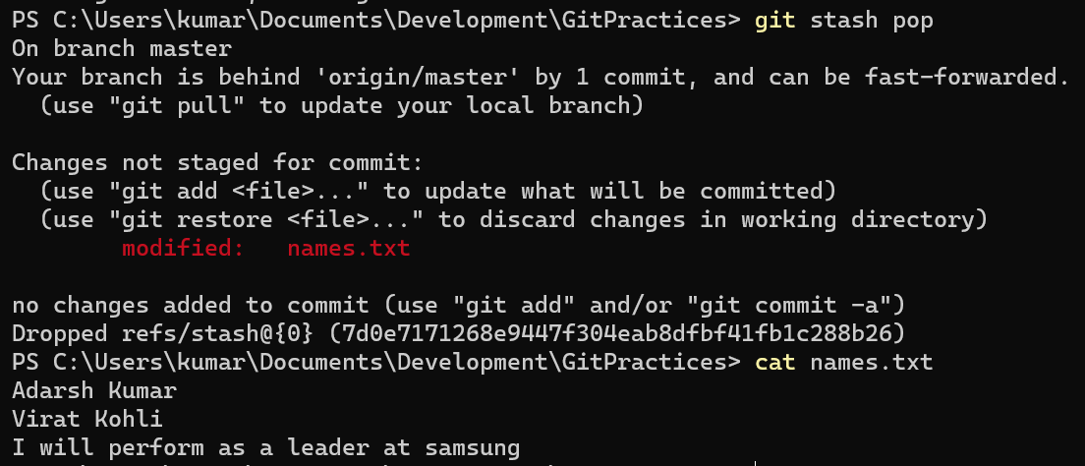

COMMAND FOR REMOVING THOSE STASH CHANGES IF YOU DON’T NEED THEM NOW:

GIT STASH CLEAR

Git remote add origin URL

One branch can open just a single pull request. So if you want to add multiple features then multiple pull request is necessary.

