**Name- Adarsh Maurya**

**Reg. no- 12303957**

**Minor Project Report**

**Factorial Calculator**

**(1) Introduction**

This project focuses on factorial, with the help of this project we can find factorial of any number.

**(2) Technologies Used**

C++

HTML, CSS, JavaScript

**(3) C++ Code**

#include <iostream>

using namespace std;

long long factorial(int n)

{

    // Base case If n is 0 or 1, return 1

    if (n == 0 || n == 1) {

        return 1;

    }

    //Recursive case

    return n * factorial(n - 1);

}

int main()

{

    int num;

    cout<<"Enter a positive number:";

    cin>>num;

    cout << "Factorial of " << num << " is "

         << factorial(num) << endl;

    return 0;

}

(4) **Output Screenshot**

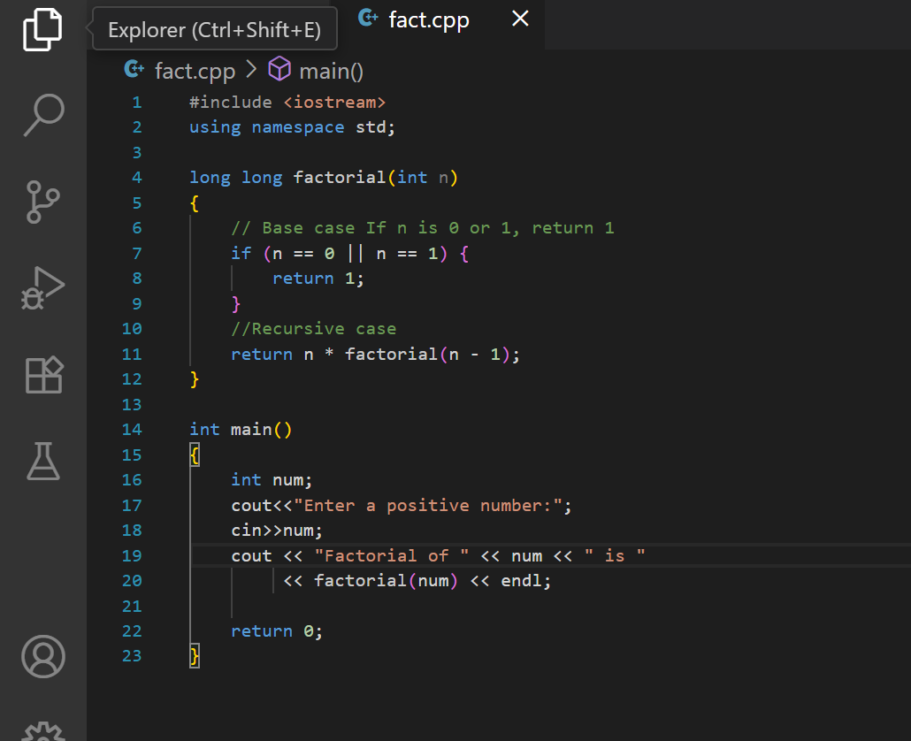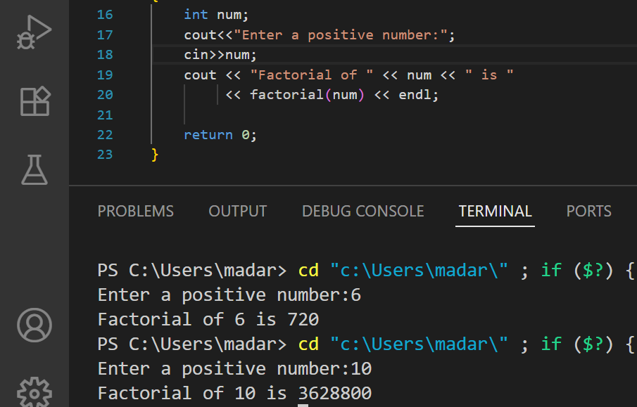

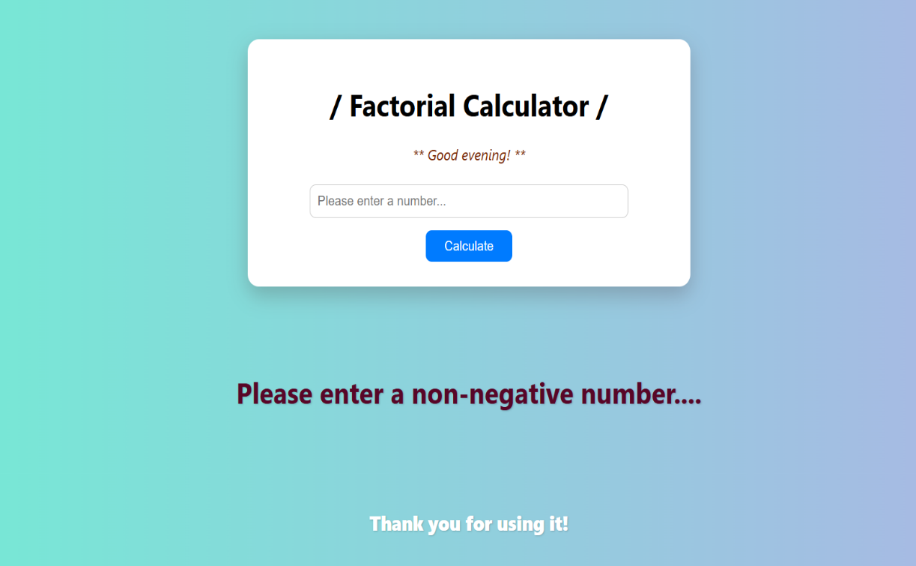

**(5) GitHub Project Link**

https://github.com/adarshm095/Factorial_calculator