|  |
| --- |
| Photo displaying partial image of two pie charts on a canvas-textured page |
| **CS361_LAB08**  **Adarsh Maddheshiya Id- 202151004** |
| |  |  |  | | --- | --- | --- | |  |  |  | |

**Q.1 create a network between 3 pcs ,Switch ,Router and server .**

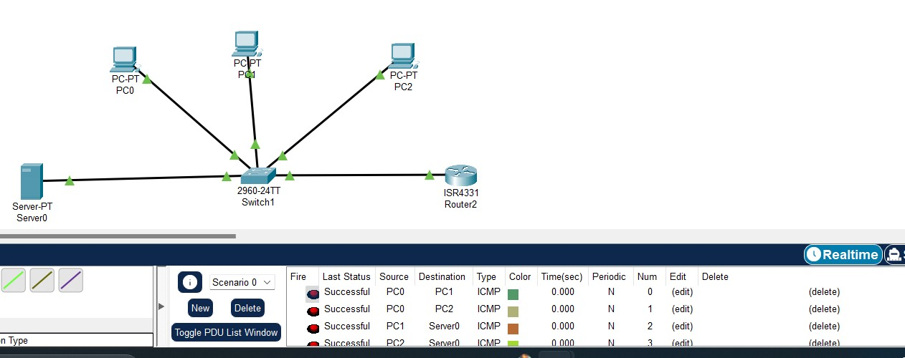

**Q.2 And take two wireless access points and connect them to switch .**

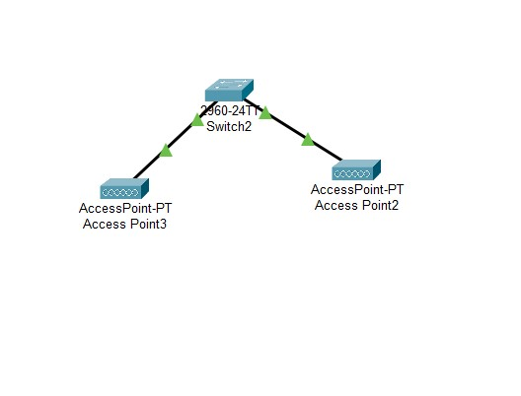

**Q.3 Connect at least 10 wireless devices (wireless desktop ,Laptop, printers, wireless mobile, tabs & etc.. ) to each access point**

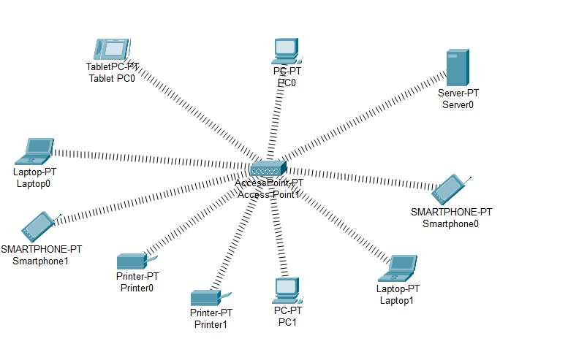

**Q.4 connect a wireless server to access point 0 & access point 1.**

