PRDA – 04 Customer Data Analysis

- How is the shopping distribution according to gender?
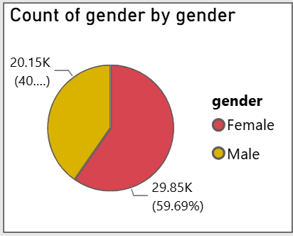

- Which gender did we sell more products to?
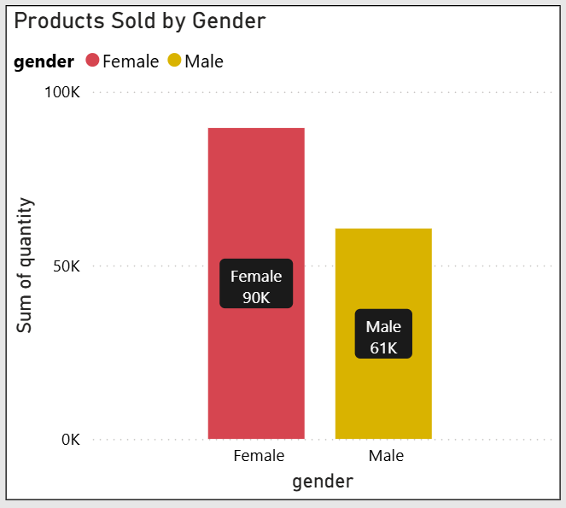

- Which gender generated more revenue?

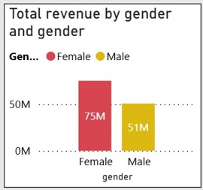

- Distribution of purchase categories relative to other columns?

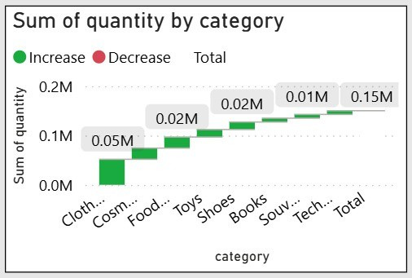

- How is the shopping distribution according to age?

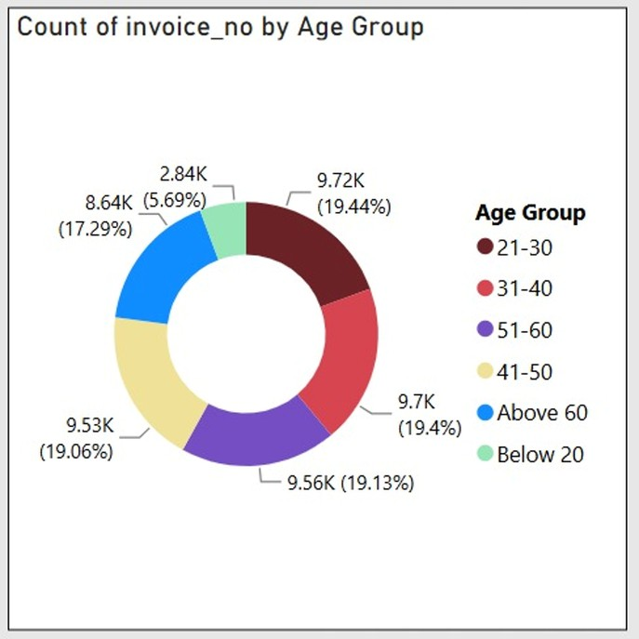

- Which age cat did we sell more products to?

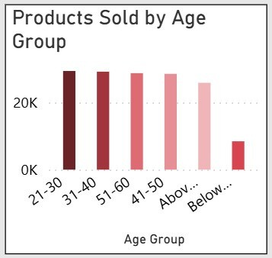

- Which age cat generated more revenue?

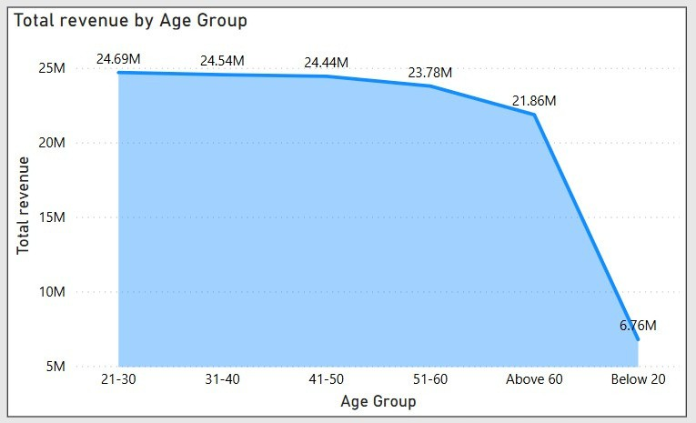

- Distribution of purchase categories relative to other columns?

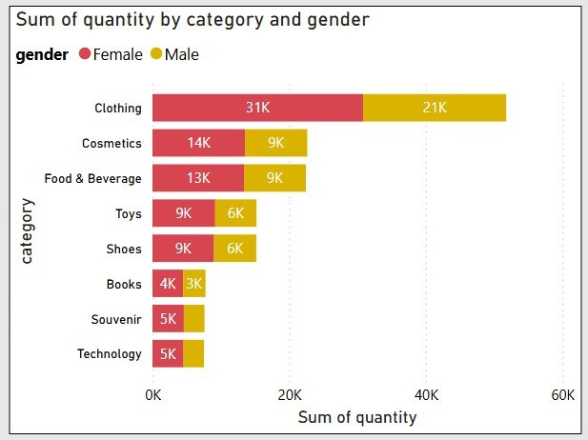

- Does the payment method have a relation with other columns?

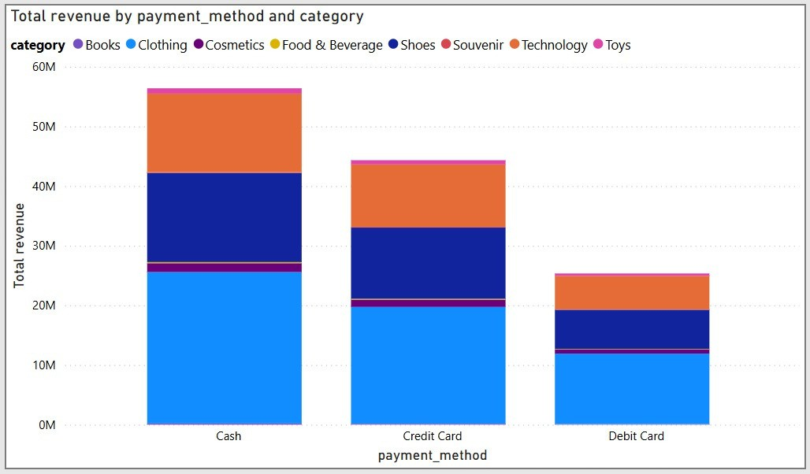

- How is the distribution of the payment method?

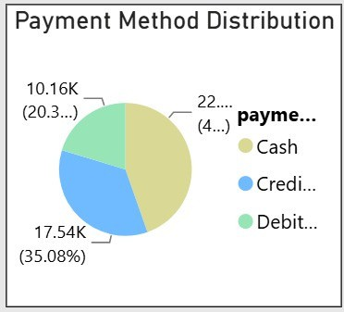

- Visualize the data using Tableau /PowerBI and derive insights and give your inputs/suggestions to the company.

