**KL Rahul’s Masterclass chase**

In the recent IPL 2025 match between Delhi Capitals and Royal Challengers Bangalore, KL Rahul played an amazing knock in guiding his team to victory. His unbeaten 93 off 53 balls showed the class and elegance of his batting ability.

This analysis examines how Rahul approached this innings – right from his cautious start to his explosive finish. Let’s look at how Rahul managed the required run rate, targeted specific bowlers, and adapted his batting approach during different phases of the chase to successfully lead Delhi Capitals to victory.

**KL Rahul 93*(53)**

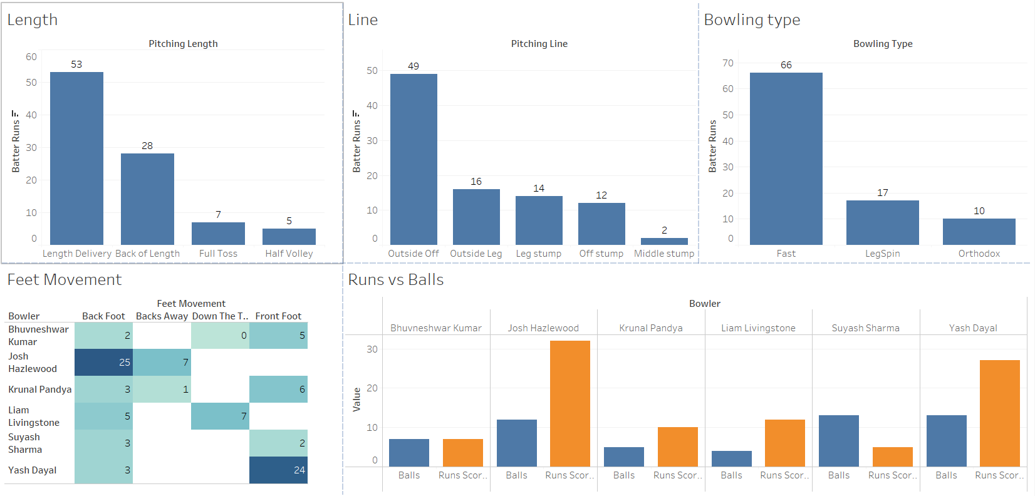

Several factors include length, line, bowling type, feet movement and the amount of runs scored against each bowler.

**Length Analysis**

KL Rahul heavily scored off length deliveries (53 runs). This clearly shows that he preferred hitting balls that were bowled in the good length area. He also scored 28 runs off back of length deliveries, while managed to not throw his wicket away against full tosses (7 runs) and half volleys (5 runs).

**Line Analysis**

Rahul was particularly aggressive against outside off deliveries, scoring 49 runs in this area. This suggests he was comfortable hitting on the off-side, especially driving and cutting. He scored 16 runs off outside leg deliveries, 14 runs off leg stump line, and 12 runs off off-stump line. This proves his ability to score all around the wicket.

**Bowling Type Response**

Rahul dominated against pace bowling, scoring 66 runs against fast bowlers. He also managed to score 17 runs against leg spin and 10 runs against orthodox spin. The strike rate against the spinners was 122 whereas the strike rate against the pacers was 212. That wicket was quite assisting the spinners and he clearly maintained his calm in hanging in there. This shows his maturity and mental strength.

**Feet Movement**

Feet movement is crucial when a batsman is facing quality bowlers. Let’s look at how Rahul used his feet against each bowler.

* Against Josh Hazlewood, Rahul primarily used back foot play and scored about 25 runs.
* Against Yash Dayal, he scored 24 runs using the front foot.
* Against the other bowlers, he played a variety of shots with minimal risk.

**Bowler Matchups**

The runs vs balls chart shows Rahul was particularly effective against Josh Hazlewood and Yash Dayal. This suggests he targeted specific bowlers in his chase strategy, likely to increase the run rate at critical moments. This includes the moment where it started drizzling and KL Rahul accelerated the run rate by targeting the over bowled by Hazlewood. He made sure that the team was ahead of the DLS par score at any given point in time. This shows his game awareness and his ability to shift gears when it’s necessary.

All these insights indicate KL Rahul played a calculated innings by targeting specific bowlers, respecting the spinners and dominating the pace bowling. The above insights demonstrate why he was able to successfully lead DC to victory in this chase.