The SQL script used to create the database:
-- WARNING: This schema is for context only and is not meant to be run.
-- Table order and constraints may not be valid for execution.
CREATE TABLE public.customers (
customer_id uuid NOT NULL DEFAULT gen_random_uuid(),
name character varying NOT NULL DEFAULT now(),
age integer,
annual_income double precision,
email character varying,
phone_number bigint,
number_of_dependents bigint,
investor_type text,
CONSTRAINT customers_pkey PRIMARY KEY (customer_id)
);
CREATE TABLE public.analysis_history (
customer_id uuid NOT NULL DEFAULT gen_random_uuid(),
analysis_id uuid NOT NULL DEFAULT gen_random_uuid(),
analysis_type text,
date_of_analysis timestamp without time zone,
CONSTRAINT analysis_history_pkey PRIMARY KEY (customer_id),
CONSTRAINT analysis_history_customer_id_fkey FOREIGN KEY (customer_id) REFERENCES public.customers(customer_id)
);
CREATE TABLE public.companies (
ticker text NOT NULL,
company_name text NOT NULL,
sector text,
CONSTRAINT companies_pkey PRIMARY KEY (ticker)
);
CREATE TABLE public.customer_assets (
asset_id uuid NOT NULL DEFAULT gen_random_uuid(),
asset_value bigint NOT NULL,
current_value double precision,
customer_id uuid,
CONSTRAINT customer_assets_pkey PRIMARY KEY (asset_id),
CONSTRAINT customer_assets_customer_id_fkey FOREIGN KEY (customer_id) REFERENCES public.customers(customer_id)
);
CREATE TABLE public.customer_liabilities (
liability_id uuid NOT NULL DEFAULT gen_random_uuid(),
liability_name text NOT NULL,
current_value double precision,
customer_id uuid,
CONSTRAINT customer_liabilities_pkey PRIMARY KEY (liability_id),
CONSTRAINT customer_liabilities_customer_id_fkey FOREIGN KEY (customer_id) REFERENCES public.customers(customer_id)
);

CREATE TABLE public.portfolio_holdings (
portfolio_id uuid NOT NULL,
holding_id uuid NOT NULL DEFAULT gen_random_uuid(),
quantity integer,
date_of_purchase time without time zone,
ticker text,
buy_price real
);
CREATE TABLE public.portfolios (
customer_id uuid NOT NULL DEFAULT gen_random_uuid(),
portfolio_id uuid NOT NULL DEFAULT gen_random_uuid(),
portfolio_name text,
CONSTRAINT portfolios_pkey PRIMARY KEY (customer_id),
CONSTRAINT portfolios_customer_id_fkey FOREIGN KEY (customer_id) REFERENCES public.customers(customer_id)
);
Focus on the table structure below:
The screenshot of the signed up users on my web application obtained using sign up:
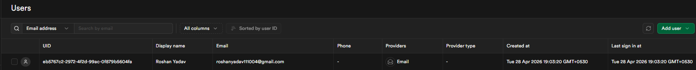

The table structure screenshot of the analysis_history on my web application:
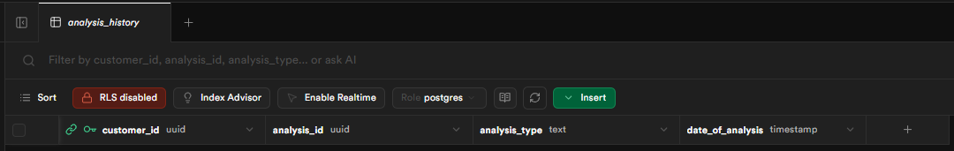

The screenshot of the customer_assets on my web application:
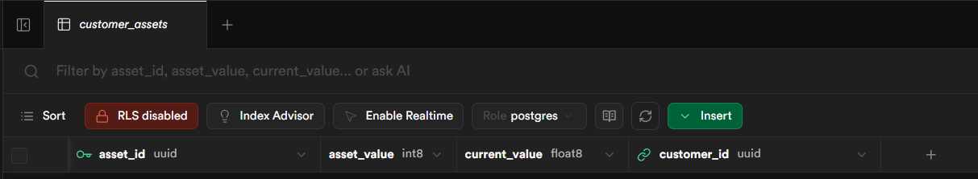

The screenshot of the customer_liabilities on my web application:
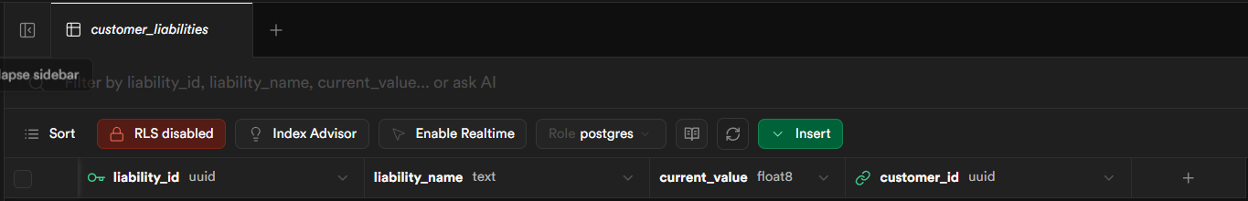

The screenshot of the customers on my web application:
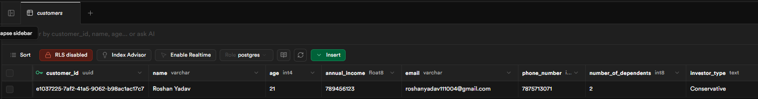
The screenshot of the portfolio_holdings on my web application:
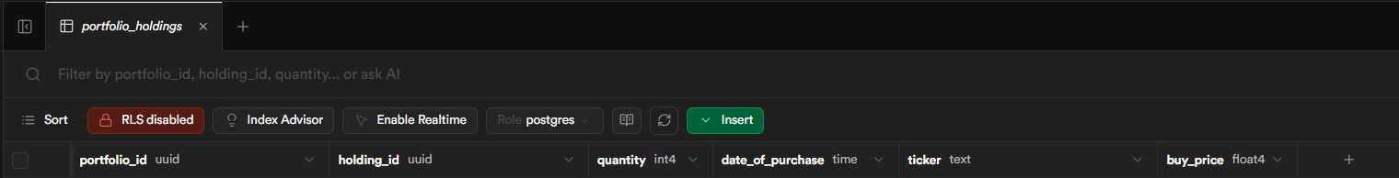

The screenshot of the portfolios on my web application:
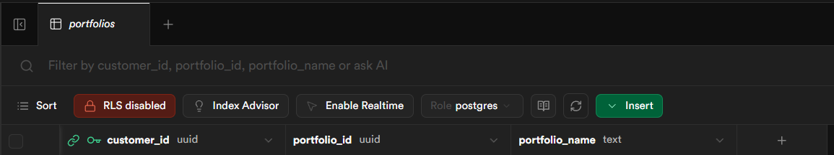

The output should be:
1. When the user clicks on the Display Name on the landing page after login should be redirected to profile page.
2. After the user is on the profile page, the user should be able to see all the fields of the database table and the data that are fetched from the database and the text “not provided” if the value is NULL in the database.
3. The Display name and email should be fetched from the authentication table.
4. The user should be able to update the details.
5. User proper industry level coding style and principles to write the code and proper and clean file structure.
Write the prompt.

