Character Recognition

## Input Image

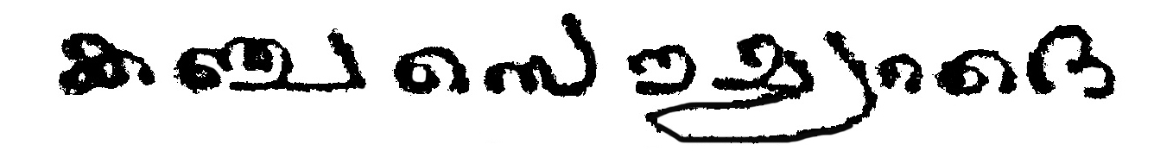

## Outputs

### VGGNET

#### Timestamp: 22-54_23-3-2022

##### Output

##### Type: Normal

**കഞ്ചസൌലദൈ**

##### Type: Finetuned

**കഞ്ചസൌഞ്ചദൈ**

### RESNET

#### Timestamp: 22-8_23-3-2022

##### Output

##### Type: Normal

**കധരസൗഗ്രരരദ**

##### Type: Finetuned

**കഖസൌഇരദെ**

### INCEPTIONNET

#### Timestamp: 11-0_24-3-2022

##### Output

##### Type: Normal

**കണരസാുരദെ**

##### Type: Finetuned

**കണസൌഗ്രൗൗെ**

### DENSENET

#### Timestamp: 9-41_24-3-2022

##### Output

##### Type: Normal

**കഞ്ചസൌഷറദെ**

##### Type: Finetuned

**കഞ്ചസൌലദൈ**

### INCEPTIONRESNET

#### Timestamp: 23-49_26-3-2022

##### Output

##### Type: Normal

**കഞ്ചസൊയരദെ**

##### Type: Finetuned

**കഞ്ചസൌയറദെ**

### EFFICIENTNET

#### Timestamp: 21-42_26-3-2022

##### Output

##### Type: Normal

**കഞ്ചംസൗഗ്ഗറദെ**

##### Type: Finetuned

**കഞ്ചസൌൂറദെ**