Character Recognition

## Input Image

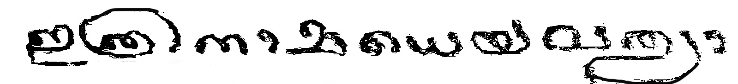

## Outputs

### VGGNET

##### Timestamp: 12-41_30-11-2021

###### Output

**ഇത്രനാമധെയവലഠദ**

### RESNET

##### Timestamp: 12-0_30-11-2021

###### Output

**ഇക്രനരമധെയവചക്രദ**

### INCEPTIONNET

##### Timestamp: 13-20_30-11-2021

###### Output

**ഇയനഭെധെയവഴൃദ**

### DENSENET

##### Timestamp: 15-1_30-11-2021

###### Output

**ഇക്രനരഷധെയവചലദ**