Character Recognition

## Input Image

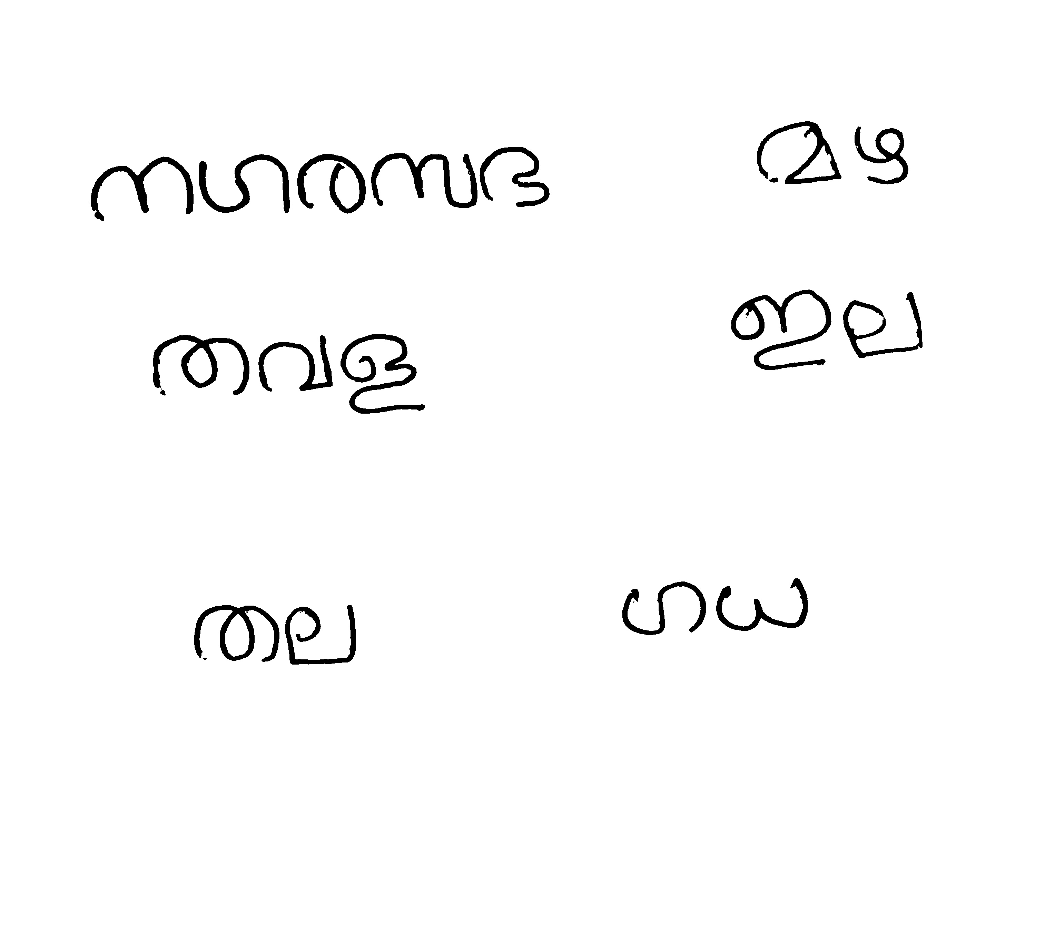

## Outputs

### VGGNET

#### Timestamp: 22-54_23-3-2022

##### Output

##### Type: Normal

**നഗരസദമഴതവഋഇലതലഗധ**

##### Type: Finetuned

**നഗരസഭമഴതവമ്ലഇലതലഗധ**

### RESNET

#### Timestamp: 22-8_23-3-2022

##### Output

##### Type: Normal

**നഗരസഭമഴതവഗ്രഇലതലഗധ**

##### Type: Finetuned

**നഗരസഭമഴതവളഇലതലഗധ**

### INCEPTIONNET

#### Timestamp: 11-0_24-3-2022

##### Output

##### Type: Normal

**നഗരസുമഴതവുഇലതഃഗധ**

##### Type: Finetuned

**നഗരസഭമഴതവൾഇലതലഗധ**

### DENSENET

#### Timestamp: 9-41_24-3-2022

##### Output

##### Type: Normal

**നഗരസഭമഴതവഇഇലതലഗഗ**

##### Type: Finetuned

**നഗരസഭമഴതവളഇലതലഗധ**

### INCEPTIONRESNET

#### Timestamp: 23-49_26-3-2022

##### Output

##### Type: Normal

**നഗദസദ്രമക്രതവഇഇലതാഗധ**

##### Type: Finetuned

**നഗരസഭമഴതവമ്ലഇലതഖഗധ**

### EFFICIENTNET

#### Timestamp: 21-42_26-3-2022

##### Output

##### Type: Normal

**നഗരസഭമഴതവഇഇലതലഗധ**

##### Type: Finetuned

**നഗരസഭമഴതവളഇലതലഗധ**