**Role-Based Access Control (RBAC) UI system**

Role-Based Access Control (RBAC) UI simplifies managing user permissions by assigning roles with specific privileges, ensuring secure, efficient access control for applications, and enhancing administrative oversight in modern systems.

**Run** :

* Terminal 1 npm start
* Terminal 2 json-server –watch db.json –port 5000
* **Admin Dashboard**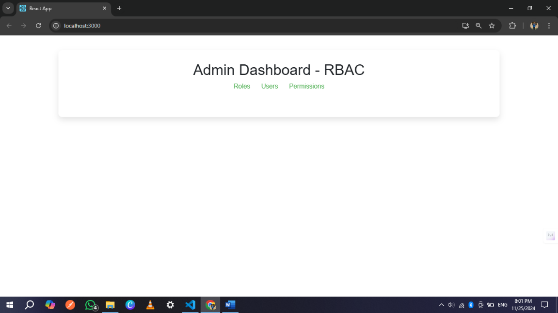
* **Roles management**

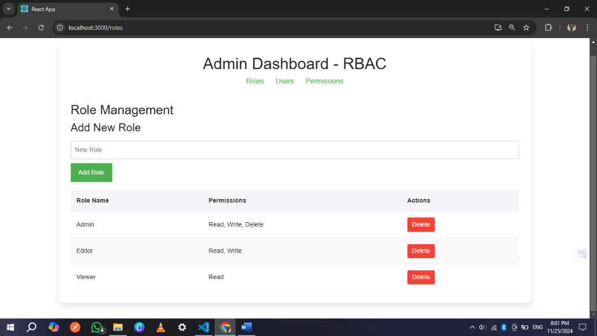

* **User management**

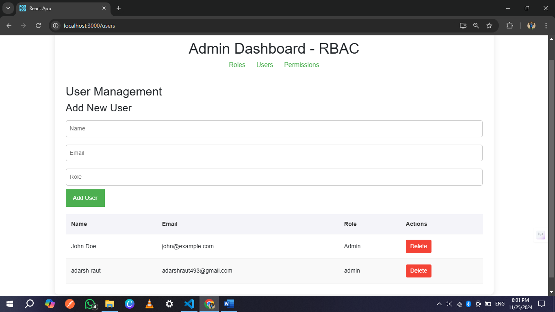

* **Permission management**

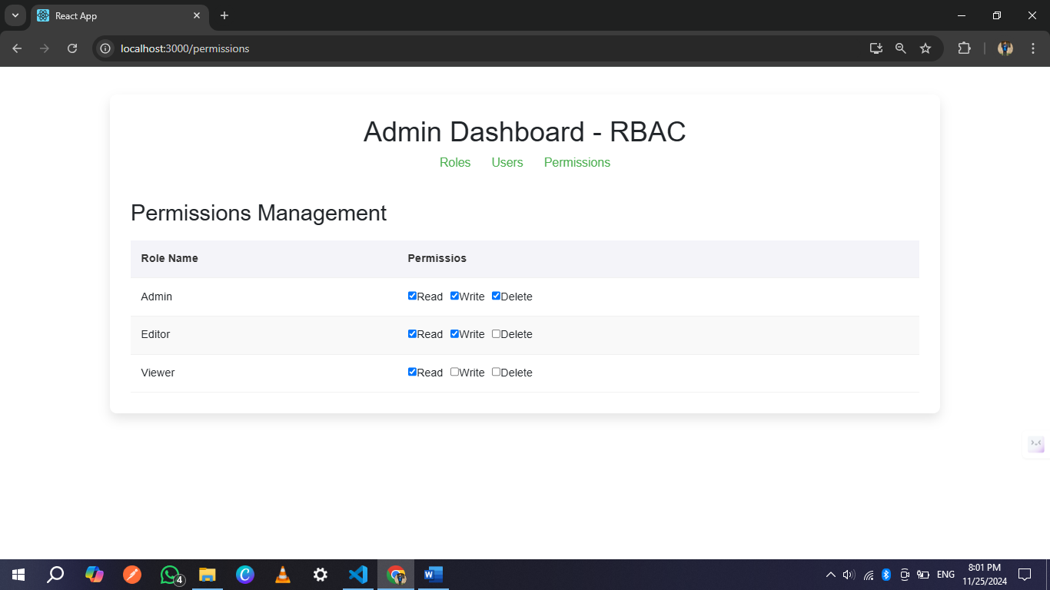

**Tools and Languages:**

* React.js
* Vs code